Nicco Fortes

11/20/22

Foundations of Programming

Module 6

Module 6

# Intro

This week we were introduced to functions and how we can implement them into our scripts. We discussed how to define them, pass arguments to them, call them, and how to store data from the output of these functions. We expanded on the “None” data type and were also introduced to global variables.

# Module 6

This module was straightforward comparted to Module 5. Subjects I focused on in this module were Positional/Named Arguments, default parameters, and Variable scope. These were the subjects I struggled with the most and played with most in the labs and the assignment.

# Assignment 6

In this assignment we were tasked with incorporating functions into our code to process certain sections of data. The assignment was conceptually easy, moving portions of the code into functions and calling them later in the script. My main struggle came from a syntax issue that appeared to be related to not visible characters when I was using the “1stTbl” variable in my script. After trouble shooting potential solutions and posting on the Discord, I found that copy and pasting from the original starter file a portion of the script solved the issue.

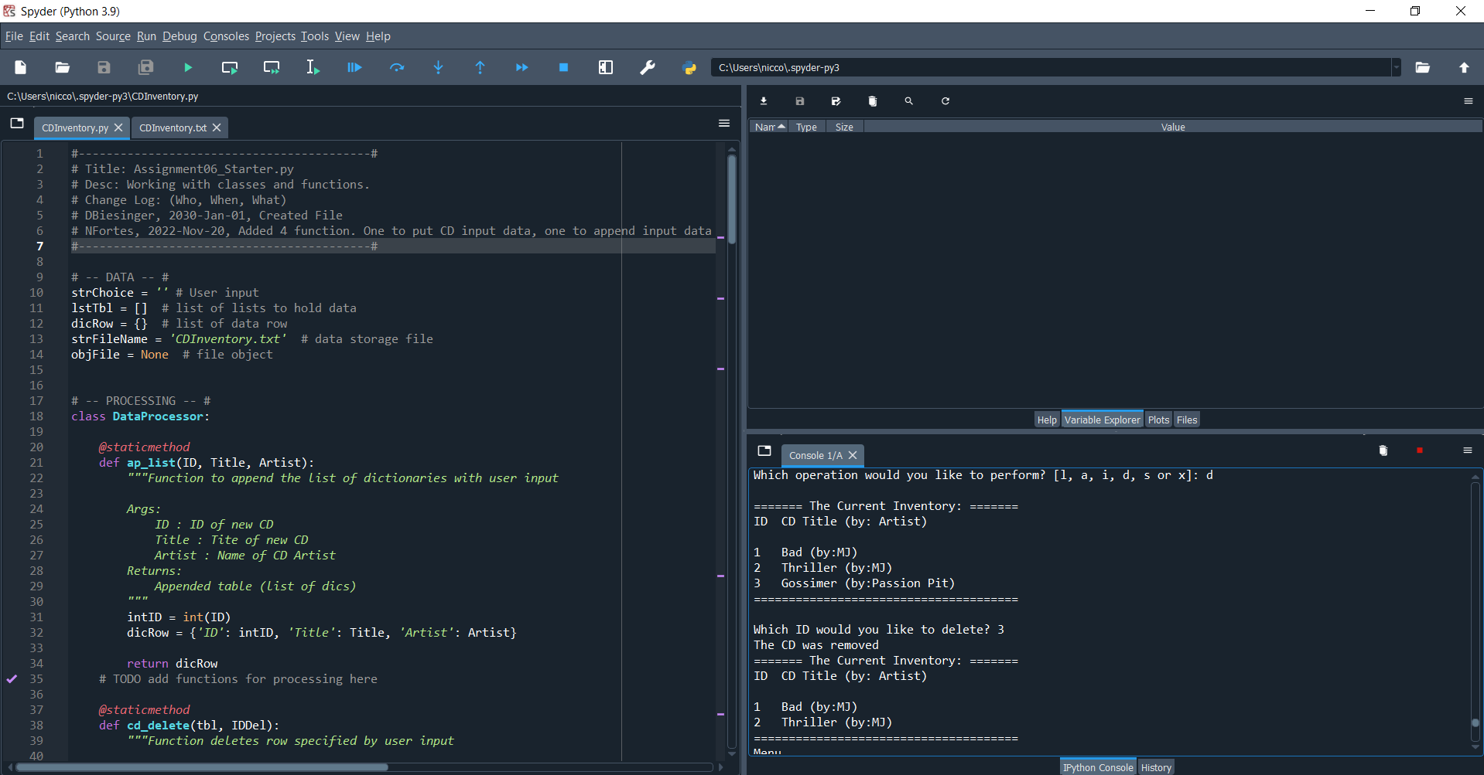

Figure : Script running in Spyder

Figure : Script running in prompt

# Summary

Learning about functions and implementing them made the body of the script easier to follow. Aside from the trouble shooting of the syntax issue in the assignment, implementing the learnings of this module was straightforward and I can see their practical application for a number of situations.

# GitHub Link

# Appendix/Search

moving syntax error python function