Hypothesis Assessment

Anthony Mascari

Western Governor’s University

C964: Capstone

# Hypothesis

The hypothesis of this project was that a model which is properly trained on the dataset will be able to accurately predict pay rates in different regions given certain input and details about the project.

# Assessment

The hypothesis for the project has proved quite true. While there are many additional variables that this particular model was not trained on, the data that was available was enough to begin generating quite accurate predictions based upon user input. Below are screenshots of some of the fields that were selected and the output that was produced by the model. Note that the red dot or line on each of the graphs is where the model placed the prediction.

Here is a better look at those same predictions:  
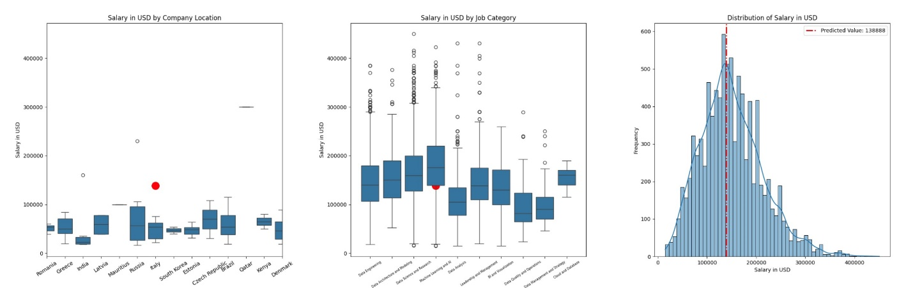

Next is a look at a graph of another position but in Denmark this time (Note the high prediction).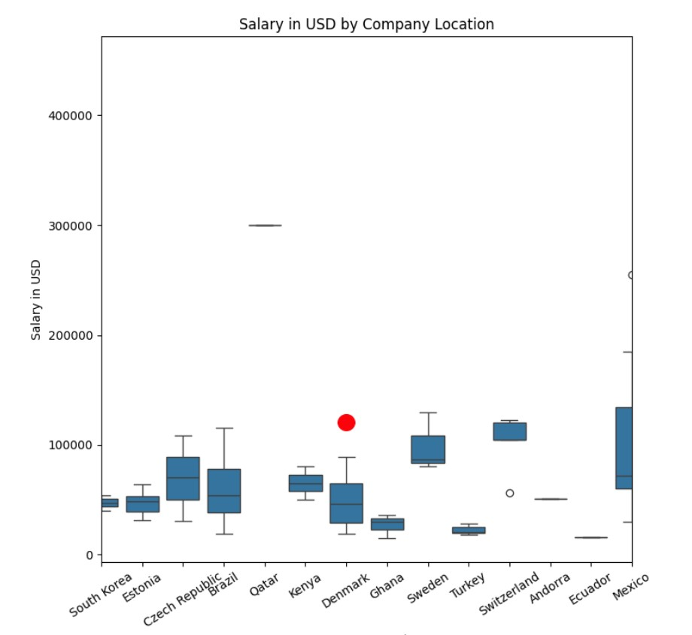

Lastly, we have a prediction for the same role (as Denmark above) in the United States.

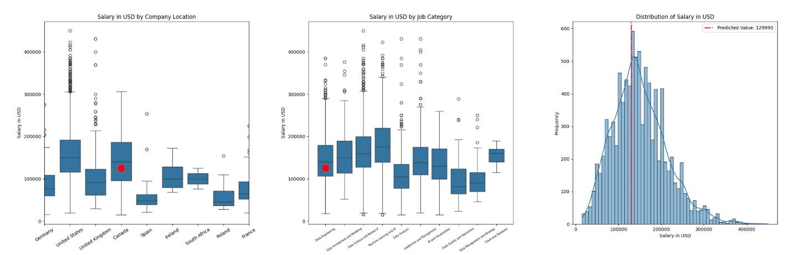

As we can see, some of the predictions for countries with fewer samples and lower ranges prove to be higher than the average for this country. This suggests that the model is not weighing the country input as heavily as it should be and that other factors such as position and role are being given too much weight for the purpose of our estimation. While there are numerous areas that this model could be improved upon, the original hypothesis holds true that it is able to adjust and predict outcomes based upon eight fields of input.