Visualizations

Anthony Mascari

Western Governor’s University

C964: Capstone

# Overview

During the data exploration phase and throughout the development phase visualization of the data and predictions proved invaluable. The following document showcases numerous data visualizations of both the raw dataset and visualizations produced by the model and completed program working together.

# Data Exploration

Below are a variety of different graphics and charts displaying useful information about the raw data. These visualizations were created using a combination of matplot and seaborn.

**Figure 1.1** *Displays the distribution of salary across the range in USD.*

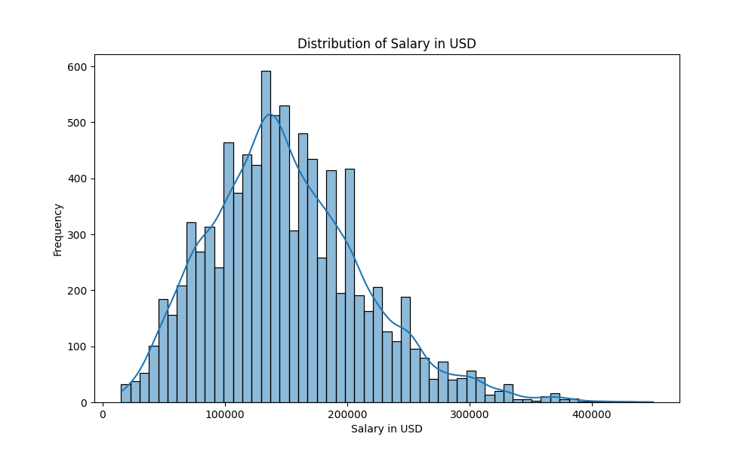

**Figure 1.2** *Displays the average salary by year in USD* 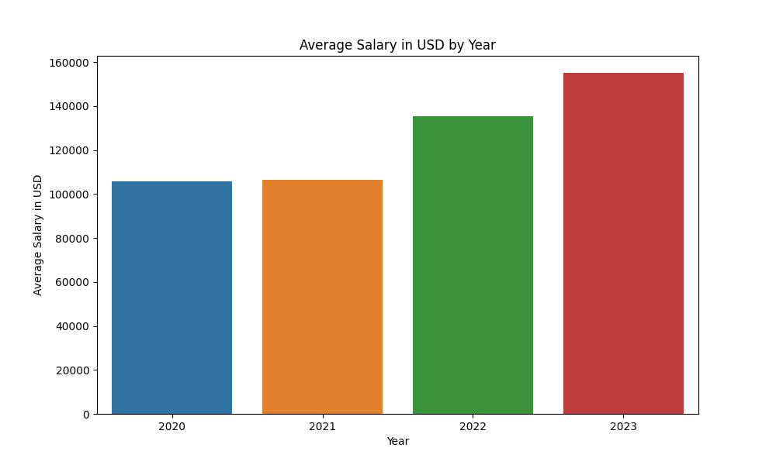

**Figure 1.3** *Displays salary in USD according to the company location.* 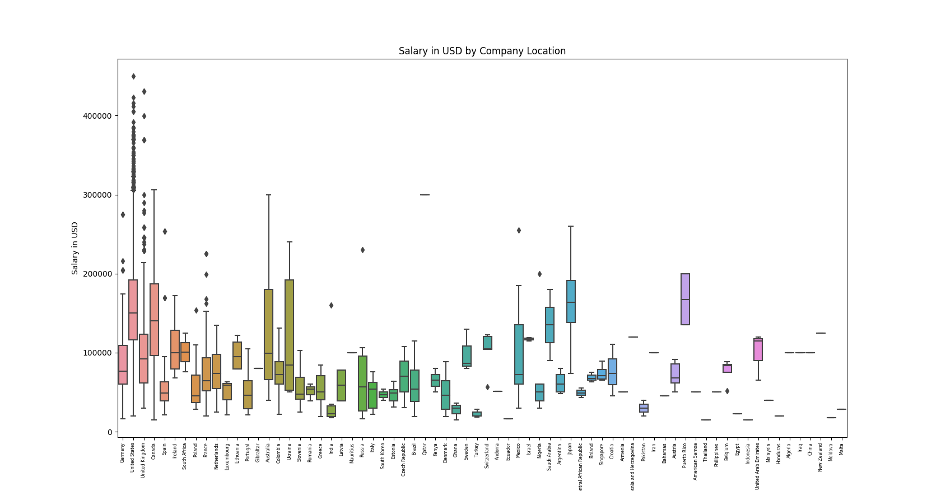

**Figure 1.4** *Displays a box and whisker chart of salaries in USD by job category from the raw data.* 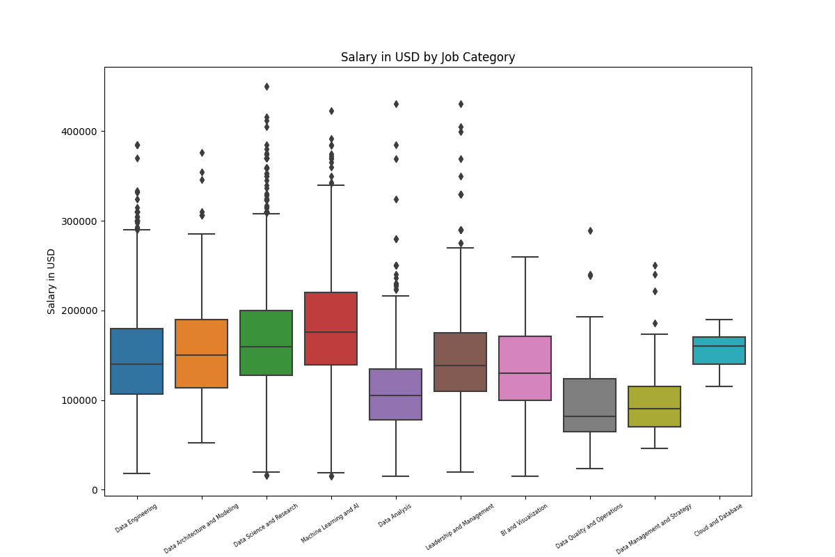

**Figure 1.5** *Displays the frequency of occurrence of the different job categories in the raw data.* 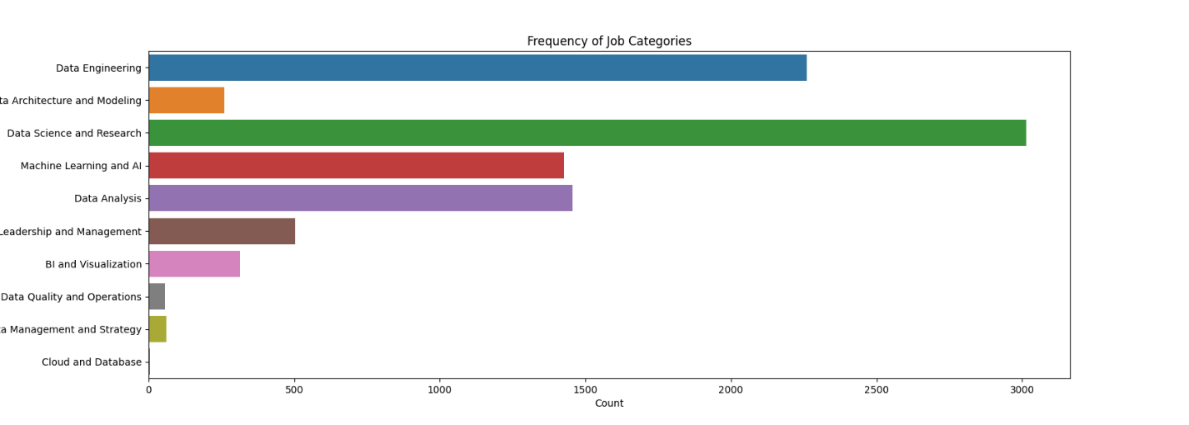

# Model Prediction Visualization

Below are a variety of different graphics and charts displaying useful information about the performance of the model and where it is making predictions in relationship to relevant ranges and categories in the data. Note that the red dot or line is an indicator of where the model made a prediction. The dot or line is placed in the relevant category that was specified as input for the prediction.

**Figure 2.1** *Displays a prediction for the Data Management category in Argentina.*

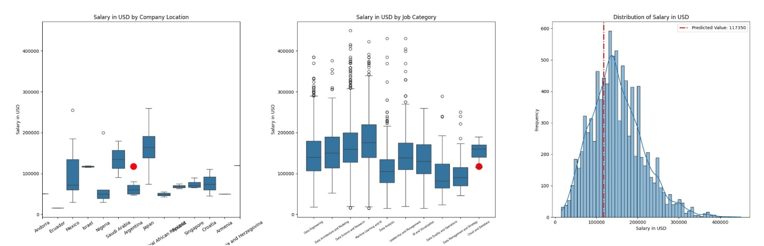

**Figure 2.2** *Displays a prediction for the Machine Learning category in Italy.*

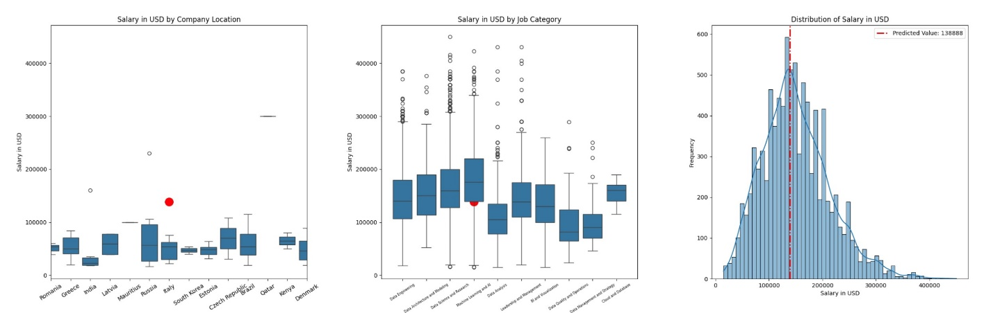

**Figure 2.3** *Displays a prediction for the Data Engineering category in the United States.*

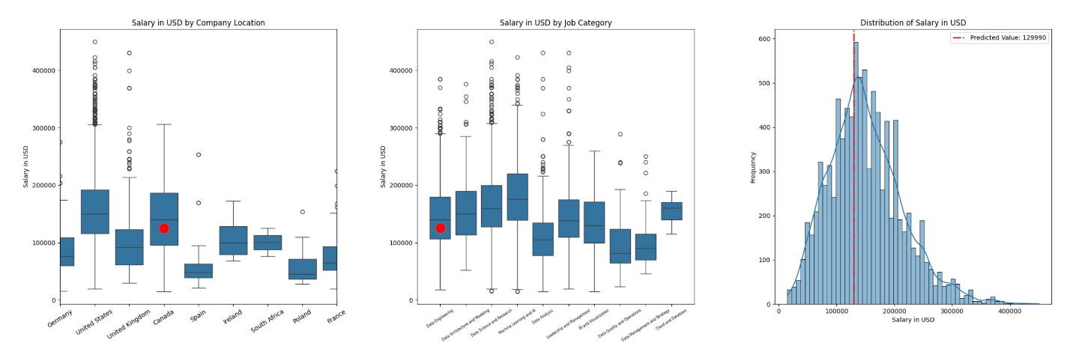

These visualizations display a variety of extremely useful insights that allow for the observation of patterns in the raw data as well as nuances from model prediction results. Throughout the development process visualizations were used as a means of ensuring that the project remained on track and that things were performing as expected.