Healthcare Dialogue System Report

Rachel Heke

Media Design School

NLP303: Natural Language Processing and Speech Recognition

Terence Mayne

March 25th, 2025

Healthcare Dialogue System Report

**Introduction / Background**

The rapid growth of digital health and telemedicine has led to innovative solutions that improve patient engagement and enhance access to healthcare services. As healthcare professionals face increasing demands and recognize the need for preliminary support before in-person consultations, automated dialogue systems have become invaluable resources. Recent events, particularly the COVID-19 pandemic, have accelerated the adoption of digital health and telemedicine, revolutionizing healthcare delivery (Whitelaw, Mamas, Topol, & Van Spall, 2020). This chatbot, designed for healthcare communication, assists users with medical inquiries, symptom triage, appointment scheduling, and prescription reminders. It effectively understands user input by utilizing natural language processing (NLP) techniques. It guides them through a secure, structured dialogue and it adheres to data privacy standards. The system is designed in compliance with HIPAA guidelines (U.S. Department of Health & Human Services, n.d.) while clearly stating that it is not a substitute for professional medical advice.

# Purpose of the Chatbot

The chatbot delivers preliminary diagnoses, assists with urgent care guidance, and facilitates seamless appointment management, including booking, cancelling, and rebooking. By efficiently managing routine healthcare interactions, the chatbot reduces waiting times, enhances patient experience, and lowers the administrative burden on healthcare providers. Additionally, customized medication reminders can improve medication adherence, which will positively impact patient outcomes and their engagement. Research suggests that task-based chatbots significantly enhance patient engagement and satisfaction (Martinengo et al., 2023).

**Process of the Code**

The chatbot was developed using Python due to its readability, modularity, and dedicated support for natural language processing libraries (Python Software Foundation, n.d.).

1. **User Input Handling**

* **Interface:** A user-friendly GUI prompts user interactions, facilitating natural and intuitive dialogues.
* **Example (Python):**

Figure 1: Greeting screen.

1. **Natural Language Processing (NLP)**

* **Intent Recognition:** Uses NLP libraries(spaCy) to accurately classify user intents, such as appointment booking or symptom assessment (Honnibal & Montani, 2023).
* **Example (Python):**

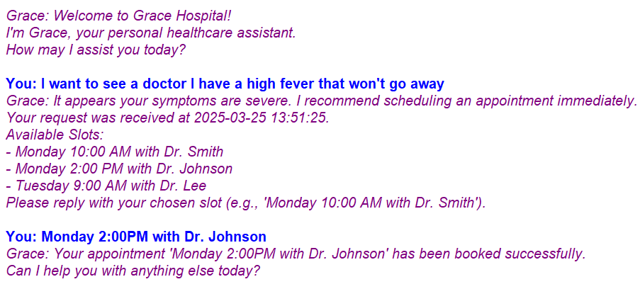

Figure 2: Appointment Scheduling Interaction between Grace Chatbot and User.

1. **Dialogue Flow Management**

* **State-Based Flow:** Directs the conversation logically based on recognized intents, ensuring coherent multi-turn interactions.
* **Example (Python):**

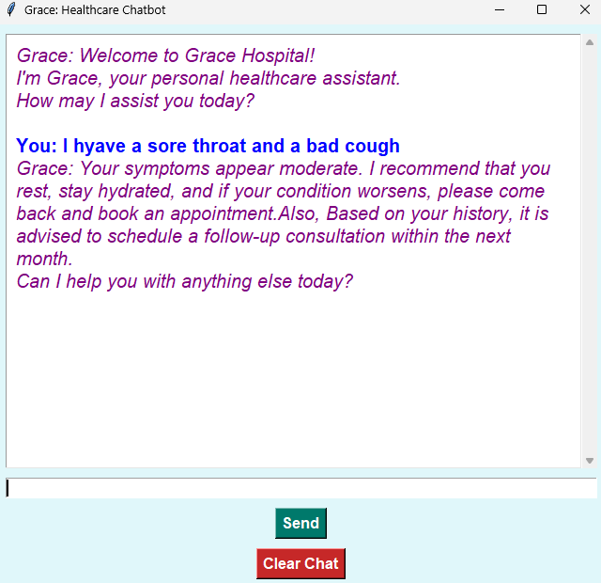

Figure 3: Symptom Triage Flow

1. **Task Handling Functions**

* **Appointment Scheduling:** Collects date, time, and doctor preference.
* **Appointment Cancellation:** Allows the users to cancel their existing appointments.
* **Appointment Rebooking:** Allows rebooking by canceling previous appointments and immediately offers available slots.
* **Symptom Triage:** Provides severity assessment with appropriate follow-up.
* **Medication Reminder:** Enables personalized daily medication reminders. Allows the user to set personalized medication reminders by giving both the desired days as well as the times.

These functions simulate real-world processes with scope for external API integration (e.g., scheduling APIs or databases) for deployment in healthcare settings.

### Screenshots / Images of the Chatbot

**Figure 1: Initial Greeting Screen**

Displays a friendly welcome message with clear user instructions.

**Figure 2: Appointment Scheduling Interaction**

Shows user-driven selection for booking appointments with date, time, and doctor preferences.

**Figure 3: Symptom Triage Flow**

Clearly illustrates chatbot dialogue assessing symptom severity and recommended actions.

**Figure 4: Medication Reminder Setup**

Shows the medication reminder confirmation interaction to demonstrate multi-turn dialogue effectiveness.

**Figure 5: Appointment Cancellation Interaction**

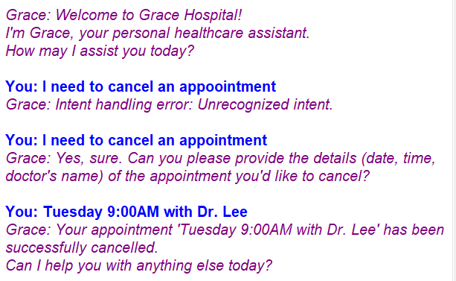

Demonstrating successful cancellation of appointment.

**Figure 6: Appointment Rebooking Interaction**

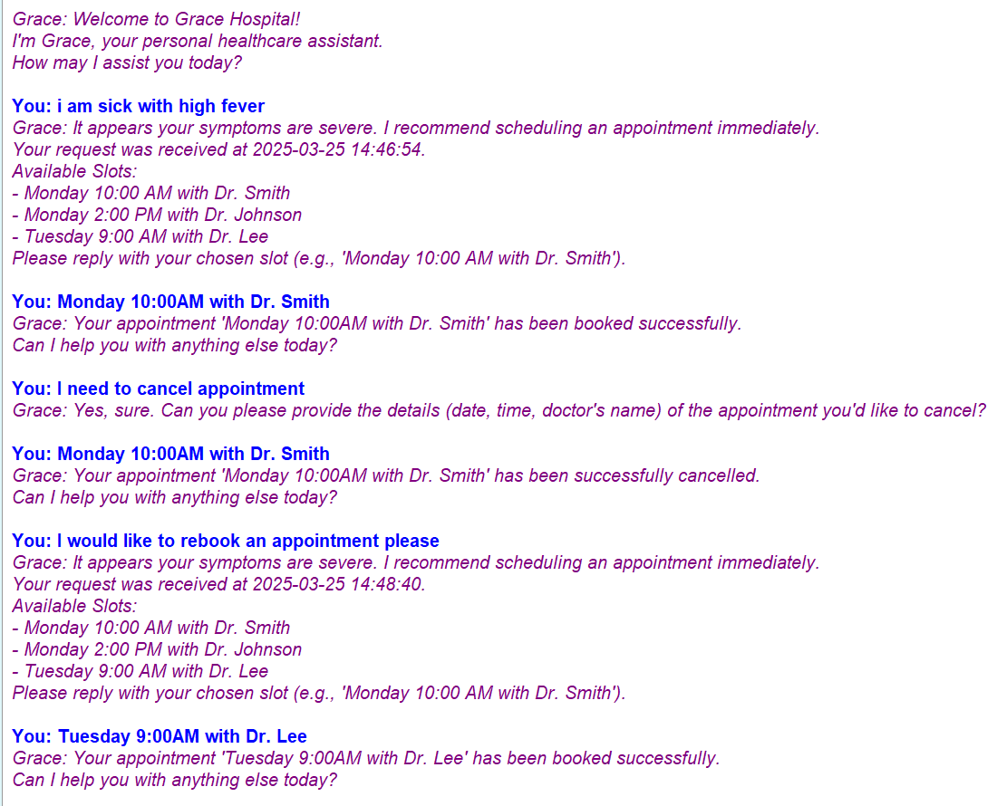

Shows chatbot cancelling previous appointment and prompting user with new available slots for rebooking.

**Figure 7: Customized Medication Reminder Setup**

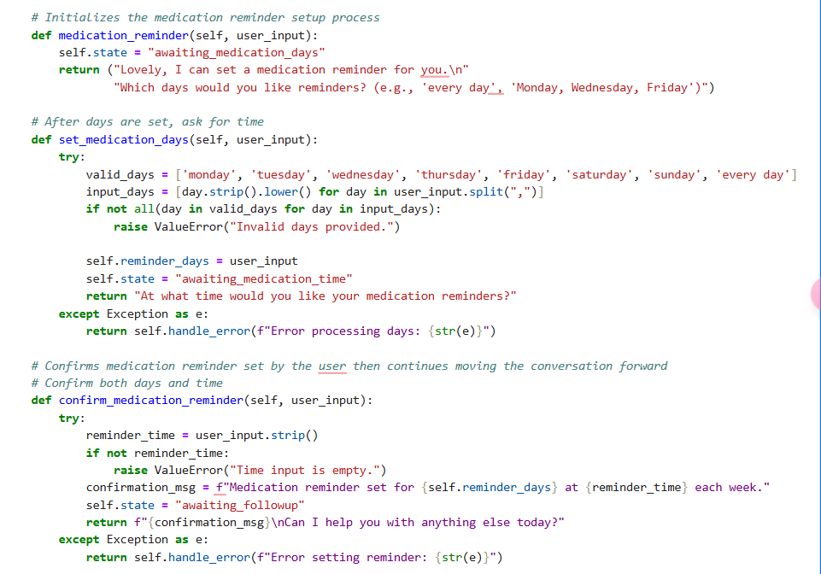

Shows chatbot interaction allowing users to specify custom days and times for medication reminders.

**Future Improvements**

The next stages of development for this chatbot could include:

* **Integration with external scheduling APIs:** Integrating real-time APIs such as Google Calendar or Microsoft Outlook to streamline booking, cancellation, and rebooking processes, providing immediate synchronization with real-world calendars.
* **Advanced NLP and AI models:** Future integration with advanced NLP models such as BERT could significantly enhance language understanding and intent recognition accuracy (Devlin et al., 2019) and securely connecting to HER systems would ensure compliance and personalized medical recommendations (U.S. Department of Health & Human Services, n.d.).

These improvements would elevate the chatbot’s functionality, accuracy, and user satisfaction, fostering greater trust and efficacy in digital healthcare interactions.

References

Whitelaw, S., Mamas, M. A., Topol, E., & Van Spall, H. G. C. (2020). Applications of digital technology in COVID-19 pandemic planning and response. The Lancet Digital Health, 2(8), e435–e440.

<https://doi.org/10.1016/S2589-7500(20)30142-4>

U.S. Department of Health & Human Services, HIPAA Guidelines – <https://www.hhs.gov/hipaa/for-professionals/index.html>

Martinengo, L., Lin, X., Jabir, A. I., Kowatsch, T., Atun, R., Car, J., & Tudor Car, L. (2023). Conversational Agents in Health Care: Expert Interviews to Inform the Definition, Classification, and Conceptual Framework. Journal of Medical Internet Research, 25, e50767. doi:10.2196/50767

[Journal of Medical Internet Research - Conversational Agents in Health Care: Expert Interviews to Inform the Definition, Classification, and Conceptual Framework](https://www.jmir.org/2023/1/e50767/)

Python Software Foundation. (n.d.). Python Documentation. Retrieved from <https://www.python.org/doc/>

Honnibal, M., & Montani, I. (2023). spaCy: Industrial-strength NLP in Python. Retrieved from <https://spacy.io/usage>

Devlin, J., Chang, M.-W., Lee, K., & Toutanova, K. (2019). BERT: Pre-training of deep bidirectional transformers for language understanding. Proceedings of the 2019 Conference of NAACL-HLT, 4171–4186. https://doi.org/10.18653/v1/N19-1423