Output ripple with static current

2*22uF/16V ceramic 1206 on both in and out
I_{OUT} [mA] | V_{RIPPLE} Out |  | V_{RIPPLE} In |  | comment
I_{OUT} [mA] | [mVpp] | screenshot | [mVpp] | screenshot
70 | 20 | 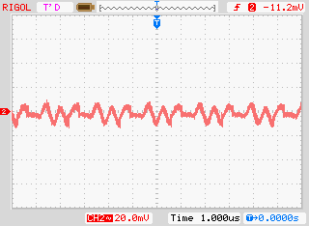 | 100
200 | 25 | 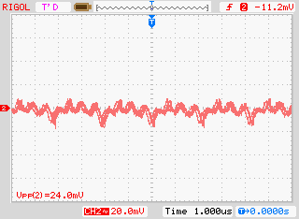 | 100
500 | 20 | 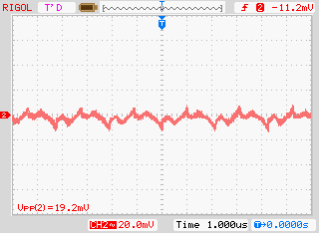 | 150 |  | cold
1000 | 20 | 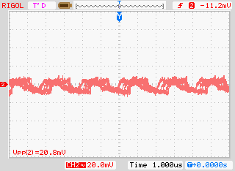 | 200 |  | Almost cold
1500 | 25 | 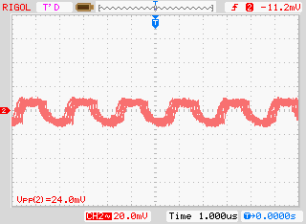 | 250 |  | Can feel a little heat
2000 | 35 | 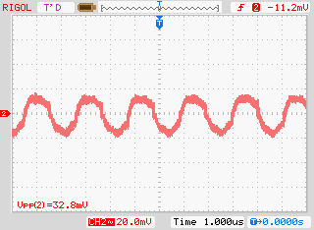 | 300 |  | hot
2500 | 40 | 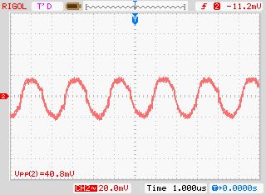 | 350 |  | Very hot
3000 | 45, 50 after couple of minutes | 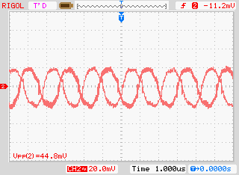 | 400 | 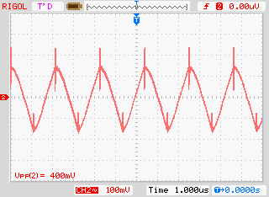 | Very, very hot
Over 3A it turns off.
IC heats the most. Caps don’t heat, inductor heats less than IC, at 3A it becomes almost as hot as IC at 2A.

With one addition of 100u/16V electrolytic cap on input
(http://pl.farnell.com/jsp/search/productdetail.jsp?id=1870603&Ntt=1870603)
I_{OUT} [mA] | V_{RIPPLE} Out |  | V_{RIPPLE} In |  | comment
I_{OUT} [mA] | [mVpp] | screenshot | [mVpp] | screenshot
1500 |  |  | 250 | 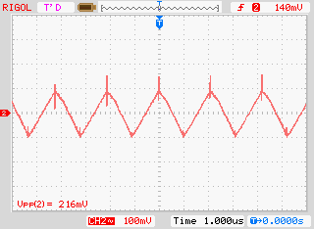
Almost no difference.
This cap is a shit. Iripple max=88mA, designed for 100Hz operation

Look at simulation 5V_dc_dc.asc and caps_freq.asc

Output drop with dynamic currents

2*22uF/16V ceramic 1206 on both in and out
- 10R resistor + 2*50cm of wire - switched on
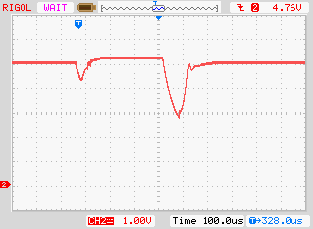
- 5R resistor + 2*50cm of wire - switched on
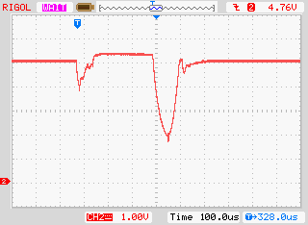
- 2R resistor + 2*50cm of wire - switched on
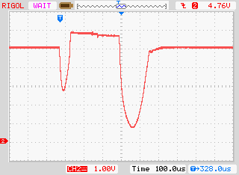

2*22uF/16V ceramic 1206 on both in and out plus 100uF electrolytic on out
- 5R resistor + 2*50cm of wire - switched on
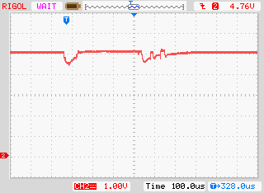
- 2R resistor + 2*50cm of wire - switched on
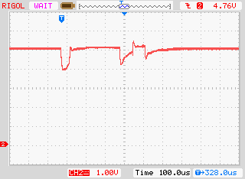
- 2R resistor + 2*50cm of wire - switched on + 20R constant on resistor
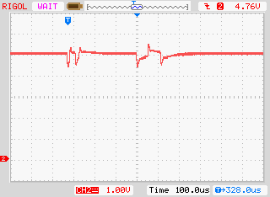
- 2R resistor + 2*50cm of wire - switched off
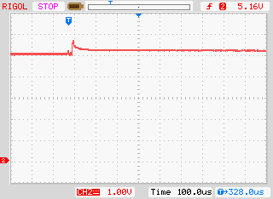

Servo current consumption when large angle change (1A/V) measured on 0R1 resistor
