Spotify Song Popularity
Capstone Final Project Report
Erik Babb · May 2026
Problem Statement
The music industry is a multi-billion dollar market where record labels compete to release songs that resonate with audiences. Spotify's popularity score is a metric from 0 to 100 reflecting how often a track has been played recently relative to other tracks on the platform. It is one of the most direct signals of a song's commercial performance. Understanding which audio attributes are associated with higher scores could give record labels a data-driven edge when making production decisions.
The question driving this project is: how can record labels increase popularity in their songs as of October 2019? The target audience is record label executives and production teams looking for evidence-based guidance. Success is defined as identifying audio and non-audio features most predictive of popularity and translating them into actionable recommendations grounded in the analysis.
Data
The dataset was sourced from the Kaggle and contains Spotify track data collected via the Spotify API. The raw dataset comprised 32,833 rows and 23 columns. Because the data was structured around playlist memberships, a single song could appear multiple times if it belonged to multiple playlists. Each row included the track's metadata (name, artist, album, release date, genre) alongside eleven audio features computed by Spotify:
- Danceability – how suitable a track is for dancing (0.0–1.0)
- Energy – perceptual measure of intensity and activity (0.0–1.0)
- Loudness – overall loudness in decibels (dB)
- Speechiness – presence of spoken words (0.0–1.0)
- Acousticness – confidence that the track is acoustic (0.0–1.0)
- Instrumentalness – likelihood the track contains no vocals (0.0–1.0)
- Liveness – presence of a live audience in the recording (0.0–1.0)
- Valence – musical positiveness conveyed by the track (0.0–1.0)
- Tempo – estimated tempo in beats per minute
- Key – estimated overall key (0–11, mapped to pitch class)
- Mode – major (1) or minor (0)
The target variable is track_popularity, the Spotify-assigned score between 0 and 100 described above.
Data Wrangling
Significant effort went into cleaning the dataset so that each record represented one unique, original song. First, five rows (less than 0.02% of the data) with missing track name, artist, or album fields were dropped. This was small enough to discard without concern. Next, three rounds of deduplication were performed. Rows sharing the same track_id were reduced to one (removing 4,476 duplicates), tracks with identical audio fingerprints but different album editions were deduplicated by keeping the higher-popularity version (618 removed), and duplicate artist-track name pairs were resolved the same way (1,508 removed). An additional 1,694 tracks with "remix" in their title were dropped because remixes share audio features with the original song but can have very different popularity, which would introduce noise into the model.
Release dates presented a formatting challenge: some entries contained only a year, others a year and month. A custom function was written to assign plausible random day and month values where they were missing, allowing the field to be converted to a proper datetime. Three new variables were engineered from this clean data: track_occurences (how many times the track appeared across all playlists before deduplication), top_genre, and top_subgenre (the most commonly associated genre for each track). Administrative columns not needed for modeling — playlist name, playlist ID, and similar identifiers — were dropped. After all steps, 24,532 unique tracks remained.
Exploratory Data Analysis
Exploratory analysis was used to understand the distribution of the target variable, examine relationships between audio features and popularity, and surface any remaining data quality issues.
As seen in the chart below, track popularity follows a roughly bell-shaped distribution with a mean of approximately 41. About 8.5% of tracks scored exactly zero, likely representing songs with no meaningful recent streaming activity. These were later removed before modeling to reduce noise. Below is the distribution with zeroes removed:
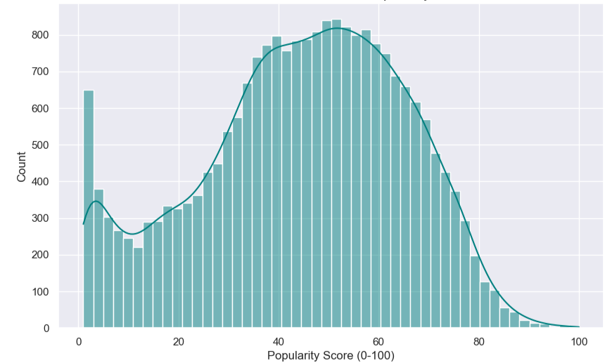

Examining popularity by genre, pop tracks showed the highest median popularity, which is consistent with pop music's broad commercial appeal and heavy playlist placement. EDM had the lowest median, likely reflecting more niche audiences
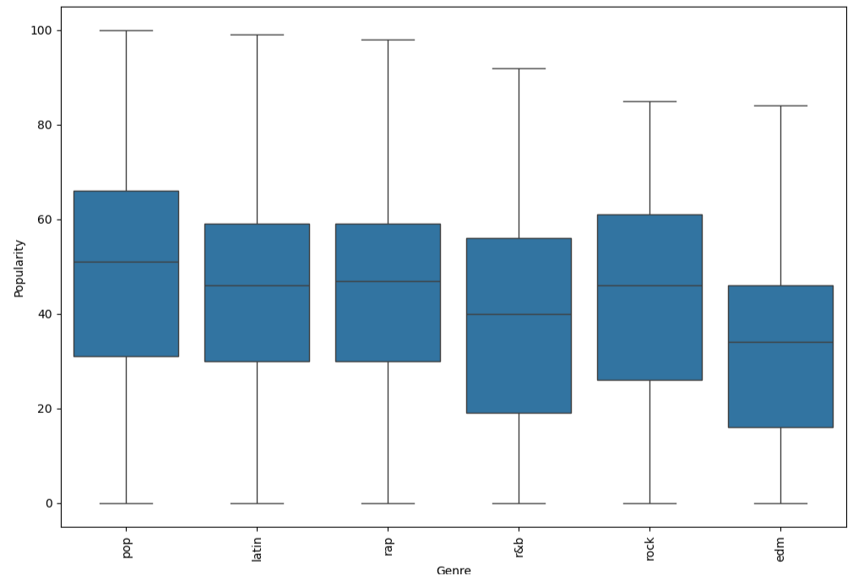
The correlation heatmap below shows Pearson coefficients between each audio feature and popularity. No single feature has a strong linear relationship with the target, confirming that song success is multidimensional and supporting the use of a non-linear ensemble model. Energy and instrumentalness show small negative correlations, while acousticness and danceability show a slight positive one.
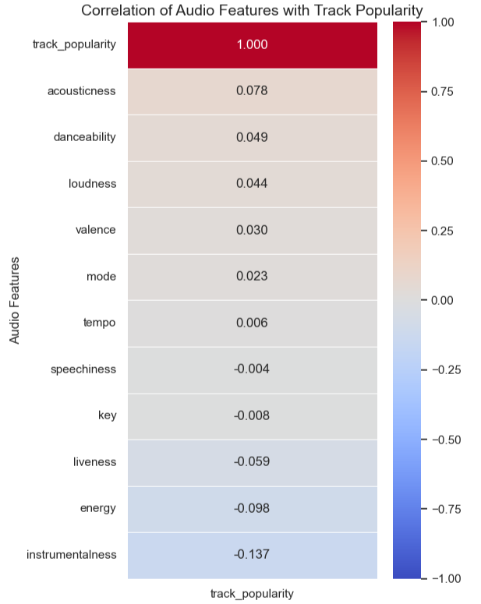
Empirical Cumulative Distribution Function (ECDF) plots were used to compare where the top-1% tracks (scores of 83 and above) fell relative to the full catalog. These highly popular tracks tend to sit around the 60th percentile for danceability, the 70th for acousticness, the 75th for speechiness, and the 30th for energy. This suggests that the most streamed songs are moderately danceable, somewhat acoustic, and less intense than the average track. Some artists had multiple hits: Billie Eilish led with 11 qualifying tracks, followed by Post Malone with 8 and Ed Sheeran with 7.
Preprocessing
The cleaned dataset was prepared for modeling through several steps. One-hot encoding was applied to top_genre (6 levels) and top_subgenre (24 levels) using drop_first=True to avoid multicollinearity. Several columns useful for exploration but not appropriate as model inputs were dropped: track name, artist, album name, raw release date components, and the raw duration in milliseconds (replaced by duration in seconds). The key field was initially encoded but later excluded after feature importance analysis showed it contributed negligibly.
The 2,080 tracks with a popularity score of exactly zero were removed at this stage. Their presence was found in testing to add noise that degraded model performance. The remaining data was split 80/20 into training (17,960 rows) and test (4,491 rows) sets using a fixed random seed. StandardScaler was then fit on the training set and applied to the test set to standardize the continuous numerical features, preventing data leakage.
Modeling
Three regression models were evaluated to predict track popularity: Ridge Regression as a linear baseline, and Random Forest and XGBoost as ensemble tree methods capable of capturing non-linear feature interactions. All three were tuned using 5-fold cross-validated GridSearchCV.
Ridge Regression served as the baseline. It applies an L2 regularization penalty and runs quickly, but is constrained to linear relationships. The best configuration found was alpha=0.1 with the auto solver, yielding a test MAE of 14.71 and R² of 0.196.
Random Forest builds many decision trees on bootstrapped samples and averages their predictions. GridSearchCV evaluated 48 combinations across tree count (200–500), depth (10, 20), feature sampling strategy, and minimum samples per split. The best configuration (n_estimators=500, max_depth=20, max_features=None, min_samples_split=5) achieved a test MAE of 13.95 and R² of 0.263.
XGBoost builds trees sequentially, each correcting errors from the previous. The best configuration (n_estimators=200, learning_rate=0.1, max_depth=5, subsample=1.0) produced virtually identical results: MAE of 13.95 and R² of 0.262.
The table below summarizes all three models. Random Forest was selected as the final model due to its marginally better MAPE and R² scores.

Model | MAE | MAPE | R² Score
Ridge Regression | 14.71 | 168.19% | 0.196
Random Forest | 13.95 | 155.58% | 0.263
XGBoost | 13.95 | 156.50% | 0.262
Model performance metrics on the held-out test set
An R² of 0.263 means the model explains roughly 26% of the variance in track popularity. An MAE of 13.95 means predictions are off by about 14 points on average. For example, a true popularity of 50, the model would predict somewhere between 36 and 64. This is modest, but not entirely unexpected as popularity is heavily influenced by marketing spend, artist recognition, social media trends, and editorial playlist placements. These factors are not captured in audio features alone.
Feature Importance
The chart below shows feature importances from the chosen Random Forest model, indicating which variables contributed most to its predictions.

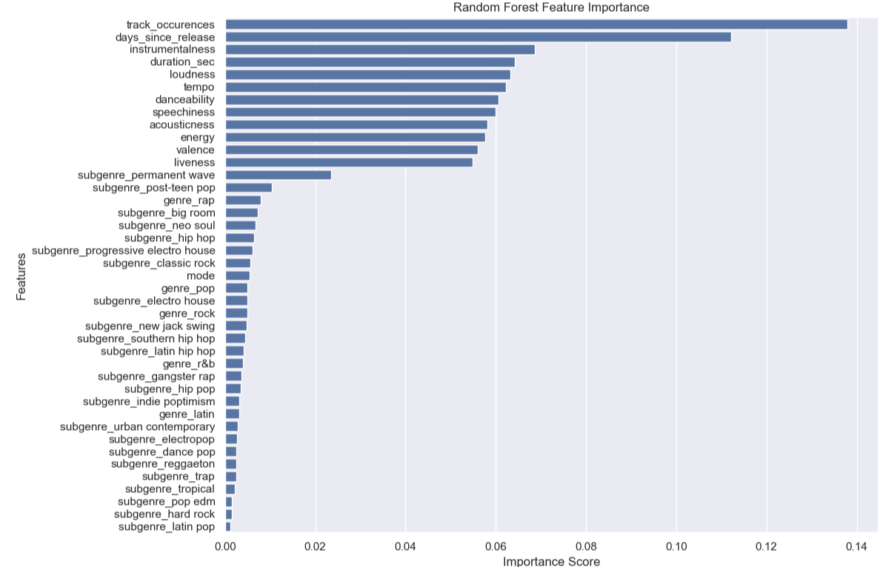

The single most important feature is track_occurences, followed closely by days_since_release. Both make intuitive sense: a song that appears across many playlists has already earned broad listener engagement, and Spotify's popularity algorithm favors recently active tracks. As noted in the modeling notebook, track_occurences was a key engineering discovery which boosted model performance substantially once added.
The third most important feature is instrumentalness, with higher instrumentalness associated with lower popularity (vocal-driven songs dominate the charts). After that, duration_sec, loudness, tempo, danceability, speechiness, and the core audio features all contribute at a broadly similar level. Genre, subgenre, and mode features contribute much smaller signal.

Recommendations
The following three recommendations are grounded directly in the top three features from the Random Forest feature importance results.
1. Invest in playlist placement. Track_occurences was the single most important predictor of popularity in the model. Songs that appear across more playlists score higher because playlists expose tracks to new listeners and sustain engagement. Record labels should prioritize editorial and algorithmic playlist pitching at release. They should also try to incorporate elements outside of the artist’s main genre. For example, a pop song which features a Latin rapper could appeal to a much broader audience and thus get worked into more playlists.
2. Release music consistently and recently. Days_since_release was the second most important feature. Spotify's popularity score is weighted toward recent streams, so newer tracks are structurally advantaged. Labels should maintain a consistent release and benefit from the algorithmic boost that recently released tracks receive.
3. Prioritize vocal-led productions over instrumentals. Instrumentalness was the third most important feature in the model. Lower instrumentalness, meaning tracks with less prominent vocals, was associated with higher popularity. Vocal-driven songs dominate the high-popularity range of this dataset. Labels should favor vocal-forward arrangements and treat instrumental releases as a niche product rather than a mainstream strategy.
Ideas for Further Research
Several natural extensions could improve model performance and deepen the recommendations. Adding lyric-based features through natural language processing such as sentiment, theme, or vocabulary would capture dimensions of a song that audio features alone cannot. Including data on marketing spend, artist social media following, or editorial playlist placement at release would likely be strong predictors and would give a more complete picture of what drives popularity. Building genre-specific models could improve accuracy, since the attributes that drive popularity in hip-hop differ from those in rock. Finally, a longitudinal model trained on weekly popularity snapshots could capture how songs gain and lose momentum over time, rather than treating popularity as a static value.
Conclusion
This project applied a full data science workflow to nearly 25,000 Spotify tracks to identify the attributes most predictive of song popularity. The final Random Forest model (MAE = 13.95, R² = 0.263) explains roughly a quarter of the variance in popularity scores using audio features, genre, and engineered features. The three strongest predictors were track_occurences, days_since_release, and instrumentalness which points to playlist strategy, release cadence, and vocal-forward production as the most data-supported levers for record labels. The recommendations in this report are bounded strictly by what the feature importance analysis directly supports, and future work incorporating lyrical content, artist-level data, and promotional variables could push model performance and recommendations to the next level.

