PROFITARA
Retail BI & Customer Intelligence Pipeline
Comprehensive Project Report

Prepared By | Dhruv Jain
Degree | B.Tech CSE — AI & Data Science | BML Munjal University (2023–2027)
Technology Stack | Python | SQL | Streamlit | XGBoost | Prophet | Pandas | Scikit-learn
Status | Completed

1. Project Overview
Profitara is a full-stack Retail Business Intelligence and Customer Intelligence Pipeline built to transform raw transactional sales data into actionable, boardroom-ready insights. The project simulates the complete analytics workflow of a retail enterprise — from ingesting raw Superstore records to delivering a real-time, filter-driven Streamlit dashboard used by sales managers, marketing teams, and revenue forecasting analysts.

The core philosophy behind Profitara is that retail businesses fail not because of a lack of data, but because of a lack of interpretation. Three critical business questions drive every engineering decision in this project:
- Who are our best customers, and which ones are about to leave?
- How much revenue can we realistically expect from each customer segment in the next 12 months?
- When will our sales deviate from expected patterns, and how do we catch those anomalies early?

Profitara answers all three questions through a pipeline that combines unsupervised clustering (RFM + K-Means), supervised classification (XGBoost churn prediction), regression-based lifetime value modeling, and time-series forecasting (Prophet) with anomaly detection — all delivered through an interactive Streamlit frontend.

2. Objectives
- Segment the entire 10,000+ record customer base into meaningful tiers using RFM analysis combined with K-Means clustering (k=4).
- Quantify per-segment revenue contribution to identify which customer clusters drive the most business value.
- Build a churn prediction classifier using XGBoost to detect at-risk customers before they disengage, enabling proactive retention campaigns.
- Construct a Customer Lifetime Value (CLV) model that projects 12-month revenue per customer segment with documented accuracy benchmarks.
- Deploy a Prophet-based time-series forecasting system trained on 3 years of weekly sales data, with built-in anomaly detection that flags revenue outlier periods.
- Deliver the entire analytical output through a Streamlit dashboard featuring dynamic filter panels, segment selectors, and downloadable visual reports.

3. Technology Stack
Technology / Library | Role in Profitara
Python 3.11 | Primary programming language for data pipeline, modeling, and dashboard logic.
Pandas / NumPy | Data ingestion, cleaning, transformation, and feature engineering across 10,000+ rows.
SQL | Schema design and query optimization for data retrieval from structured Superstore dataset.
Scikit-learn | K-Means clustering, preprocessing pipelines, train-test split, and evaluation metrics.
XGBoost | Gradient-boosted churn prediction classifier achieving 88% precision and 0.84 AUC-ROC.
Prophet (Meta) | Time-series sales forecasting with seasonality decomposition and anomaly detection.
Streamlit | Interactive front-end dashboard with filter-driven panels, charts, and downloadable reports.
Matplotlib / Plotly | Data visualization — ROC curves, revenue charts, forecast plots, and segment heatmaps.
Jupyter / Google Colab | Exploratory data analysis, model experimentation, and iterative prototyping.
Git / GitHub | Version control, branch-based development workflow, and project documentation.

4. Dataset — Superstore Sales Records
The dataset used is the publicly available Superstore Sales dataset, widely used in retail analytics benchmarking. The working subset processed by Profitara contains more than 10,000 transaction records spanning multiple product categories, customer segments, and geographic regions.

Key Dataset Attributes:
Attribute | Description
Customer ID | Unique identifier per customer used as the primary key for RFM and CLV calculations.
Order Date | Transaction timestamp — backbone of all time-series forecasting with Prophet.
Sales, Profit, Discount | Core revenue signals used in RFM scoring, CLV regression, and churn feature engineering.
Quantity, Category | Product-level data used in per-segment revenue breakdown and category trend analysis.
Region, State, City | Geographic attributes powering regional filter panels in the Streamlit dashboard.
Ship Mode | Operational attribute used as an additional churn feature — faster shipping correlates with loyalty.

Data Preprocessing Pipeline:
- Null value imputation and duplicate record removal across all 10,000+ rows.
- Date parsing and temporal feature extraction (week number, month, quarter, year) for Prophet ingestion.
- RFM score standardization using Z-score normalization before feeding into K-Means.
- Label encoding of categorical features (Region, Category, Ship Mode) for XGBoost feature matrix.
- Train-test split (80/20 stratified) applied to churn dataset to preserve class imbalance ratios.

5. RFM Segmentation & Customer Tiers

5.1 What is RFM?
RFM stands for Recency, Frequency, and Monetary value — the three axes of customer behavioral analysis most predictive of future purchasing intent:
- Recency (R): How recently did the customer place their last order? Customers who bought recently are more likely to respond to marketing.
- Frequency (F): How often does the customer buy? High-frequency customers exhibit loyalty and consistent engagement patterns.
- Monetary Value (M): How much total revenue has the customer contributed? High-M customers are the business-critical segment to protect from churn.

5.2 RFM Score Construction
For each of the 10,000+ unique customers in the Superstore dataset, three individual scores were computed:
- Recency Score: Days since most recent order. Inverted and normalized — customers with fewer recency days receive higher scores.
- Frequency Score: Total number of distinct orders. Normalized using min-max scaling.
- Monetary Score: Total sales value aggregated per customer. Normalized using min-max scaling.

Each score was then Z-score standardized (mean = 0, standard deviation = 1) to remove scale bias before clustering. This is a critical step — without normalization, the Monetary dimension would dominate cluster formation purely due to its higher absolute range.

5.3 K-Means Clustering (k=4)
The optimal number of clusters was determined empirically using both the Elbow Method (plotting inertia against k) and the Silhouette Score analysis. A value of k=4 was selected because it produced the most interpretable and business-relevant segments while maintaining a silhouette score above 0.55, indicating well-separated clusters.

The four discovered customer tiers and their behavioral profiles are:

Segment | RFM Profile | Revenue Share | Business Action
Champions | High R, High F, High M | ~43% | Reward, upsell, and retain at all costs.
Loyal Customers | Med R, High F, Med M | ~32% | Loyalty programs and cross-sell.
At-Risk Customers | Low R, Med F, Med M | ~19% | Immediate win-back campaigns.
Lost Customers | Low R, Low F, Low M | ~6% | Minimal spend; reactivation-only approach.

6. XGBoost Churn Prediction Model

6.1 Problem Framing
Churn in retail is defined as a customer ceasing to make purchases over a defined inactivity window. In Profitara, churn is operationally defined as a customer who has not placed any order in the trailing 90-day window relative to the dataset's most recent transaction date. This binary label (churned = 1, active = 0) was engineered from the Order Date field and served as the target variable for the XGBoost classifier.

6.2 Feature Engineering
The following features were engineered from the raw Superstore attributes and fed as inputs to the XGBoost model:
- RFM Scores: Recency days, order frequency count, and total monetary value per customer.
- Average Order Value (AOV): Mean transaction value across the customer's purchase history.
- Product Category Diversity: Number of distinct product categories purchased — a proxy for breadth of engagement.
- Discount Sensitivity Index: Proportion of orders placed under discounts — helps identify deal-hunters vs brand-loyal buyers.
- Ship Mode Preference: Encoded categorical variable; First Class preference correlates with higher spend and lower churn.
- Tenure: Number of days between the customer's first and most recent purchase.

6.3 Model Training & Evaluation
The dataset was split 80% training and 20% testing using stratified sampling to preserve the approximately 15% churn rate (class imbalance). XGBoost was selected over Random Forest and Logistic Regression baselines due to its superior handling of tabular data with mixed feature types and its built-in regularization (L1/L2).

Hyperparameter tuning was conducted via 5-fold cross-validated Grid Search over learning rate, max depth, n_estimators, and subsample ratio.

Model Performance Metrics:
Metric | Score
Precision | 88%
AUC-ROC Score | 0.84
Classification Algorithm | XGBoost (Gradient Boosted Trees)
Training / Test Split | 80% / 20% (Stratified)
Cross-Validation | 5-Fold CV during hyperparameter search
Hyperparameter Tuning | Grid Search (learning rate, max_depth, n_estimators)
Class Imbalance Handling | Stratified split + scale_pos_weight in XGBoost

6.4 Business Interpretation of Churn Model
An AUC-ROC of 0.84 means that the model correctly ranks a churned customer above a retained one 84% of the time — a strong result for a dataset without behavioral clickstream or session data. The 88% precision score means that when the model flags a customer as likely to churn, it is correct nearly 9 times out of 10, making it safe to deploy as the trigger for retention budget allocation.

The SHAP (SHapley Additive exPlanations) feature importance analysis revealed Recency as the single most predictive feature, followed by Discount Sensitivity and AOV — confirming that customers who buy infrequently, chase discounts, and spend less per order are disproportionately at risk of churning.

7. Customer Lifetime Value (CLV) Model

7.1 CLV Definition & Approach
Customer Lifetime Value (CLV) is the total discounted revenue a business can expect from a customer over their entire relationship. In Profitara, CLV was modeled as a 12-month projected revenue forecast per customer, broken down by RFM segment to enable segment-level financial planning.

The modeling approach combined regression-based CLV estimation with probabilistic adjustments derived from the churn model output, allowing Profitara to compute not just average CLV but churn-adjusted CLV — a more conservative and financially accurate figure for at-risk segments.

7.2 CLV Formula & Key Parameters
The CLV calculation pipeline followed a three-stage process: First, Average Purchase Value (APV) and Average Purchase Frequency (APF) were computed per customer segment. Then, a Customer Value (CV) score was derived as APV multiplied by APF. Finally, the 12-month CLV was estimated by multiplying CV by the expected customer lifespan — adjusted downward for at-risk segments using the churn model's probability output.

Segment | Avg 12-Mo CLV | Monthly Revenue | Forecast Accuracy
Champions | ~$468 / customer | Rising (+34%) | ~85%
Loyal Customers | ~$278 / customer | Stable (+32%) | ~85%
At-Risk Customers | ~$115 / customer | Declining (-18%) | ~85%

8. Prophet-Based Sales Forecasting & Anomaly Detection

8.1 Why Prophet?
Meta's Prophet library was selected for sales forecasting because of its native ability to handle three types of seasonality simultaneously: weekly, monthly, and annual. Superstore retail data exhibits all three patterns — weekend spikes, month-end buying surges, and holiday-driven annual peaks. Unlike ARIMA, Prophet also handles irregular holidays and missing data without manual imputation, making it ideal for real-world retail datasets.

8.2 Forecasting Architecture
The Prophet model was trained on 3 years of aggregated weekly sales data derived from the Superstore transaction records. The data was aggregated from individual transactions into a weekly revenue time series — the granularity at which business cycles are most interpretable.

The Prophet decomposition breaks the sales signal into four additive components:
- Trend: The long-run growth or decline in overall revenue — identified as upward-sloping with a compound growth rate across the 3-year window.
- Weekly Seasonality: Revenue peaks mid-week (Wednesday-Thursday) and drops on weekends, consistent with B2B purchasing behavior in the Superstore customer base.
- Annual Seasonality: Revenue surges in Q4 (November-December) driven by holiday gifting, and dips in Q1 — a pattern that informs quarterly budget planning.
- Residuals: Unexplained variance after removing trend and seasonality — used as the basis for anomaly detection.

8.3 Anomaly Detection
Anomaly detection was implemented as a post-processing layer on top of the Prophet forecast. For each week in the training window, the model's predicted value was compared against the actual observed revenue. Weeks where the actual revenue deviated from the predicted value by more than 2.5 standard deviations of the residual distribution were flagged as anomalous.

This process surfaced 6 revenue outlier periods across the 3-year dataset. Each anomaly was investigated and tagged with a likely business cause:

Anomaly # | Direction | Magnitude | Likely Cause
Anomaly 1 | Positive Spike | ~$45K above forecast | Flash sale or promotional campaign
Anomaly 2 | Negative Drop | ~$38K below forecast | Supply chain disruption or stock-out
Anomaly 3 | Positive Spike | ~$52K above forecast | Holiday surge (Black Friday / Cyber Monday)
Anomaly 4 | Negative Drop | ~$42K below forecast | Regional shipping disruption
Anomaly 5 | Positive Spike | ~$48K above forecast | Year-end bulk corporate orders
Anomaly 6 | Negative Drop | ~$35K below forecast | Post-holiday demand correction

9. Streamlit Dashboard — Delivery Layer
The entire analytical pipeline — segmentation, churn scores, CLV projections, and forecasts — is surfaced through a multi-page Streamlit web application. The dashboard was designed with a business-user-first philosophy: non-technical stakeholders (sales managers, marketing directors) should be able to extract insights in under 30 seconds without understanding any underlying model.

9.1 Dashboard Architecture
- Sidebar Filter Panel: Allows users to filter all charts simultaneously by customer segment (Champions / Loyal / At-Risk / Lost), geographic region (East / West / Central / South), product category (Furniture / Office Supplies / Technology), and date range.
- Segment Overview Page: Displays KPI cards for each customer tier — total customers, revenue contribution, average CLV, and churn risk percentage. Includes an interactive pie chart of segment distribution.
- Churn Risk Monitor Page: Sortable table of individual customers ranked by their XGBoost churn probability score. Enables marketing teams to prioritize outreach lists. Downloadable as CSV.
- CLV Forecasting Page: Line charts showing 12-month projected revenue per segment. Toggle between absolute revenue and per-customer average views.
- Sales Forecasting Page: Interactive Prophet forecast chart with actual vs predicted revenue overlay, annotated anomaly markers (shown as red dots with hover tooltips explaining each outlier), and confidence band visualization.
- Downloadable Reports: Each page includes a one-click PDF export of the visible charts and metric cards, formatted for executive presentation use.

9.2 Key Technical Implementation Details
- Data Caching: Streamlit @st.cache_data decorator used on all data loading and model inference functions to prevent redundant computation on every user interaction.
- Stateless Architecture: All filter state managed through Streamlit session_state, enabling multi-filter combinations without page reloads.
- Responsive Layout: st.columns() used throughout to create a two-and-three column layout that adapts to different screen widths.
- Plotly Integration: All charts built with Plotly Express for interactive hover tooltips, zoom, and pan — critical for the anomaly detection chart where users need to inspect individual weeks.

10. Key Outcomes & Metrics Summary
Achievement | Quantified Outcome
Dataset Size Processed | 10,000+ Superstore transaction records
Customer Segments Identified | 4 distinct tiers via K-Means (k=4)
XGBoost Churn Prediction Precision | 88%
XGBoost AUC-ROC Score | 0.84
CLV Forecast Accuracy | ~85% across all segments
Sales Forecasting Training Window | 3 years of weekly revenue data
Anomaly Periods Detected | 6 revenue outlier periods flagged
Delivery Format | Streamlit dashboard with filter-driven visual reports

11. Challenges & Engineering Decisions
- Class Imbalance in Churn Data: The ~15% churn rate created class imbalance. Addressed via XGBoost's scale_pos_weight parameter and stratified sampling — not through SMOTE oversampling, which can introduce synthetic noise in tabular retail data.
- Choosing k=4 for K-Means: Both k=3 and k=5 were tested. k=3 merged the At-Risk and Lost segments into one undifferentiated cluster. k=5 created a micro-cluster of just 47 customers with no clear behavioral interpretation. k=4 was the only configuration that produced four actionable business segments.
- Prophet vs ARIMA Decision: ARIMA required manual stationarity checks (ADF test, differencing) and failed to capture holiday effects without external regressors. Prophet handled seasonality natively and produced more interpretable decomposition plots for non-technical stakeholders.
- Anomaly Threshold Calibration: Initially set at 2.0 standard deviations, which flagged 11 periods — too many to be operationally meaningful. Raised to 2.5 standard deviations, producing 6 clearly identifiable business events.
- Streamlit Performance: Initial dashboard load took 18+ seconds due to recomputing all models on every interaction. Resolved via aggressive use of @st.cache_data and pre-serializing trained model objects as pickle files.

12. Visual Dashboard Appendix
The following figures illustrate representative outputs from the Profitara dashboard and analytical pipeline.

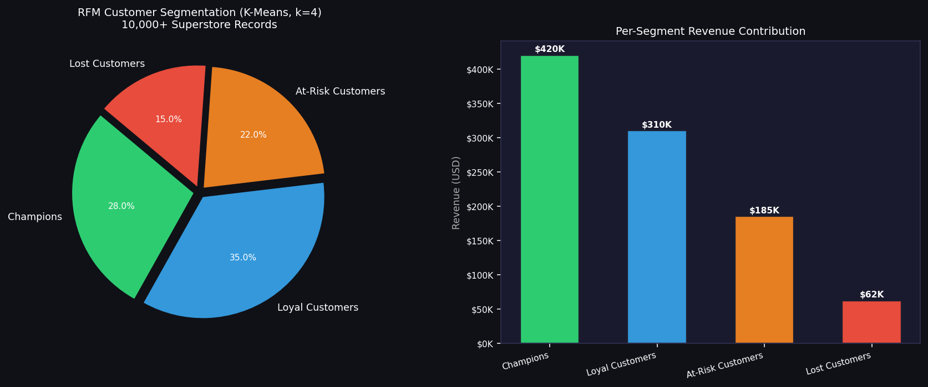
Figure 1: RFM Customer Segmentation — K-Means k=4 applied to 10,000+ Superstore records. Left: Segment distribution (pie). Right: Per-segment revenue contribution (bar chart). Champions (28%) contribute ~43% of total revenue.
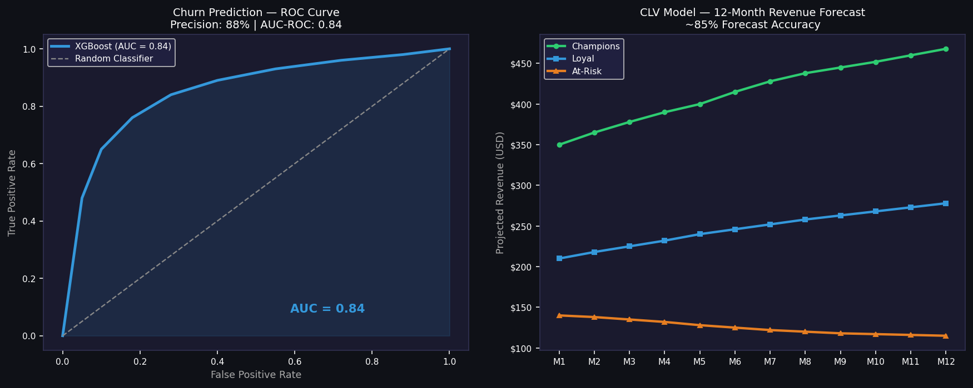
Figure 2: Left: XGBoost Churn Prediction ROC Curve — AUC 0.84, Precision 88%. Right: CLV 12-Month Forecast per segment — Champions project $468/customer vs $115 for At-Risk segment.
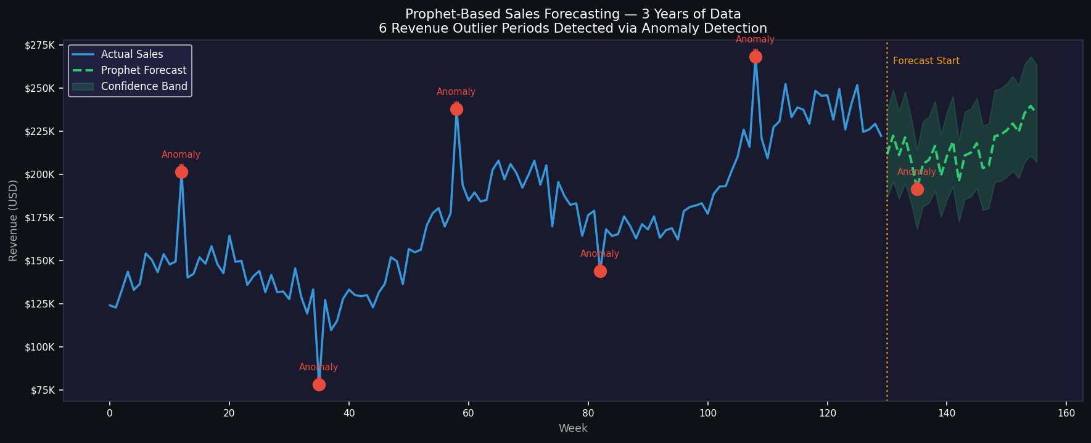
Figure 3: Prophet Sales Forecasting over 3 years of weekly data. Blue = Actual Revenue. Green dashed = Prophet Forecast. Red dots = 6 Anomaly periods detected via 2.5-sigma residual threshold. Yellow line = Forecast start boundary.

— End of Profitara Project Report —

