Features
- Chip characteristics
  - Built-in ESP32-S3R8 chipXtensa dual-core 32-bit LX7Microprocessor, supporting clock frequencies up to 240 MHz
  - Operating voltage: 3.0V~3.6V
  - 384 KB ROM，512 KB SRAM，16 KB RTC SRAM
  - Flash memory is available up to 16 MB (default), and PSRAM is available up to 8 MB (default).
  - Peripherals：PWM/ I2C/ UART/SPI/SDIO / IrDA
- Wi-Fi
  - 802.11 b/g/n
  - Data rates up to 150 Mbps in 802.11n mode.
  - Supports A-MPDU and A-MSDU aggregation
  - Supports STA/AP/STA+AP working modes
  - perating channel center frequency range：2412 ~ 2484 MHz
- Bluetooth
  - Bluetooth Low (Bluetooth LE)：Bluetooth 5、Bluetooth mesh
  - Supported speeds include 125 Kbps、500 Kbps、1 Mbps、2 Mbps.
  - Advertising Extensions
  - Multiple Advertisement Sets
  - Channel Selection Algorithm #2

模块外设
  - GPIO, SPI, LCD, Camera interface, UART, I2C, I2S, Infrared remote control, Pulse counter, LED PWM, USB 1.1 OTG, USB Serial/JTAG controller, MCPWM, SDIO host interface, GDMA, TWAI® controller (ISO 11898-1 compliant), ADC, Touch sensor, Temperature sensor, Timer and watchdog timer
  - Operating temperature range: -40℃ to 105℃
  - Module dimensions：18mm*25.5mm*3mm
  - Module color: Black
- Application scenarios
● Smart Home ●Smart Building
● Electrical Lighting ● Baby Monitoring
● Webcams ● Wearable electronics
● Smart Bus ● Wireless Location Sensing
● Wireless Positioning System Beacon
● Industrial Wireless Control

Module model
Name | Antenna type
XH-S3E | Onboard PCB Antenna (default)）
 | External IPEX Antenna (optional)）
Module structure diagram
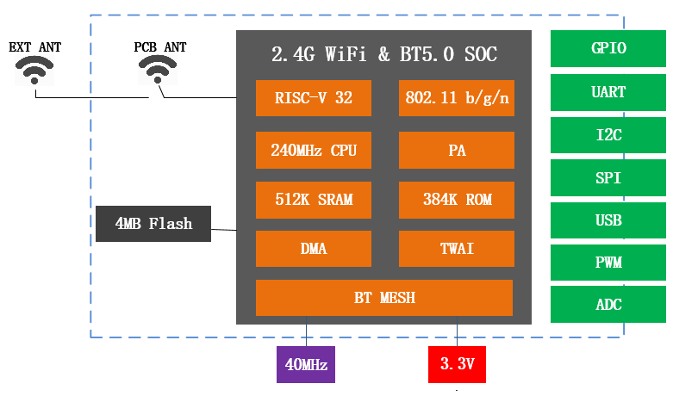

Document Update Notes

Date | Version | Update content
2026-02-03 | V1.1 | First release

Table of contents

1. Product Overview 4
2. Interface Definition 8
3. Appearance and Dimensions 13
4. Electrical Characteristics 14
5. Radio Frequency Power Consumption 15
6. Radio Frequency Characteristics 17
7. Recommended Furnace Temperature Profile 19
8. Modular System 20
9. PCB design 21
10. Suggestions for peripheral wiring 23
Disclaimer and Copyright Notice 24

1. Product Overview
The XH-S3E module integrates the ESP32-S3 series chip, which features scalability and adaptability. The two CPU cores can be controlled independently. The CPU clock frequency is adjustable from 80 MHz to 240 MHz. Users can power off the CPU and utilize the low-power coprocessor to monitor peripheral status changes or whether certain analog quantities exceed thresholds. The ESP32-S3 also integrates a rich set of peripherals, including a capacitive touch sensor, SD card interface, Ethernet interface, high-speed SPI, UART, I2S, and I2C.
The XH-S3E module integrates traditional Bluetooth, Bluetooth Low Energy (BLE), and Wi-Fi, offering a wide range of applications: Wi-Fi supports extremely long-range communication and direct internet connection via routers; while Bluetooth allows users to connect to their phones or broadcast BLE Beacon signals for signal detection. The ESP3-S3 chip's sleep current is less than 5 µA, making it suitable for battery-powered wearable electronic devices. The module supports data transfer rates up to 150 Mbps and antenna output power up to 20 dBm, enabling maximum wireless communication range. Therefore, this module boasts industry-leading specifications, exhibiting excellent performance in terms of high integration, wireless transmission distance, power consumption, and network connectivity.
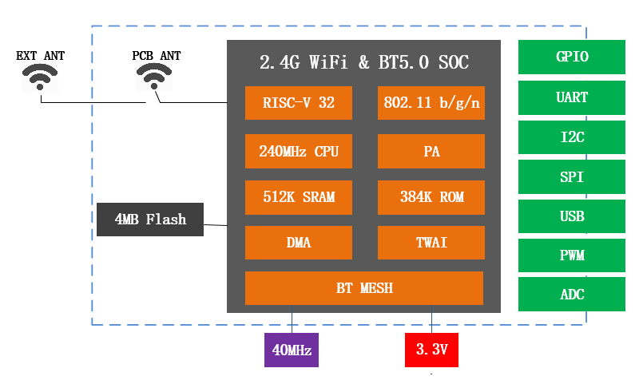

Figure 1.1 Module structure diagram

Order code | Flash2 | PSRAM | Ambient temperature  (°C) | Module size (mm)
XH-S3E-N4R2 | 4 MB (Quad SPI) | 2 MB (Quad SPI) | –40 ~ 105 | 18.0*25.5*3.0
XH-S3E-N8R2 | 8 MB (Quad SPI) | 2 MB (Quad SPI) | –40 ~ 105 | 18.0*25.5*3.0
XH-S3E-N16R2 | 16 MB (Quad SPI) | 2 MB (Quad SPI) | –40 ~ 105 | 18.0*25.5*3.0
XH-S3E-N4R8 | 4 MB (Quad SPI) | 8 MB (Octal SPI) | –40 ~ 85 | 18.0*25.5*3.0
XH-S3E-N8R8 | 8 MB (Quad SPI) | 8 MB (Octal SPI) | –40 ~ 85 | 18.0*25.5*3.0
XH-S3E-N16R8 | 16 MB (Quad SPI) | 8 MB (Octal SPI) | –40 ~ 85 | 18.0*25.5*3.0

Category | Project | Product Specifications
Wi-Fi | Frequency range | 2.4~2.5 GHz
Wi-Fi | Protocol | 802.11 b/g/n/d/e/i/k/r (802.11n， speeds up to 150 Mbps )
Wi-Fi | Protocol | Frame aggregation (TX/RX A-MPDU, TX/RX A-MSDU)
Bluetooth | Protocol | Bluetooth Low Energy (Bluetooth LE)：Bluetooth 5、Bluetooth mesh
Bluetooth | RF | NZIF receiver with -98 dBm sensitivitySupports speeds of 125 Kbps, 500 Kbps, 1 Mbps, and 2 Mbps.
Bluetooth | RF | Advertising Extensions，Multiple Advertisement Sets
Bluetooth | RF | Channel Selection Algorithm #2
Hardware | Module interface | SPI, LCD, Camera interface, UART, I2C, I2S, Infrared remote control, Pulse counter, LED PWM, USB Serial/JTAG controller, MCPWM, SDIO host, GDMA, TWAI® controller (compliant with ISO 11898-1), ADC, Touch sensor, Temperature sensor, Timer and watchdog timer
Hardware | Module interface | The SP32-S3 also features a full-speed USB 1.1 On-The-Go (OTG) interface for USB communication.
Hardware | Onboard clock | 40MHz crystal oscillator, 32 kHz crystal oscillator
Hardware | Operating voltage | 3.0~3.6V
Hardware | Operating current | Average ：300 mA
Hardware | Operating temperature range | -40°C~+105°C
Hardware | Package size | 18 mm x 25.3 mm x 3 mm
Software | Wi-Fi mode | Station/softAP/SoftAP+station/P2P
Software | Security Mechanism | WPA/WPA2/WPA2-Enterprise/WPS
Software | Encryption type | AES/RSA/ECC/SHA
Software | Firmware upgrade | USB/UART download/OTA (download and write firmware via network/host)
Software | Software | Supports cloud server development / SDK is used for user firmware development
Software | Network Protocol | IPv4、IPv6、SSL、TCP/UDP/HTTP/FTP/MQTT

2. Interface Definition

XH-S3E interfaceThe definition is shown in the figure below。

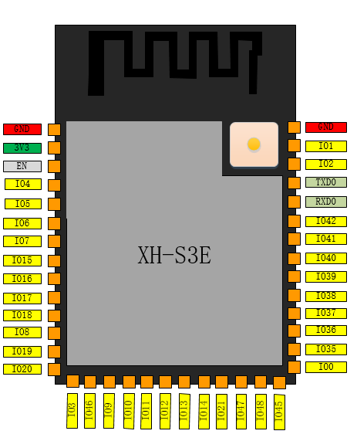
Figure 2.1XH-S3E Pin Definitions

Module pinsThe definitions are shown in the table below。

Table 2.1Pin mode

Model | GPIO
UART Download Mod | Low
Flash Boot | High

Table 2.2Module pin function definition

Name | Number | Type a | Function
GND | 1 | P | GNDD
3V3 | 2 | P | POWER
EN | 3 | I | High level: Chip enabled;  Low level: Chip off;  Be careful not to letENThe pins are floating.
IO4 | 4 | I/O/T | RTC_GPIO4, GPIO4, TOUCH4, ADC1_CH3
IO5 | 5 | I/O/T | RTC_GPIO5, GPIO5, TOUCH5, ADC1_CH4
IO6 | 6 | I/O/T | RTC_GPIO6, GPIO6, TOUCH6, ADC1_CH5
IO7 | 7 | I/O/T | RTC_GPIO7, GPIO7, TOUCH7, ADC1_CH6
IO15 | 8 | I/O/T | RTC_GPIO15, GPIO15, U0RTS, ADC2_CH4, XTAL_32K_P
IO16 | 9 | I/O/T | RTC_GPIO16, GPIO16, U0CTS, ADC2_CH5, XTAL_32K_N
IO17 | 10 | I/O/T | RTC_GPIO17, GPIO17, U1TXD, ADC2_CH6
IO18 | 11 | I/O/T | RTC_GPIO18, GPIO18, U1RXD, ADC2_CH7, CLK_OUT3
IO8 | 12 | I/O/T | RTC_GPIO8, GPIO8, TOUCH8, ADC1_CH7, SUBSPICS1
IO19 | 13 | I/O/T | RTC_GPIO19, GPIO19, U1RTS, ADC2_CH8, CLK_OUT2, USB_D­
IO20 | 14 | I/O/T | RTC_GPIO20, GPIO20, U1CTS, ADC2_CH9, CLK_OUT1, USB_D+
IO3 | 15 | I/O/T | RTC_GPIO3, GPIO3, TOUCH3, ADC1_CH2
IO46 | 16 | I/O/T | GPIO46
IO9 | 17 | I/O/T | RTC_GPIO9, GPIO9, TOUCH9, ADC1_CH8, FSPIHD, SUBSPIHD
IO10 | 18 | I/O/T | RTC_GPIO10, GPIO10, TOUCH10, ADC1_CH9, FSPICS0, FSPIIO4, SUBSPICS0
IO11 | 19 | I/O/T | RTC_GPIO11, GPIO11, TOUCH11, ADC2_CH0, FSPID, FSPIIO5, SUBSPID
IO12 | 20 | I/O/T | RTC_GPIO12, GPIO12, TOUCH12, ADC2_CH1, FSPICLK, FSPIIO6, SUBSPICLK
IO13 | 21 | I/O/T | RTC_GPIO13, GPIO13, TOUCH13, ADC2_CH2, FSPIQ, FSPIIO7, SUBSPIQ
IO14 | 22 | I/O/T | RTC_GPIO14, GPIO14, TOUCH14, ADC2_CH3, FSPIWP, FSPIDQS, SUBSPIWP
IO21 | 23 | I/O/T | RTC_GPIO21, GPIO21
IO47 | 24 | I/O/T | SPICLK_P_DIFF, GPIO47, SUBSPICLK_P_DIFF
IO48 | 25 | I/O/T | SPICLK_N_DIFF, GPIO48, SUBSPICLK_N_DIFF
IO45 | 26 | I/O/T | GPIO45
IO0 | 27 | I/O/T | RTC_GPIO0, GPIO0
IO35 b | 28 | I/O/T | SPIIO6, GPIO35, FSPID, SUBSPID
IO36 b | 29 | I/O/T | SPIIO7, GPIO36, FSPICLK, SUBSPICLK
IO37 b | 30 | I/O/T | SPIDQS, GPIO37, FSPIQ, SUBSPIQ
IO38 | 31 | I/O/T | GPIO38, FSPIWP, SUBSPIWP
IO39 | 32 | I/O/T | MTCK, GPIO39, CLK_OUT3, SUBSPICS1
IO40 | 33 | I/O/T | MTDO, GPIO40, CLK_OUT2

名称 | 序号 | 类型 a | 功能
IO41 | 34 | I/O/T | MTDI, GPIO41, CLK_OUT1
IO42 | 35 | I/O/T | MTMS, GPIO42
RXD0 | 36 | I/O/T | U0RXD, GPIO44, CLK_OUT2
TXD0 | 37 | I/O/T | U0TXD, GPIO43, CLK_OUT1
IO2 | 38 | I/O/T | RTC_GPIO2, GPIO2, TOUCH2, ADC1_CH1
IO1 | 39 | I/O/T | RTC_GPIO1, GPIO1, TOUCH1, ADC1_CH0
GND | 40 | P | GND
EPAD | 41 | P | GND

P: Power supply; I: Input; O: Output; T: Can be set to high impedance. Bold text indicates the default function of the pin.
The default function of pins 28 to 30 is determined by the eFuse bit.
b. In modules with OSPI PSRAM (i.e., the built-in chip is ESP32-S3R8), pins IO35, IO36, and IO37 are used to connect to the integrated OSPI PSRAM within the module and cannot be used for other functions.

Illustrate:
The following content is excerpted from 《ESP32-S3Series Chip Technical Specifications ofStrappingFootprint chapter.
ESP32-S3 has 4 strapping pins:
• GPIO0
• GPIO45
• GPIO46
• GPIO3
The software can read the values ​​of these pins' strapping in the "GPIO_STRAPPING" register.
During the chip's system reset (power-on reset, RTC watchdog reset, undervoltage reset, analog super watchdog reset, crystal clock glitch detection reset), the strapping pin samples the voltage level on its own pin and stores it in a latch. The latched value is "0" or "1" and is maintained until the chip is powered off or shut down.
GPIO0, GPIO45, and GPIO46 are connected to internal weak pull-up/pull-down pins by default. If these pins have no external connection or the connected external line is in a high-impedance state, the internal weak pull-up/pull-down pins will determine the default input level of these pins.
GPIO3 is in a floating state by default. The GPIO3 strapping value can be used to switch the source of the CPU's internal JTAG signal, as shown in the table.5As shown in the table. In this case, the strapping value is controlled by an external line, and the external line cannot be in a high-impedance state.4Listed EFUSE_DIS_USB_JTAG,
All configuration combinations of EFUSE_DIS_PAD_JTAG and EFUSE_STRAP_JTAG_SEL are used to select the JTAG signal source.

EFUSE_STRAP_JTAG_SEL | EFUSE_DIS_USB_JTAG | EFUSE_DIS_PAD_JTAG | JTAG Signal source selection
1 | 0 | 0 | See table5
0 | 0 | 0 | USB Serial/JTAG
 | 0 | 1 | USB Serial/JTAG
 | 1 | 0 | On the chipJTAGpin
 | 1 | 1 | N/A

To change the value of the strapping, users can apply external pull-down/pull-up resistors, or use the host MCU's GPIO to control the strapping pin level during ESP32-S3 power-on reset.
After the reset is released, the strapping pin functions the same as the normal pin.
Please refer to the table for the meaning of the strip pin configuration.5.
表 5: Strapping
VDD_SPI Voltage
Pin | default | 3 .3 V | 1 .8 V
GPIO45 | drop down | 0 | 1
System startup mode 1
Pin | default | SPI | Download Startup Mode
GPIO0 | Pull up | 1 | 0
GPIO46 | drop down |  | 0
During system startup, control ROM CodePrint 2
Pin | default | Normal printing | No printing after power-on
GPIO46 | drop down | See section [number] for details.2Explanation | See section [number] for details.2Explanation
JTAGSignal source selection
Pin | default | EFUSE_DIS_USB_JTAG = 0, EFUSE_DIS_PAD_JTAG = 0, EFUSE_STRAP_JTAG_SEL=1
GPIO3 | N/A | 0:JTAGThe signal originates from the chip.JTAGpin  1:JTAGThe signal comes fromUSB Serial/JTAGcontroller

Illustrate:
1.GPIO46 = 1andGPIO0 = 0Not usable.
2. ROM CodePower-on printing passes by defaultUART0(U0TXD(Pin) andUSB Serial/JTAGController printing. This is achieved through configuration registers and... eFuseConfigurable to be turned offROM CodePrint upon power-on. For detailed information, please refer to [the relevant documentation/document/etc.].ESP32-S3Chapters in the Technical Reference ManualchipBootcontrol.

The VDD_SPI voltage is determined by the GPIO45 strapping value or the EFUSE_VDD_SPI_TIEH setting in eFuse. When EFUSE_VDD_SPI_FORCE is 0, the VDD_SPI voltage is determined by the GPIO45 strapping value; when EFUSE_VDD_SPI_FORCE is 1, the VDD_SPI voltage is determined by the EFUSE_VDD_SPI_TIEH setting in eFuse. For information on the default configuration, please refer to the table below：
Surface 6:VDD_SPIDefault voltage configuration

Chip Model | EFUSE_VDD_SPI_FORCE | EFUSE_VDD_SPI_TIEH | VDD_SPI
ESP32-S3 | 0 | 0 | GPIO45
ESP32-S3R2 | 1 | 1 | Forced to 3 .3 V
ESP32-S3R8 | 1 | 1 | Forced to 3 .3 V
ESP32-S3R8V | 1 | 0 | Forced to 1 .8 V
ESP32-S3FN8 | 1 | 1 | Forced to 3 .3 V
ESP32-S3FH4R2 | 1 | 1 | Forced to 3 .3 V

picture4This displays the setup and hold times of the CHIP_PU strapping pin before and after power-on. The parameters are explained in the table below.7As shown.

CHIP_PU |   t  t  HD  SU  VIL_nRST  VIH
Strapping pin
picture 4:StrappingPin setup time and hold time

Surface 7:Strapping Pin setup and hold time parameter descriptions

 | Illustrate | Min (ms)
SU  t | CHIP_PUSetup time before power-on | 0
HD  t | CHIP_PUSetup time before power-on | 3

3. Appearance and Dimensions

The module's external dimensions are 18mm x 25.5mm x 3mm (as shown in the figure).




Unit: mm
6
7.49
40 x0.9
1.5
0.5
1.27
25.5
16.51
40 x1.5
40
1
Via for thermal pad
Copper

18

Antenna Area

26
15
0.5 1.27
2.015 2.015
17.5

3.1 Module Dimension Diagram

(a) Top view
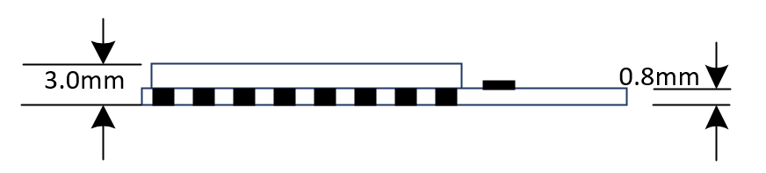
(b) Side view

Table 3.1Module Size Comparison Table

L | W | H | PAD size (bottom) | Pin spacing
25.5 mm | 18 mm | 3 mm | 0.45 mm x 0.9 mm | 0.8 ± 0.1 mm

4. Electrical Characteristics

表4. 1绝对电气参数
Parameter | Describe | MIN | MAX | Unit
Ts | Storage temperature | -40 | 105 | ℃
VBAT | Power supply voltage | -0.3 | 3.6 | V
Electrostatic discharge voltage | TAMB-25℃ | -4 | 4 | kV
Electrostatic discharge voltage | TAMB-25℃ | -200 | 200 | V

Table 4.2 Normal Operating Conditions

Parameter | Describe | Minimum | Typical | Maximum v
Ta | Operating temperature | -40 | - | 85
VBAT | Power supply voltage | 3 | 3.3 | 3.6
VOL | IO low level output | VSS | - | VSS+0.3
VOH | IO high-level output | VBAT-0.3 | - | VBAT

五.RF Power consumption
Table 5.1Power consumption
Work mode | describe |  | average value (mA) | peak (mA)
Work mode | TX | 802.11b, 20 MHz, 1 Mbps, @19.5 dBm | 239 | 355
Work mode | TX | 802 . 11g, 20 MHz, 54 Mbps, @15 dBm | 190 | 297
Work mode | TX | 802 . 11n, 20 MHz, MCS7, @13 dBm | 183 | 286
Work mode | TX | 802 . 11n, 40 MHz, MCS7, @13 dBm | 165 | 285
Work mode | RX | 802 . 11b/g/n, 20 MHz | 85 | 95
Work mode | RX | 802 . 11n, 40 MHz | 88 | 97

1 Power consumption data are based on tests conducted at the RF interface under a 3.3V power supply and an ambient temperature of 25°C. All transmit data are measured based on a 50% duty cycle.
2. When measuring RX power consumption data, peripherals are turned off and the CPU is in idle state.

Table 5.2 Dormant Current

Power saving mode | describe | Power consumption
Active (RF operation) | Wi-Fi Tx packet 13 dBm~21 dBm | 160~260 mA
Active (RF operation) | Wi-Fi/BT Tx packet 0 dBm | 120 mA
Active (RF operation) | Wi-Fi/BT Rx and eavesdropping | 80~90 mA
Active (RF operation) | Associated sleep mode (associated with Light-sleep mode) | 0.9 mA@DTIM3,  1.2 mA@DTIM1
Modem-sleep | The CPU is in working state. | Maximum speed: 20 mA
Modem-sleep | The CPU is in working state. | Normal speed: 5~10 mA
Modem-sleep | The CPU is in working state. | Slow speed: 3 mA
Light-sleep | - | 0.8 mA
Deep-sleep | The ULP coprocessor is in operation. | 0.1 mA
Deep-sleep | Ultra-low power sensor monitoring methods | 25 uA @1 % duty
Deep-sleep | RTC timer + RTC memory | 20uA
Hibernation | Only the RTC timer is active. | 2.5 uA

\

Active mode: The chip's radio frequency is active. The chip can receive, transmit, and listen for signals.
Modem-sleep mode: The CPU remains running, and the clock can be configured. Wi-Fi/Bluetooth baseband and RF are off.
Light-sleep mode: The CPU is suspended. The RTC and ULP coprocessors operate. Any wake-up event (MAC, host, RTC timer, or external interrupt) will wake the chip.
Deep-sleep mode: Only the RTC is active. Wi-Fi and Bluetooth connectivity data is stored in the RTC. The ULP coprocessor remains running.
Hibernation Mode: The built-in 8 MHz oscillator and ULP coprocessor are disabled. RTC memory reclamation power is cut off. Only one RTC clock timer on the slow clock and some RTC GPIOs are active. The RTC timer or RTC GPIOs can wake the chip from Hibernation mode.
Associated sleep mode: Power saving mode switches between Active mode and Modem-sleep/Light-sleep mode. The CPU, Wi-Fi, Bluetooth, and RF are periodically woken up according to preset times to ensure Wi-Fi/Bluetooth connectivity.
Ultra-low power sensor monitoring method: The main system is in deep-sleep mode, and the ULP coprocessor is periodically turned on or off to measure sensor data. Based on the data measured by the sensors, the ULP coprocessor decides whether to wake up the main system. Power consumption varies depending on the power-saving mode/sleep mode and the operating status of the functional modules.

6.Radio frequency characteristics
The data in the table below were measured at an indoor temperature and a voltage of 3.3V.

Table 6.1WiFi radio frequency standard

name |  | describe
Operating channel center frequency range 1 |  | 2412 ~ 2484 MHz
Wi-Fi protocol |  | IEEE 802.11b/g/n
Data rate | 20 MHz | 11b: 1, 2, 5.5, 11 Mbps  11g: 6, 9, 12, 18, 24, 36, 48, 54 Mbps  11n: MCS0-7, 72.2 Mbps (Max)
Data rate | 40 MHz | 11n: MCS0-7, 150 Mbps (Max)
Antenna type |  | PCB antenna, external antenna 2

1. The center frequency range of the operating channel should conform to national or regional standards and specifications. The software can configure the center frequency range of the operating channel.
2. The output impedance of the module using an external antenna is 50 Ω. The output impedance of the module without an external antenna does not need to be considered.

Table 6.2 WiFi Acceptance Characteristics
Parameters | Min | Typical | Max | unit
PER<8%，RX sensitivity，802.11b DSSS Mode 11M | - | -88 | - | dBm
PER<10%，RX sensitivity，802.11g OFDM Mode 54M | - | -74 | - | dBm
PER<10%，RX sensitivity，802.11n OFDM Mode MCS7 | - | -73 | - | dBm
PER<10%，RX sensitivity，BLE LE 1M | - | -96 | - | dBm

Table 6.3 Bluetooth Transmission Characteristics
Parameters | Min | Typical | Max | unit
Operating frequency | 2402 | - | 2480 | MHz
air speed | - | 1 | - | Mbps
Transmit power | -20 | 6 | 20 | dBm
Frequency error | -150 | - | 150 | KHz

表6. 3 蓝牙接受特征
Parameters | Min | Typical | Max | unit
RX Sensitivity | - | -96 | - | dBm
Maximum RF signal input | -10 | - | - | dBm
Intermodulation | - | - | -23 | dBm
Common channel rejection ratio | - | 10 | - | dB

七. Recommended Furnace Temperature Profile

The recommended furnace temperature profile is as follows:

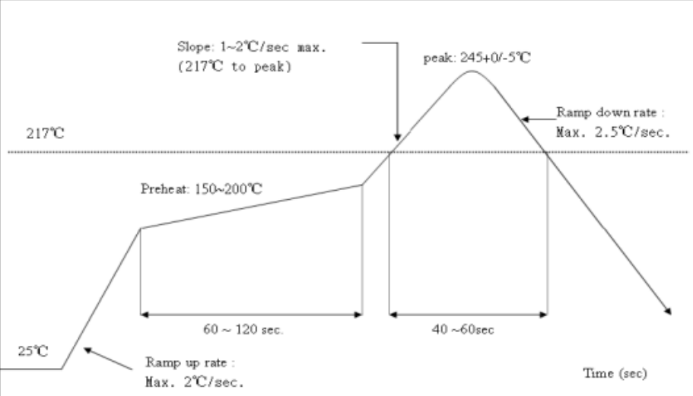
Figure 7.1Recommended furnace temperature profile

8. Minimum Module System and Automatic Download Circuit
The minimum system circuit diagram of the module is as follows:

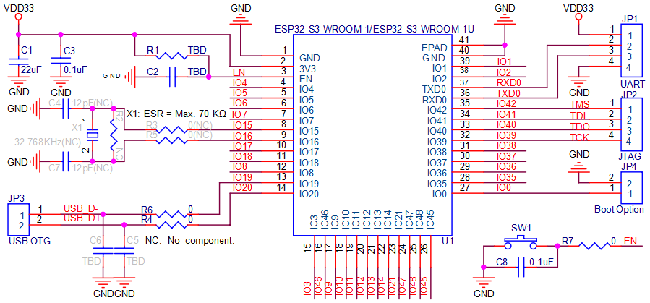
Figure 9.1Minimal System

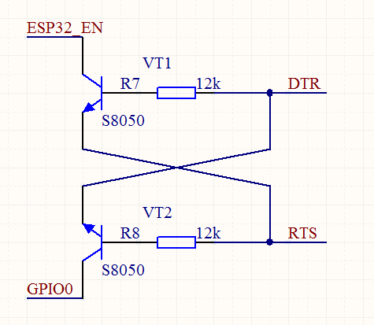

Figure 9.2 Automatic Download Circuit
Note:
(1) The module is powered by DC 3.3V;
(2) The maximum output current of the Wi-Fi module IO is 12mA;
(3) The RST pin of the Wi-Fi module is active low;
(4) The RXD of the Wi-Fi module is connected to the TXD of the external MCU, and the TXD of the Wi-Fi module is connected to the RXD of the external MCU;
(5)By connecting the module's EN and GPIO pins to the serial port chip's DTR and RTS pins, software...Automatic download mode.
(6) When the module enters FLASH download mode: IO0 is at a low level, and then the module is reset and powered on; when the Wi-Fi module enters normal working mode: IO0 is at a high level, and the module is reset and powered on.

9. Recommended PCB Design (Taking XH-C2F as an Example)
Wi-FiThe module can be directly soldered onto the PCB board. To ensure optimal RF performance for your end products, please carefully design the placement of the module and antenna on the baseboard according to this guide.For the PCB antenna version module, there are three options available.
For the ESP-32S version with an external antenna, the placement of the module is less critical due to the external antenna; the layout suggestions for XH-C3F can be adjusted accordingly. The specifications of the external antenna connector are shown in the figure below.
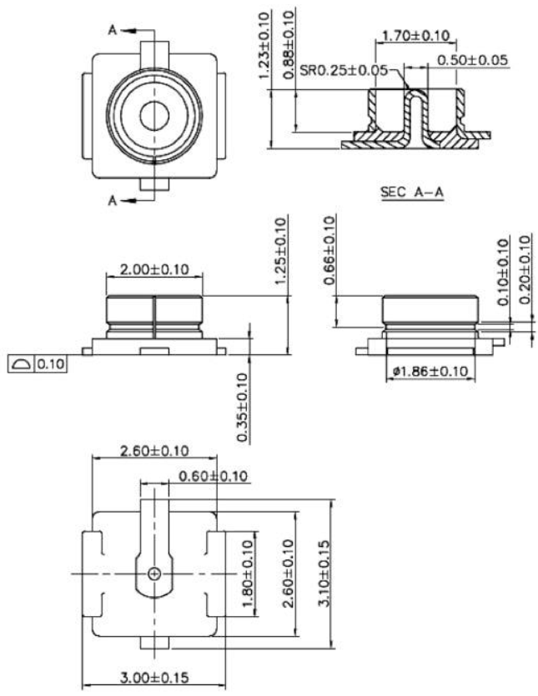

Option 1: Preferred option: The WiFi module is placed against the edge of the board, with all antennas exposed, and there are no metal objects around the antennas, including wires, metal casings, counterweights, etc.
Option 2: Suboptimal solution: The WiFi module is placed against the edge of the board, with a cutout below the antenna and a gap of at least 5mm between it and the surrounding PCB. There are no metal objects around the antenna, including wires, metal casings, counterweights, etc.
Option 3: General solution: Place the WiFi module against the edge of the board, leaving the PCB area below the antenna clear and without copper plating.
Note: The WiFi module should not be placed in the middle of the motherboard, and it is not recommended to have other metal objects around it.
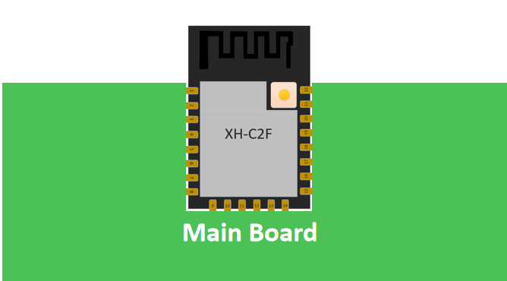

Figure 10.2planone-Antenna outside the board frame
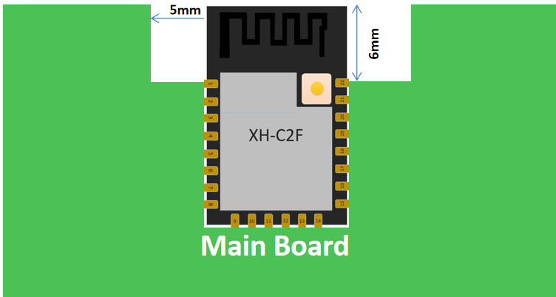
Figure 10.3Option 2 -The antenna is placed along the edge of the board and the space below it is hollowed out.

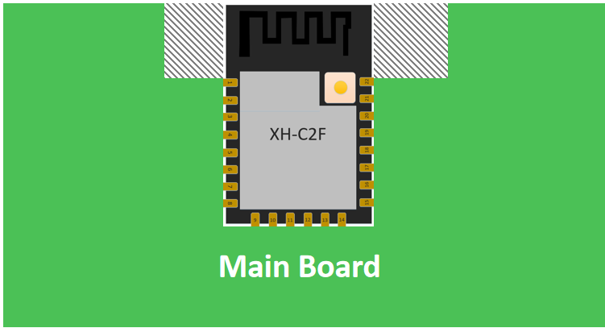
Figure 10.4Option 3 -The antenna is placed along the edge of the board and no copper is laid underneath it.

10. Suggestions for peripheral wiring
Wi-Fi moduleThe integration of high-speed GPIO and peripheral interfaces can generate significant switching noise. For applications with stringent power consumption and EMI requirements, it is recommended to connect a 10-100 ohm resistor in series on the digital I/O lines. This helps suppress overshoot and smooth the signal during switching.,This practice can also prevent electrostatic discharge (ESD) to some extent.

Disclaimer and Copyright Notice

The information contained herein, including URLs provided for reference, is subject to change without notice.
This document is provided "as is" without any warranty, including any warranty of merchantability, fitness for a particular purpose, or non-infringement, and any warranty of any proposal, specification, or sample mentioned elsewhere. This document assumes no liability, including liability for any infringement of any patent rights arising from the use of the information contained herein. This document does not grant any license to use any intellectual property rights herein, whether express or implied, by estoppel or otherwise.
The Wi-Fi Alliance member logo is the property of the Wi-Fi Alliance.
All trademark names, trademarks and registered trademarks mentioned in this article are the property of their respective owners

Note meaning

The contents of this manual may change due to product upgrades or other reasons.Shenzhen Xinghuo Sicheng Technology Co., Ltd.We reserve the right to modify the contents of this manual without prior notice or warning. This manual is for guidance purposes only.Shenzhen Xinghuo Sicheng Technology Co., Ltd.We have made every effort to provide accurate information in this manual, but we do not guarantee that the manual is completely error-free, and all statements, information and recommendations in this manual do not constitute any express or implied warranty.

