- sudo rpm -ivh http://repo.postgrespro.ru/pgpro-14/keys/postgrespro-std-14.centos.yum-14-0.3.noarch.rpm
- sudo yum install postgrespro-std-14
- 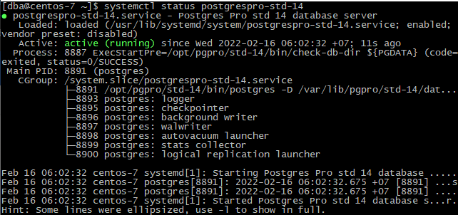
- 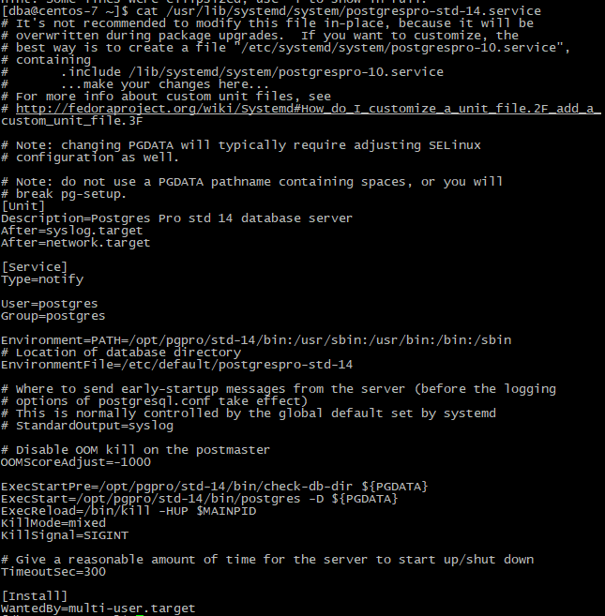
- 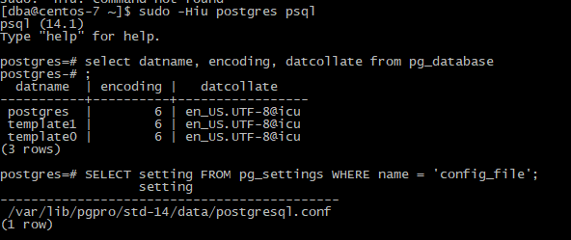

- sudo yum install nginx
- 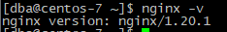
- sudo firewall-cmd --permanent --zone=public --add-service=http
- sudo firewall-cmd --permanent --zone=public --add-service=https
- sudo firewall-cmd –reload
- systemctl start nginx
- 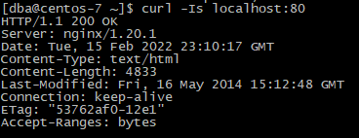
- 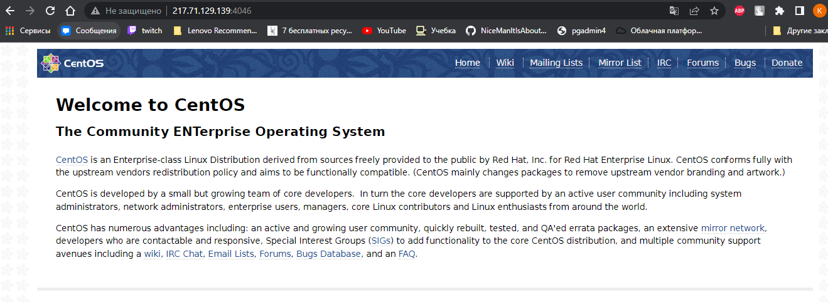http://217.71.129.139:4046/

- yum install python-pip
- sudo yum install https://download.postgresql.org/pub/repos/yum/reporpms/EL-6-x86_64/pgdg-redhat-repo-latest.noarch.rpm
- sudo yum install epel-release
- sudo yum install https://ftp.postgresql.org/pub/pgadmin/pgadmin4/yum/pgadmin4-redhat-repo-2-1.noarch.rpm
- sudo yum clean all
- sudo yum install epel-release
- sudo yum -y update
- sudo yum -y install python-pip
- sudo yum -y install python3-pip
- sudo python3 -m pip install -U setuptools
- sudo python3 -m pip install -U pip
- mkdir .pgadmin
- mkdir .pgadmin/sessions
- mkdir .pgadmin/storage
- sudo yum install pgadmin4
- cd /usr/pgadmin4/web/
- sudo vi config_local.py
SERVER_MODE = False
LOG_FILE = '/home/dba/.pgadmin/pgadmin4.log'
SQLITE_PATH = '/home/dba/.pgadmin/pgadmin4.db'
SESSION_DB_PATH = '/home/dba/.pgadmin/sessions'
STORAGE_DIR = '/home/dba/.pgadmin/storage'
- /usr/pgadmin4/venv/bin/python /usr/pgadmin4/web/pgAdmin4.py 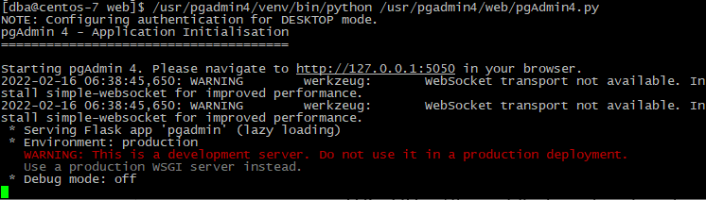
- cd /usr/lib/systemd/system
- sudo vi pgadmin.service
[Unit]
Description=pgAdmin4 Service
After=network.target

[Service]
User=dba
Group=dba
ExecStart=/usr/pgadmin4/venv/bin/python /usr/pgadmin4/web/pgAdmin4.py
PrivateTmp=true

[Install]
WantedBy=multi-user.target
- systemctl daemon-reload
- systemctl enable pgadmin
- systemctl start pgadmin
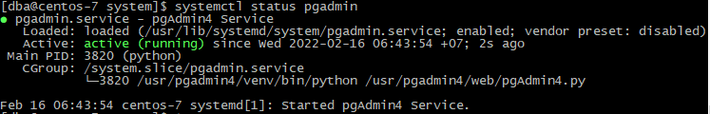
- sudo setsebool httpd_can_network_connect on -P
- cd /etc/nginx/default.d
- sudo vi pgadmin.conf
location / {
proxy_set_header Host $http_host;
proxy_set_header X-Forwarded-For $remote_addr;
proxy_set_header X-Forwarded-Proto $scheme;
proxy_set_header X-Real-IP $remote_addr;
proxy_pass http://127.0.0.1:5050/;
}
- sudo vi nginx.conf комментируем local /
- sudo systemctl reload nginx
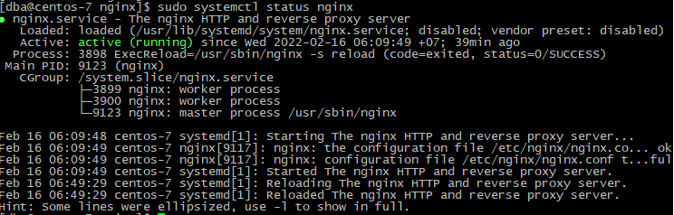
- http://217.71.129.139:4046/browser/
- psql postgres
- \password postgres
- 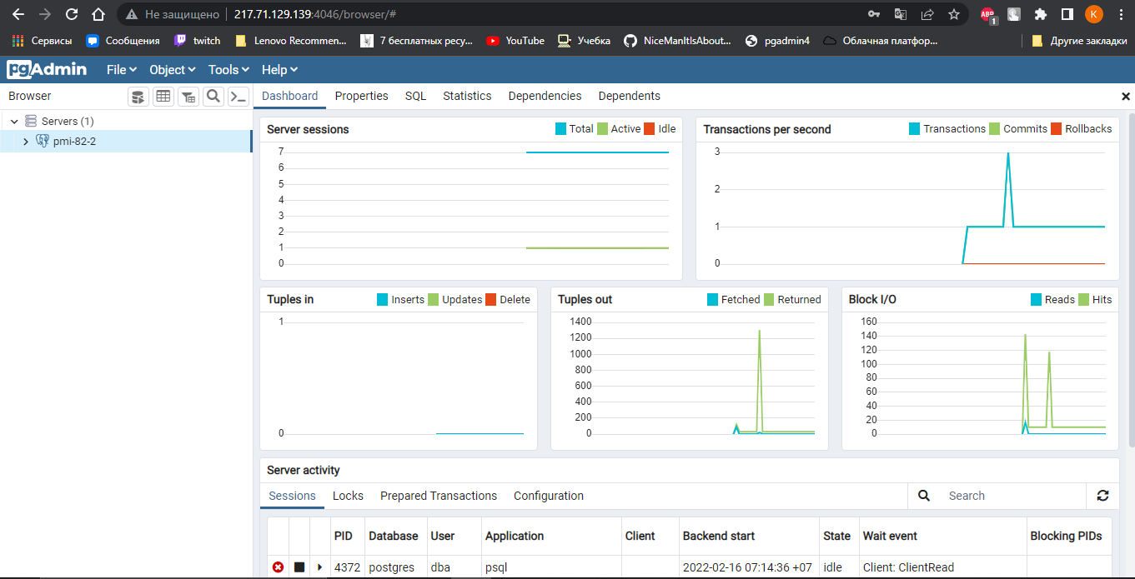
- wget https://edu.postgrespro.ru/demo_small_20161013.zip
- sudo yum install unzip
- unzip demo_small_20161013.zip
- psql postgres < demo_small.sql
- 