NM VIBE
Project Documentation
Version 2.1 · 2026-11-06 · Prepared for Niceman · Formerly "NM VYBE"
This document was updated on 2026-11-06 to record the approved free and open-source product model and current project direction. It describes the project and planned work; verify implementation status in docs/IMPLEMENTATION_STATUS.md.
What is new in this version
1. The whole project is renamed from NM VYBE to NM VIBE, with a safe rename checklist (section 1.2).
2. A new adaptive refresh-rate and UI smoothness design, so the app matches 60, 90, 120 or 144 Hz screens (section 5).
3. A cleaned, layer-correct file structure, with a move table from today's code to the target (section 7).
4. System models: use case diagram, ER diagram and three sequence diagrams (section 8).
5. Development tools, external interface requirements and references (sections 9, 10 and 13).

1. Overview and current status
NM VIBE is a completely free and open-source, local-first music player for Android (primary) and Windows (beta). There will be no paid editions, subscriptions, premium memberships, or paid feature unlocks. The promise is "your music, your vibe": no ads or tracking. Smoothness is the product, so every change is judged on whether it keeps the app fast and stable.

1.1 Built and not built
Built and passing automated checks (as reported by the last ChatGPT runs; run the checks yourself before release):
- Local library scanning, tag and artwork reading (ID3, FLAC, MP4, OGG, WAV), playlists, queue, synced lyrics (.lrc), equalizer on Android, sleep timer and background playback.
- A Node.js backend with /health, /v1/music/search, /v1/music/stream/:id and /v1/updates/latest, with rate limits, caching and tests.
- A secure update flow that hands off to the stores and verifies Windows installers by hash.
- Defensive download storage: .part files, startup cleanup and a DownloadRecord.
- A 5,000-song list that scrolled at 60 fps on Windows in profile mode with no missed frames.
Not done yet:
- A real-phone test on Android, and a refresh-rate test on 90 and 120 Hz phones.
- A stream cache, a download manager screen, Audius and internet radio sources.
- Google sign-in and playlist backup, store listings, release signing, MSIX packaging and a privacy policy.
- CI (there is no .github/ folder yet) and the structure clean-up in section 7.

1.2 Renaming NM VYBE to NM VIBE
The name appears in about 80 files (roughly 100 uses of nm_vybe alone), so it is more than a display-name change. Do it as one commit, before the first store upload, because an Android applicationId cannot be changed after publishing.
Where | Today | Becomes
Display name and text | NM VYBE (README, docs, UI strings, web/manifest.json, web/index.html) | NM VIBE
Dart package | nm_vybe (pubspec.yaml and every package:nm_vybe/ import) | nm_vibe
Classes | NmVybeApp, NmVybeAudioHandler | NmVibeApp, NmVibeAudioHandler
Android | com.nmnext.nmvybe (namespace and applicationId in build.gradle.kts) | com.nmnext.nmvibe
Windows and macOS | nm_vybe.exe, nm_vybe.app, runner and CMake names, RunnerTests ids | nm_vibe.*
Local data | .nm_vybe_data, nm_vybe.db, env var NM_VYBE_DATA_DIR | .nm_vibe_data, nm_vibe.db, NM_VIBE_DATA_DIR
Backend | package name nm-vybe-music-api | nm-vibe-music-api
Tools and scripts | tool/*.py, tool/*.ps1, tool/*.dart | same files, new names inside

Do not lose existing data
Renaming the database file and data folder would hide the library and playlists of anyone who already ran a build. Add a small startup migration: if the new nm_vibe.db is missing and nm_vybe.db exists, rename it. Add one test for it. This follows the hard rule "don't break the user's data".
After the rename run flutter clean, flutter pub get, flutter analyze and flutter test. Do a final search for "vybe" (any case) and check nothing is left except the migration code.
Recommendation: use the Musify-style architecture (several sources behind one interface, plus local files and a download record), and do not build YouTube or social-media extraction. This multi-source hybrid is the architecture in lib/data/ and is a suitable foundation for a free and open-source app.
"The Musify method" means two different things, and they should be judged separately:
- The architecture (many sources, one contract, a repository that decides between a saved file and a stream). This is good engineering and is what NM VIBE adopts.
- The catalog trick (extracting audio from YouTube and other platforms). This is why Musify can play almost anything, and it is the part that cannot be sold. Musify's own pubspec.yaml depends on youtube_explode_dart and youtube_music_explode_dart, and its licence file is GPL-3.0.
Catalog size | Nearly everything online | Independent artists only | Your own files plus every source that allows it
Legal basis | Breaks platform terms; no licence from rights holders | Needs a commercial agreement; the free API is non-commercial | Each source is used only as its terms allow
Store risk | High: apps like this are removed from stores | Low once licensed | Low
Compatible with the approved product model | No (source policy) | Only with provider agreement | Yes, with source terms respected

Why not copy Musify. Musify is GPL-3.0, so copied code must comply with that licence and preserve its copyright and notice requirements. Ideas and architecture are free to use; code is not. Separately, an app that extracts YouTube audio risks store removal and developer-account action, and the method breaks frequently.

3. Architecture
The app has four layers. Screens talk to controllers, controllers talk to repositories, repositories talk to sources and storage, and the audio layer decides at play time between a saved file and a stream.
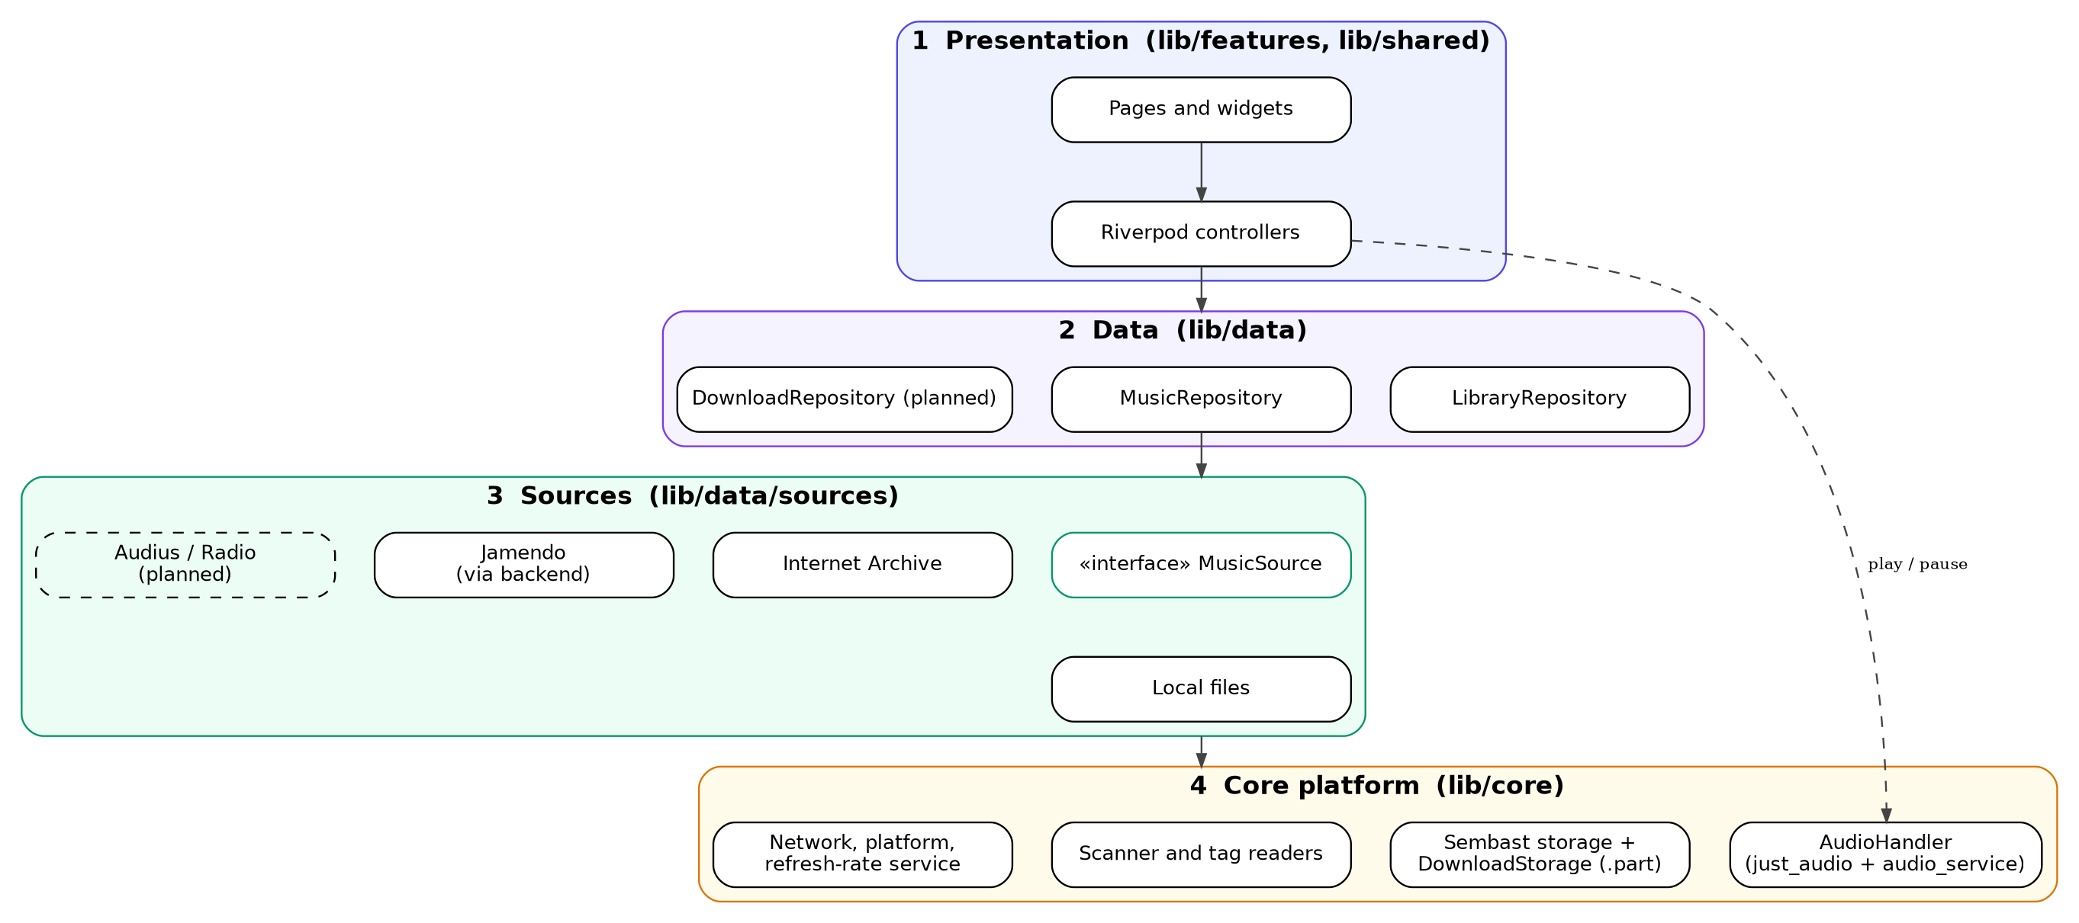
Figure 1. The four layers of NM VIBE
When a track plays, the repository first looks for a DownloadRecord whose file exists on disk. If it does, the player opens the file. Otherwise it asks the source for a stream URL. Adding a source means writing one class that implements MusicSource and registering it. No screen changes.

Stack
Flutter and Dart, Riverpod 3.x for state, just_audio with audio_service for playback (just_audio_media_kit on Windows), Sembast for storage, a Node.js backend on Render, and a Next.js website later.

4. Music sources and offline rules
The rule for every source: stream or download only what its own terms allow, and let the code enforce it. A source can forbid downloads for the whole service (canDownload), and a single track can forbid them too (downloadAllowed). The repository starts a download only when both are true. Terms were checked on 2026-10-31 (see docs/SOURCES.md) and must be rechecked before release.
Source | Stream | Offline copy | Status and conditions
Local files | Yes | Already on device | Built. The main catalog.
Internet Archive | Yes | Only items marked public domain, CC0, CC BY or CC BY-SA | Built. The uploader declares the licence, so it is checked per item. Unknown, NC and ND items are stream only.
Audius | Yes | No | Not built. Read the API terms and get a key before building.
Internet radio | Yes | No | Not built. Public stream endpoints only.
YouTube, Piped, social platforms | — | — | Do not build. Breaks platform terms; high risk of store removal; constant maintenance.

4.1 Download pipeline
- The repository checks canDownload for the source and downloadAllowed for the track. If either is false, no download is offered.
- Bytes are written to <id>.part inside the private app directory, so a half-finished file is never played.
- On success the size is verified. A SHA-256 check is added where a source publishes a hash (planned).
- The file is renamed to its final name in one step. Leftover .part files are deleted at startup.
- A DownloadRecord is saved with source, track id, local path, codec, bitrate, licence, size and time.

4.2 Hybrid playback
At play time the repository checks for a record whose localPath exists. A present file plays offline; anything else plays from its stream URL. A stream cache (planned) will wrap HTTP streams in LockCachingAudioSource so replays work offline, with a size limit and a "Clear cache" button. Cached streams stay separate from downloads, because only explicit downloads are licensed offline copies.

5. Smooth UI and adaptive refresh rate
Goal: the interface should run at the refresh rate of the device it is on (60, 90, 120 or 144 Hz) and never drop frames during scrolling, page transitions, the now-playing screen or the lyrics view. This is a planned feature: the repository has no refresh-rate code yet.

5.1 What "matching the screen" needs per platform
Platform | Approach | Notes
Android | Ask the system for the highest display mode at the current resolution at startup (flutter_displaymode, setHighRefreshRate()), and re-apply when the app returns to the foreground. | Needed on phones with fixed steps such as 60/90/120 Hz. Phones with LTPO panels adapt on their own. The package is MIT licensed and Android only; check its maintenance state before adding it (ask first, as required for any dependency).
iOS (later) | Set CADisableMinimumFrameDurationOnPhone to true in Info.plist so ProMotion iPhones can run above 60 Hz. | iOS manages the rate itself; no plugin needed.
Windows, macOS, Linux | Nothing to set. Flutter follows the monitor's vsync. | Test on a 120 or 144 Hz monitor.

5.2 Design and code rules
- Read the real rate, do not assume 60. Use View.of(context).display.refreshRate where a number is needed (for example, to scale a frame-budget warning).
- Frame budget: 16.7 ms at 60 Hz, 11.1 ms at 90 Hz, 8.3 ms at 120 Hz, 6.9 ms at 144 Hz. Build and raster work must fit the budget of the highest rate you target.
- Never hard-code 16 ms timers or frame counts. Drive animations with AnimationController and a vsync, and express motion in time (milliseconds), not frames, so speed looks the same at any rate.
- Keep rebuilds small: const widgets, ListView.builder with item extents, RepaintBoundary around the progress bar and artwork, and Riverpod select so a position tick does not rebuild the whole page.
- Heavy work off the UI thread: scanning and tag reading run in an isolate; artwork is decoded at display size, not full size.
- No `setState` on a timer for the seek bar. Listen to the audio position stream and update only the seek bar widget.

5.3 Settings and battery
Add a Display section in Settings with "Refresh rate: Auto (recommended) / Battery saver (60 Hz)". Auto asks for the highest mode; Battery saver releases the request. The choice is stored as refresh_mode in the settings store. When the phone is in power-saver mode the app should not fight the system.

5.4 How to verify
- Run in profile mode on a real 90 or 120 Hz phone, open the DevTools performance overlay, and scroll the 5,000-song list and the Discover page. Both the UI and raster threads must stay under the frame budget with no red frames.
- Log display.refreshRate at startup and show it in a hidden diagnostics row in Settings, so a tester can confirm the app really got 90 or 120 Hz.
- Extend integration_test/library_scroll_test.dart to record frame timings and fail if the 99th percentile exceeds the budget.
Some phones drop back to 60 Hz when the screen is idle. That is Android's adaptive behaviour and is not a bug; the rate should rise again as soon as the user scrolls or touches the screen.

6. What to change and add
Most of the Musify-style design is already built. This is what the repository still needs, in the order to do it.

6.1 Fix first (small, high value)
- Rename to NM VIBE with the migration in section 1.2.
- Repository hygiene. Repository visibility is an owner choice. Keep secrets private and merge the approved working branch into main.
- Product model. NM VIBE is free and open source. Do not add purchases, paid editions, subscriptions, premium memberships, paid feature unlocks, or purchase-entitlement verification.

6.2 Structure clean-up (no behaviour change)
- Fix the layer violations: lib/data/sources/* and lib/core/* import features/library/models/song_model.dart. Move the models to lib/data/models/.
- Move lib/core/providers/app_providers.dart to lib/shared/providers/, because it imports features.
- Delete the two near-empty shims lib/features/settings/controllers/update_controller.dart and lib/features/settings/models/update_info_model.dart; import from features/updates/ directly.
- Merge lib/core/data/ into lib/data/repositories/; split lib/core/services/ by job (audio, storage, scanner).
- Move DownloadRecord out of download_storage.dart into lib/data/models/download_record.dart.
- test_driver/ repeats the file names in integration_test/; keep one set after checking which one your scripts use.
- Split the largest files: now_playing_page.dart (908 lines), player_controls.dart (764), scanner_service.dart (709), settings_page_sections.dart (687), add_to_playlist_sheet.dart (656), discover_page.dart (645).

6.3 New features, one at a time
- Adaptive refresh rate and the Display setting (section 5).
- Stream cache with a size limit and a Clear cache button.
- Download manager: queue, progress, retry, cancel, and a Downloads screen showing size per source.
- SHA-256 verification where a source publishes a hash.
- Audius and internet radio sources, after reading their API terms.
- Google sign-in and playlist backup, with playlist export as a fallback.
- GitHub Actions: flutter analyze, flutter test and the backend tests on every push.

7. File structure
Your layout is close to what the repository already has, so this is a tidy-up and not a rewrite. The corrections are: models live in data/, one home for repositories, a core/ split by job, no shim files, a download manager beside the source layer, and a display/ service for refresh rate.

7.1 Project root
nm_vibe/
├── android/ ios/ windows/ macos/ linux/ web/ platform projects
├── assets/
│ ├── icons/ app icon sources
│ ├── images/ placeholder art
│ └── licenses/ third-party licence texts for the About page
├── backend/ Node.js API: server.mjs, server.test.mjs, README
├── docs/ ARCHITECTURE, SOURCES, UPDATES, DECISIONS, release checklist,
│ NM_VIBE_Project_Documentation, CHATGPT_INSTRUCTIONS
├── integration_test/ play a file, scroll 5,000 songs, download recovery
├── lib/ the Flutter app (section 7.2)
├── test/ mirrors lib/: core/ data/ features/ fixtures/
├── third_party/ patched packages (on_audio_query_android)
├── tool/ helper scripts: icons, demo library, profiling
├── .github/workflows/ ci.yml: analyze, test, backend test (planned)
├── analysis_options.yaml pubspec.yaml pubspec.lock render.yaml README.md
└── .gitignore build/, .dart_tool/, *.jks, key.properties, .env, *.log

7.2 Inside lib/
lib/
├── main.dart boot only: storage, audio handler, ProviderScope
├── app.dart NmVibeApp: MaterialApp, theme, routes
├── core/ no UI, no feature logic
│ ├── audio/ audio_handler.dart, audio_session_setup.dart
│ ├── storage/ db_service, app_storage, settings_service, download_storage
│ ├── scanner/ scanner_service, artwork_service, tags/ (id3, flac, mp4, ogg)
│ ├── display/ refresh_rate_service.dart, frame_budget.dart NEW
│ ├── platform/ platform_info.dart, per-OS media controls
│ ├── network/ http_client.dart (timeouts, HTTPS only), connectivity
│ ├── theme/ app_theme, color_schemes, text_styles
│ ├── constants/ app_constants, theme_constants
│ └── utils/ formatters, logger, semver
├── data/ where data comes from
│ ├── models/ song, playlist, library_groups, download_record
│ ├── sources/ music_source (interface), local_files, internet_archive,
│ ├── repositories/ library_repository, in_memory_library_repository,
│ │ music_repository, download_repository (NEW)
│ └── downloads/ download_manager, download_task, offline_index NEW
├── features/ one folder per feature, never imports another feature
│ ├── library/ controllers/ views/ widgets/
│ ├── player/ controllers/ services/ (lyrics) views/ widgets/
│ ├── playlists/ views/
│ ├── discover/ views/ online source search and licensed download UI
│ ├── downloads/ downloads screen, storage per source NEW
│ ├── settings/ controllers/ (equalizer) views/ display section
│ ├── updates/ controllers/ models/ services/ views/ (one copy only)
│ └── account/ Google sign-in, playlist backup PLANNED
└── shared/
├── providers/ app_providers.dart
└── widgets/ app_shell, mini_player, album_art, song_tile, empty_state,
loading_skeleton, desktop_now_playing_pane, custom_button

7.3 Move table: today to target
Today | Target
core/data/* | data/repositories/
core/models/library_groups.dart | data/models/
features/library/models/song_model.dart, playlist_model.dart | data/models/
core/providers/app_providers.dart | shared/providers/
core/services/audio_handler.dart | core/audio/
core/services/db_service, app_storage, settings_service, download_storage | core/storage/ (DownloadRecord to data/models/)
core/services/scanner_service, artwork_service, tag_reader*.dart | core/scanner/ and core/scanner/tags/
core/services/lyrics_service.dart | features/player/services/
core/utils/platform_info.dart | core/platform/
features/settings/…/update_controller.dart, update_info_model.dart | delete; use features/updates/
features/library/widgets/song_tile, empty_state, loading_skeleton | shared/widgets/ (used by several features)

7.4 Rules that keep it clean
- Direction is features → data → core. core/ never imports data/ or features/; data/ never imports features/.
- A feature may import core/, data/ and shared/, never another feature.
- Screens call controllers, controllers call repositories, repositories call sources and storage. No screen touches a source, http or a file directly.
- Platform-specific code sits behind an interface in core/platform/, one implementation per OS.
- One file does one job; a file over about 400 to 500 lines gets split by responsibility.
- Source-specific code (URLs, JSON parsing, licence rules) lives only inside that source's file.
- Move in small steps: one folder per commit, with flutter analyze and flutter test green before the next move. Order: shims, models, repositories, core/services by folder, then the large files.

8. System models
These models describe how NM VIBE is used, what data it keeps and how the main flows run. They match the code in the repository; items marked planned are not built yet. Update the diagrams whenever a design changes.

8.1 Use case diagram
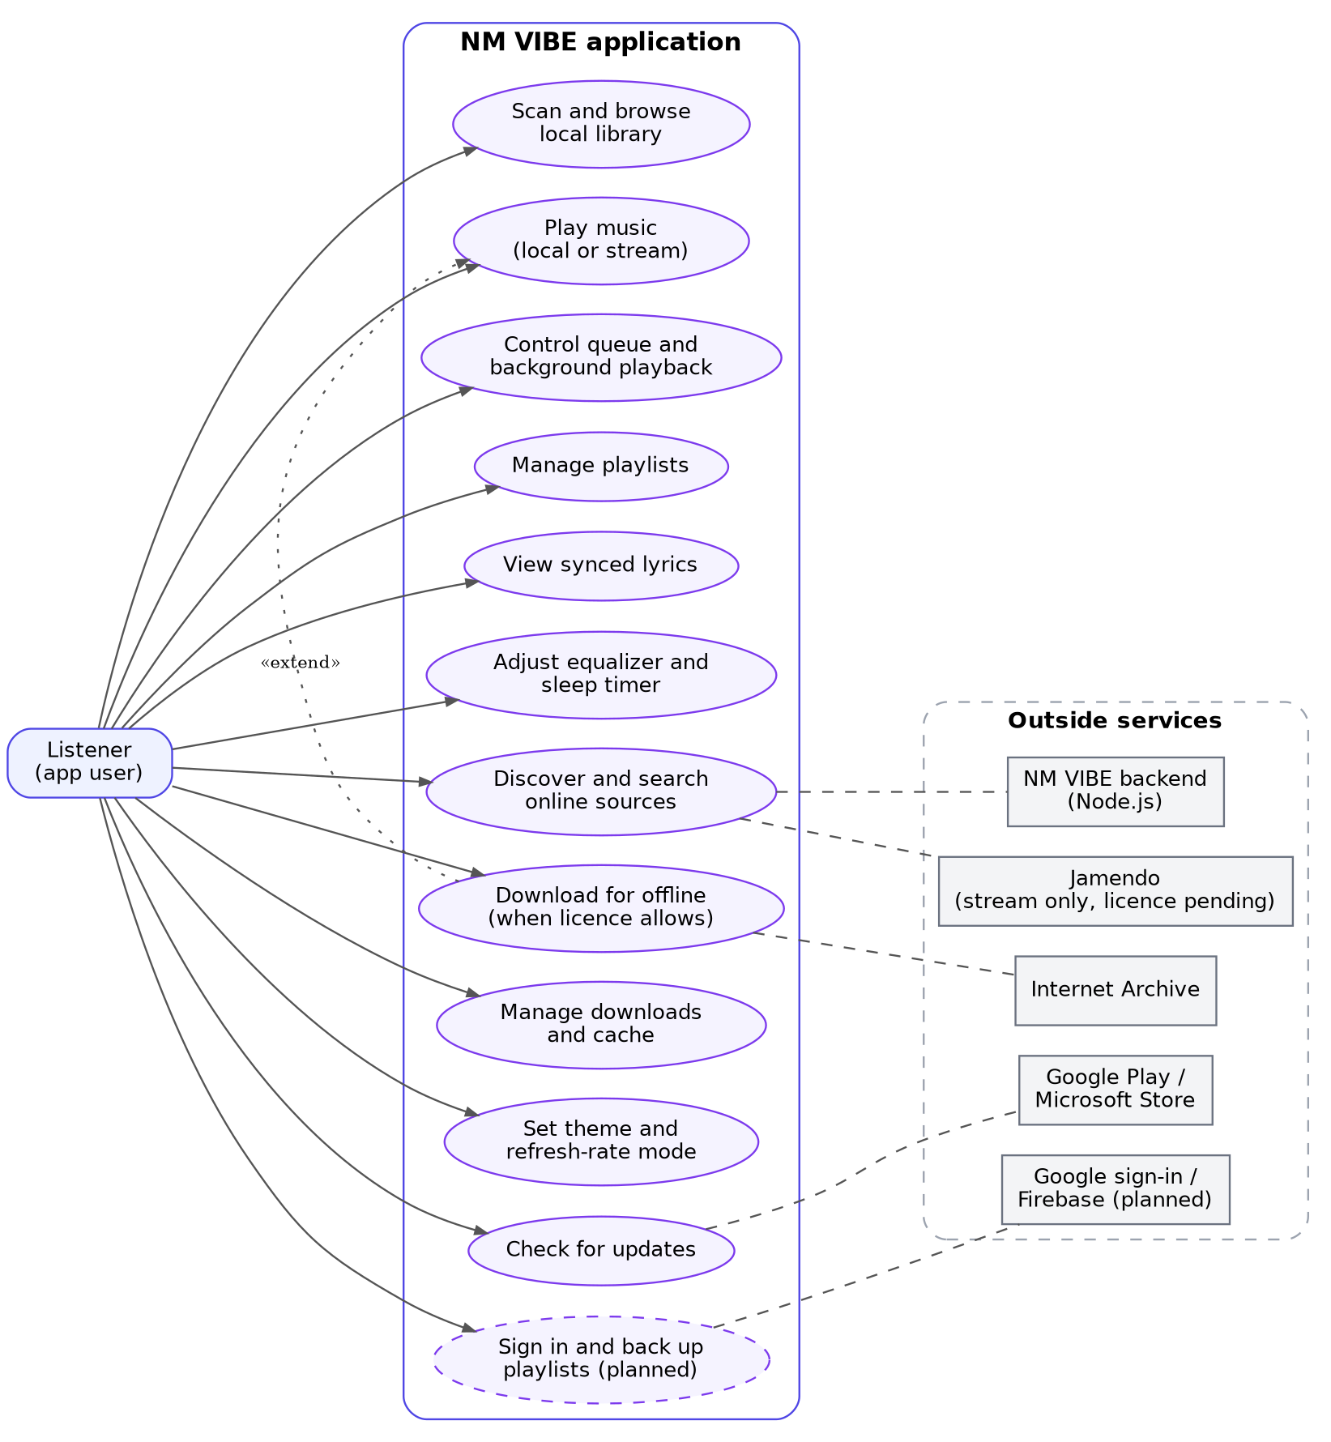
Figure 2. Use cases of the Listener and the outside services they touch
Use case | Summary
Scan and browse local library | The listener adds folders; the app reads tags and artwork and groups songs by album and artist.
Play music (local or stream) | A local file plays offline; an online track plays from its stream URL.
Control queue and background playback | Queue, shuffle, repeat, lock-screen and headset controls through audio_service.
Manage playlists | Create, rename, reorder and delete playlists; add songs from any screen.
View synced lyrics | Reads .lrc files and highlights the current line.
Adjust equalizer and sleep timer | Presets and bands on Android; sleep timer on all platforms.
Download for offline | Extends "Play": offered only when the source and the track licence allow it.
Manage downloads and cache | See sizes per source, remove copies, clear the stream cache (planned).
Set theme and refresh-rate mode | Dark, light, dynamic colour, album-art colours; Auto or Battery saver refresh rate (planned).
Check for updates | Hands off to Google Play or the Microsoft Store; Windows installers are hash-verified.
Sign in and back up playlists | Planned. Local playback never requires sign-in.

8.2 ER diagram
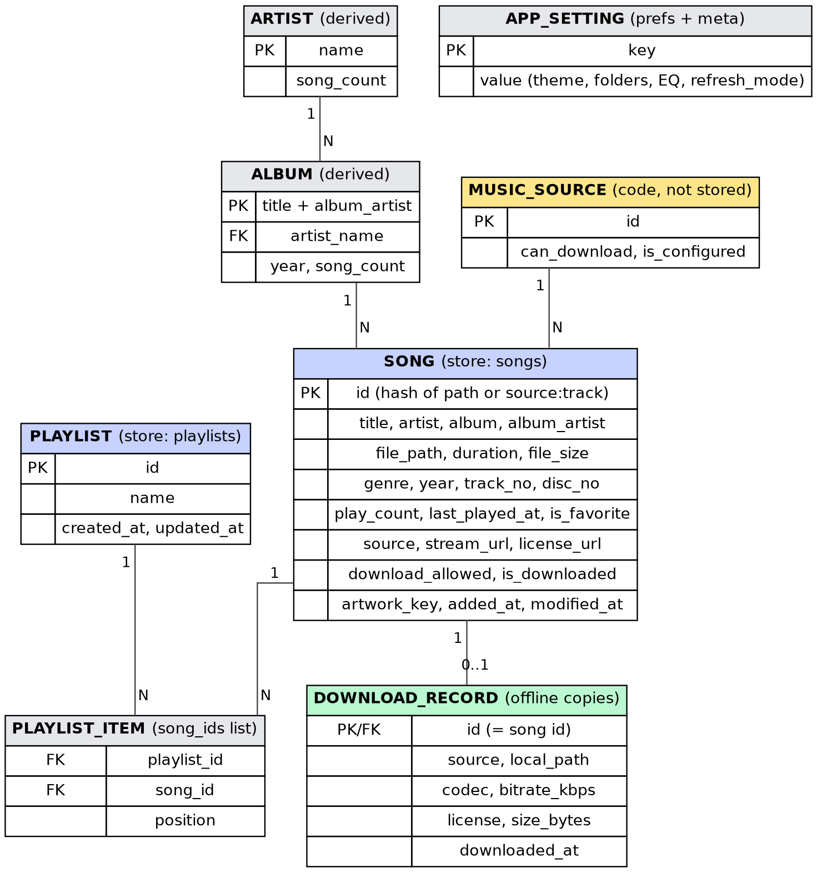
Figure 3. Entities and relationships
Sembast is a document store, so these are collections of maps, not SQL tables. Notes on the model:
- Song and Playlist are stored (songs, playlists); settings live in preferences and a meta store.
- Playlist item is not a separate collection today: a playlist keeps an ordered songIds list. It is drawn as an entity to show the many-to-many link between playlists and songs.
- Album and Artist are derived groups computed from songs (library_groups.dart), not stored.
- Download record exists only for saved songs (0 or 1 per song). It holds source, local path, codec, bitrate, licence, size and time. The class exists in download_storage.dart today; moving it to data/models/ is part of the clean-up.
- Music source is code (the MusicSource contract), shown to explain where source and can_download come from.
- Any change to these shapes needs a migration and a test.

8.3 Sequence diagrams

Play a track
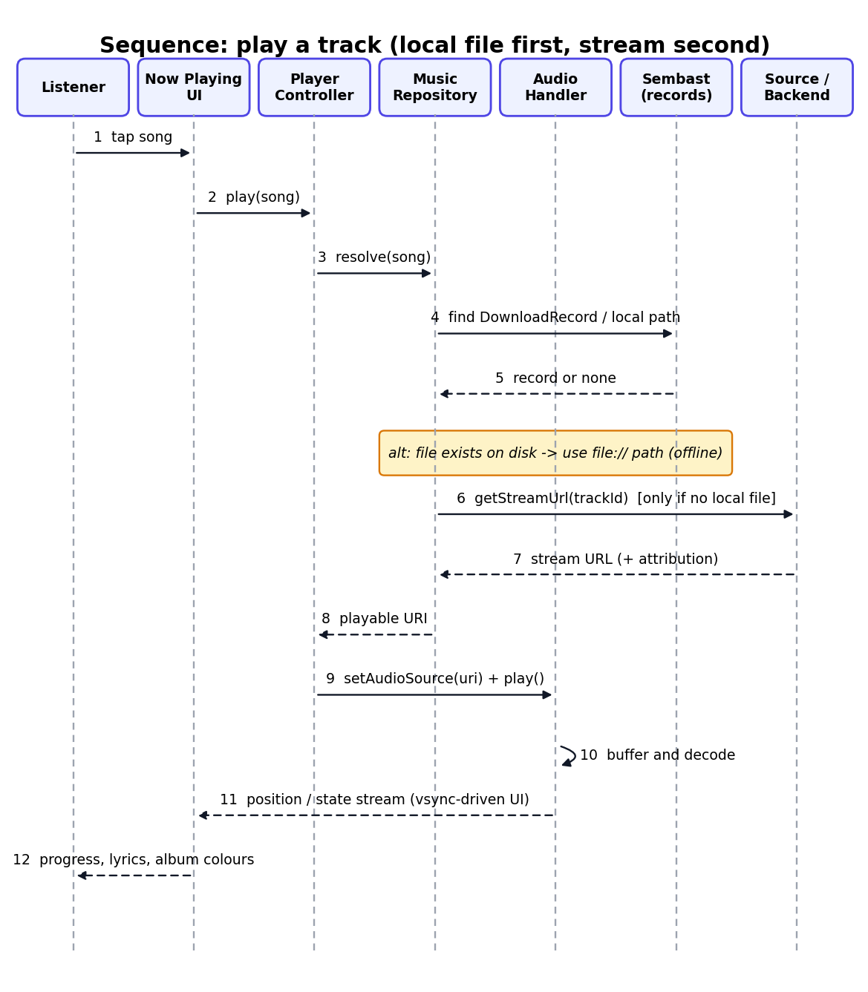
Figure 4. Local file first, stream second

Download a track for offline listening
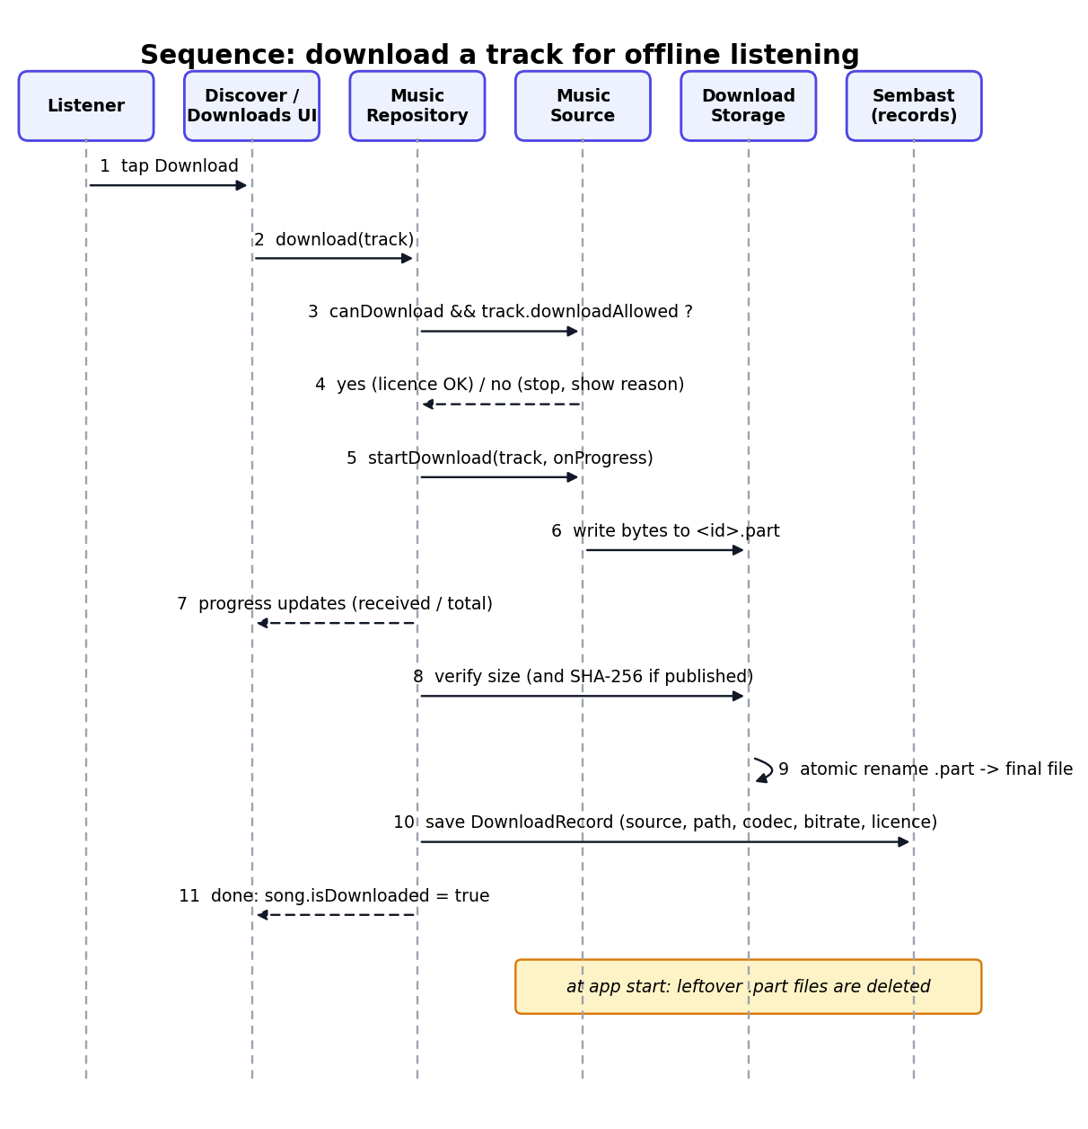
Figure 5. Licence check, .part file, verify, atomic rename, record

Scan the local library
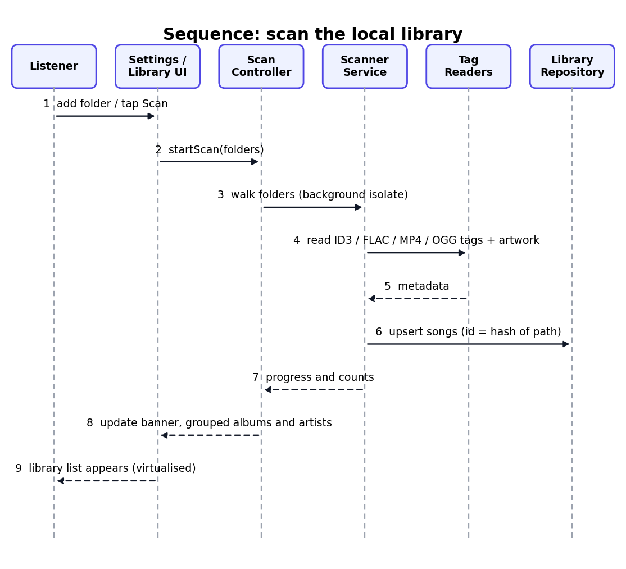
Figure 6. Folder scan in a background isolate

9. Development tools
Area | Tool | Used for
Framework and language | Flutter and Dart (SDK constraint in pubspec.yaml; Flutter version in flutter_version.txt) | One codebase for Android and Windows, with macOS, iOS and Linux later
State management | flutter_riverpod 3.x | Providers and controllers
Audio | just_audio, just_audio_media_kit, media_kit_libs_windows_audio, audio_service, audio_session | Playback, Windows backend, background and lock-screen controls
Storage | sembast, shared_preferences, path_provider, path, crypto | Library and playlist store, settings, file paths, hashing
Library and files | on_audio_query (patched in third_party/), file_picker | Android media query and folder selection
UI | Material 3, dynamic_color | Theme and system colours
Platform services | http, connectivity_plus, package_info_plus, url_launcher, in_app_update | Network, version info, store links and updates
Planned packages | flutter_displaymode, Firebase Auth and Firestore, LockCachingAudioSource (part of just_audio) | Refresh rate, sign-in and backup, stream cache
Backend | Node.js 20 or newer, node --test | Music search, stream, update endpoints; rate limits and caching
Hosting | Render (render.yaml) | Backend hosting (not yet deployed)
Build | Gradle (Kotlin DSL), Android SDK, Visual Studio C++ tools, MSIX packaging (planned) | Android and Windows builds
Editors | VS Code (.vscode/), Android Studio | Editing, debugging, emulators
Quality | flutter analyze, flutter test, integration_test, Flutter DevTools, flutter_lints | Static checks, tests and profiling
Version control and CI | Git and GitHub; GitHub Actions (planned) | Source control, automatic checks on every push
Scripts | Python and PowerShell in tool/ | Icons, demo library, window capture, profiling
Diagrams and docs | Graphviz, Markdown, Word | System models and documentation
AI assistants | ChatGPT (task prompts in the instructions document), Claude | Code tasks and documentation

10. External interface requirements

10.1 User interface
- Look and feel: Material 3, light and dark themes, dynamic system colour on Android, and accent colours taken from the current album art.
- Layouts: on phones, a bottom navigation shell (Library, Discover, Playlists, Settings) with a mini player above it and a full Now Playing page. On desktop, the same pages with a side Now Playing pane (desktop_now_playing_pane.dart).
- Main screens: Library (songs, albums, artists), Album and Artist detail, Playlists and Playlist detail, Discover, Now Playing (artwork, controls, lyrics, queue, equalizer), Settings, Downloads (planned), and the update gate.
- Smoothness: the UI follows the screen refresh rate (section 5), with loading skeletons and empty and error states so nothing looks frozen.
- Input: touch on phones; mouse, keyboard and media keys on Windows; headset and Bluetooth buttons through the media session.
- Accessibility: text scales with system font size, minimum touch targets of 48 dp, readable contrast in both themes, and labels on icon buttons.
- Clarity about licences: every online track shows its source, credit and licence link; the Download button appears only when the licence allows it.

10.2 Hardware interfaces
Hardware | Requirement
Device | Android phone or tablet (primary) and Windows PC (beta). macOS, iOS and Linux projects exist but are not release targets yet.
Display | Any resolution; variable or fixed refresh rate of 60 to 144 Hz is supported and used when available.
Storage | Read access to the user's music folders; private app storage for the database, artwork cache and offline downloads.
Audio output | Speaker, wired headset, Bluetooth and USB audio; the audio session is managed by audio_session.
Media controls | Notification and lock-screen controls on Android; system media transport controls on Windows; headset buttons.
Network | Wi-Fi or mobile data for online sources, updates and backup. The local library works fully offline.

10.3 Software interfaces
Interface | Description
Operating systems | Android and Windows today. The exact minimum versions must be confirmed from build.gradle.kts and the Windows runner before the store listing.
NM VIBE backend (REST, JSON) | GET /health, GET /v1/music/search, GET /v1/music/stream/:id, GET /v1/updates/latest. Holds API keys, applies rate limits and caching.
Internet Archive APIs | Item search and item metadata, including licenseurl; used for search, streaming and licensed downloads.
Audius API, internet radio | Planned. Stream only.
Google Play and Microsoft Store | Free distribution and updates. The app hands off to the store rather than updating itself; Windows installers are verified by hash.
Firebase Auth and Firestore | Planned for Google sign-in and playlist backup. Local use never requires it.
Platform media APIs | Android MediaSession and audio focus, Windows media transport controls, through audio_service and audio_session.
File system | Local files and tags in MP3, FLAC, M4A, OGG and WAV; .lrc lyric files.

10.4 Communication interfaces
- HTTPS only, with timeouts, and no tokens or keys in logs.
- JSON over REST to the backend; progressive HTTP audio streams to the player.
- No API keys, tokens or passwords in the app or in Git; keys live in the backend environment or in git-ignored files.
- The backend rate-limits requests and caches search results to stay inside source terms.

11. Roadmap and status by phase
Status comes from the ChatGPT reports so far. "Done" means automated checks passed, not that a phone test has been done.
Phase | What it covers | Status
1 | Foundation: structure, local library, playback, playlists, storage | Done
2 | Performance: 5,000-song list, scanning, startup | Done on a Windows profile run; Android phone run still to do
4a | Updates handed off to the stores, installer hash check | Done
4b | Google sign-in and playlist backup | Prompt given to ChatGPT; result not reported yet
4c | No paid editions, subscriptions, premium memberships, or paid feature unlocks | Not applicable; product decision approved
5 | Release: signing, store listings, MSIX, privacy policy, closed testing | Not started
New | Rename to NM VIBE, structure clean-up, adaptive refresh rate, stream cache, download manager | Planned (sections 1.2, 5, 6)

Next steps in order:
- Run the app on a real Android phone: playback, background play, equalizer, scanning, update screen, and the refresh rate on a 90 or 120 Hz device.
- Rename to NM VIBE (with the data migration), then do the structure clean-up in small commits.
- Add adaptive refresh rate, then the stream cache and the download manager.
- Finish 4b only after the playlist-backup promise and privacy requirements are approved, then proceed to release preparation.
- Set up Google Play Console and Firebase, write the privacy policy, then start Phase 5.

12. Risks and open decisions
Item | Why it matters | Your decision
YouTube and social extraction | It is the "plays everything" feature, but it breaks platform terms and can get the app and developer account removed. | Decided: not built. Revisit only with a licensed provider.
Third-party code | Musify is GPL-3.0; any reused code would carry its licence obligations. | Do not copy Musify code; preserve third-party copyright and licence notices.
Rename timing | The Android applicationId cannot change after publishing; renaming data files can hide user libraries. | Rename now, with the data migration.
Product model | No paid access or entitlement system is needed. | Approved: free and open source, with no paid features.
"Playlists for life" | Backup depends on Firebase and your ongoing costs. | Promise "backup while the service runs" and offer playlist export.
Audius terms | Only the Terms of Use were read, not the API terms or key rules. | Read them before building the source.
Repository visibility and software licence | The repository is private today; visibility is an owner choice. Open-source distribution requires selecting a software licence. | Protect secrets. Select and approve the software licence separately before creating a root LICENSE.
Refresh-rate coverage | Behaviour differs by phone maker and panel type; some phones drop to 60 Hz when idle. | Test on at least one 90 Hz and one 120 Hz phone.
Store requirements | Google Play may require a closed test before production, a privacy policy and account deletion. Check current rules. | Create the Play Console account early.
No CI | Regressions reach main unnoticed. | Add the GitHub Actions workflow.

13. References

Project documents and code
- NM VIBE repository (uploaded as NM-Vybe-main.zip): docs/ARCHITECTURE.md, docs/SOURCES.md, docs/UPDATES.md, docs/COMMERCIAL_V1_PLAN.md, docs/STABILITY_GATE.md, docs/PHASE_2_PERFORMANCE_REPORT.md, docs/ANDROID_TEST.md, docs/WINDOWS_TEST.md.
- NM VYBE – Project Documentation (previous version) and NM VYBE – Instructions for ChatGPT.
- Musify (uploaded as Musify-master.zip), studied for architecture only: https://github.com/gokadzev/Musify (GPL-3.0).

Music source APIs and licensing
- Internet Archive Item Search API: https://archive.org/services/docs/api/metadata.html
- Internet Archive Item Metadata API: https://archive.org/services/docs/api/md-read.html
- Internet Archive rights guidance: https://help.archive.org/help/rights/
- Internet Archive Terms of Use: https://archive.org/about/terms.php
- Creative Commons licence deeds: https://creativecommons.org/share-your-work/cclicenses/
- GNU General Public License v3.0: https://www.gnu.org/licenses/gpl-3.0.html
- Audius developer documentation: https://docs.audius.org (read the API terms before building).

Frameworks, packages and design
- Flutter documentation and performance guidance: https://docs.flutter.dev and https://docs.flutter.dev/perf
- Riverpod: https://riverpod.dev
- Packages on pub.dev: just_audio, just_audio_media_kit, audio_service, audio_session, sembast, dynamic_color, file_picker, connectivity_plus, in_app_update (https://pub.dev).
- flutter_displaymode (Android display mode and high refresh rate, MIT): https://pub.dev/packages/flutter_displaymode
- Material Design 3: https://m3.material.io
- Graphviz (diagrams): https://graphviz.org

