Discretization of pressure Poisson equation for Ghost Fluid Method























Introduce boundary condition



If there is the liquid-vapor interface in the west direction:



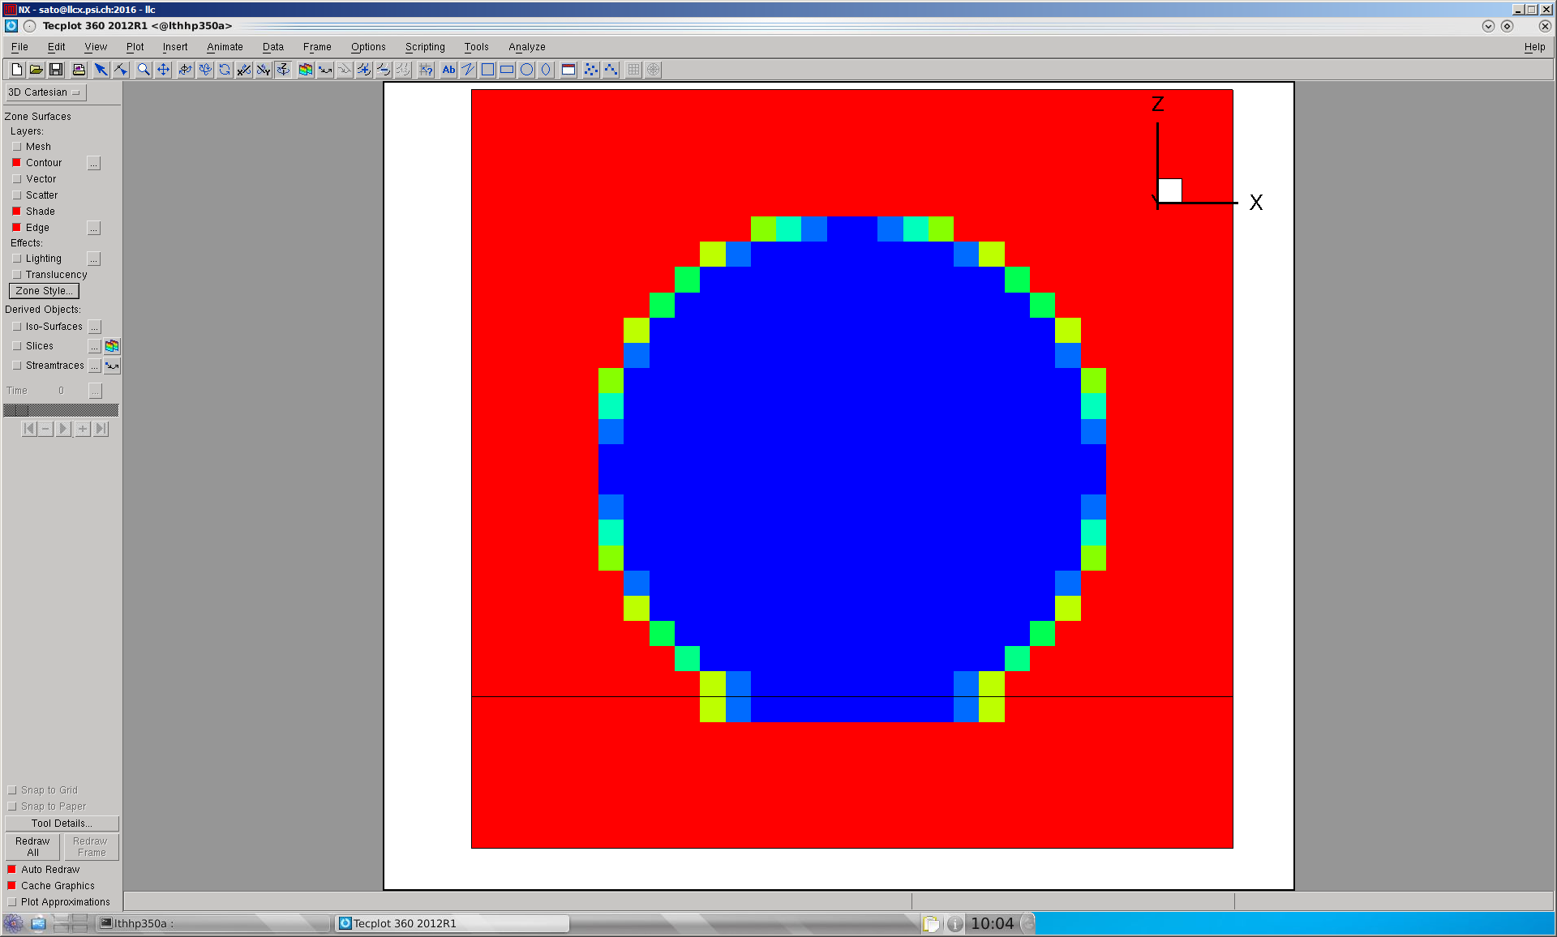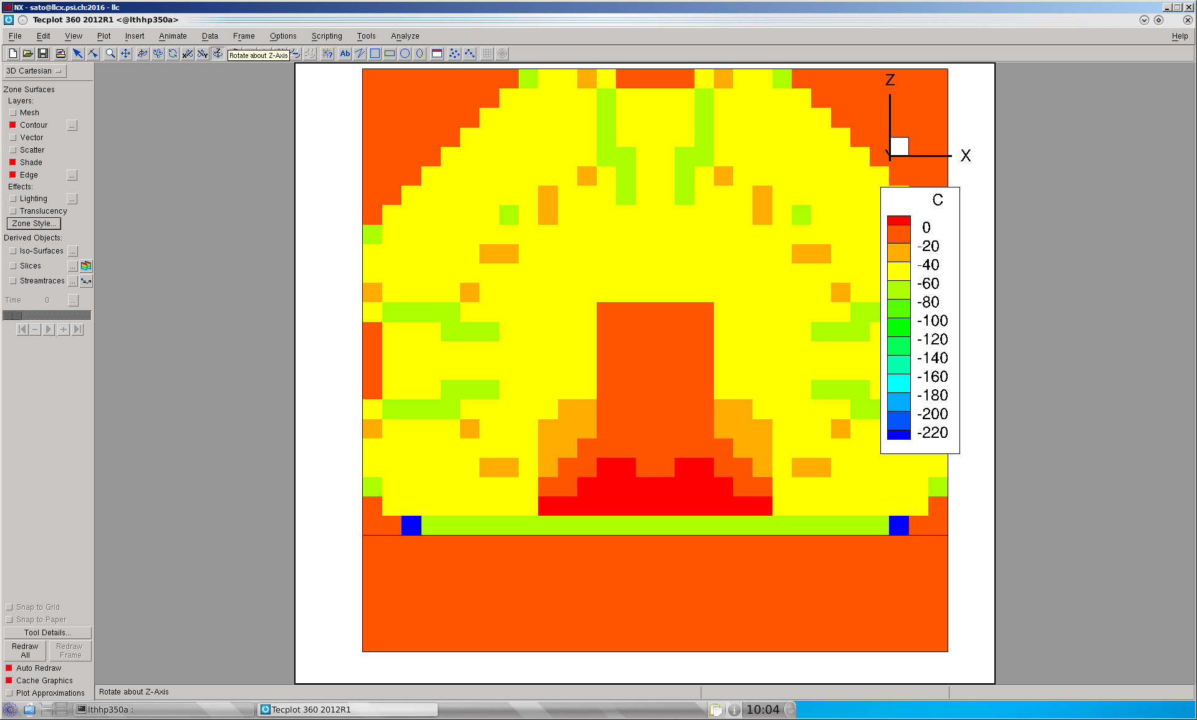

Bubble

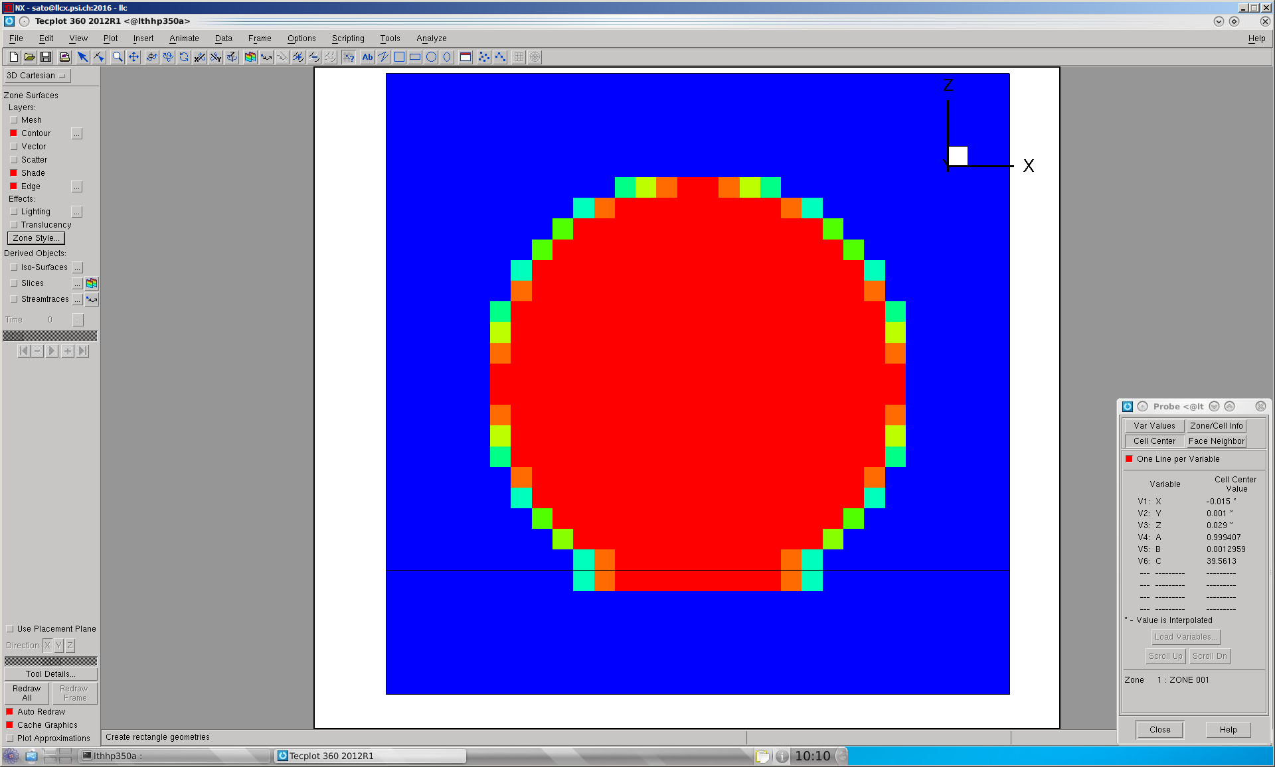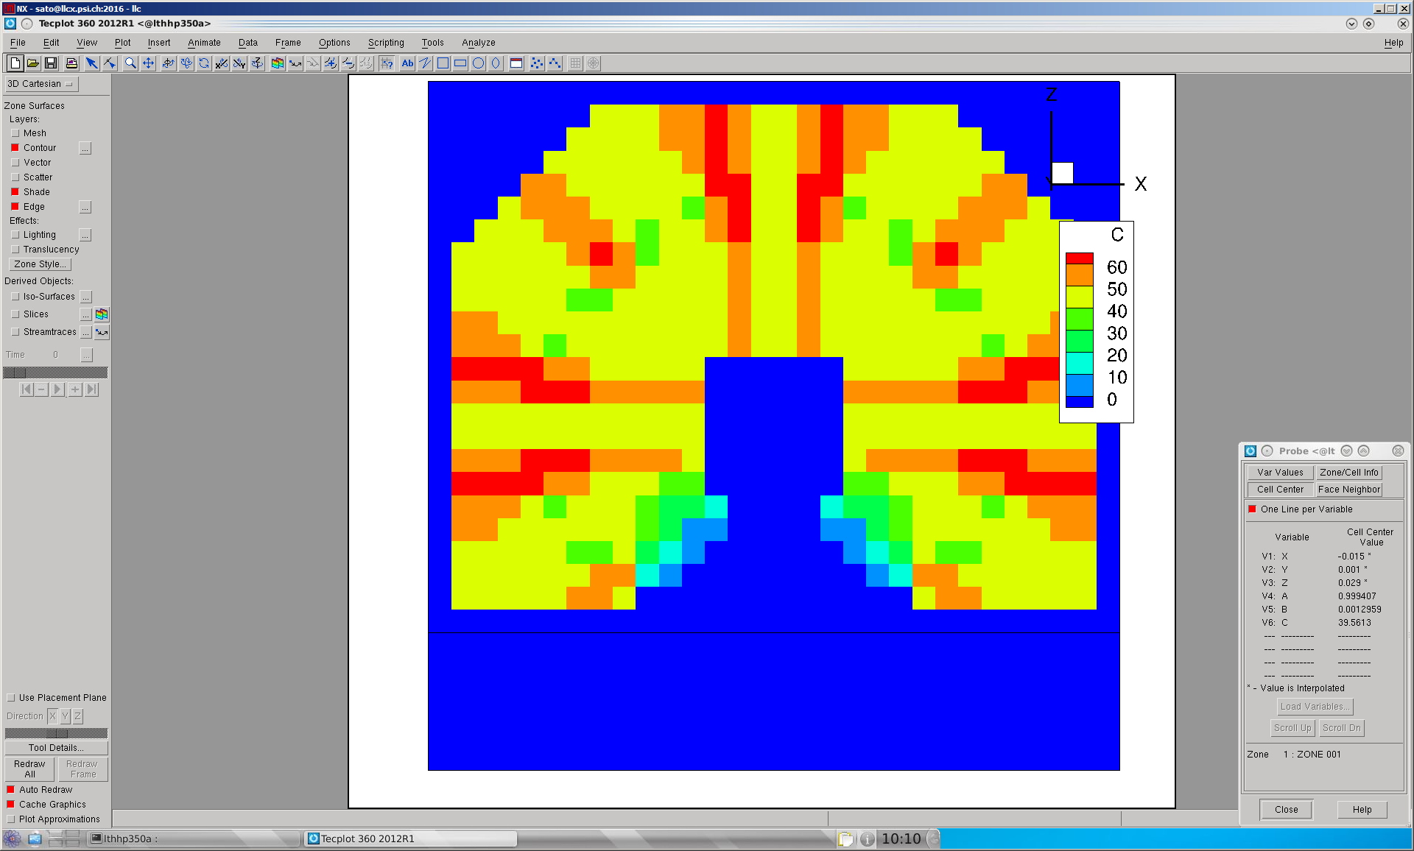

Droplet

If (i,j,k) is liquid and (i-1,j,k) is vapor; kappa is positive; p(i-1) < p(i); i_phase = 1

If (i,j,k) is liquid and (i-1,j,k) is vapor; kappa is negative; p(i-1) > p(i); i_phase = 1

If (i,j,k) is vapor and (i-1,j,k) is liquid; kappa is positive; p(i-1) > p(i); i_phase = -1

If (i,j,k) is vapor and (i-1,j,k) is liquid; kappa is negative; p(i-1) < p(i) ; i_phase = -1



If there is the liquid-vapor interface in the west direction:



If (i,j,k) is liquid and (i+1,j,k) is vapor; kappa is positive; p(i) > p(i+1)

If (i,j,k) is liquid and (i+1,j,k) is vapor; kappa is negative; p(i) < p(i+1)

If (i,j,k) is vapor and (i+1,j,k) is liquid; kappa is positive; p(i) < p(i+1)

If (i,j,k) is vapor and (i+1,j,k) is liquid; kappa is negative; p(i) > p(i+1)

