Test code: randomflow-inlet

# Outline

The main function “main.cpp” demonstrates how to introduce random flow as inlet boundary condition.

# Condition of simulation

The flow condition is as follows:

- Single phase flow

- Inlet velocity: Random flow generator

- Turbulent flow : Smagorinsky model

The random flow generator is based on the reference: A. Li, G. Ahmadi, R.G. Bayer, M.A. Gaynes, Aerosol particle deposition in an obstructed turbulent duct flow, Journal of Aerosol Science, 25 (1994) 91-112.

The boundary condition is illustrated in Fig. 1.



Fig. : Boundary condition

# Variables

|  |  |  |  |
| --- | --- | --- | --- |
| Variable | Form | Description | Unit |
| vel_ave | real | average velocity | m/s |
| tl | real | turbulent length scale | m |
| tt | real | turbulent time scale | s |
| copy_plane | real ** | Array used for copying scalar variable |  |
| copy_planeVec | real *** | Array used for copying vector variable |  |

About the turbulent length and time scale, please read next.



# Results

Velocity field at time 9e-5 is shown in Fig. 2.

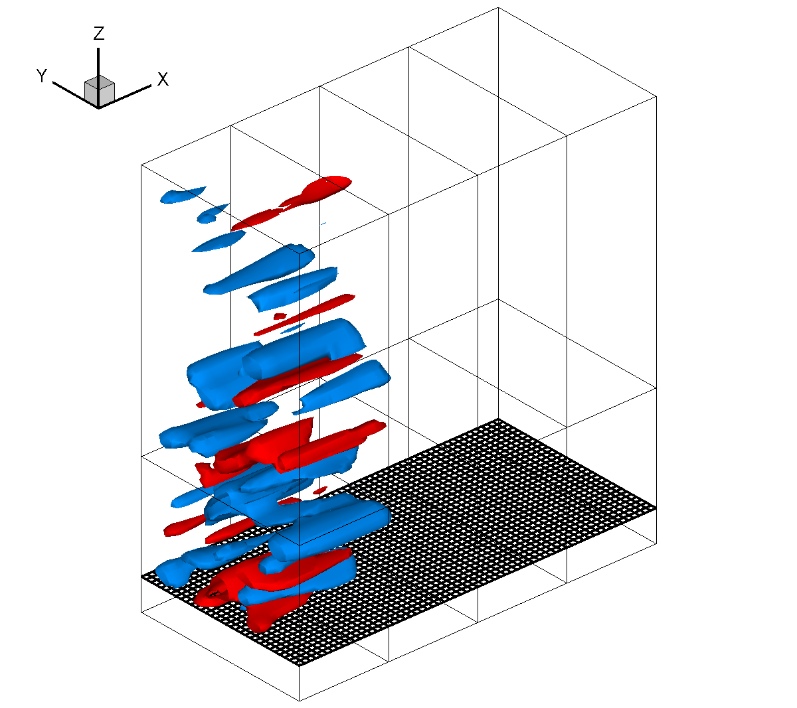 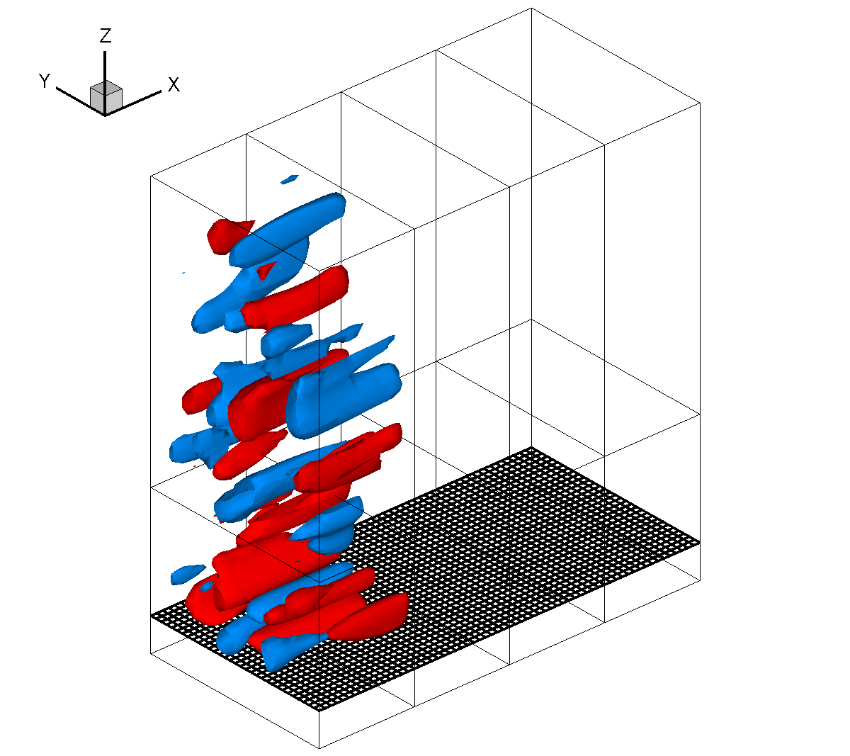

Fig. : Iso-surface of v (left) and w (right) at -0.3 and 0.3 m/s.