Sample code: two-domains-velocity

# Outline

The main function “main.cpp” demonstrates how to connect multiple domains. The two domains are connected via special boundary conditions, bnd_extract and bnd_insert.

# Condition of simulation

The flow condition is as follows:

- Two-phase flow: CIP-CSL2 is used.

- Turbulent flow : WALE model is used.

- Temperature: Temperature at liquid-vapor interface is assumed to be saturation temperature.

In the first domain “dom_1”, flow current is driven by a prescribed pressure drop. The objective of computing “dom_1” is to obtain a fully developed flow, which will be used for “dom_2” as a inlet boundary condition. The boundary condition is illustrated in Fig. 1.

In the second domain “dom_2”, inlet velocity field is taken from “dom_1”. In this domain, phase change is computed. Note that phase change cannot be taken into account in “dom_1”, because of the usage of the periodic boundary condition.

The initial condition is shown in Fig. 2. Wavy liquid-vapor interface is introduced in dom_1 to visualize the wave propagation, while flat interface is used in dom_2. The velocity field is set at zero.



Fig. : Boundary condition for velocity field.

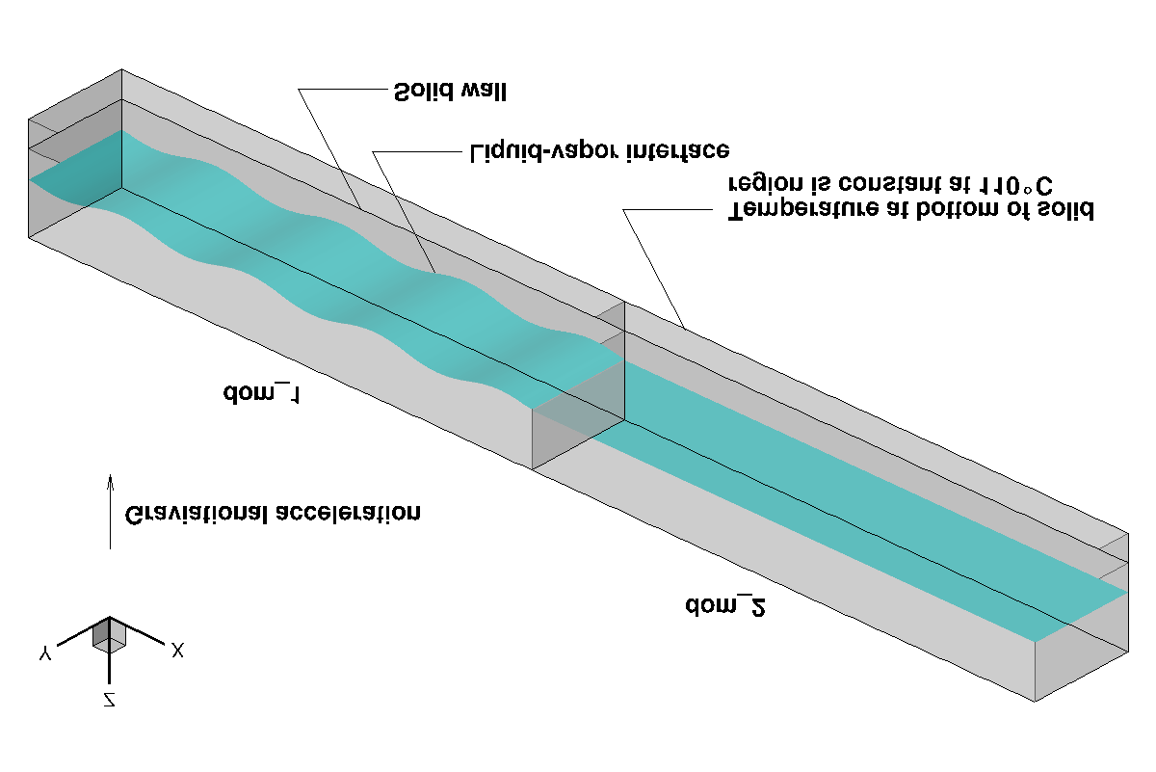

Fig. : Initial condition.

# Variables

|  |  |  |  |
| --- | --- | --- | --- |
| Variable | Form | Description | Unit |
| tsat | real | Saturation temperature | ˚C |
| dpdx | real | Prescribed pressure drop, | N/m3 |
| dom1, dom2 | Domain | Computational domain |  |
| wd_1, wd_2 | Scalar | Distance from wall in domain 1 and 2, respectively | m |
| mdot_2 | Scalar | Phase change rate | kg/m3s |
| copy_plane | real ** | Array used for copying scalar variable |  |
| copy_planeVec | real *** | Array used for copying vector variable |  |

# Results

Time evolution of wave elevation is shown in Fig. 3. The wave propagates from dom_1 to dom_2, whereas the wave elevation damps. The side view of the flow field is presented in Fig. 4.

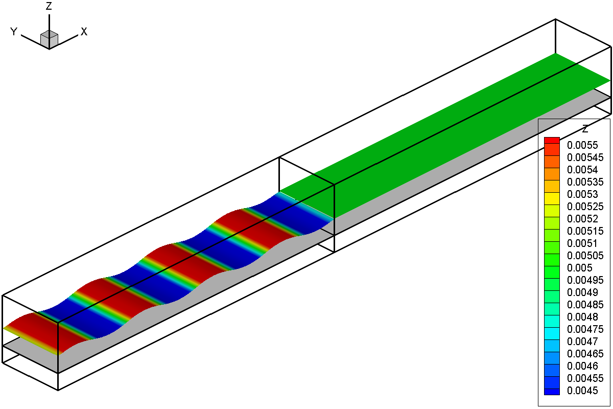

*t* = 0 *s*

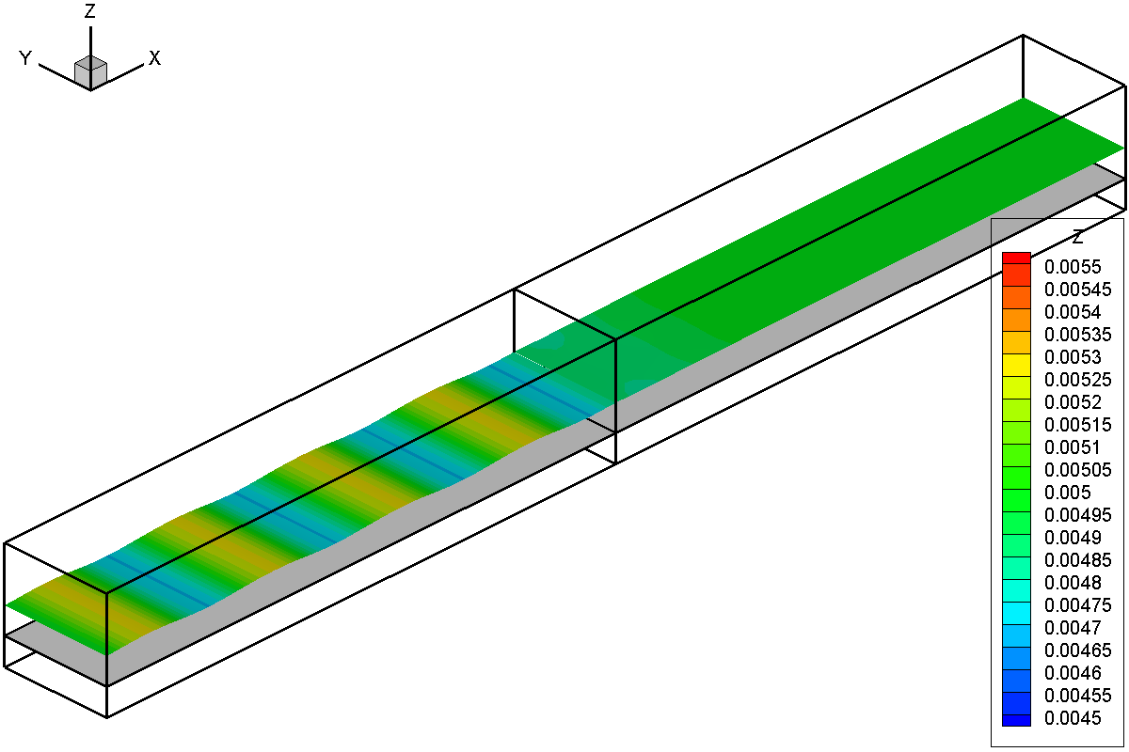

*t* = 0.02 *s*

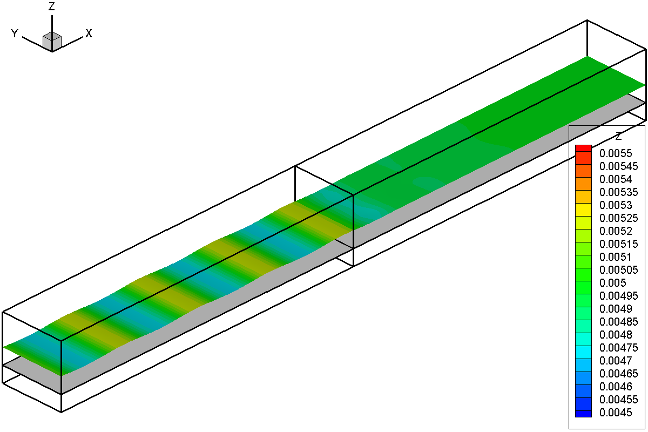

*t* = 0.04 *s*

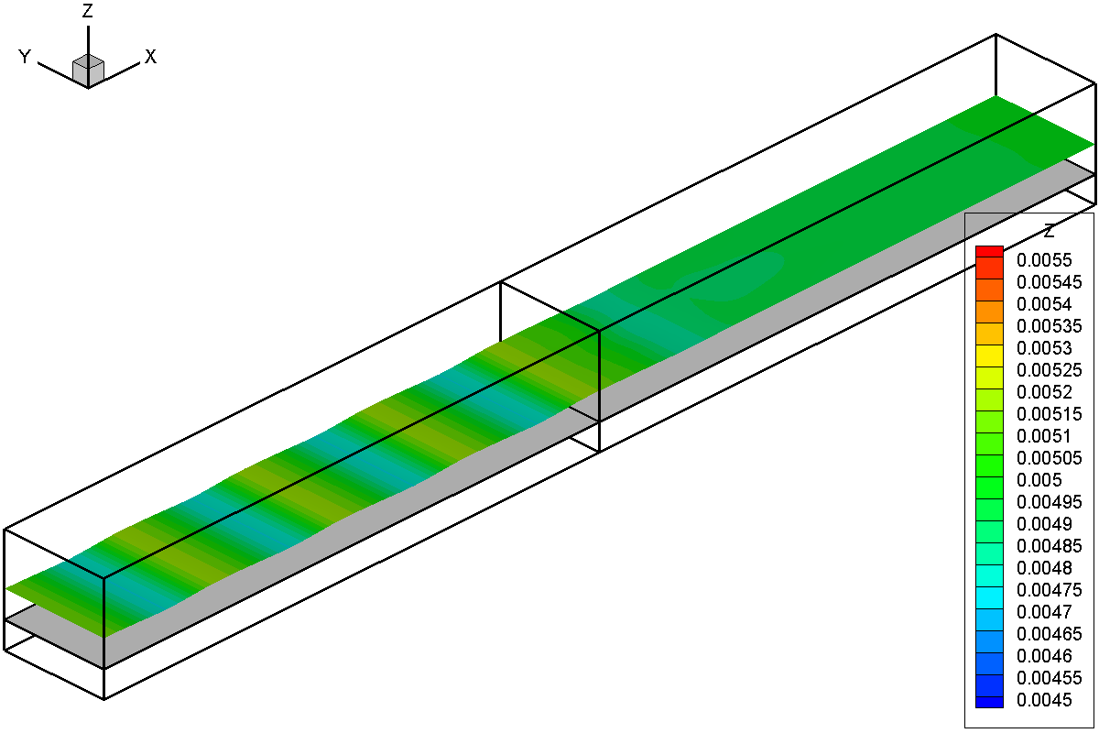

*t* = 0.06 *s*

Fig. : Evolution of wave elevation.

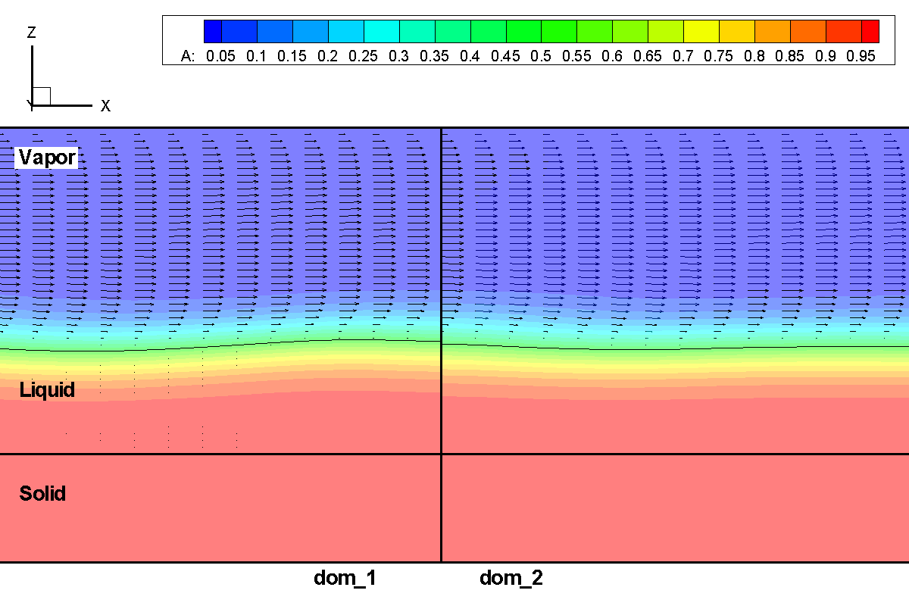

Fig. : Side view of flow field at t = 0.06 *s* around the connection between dom_1 and dom_2. The contour color is the color function.