100 time step

Without wall

CSF

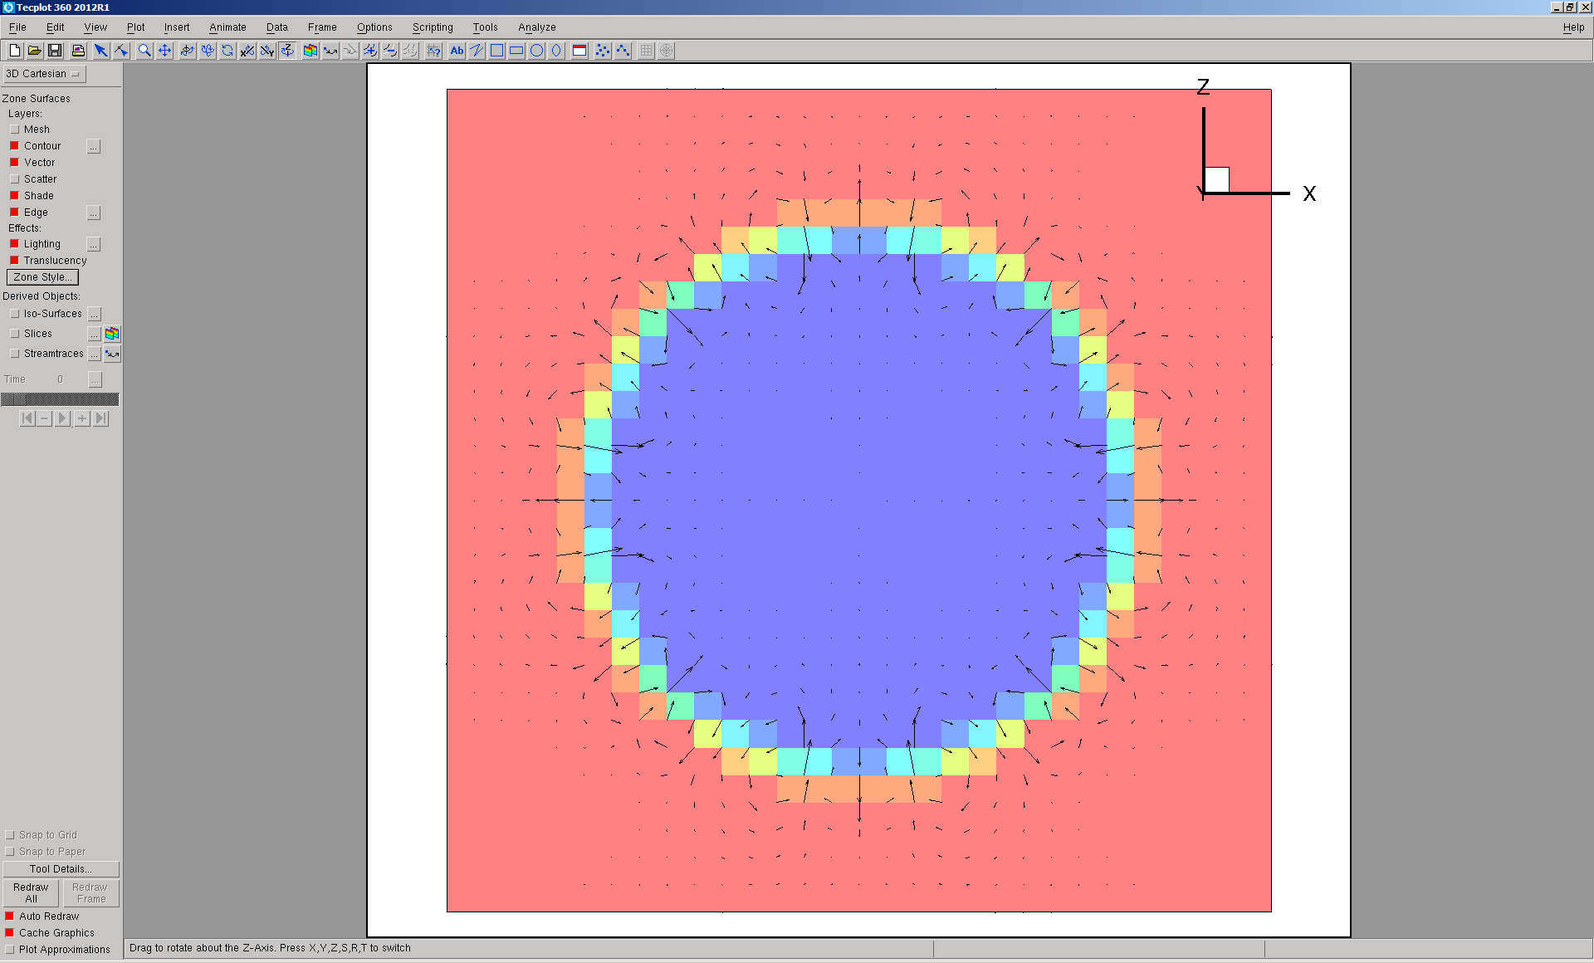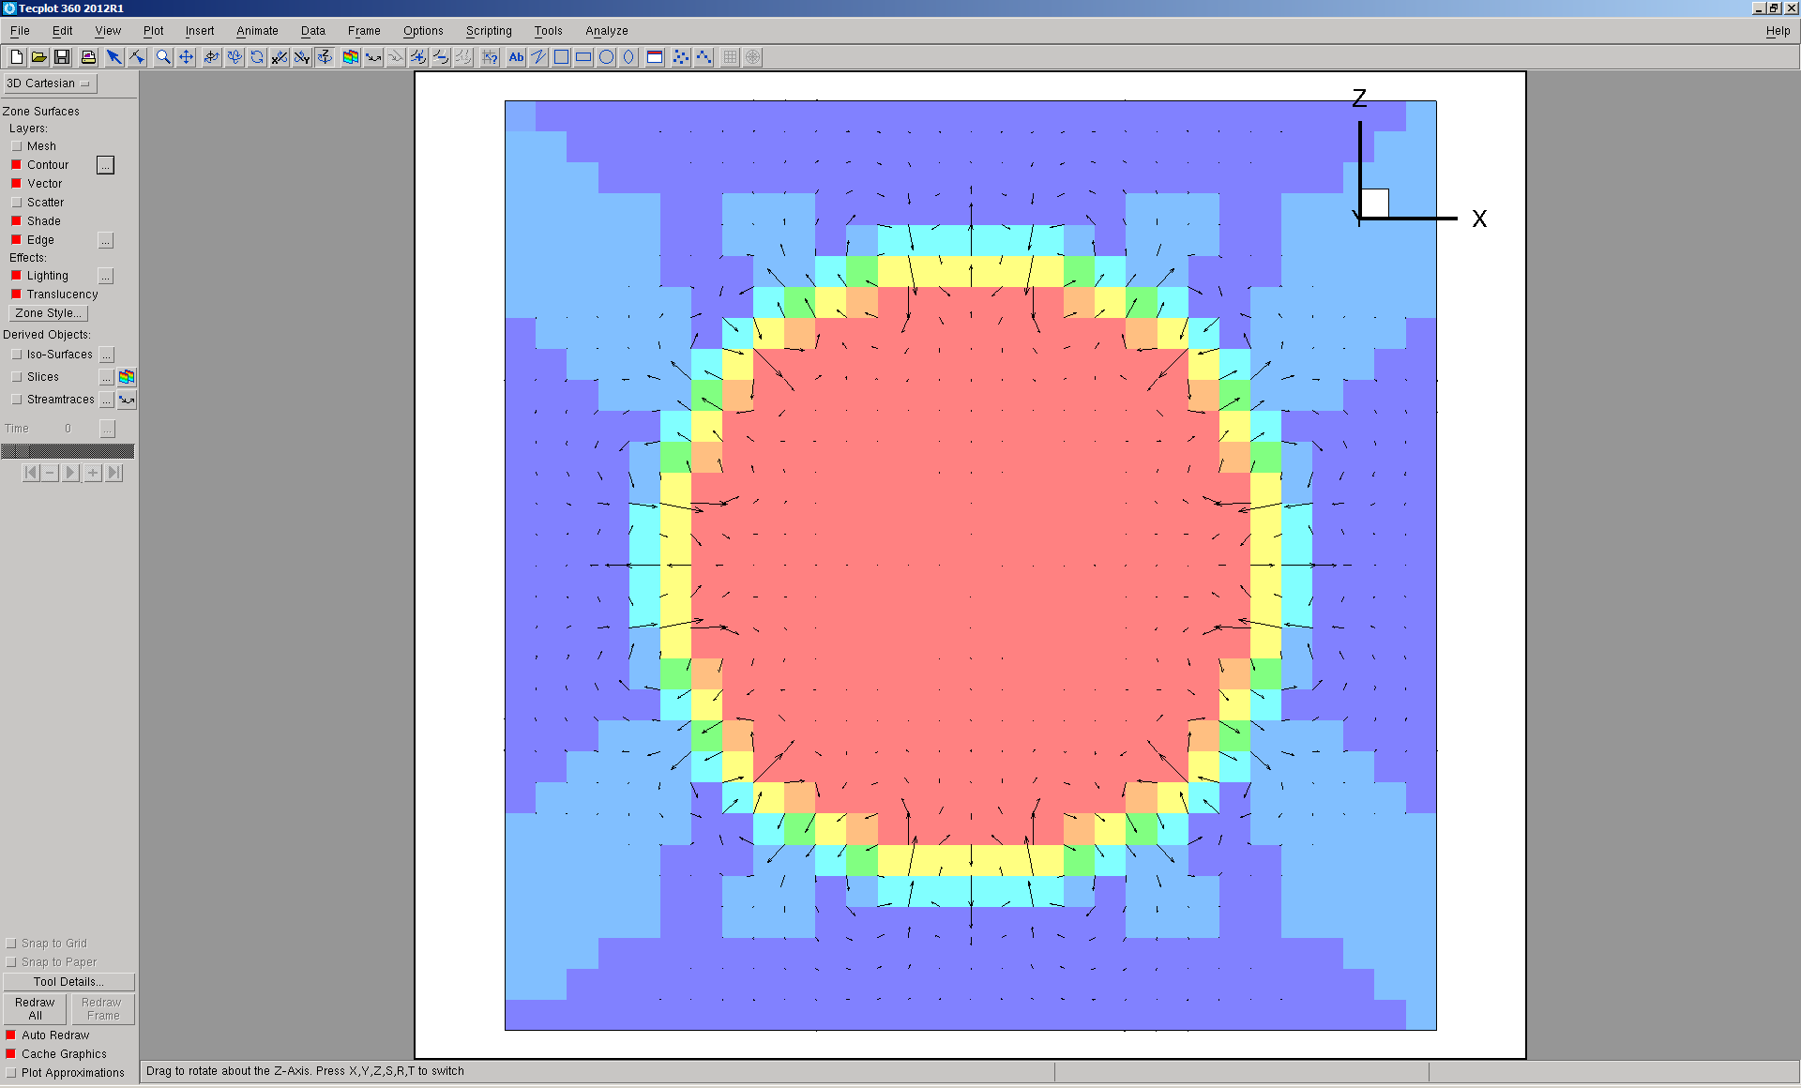

Color function Pressure

Umax=0.000785495

GFM

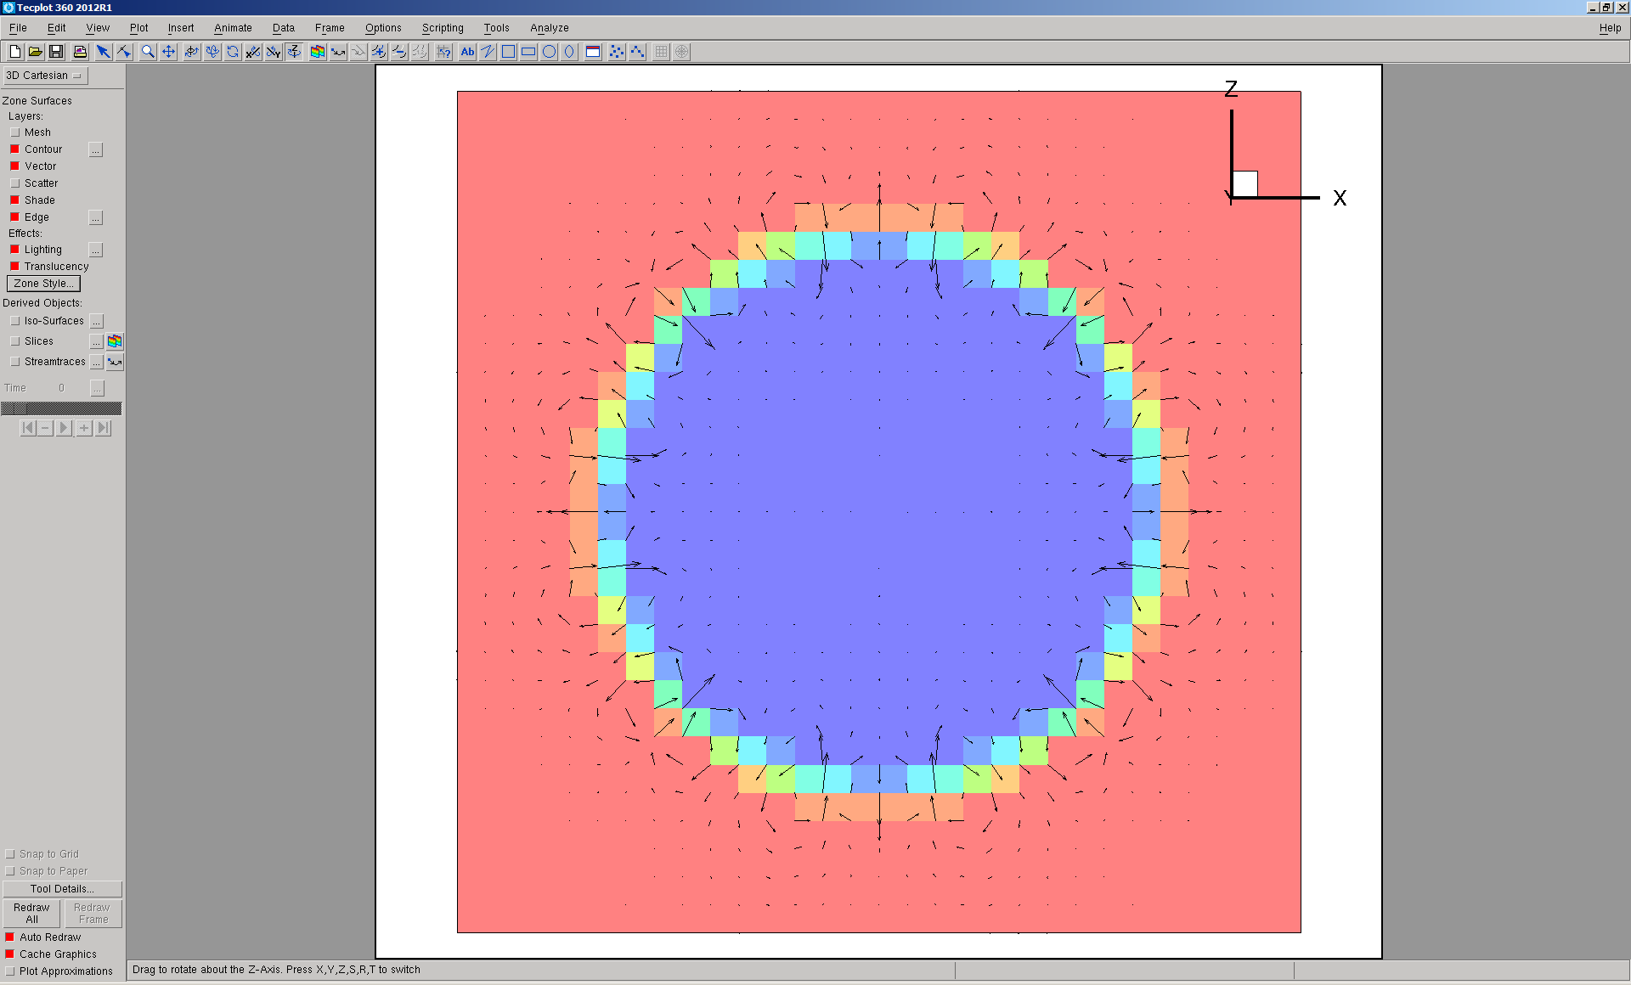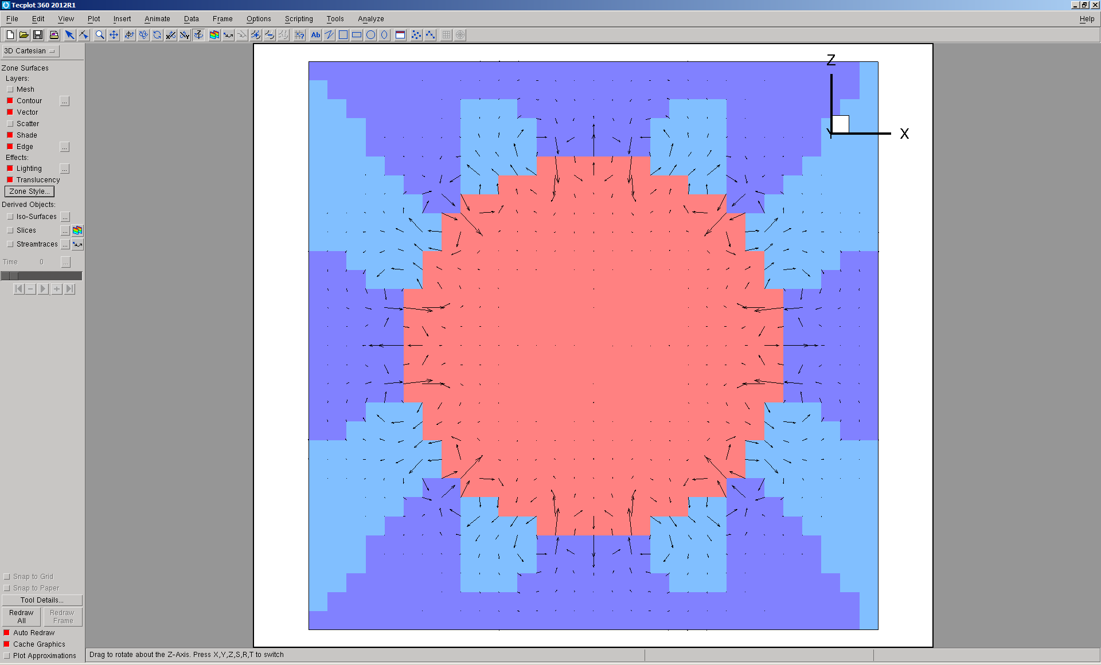

Color function Pressure

Umax = 0.000875163

With wall, Contact angle = 0 deg., 100 step

CSF

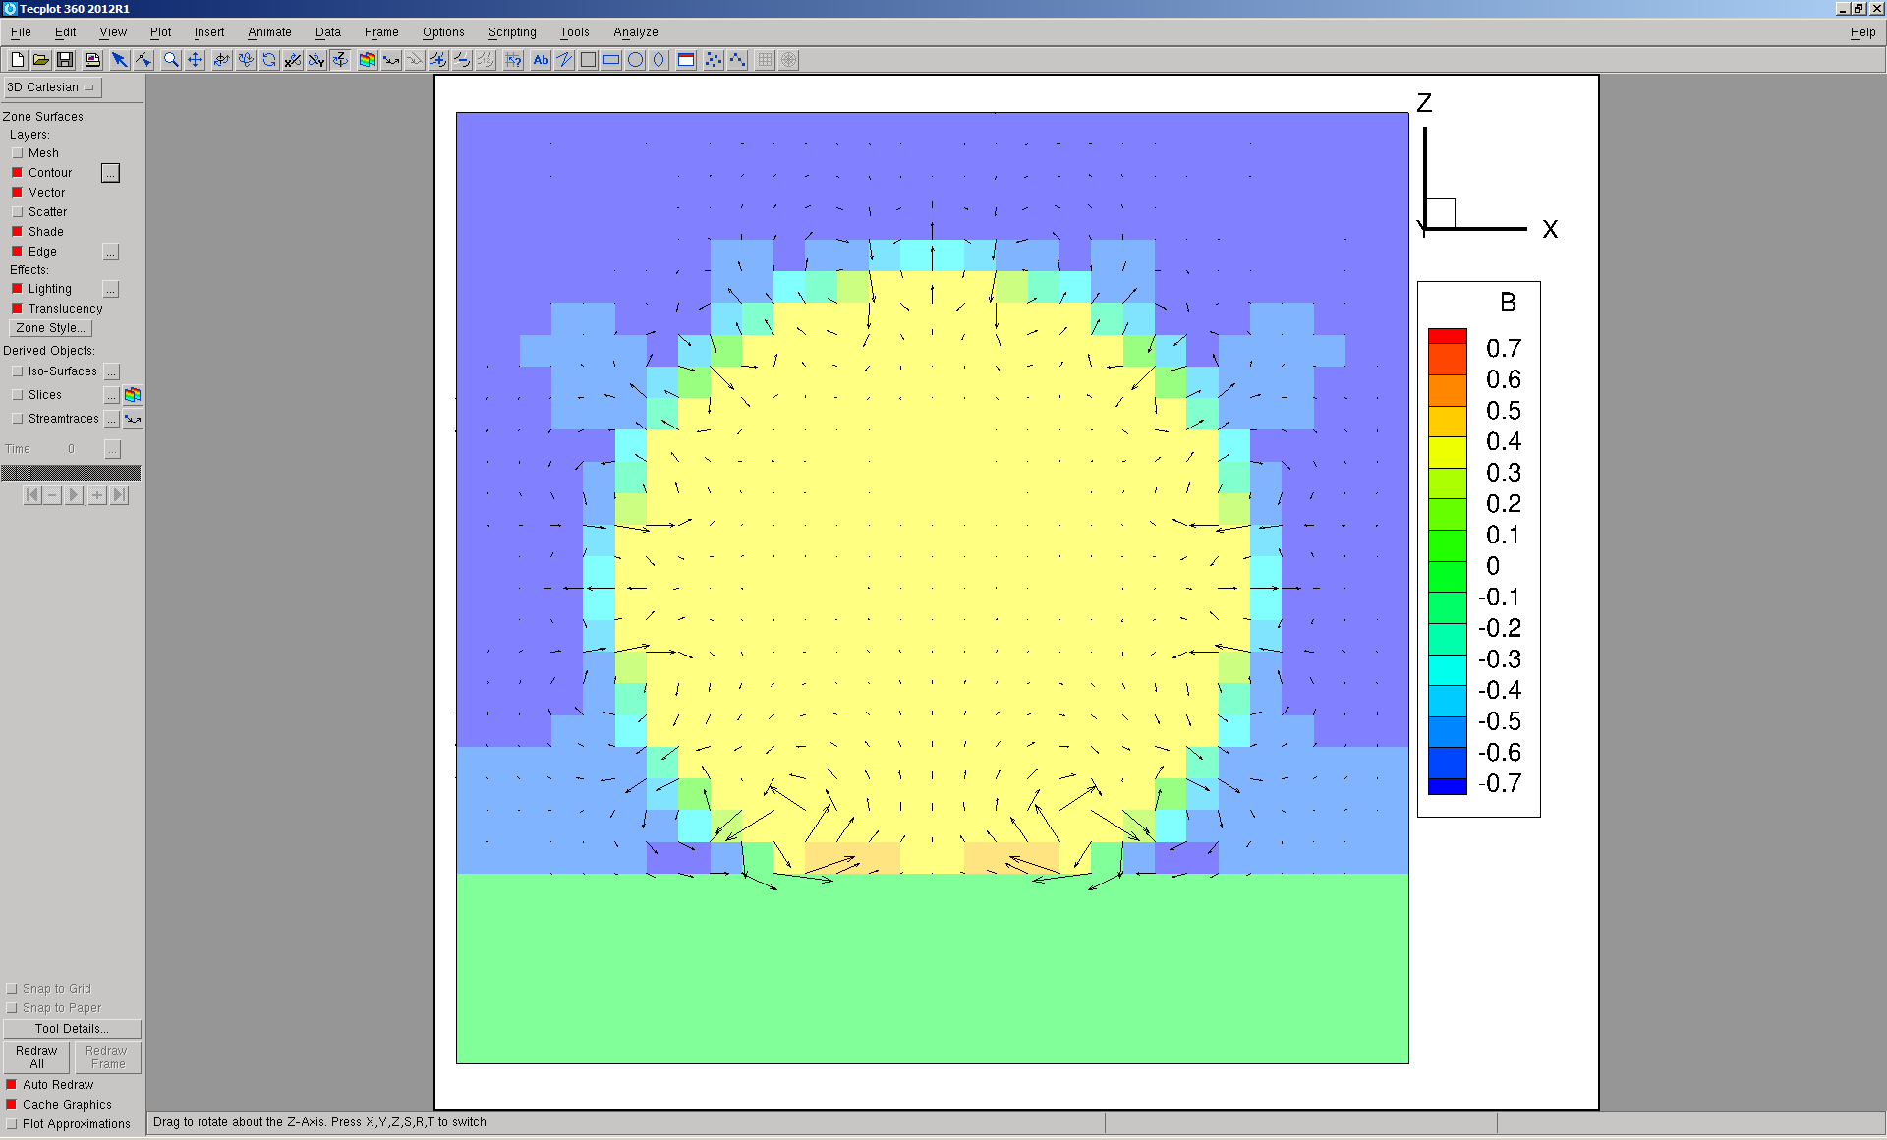Pressure distribution

Umax = 0.00241, Wmin=0.0020, Wmax = 0.00074

GFM

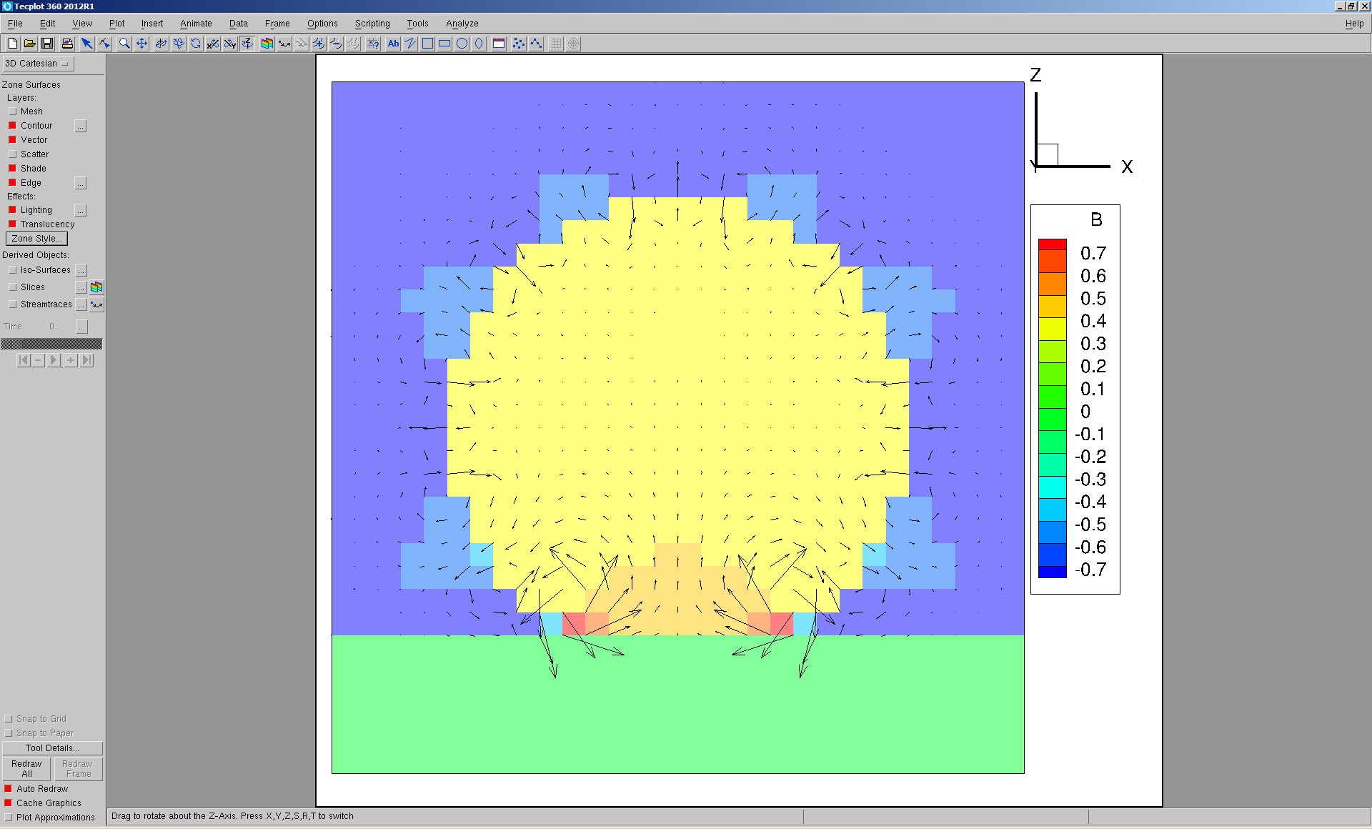 Pressure distribution

Umax = 0.00402, Wmin=-0.0048, Wmax=0.00220

With wall, Contact angle = 0 deg., 3000 step

CSF

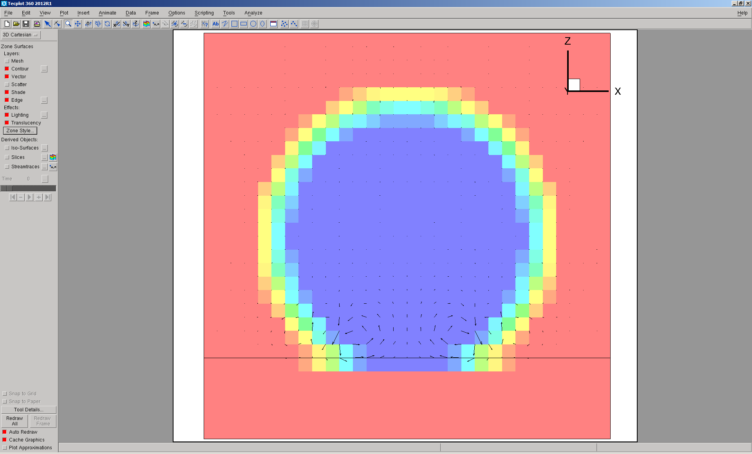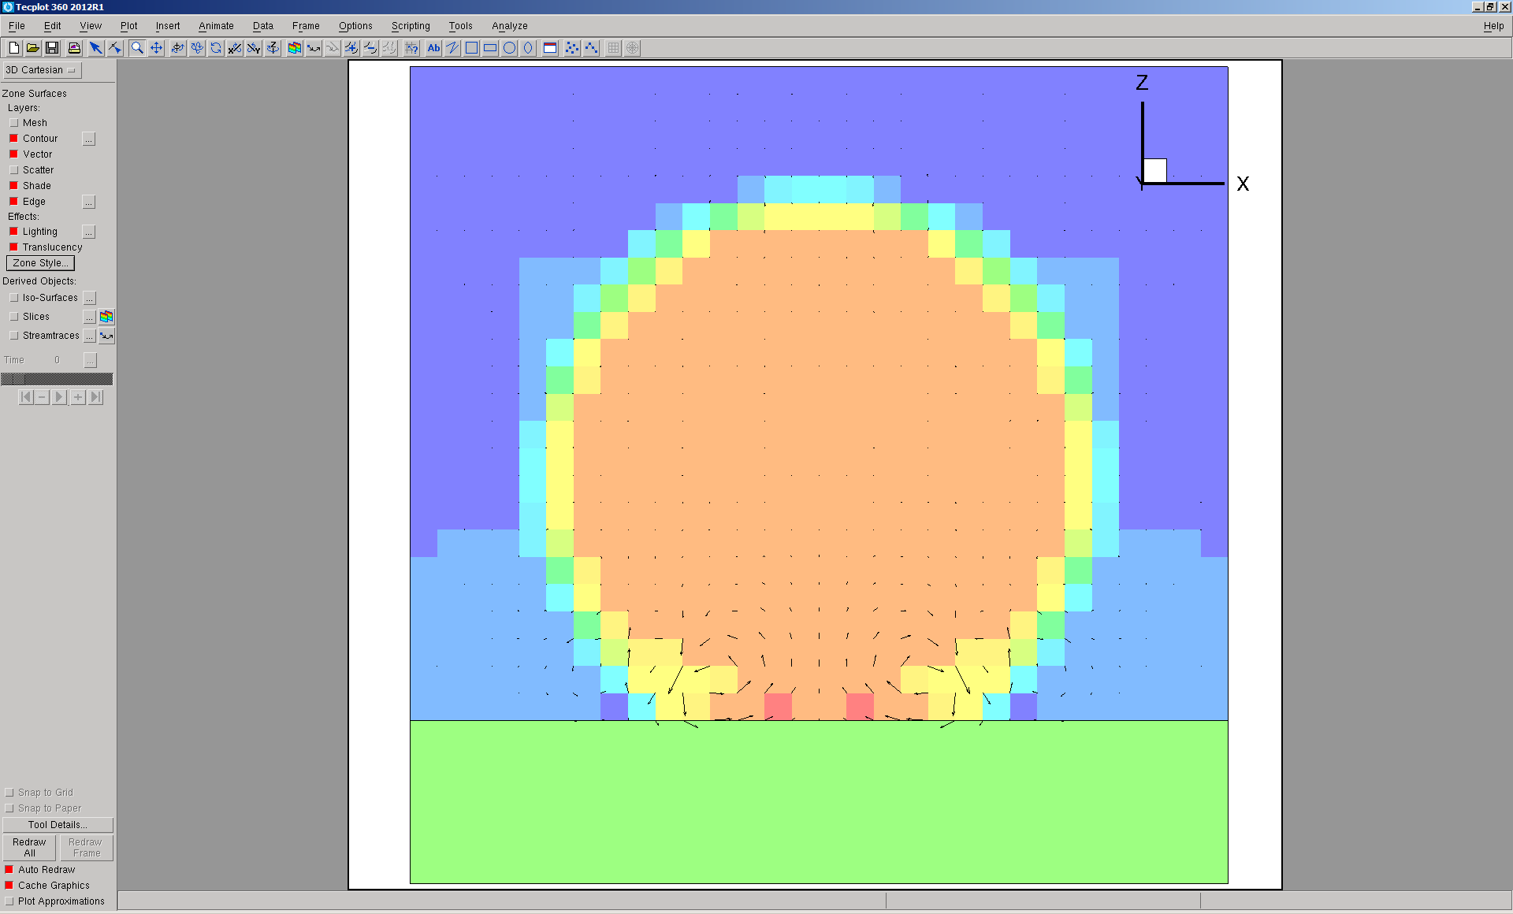

GFM, diverges at 3820

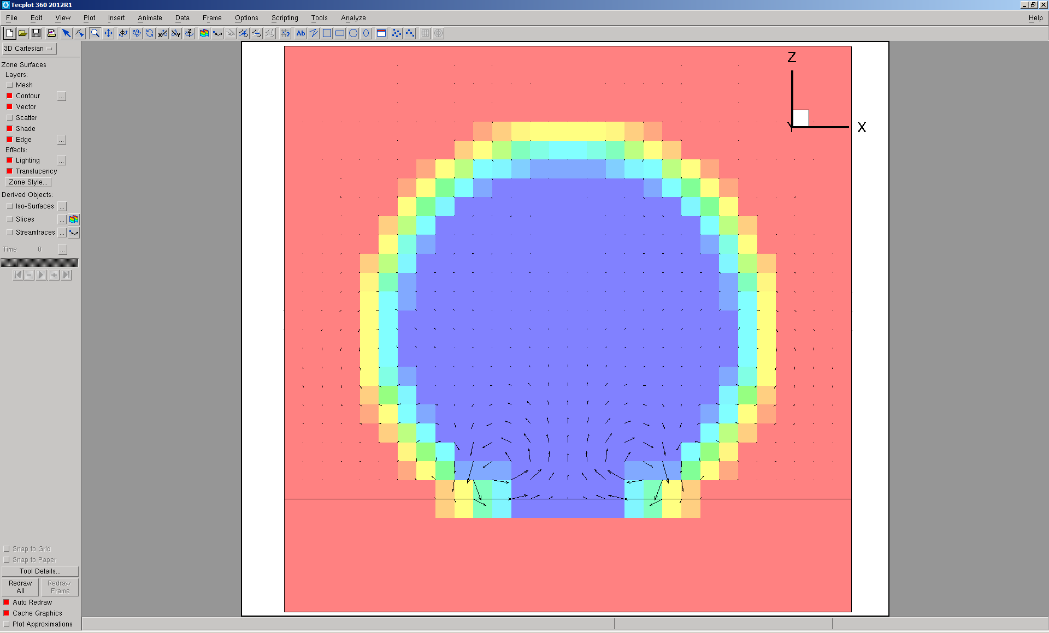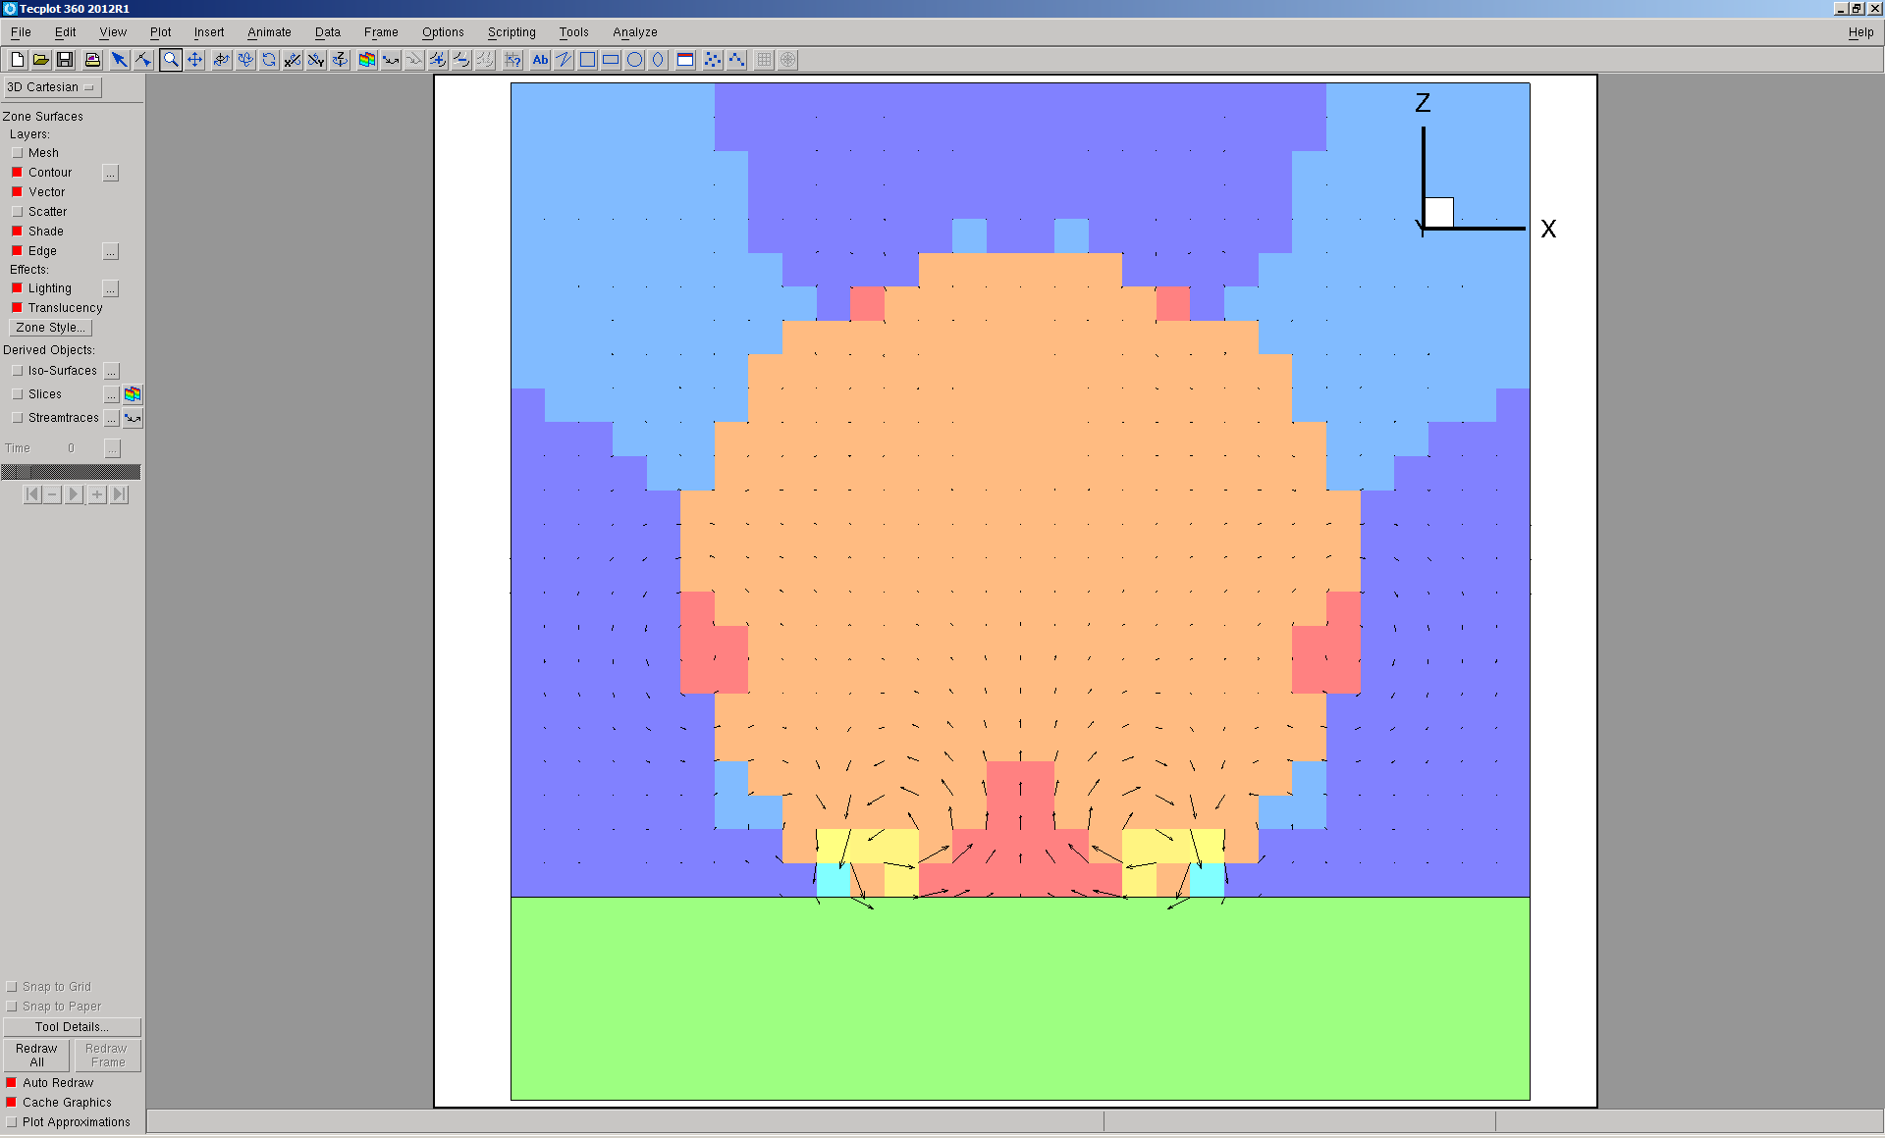

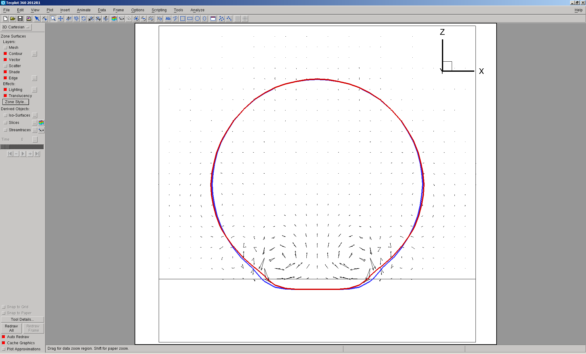

Comparison of bubble shape: CSF blue, GFM red

With wall, Contact angle = 0 deg., 10000 step

Divergence can be avoided, **when multi-grid is not used for both CSF and GFM**.

CSF

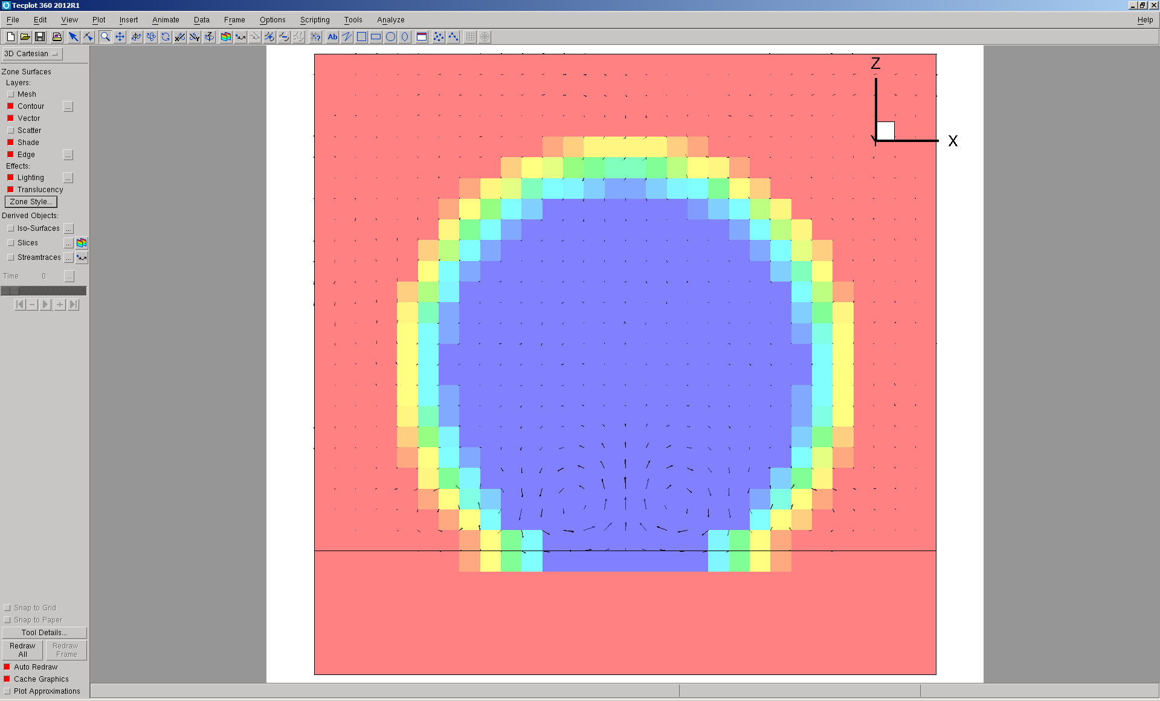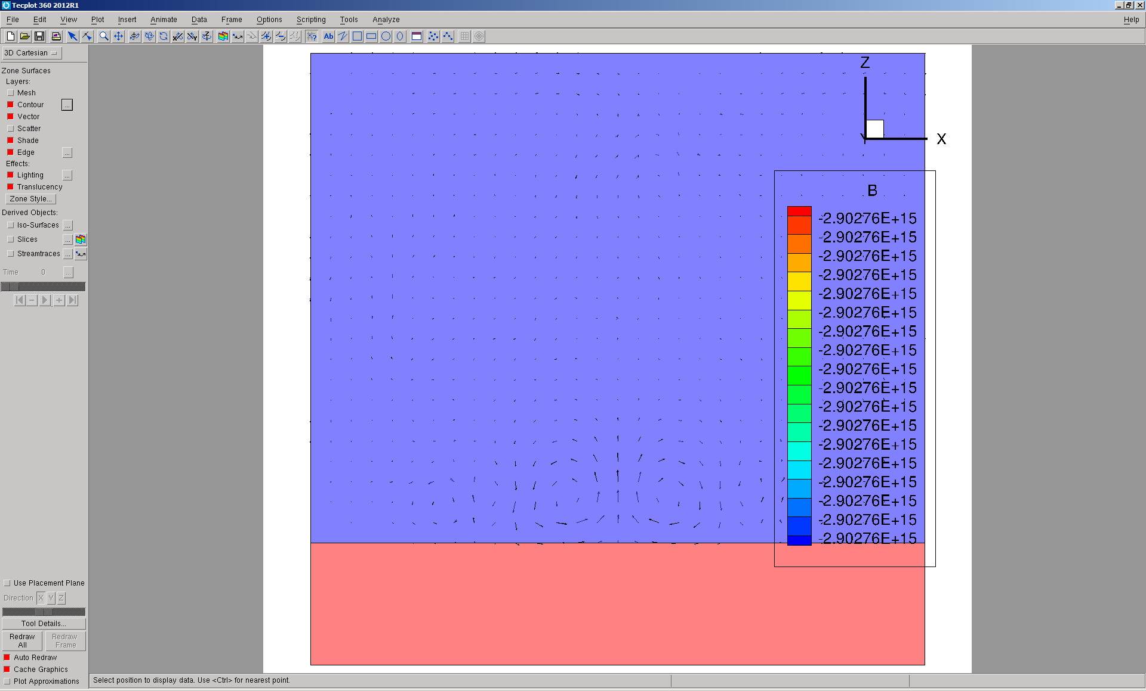

Umax=0.015

GFM

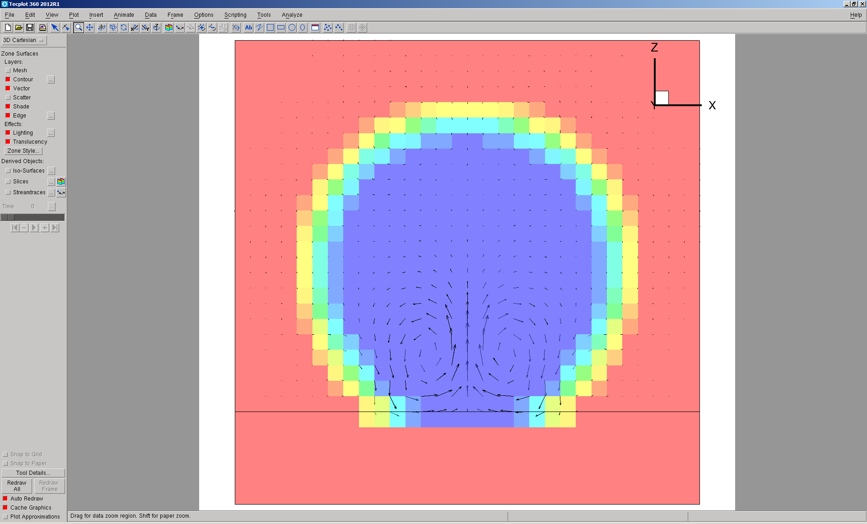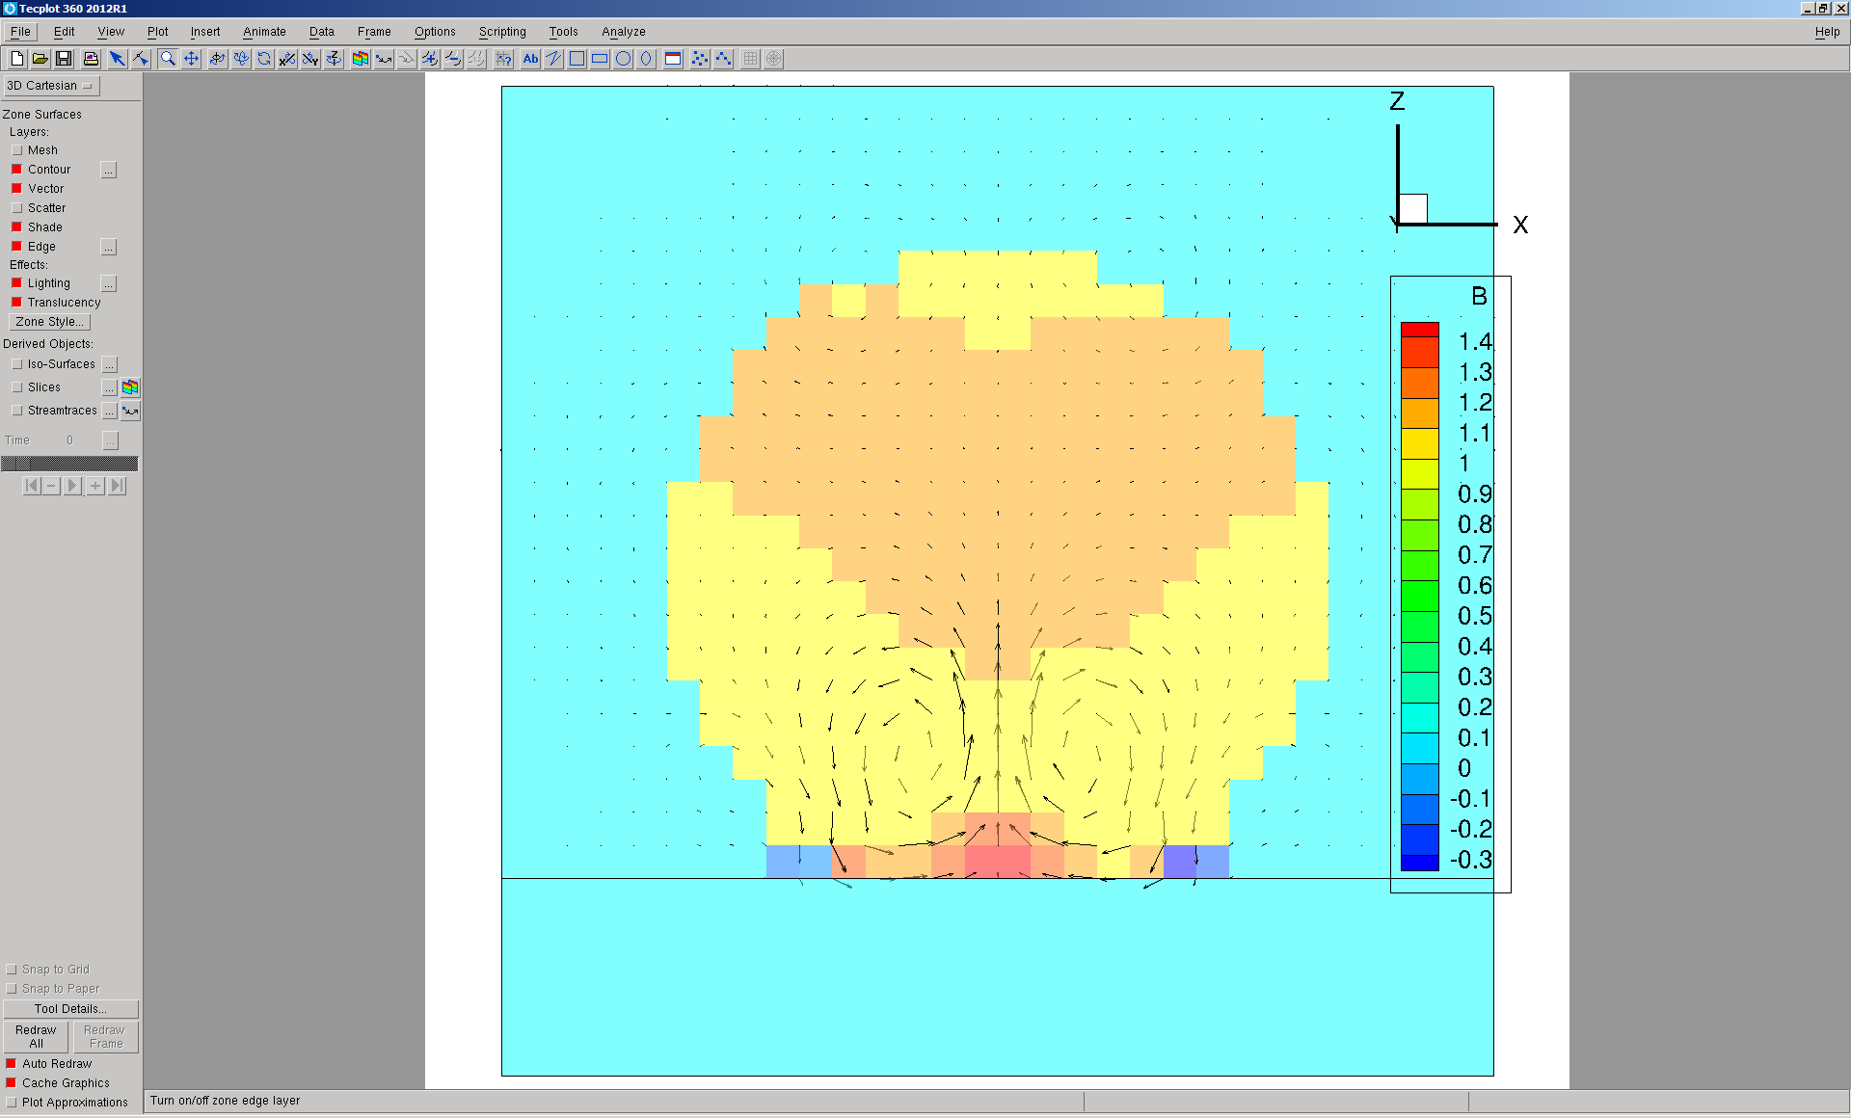

Umax=0.037

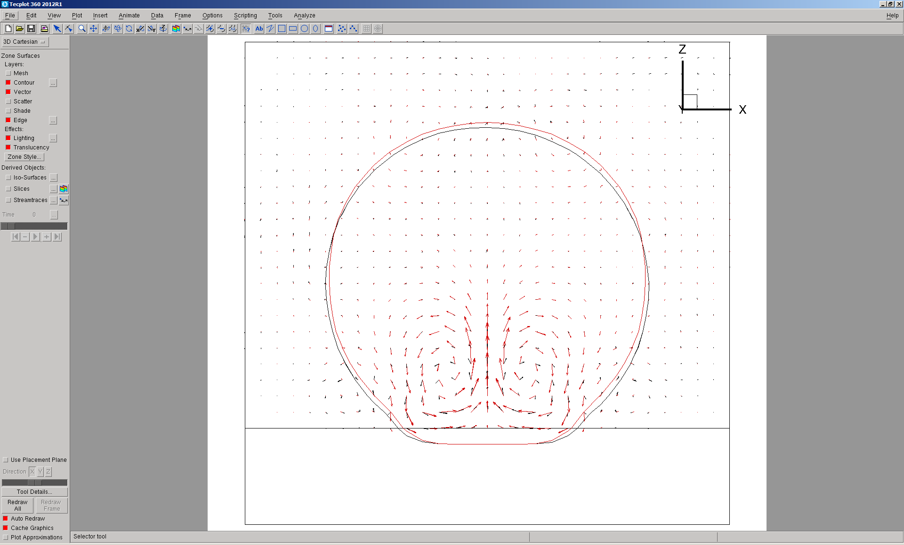

With wall, Contact angle = 0 deg., 10000 step, with middle dt.

dt = 0.1*pow(air.rho()->value()*pow(dxmin,3.0)/(2.0*3.1415*mixed.sigma()->value()),0.5)

Divergence can be avoided, **when multi-grid is not used for both CSF and GFM**.

CSF

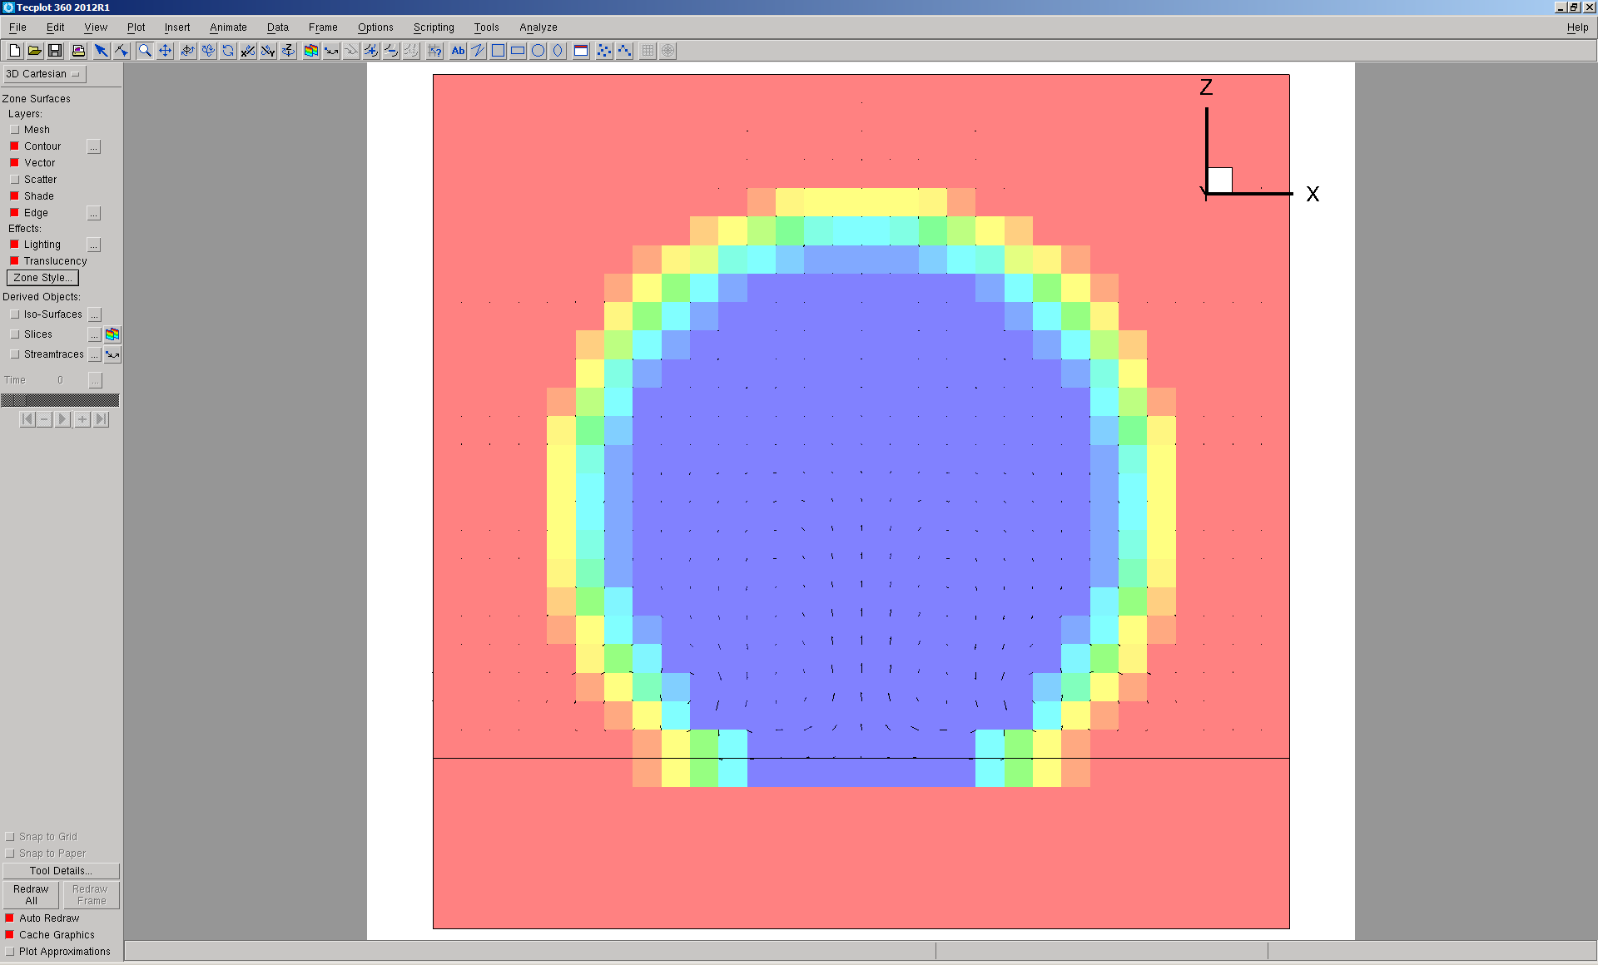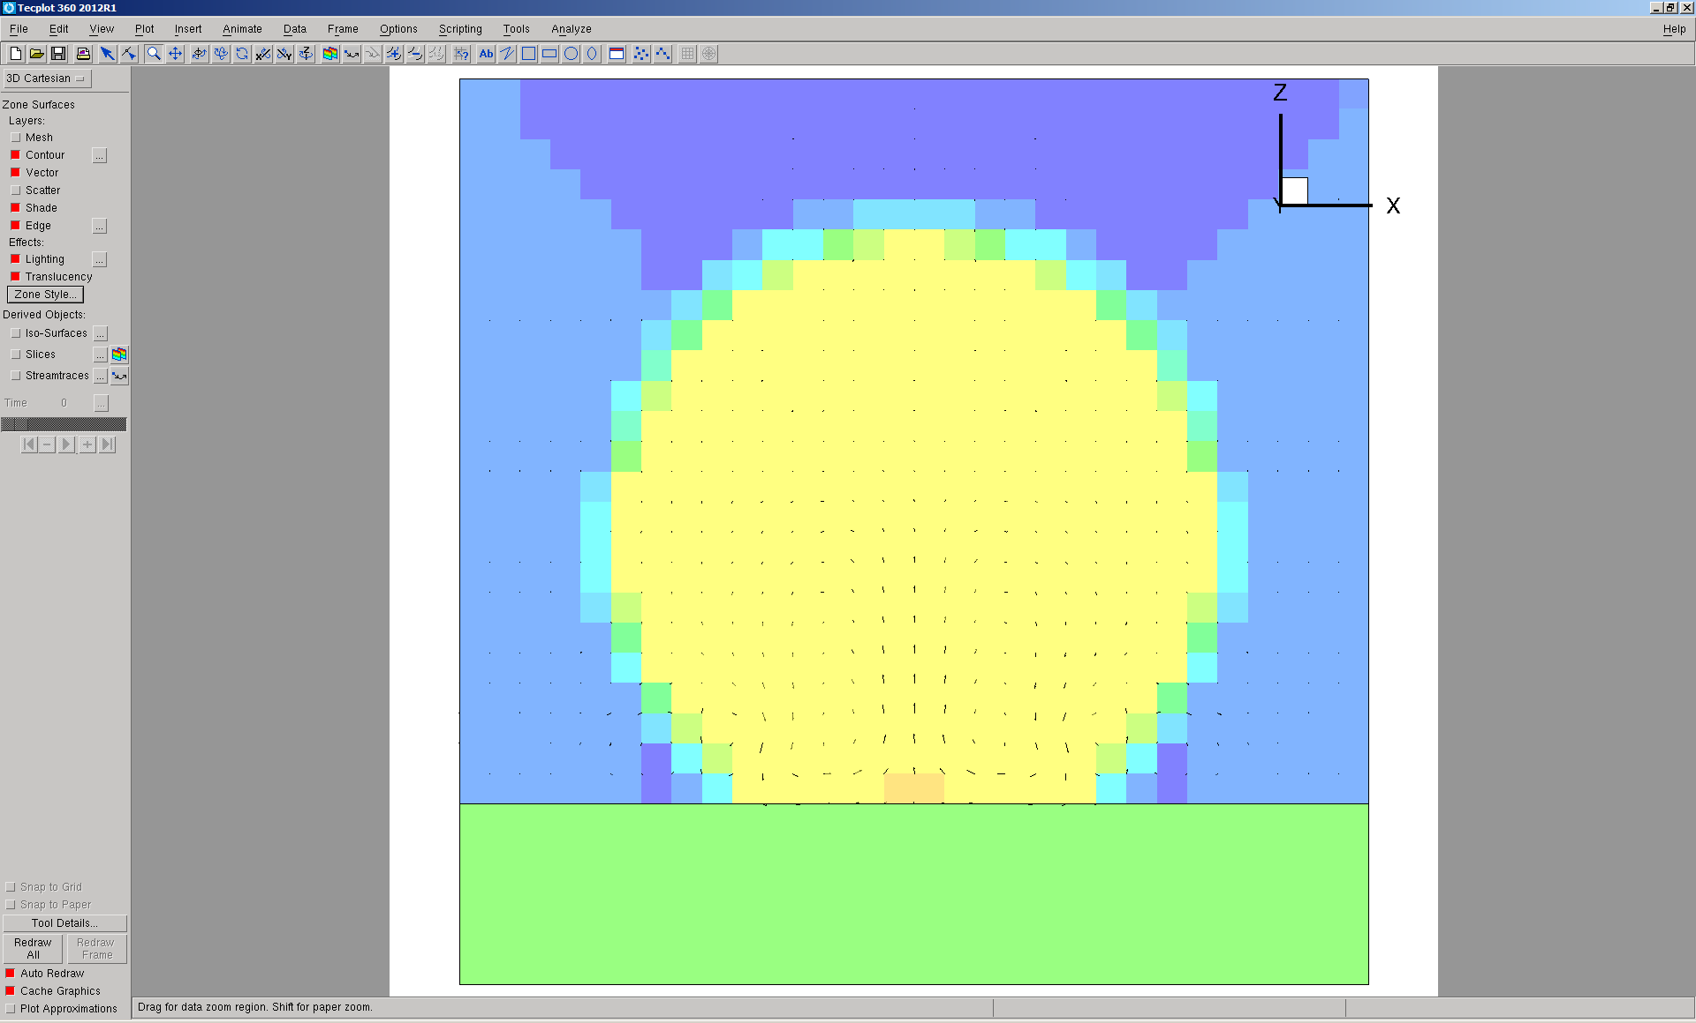

GFM

