Discretization of pressure Poisson equation for Ghost Fluid Method

Introduce boundary condition
If there is the liquid-vapor interface in the west direction:

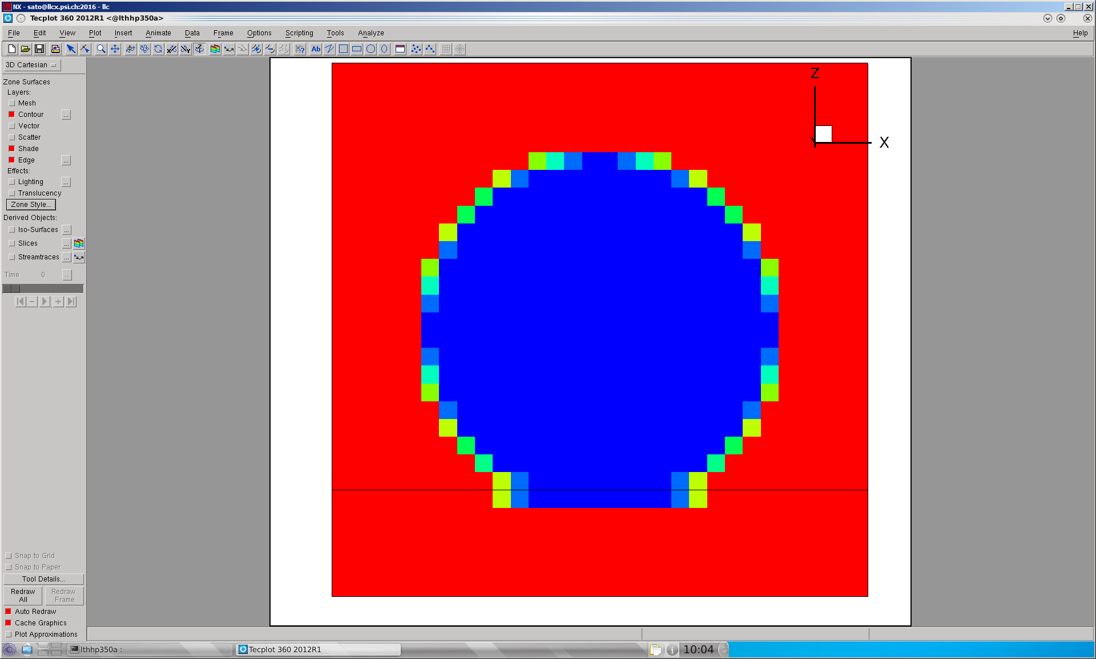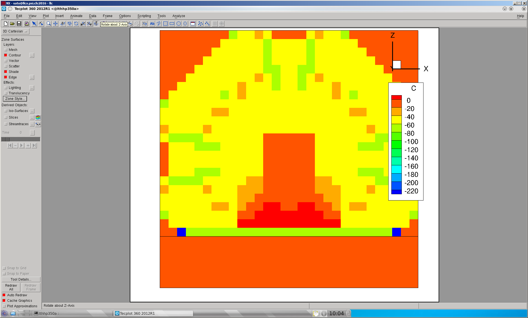
Bubble
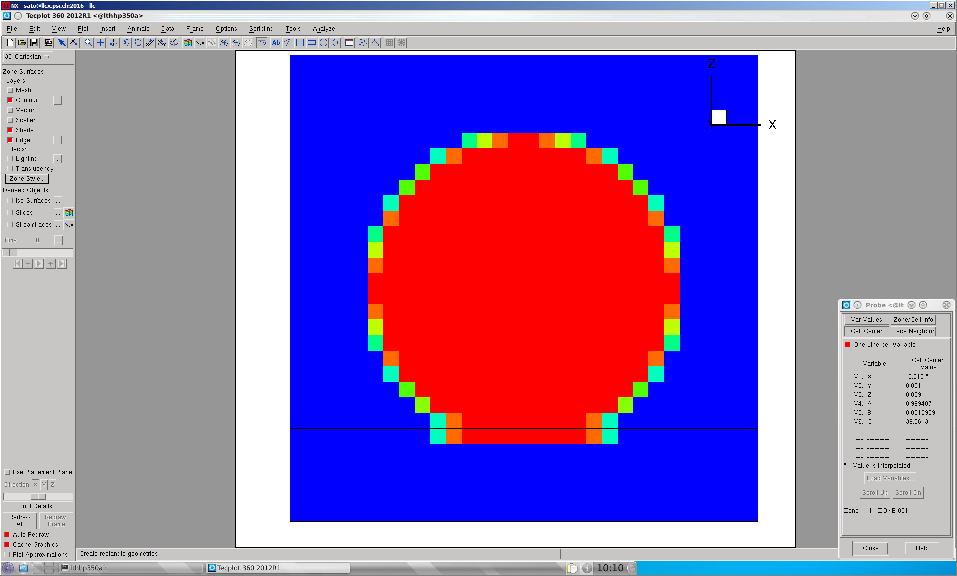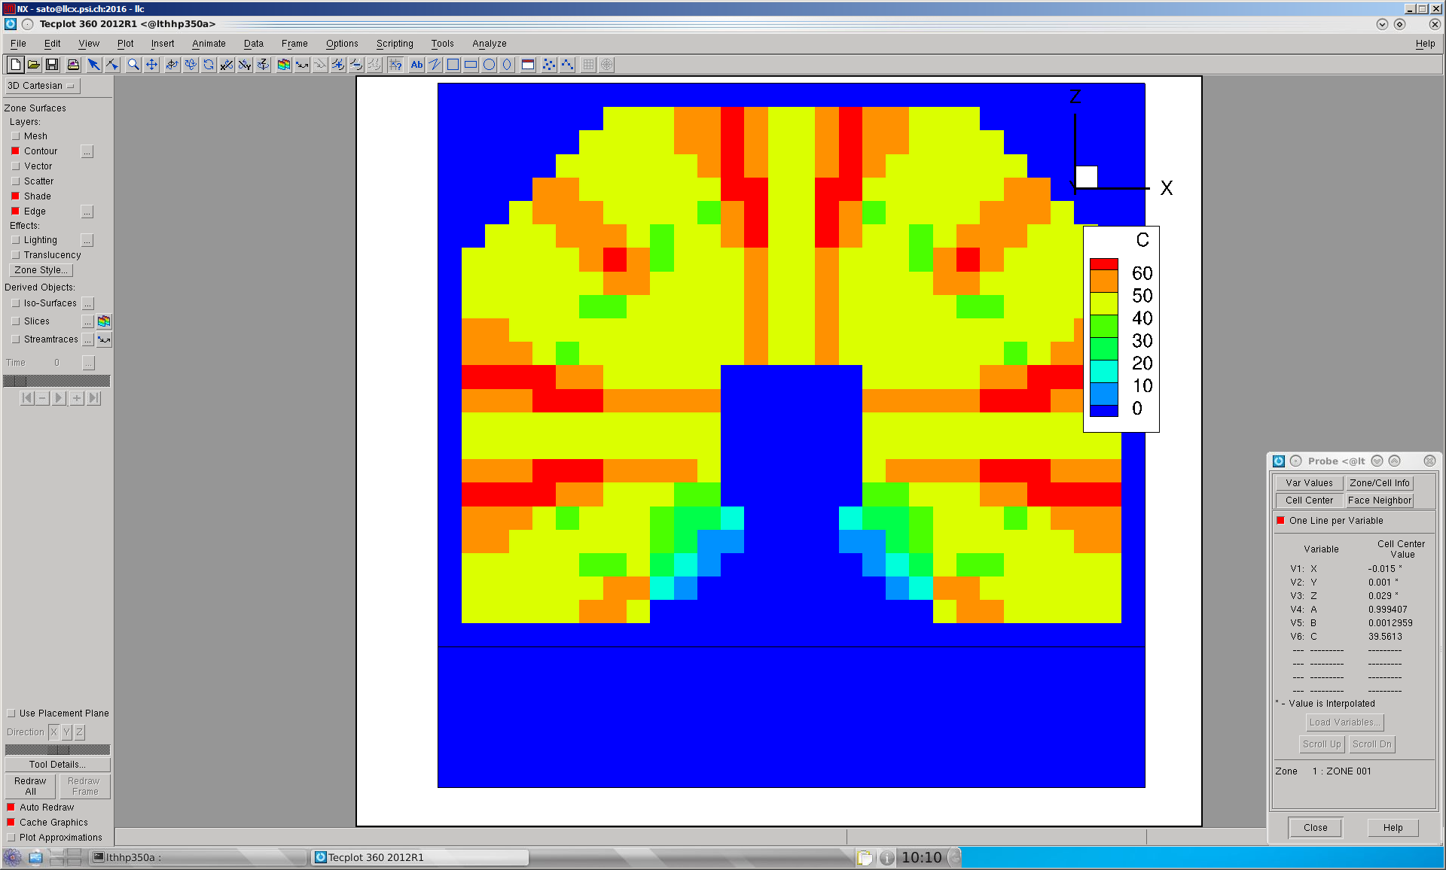
Droplet

If (i,j,k) is liquid and (i-1,j,k) is vapor; kappa is positive; p(i-1) < p(i); i_phase = 1
If (i,j,k) is liquid and (i-1,j,k) is vapor; kappa is negative; p(i-1) > p(i); i_phase = 1

If (i,j,k) is vapor and (i-1,j,k) is liquid; kappa is positive; p(i-1) > p(i); i_phase = -1
If (i,j,k) is vapor and (i-1,j,k) is liquid; kappa is negative; p(i-1) < p(i) ; i_phase = -1

If there is the liquid-vapor interface in the west direction:

If (i,j,k) is liquid and (i+1,j,k) is vapor; kappa is positive; p(i) > p(i+1)
If (i,j,k) is liquid and (i+1,j,k) is vapor; kappa is negative; p(i) < p(i+1)

If (i,j,k) is vapor and (i+1,j,k) is liquid; kappa is positive; p(i) < p(i+1)
If (i,j,k) is vapor and (i+1,j,k) is liquid; kappa is negative; p(i) > p(i+1)

