100 time step

Without wall
CSF
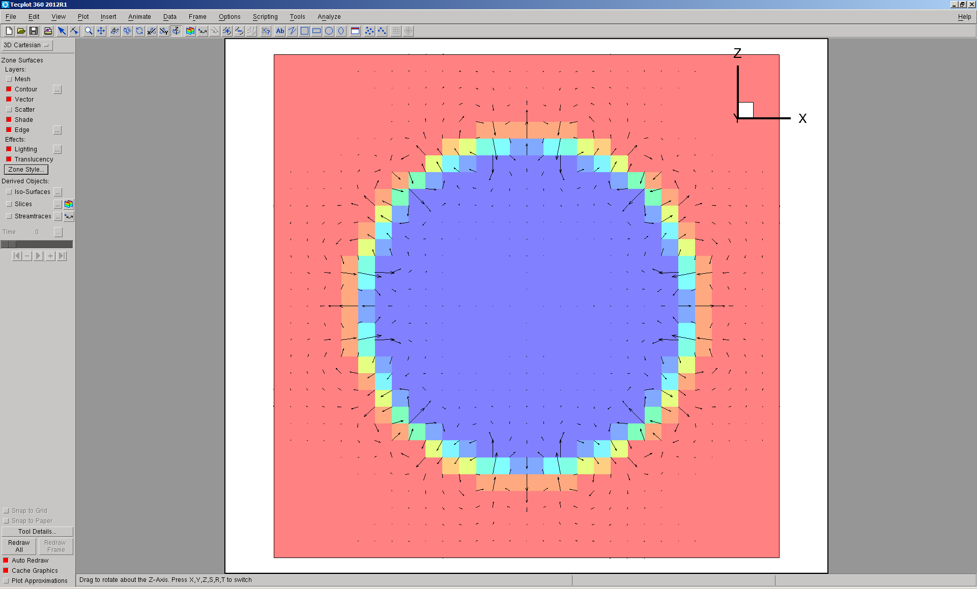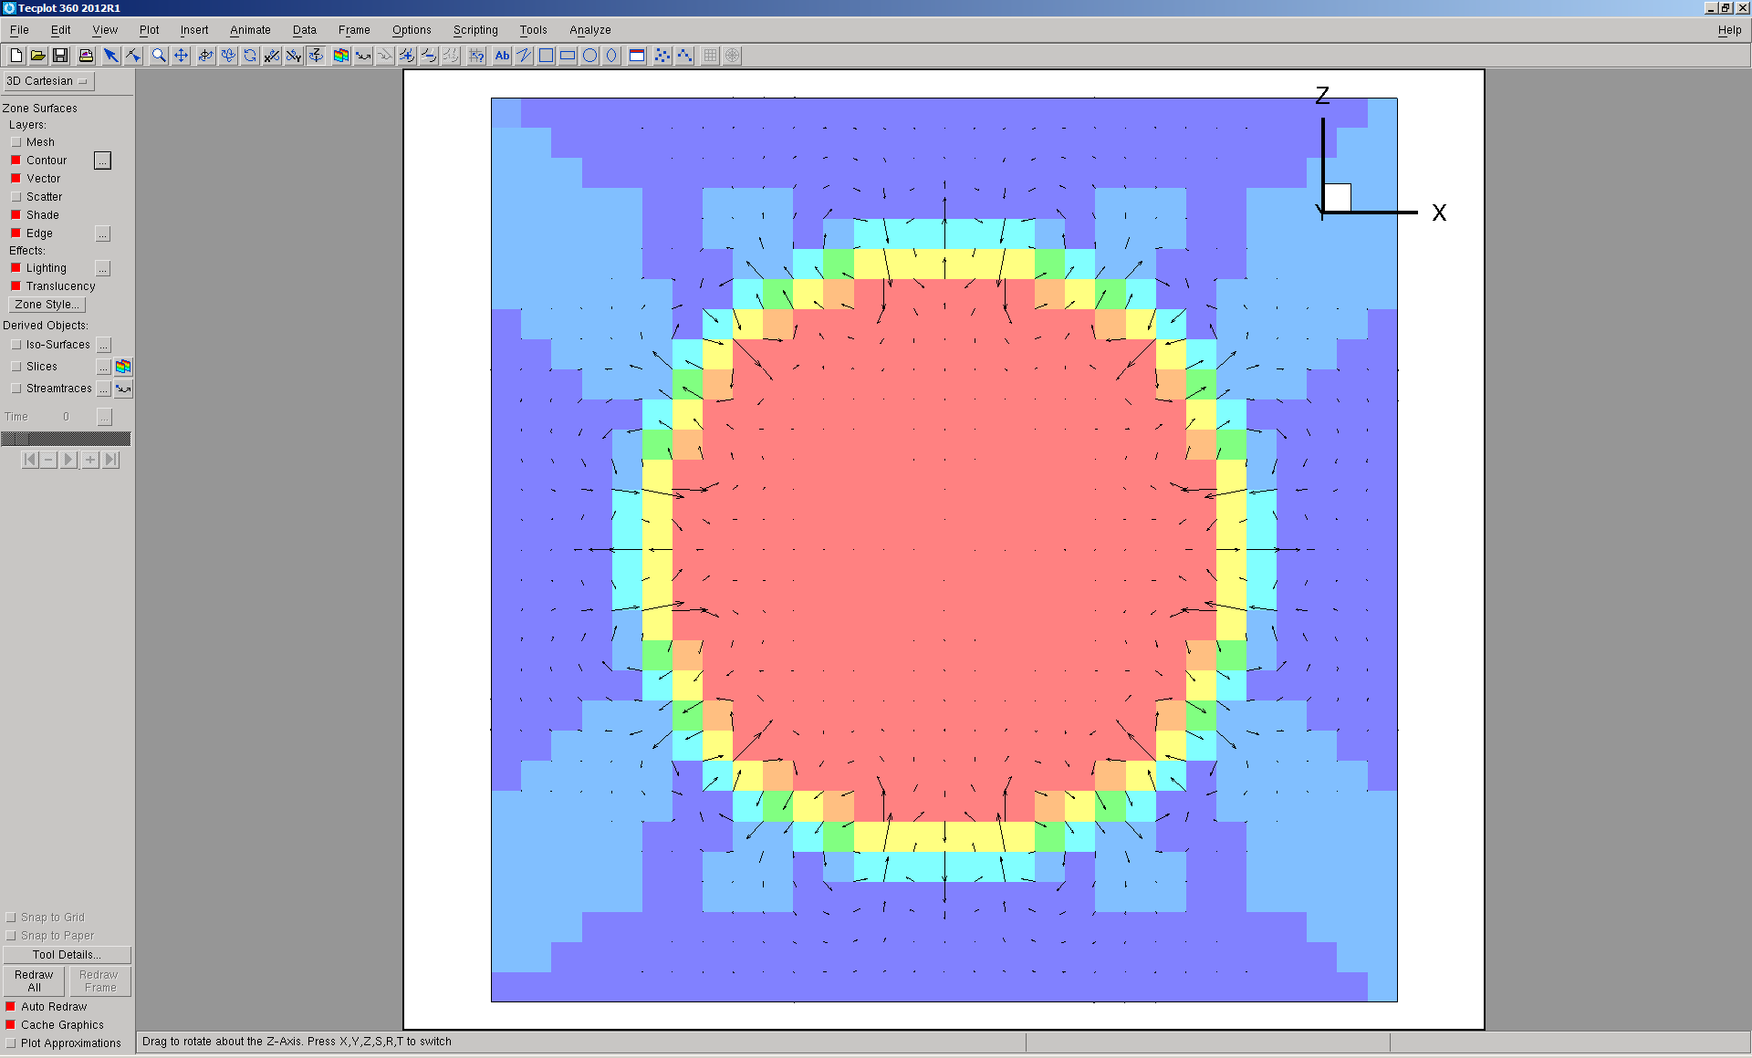
Color function Pressure
Umax=0.000785495

GFM
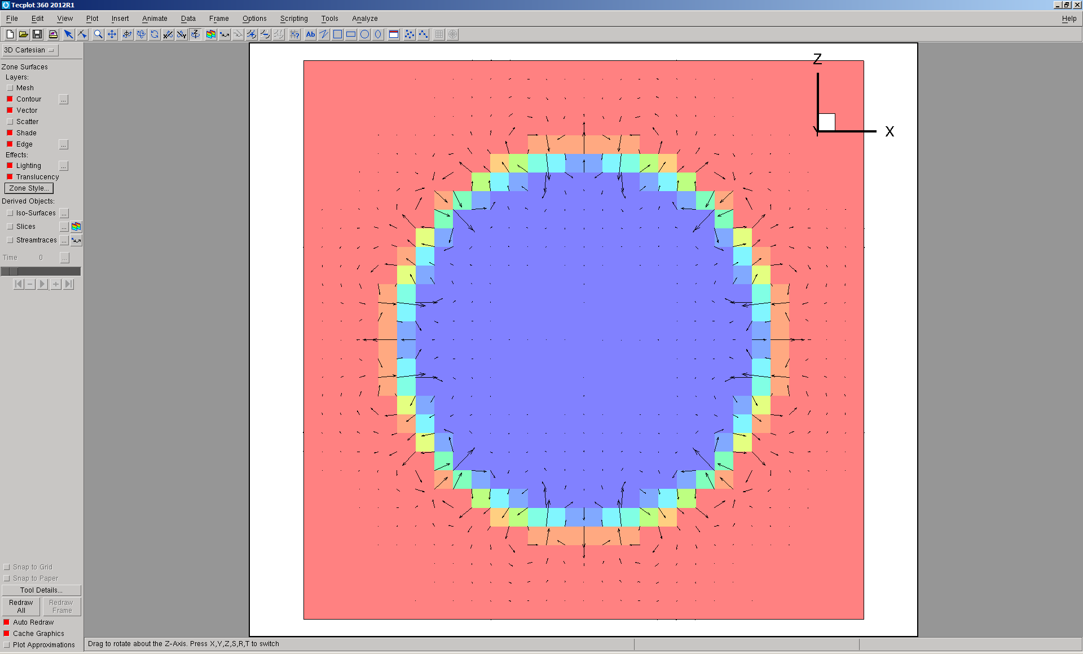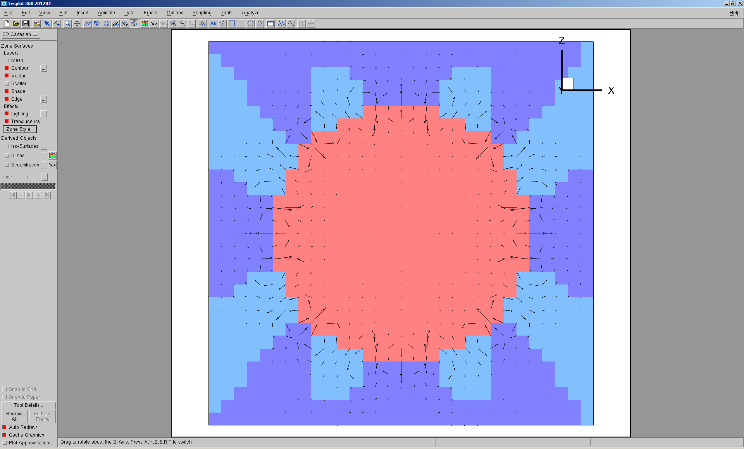
Color function Pressure
Umax = 0.000875163

With wall, Contact angle = 0 deg., 100 step
CSF
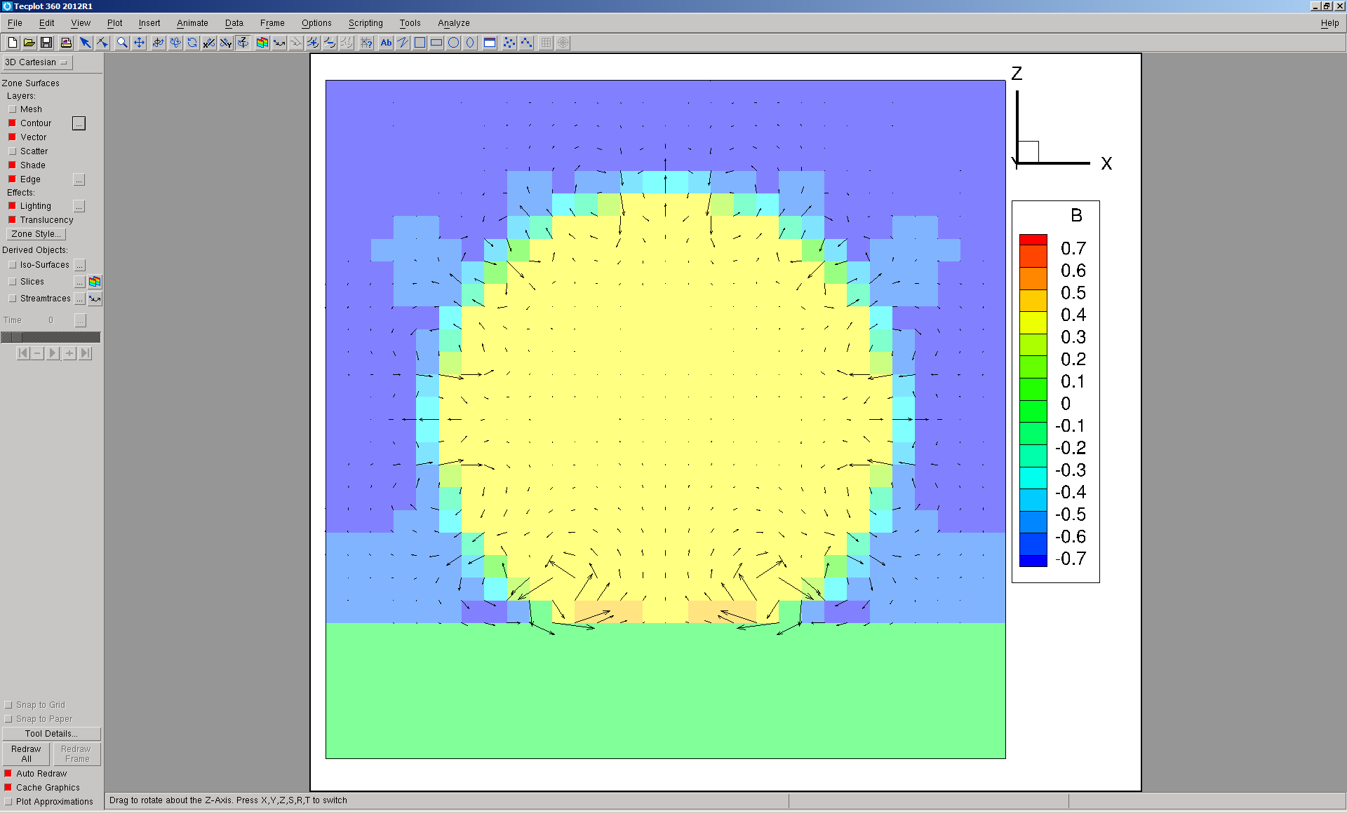Pressure distribution
Umax = 0.00241, Wmin=0.0020, Wmax = 0.00074
GFM
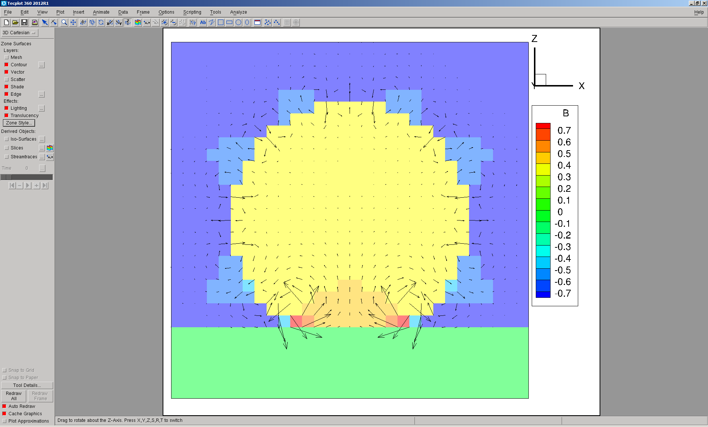 Pressure distribution
Umax = 0.00402, Wmin=-0.0048, Wmax=0.00220

With wall, Contact angle = 0 deg., 3000 step

CSF
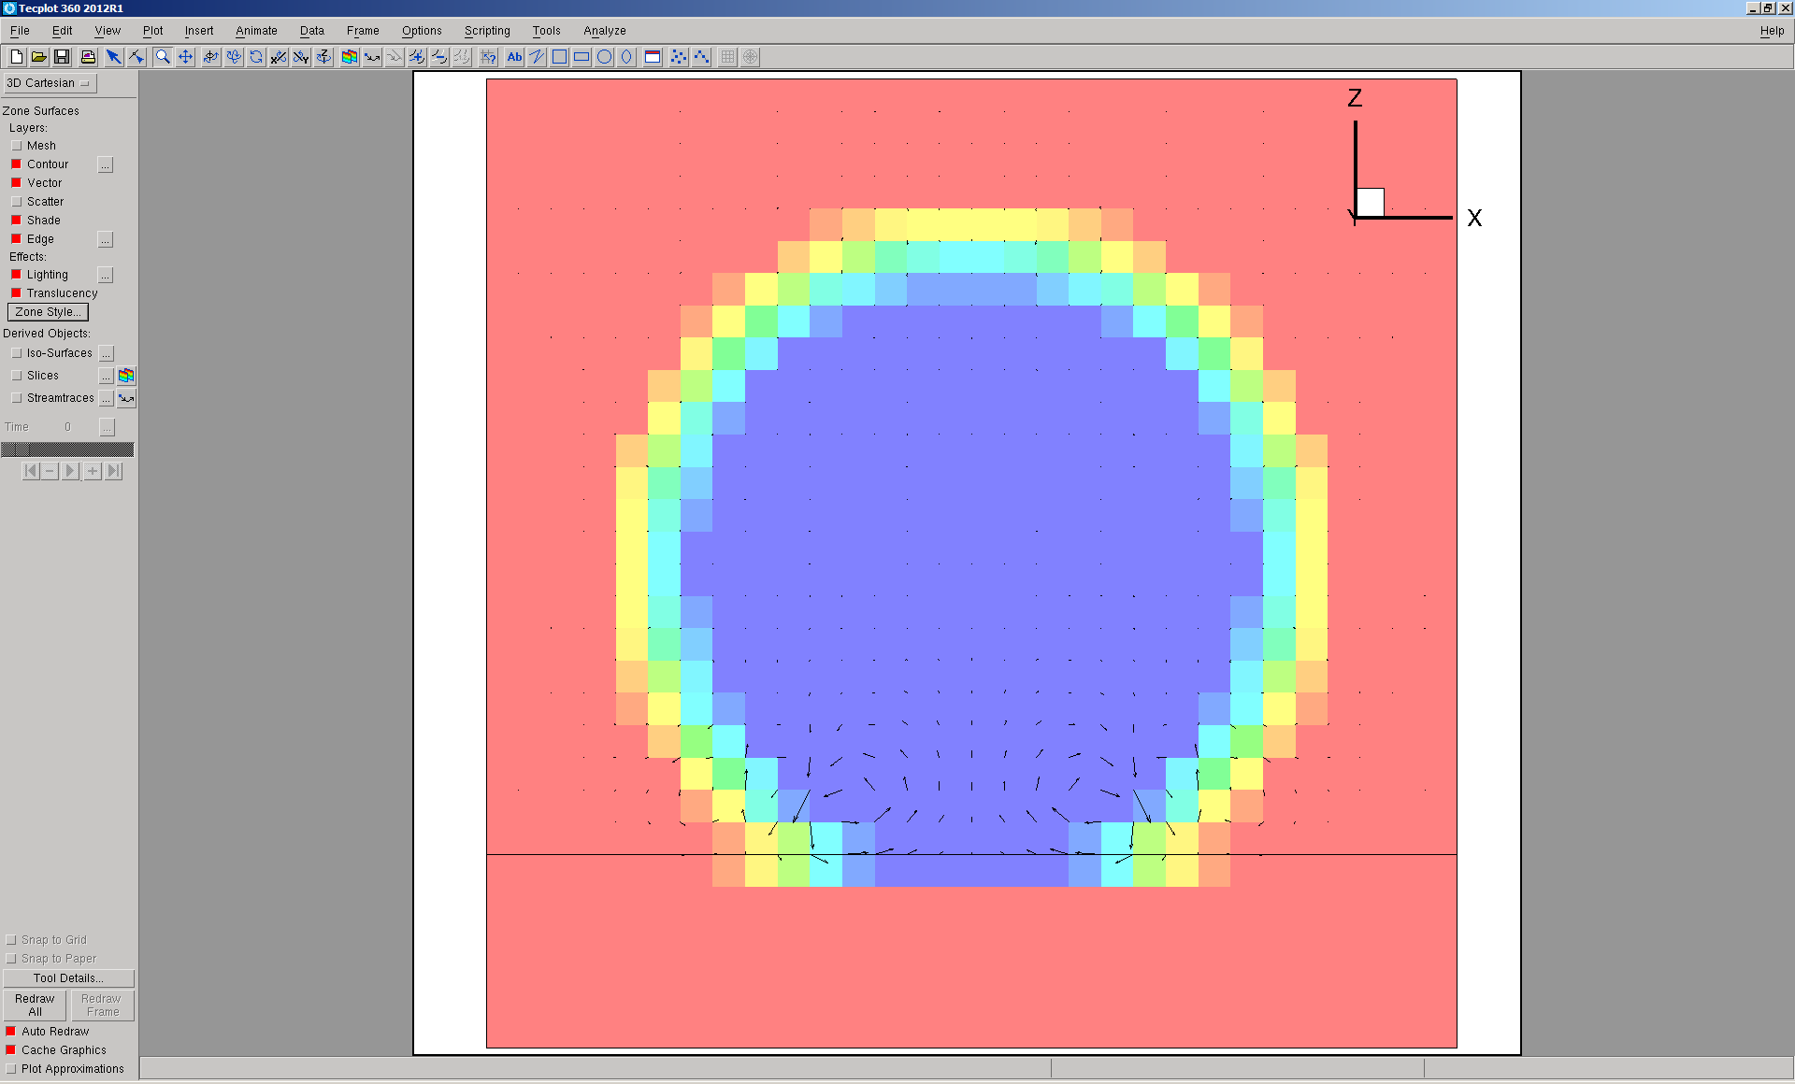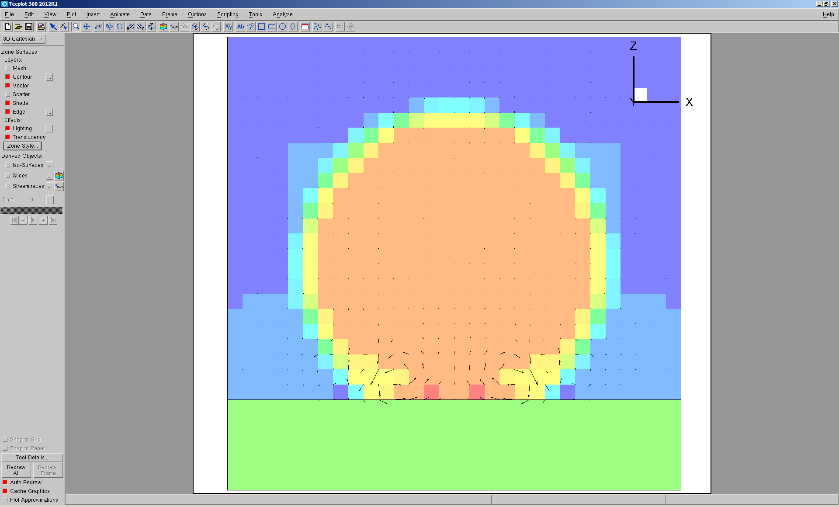
GFM, diverges at 3820
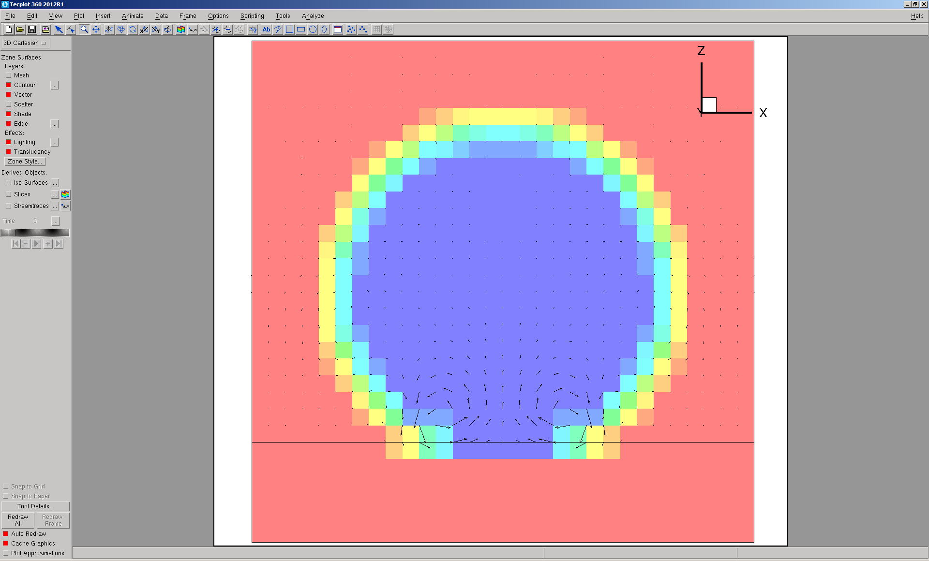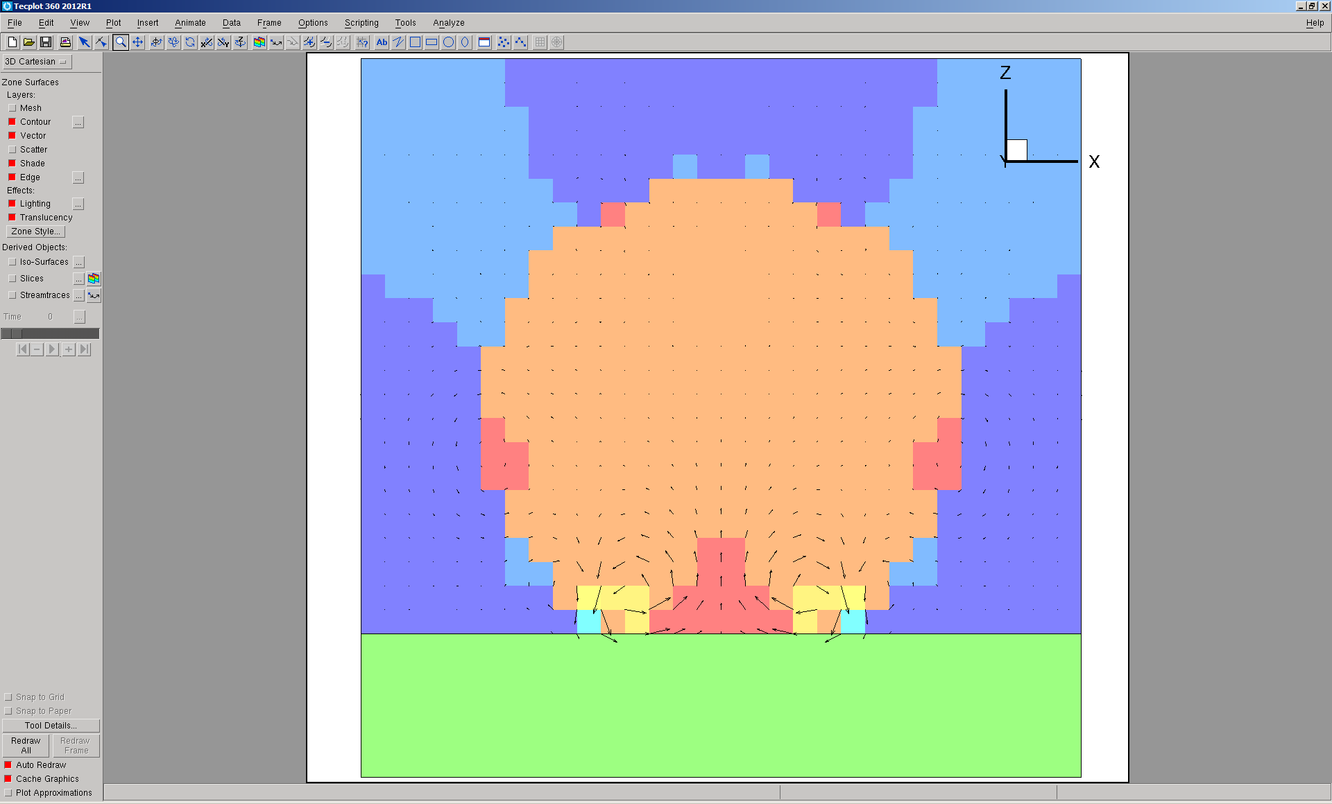

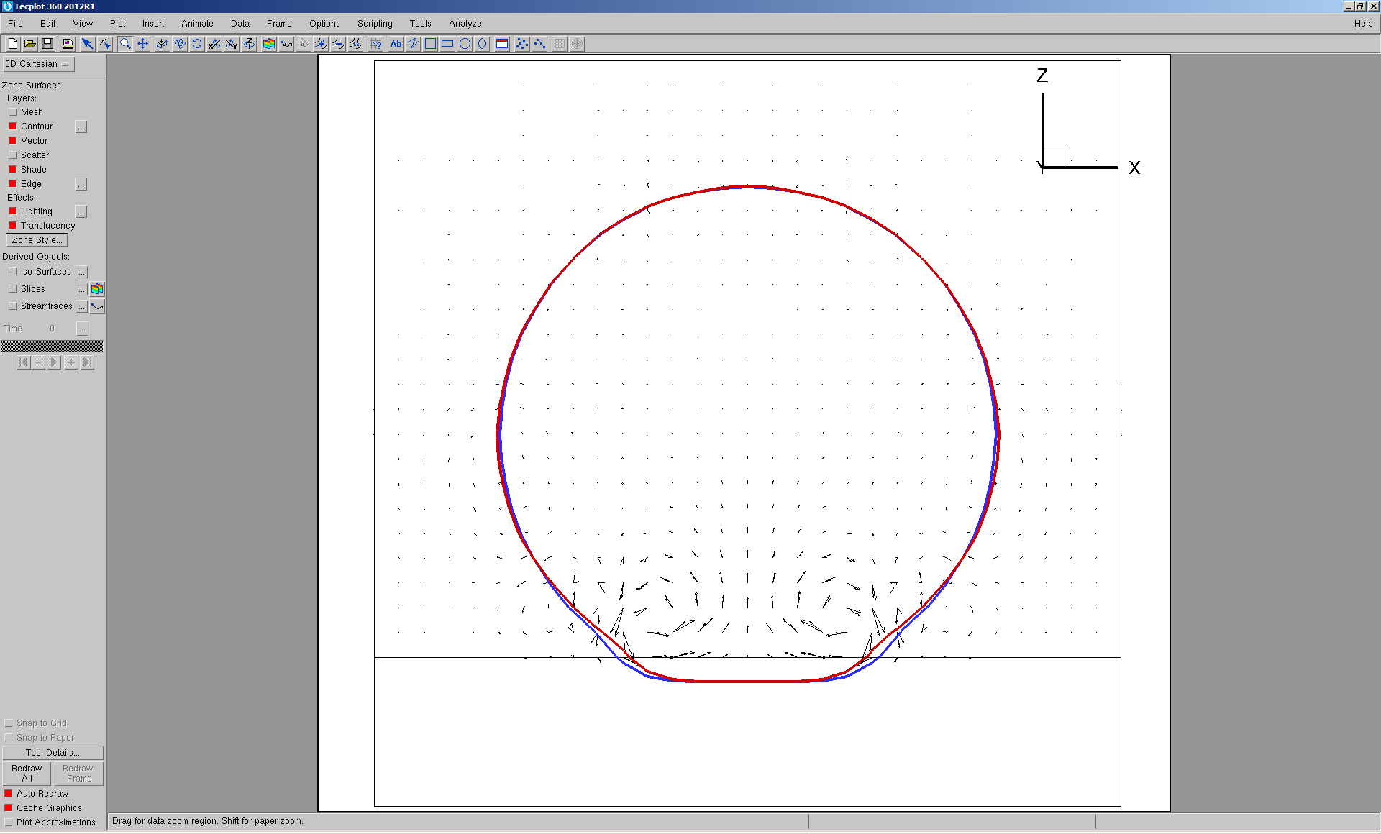
Comparison of bubble shape: CSF blue, GFM red

With wall, Contact angle = 0 deg., 10000 step
Divergence can be avoided, when multi-grid is not used for both CSF and GFM.

CSF
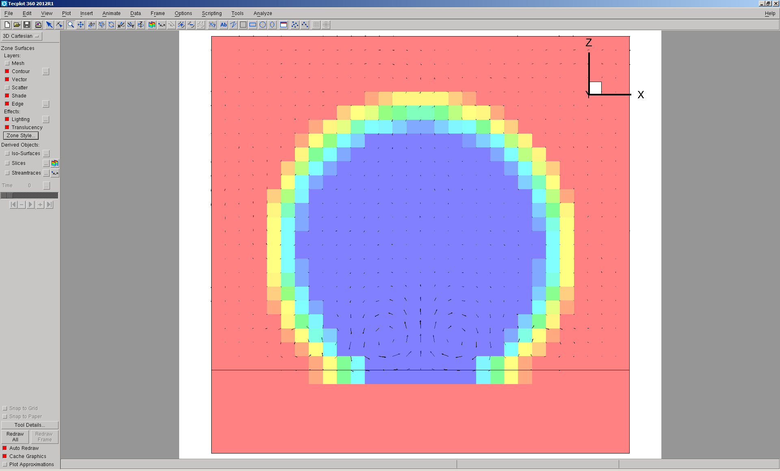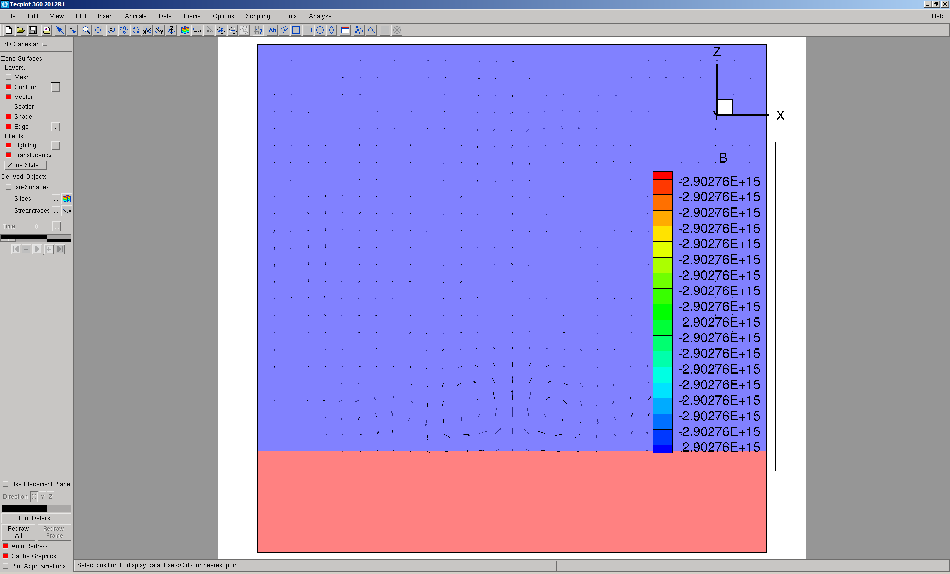
Umax=0.015
GFM
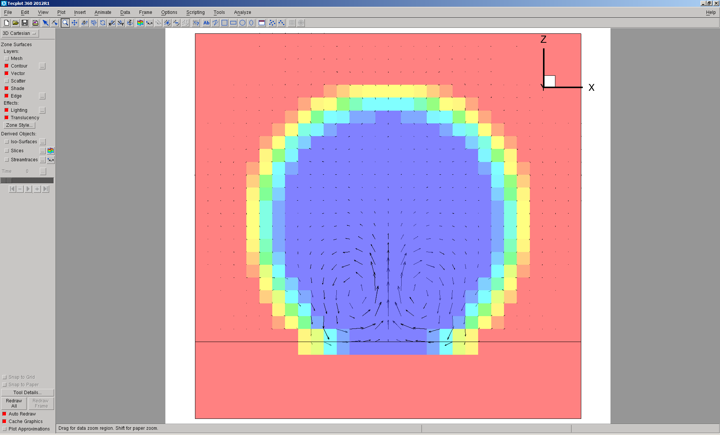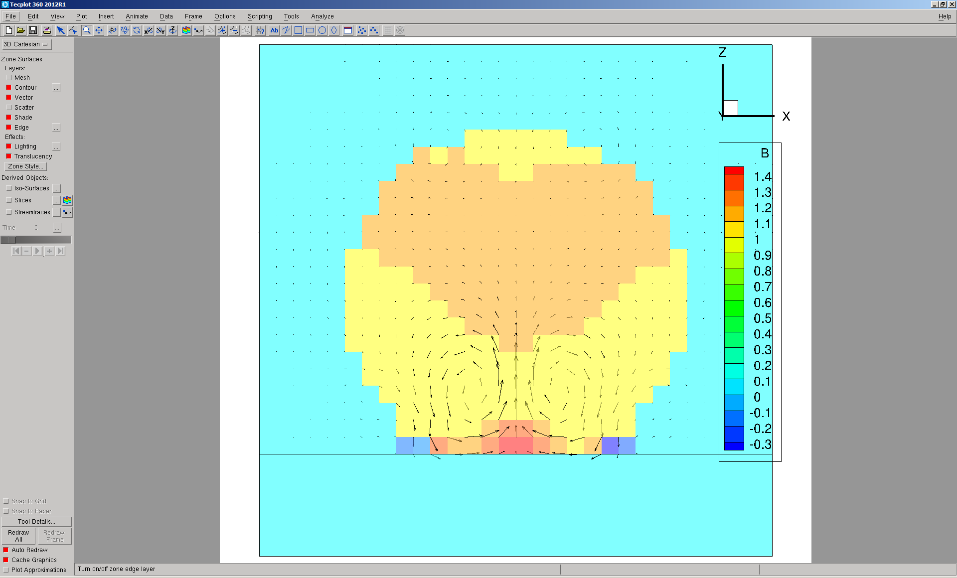
Umax=0.037
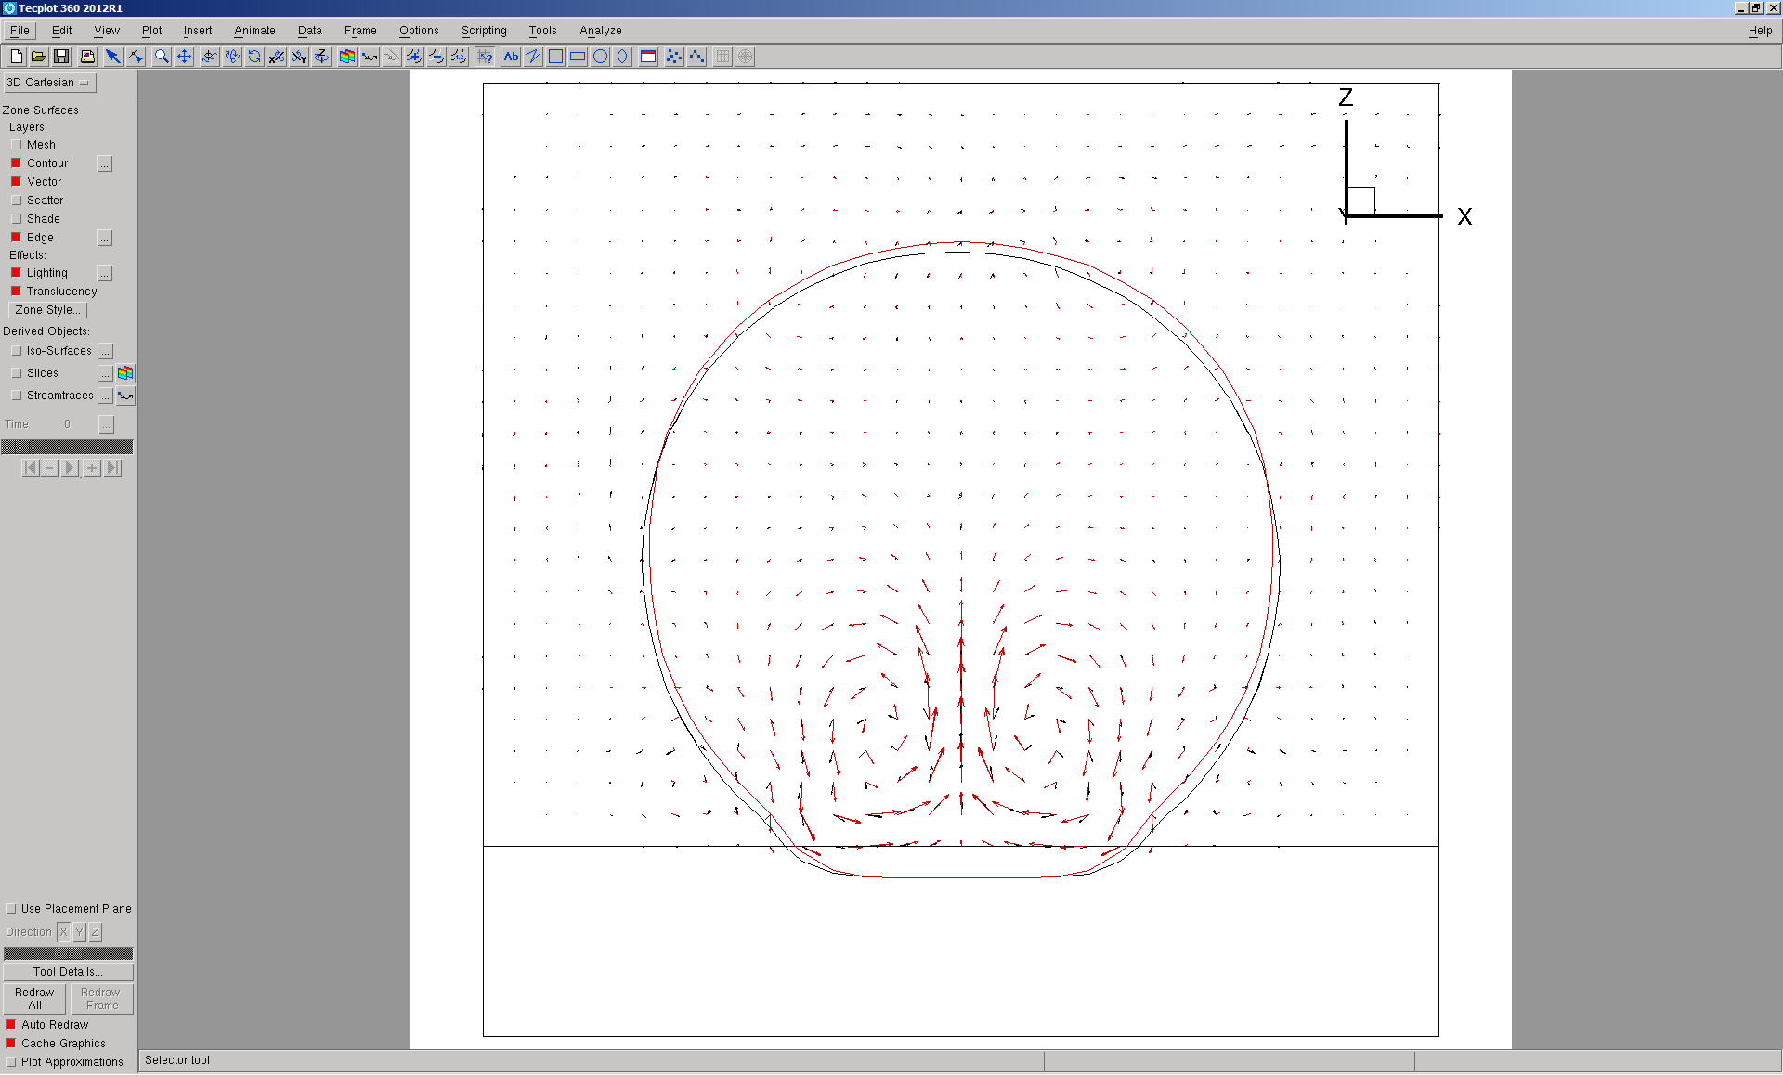

With wall, Contact angle = 0 deg., 10000 step, with middle dt.
dt = 0.1*pow(air.rho()->value()*pow(dxmin,3.0)/(2.0*3.1415*mixed.sigma()->value()),0.5)
Divergence can be avoided, when multi-grid is not used for both CSF and GFM.

CSF
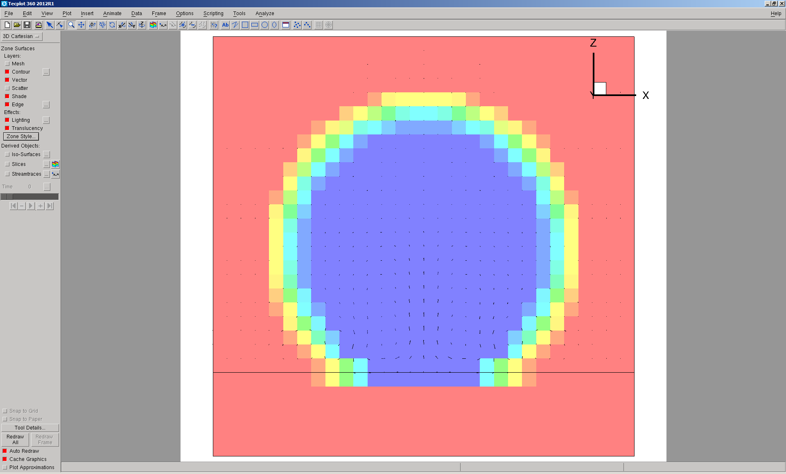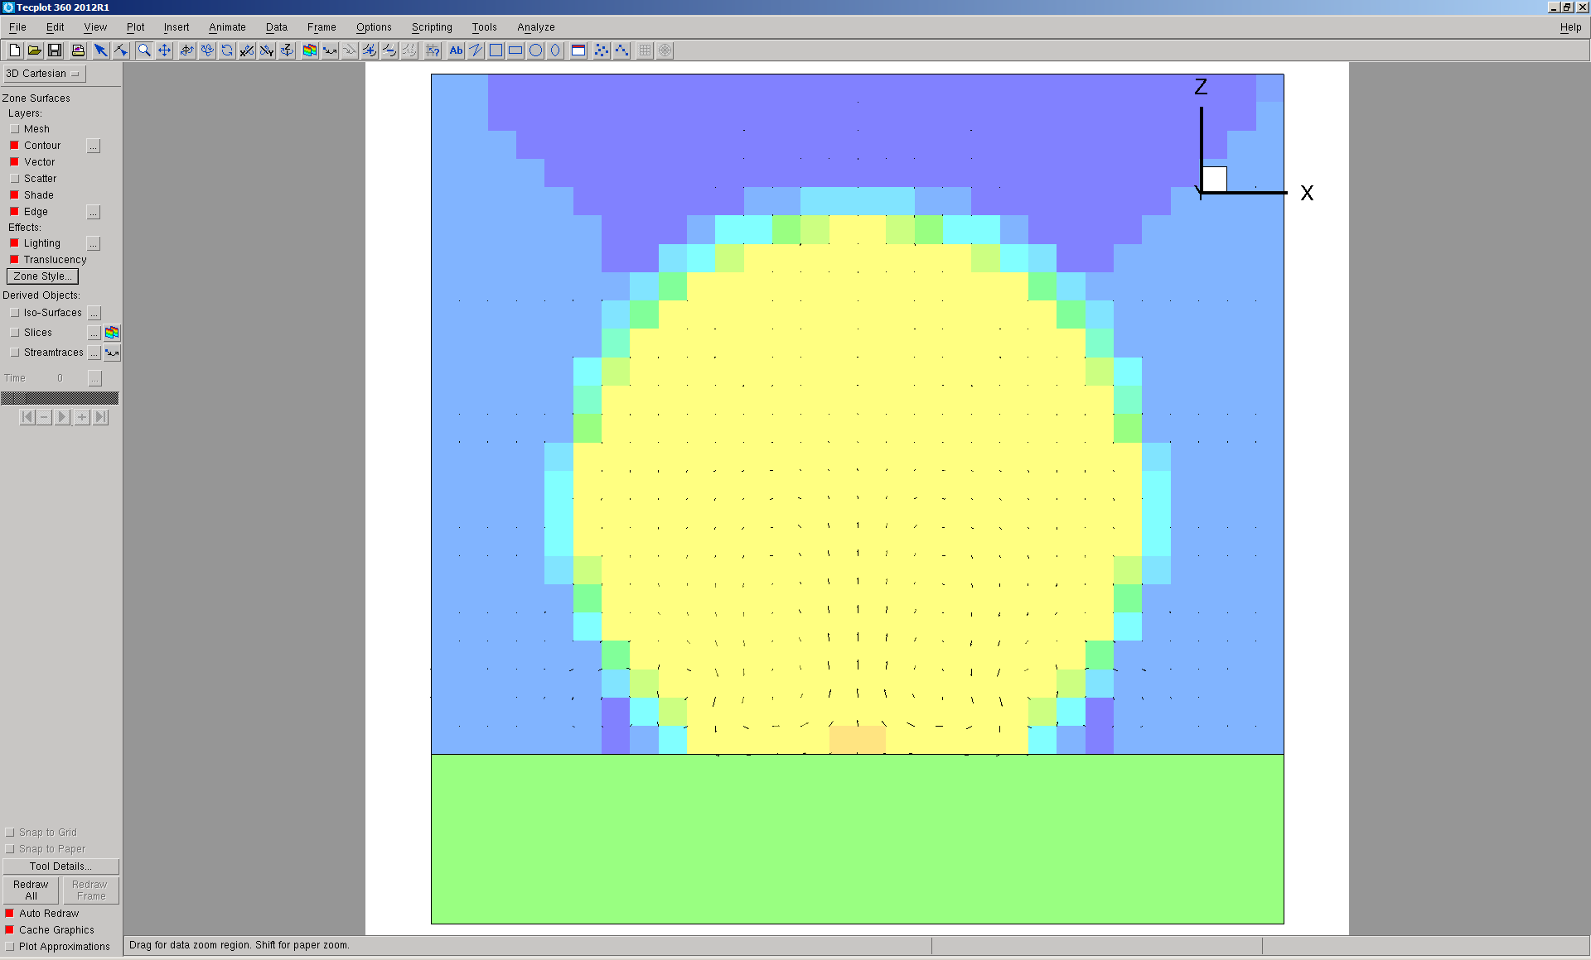
GFM
