Test code: randomflow-inlet

Outline
The main function “main.cpp” demonstrates how to introduce random flow as inlet boundary condition.

Condition of simulation
The flow condition is as follows:
- Single phase flow
- Inlet velocity: Random flow generator
- Turbulent flow : Smagorinsky model
The random flow generator is based on the reference: A. Li, G. Ahmadi, R.G. Bayer, M.A. Gaynes, Aerosol particle deposition in an obstructed turbulent duct flow, Journal of Aerosol Science, 25 (1994) 91-112.
The boundary condition is illustrated in Fig. 1.

Fig. 1: Boundary condition

Variables
Variable | Form | Description | Unit
vel_ave | real | average velocity | m/s
tl | real | turbulent length scale | m
tt | real | turbulent time scale | s
copy_plane | real ** | Array used for copying scalar variable
copy_planeVec | real *** | Array used for copying vector variable

About the turbulent length and time scale, please read next.

Results
Velocity field at time 9e-5 is shown in Fig. 2.
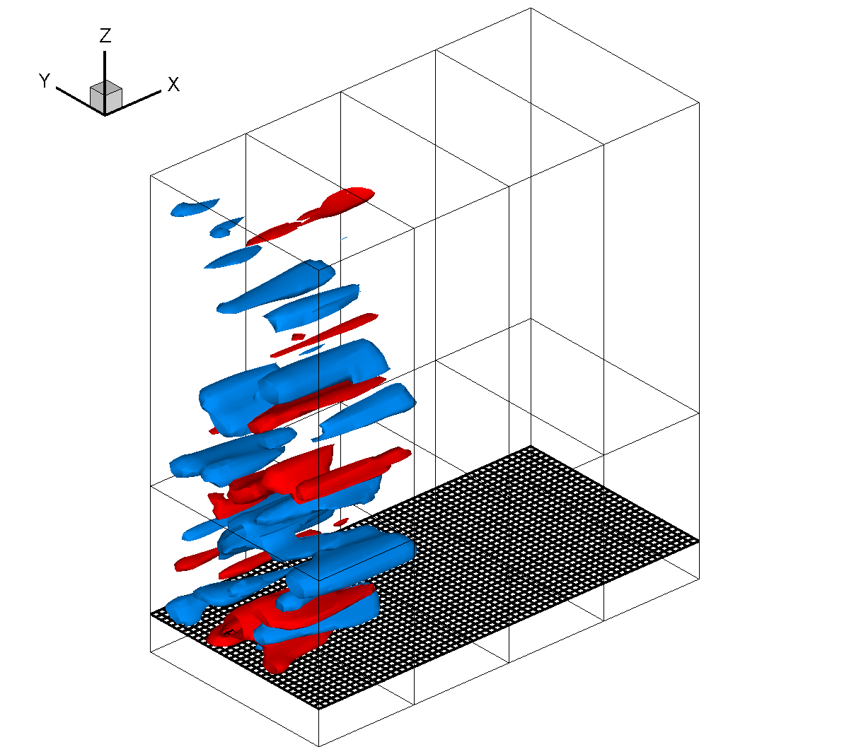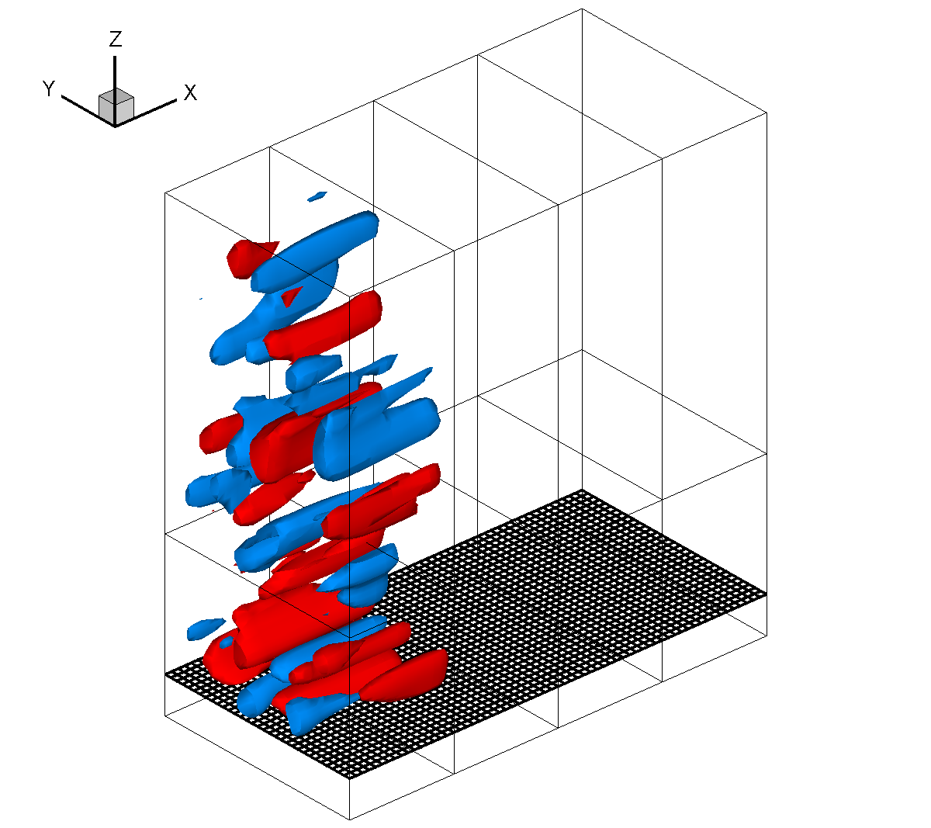
Fig. 2: Iso-surface of v (left) and w (right) at -0.3 and 0.3 m/s.

