Sample code: two-domains-velocity

Outline
The main function “main.cpp” demonstrates how to connect multiple domains. The two domains are connected via special boundary conditions, bnd_extract and bnd_insert.

Condition of simulation
The flow condition is as follows:
- Two-phase flow: CIP-CSL2 is used.
- Turbulent flow : WALE model is used.
- Temperature: Temperature at liquid-vapor interface is assumed to be saturation temperature.

In the first domain “dom_1”, flow current is driven by a prescribed pressure drop. The objective of computing “dom_1” is to obtain a fully developed flow, which will be used for “dom_2” as a inlet boundary condition. The boundary condition is illustrated in Fig. 1.

In the second domain “dom_2”, inlet velocity field is taken from “dom_1”. In this domain, phase change is computed. Note that phase change cannot be taken into account in “dom_1”, because of the usage of the periodic boundary condition.

The initial condition is shown in Fig. 2. Wavy liquid-vapor interface is introduced in dom_1 to visualize the wave propagation, while flat interface is used in dom_2. The velocity field is set at zero.

Fig. 1: Boundary condition for velocity field.

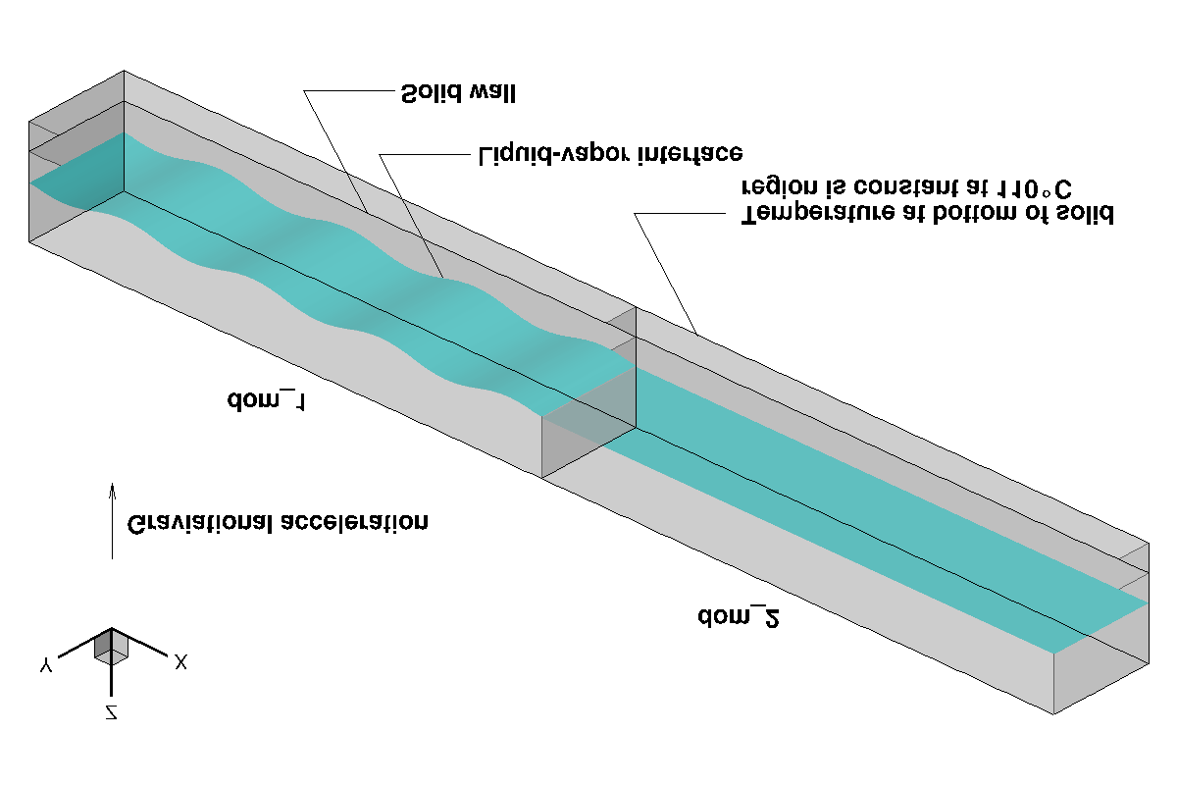
Fig. 2: Initial condition.

Variables
Variable | Form | Description | Unit
tsat | real | Saturation temperature | ˚C
dpdx | real | Prescribed pressure drop, | N/m³
dom1, dom2 | Domain | Computational domain
wd_1, wd_2 | Scalar | Distance from wall in domain 1 and 2, respectively | m
mdot_2 | Scalar | Phase change rate | kg/m³s
copy_plane | real ** | Array used for copying scalar variable
copy_planeVec | real *** | Array used for copying vector variable

Results
Time evolution of wave elevation is shown in Fig. 3. The wave propagates from dom_1 to dom_2, whereas the wave elevation damps. The side view of the flow field is presented in Fig. 4.

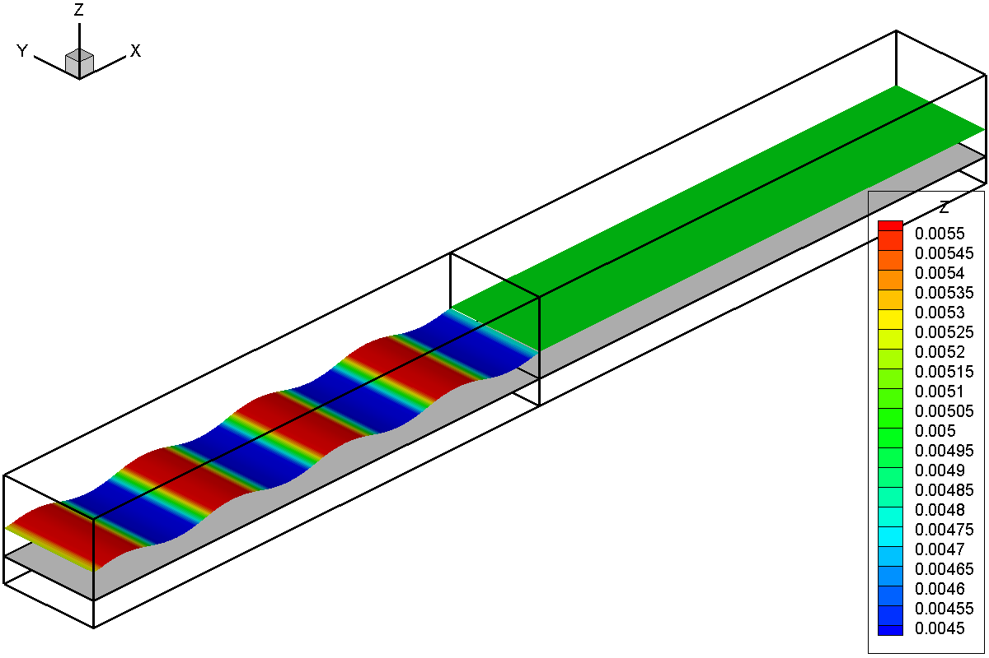
t = 0 s
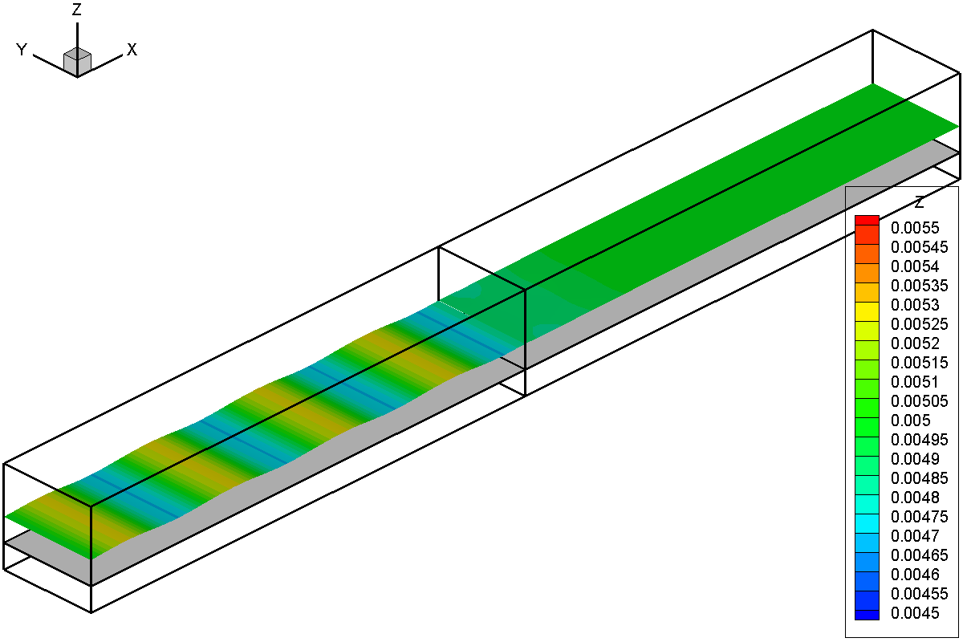
t = 0.02 s
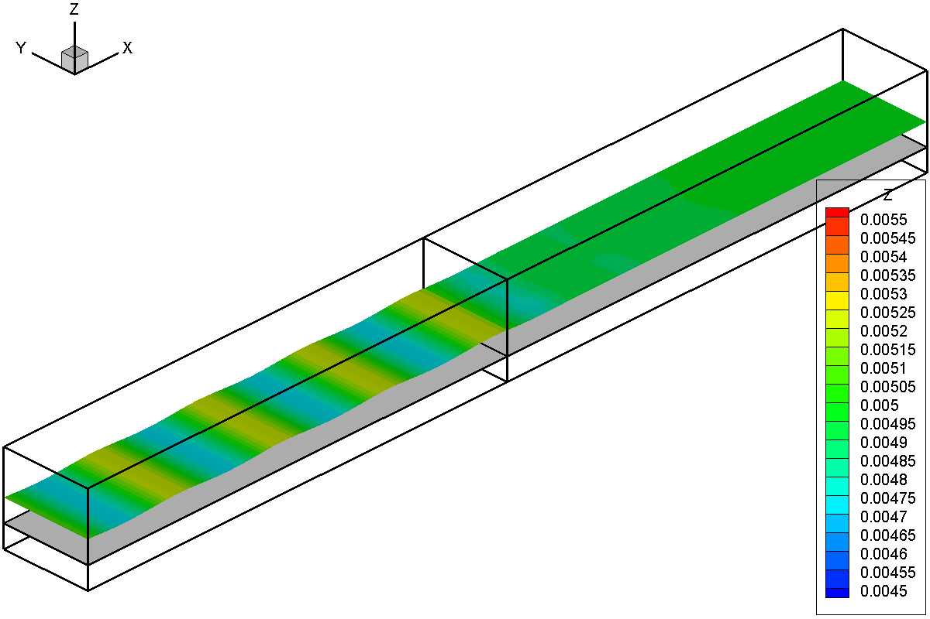
t = 0.04 s
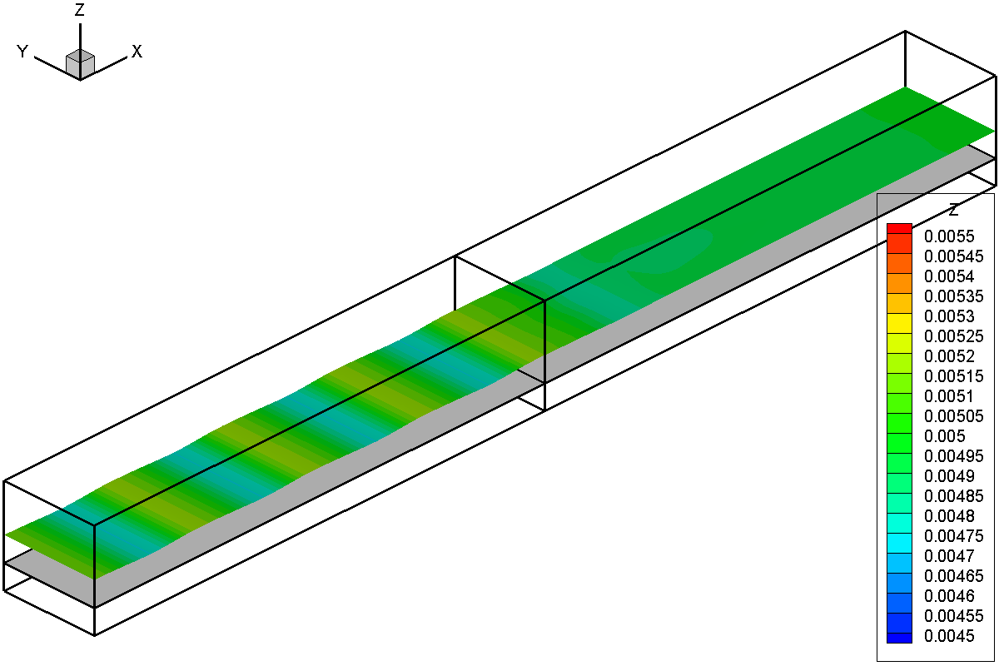
t = 0.06 s
Fig. 3: Evolution of wave elevation.
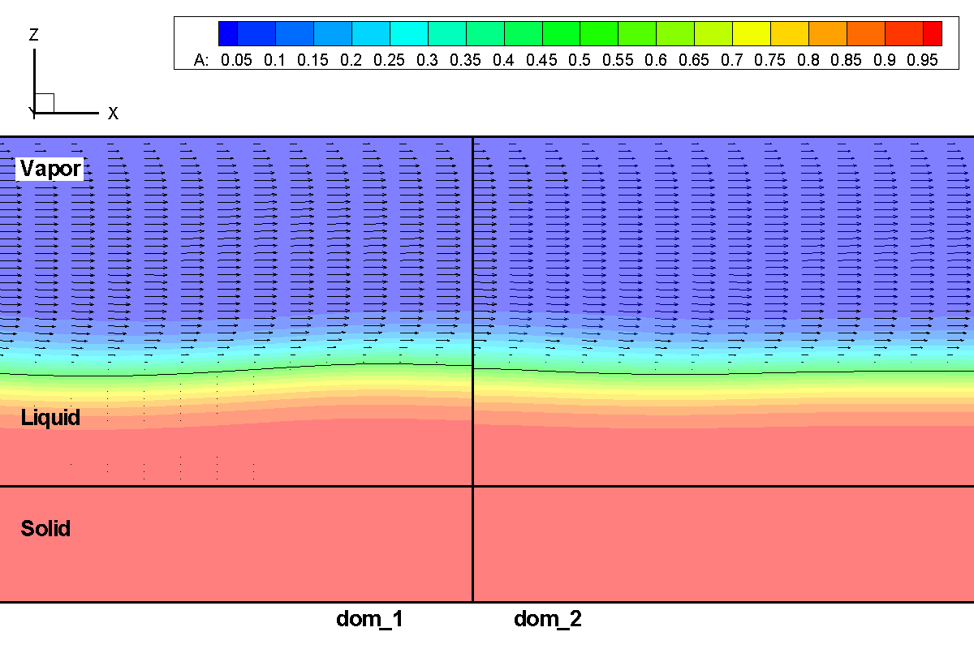
Fig. 4: Side view of flow field at t = 0.06 s around the connection between dom_1 and dom_2. The contour color is the color function.

