Test-ChangeGrid
Problem: rising bubble with CIPCSL2

1. Compile main-org.cpp → Boil-org
run 20 time steps
output: *20.bck, g1.grid
2. Compile main-new.cpp → Boil-new
run till output of g2.grid
3. ChangeGrid
input: g1.grid, g2.grid, *20.bck
output: *20.bck2
(ChangeGrid < input.txt; bck2bck.sh)
4. Run Boil-new

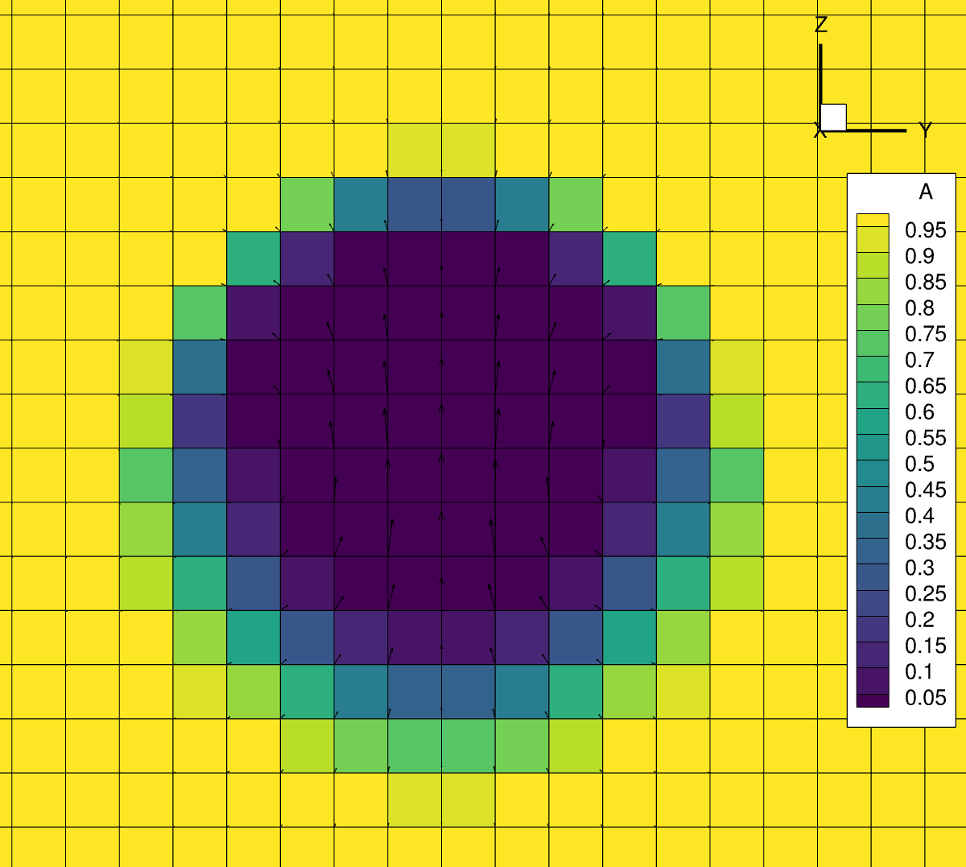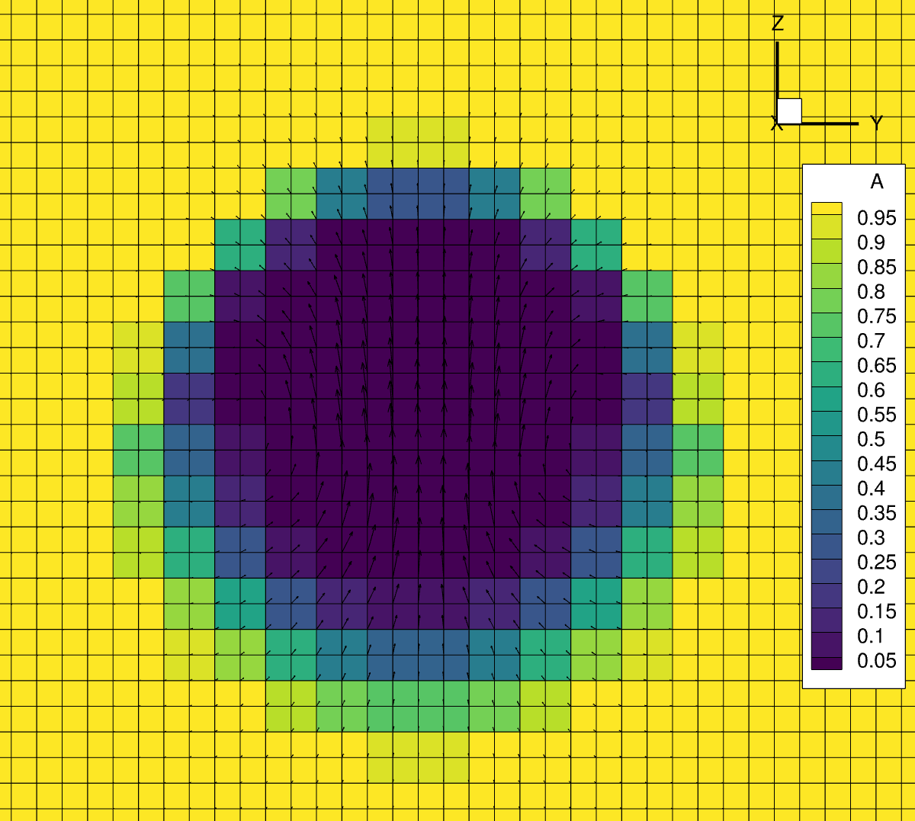
Time step 20 on old grid Time step 20 on new grid
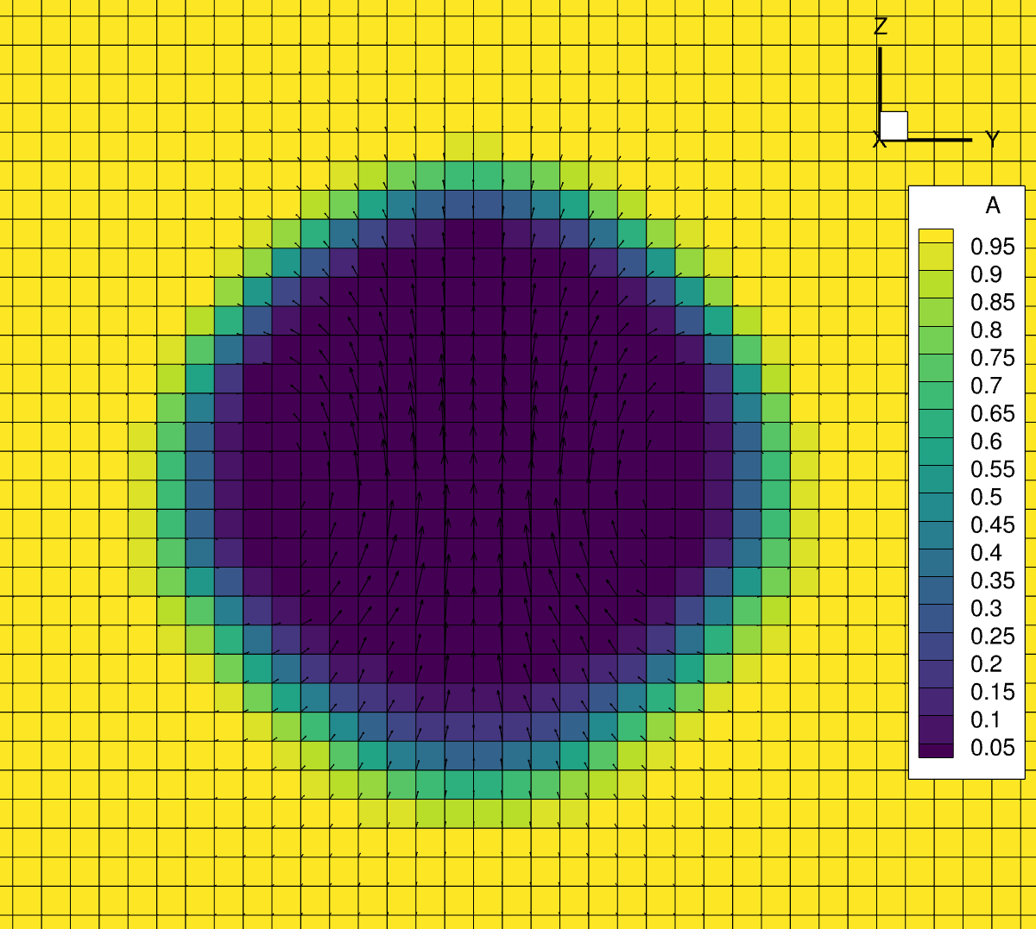
Time step 30 on new grid

Main.cpp for restart after ChangeGrid

############### solver part ##############
conc.set_globalSharpening(); // globalSharpening could be mandatory. Don’t use default
conc.set_itsharpen(4); // 4 or 8 are successful ;

############### restart part ##############
int nrestart=20;
uvw.load("uvw", nrestart);
press.load("press", nrestart);
#ifdef USE_VOF
c.load("c", nrestart);
#else
c.load("conc-phi", nrestart); // load conc-phi as c.
#endif
uvw.exchange_all();
p.exchange_all();
c.exchange_all();
conc.init(); // after ChangeGrid, init() must be called.

