Test-ChangeGrid
Problem: rising bubble with VOF

1. Compile main-org.cpp → Boil-org
run 20 time steps
output: *20.bck, g1.grid
2. Compile main-new.cpp → Boil-new
run till output of g2.grid
3. ChangeGrid
input: g1.grid, g2.grid, *20.bck
output: *20.bck2
(ChangeGrid < input.txt; bck2bck.sh)
4. Run Boil-new

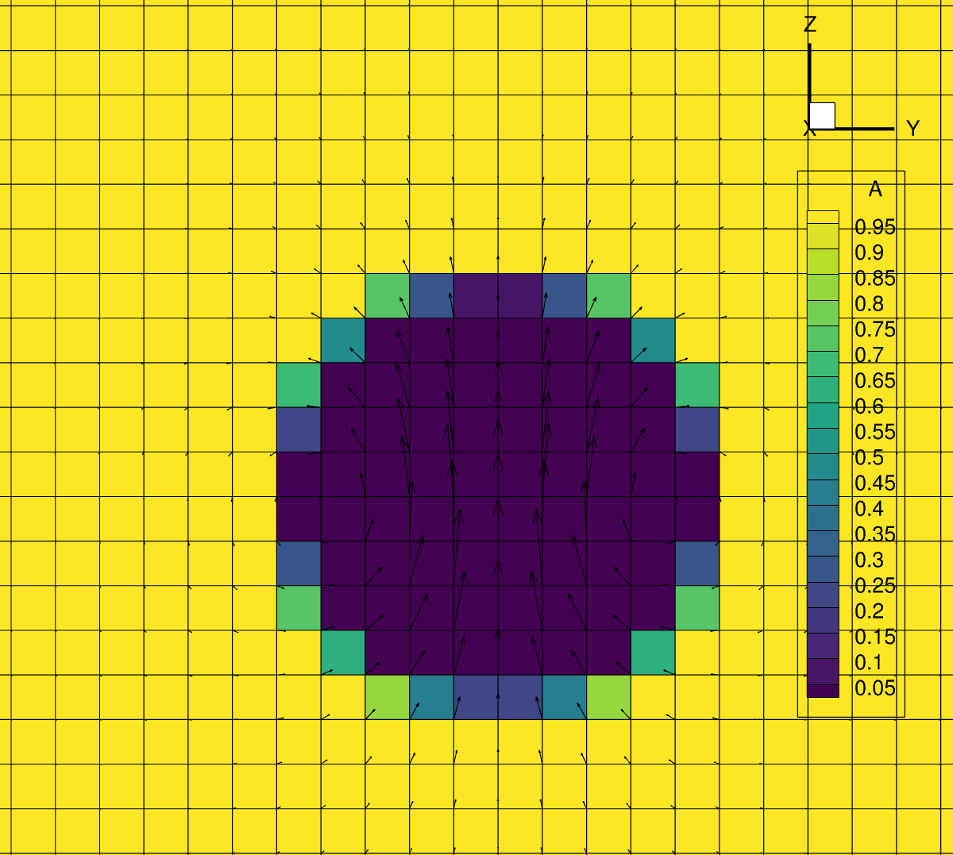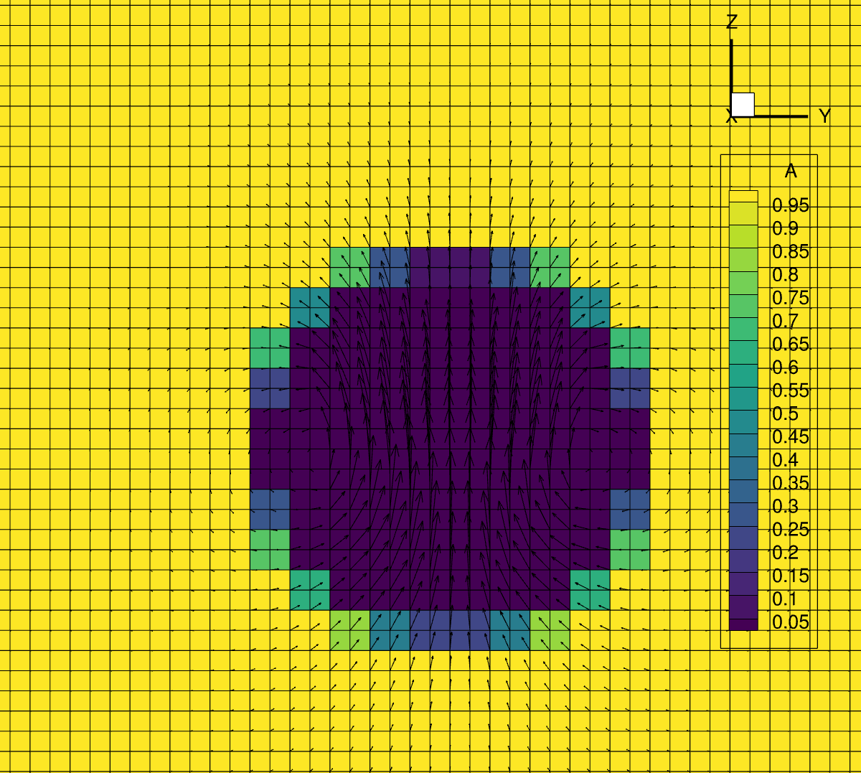
Time step 20 on old grid Time step 20 on new grid
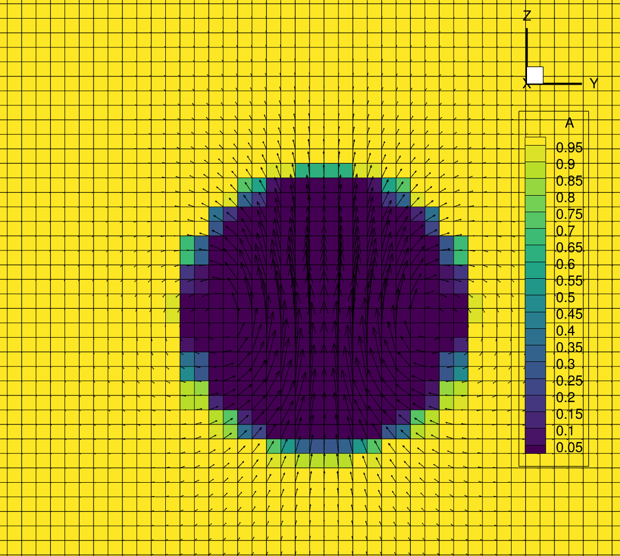
Time step 30 on new grid

