Diffusion equation for the smoothed VOF function

Governing equation and discretization

Discretization
Time discretization: First-order-accurate implicit scheme
Spatial discretization: Second-order-accurate central-differencing discretization scheme

Parameters
,

Implementation

Result
Aspect ratio of grid = 4
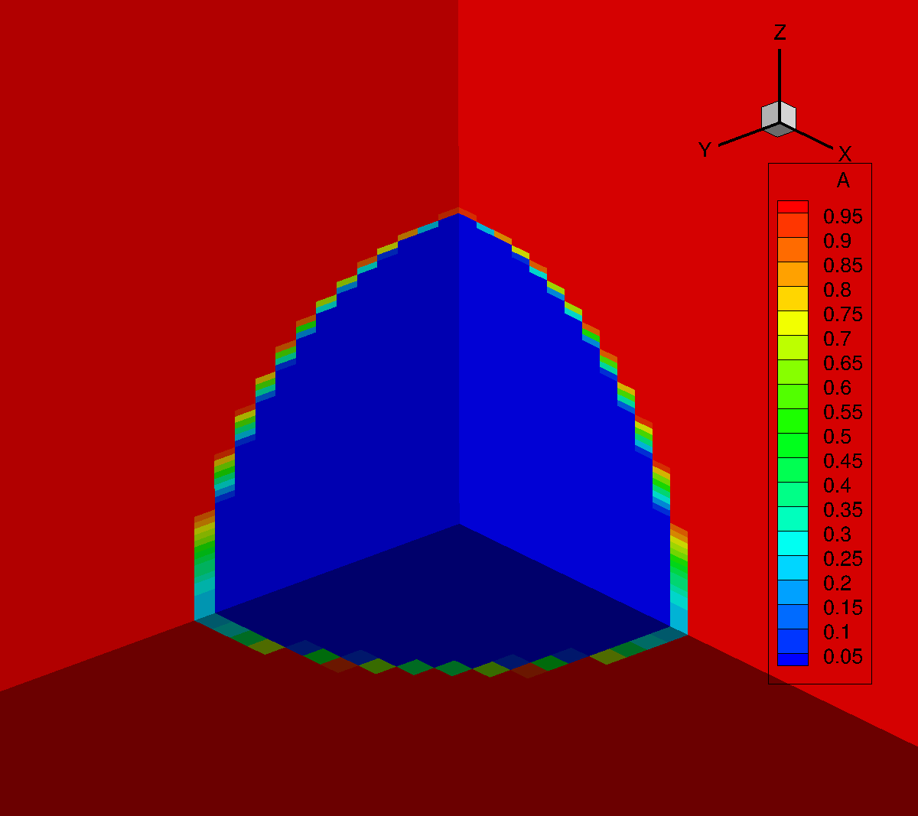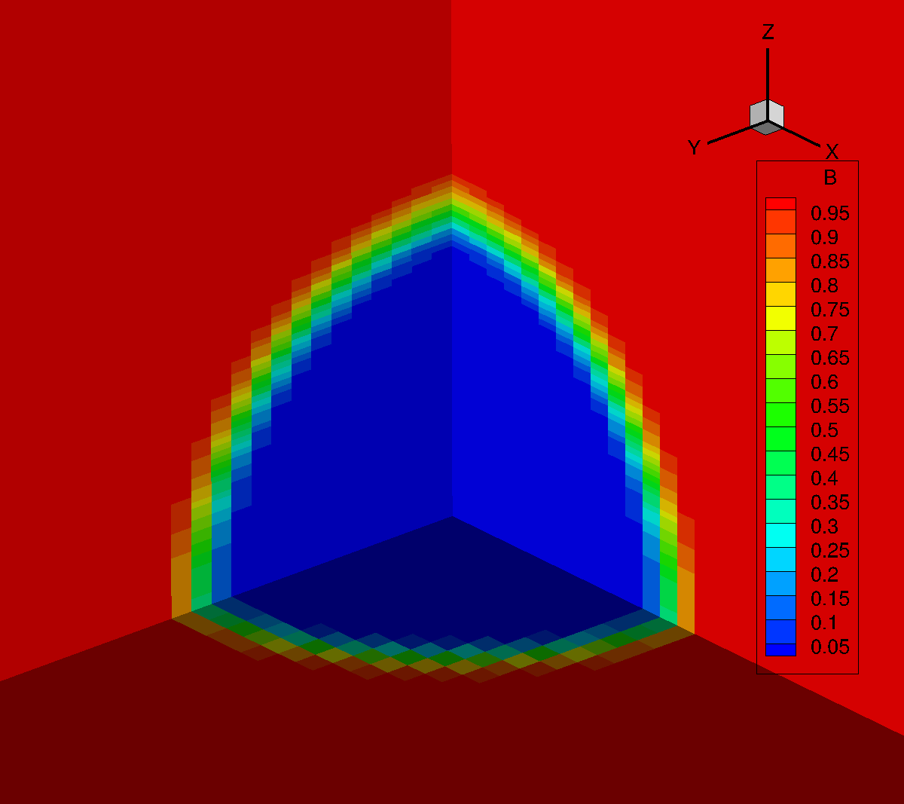
Original VOF function Smoothed VOF function
Result at the first time step, number of iterations = 16

Warning!!! In VOF class, there are bugs related to boundary conditions. Next implementation changes the range of loop. I need to fix this soon.
For( int b=0; b<phi.bc().count(); b++ ) {
/* WARNING!!! This implementation causes the error in
loop range of bc().at(b).si(), ei(), sj(), ej()... starting with 5!!! */
nx.bc().add(phi.bc().at(b));
ny.bc().add(phi.bc().at(b));
nz.bc().add(phi.bc().at(b));
mx.bc().add(phi.bc().at(b));
my.bc().add(phi.bc().at(b));
mz.bc().add(phi.bc().at(b));
nalpha.bc().add(phi.bc().at(b));
adens.bc().add(phi.bc().at(b));
}

