INTRODUCTION

There is a big influence of technology on our daily life. Electronic devices, multimedia and computers are things we have to deal with every day. Especially the Internet is becoming more and more important for nearly everybody as it is one of the newest and most forward-looking media and surely the medium of the future.

It is naturally engaging and, in an age of information overload, it's vital for small businesses to offer content that is easy to digest; if not, consumers will simply move on. Video does this very well. If a picture paints 1,000 words then one minute of video is worth 1.8 million, so say Forrester's researchers. With online video quickly becoming a key means for people to satisfy their information and entertainment needs.

Streaming video is content sent in compressed form over the Internet and displayed by the viewer in real time. With streaming video or streaming media, a Web user does not have to wait to download a file to play it. Instead, the media is sent in a continuous stream of data and is played as it arrives.
Streaming is not only for video content. Entertainment, gaming, learning and more are part of the delivery system. Content creators, whether it be videos, apps or games, will now have an easier time of setting up and managing their streams.

This project is based on “Online Video Streaming”. The motive of the project is to providing the facilities to watch online videos free of cost. Not only the users can view the videos and they can also share them with others, infect they can register themselves to the site which will provides them tons of facilities such as host own channel on our site to share his/her videos to the world, there are other facilities too such as upload videos along with subtitles, upload custom thumbnails for video, they can even provide textual description about the video, they can download videos and even only audio from the video separately if they need so. User can download video without need to install any plugin/extension to the browser or any third party application.

With billions of viewers watching videos on this site every single day, it is safe to say they're extremely loyal followers who love their channels. Content creators can use the new subscription notification feature to let their fans know they have uploaded a new video. Fans will have access to opt in and receive notifications through their email every time a new video is published from the channel they have subscribed.

There is a big influence of technology on our daily life. Electronic devices, multimedia and computers are the things we have to deal with every day. Especially the Internet is becoming more and more important for nearly everybody as it is one of the newest and most forward-looking media and surely the medium of the future.

PROBLEM STATEMENT

It is now common that we can see TV programs and movies with a cell phone. Increasing number of them are now equipped with web accessible ability. Processing ability of recent cell phones is now similar to that of PC several years ago and they can play multimedia files through web access. It is a big merit that mobile cell phone can play multimedia files made for PC. However, the problem is that plenty of the files are not directly usable for cell phones. Due to large-sized, non-stream format files they are difficult to be played on cell phones. Also cell phones are come with very limited storage, so we can’t store such plenty of video on our cell phone. Even though recent cell phones contain large storage than old ones, video file size is also increasing beyond the capacity of cell phones. In addition, even if cell phones have enough storage to save large video files, they still have the limited resource environment: low processing ability and small view size. Since most recent video files are formatted by advanced codec with wide view size configuration, cell phones are unable to play the quality that is expected to be shown. Playing high-quality video files for PC in the low-quality environment of a cell phone is inefficient and resource-wasteful. Streaming service can be the solution of the two problems. However, present streaming services also have limits. Most of them are for subscribed customers and contents are limited. Moreover, they support little dynamic controls over the stream, which are very natural for non-stream format files. In cell phones dynamic control functions are more important due to their resource and power constrains than those of PCs. Since computer performance and network speed has greatly enhanced, we can utilize a third party file-converting server for customized and manageable streaming services for cell phones. Saving video for later offline access (downloading video) is another issue. Downloading and sharing the video with other users, extracting audio from video, and converting video to certain different format to alter video processing which varies from device to device, because some processor and Operating system handles video file formats differently and processing them varies, these are some other issues. To perform these action with variety of tools outside a website is a cumbersome activity.
- Since cell phones do not have sufficient storage to save large-sized non-stream format video files, URLs of the video files are redirected to a third-party server and cell phones get streaming services from the server.
- Since plenty of video files in the Internet are formatted for PCs and each cell phone has different compatibility, the server customizes the streaming file through optimizing process; it prevents waste of resources in cell phones to play streaming videos.
- By making the client and the server have seeking functionality of a streaming data, cell phones can control the stream dynamically without actually downloading the file to their local machine.

This site aims at overcoming the difficulties faced by the users when using Video Streaming websites. It will provide a platform where an individual would be able to upload, watch and share personal, business, or royalty-free videos. Users will also be able to download the video and audio separately.

OBJECTIVE

The objective of the project is to provide the facility to watch online videos and share them with others. The objective is further elaborated as:
- Any guest user can search and watch any available video on the site.
- A Guest can register on the website.
- The confirmation mail will be sent to the user after the registration. User must click on the provided link that will be given in the confirmation mail for verifying and activating account.
- Users can upload their video and audio and can create their own channel on the site.
- User can create multiple playlists for grouping videos of their choice.
- User can also add video to their playlists for later east access.
- The user will also be provided with the list of videos of their interest according to the searches they had done before.
- Subscribers will automatically receive a notification after upload of any video from the channels they have subscribed.
- User then they can also download a video in mp4 and mp3 formats directly through their browsers.
- User can also convert the video they are watching directly from their browser in multiple video formats as per user’s need.
- User can also upload and provide a subtitles file for their videos they have uploaded.
- User can upload and provide custom thumbnail for their video which would be visible on top of video before its play.
- User can also create an automated thumbnail for their video which will get extracted from their video itself.
- User can easily play and download the video and audio files from site without need to install any plugin/extension/or third party tool.

SCOPE

The project aims at increasing the usability of the site. The user interface of the site will be simple enough to attract towards the site in first visit. Other sites lack in providing the download features like in YouTube do not have this feature. This project will have one click download option and also the option of downloading the audio and video separately as per the user requirement. It will be much easier to share the videos with friends than You Tube. Moreover the videos can be converted into popular formats and then can be downloaded which will save the data usage of the user.

This project will use method streaming video on-demand application. Nowadays users are busy in creating and uploading content so VOD is the best possible way to keep the people busy and entertained.

The registered users will have the access to create their own channels and host their videos. It will also be useful for the business communities for promoting themselves to large number of audience at a much cheaper rate. The students will also be benefitted with the project as they can get tutorials on various subject and also can have the better learning experience by watching the real life examples that are related to their topics. For small children also the project aims at providing the content for learning and entertaining those putting nursery rhymes and poems.

All these features with some extra features are provided in the project with a very simple and attractive user interface which is the USP of the project to survive in the market.

COMPETITIVE ADVANTAGE

Although at present there are many existing websites which provides the same features that we are providing.

This project has a different feature i.e. downloading feature of both audio and video and also in popular formats. Also it helps the business organizations to promote their business among the customers and the users. The one can also like, comment, share a particular video and can subscribe to the list of channels.

Our site is responsive it will open on any screen size with any resolution .and it will not hinder the user experience like many sites with poor grid system.
Also the user can play audio only in case of music files or audio-biography.this saves the bandwidth of the user.

Also we support all browser from ie to chrome and safari and opera. Mobile browsers are also supported like opera mini, uc browser etc.
A web developer even can embed a video to his site for more customisation .like if he want to make a separate page for his client and want our video service in it. he just need to include the code which is available at a single click.

In today's world people turn to internet for every problem. This project will help the users to view and entertain themselves by watching their favourite videos. It can be a primary platform that amass undivided attention from the more professionally minded segment of rising artists.

Software Development Life Cycle Model

Rapid Application Development (RAD) Model has been implemented in this project. Rapid Application development focuses on gathering customer requirements through workshops or focus groups, early testing of the prototypes by the customer using iterative concept, reuse of the existing prototypes (components), continuous integration and rapid delivery. In RAD model the functional modules are developed in parallel as prototypes and are integrated to make the complete product for faster product delivery.

IMPORTANCE OF RAD MODEL
In RAD Model, Development starts as soon as requirement gathered and delivered initial working prototype to the client to get the feedback. Once client gives the feedback, based on the client’s feedback other changes are done. This process goes parallel with co-operation with client and developers. Each prototype is delivered to the client with working functionality and changes made based on the client’s feedback. Development moves faster in RAD Model with minimum errors. RAD Model follows the incremental delivery of the modules. The main goal or RAD Model is to make the re-usability of the developed components.
Since the project has a development time of a few months only, the rapid action development model is the best to use at this time as it provides quick results and its modules can be reused in the project.
Advantages of RAD Model:
- Fast application development and delivery.
- Lest testing activity required.
- Visualization of progress.
- Less resources required.
- Review by the client from the very beginning of development so very less chance to miss the requirements.
- Very flexible if any changes required.
- Cost effective.
- Good for small projects.
Disadvantages of RAD Model:
- High skilled resources required.
- On each development phase client’s feedback required.
- Automated code generation is very costly.
- Difficult to manage.
- Not a good process for long term and big projects.
- Proper modularization of project required.

When RAD Model should be followed:
- For low budgets projects for which automated code generation cost is low.
- When high skilled resources are available.
- When it’s easy to modularize the project.
- If technical risks are low.
- If development needed to complete in specified time.
- RAD Model is suitable if the functionality have less dependencies on other functionality.

Identification of Users
Users / Citizens:
Citizen can search for videos watch videos.
They can register with this site.
They can create and host channel.
They can upload and publically share videos with other citizens.
They can watch videos of other citizens.
They can vote a video as like or dislike.
They can post comments on videos and replies to others comments.
They can subscribe to other channels.
Guest:
Guest can search for videos watch videos.
They can register themselves to the site and become a user.
They can watch videos of other citizens.
They cannot vote a video as like or dislike.
They cannot post comments on videos and replies to others comments but they can read them.

Requirement gathering
Questioner
Definition
A Questionnaire is a research instrument consisting of a series of Questions and other prompts for the purpose of gathering information from respondents. Although they are often designed for statistical analysis of the responses.

Advantage
Questionnaires have advantages over some other types of surveys in that they are cheap, do not require as much effort from the Questioner as verbal or telephone surveys, and often have standardized answers that make it simple to compile data. However, such standardized answers may frustrate users. Questionnaires are also sharply limited by the fact that respondents must be able to read the Questions and respond to them.

QUESTIONNAIRE - Video Streaming Site
Ques. 1: Have you ever used any online Video streaming site?
- Yes
- No

Ques. 2: How much hours do you usually spend on online video streaming per day?
- Less than 1hr
- 2hr - 4hr
- 4hr - 6hr
- 6hr or more

Ques. 3: Which type of videos do you prefer to watch online?
- Educational
- Gaming
- Technical
- Movies and songs
- Other __________
Ques. 4: What do you like most about any online Video streaming site?
- Design / GUI
- Responsiveness
- Streaming and buffering Speed

Ques. 5: Select your favorite site:
- YouTube
- Daily Motion
- Vimeo
- Facebook
- Other _____________

Ques. 6: What do you prefer, having the same site to be responsive in different devices? Or prefer having separate application for portable devices to access the same.
- Responsive site
- Separate application
Ques. 7: What do you prefer more PC/Mac or Tablet/Mobile to access a video streaming site
- PC/Mac
- Tablet/Mobile
Ques. 8: Do you think video streaming sites should also have download button to download and save videos for later offline access?
- No
- Yes
- Downloading should be Free
- Downloading should be premium

Ques. 9: Do you think video streaming sites should also have option to listen only audio from a video and reduce data usage and bandwidth?
- Yes
- No
- Only for music videos

Ques. 10: Do you currently post your own videos on video streaming sites?
- Yes
- No

Ques. 11: What web browser(s) do you use the most?
- Chrome
- Firefox
- Internet Explorer
- Safari
- Opera
- Other _____________

Ques. 12: Have you ever had a dissatisfying experience with a web site that caused you to leave the site and look at another vendor's web site instead? If so, what were the reasons?
- No, this hasn't happened to me
- Yes, the site was disorganized/confusing
- Yes, the individual pages were poorly designed
- Yes, the site was obnoxious/annoying
- Yes, the pages were too slow to download
- Yes, I could not find what I was looking for
- Yes, for other reasons

Feasibility studies
Feasibility study tried to determine whether a given solution would work or not. Its main objective is not to solve the problem, but to acquire its scope. Its focuses on following:
- Meet user requirements
- Best utilization of available resources
- Develop a cost effective system
It is further classified into 3 aspects:
Technical feasibility
Issues to be study are, whether the work for the project will be done with current equipment, existing software technology and available personnel? If the new technology is required, then what is the likelihood that it can be developed?

The video streaming site it technically feasible. It doesn’t have any technical fault and work properly in the given environment. The primary technical requirement includes the availability of a web hosting server, web browser and text editor tool.

The tools we are requiring are all available to us they are:
Hardware
- Web Hosting Server
Software
- Local Web Hosting Server Application
- Web browser
- Test Editor
Technology
- HTML: For Development of front-end structure
- CSS: For enhancement appearance of front-end and user interface
- Bootstrap: For speeding up of front-end development process, create responsive design
- JavaScript: For dynamically update / changes on client site
- AJAX: To perform Call-backs, Making Asynchronous Calls between client and server, Increasing speed and reducing bandwidth usage
- PHP: To perform server side operations
- MySQL: For maintaining database and relations
- FFMPEG: To preform streaming of video at client-site and video conversion

Economic feasibility
Issues to be study are, whether the new system is cost effective or not? The benefits in the form of reduced cost?
The video streaming site it economically feasible. As the there is no such need to install any hardware. The project will only be required a hosting server which will be cost factor depending upon site usage. But the overall cost on the project software is medium.

Operational feasibility
Issues to be study are, is there sufficient support for management and users? Is the current method acceptable to users? Will the proposed system cause any harm?
The video streaming site it operation feasible. This website provides user easy access to upload videos and modifications with them, and also gives them access to watch videos of other users. The website is very user friendly and user do not require any prior knowledge to go through the various operations.

Physical Design

Flowchart
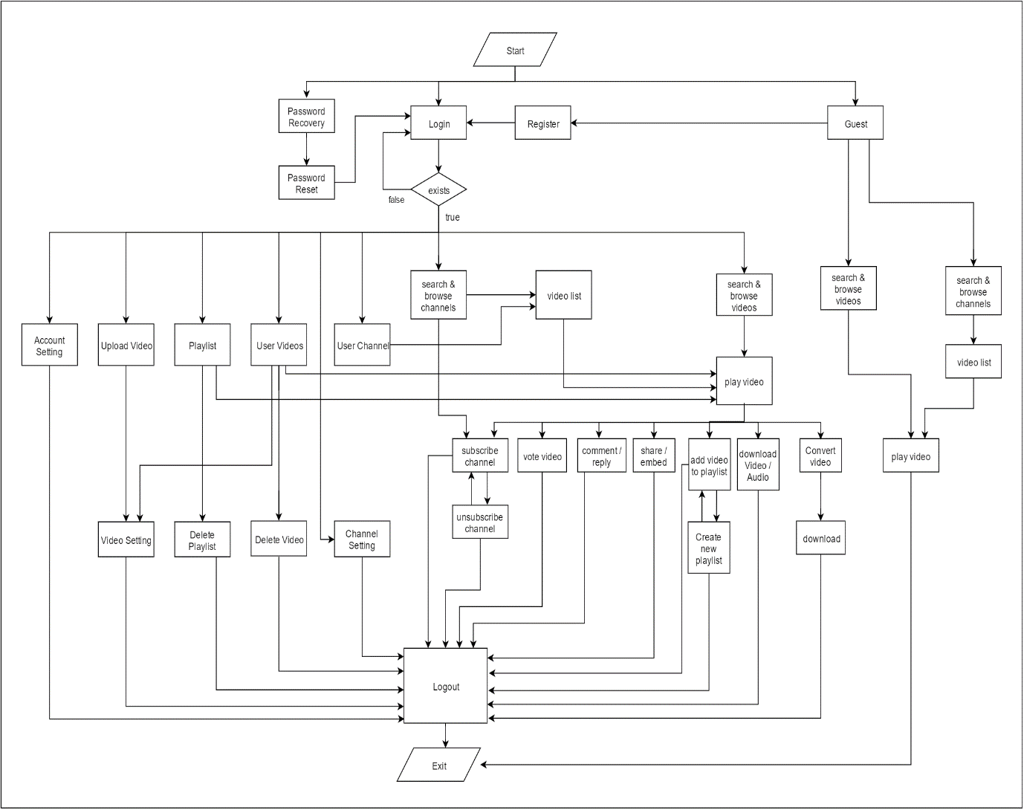

Use Case Diagram
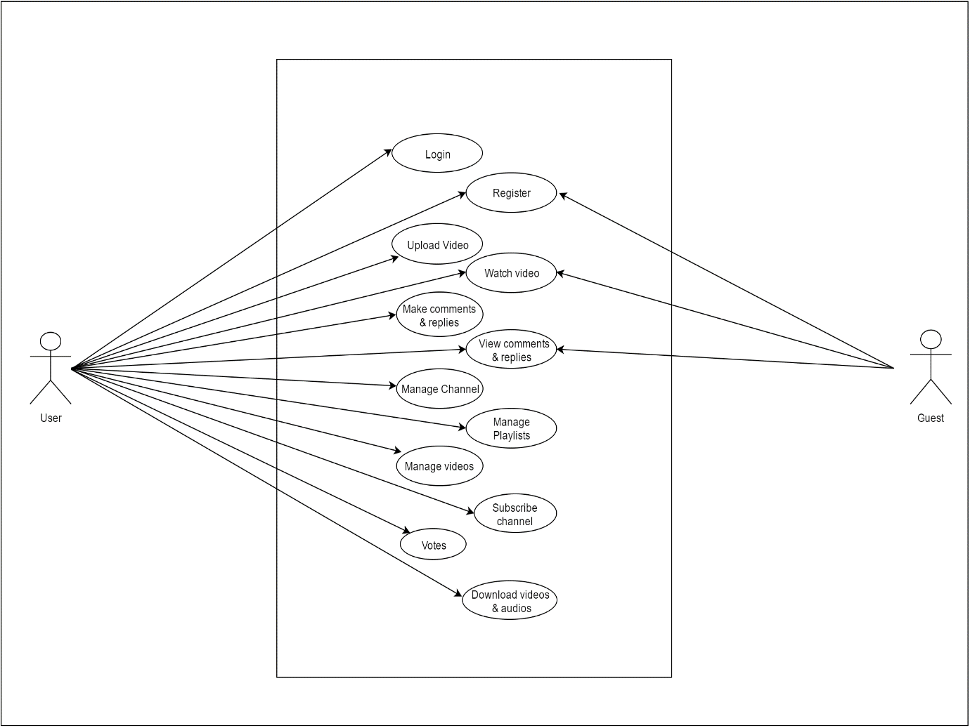

Data Flow Diagram
DEFINATION

Context Level Diagram

Level-1 Diagram
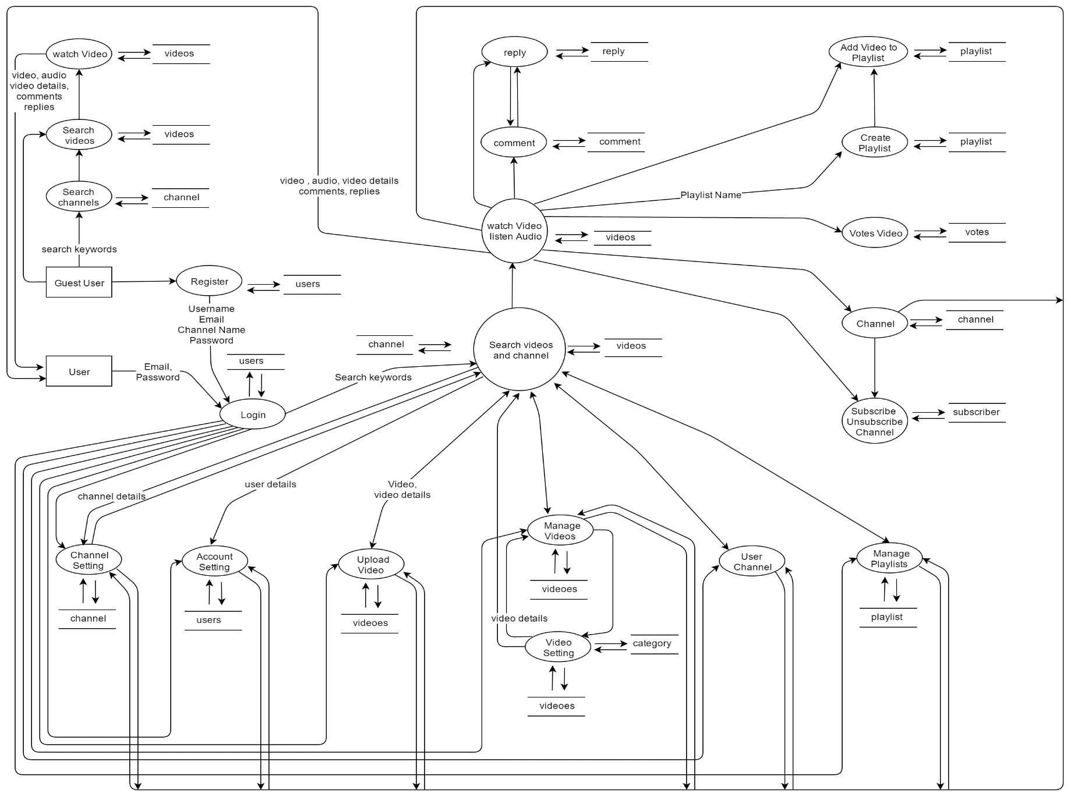

System Design

Entity Relationship Diagram
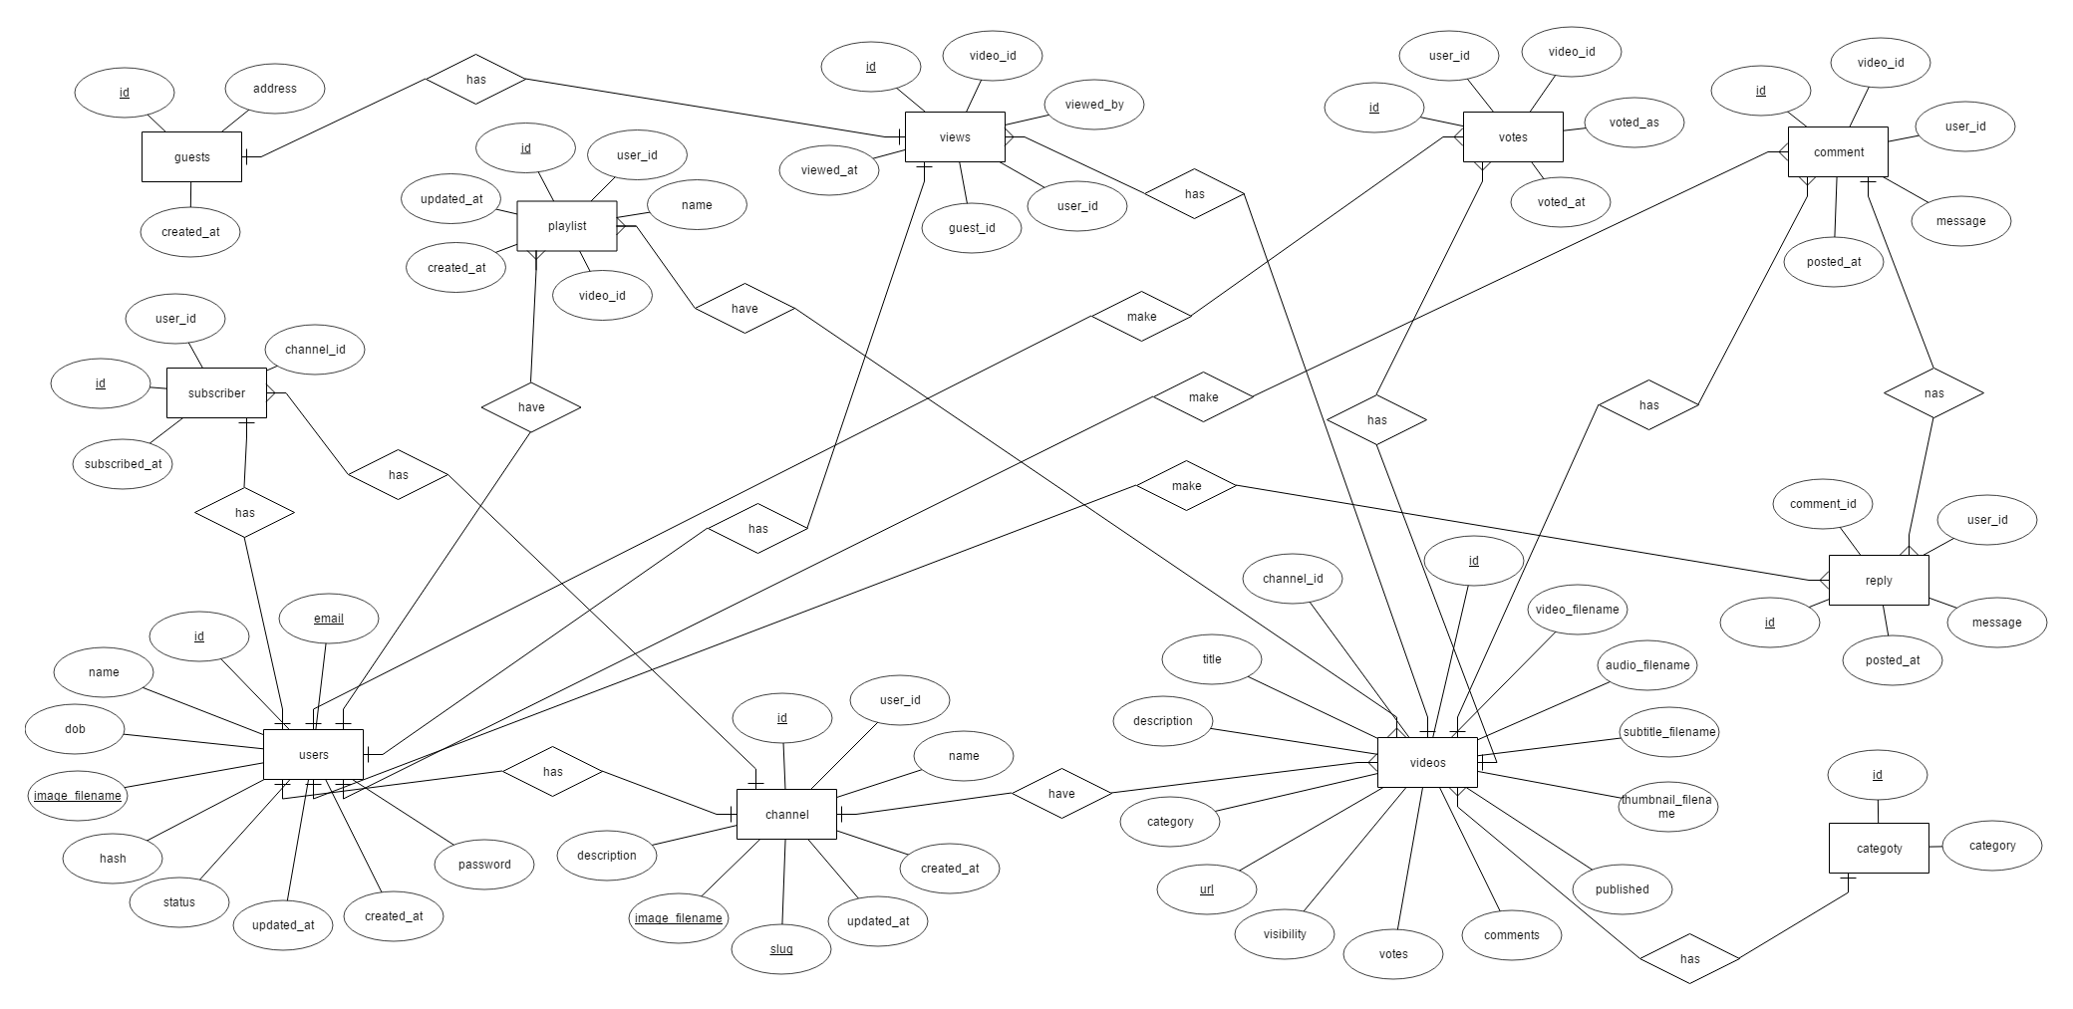
Database Schema Table Structure

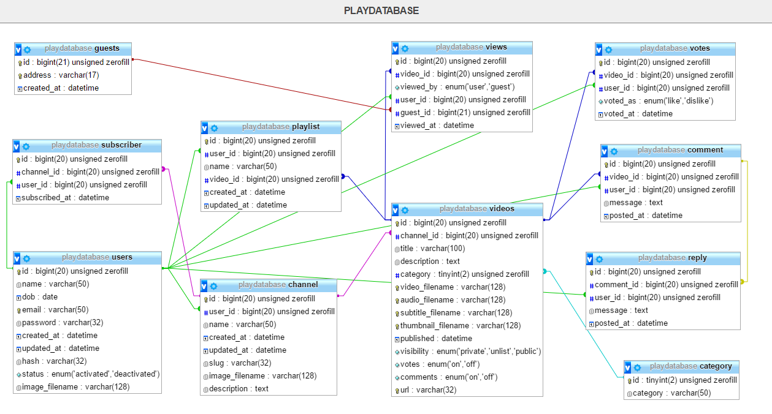
User Interface
Input Design
Output Design

Project is divided into three phases. They are:
- PHASE –I ------------------------------------------------Refer Annexure –I for details
  - Project Team Formation
  - Guide Allocation
  - Project title & Platform Selection
  - Synopsis Submission
- PHASE-II------------------------------------------------Refer Annexure –II for details
  - SDLC selection & timeline submission
  - Project Analysis &Feasibility Study Report
  - SRS-Functional & Non Functional Requirements
  - System Design Diagram ‘s
- PHASE-III------------------------------------------------Refer Annexure –III for details
  - Project Coding
  - Project Testing
  - Project Report Submission

Test ID | Test Scenario | Test Input | Expected Output | Actual Result | Paas/Fail
LOG1 | Check User login  With valid id and password | Id = vkd  Pass= qert373 | User should login | As expected | pass
LOG2 | Check User login  With valid id and wrong password | Id = vkd  Pass = abc | User cant login | As expected | pass
LOG3 | Check User login  With valid id and password for unregistered user | Id = Hitesh  Pass = idkiamnoob | User  Cant login | As expected | pass
LOG4 | Check User login  With wrong id and valid password | Id = gaurav  Pass= qert373 | User Cant Login | As expected | pass
LOG4 | No details provided | Id = null  Pass = null | User cant login | As expected | pass

