PARALLEL GRAPH PROCESSING ON SHARED-MEMORY MULTICORE SYSTEMS
A Comparative Case Study of Breadth-First Search and PageRank
Course: BCSE412L — Parallel Computing
Case studies: CS4–S01 Parallel BFS; CS4–S02 Parallel PageRank
School of Computer Science and Engineering
Semester: [confirm semester]
Batch ID: [enter batch ID]
Student names and IDs: [enter all members]
Faculty: [enter faculty name]
Submission date: [enter date]
Prepared from the uploaded experiment artifacts. Verify all metadata and course-specific formatting before submission.

Abstract
This study examines how two common graph algorithms—breadth-first search (BFS) and PageRank—behave when parallelized on a shared-memory machine using OpenMP. The experiments include both real-world and synthetic graphs. BFS uses a sequential queue-based baseline and a level-synchronous top-down parallel traversal. PageRank uses sequential and OpenMP pull-style power iteration, with static and dynamic scheduling. Experiments were run in a Kali GNU/Linux ARM64 environment reporting four logical CPU cores and 3.8 GB RAM. BFS was evaluated on six graph workloads; the best reported four-thread speedup was 3.11× on rmat-s20, while the smallest graph, ca-GrQc, became slower under OpenMP. PageRank was evaluated on five graph workloads and three R-MAT scales; the largest reported four-thread static speedup was 3.72× on rmat-s18, whereas web-Google and roadNet-CA scaled less effectively. The results show that graph structure, workload size, scheduling overhead, convergence iterations, and run-to-run variability all influence performance. Because this is a small single-machine study, conclusions are limited to the tested implementation and environment. The report retains observed results and explicitly notes anomalous variability rather than treating speedup as guaranteed.

1. Introduction
Graph algorithms are used in web analysis, social networks, recommendation systems, and scientific computing. Their irregular memory access patterns and uneven work distribution can make multicore parallelization less predictable than parallelizing dense numerical loops. This report combines two case studies: S01 studies BFS, which advances through a graph frontier level by level; S02 studies PageRank, which repeatedly updates vertex scores until a convergence criterion is reached.

1.1 Research questions
- S01: How do graph size and structure affect BFS runtime, traversal throughput, and speedup?
- S02: How do graph size, edge count, degree distribution, and scheduling policy affect PageRank runtime and scalability?
- Across both kernels: What evidence indicates overheads from synchronization, scheduling, or insufficient parallel work?

1.2 Objectives
- Compare sequential baselines with OpenMP implementations using measured runtimes.
- Report speedup, efficiency, throughput, graph properties, and variability.
- Compare static and dynamic scheduling for PageRank.
- Document the tested environment, correctness checks, limitations, and reproducible artifacts.

2. Background

2.1 Breadth-First Search
BFS discovers vertices by increasing distance from a source. The supplied implementation uses a sequential queue-based baseline and a level-synchronous top-down OpenMP traversal. Threads process frontier vertices, claim unvisited neighbours through atomic coordination, collect discoveries in thread-local buffers, and merge these buffers into the next frontier. A barrier separates levels. The implementation samples source vertices from the largest connected component, so the selected sources can reach the same vertex set.

2.2 PageRank
PageRank estimates the stationary importance of vertices under a random walk with restart. The supplied implementation uses pull-style updates over incoming adjacency lists, damping factor 0.85, and L1 convergence tolerance 1e-8 with a maximum of 100 iterations. Dangling rank is redistributed uniformly. Static scheduling assigns contiguous work; dynamic scheduling uses chunks of 64 vertices. The reported experiments reached convergence in the listed iteration counts.

2.3 Metrics
Metric | Definition / interpretation
Speedup | Median sequential runtime divided by median parallel runtime for the same dataset.
Efficiency | Speedup divided by thread count; values below 1 indicate less-than-linear scaling.
BFS MTEPS | Adjacency entries scanned per second in millions; for symmetrised graphs, each undirected edge is represented twice.
PageRank MEPS | Million CSR adjacency entries read per second.
CV (%) | Coefficient of variation of runtime; high values signal unstable measurements.
PageRank time per iteration | Total measured runtime divided by the reported iteration count.

3. Experimental Environment
Environment metadata from the S02 artifact reports Kali GNU/Linux Rolling, Linux kernel 6.6.15-arm64, ARM64 architecture, four logical CPUs, one thread per core, and 3.8 GB RAM. The compiler is g++ 13.2.0 (Debian). The hardware string identifies the environment as an Apple-vendor ARM system, but does not provide a specific model name. This report therefore does not infer a specific CPU model.
Setting | Recorded value
Operating system | Kali GNU/Linux Rolling
Kernel / architecture | 6.6.15-arm64 / aarch64
CPU resources | 4 logical CPUs; 4 cores reported; 1 thread per core
RAM | 3.8 GB
Compiler | g++ 13.2.0
PageRank damping | 0.85
PageRank tolerance / iteration cap | 1e-8 / 100
Thread configurations | 1, 2, 4
PageRank schedules | static; dynamic chunk 64
Timing excludes graph loading and CSR construction; BFS timing covers traversal only, and the README states that distance-array reset is excluded while OpenMP region startup is included. PageRank graph loading and transposition are also recorded separately from the timed iteration loop. Profiled rows are diagnostic and should not be mixed with unprofiled headline timings.

4. Datasets

4.1 BFS workloads
Dataset | Vertices | Adjacency entries | BFS levels | Structure
ca-GrQc | 5,242 | 28,968 | 12 | Undirected SNAP graph
email-Enron | 36,692 | 367,662 | 9 | Undirected SNAP graph
rmat-s16 | 65,536 | 1,819,896 | 6 | Synthetic R-MAT
roadNet-CA | 1,965,206 | 5,533,214 | 690 | Road network
rmat-s18 | 262,144 | 7,610,360 | 6 | Synthetic R-MAT
rmat-s20 | 1,048,576 | 31,400,212 | 7 | Synthetic R-MAT

4.2 PageRank workloads
Dataset | Vertices | Adjacency entries | Directed? | Notable graph statistic
ca-GrQc | 5,242 | 28,968 | No | In-degree Gini 0.555
email-Enron | 36,692 | 367,662 | No | In-degree Gini 0.730
web-Google | 875,713 | 5,105,039 | Yes | 136,259 dangling vertices; max in-degree 6,326
roadNet-CA | 1,965,206 | 5,533,214 | No | In-degree Gini 0.186
rmat-s16 | 65,536 | 1,819,896 | No | In-degree Gini 0.868
rmat-s18 | 262,144 | 7,610,360 | No | In-degree Gini 0.895
rmat-s20 | 1,048,576 | 31,400,212 | No | In-degree Gini 0.915
The PageRank summary table includes five named workload families (ca-GrQc, email-Enron, web-Google, roadNet-CA, and three R-MAT scales). These include both directed and undirected inputs, so their behaviour should not be interpreted as a controlled directedness comparison.

5. Methodology

5.1 S01 BFS
The baseline is sequential queue-based BFS. The parallel version is level-synchronous top-down BFS using OpenMP and dynamically scheduled frontier chunks. Each parallel run is checked against sequential distances; the project documentation states that any mismatch aborts execution. The reported BFS measurements aggregate sampled sources and repetitions. Graph loading and CSR construction are outside the traversal timing.

5.2 S02 PageRank
The sequential and parallel implementations use pull-style PageRank. The graph is stored in CSR form and transposed once so that each destination can traverse its incoming neighbours. Each iteration computes vertex contributions and dangling mass, then pulls contributions into each destination rank and accumulates L1 change. The OpenMP version uses one parallel region and runtime scheduling. The report uses the final generated summary table and preserves the pilot backup as a separate run set.

5.3 Reproducibility and correctness
The package includes source code, experiment and analysis scripts, raw CSV files, environment metadata, and plots. BFS includes a test executable and test source. The PageRank folder contains a file named tests/test_bfs.cpp rather than an obviously PageRank-specific test file, so the archive alone does not demonstrate a separate PageRank unit-test suite. The PageRank master rows mark runs as verified and converged, with final L1 change below tolerance; the implementation and correctness checks should be retained with the submission.

6. Results: S01 Parallel BFS
Table 1 presents the sequential baseline and four-thread OpenMP results from the generated BFS summary. Speedup is calculated against the sequential median.
Dataset | Seq. ms | OpenMP 4T ms | Speedup | Efficiency | CV at 4T
ca-GrQc | 0.083 | 0.121 | 0.68× | 0.17 | 52.2%
email-Enron | 0.607 | 0.328 | 1.85× | 0.46 | 104.0%
rmat-s16 | 2.314 | 0.964 | 2.40× | 0.60 | 34.5%
roadNet-CA | 35.518 | 14.605 | 2.43× | 0.61 | 1.2%
rmat-s18 | 14.399 | 4.932 | 2.92× | 0.73 | 40.8%
rmat-s20 | 84.276 | 27.095 | 3.11× | 0.78 | 9.5%
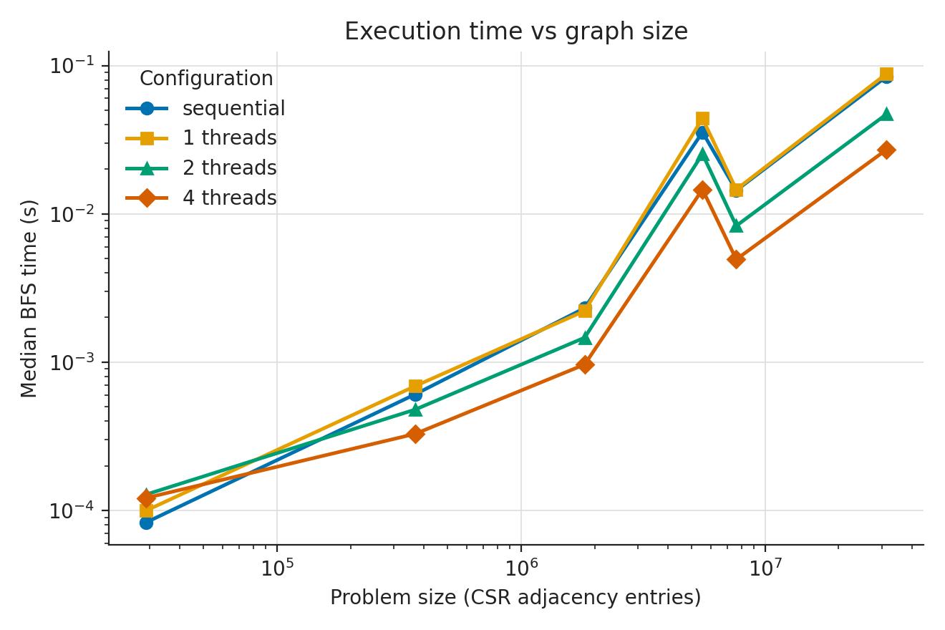
Figure 1. BFS runtime versus graph size.
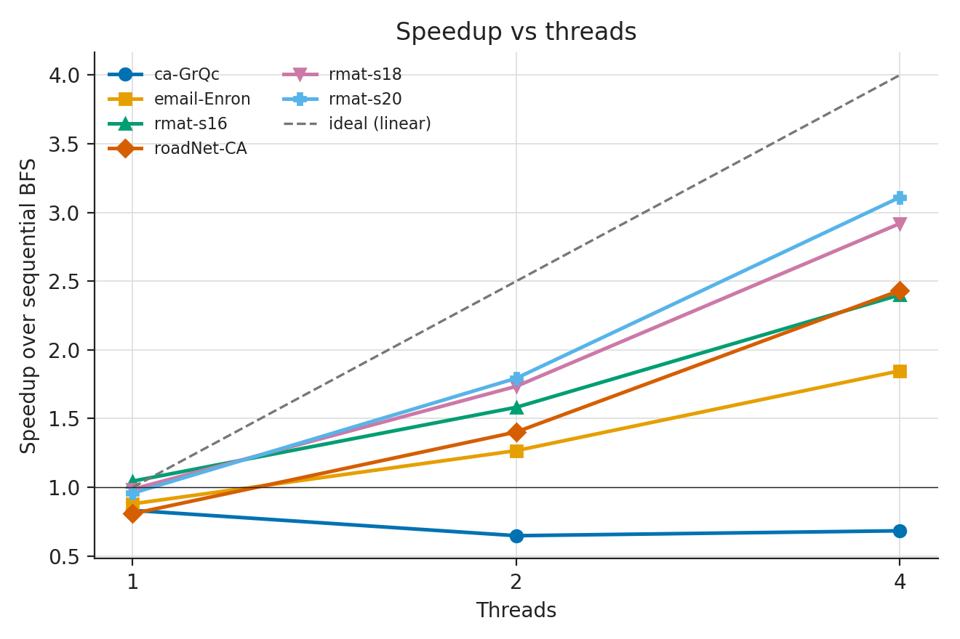
Figure 2. BFS speedup versus thread count.
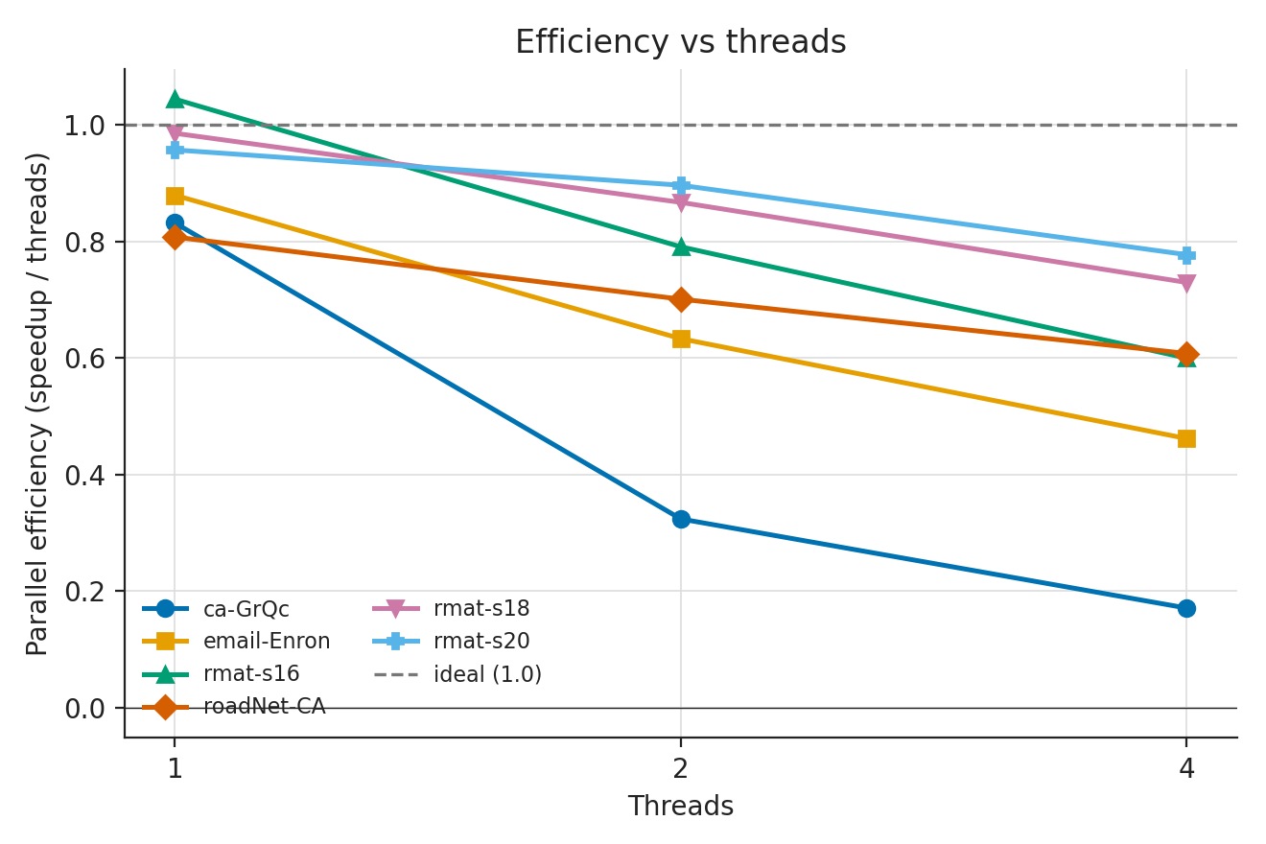
Figure 3. BFS parallel efficiency.
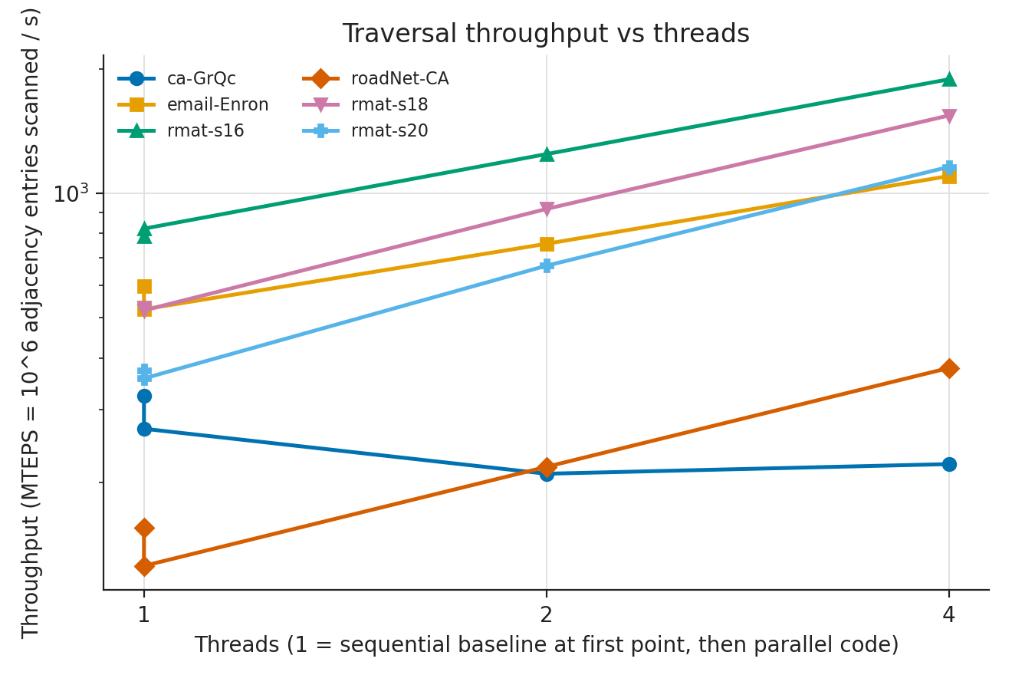
Figure 4. BFS throughput.

6.1 Discussion of BFS results
The best reported four-thread speedup is 3.11× on rmat-s20, with 0.78 efficiency. rmat-s18 reaches 2.92×, while roadNet-CA reaches 2.43× despite its much larger BFS depth of 690 levels. In contrast, ca-GrQc slows from 0.083 ms sequentially to 0.121 ms with four threads (0.68× speedup), consistent with parallel overhead dominating a very small workload.
Variability limits confidence in some comparisons. The reported coefficient of variation for email-Enron at four threads is 104%, and for rmat-s18 at four threads is 40.8%. These values are large relative to the median and mean the reported medians should be interpreted cautiously. The roadNet-CA four-thread CV is only 1.2%, making that measurement comparatively stable. The results support the limited conclusion that larger workloads often benefit more from parallelism, but topology and variability prevent a simple size-only rule.

7. Results: S02 Parallel PageRank
Table 2 compares the sequential baseline with the four-thread static and dynamic scheduling results in the final PageRank summary.
Dataset | Seq. ms | Static 4T ms | Static speedup | Dynamic 4T ms | Dynamic speedup
ca-GrQc | 5.719 | 2.054 | 2.78× | 2.881 | 1.99×
email-Enron | 57.863 | 35.707 | 1.62× | 18.590 | 3.11×
rmat-s16 | 72.778 | 19.937 | 3.65× | 20.882 | 3.49×
web-Google | 1502.129 | 787.993 | 1.91× | 903.606 | 1.66×
roadNet-CA | 1529.891 | 848.158 | 1.80× | 1118.377 | 1.37×
rmat-s18 | 395.737 | 106.335 | 3.72× | 131.973 | 3.00×
rmat-s20 | 1894.667 | 938.272 | 2.02× | 978.942 | 1.94×
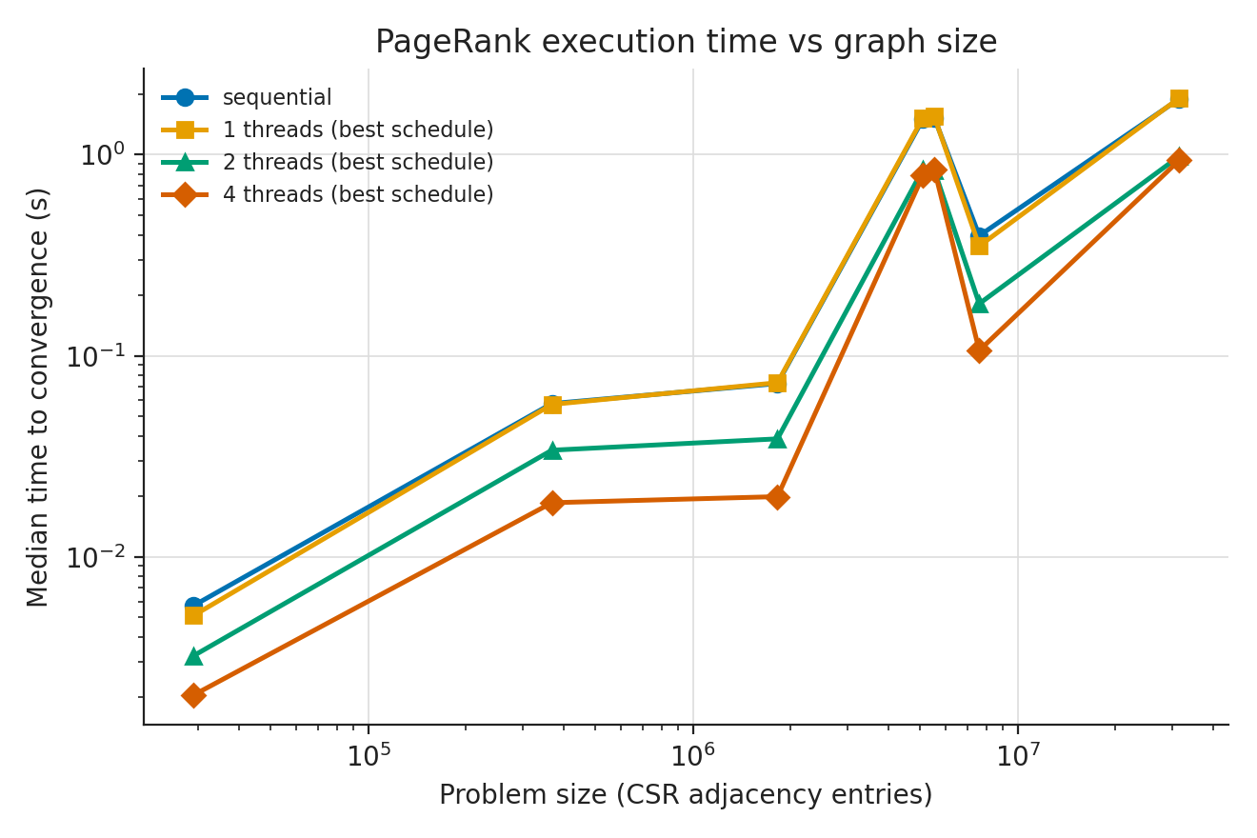
Figure 5. PageRank total runtime by workload.
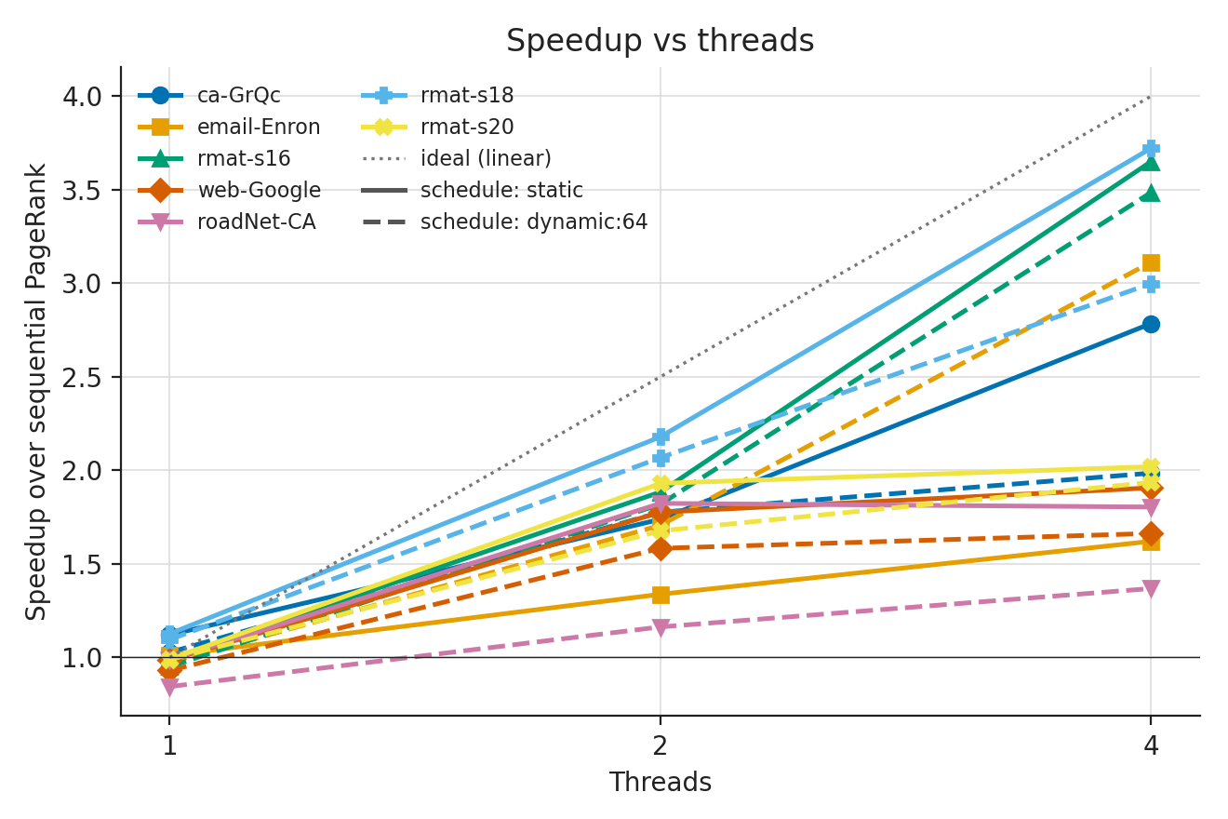
Figure 6. PageRank speedup versus thread count.
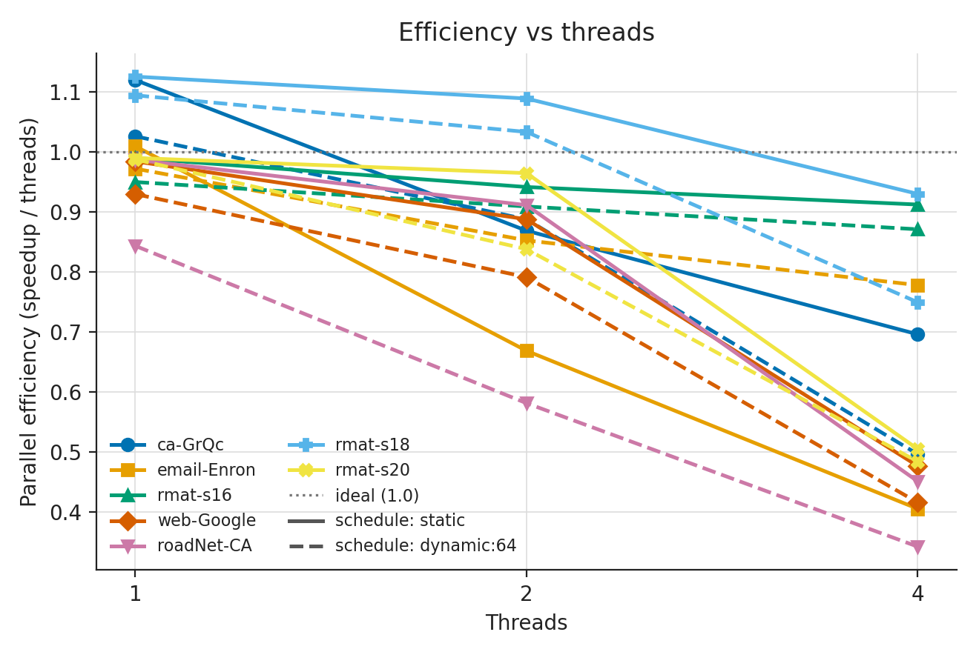
Figure 7. PageRank efficiency versus thread count.
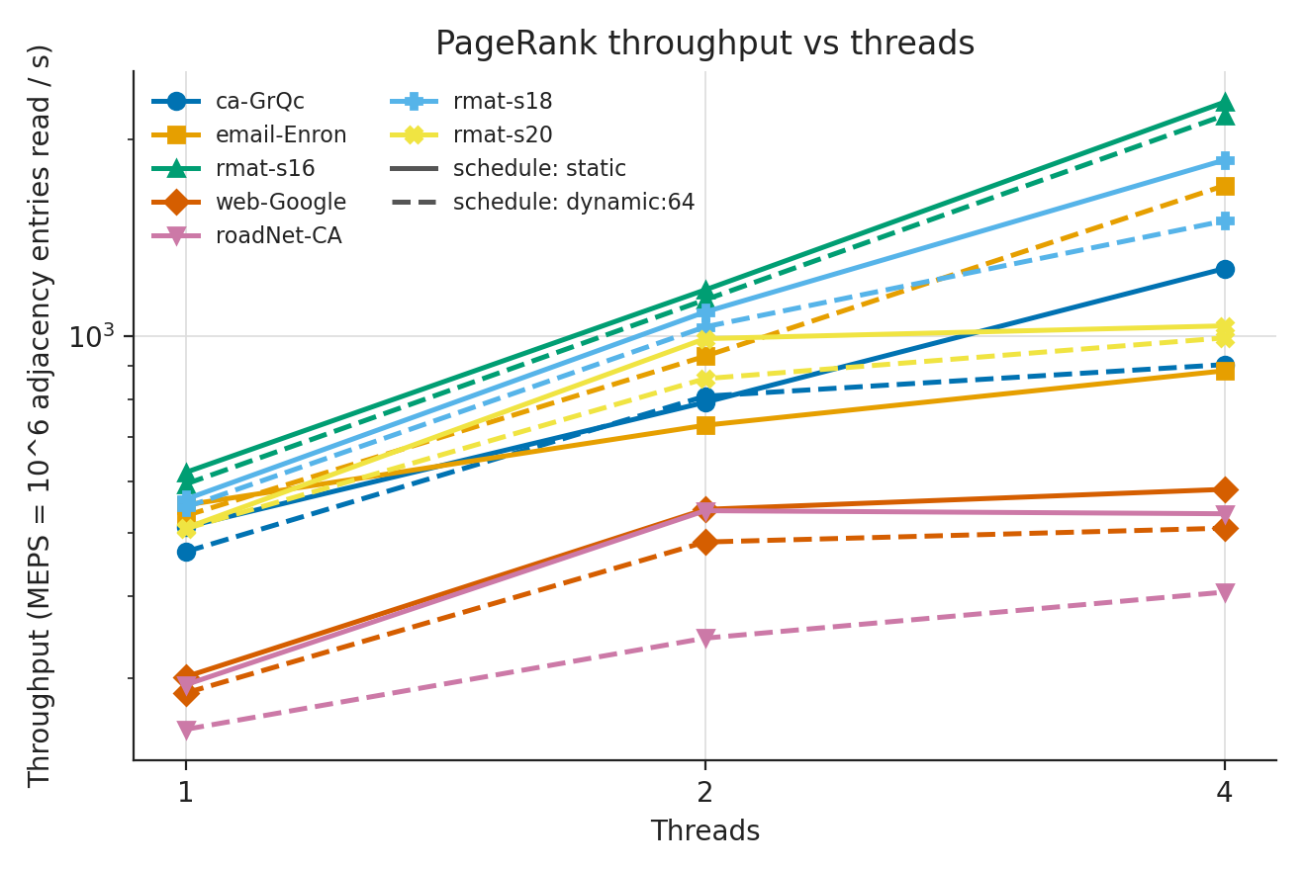
Figure 8. PageRank throughput.
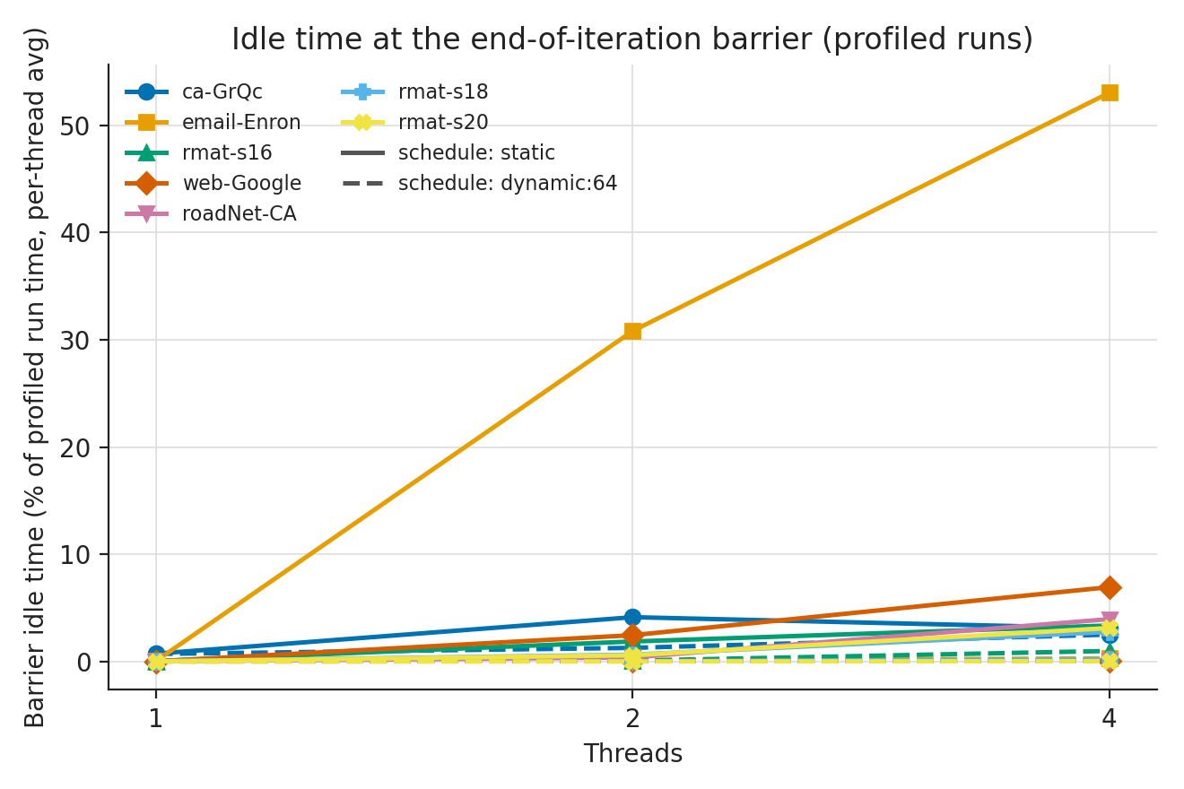
Figure 9. PageRank barrier idle time.
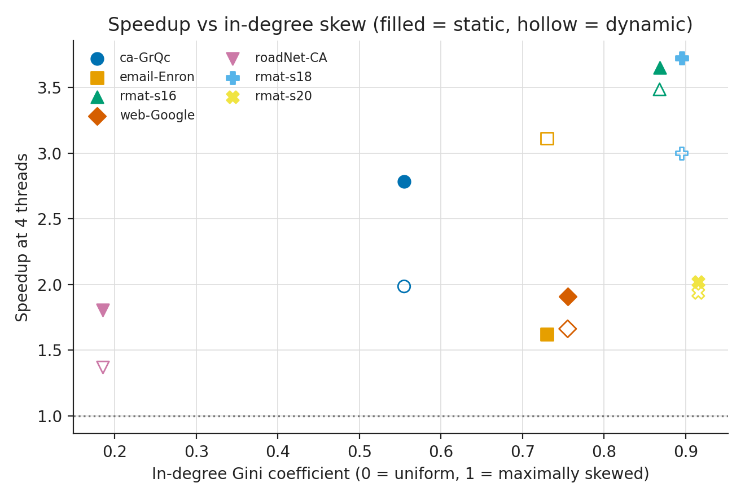
Figure 10. PageRank speedup and in-degree Gini coefficient.

7.1 PageRank scheduling and graph structure
Static scheduling is faster in the four-thread results for ca-GrQc (2.78× versus 1.99×), rmat-s16 (3.65× versus 3.49×), web-Google (1.91× versus 1.66×), roadNet-CA (1.80× versus 1.37×), rmat-s18 (3.72× versus 3.00×), and rmat-s20 (2.02× versus 1.94×). email-Enron is the exception: dynamic scheduling reaches 3.11×, compared with 1.62× for static. This suggests dynamic scheduling can help some degree distributions but adds overhead or performs worse on others.
The R-MAT graphs have high in-degree Gini coefficients (0.868–0.915), reflecting skewed degree distributions. However, the highest speedup does not simply increase with graph size: rmat-s18 reaches 3.72× with static scheduling, while rmat-s20 reaches 2.02×. The roadNet-CA result also shows that more adjacency entries alone do not guarantee stronger scaling.
The iteration counts range from 25 to 90 in the generated summary. Since total time depends on both work per iteration and number of iterations, comparisons should use time per iteration alongside total convergence time. The MEPS metric describes the adjacency entries read per second and is implementation- and machine-dependent rather than a universal performance score.

7.2 Measurement caveats
Some PageRank timing coefficients of variation are high: ca-GrQc dynamic four-thread CV is 140.0%, and web-Google static four-thread CV is 21.9%. Results for configurations with high CV should be interpreted cautiously and, if time permits, rerun with more repetitions under controlled conditions. The project has a pilot_backup directory; the report uses the final summary table rather than combining pilot and final-run measurements.

8. Cross-kernel comparison
Dimension | BFS (S01) | PageRank (S02) | Interpretation
Work pattern | Frontier and level based | Repeated whole-graph iterations | BFS work depends on source and frontier; PageRank repeats adjacency scans.
Stopping condition | Frontier becomes empty | L1 change below tolerance or iteration cap | PageRank cost includes convergence iterations.
Synchronization | Level barriers and frontier merge | Iteration phases and reductions | Repeated barriers can limit scaling.
Throughput | MTEPS | MEPS | Definitions differ; raw throughput numbers should not be compared directly.
Best four-thread speedup | 3.11× on rmat-s20 | 3.72× static on rmat-s18 | Best cases differ by kernel and graph.
Small-workload behaviour | ca-GrQc slower at 2T/4T | Small graph can still accelerate, but CV is high | Overheads and measurement noise matter.
The kernels should not be compared by raw elapsed seconds because they perform different work and use different stopping criteria. The meaningful comparison is the shape of scaling and the influence of graph structure, synchronization, scheduling, and workload size.

9. Limitations and Threats to Validity
- All measurements were collected on one environment reporting four logical CPUs and 3.8 GB RAM; results may differ on physical multicore servers.
- The hardware metadata does not identify a specific CPU model, so hardware-specific generalization is not justified.
- Some configurations exhibit high runtime CV, which reduces confidence in their relative ranking.
- BFS uses top-down level-synchronous traversal only; direction-optimizing or work-stealing variants were not compared.
- PageRank conclusions depend on damping, tolerance, iteration cap, dangling-node handling, and the directedness of the input.
- The PageRank sparsity question is only partially isolated: the dataset sweep changes graph family and other properties, not just edge count. A fixed-vertex Erdős–Rényi edge-density sweep would be needed to make a stronger causal claim about sparsity alone.
- Profiled instrumentation can perturb execution and should be reported separately from normal timing.
- No energy measurements are reported, and scheduling time is not independently measured by the OpenMP runtime in these artifacts.

10. Conclusion
The experiments show that parallel graph-kernel performance depends on workload size and graph structure rather than thread count alone. For BFS, four-thread speedup ranges from 0.68× on ca-GrQc to 3.11× on rmat-s20. The smallest workload is too short to amortize parallel overhead, while larger synthetic graphs benefit more substantially. For PageRank, the best four-thread result is 3.72× on rmat-s18 with static scheduling. Static scheduling outperforms dynamic scheduling on most tested PageRank datasets, but email-Enron is a clear exception where dynamic scheduling is substantially faster. Larger graphs do not always scale better, and high run-to-run variability makes some observations provisional. The study therefore supports workload-specific tuning and careful reporting of variability, rather than a universal claim that larger or sparser graphs always achieve higher speedup.

10.1 Future work
- Repeat experiments with more timed repetitions and controlled CPU load; report medians and spread.
- Run on a machine with more physical cores and record thread affinity and CPU model.
- Add a fixed-vertex Erdős–Rényi sweep varying only edge probability to isolate sparsity.
- Compare alternative BFS strategies, vertex reorderings, and PageRank memory layouts.
- Use platform-supported performance counters for memory bandwidth and energy if available.

11. Reproducibility checklist
- ☐ Keep both source folders and Makefiles with the submission.
- ☐ Include raw CSVs, summary CSVs, environment files, and plot scripts.
- ☐ State exact commands and configuration variables used for the final runs.
- ☐ Keep pilot and final runs separate; do not merge their CSVs without marking the run set.
- ☐ Verify all report numbers against the included summary tables.
- ☐ Add batch ID, team member names/IDs, faculty, semester, and date.
- ☐ Verify the course manual’s page count, citation style, and submission format before exporting.

References
- [1] L. Page, S. Brin, R. Motwani, and T. Winograd, “The PageRank Citation Ranking: Bringing Order to the Web,” Stanford InfoLab technical report, 1998.
- [2] I. C. F. Ipsen and T. M. Selee, “PageRank Computation, with Special Attention to Dangling Nodes,” SIAM Journal on Matrix Analysis and Applications, vol. 29, no. 4, pp. 1281–1296, 2007, doi:10.1137/060664331.
- [3] S. Beamer, K. Asanović, and D. Patterson, “The GAP Benchmark Suite,” arXiv:1508.03619, 2015.
- [4] G. Szárnyas et al., “LAGraph: Linear Algebra, Network Analysis Libraries, and the Study of Graph Algorithms,” arXiv:2104.01661, 2021.
- [5] D. Chakrabarti, Y. Zhan, and C. Faloutsos, “R-MAT: A Recursive Model for Graph Mining,” Proceedings of the SIAM International Conference on Data Mining, 2004.
- [6] Stanford Network Analysis Project, “web-Google,” SNAP dataset page. Verify access date and dataset details in the final submission.
- [7] S. Beamer, K. Asanović, and D. Patterson, “Direction-Optimizing Breadth-First Search,” SC ’12: Proceedings of the International Conference on High Performance Computing, Networking, Storage and Analysis, 2012. Verify bibliographic details before final submission.

Appendix A. Artifact inventory
S01 archive includes src/graph.hpp, src/bfs.hpp, src/bfs_bench.cpp, tests/test_bfs.cpp, scripts/run_experiments.sh, scripts/analyze.py, raw and summary CSVs, environment metadata, and BFS figures.
S02 archive includes src/graph.hpp, src/pagerank.hpp, src/pagerank_bench.cpp, scripts/run_pagerank.sh, scripts/analyze_pagerank.py, raw and summary CSVs, graph statistics, schedule comparison, overhead output, environment metadata, figures, and a pilot_backup directory.
The S02 package now has a PageRank-specific README and Makefile, plus a small PageRank smoke test that checks the uniform-rank solution on a two-vertex graph for sequential, static-schedule, and dynamic-schedule execution. This is a focused correctness check, not comprehensive coverage of all datasets or parameter settings. Full benchmark reproduction should still be performed on the submission machine.

Appendix B. Packaging and clean-run procedure
The accompanying ZIP keeps both case studies in one project folder so the source, scripts, results, and report travel together. Large source datasets and machine-specific binaries are intentionally excluded; the recorded CSV outputs and figures are retained.

Recommended validation sequence
- Extract the ZIP into a new directory rather than testing only in the working folder.
- Run `make clean && make test` in both S01_Parallel_BFS and S02_Parallel_PageRank.
- Confirm that the PageRank build produces `bin/pagerank_bench` and its smoke test prints `PAGERANK TESTS PASSED`.
- Download only the datasets needed for the run and record their source, version, checksum, and preprocessing.
- Run a small test configuration first; inspect the log and output CSV before launching the full benchmark.
- Regenerate the analysis tables and plots from the raw CSVs, then compare the summary values with the report.
- Replace all cover-page placeholders and verify the course's required citation style and submission format.

What the current results do—and do not—show
The archived results support workload-specific observations about scaling and scheduling on the recorded four-logical-CPU ARM64 environment. They do not establish that the same speedups will hold on other processors, and the PageRank workload set does not isolate sparsity as a single independent variable. High-variability configurations should be treated as suggestive rather than decisive. No fabricated or estimated measurements have been added.

