🧠 The Big Picture (start here)
Think of NLP systems like a language factory:
- Encoder → understands language
- Decoder → generates language
- Transformer → the architecture that powers both
- BERT → encoder-based model
- GPT → decoder-based model
Transformer (the foundation)
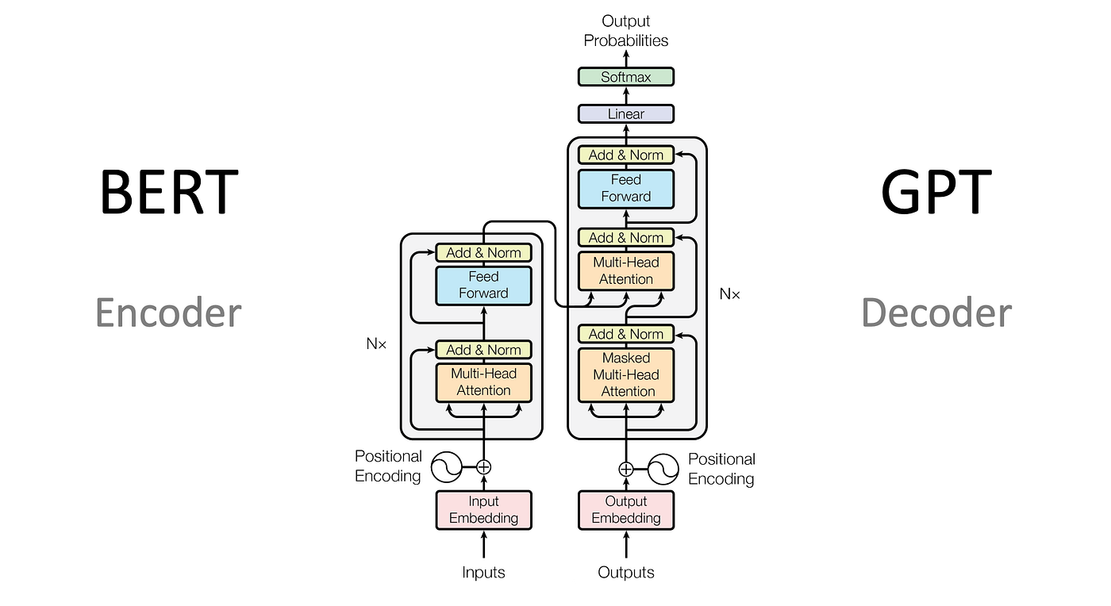
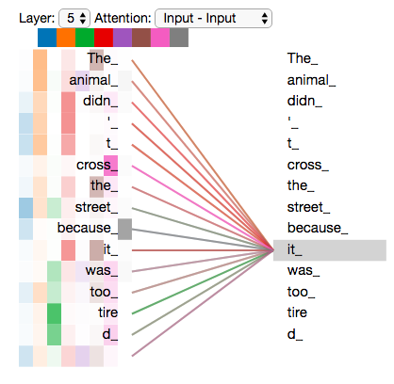
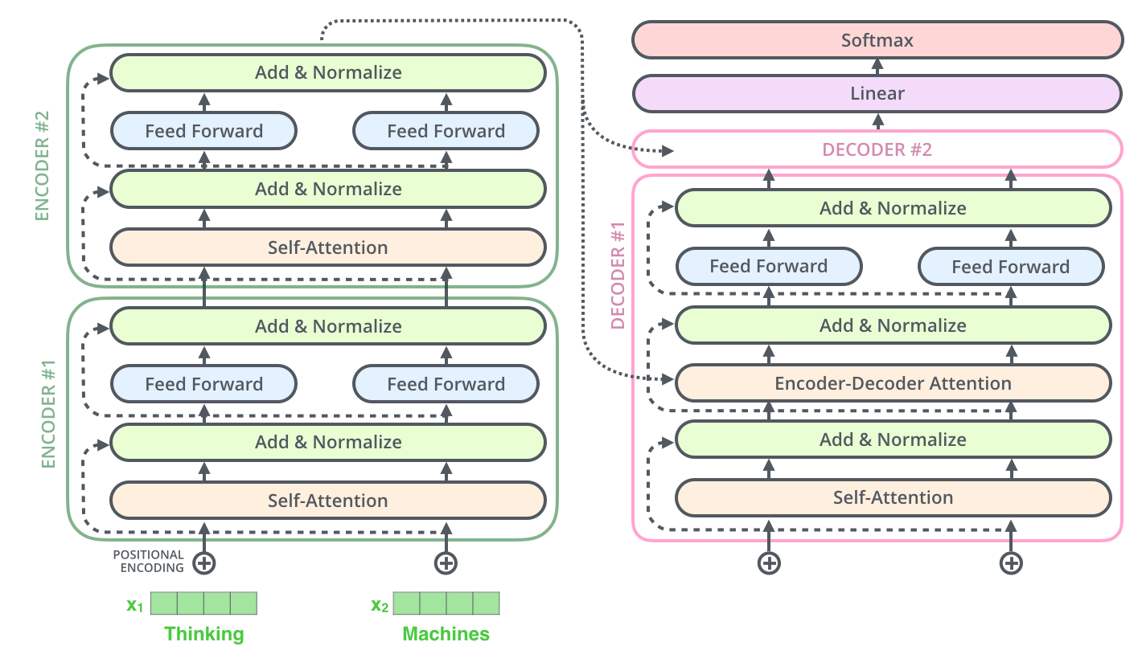
What it is:
A deep learning architecture introduced in the “Attention Is All You Need” paper.
Key idea:
Instead of reading text word-by-word (like older models), it uses attention to look at all words at once and figure out relationships.
Why it matters:
- Handles context much better
- Enables parallel processing (faster training)
- Became the backbone of all modern NLP
**Without transformers, no BERT, no GPT.

ENCODER
What it does:
Takes input text and turns it into a meaningful (numerical) representation (embeddings).
The encoder is the part of the transformer that reads and understands text.
- It takes a sentence and converts it into a numerical representation (embedding)
- It uses attention to understand how words relate to each other
Output: a structured representation of meaning
Think of it like:
“What does this sentence mean?”
Example:
Input: “The bank is near the river”
Encoder figures out: “bank = riverbank, not financial institution”
Used for:
- Classification (spam detection)
- Sentiment analysis
- Search / embeddings
- Named entity recognition

DECODER
What it does:
Takes context and generates text step-by-step.
Think of it like:
“Given what I know so far, what comes next?”
Example:
Input: “The cat sat on the…”
Decoder predicts: “mat”
Used for:
- Text generation
- Chatbots
- Translation
- Code generation

BERT (Encoder-based model)
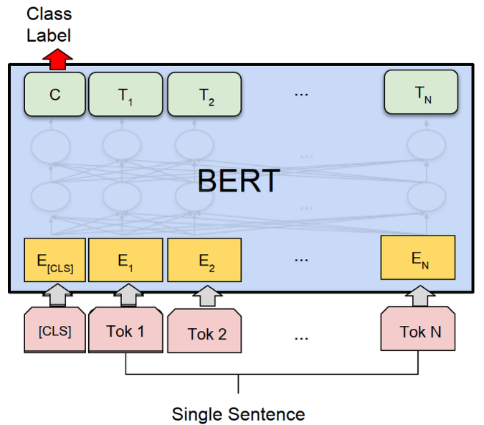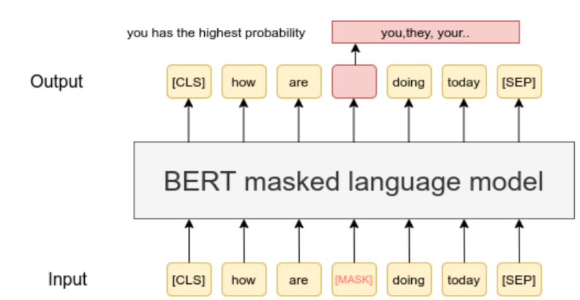

Key trait:
Bidirectional understanding → Looks at words before AND after a token
BERT uses only the encoder.
- It reads text in both directions (left and right)
- It is trained by hiding words and predicting them
How it learns:
- Masks words and predicts them
(“The cat sat on the [MASK]”)
Strength: Deep understanding of context
Best for:
- Classification tasks
- Semantic search
• Sentiment analysis
- • Search engines
- Question answering (understanding, not generating)

GPT (Decoder-based model)
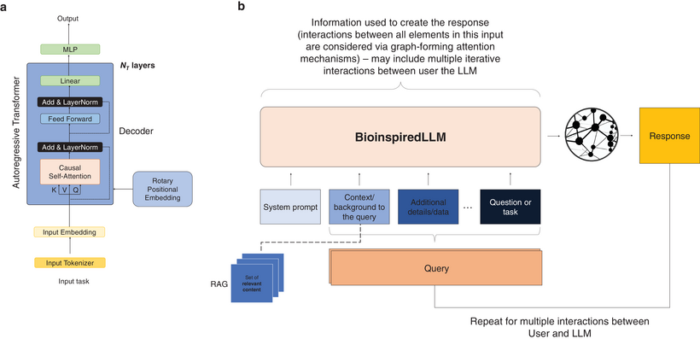
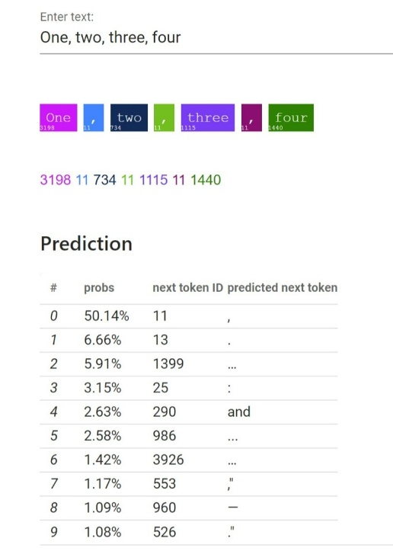
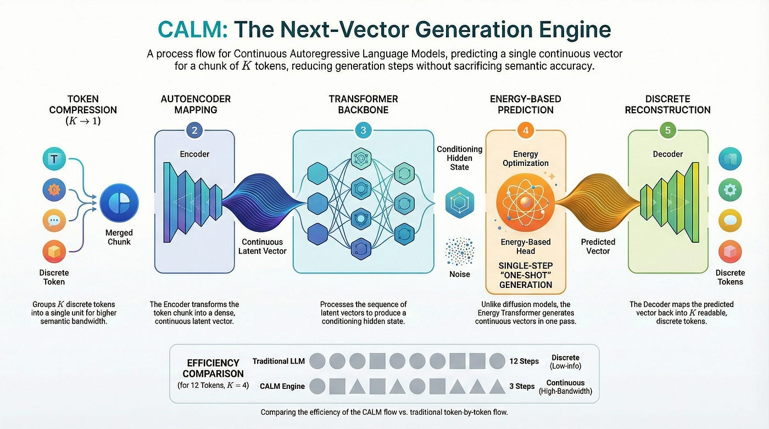
What it is: GPT
Key trait:
Autoregressive (one direction) → Predicts next word based on previous words only
How it learns:
- “Next token prediction”
Strength:
Natural language generation
Best for:
- Writing
- Chatbots
- Coding
- Creative tasks

How They ALL Fit Together
1. Transformer = the engine
- Provides the architecture (attention, layers)
2. Encoder = understanding module
- Reads and interprets text
3. Decoder = generation module
- Produces text
4. BERT = Encoder-only Transformer
- Uses only encoder stack
- Focus: understanding
5. GPT = Decoder-only Transformer
- Uses only decoder stack
- Focus: generation

Clean Mental Model
Component | Role | Real-world analogy
Transformer | Brain architecture | The wiring of a brain
Encoder | Comprehension | Reading & understanding
Decoder | Speech | Talking / writing
BERT | Deep reader | Analyst
GPT | Fluent speaker | Writer

Feature | Encoder | Decoder
Attention type | Full self-attention | Masked self-attention
Direction | Bidirectional | Left → right only
Goal | Understand text | Generate text
Sees future words? | ✅ Yes | ❌ No
Output | Meaning (embeddings) | Words (tokens)

Why This Matters
This isn’t just theory—you’ll see it everywhere:
- Cybersecurity → analyzing logs (BERT-style)
- AI apps → chatbots (GPT-style)
- Data pipelines → embeddings (encoder outputs)
- LLM security → prompt injection targets decoder behavior
The Shortcut Insight (this is gold)
If you remember nothing else:
BERT = understand text
GPT = generate text
Transformer = the system that makes both possible

