Министерство образования Республики Беларусь

БЕЛОРУССКИЙ ГОСУДАРСТВЕННЫЙ УНИВЕРСИТЕТ

Факультет прикладной математики и информатики

Ничипорук Роман Олегович

Конфигурация RIPv2 и ее проверка

Отчет по лабораторной работе № 9,
вариант 2
( “Компьютерные сети”)

студента 3-го курса 4-ой группы

Преподаватель
Горячкин В.В.

Вариант | Сеть 1 - 6
2 | 31.0.0.0/16  32.0.0.0/16  33.0.0.0/16  34.0.0.0/16  35.0.0.0/16  36.0.0.0/16

1. Задание 1. Проектирование сети
- Согласно вашему варианту задания составьте адресную схему сети.
- Используя CLI настроить сетевые интерфейсы всех устройств.
- Перед настройкой RIP назначьте IP-адреса и маски всем интерфейсам, задействованным в маршрутизации. Задайте при необходимости тактовую частоту для последовательных каналов.
- Подсети и интерфейсы маршрутизаторов подписать
R_NRO_1
Router#configure terminal
Enter configuration commands, one per line. End with CNTL/Z.
Router(config)#hostname R_NRO_1
R_NRO_1(config)#interface FastEthernet0/0
R_NRO_1(config-if)#ip address 34.0.0.1 255.255.0.0
R_NRO_1(config)#interface Serial0/0
R_NRO_1(config-if)#ip address 31.0.0.1 255.255.0.0
R_NRO_1(config)#interface Serial0/1
R_NRO_1(config-if)#ip address 33.0.0.2 255.255.0.0
R_NRO_2
Router>enable
Router#configure terminal
Enter configuration commands, one per line. End with CNTL/Z.
Router(config)#hostname R_NRO_2
R_NRO_2(config)#interface FastEthernet0/0
R_NRO_2(config-if)#ip address 35.0.0.1 255.255.0.0
R_NRO_2(config)#interface Serial0/1
R_NRO_2(config-if)#ip address 31.0.0.2 255.255.0.0
R_NRO_2(config)#interface Serial0/0
R_NRO_2(config-if)#ip address 32.0.0.1 255.255.0.0
R_NRO_3
Router>enable
Router#configure terminal
Enter configuration commands, one per line. End with CNTL/Z.
Router(config)#hostname R_NRO_3
R_NRO_3(config)#interface FastEthernet0/0
R_NRO_3(config-if)#ip address 36.0.0.1 255.255.0.0
R_NRO_3(config)#interface Serial0/0
R_NRO_3(config-if)#ip address 33.0.0.1 255.255.0.0
R_NRO_3(config)#interface Serial0/1
R_NRO_3(config-if)#ip address 32.0.0.2 255.255.0.0

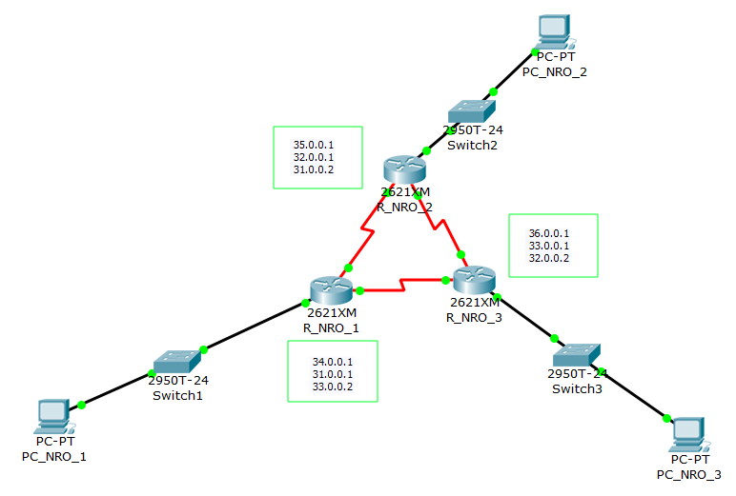

- После завершения базовой настройки выдайте таблицы маршрутизации и проанализируйте их содержимое.
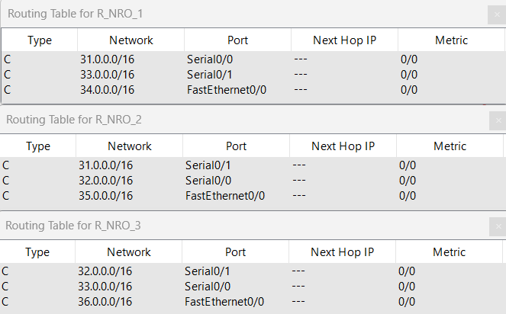

- Перейдите к настройте протокола RIP.

2. Задание 2

- Согласно вашему варианту задания, настройте RIPv2 на маршрутизаторах.
R_NRO_1
R_NRO_1>enable
R_NRO_1#configure terminal
Enter configuration commands, one per line. End with CNTL/Z.
R_NRO_1(config)#router rip
R_NRO_1(config-router)#network 34.0.0.0
R_NRO_1(config-router)#network 31.0.0.0
R_NRO_1(config-router)#network 33.0.0.0
R_NRO_2
R_NRO_2>enable
R_NRO_2#configure terminal
Enter configuration commands, one per line. End with CNTL/Z.
R_NRO_2(config)#router rip
R_NRO_2(config-router)#network 35.0.0.0
R_NRO_2(config-router)#network 32.0.0.0
R_NRO_2(config-router)#network 31.0.0.0
R_NRO_3
R_NRO_3>enable
R_NRO_3#configure terminal
Enter configuration commands, one per line. End with CNTL/Z.
R_NRO_3(config)#router rip
R_NRO_3(config-router)#network 36.0.0.0
R_NRO_3(config-router)#network 33.0.0.0
R_NRO_3(config-router)#network 32.0.0.0

Отметить особенности протокола RIP.
RIP – протокол маршрутизации, предназначен для динамической маршрутизации, т.е. создания таблиц маршрутизации без непосредственного участия администратора сети.
RIP – дистанционно-векторный протокол. В качестве метрики расстояния используется количество хопов (промежуточных маршрутизаторов, которые надо пройти на пути к сети). Для протокола RIP максимальный диаметр сети – 15. Маршрут с метрикой 16 считается недостижимым.

3. Задание 3. Тестирование протокола RIP
8. Использовать команды show ip protocols для инсталлированных протоколов и команду show ip route для просмотра таблиц маршрутизации всех маршрутизаторов.
show ip route
R_NRO_1
R_NRO_1#show ip route
Codes: C - connected, S - static, I - IGRP, R - RIP, M - mobile, B - BGP
D - EIGRP, EX - EIGRP external, O - OSPF, IA - OSPF inter area
N1 - OSPF NSSA external type 1, N2 - OSPF NSSA external type 2
E1 - OSPF external type 1, E2 - OSPF external type 2, E - EGP
i - IS-IS, L1 - IS-IS level-1, L2 - IS-IS level-2, ia - IS-IS inter area
* - candidate default, U - per-user static route, o - ODR
P - periodic downloaded static route

Gateway of last resort is not set

31.0.0.0/16 is subnetted, 1 subnets
C 31.0.0.0 is directly connected, Serial0/0
R 32.0.0.0/8 [120/1] via 31.0.0.2, 00:00:06, Serial0/0
[120/1] via 33.0.0.1, 00:00:13, Serial0/1
33.0.0.0/16 is subnetted, 1 subnets
C 33.0.0.0 is directly connected, Serial0/1
34.0.0.0/16 is subnetted, 1 subnets
C 34.0.0.0 is directly connected, FastEthernet0/0
R 35.0.0.0/8 [120/1] via 31.0.0.2, 00:00:06, Serial0/0
R 36.0.0.0/8 [120/1] via 33.0.0.1, 00:00:13, Serial0/1
R_NRO_2
R_NRO_2#show ip route
Codes: C - connected, S - static, I - IGRP, R - RIP, M - mobile, B - BGP
D - EIGRP, EX - EIGRP external, O - OSPF, IA - OSPF inter area
N1 - OSPF NSSA external type 1, N2 - OSPF NSSA external type 2
E1 - OSPF external type 1, E2 - OSPF external type 2, E - EGP
i - IS-IS, L1 - IS-IS level-1, L2 - IS-IS level-2, ia - IS-IS inter area
* - candidate default, U - per-user static route, o - ODR
P - periodic downloaded static route

Gateway of last resort is not set

31.0.0.0/16 is subnetted, 1 subnets
C 31.0.0.0 is directly connected, Serial0/1
32.0.0.0/16 is subnetted, 1 subnets
C 32.0.0.0 is directly connected, Serial0/0
R 33.0.0.0/8 [120/1] via 31.0.0.1, 00:00:25, Serial0/1
[120/1] via 32.0.0.2, 00:00:01, Serial0/0
R 34.0.0.0/8 [120/1] via 31.0.0.1, 00:00:25, Serial0/1
35.0.0.0/16 is subnetted, 1 subnets
C 35.0.0.0 is directly connected, FastEthernet0/0
R 36.0.0.0/8 [120/1] via 32.0.0.2, 00:00:01, Serial0/0

R_NRO_3
R_NRO_3#show ip route
Codes: C - connected, S - static, I - IGRP, R - RIP, M - mobile, B - BGP
D - EIGRP, EX - EIGRP external, O - OSPF, IA - OSPF inter area
N1 - OSPF NSSA external type 1, N2 - OSPF NSSA external type 2
E1 - OSPF external type 1, E2 - OSPF external type 2, E - EGP
i - IS-IS, L1 - IS-IS level-1, L2 - IS-IS level-2, ia - IS-IS inter area
* - candidate default, U - per-user static route, o - ODR
P - periodic downloaded static route

Gateway of last resort is not set

R 31.0.0.0/8 [120/1] via 32.0.0.1, 00:00:25, Serial0/1
[120/1] via 33.0.0.2, 00:00:24, Serial0/0
32.0.0.0/16 is subnetted, 1 subnets
C 32.0.0.0 is directly connected, Serial0/1
33.0.0.0/16 is subnetted, 1 subnets
C 33.0.0.0 is directly connected, Serial0/0
R 34.0.0.0/8 [120/1] via 33.0.0.2, 00:00:24, Serial0/0
R 35.0.0.0/8 [120/1] via 32.0.0.1, 00:00:25, Serial0/1
36.0.0.0/16 is subnetted, 1 subnets
C 36.0.0.0 is directly connected, FastEthernet0/0

show ip protocols
R_NRO_1
R_NRO_1#show ip protocols
Routing Protocol is "rip"
Sending updates every 30 seconds, next due in 5 seconds
Invalid after 180 seconds, hold down 180, flushed after 240
Outgoing update filter list for all interfaces is not set
Incoming update filter list for all interfaces is not set
Redistributing: rip
Default version control: send version 1, receive any version
Interface Send Recv Triggered RIP Key-chain
FastEthernet0/0 1 2 1
Serial0/0 1 2 1
Serial0/1 1 2 1
Automatic network summarization is in effect
Maximum path: 4
Routing for Networks:
31.0.0.0
33.0.0.0
34.0.0.0
Passive Interface(s):
Routing Information Sources:
Gateway Distance Last Update
31.0.0.2 120 00:00:23
33.0.0.1 120 00:00:00
--More--
R_NRO_2
R_NRO_2#show ip protocols
Routing Protocol is "rip"
Sending updates every 30 seconds, next due in 5 seconds
Invalid after 180 seconds, hold down 180, flushed after 240
Outgoing update filter list for all interfaces is not set
Incoming update filter list for all interfaces is not set
Redistributing: rip
Default version control: send version 1, receive any version
Interface Send Recv Triggered RIP Key-chain
FastEthernet0/0 1 2 1
Serial0/1 1 2 1
Serial0/0 1 2 1
Automatic network summarization is in effect
Maximum path: 4
Routing for Networks:
31.0.0.0
32.0.0.0
35.0.0.0
Passive Interface(s):
Routing Information Sources:
Gateway Distance Last Update
31.0.0.1 120 00:00:23
32.0.0.2 120 00:00:01
--More--
R_NRO_3
R_NRO_3#show ip protocols
Routing Protocol is "rip"
Sending updates every 30 seconds, next due in 21 seconds
Invalid after 180 seconds, hold down 180, flushed after 240
Outgoing update filter list for all interfaces is not set
Incoming update filter list for all interfaces is not set
Redistributing: rip
Default version control: send version 1, receive any version
Interface Send Recv Triggered RIP Key-chain
FastEthernet0/0 1 2 1
Serial0/1 1 2 1
Serial0/0 1 2 1
Automatic network summarization is in effect
Maximum path: 4
Routing for Networks:
32.0.0.0
33.0.0.0
36.0.0.0
Passive Interface(s):
Routing Information Sources:
Gateway Distance Last Update
32.0.0.1 120 00:00:26
33.0.0.2 120 00:00:26
--More--

- Результаты тестирования представить в отчете.
Pinging
R_NRO_1
PC>ping 35.0.0.2

Pinging 35.0.0.2 with 32 bytes of data:

Reply from 35.0.0.2: bytes=32 time=6ms TTL=126
Reply from 35.0.0.2: bytes=32 time=1ms TTL=126
Reply from 35.0.0.2: bytes=32 time=2ms TTL=126
Reply from 35.0.0.2: bytes=32 time=2ms TTL=126

Ping statistics for 35.0.0.2:
Packets: Sent = 4, Received = 4, Lost = 0 (0% loss),
Approximate round trip times in milli-seconds:
Minimum = 1ms, Maximum = 6ms, Average = 2ms

PC>ping 36.0.0.2

Pinging 36.0.0.2 with 32 bytes of data:

Reply from 36.0.0.2: bytes=32 time=1ms TTL=126
Reply from 36.0.0.2: bytes=32 time=1ms TTL=126
Reply from 36.0.0.2: bytes=32 time=1ms TTL=126
Reply from 36.0.0.2: bytes=32 time=3ms TTL=126

Ping statistics for 36.0.0.2:
Packets: Sent = 4, Received = 4, Lost = 0 (0% loss),
Approximate round trip times in milli-seconds:
Minimum = 1ms, Maximum = 3ms, Average = 1ms
R_NRO_2
PC>ping 36.0.0.2

Pinging 36.0.0.2 with 32 bytes of data:

Reply from 36.0.0.2: bytes=32 time=6ms TTL=126
Reply from 36.0.0.2: bytes=32 time=1ms TTL=126
Reply from 36.0.0.2: bytes=32 time=1ms TTL=126
Reply from 36.0.0.2: bytes=32 time=1ms TTL=126

Ping statistics for 36.0.0.2:
Packets: Sent = 4, Received = 4, Lost = 0 (0% loss),
Approximate round trip times in milli-seconds:
Minimum = 1ms, Maximum = 6ms, Average = 2ms

PC>ping 34.0.0.2

Pinging 34.0.0.2 with 32 bytes of data:

Reply from 34.0.0.2: bytes=32 time=1ms TTL=126
Reply from 34.0.0.2: bytes=32 time=1ms TTL=126
Reply from 34.0.0.2: bytes=32 time=4ms TTL=126
Reply from 34.0.0.2: bytes=32 time=6ms TTL=126

Ping statistics for 34.0.0.2:
Packets: Sent = 4, Received = 4, Lost = 0 (0% loss),
Approximate round trip times in milli-seconds:
Minimum = 1ms, Maximum = 6ms, Average = 3ms
R_NRO_3
PC>ping 35.00.0.2

Pinging 35.00.0.2 with 32 bytes of data:

Reply from 35.0.0.2: bytes=32 time=5ms TTL=126
Reply from 35.0.0.2: bytes=32 time=1ms TTL=126
Reply from 35.0.0.2: bytes=32 time=5ms TTL=126
Reply from 35.0.0.2: bytes=32 time=2ms TTL=126

Ping statistics for 35.0.0.2:
Packets: Sent = 4, Received = 4, Lost = 0 (0% loss),
Approximate round trip times in milli-seconds:
Minimum = 1ms, Maximum = 5ms, Average = 3ms

PC>ping 34.00.0.2

Pinging 34.00.0.2 with 32 bytes of data:

Reply from 34.0.0.2: bytes=32 time=7ms TTL=126
Reply from 34.0.0.2: bytes=32 time=8ms TTL=126
Reply from 34.0.0.2: bytes=32 time=9ms TTL=126
Reply from 34.0.0.2: bytes=32 time=10ms TTL=126

Ping statistics for 34.0.0.2:
Packets: Sent = 4, Received = 4, Lost = 0 (0% loss),
Approximate round trip times in milli-seconds:
Minimum = 7ms, Maximum = 10ms, Average = 8ms

- Сделать анализ таблиц маршрутизации, полученных в заданиях 5 и 9
По сравнению с пунктом 5 добавились маршруты к сетям, которые не подключены к маршрутизаторам через кабели, они были добавлены динамически с помощью протокола RIP и поэтому в таблице маршрутизации помечены буквой R. Расстояние до сети (метрику) маршрута так же можно увидеть в таблице маршрутизации в квадратных скобках [120 / метрика].

4. Задание 4. Конфигурирование пассивных интерфейсов

- Для заданной сети для всех маршрутизаторов определить и настроить пассивные интерфейсы.
Зачем иногда нужны пассивные интерфейсы?.
Passive interface
R_NRO_1
R_NRO_1>enable
R_NRO_1#configure terminal
Enter configuration commands, one per line. End with CNTL/Z.
R_NRO_1(config)#router rip
R_NRO_1(config-router)#passive-interface FastEthernet0/0
R_NRO_1(config-router)#
R_NRO_2
R_NRO_2>enable
R_NRO_2#configure terminal
Enter configuration commands, one per line. End with CNTL/Z.
R_NRO_2(config)#router rip
R_NRO_2(config-router)#passive-interface FastEthernet0/0
R_NRO_3
R_NRO_3>enable
R_NRO_3#configure terminal
Enter configuration commands, one per line. End with CNTL/Z.
R_NRO_3(config)#router rip
R_NRO_3(config-router)#passive-interface FastEthernet0/0
Роутер не может узнать о том, что в какой-то из сетей нет RIP устройств и туда нет необходимости отправлять пакеты протокола RIP для построения таблиц маршрутизации. Мы можем указать это роутеру и тогда мы не будем дополнительно занимать канал бесполезным (в данном случае) трафиком. Так же это позволит увеличить безопасность нашей сети, так как широковещательный трафик легко перехватить.

- Сравнить объем трафика c трафиком в предыдущих заданиях.
Объем трафика уменьшился так как роутеры больше не рассылают таблицы маршрутизации в сети для которых нет такой необходимости.

5. Задание 5. Тестирование сети
- Используя команды (какие?) и как Вы сможете проверить достижимость всех узлов пользователей.
Используем команд ping, traceroute
PC_1
PC>ping 35.0.0.2

Pinging 35.0.0.2 with 32 bytes of data:

Reply from 35.0.0.2: bytes=32 time=2ms TTL=126
Reply from 35.0.0.2: bytes=32 time=1ms TTL=126
Reply from 35.0.0.2: bytes=32 time=1ms TTL=126
Reply from 35.0.0.2: bytes=32 time=1ms TTL=126

Ping statistics for 35.0.0.2:
Packets: Sent = 4, Received = 4, Lost = 0 (0% loss),
Approximate round trip times in milli-seconds:
Minimum = 1ms, Maximum = 2ms, Average = 1ms

PC>ping 36.0.0.2

Pinging 36.0.0.2 with 32 bytes of data:

Reply from 36.0.0.2: bytes=32 time=6ms TTL=126
Reply from 36.0.0.2: bytes=32 time=2ms TTL=126
Reply from 36.0.0.2: bytes=32 time=1ms TTL=126
Reply from 36.0.0.2: bytes=32 time=13ms TTL=126

Ping statistics for 36.0.0.2:
Packets: Sent = 4, Received = 4, Lost = 0 (0% loss),
Approximate round trip times in milli-seconds:
Minimum = 1ms, Maximum = 13ms, Average = 5ms
PC_2
PC>ping 34.0.0.2

Pinging 34.0.0.2 with 32 bytes of data:

Reply from 34.0.0.2: bytes=32 time=2ms TTL=126
Reply from 34.0.0.2: bytes=32 time=2ms TTL=126
Reply from 34.0.0.2: bytes=32 time=2ms TTL=126
Reply from 34.0.0.2: bytes=32 time=2ms TTL=126

Ping statistics for 34.0.0.2:
Packets: Sent = 4, Received = 4, Lost = 0 (0% loss),
Approximate round trip times in milli-seconds:
Minimum = 2ms, Maximum = 2ms, Average = 2ms

PC>ping 36.0.0.2

Pinging 36.0.0.2 with 32 bytes of data:

Reply from 36.0.0.2: bytes=32 time=1ms TTL=126
Reply from 36.0.0.2: bytes=32 time=1ms TTL=126
Reply from 36.0.0.2: bytes=32 time=1ms TTL=126
Reply from 36.0.0.2: bytes=32 time=1ms TTL=126

Ping statistics for 36.0.0.2:
Packets: Sent = 4, Received = 4, Lost = 0 (0% loss),
Approximate round trip times in milli-seconds:
Minimum = 1ms, Maximum = 1ms, Average = 1ms

PC_3
PC>ping 34.0.0.2

Pinging 34.0.0.2 with 32 bytes of data:

Reply from 34.0.0.2: bytes=32 time=14ms TTL=126
Reply from 34.0.0.2: bytes=32 time=1ms TTL=126
Reply from 34.0.0.2: bytes=32 time=1ms TTL=126
Reply from 34.0.0.2: bytes=32 time=1ms TTL=126

Ping statistics for 34.0.0.2:
Packets: Sent = 4, Received = 4, Lost = 0 (0% loss),
Approximate round trip times in milli-seconds:
Minimum = 1ms, Maximum = 14ms, Average = 4ms

PC>ping 35.0.0.2

Pinging 35.0.0.2 with 32 bytes of data:

Reply from 35.0.0.2: bytes=32 time=2ms TTL=126
Reply from 35.0.0.2: bytes=32 time=2ms TTL=126
Reply from 35.0.0.2: bytes=32 time=2ms TTL=126
Reply from 35.0.0.2: bytes=32 time=1ms TTL=126

Ping statistics for 35.0.0.2:
Packets: Sent = 4, Received = 4, Lost = 0 (0% loss),
Approximate round trip times in milli-seconds:
Minimum = 1ms, Maximum = 2ms, Average = 1ms
R_NRO_1
R_NRO_1>enable
R_NRO_1#traceroute 33.0.0.1
Type escape sequence to abort.
Tracing the route to 33.0.0.1

1 33.0.0.1 1 msec 2 msec 1 msec
R_NRO_1#traceroute 31.0.0.1
Type escape sequence to abort.
Tracing the route to 31.0.0.1

1 31.0.0.2 0 msec 0 msec 3 msec
2 31.0.0.1 3 msec 1 msec 1 msec
R_NRO_1#traceroute 32.0.0.1
Type escape sequence to abort.
Tracing the route to 32.0.0.1

1 31.0.0.2 0 msec 0 msec 2 msec
R_NRO_1#traceroute 33.0.0.1
Type escape sequence to abort.
Tracing the route to 33.0.0.1

1 33.0.0.1 3 msec 0 msec 0 msec
R_NRO_1#traceroute 34.0.0.1
Type escape sequence to abort.
Tracing the route to 34.0.0.1

1 34.0.0.1 1 msec 6 msec 1 msec
R_NRO_1#traceroute 35.0.0.1
Type escape sequence to abort.
Tracing the route to 35.0.0.1

1 31.0.0.2 0 msec 8 msec 1 msec
R_NRO_1#traceroute 36.0.0.1
Type escape sequence to abort.
Tracing the route to 36.0.0.1

1 33.0.0.1 1 msec 0 msec 1 msec
R_NRO_1#traceroute 34.0.0.2
Type escape sequence to abort.
Tracing the route to 34.0.0.2

1 34.0.0.2 1 msec 1 msec 0 msec
R_NRO_1#traceroute 35.0.0.2
Type escape sequence to abort.
Tracing the route to 35.0.0.2

1 31.0.0.2 6 msec 0 msec 1 msec
2 35.0.0.2 0 msec 1 msec 1 msec
R_NRO_1#traceroute 36.0.0.2
Type escape sequence to abort.
Tracing the route to 36.0.0.2

1 33.0.0.1 6 msec 1 msec 0 msec
2 36.0.0.2 0 msec 1 msec 0 msec

R_NRO_2
R_NRO_2>enable
R_NRO_2#traceroute 31.0.0.1
Type escape sequence to abort.
Tracing the route to 31.0.0.1

1 31.0.0.1 0 msec 2 msec 0 msec
R_NRO_2#traceroute 32.0.0.1
Type escape sequence to abort.
Tracing the route to 32.0.0.1

1 32.0.0.2 7 msec 0 msec 1 msec
2 32.0.0.1 1 msec 6 msec 10 msec
R_NRO_2#traceroute 33.0.0.1
Type escape sequence to abort.
Tracing the route to 33.0.0.1

1 31.0.0.1 0 msec 0 msec 1 msec
R_NRO_2#traceroute 34.0.0.1
Type escape sequence to abort.
Tracing the route to 34.0.0.1

1 31.0.0.1 30 msec 2 msec 1 msec
R_NRO_2#traceroute 35.0.0.1
Type escape sequence to abort.
Tracing the route to 35.0.0.1

1 35.0.0.1 3 msec 8 msec 3 msec
R_NRO_2#traceroute 36.0.0.1
Type escape sequence to abort.
Tracing the route to 36.0.0.1

1 32.0.0.2 5 msec 8 msec 1 msec
R_NRO_2#traceroute 34.0.0.2
Type escape sequence to abort.
Tracing the route to 34.0.0.2

1 31.0.0.1 4 msec 2 msec 0 msec
2 34.0.0.2 1 msec 1 msec 0 msec
R_NRO_2#traceroute 35.0.0.2
Type escape sequence to abort.
Tracing the route to 35.0.0.2

1 35.0.0.2 0 msec 0 msec 0 msec
R_NRO_2#traceroute 36.0.0.2
Type escape sequence to abort.
Tracing the route to 36.0.0.2

1 32.0.0.2 1 msec 1 msec 1 msec
2 36.0.0.2 1 msec 0 msec 1 msec
R_NRO_3
R_NRO_3>enable
R_NRO_3#traceroute 31.0.0.1
Type escape sequence to abort.
Tracing the route to 31.0.0.1

1 33.0.0.2 5 msec 7 msec 0 msec
R_NRO_3#traceroute 32.0.0.1
Type escape sequence to abort.
Tracing the route to 32.0.0.1

1 32.0.0.1 0 msec 3 msec 1 msec
R_NRO_3#traceroute 33.0.0.1
Type escape sequence to abort.
Tracing the route to 33.0.0.1

1 33.0.0.2 11 msec 4 msec 0 msec
2 33.0.0.1 1 msec 4 msec 0 msec
R_NRO_3#traceroute 34.0.0.1
Type escape sequence to abort.
Tracing the route to 34.0.0.1

1 33.0.0.2 3 msec 1 msec 2 msec
R_NRO_3#traceroute 35.0.0.1
Type escape sequence to abort.
Tracing the route to 35.0.0.1

1 32.0.0.1 5 msec 2 msec 1 msec
R_NRO_3#traceroute 36.0.0.1
Type escape sequence to abort.
Tracing the route to 36.0.0.1

1 36.0.0.1 4 msec 3 msec 7 msec
R_NRO_3#traceroute 34.0.0.2
Type escape sequence to abort.
Tracing the route to 34.0.0.2

1 33.0.0.2 0 msec 1 msec 0 msec
2 34.0.0.2 0 msec 1 msec 0 msec
R_NRO_3#traceroute 35.0.0.2
Type escape sequence to abort.
Tracing the route to 35.0.0.2

1 32.0.0.1 5 msec 2 msec 2 msec
2 35.0.0.2 1 msec 0 msec 1 msec
R_NRO_3#traceroute 36.0.0.2
Type escape sequence to abort.
Tracing the route to 36.0.0.2

1 36.0.0.2 1 msec 1 msec 0 msec

- Выдать снова таблицы маршрутизации всех трех маршрутизаторов.
Можете воспользоваться любыми допустимыми средствами.
Проанализируйте ранее выданные и сейчас таблицы маршрутизации
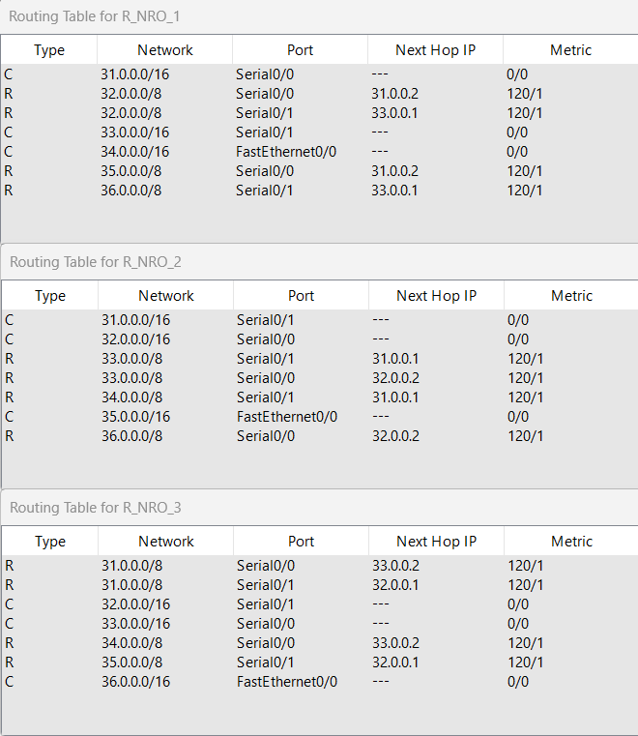
Таблицы маршрутизации не отличаются от полученных в пункте 8

- Сохраните модель в файле №группа_Lab9_FIO_01.pkt.
- Создайте модель сети №2 (сделайте копию модели сети в файле №группа_ Lab9_FIO_02.pkt.)
Далее продолжайте работать только с моделью №2 в файле
№группа_ Lab9_FIO_02.pkt
- Разорвите канал связи между какой-нибудь парой смежных маршрутизаторов ( например; вытащили кабель из порта ) схема должна быть представлена в отчете.
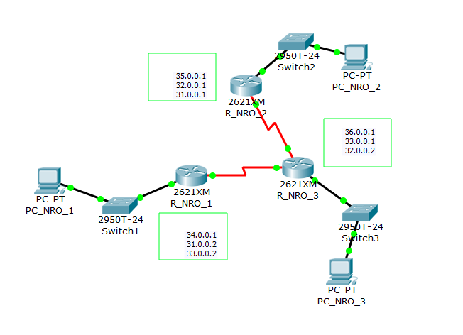

- Снова проверить достижимость всех узлов пользователей.
PC_1
Ping statistics for 35.0.0.2:
Packets: Sent = 4, Received = 4, Lost = 0 (0% loss),
Approximate round trip times in milli-seconds:
Minimum = 2ms, Maximum = 3ms, Average = 2ms

PC>ping 36.0.0.2

Pinging 36.0.0.2 with 32 bytes of data:

Reply from 36.0.0.2: bytes=32 time=2ms TTL=126
Reply from 36.0.0.2: bytes=32 time=1ms TTL=126
Reply from 36.0.0.2: bytes=32 time=1ms TTL=126
Reply from 36.0.0.2: bytes=32 time=1ms TTL=126

Ping statistics for 36.0.0.2:
Packets: Sent = 4, Received = 4, Lost = 0 (0% loss),
Approximate round trip times in milli-seconds:
Minimum = 1ms, Maximum = 2ms, Average = 1ms
PC_2
PC>ping 34.0.0.2

Pinging 34.0.0.2 with 32 bytes of data:

Reply from 34.0.0.2: bytes=32 time=68ms TTL=125
Reply from 34.0.0.2: bytes=32 time=2ms TTL=125
Reply from 34.0.0.2: bytes=32 time=2ms TTL=125
Reply from 34.0.0.2: bytes=32 time=2ms TTL=125

Ping statistics for 34.0.0.2:
Packets: Sent = 4, Received = 4, Lost = 0 (0% loss),
Approximate round trip times in milli-seconds:
Minimum = 2ms, Maximum = 68ms, Average = 18ms

PC>ping 36.0.0.2

Pinging 36.0.0.2 with 32 bytes of data:

Reply from 36.0.0.2: bytes=32 time=1ms TTL=126
Reply from 36.0.0.2: bytes=32 time=1ms TTL=126
Reply from 36.0.0.2: bytes=32 time=9ms TTL=126
Reply from 36.0.0.2: bytes=32 time=1ms TTL=126

Ping statistics for 36.0.0.2:
Packets: Sent = 4, Received = 4, Lost = 0 (0% loss),
Approximate round trip times in milli-seconds:
Minimum = 1ms, Maximum = 9ms, Average = 3ms
PC_3
PC>ping 34.0.0.2

Pinging 34.0.0.2 with 32 bytes of data:

Reply from 34.0.0.2: bytes=32 time=17ms TTL=126
Reply from 34.0.0.2: bytes=32 time=1ms TTL=126
Reply from 34.0.0.2: bytes=32 time=1ms TTL=126
Reply from 34.0.0.2: bytes=32 time=1ms TTL=126

Ping statistics for 34.0.0.2:
Packets: Sent = 4, Received = 4, Lost = 0 (0% loss),
Approximate round trip times in milli-seconds:
Minimum = 1ms, Maximum = 17ms, Average = 5ms

PC>ping 35.0.0.2

Pinging 35.0.0.2 with 32 bytes of data:

Reply from 35.0.0.2: bytes=32 time=9ms TTL=126
Reply from 35.0.0.2: bytes=32 time=2ms TTL=126
Reply from 35.0.0.2: bytes=32 time=1ms TTL=126
Reply from 35.0.0.2: bytes=32 time=1ms TTL=126

Ping statistics for 35.0.0.2:
Packets: Sent = 4, Received = 4, Lost = 0 (0% loss),
Approximate round trip times in milli-seconds:
Minimum = 1ms, Maximum = 9ms, Average = 3ms

- Снова выдать таблицы маршрутизации всех трех маршрутизаторов.
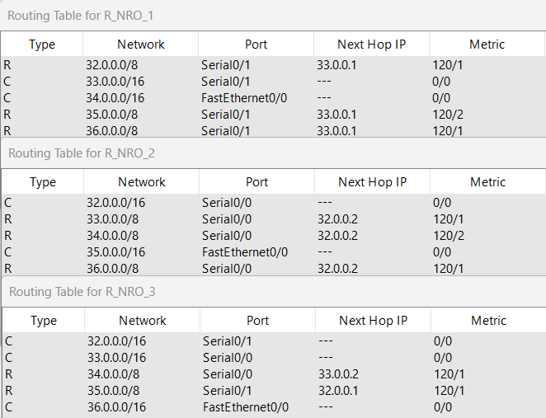

- Проанализировать таблицы маршрутизации до и после разрыва канала связи. Сделать выводы.
Таблицы маршрутизации изменились. Все маршруты, использовавшие соединение
между роутерами R_CRM_1 и R_CRM_2, были перестроены.

- Создайте модель сети №3 (сделайте копию модели сети в файле
№группа_ Lab9_FIO_03.pkt.).
Восстановите Разорванный канал связи в пункте 17.
Снова проверить достижимость всех узлов пользователей. Проанализировать таблицы маршрутизации после разрыва (были уже получены в пункте 19) и после восстановления канала связи.
Сделать выводы
PC_1
Ping statistics for 35.0.0.2:
Packets: Sent = 4, Received = 4, Lost = 0 (0% loss),
Approximate round trip times in milli-seconds:
Minimum = 2ms, Maximum = 3ms, Average = 2ms

PC>ping 36.0.0.2

Pinging 36.0.0.2 with 32 bytes of data:

Reply from 36.0.0.2: bytes=32 time=2ms TTL=126
Reply from 36.0.0.2: bytes=32 time=1ms TTL=126
Reply from 36.0.0.2: bytes=32 time=1ms TTL=126
Reply from 36.0.0.2: bytes=32 time=1ms TTL=126

Ping statistics for 36.0.0.2:
Packets: Sent = 4, Received = 4, Lost = 0 (0% loss),
Approximate round trip times in milli-seconds:
Minimum = 1ms, Maximum = 2ms, Average = 1ms
PC_2
PC>ping 34.0.0.2

Pinging 34.0.0.2 with 32 bytes of data:

Reply from 34.0.0.2: bytes=32 time=68ms TTL=125
Reply from 34.0.0.2: bytes=32 time=2ms TTL=125
Reply from 34.0.0.2: bytes=32 time=2ms TTL=125
Reply from 34.0.0.2: bytes=32 time=2ms TTL=125

Ping statistics for 34.0.0.2:
Packets: Sent = 4, Received = 4, Lost = 0 (0% loss),
Approximate round trip times in milli-seconds:
Minimum = 2ms, Maximum = 68ms, Average = 18ms

PC>ping 36.0.0.2

Pinging 36.0.0.2 with 32 bytes of data:

Reply from 36.0.0.2: bytes=32 time=1ms TTL=126
Reply from 36.0.0.2: bytes=32 time=1ms TTL=126
Reply from 36.0.0.2: bytes=32 time=9ms TTL=126
Reply from 36.0.0.2: bytes=32 time=1ms TTL=126

Ping statistics for 36.0.0.2:
Packets: Sent = 4, Received = 4, Lost = 0 (0% loss),
Approximate round trip times in milli-seconds:
Minimum = 1ms, Maximum = 9ms, Average = 3ms
PC_3
PC>ping 34.0.0.2

Pinging 34.0.0.2 with 32 bytes of data:

Reply from 34.0.0.2: bytes=32 time=17ms TTL=126
Reply from 34.0.0.2: bytes=32 time=1ms TTL=126
Reply from 34.0.0.2: bytes=32 time=1ms TTL=126
Reply from 34.0.0.2: bytes=32 time=1ms TTL=126

Ping statistics for 34.0.0.2:
Packets: Sent = 4, Received = 4, Lost = 0 (0% loss),
Approximate round trip times in milli-seconds:
Minimum = 1ms, Maximum = 17ms, Average = 5ms

PC>ping 35.0.0.2

Pinging 35.0.0.2 with 32 bytes of data:

Reply from 35.0.0.2: bytes=32 time=9ms TTL=126
Reply from 35.0.0.2: bytes=32 time=2ms TTL=126
Reply from 35.0.0.2: bytes=32 time=1ms TTL=126
Reply from 35.0.0.2: bytes=32 time=1ms TTL=126

Ping statistics for 35.0.0.2:
Packets: Sent = 4, Received = 4, Lost = 0 (0% loss),
Approximate round trip times in milli-seconds:
Minimum = 1ms, Maximum = 9ms, Average = 3ms
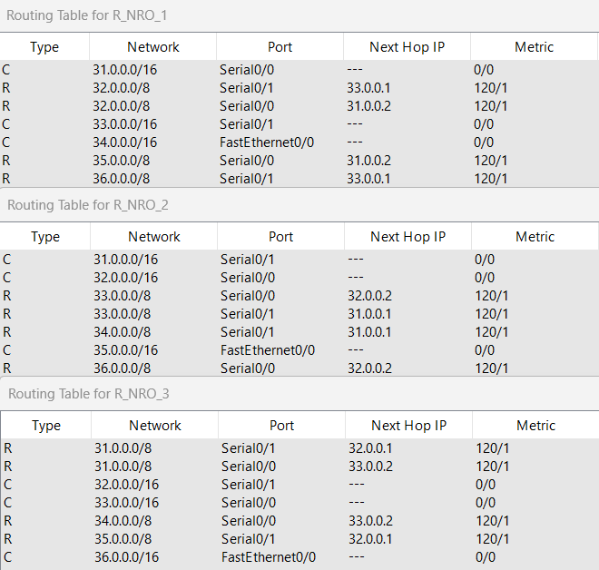
Все заработало как в модели 1, так как пути выдались автоматически.

6. Задание 6. Тесты
Дать письменно в отчете аргументированные ответы на следующие вопросы.
- Может ли работать маршрутизатор, не имея таблицы маршрутизации? Варианты ответов:
а) может, если выполняется маршрутизация от источника;
б) нет, это невозможно;
в) может, если в маршрутизаторе задан маршрут по умолчанию;
г) может, если выполняется лавинная маршрутизация
Ответ: г) может, если выполняется лавинная маршрутизация

- Можно ли обойтись в сети без протоколов маршрутизации?

Ответ: Да, можно. Тогда придется настраивать таблицы маршрутизации вручную. Применение протоколов маршрутизации позволяет избежать ручного ввода всех допустимых маршрутов, что, в свою очередь, снижает количество ошибок и облегчает работу администратора сети. Так же использование протоколов маршрутизации позволяет быстрее реагировать на изменение сети, например, выход из строя какого-то из маршрутизаторов, потому что без использования протоколов маршрутизации администратору пришлось бы вручную изменять все таблицы маршрутизации, а при использовании протоколов изменения произойдут автоматически.

- По какой причине в протоколе RIP расстояние в 16 хопов между сетями полагается недостижимым?
Варианты ответов:
а) поле, отведенное для хранения значения расстояния,
имеет длину 4 двоичных разряда;
б) сети, в которых работает RIP, редко бывают большими;
в) для получения приемлемого времени сходимости алгоритма.

Ответ: в) для получения приемлемого времени сходимости алгоритма
Такое значение «бесконечного» расстояния вызвано тем, что при разрывах связей в протоколе RIP могут образовываться зацикливание пакетов в петлях сети. И чем меньше используемое «бесконечное» расстояние, тем быстрее разрешается эта проблема.

7. Дополнительное задание 7 (только для желающих).
Легенда
- Создайте модель№4 сети (сделайте копию модели (№группа_Lab9_ФИО_02.pkt ) сети в файле №группа_Lab9_ФИО_04.pkt).
Далее продолжайте работать только с моделью №4 в файле №группа_Lab9_ФИО_04.pkt.
- В силу экономических, политических или иных причин, а скорей всего по вине студента-стажера администратора сети 192.168.5.0 был разорван канал связи между парой смежных маршрутизаторов R2 и R3 (см. например; как на рисунке ниже).

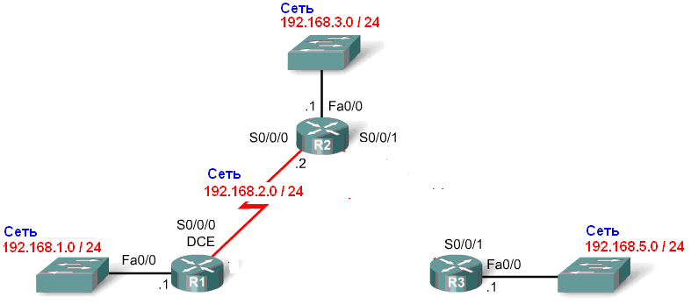
Рисунок 12
- Решение проблемы студентом стажером.
Администратор сети 192.168.5.0 (студент_стажер ФПМИ Иванов), чтобы скрыть эту ситуацию (см. п.2), и свою вину от своего руководства и как то оживить сеть, подпольно подсоединил временно свой маршрутизатор R3 к коммутатору-хабу сети 192.168.1.0. Кстати, администратором сети 192.168.1.0 был хороший друг нашего студента (также ФППИ –шник). Схему временного подключения представить в отчете. (Сетевые адреса сохранить из вашего варианта задания).
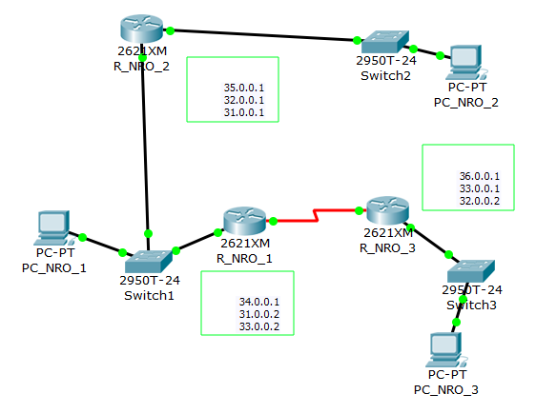

- Оценить решение студентов.
  - Снова проверить достижимость всех узлов пользователей.
  - Опять выдать таблицы маршрутизации всех трех маршрутизаторов.
  - Выполнить сравнительный анализ таблиц маршрутизации.

