MINISTRY OF EDUCATION, CULTURE AND RESEARCH
OF THE REPUBLIC OF MOLDOVA
Technical University of Moldova
Faculty of Computers, Informatics and Microelectronics
Department of Software Engineering and Automation

Report
on laboratory work no. 1
Operating Systems
Topic: First Steps in the Linux Shell

Done by:
st. gr. FAF-242, Nichita Rusnac

Checked by:
Patricia Reitman, university assistant
DISA, FCIM, UTM

Chișinău – 2026

Table of Contents
1 Purpose of the work 3
2 Part 1. Where am I? 3
3 Part 2. Files and permissions 4
4 Part 3. Processes 6
5 Part 4. Memory, disks and devices 8
6 Wrap-up 10

All screenshots below come from my own terminal session, in the order I ran the commands. I did the lab on my Ubuntu 24.04 ARM (aarch64) machine on AWS, connected over SSH, as my normal user ubuntu, in a working folder ~/os-lab1.

1 Purpose of the work
- find out what machine and system I'm working on: user, kernel, architecture, uptime
- move around the file tree and read ls -l output (type, permissions, links, owner, size)
- create, copy, rename and delete files and directories, and change their permissions with chmod
- see processes from the outside (ps, top), run a job in the background and stop it with kill
- look at a single process, memory, disks and devices through the files the kernel exposes in /proc and /dev

2 Part 1. Where am I?
mkdir -p ~/os-lab1 && cd ~/os-lab1
whoami ; uname -a ; uptime ; pwd
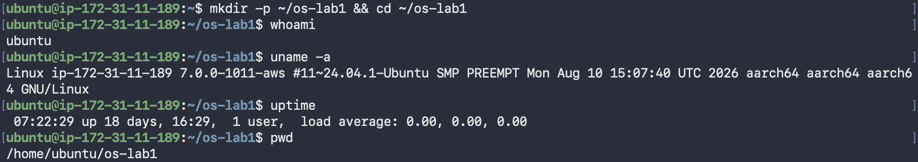
Figure 1.1 – User, kernel, uptime and current directory
- whoami → ubuntu, a normal user, not root.
- uname -a → kernel 7.0.0-1011-aws built for Ubuntu 24.04 (#11~24.04.1-Ubuntu), on aarch64, a 64-bit ARM CPU. The hostname ip-172-31-11-189 is the private AWS address of the machine.
- uptime → up 18 days, 1 user logged in, load average 0.00, so the machine was almost idle.
- pwd → /home/ubuntu/os-lab1.
ls -la ; ls -la ~
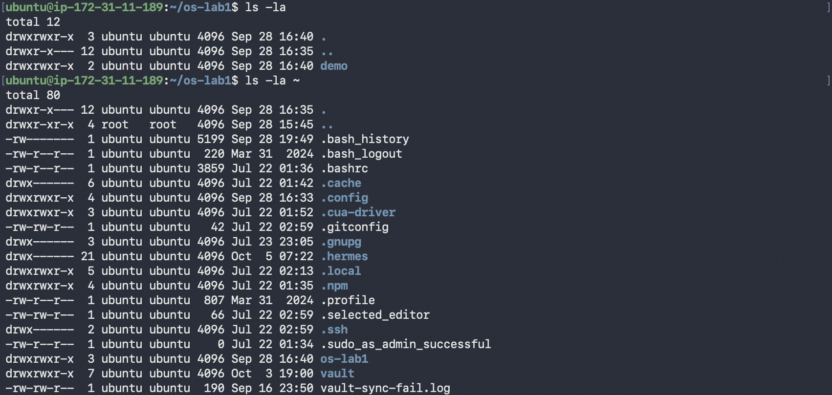
Figure 1.2 – ls -la in the lab folder and in my home directory
-l gives the long format and -a also shows hidden names (the ones starting with .). Each line reads as: type and permissions, link count, owner, group, size in bytes, modification time, name. A few things stood out:
- demo was already there from an earlier try on 28 September, which explains the error in Part 2.
- .. of my home is /home, owned by root. Everything inside my home is owned by ubuntu.
- .ssh and .cache are drwx------, so only I can enter them. .bashrc and .profile are -rw-r--r--, readable by everyone.
cd /etc && ls | head
cd ~/os-lab1/
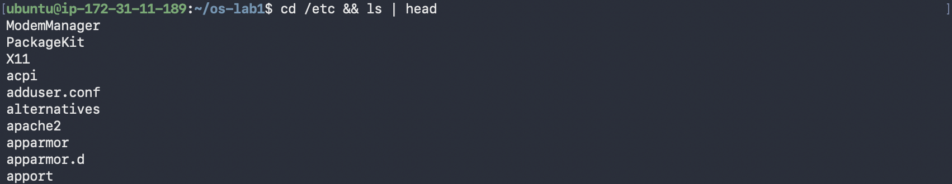
Figure 1.3 – The first entries in /etc
/etc holds system-wide configuration: adduser.conf, apache2, apparmor, alternatives and so on. head kept only the first 10 lines of the listing.

3 Part 2. Files and permissions
My first attempts had a few mistakes, and the errors turned out to be useful:
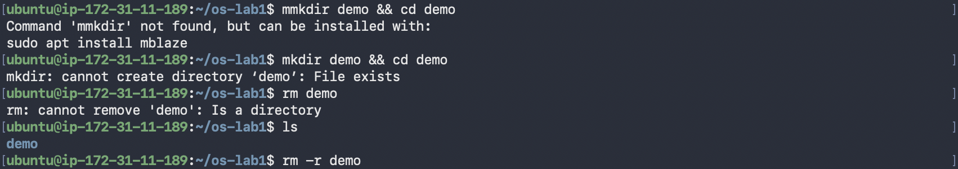
Figure 2.1 – A typo, a directory that already exists, and rm on a directory
- mmkdir → Command 'mmkdir' not found, but can be installed with: sudo apt install mblaze. Ubuntu's command-not-found helper searches its package index for a program with that name.
- mkdir demo → File exists, the demo left over from 28 September.
- rm demo → Is a directory. Plain rm only removes files, rm -r removes a directory and everything inside it.
Then the real sequence:
mkdir demo && cd demo
echo "hello operating systems" > note.txt
cp note.txt copy.txt
mv copy.txt renamed.txt
ls -l ; cat renamed.txt
rm renamed.txt ; ls -l note.txt
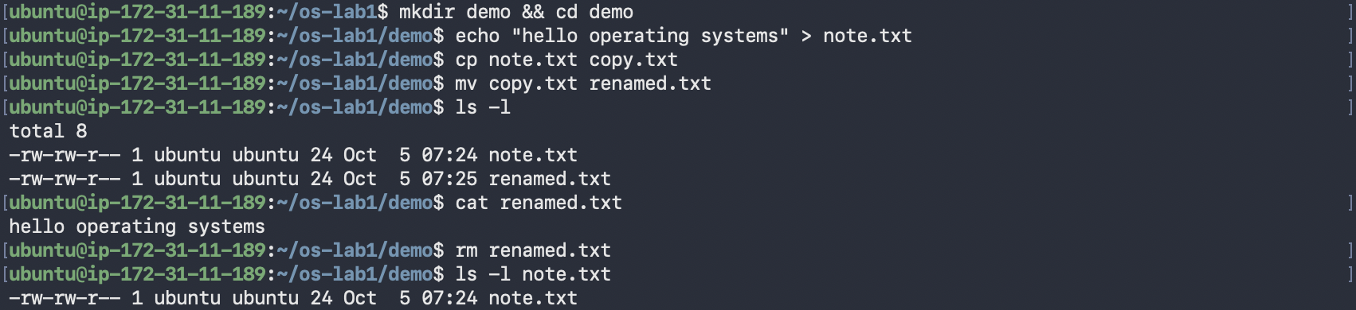
Figure 2.2 – Creating, copying, renaming and deleting a file
Both files are 24 bytes: 23 characters of hello operating systems plus the newline echo adds. renamed.txt has a later time (07:25) than note.txt (07:24), because cp creates a new file at the moment of copying, while mv only gives the existing file a new name and keeps its time.
chmod 600 note.txt ; ls -l note.txt
chmod 644 note.txt ; ls -l note.txt
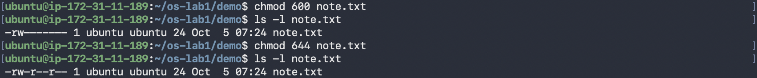
Figure 2.3 – Changing permissions with chmod
Mode | ls -l | Owner | Group | Others
(new file) | -rw-rw-r-- | read, write | read, write | read
600 | -rw------- | read, write | none | none
644 | -rw-r--r-- | read, write | read | read
Each digit is the sum of read (4), write (2) and execute (1) for owner, group and others. A new file starts as -rw-rw-r-- (664) because my umask is 0002 (seen later in /proc/<pid>/status, Figure 3.3), which only takes away write for others.

4 Part 3. Processes
ps aux | head
top
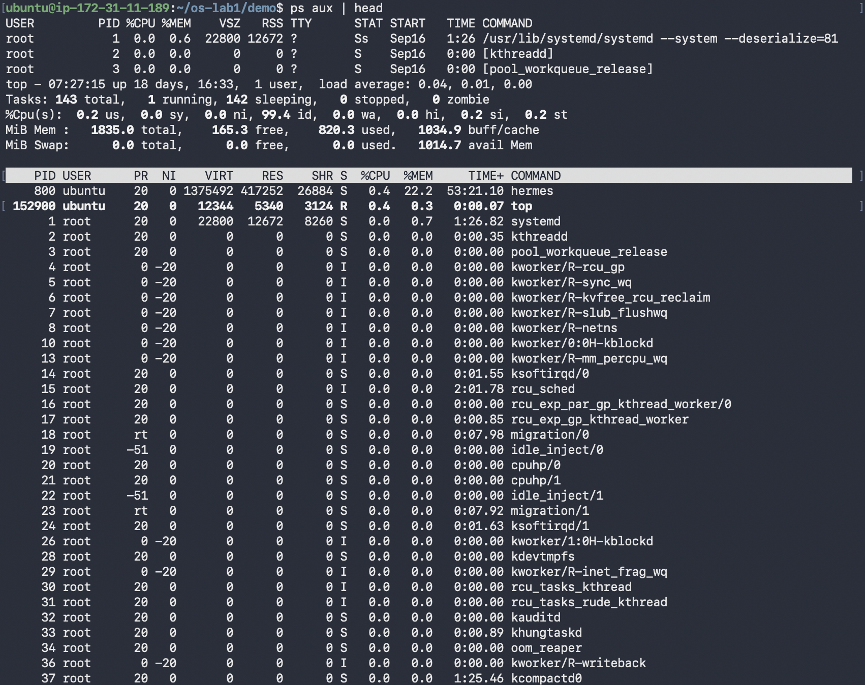
Figure 3.1 – ps aux and top
- PID 1 is systemd, the first process the kernel starts, and every other user process descends from it. PID 2 is [kthreadd]. Names in square brackets are kernel threads, which have no program file and use 0 memory in the VSZ/RSS columns.
- top shows the whole system live: 143 tasks, 1 running, 142 sleeping, 0 zombies, CPU 99.4% idle, 1835 MiB of RAM and no swap. The biggest process is hermes (PID 800) at 22.2% of memory. Most of the list is kernel workers (kworker, ksoftirqd, migration, rcu_*), one set per CPU.
sleep 300 &
jobs
ps -ef | grep sleep
kill 152903
jobs
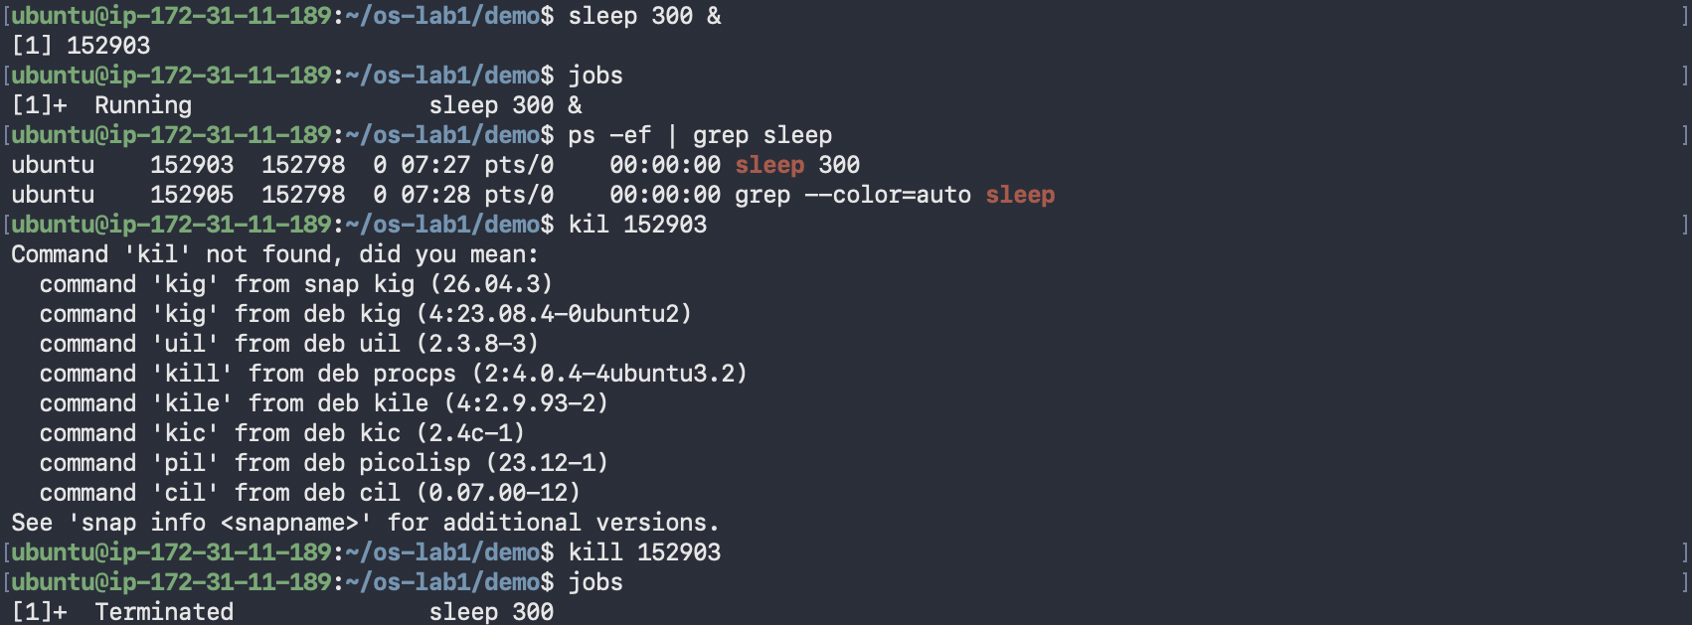
Figure 3.2 – Running sleep in the background and stopping it
& started sleep in the background and the shell printed the job number and PID: [1] 152903. jobs showed it as Running. In ps -ef its parent PID (PPID) is 152798, my bash shell. grep also shows up because it was running at the same moment and its own command line contains "sleep". After a typo (kil, which again got package suggestions) kill 152903 sent the default signal, SIGTERM, and jobs reported Terminated.
sleep 300 &
PID=$!
ls /proc/$PID/
cat /proc/$PID/status | head -20
kill $PID ; jobs
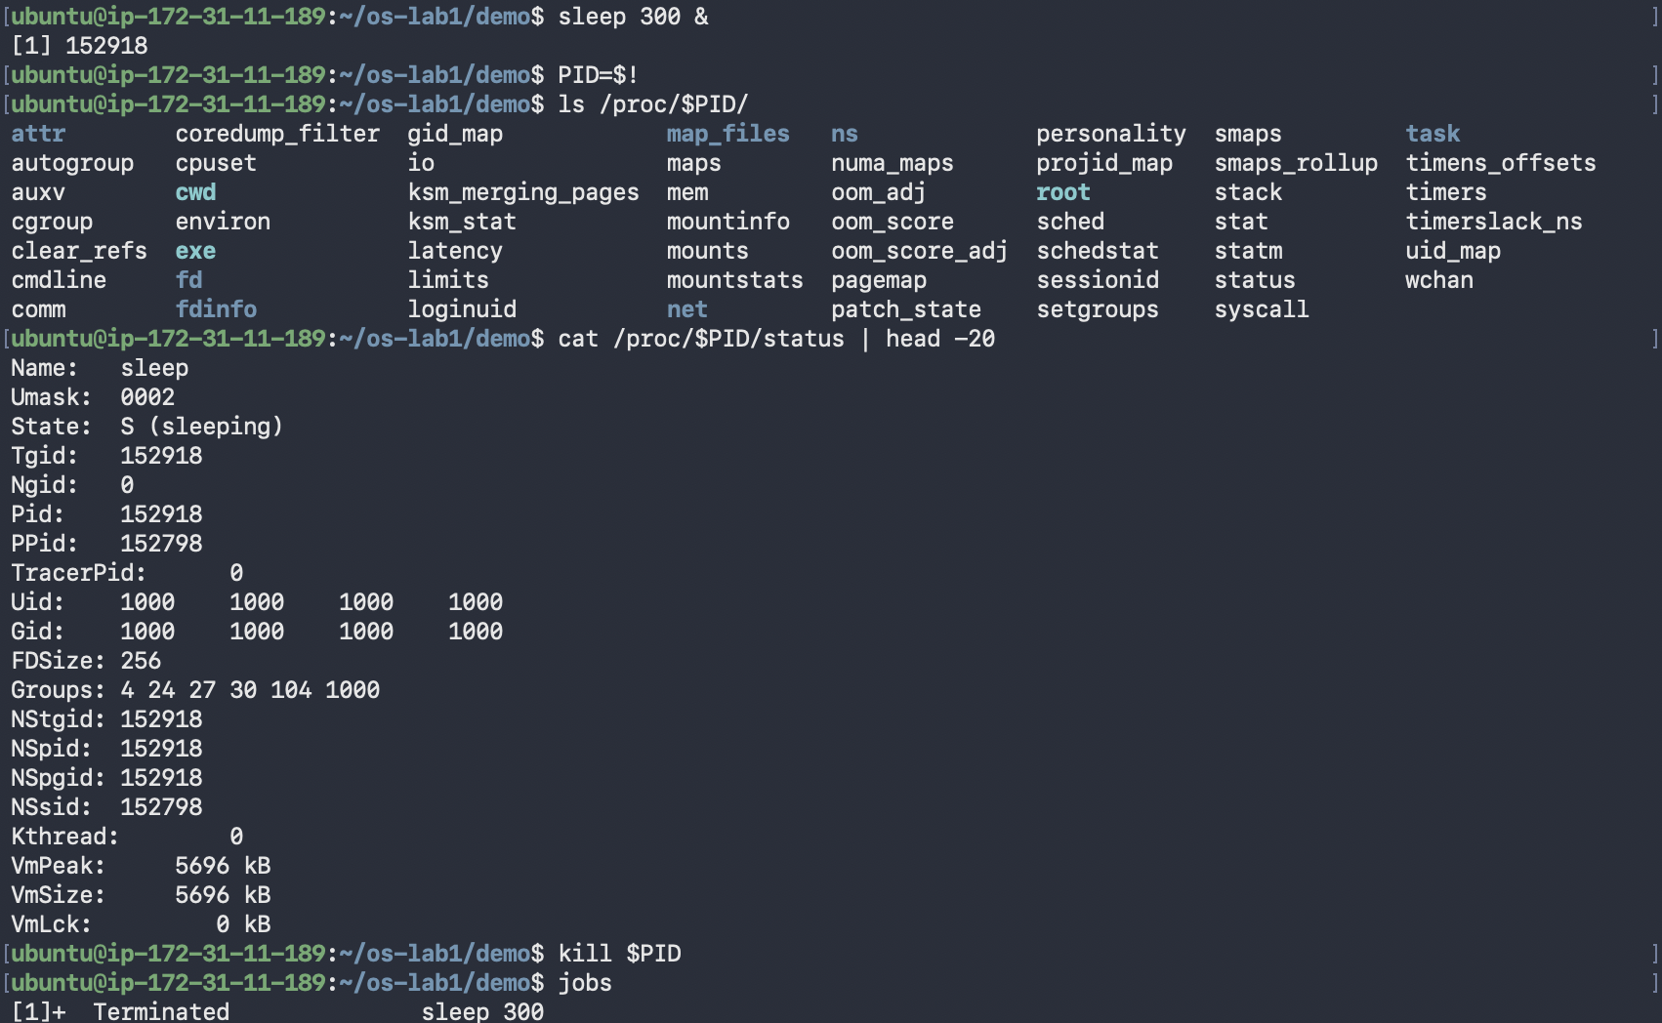
Figure 3.3 – The process seen through /proc/PID
$! holds the PID of the last background job, so I didn't have to copy it by hand. /proc/152918/ is not a real folder on disk: the kernel generates it for that process, with entries such as cmdline, cwd, exe, fd, environ, maps and status. From status:
- Name: sleep, State: S (sleeping), it's waiting for its timer
- Pid: 152918, PPid: 152798, same parent shell as before
- Uid: 1000, Groups: 4 24 27 30 104 1000, it runs with my identity
- Umask: 0002, inherited from the shell
- VmSize: 5696 kB of virtual memory

5 Part 4. Memory, disks and devices
free -h
cat /proc/meminfo | head -6
sleep 300 & PID=$!
grep VmRSS /proc/$PID/status
kill $PID
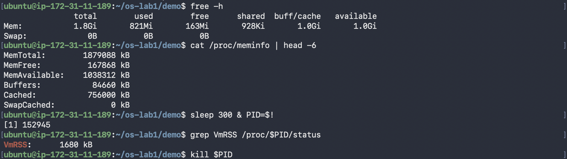
Figure 4.1 – Memory: free, /proc/meminfo, and one process
free -h reports 1.8 GiB total, 821 MiB used, 163 MiB free, 1.0 GiB of buffers/cache and 1.0 GiB available, with no swap. These numbers come straight from /proc/meminfo: MemFree: 167868 kB ≈ 163 MiB and MemAvailable: 1038312 kB ≈ 1.0 GiB. "Free" is low only because Linux uses spare RAM as a file cache (Cached: 756000 kB), and that cache is given back when programs need it, which is why "available" is much bigger than "free".
The sleep process had VmRSS: 1680 kB actually in RAM, out of the 5696 kB of virtual memory it has mapped. Shared libraries and pages it never touched don't count toward RSS.
df -h ; lsblk ; du -sh ~/os-lab1
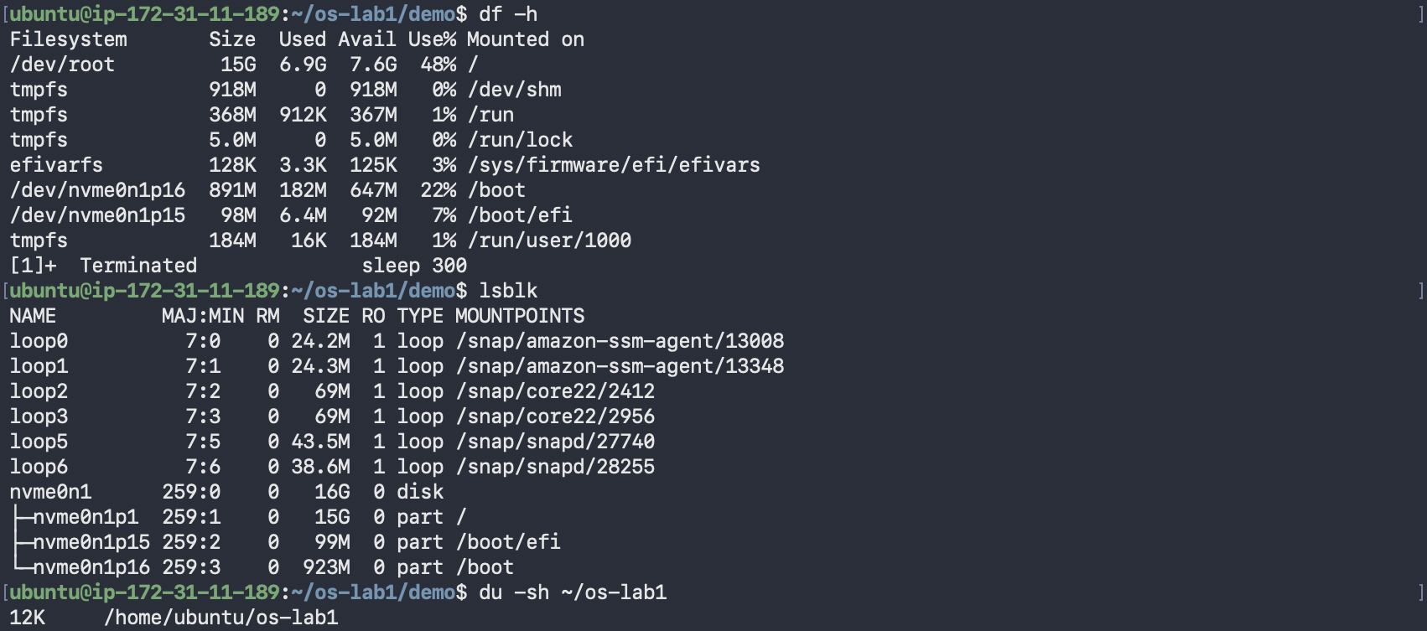
Figure 4.2 – File systems, block devices and folder size
- lsblk shows one 16 GB NVMe disk, nvme0n1, split into p1 (15G, mounted on /), p15 (99M, /boot/efi) and p16 (923M, /boot). The loop0–loop6 devices are snap packages, each a file-system image mounted read-only (RO 1).
- df -h: the root file system has 15G, 6.9G used, 7.6G free (48%). The tmpfs lines (/dev/shm, /run, /run/lock) live in RAM, not on the disk.
- du -sh ~/os-lab1 → 12K: three 4 KiB blocks for the two directories and note.txt. A 24-byte file still takes a whole block.
ls -l /dev | head
mount | head
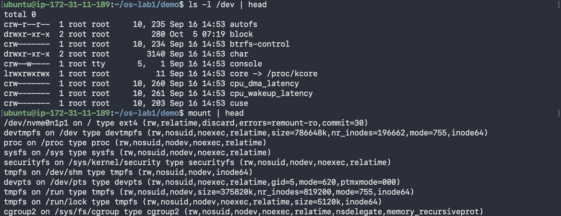
Figure 4.3 – Device files and mounted file systems
In /dev the first letter of the mode is the file type: c for a character device, d for a directory and l for a symbolic link (core -> /proc/kcore). Instead of a size, device files show two numbers, major and minor (console is 5, 1), which tell the kernel which driver handles them. So the terminal is just a file, /dev/console, owned by root:tty.
mount shows that / is an ext4 file system on /dev/nvme0n1p1, while /proc (proc), /sys (sysfs), /dev (devtmpfs) and /run (tmpfs) are virtual file systems that the kernel creates in memory. That is why /proc/$PID/status and /proc/meminfo could be read with plain cat earlier.

6 Wrap-up
In this first lab I got to know the machine I'll use for the course: an Ubuntu 24.04 ARM server on AWS with a 7.0 kernel, 1.8 GiB of RAM and a 16 GB NVMe disk. I practised moving around the tree and reading ls -l, created, copied, renamed and deleted files, and changed their permissions with chmod (600 and 644), which also explained why new files start as 664 with umask 0002. On the process side, ps and top showed that most of the 143 tasks are kernel threads under systemd (PID 1) and kthreadd (PID 2), and I ran sleep in the background, found it with jobs, ps and $!, and stopped it with kill. The main idea I took away is that Linux exposes almost everything as files: a process is a folder in /proc, memory statistics are /proc/meminfo (which free just formats), and the terminal is a device file in /dev.

