MINISTRY OF EDUCATION, CULTURE AND RESEARCH
OF THE REPUBLIC OF MOLDOVA
Technical University of Moldova
Faculty of Computers, Informatics and Microelectronics
Department of Software Engineering and Automation

Report
on laboratory work no. 2
Operating Systems
Topic: Meet the OS You Will Build

Done by:
st. gr. FAF-242, Nichita Rusnac

Checked by:
Patricia Reitman, university assistant
DISA, FCIM, UTM

Chișinău – 2026

Table of Contents
1 Purpose of the work 3
2 Part 1. Build it and boot it 3
3 Part 2. Use xv6 as the Unix it is 4
4 Part 3. Read the source 6
5 Part 4. My first xv6 program 8
6 Wrap-up 10

All screenshots below come from my own session, in the order I ran the commands. Linux commands ran in bash on my Ubuntu 24.04 ARM machine on AWS, connected over SSH. xv6 commands ran at the xv6 $ prompt inside QEMU (make qemu). I started from a fresh clone of upstream mit-pdos/xv6-riscv. The program I wrote (sleep.c) is next to this note in the Lab2/ folder.

1 Purpose of the work
- build the xv6 kernel with a RISC-V cross-compiler and boot it in QEMU
- use xv6 as a small Unix: run its programs, a pipe, and its own test suite
- read the source of a few user programs and find where a system call is implemented in the kernel
- write a first xv6 program (sleep), add it to the build, and run it inside xv6

2 Part 1. Build it and boot it
cd ~/xv6-riscv 2>/dev/null || git clone https://github.com/mit-pdos/xv6-riscv ~/xv6-riscv
cd ~/xv6-riscv && ls
make qemu
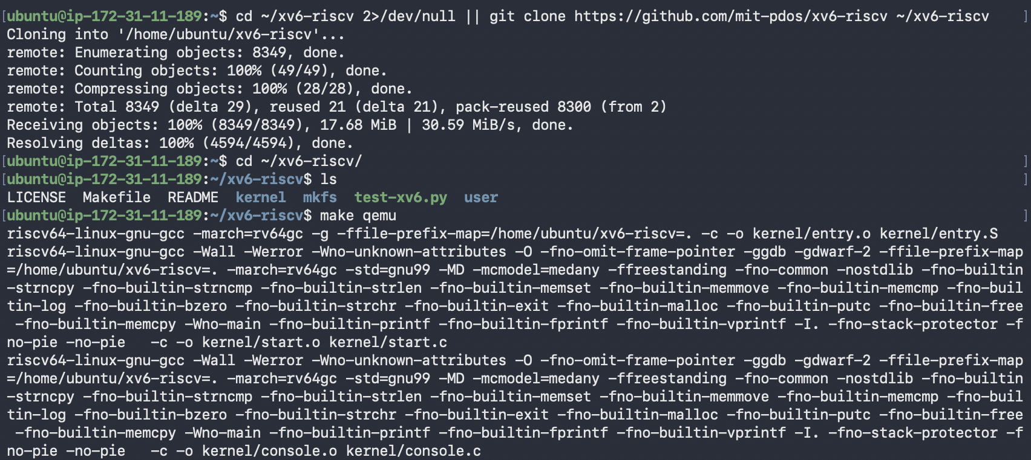
Figure 1.1 – Cloning xv6-riscv and starting the build
Every file is compiled with riscv64-linux-gnu-gcc -march=rv64gc. This is a cross-compiler: it runs on the VM but produces machine code for a RISC-V CPU. QEMU then emulates a RISC-V machine and boots the kernel that was just built.
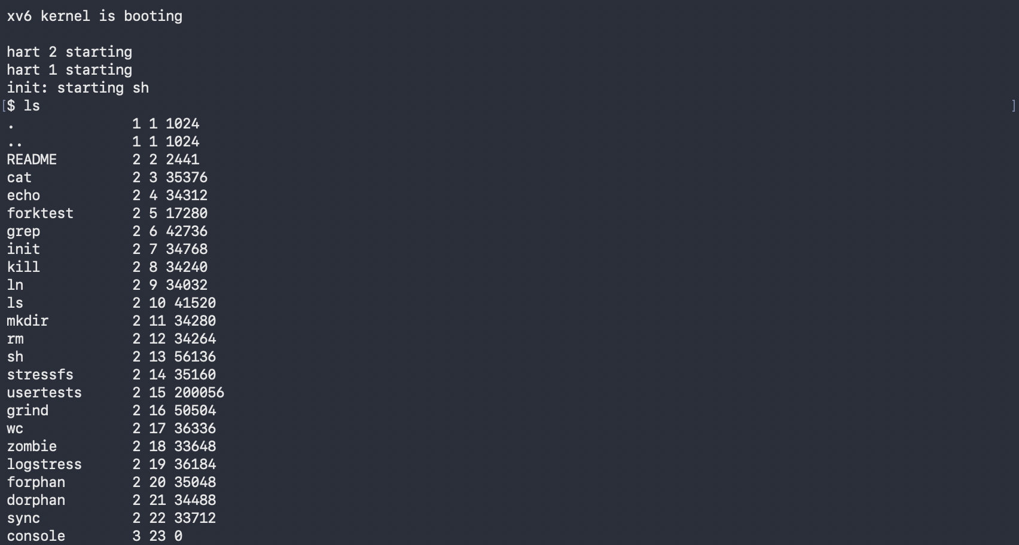
Figure 1.2 – xv6 boots, starts the shell, and ls lists the root directory
The lines hart 2 starting and hart 1 starting are the extra CPU cores coming online. "Hart" is the RISC-V term for a hardware thread, and QEMU is started with -smp 3, so there are three of them. After that init launches the shell and the $ prompt appears.

3 Part 2. Use xv6 as the Unix it is
$ cat README
$ echo hello xv6
$ ls | grep c
$ wc README
$ usertests -q
Figure 2.1 – Start of cat README (the rest of the file is cut)
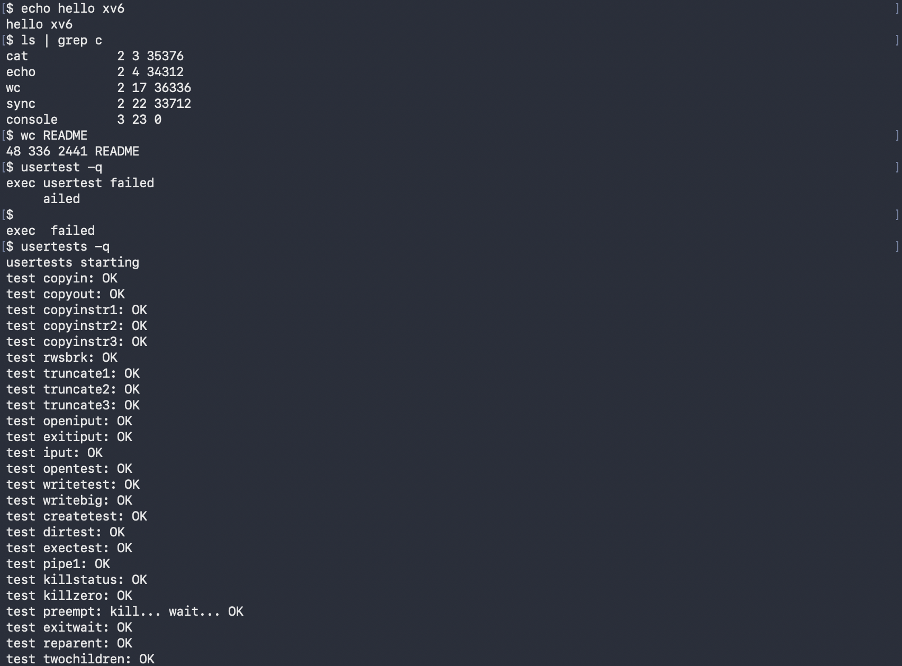
Figure 2.2 – echo, the pipe ls | grep c, wc README, a mistyped usertest, then usertests -q
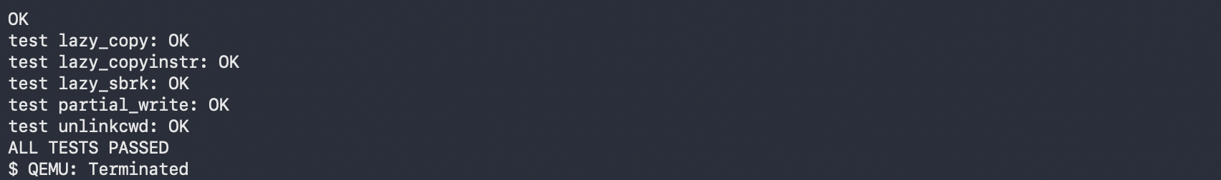
Figure 2.3 – End of usertests -q with ALL TESTS PASSED, then QEMU closed with Ctrl-A, X
1. Three programs xv6 ships with
ls, cat and grep. It also includes echo, wc, mkdir, rm, kill, sh and test programs such as usertests.
2. Which two OS features must exist for a pipe to work?
- Processes. The shell uses fork() to create two processes and exec() to load ls and grep into them, so both run at the same time.
- Inter-process communication. pipe() gives a kernel buffer with a read end and a write end (two file descriptors). The shell attaches the output of ls to the write end and the input of grep to the read end, so the data passes from one process to the other through the kernel.
3. xv6 shell vs the Linux shell from Lab 1
The core is the same: running programs, pipes, < and > redirection, & and ;. Everything else is missing. There is no history, no tab completion, no variables and no wildcards. Error messages are minimal too. My typo usertest only produced exec usertest failed (Figure 2.2), where Linux would say "command not found" and suggest packages, like it did for mmkdir in Lab 1.
Interesting output
xv6's ls prints the name, type, inode number and size of each entry. Type 1 is a directory, 2 a regular file and 3 a device, so console 3 23 0 is the terminal exposed as a file, the same idea as /dev/console in Lab 1. wc README returned 48 336 2441 (lines, words, bytes), and 2441 is exactly the size ls shows for README. usertests -q ended with ALL TESTS PASSED, which confirms the kernel I built works.

4 Part 3. Read the source
After quitting QEMU I read some of the source on the VM.
sed -n "1,40p" user/ls.c
sed -n "1,30p" user/cat.c
cat user/user.h
grep -n "sys_read\|sys_write" kernel/sysfile.c | head
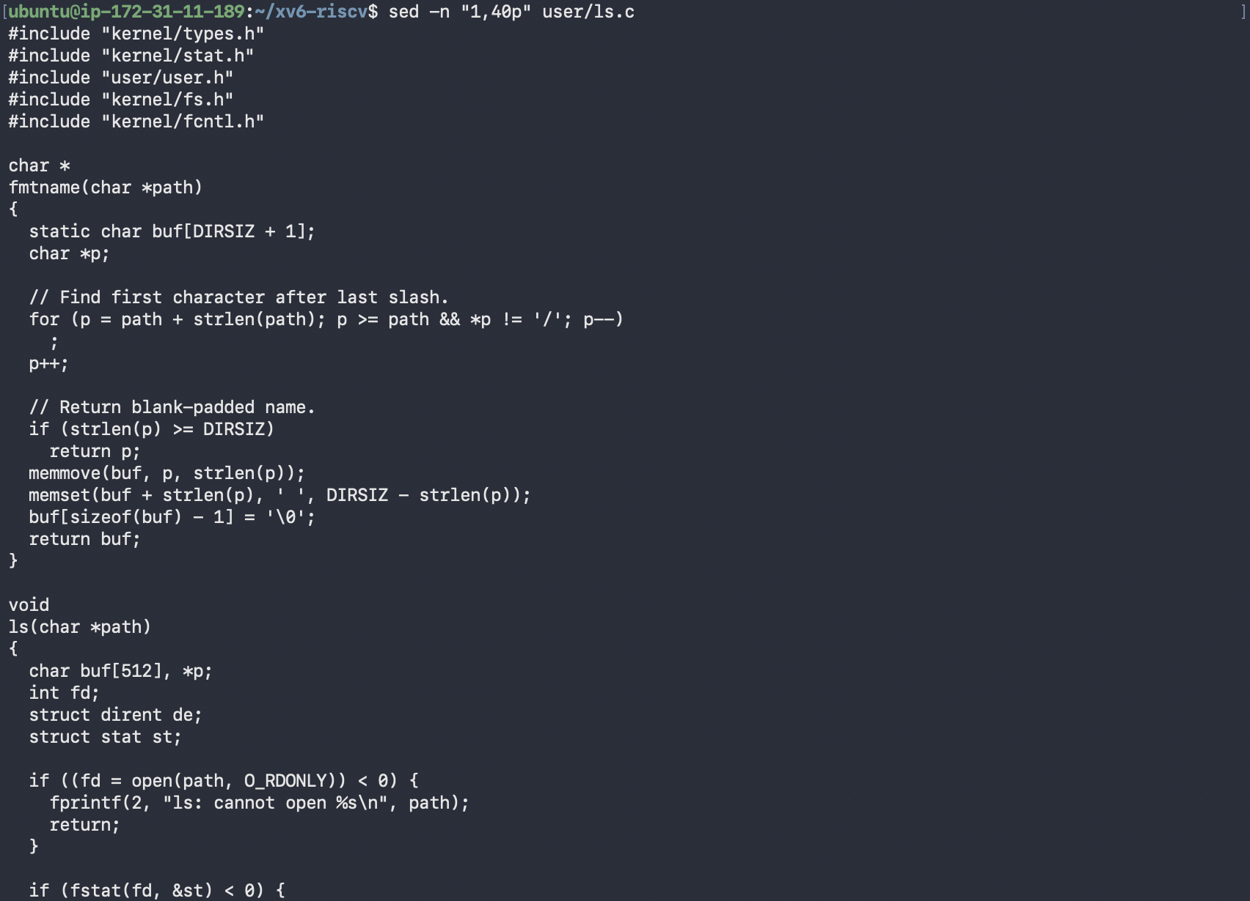
Figure 3.1 – The first 40 lines of user/ls.c
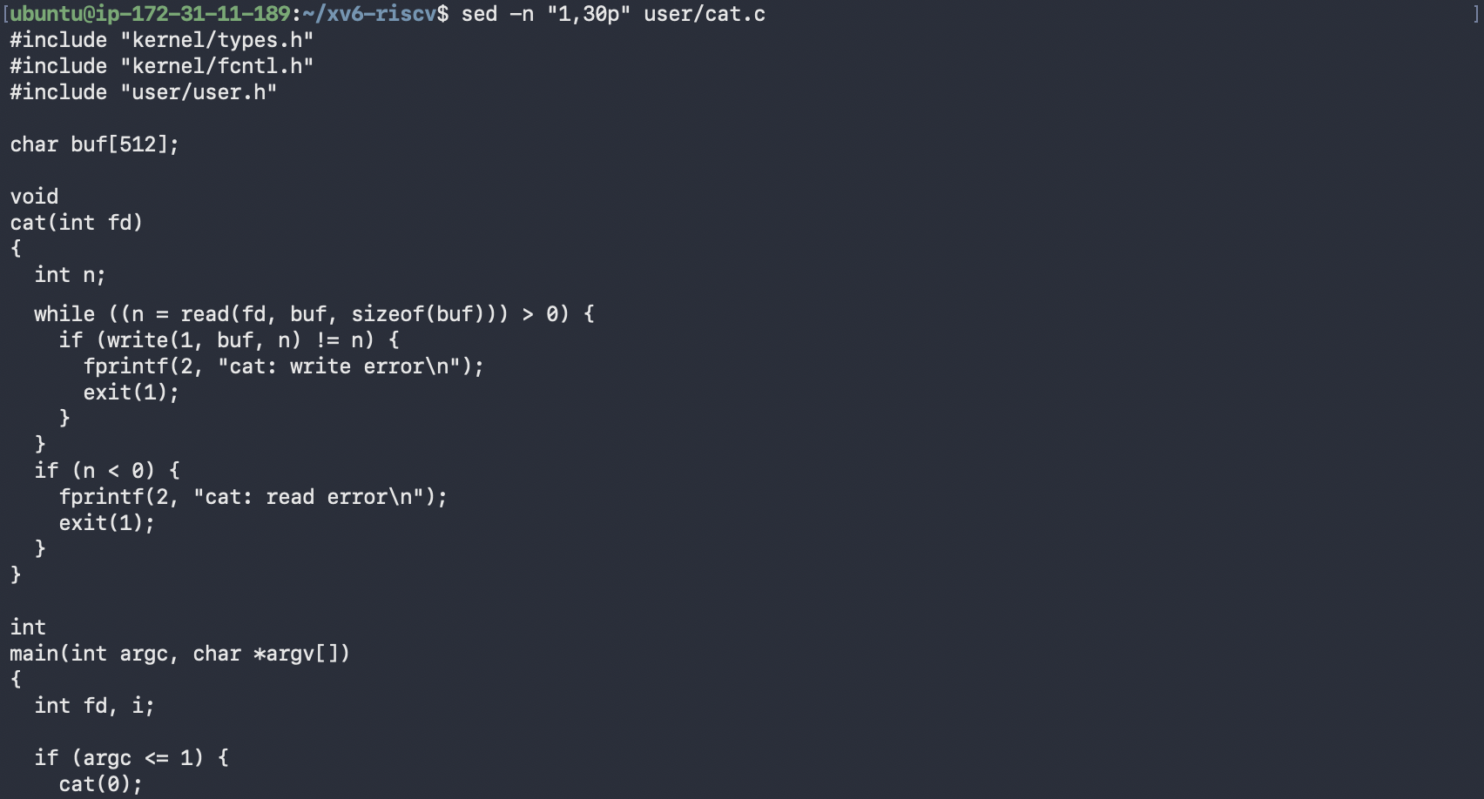
Figure 3.2 – The first 30 lines of user/cat.c
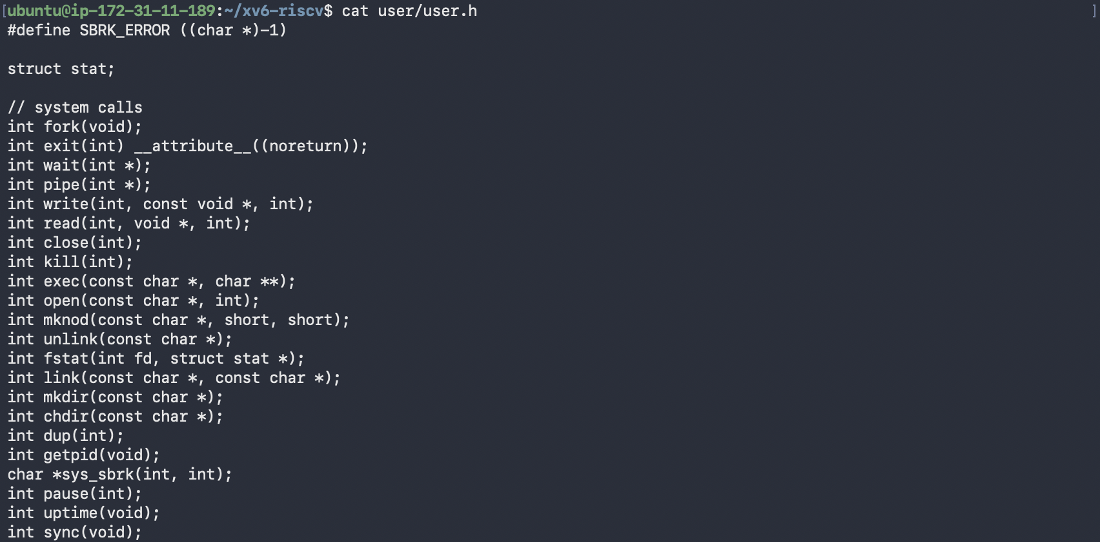
Figure 3.3 – The system call declarations in user/user.h
Figure 3.4 – Locating sys_read and sys_write in kernel/sysfile.c
1. Which system calls does user/cat.c use, and what does each ask the kernel?
- read(fd, buf, sizeof(buf)) asks the kernel to copy up to 512 bytes from an open file into buf. It returns the number of bytes read, or 0 at end of file.
- write(1, buf, n) asks the kernel to send n bytes to file descriptor 1, the standard output (the console).
- exit(1) asks the kernel to terminate the process and pass the status to its parent.
- open() and close() appear further down in main, to open each file given on the command line and release it afterwards.
fprintf(2, ...) is not a system call. It is a library function from printf.c that eventually calls write() on fd 2 (standard error).
2. Where is sys_read implemented?
In kernel/sysfile.c at line 69, with sys_write at line 83 (Figure 3.4).
3. Difference between kernel/ and user/
kernel/ is the operating system itself. It runs in privileged (supervisor) mode with full access to memory and devices. user/ contains ordinary programs that run in unprivileged user mode, and the only way they can do anything outside their own memory is to ask the kernel through the system calls declared in user/user.h.
Interesting output
Figure 3.3 shows that the entire interface between programs and the kernel is 22 system calls, while Linux has several hundred. It also shows that this version has no sleep() declaration, only pause(int), which turned out to matter in Part 4.

5 Part 4. My first xv6 program
My first attempts to create user/sleep.c with a one-line echo failed, because bash treated <ticks> inside the string as an input redirection (-bash: ticks: No such file or directory). I switched to a heredoc (cat > user/sleep.c << 'EOF') with the code from the lab sheet.
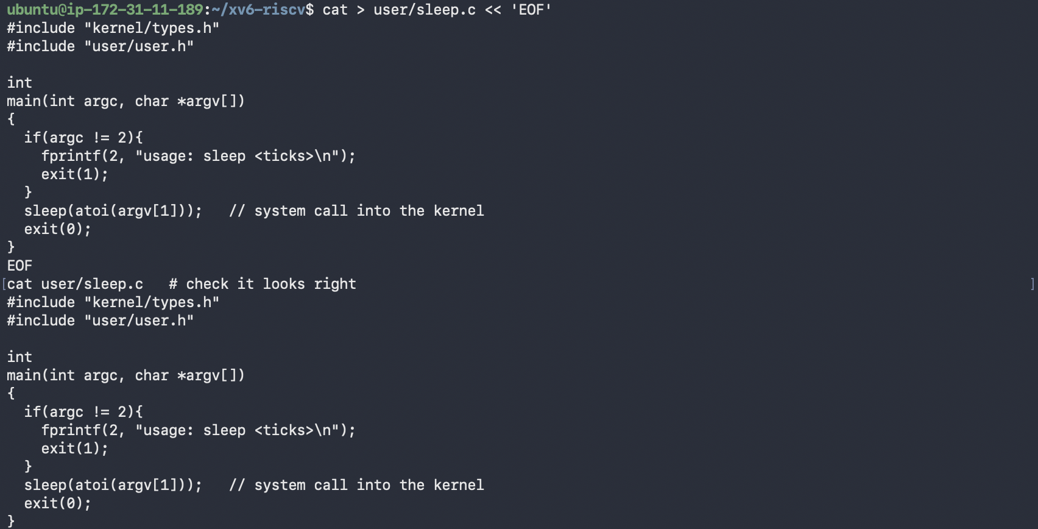
Figure 4.1 – Writing user/sleep.c with a heredoc and printing it back
Next I opened the Makefile in vim and added one line to UPROGS, indented with a TAB like the other entries:
UPROGS=\
$U/_cat\
$U/_echo\
$U/_sleep\
$U/_forktest\
...
The first build failed with implicit declaration of function 'sleep'. In current upstream xv6 the sleep system call has been renamed to pause() (user/user.h line 25, implemented as sys_pause in kernel/sysproc.c). It does the same thing the lab describes, waiting for a number of clock ticks, so I replaced the call with sed and checked the result with grep. The program is still called sleep.
sed -i 's/sleep(atoi(argv\[1\]))/pause(atoi(argv[1]))/' user/sleep.c
grep -n pause user/sleep.c user/user.h
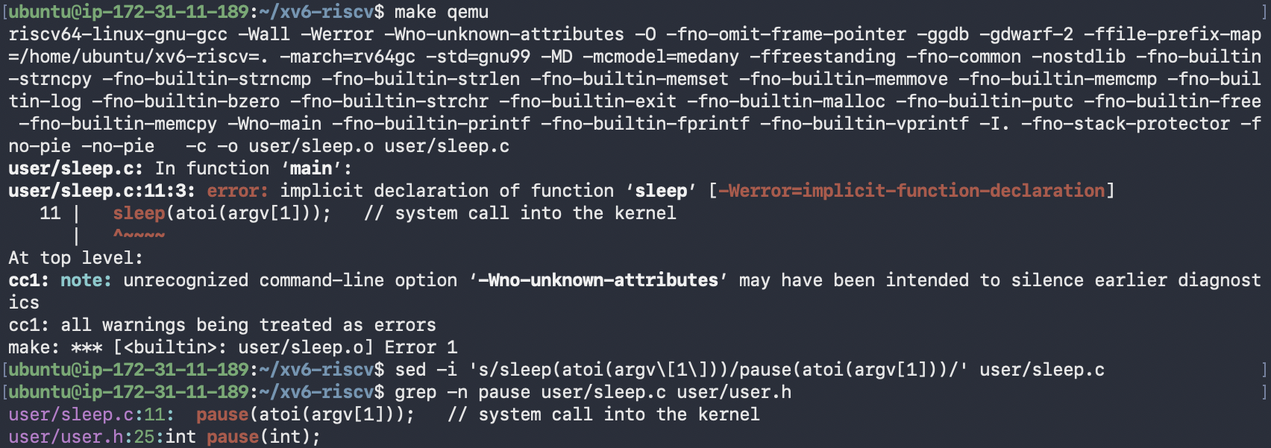
Figure 4.2 – The build error for sleep() and the switch to pause()
Final user/sleep.c:
#include "kernel/types.h"
#include "user/user.h"
int
main(int argc, char *argv[])
{
if(argc != 2){
fprintf(2, "usage: sleep <ticks>\n");
exit(1);
}
pause(atoi(argv[1])); // system call into the kernel
exit(0);
}
Then I rebuilt and tested it inside xv6:
make qemu
$ sleep 10
$ sleep
usage: sleep <ticks>
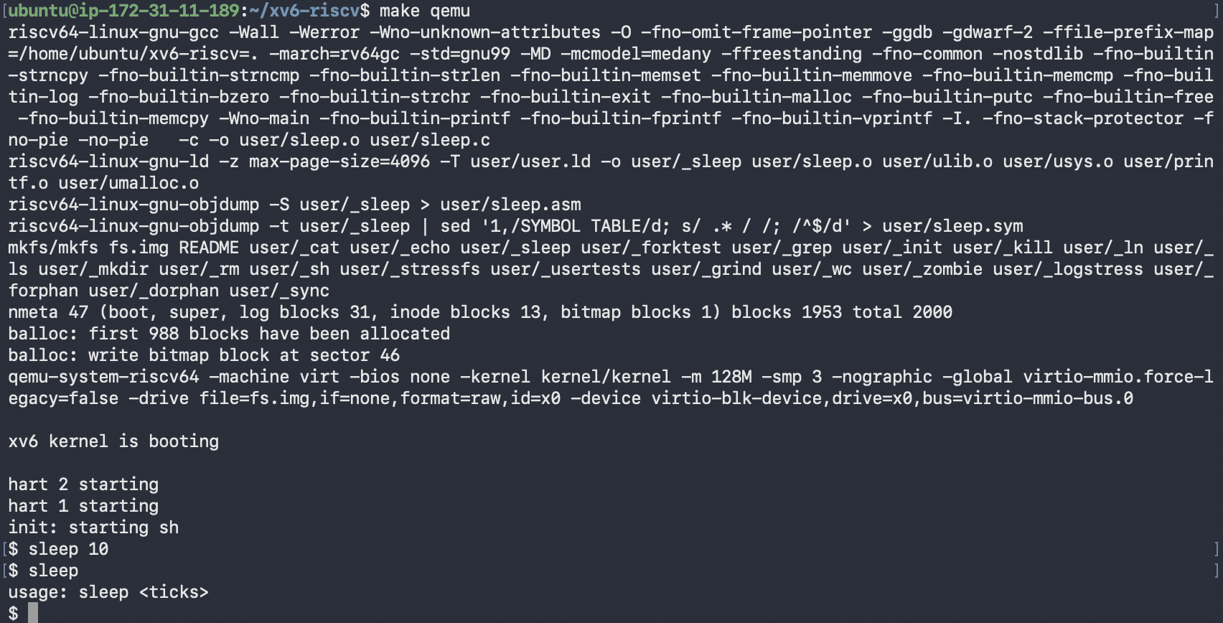
Figure 4.3 – A successful rebuild, then sleep 10 and sleep with no argument inside xv6
The mkfs line now includes user/_sleep, so the program was packed into the xv6 disk image. Inside xv6, sleep 10 paused before returning to the prompt. One tick is roughly 0.1 s in QEMU, so that is about one second. Running sleep without an argument printed usage: sleep <ticks>, so the argument check works as well.

6 Wrap-up
I built xv6 from source with a RISC-V cross-compiler and booted it in QEMU on three harts. Inside it, the basics of Unix were all there: ls, cat, echo, wc, a working pipe, and a kernel that passed the full usertests suite. Reading the source showed how thin the layer between programs and the kernel is: cat is a loop of read() and write(), user/user.h lists only 22 system calls, and each one has a sys_* implementation in kernel/ that runs in privileged mode. Writing sleep taught me the whole path of adding a program (source in user/, a TAB-indented line in UPROGS, mkfs packing it into fs.img) and that the current xv6 renamed the sleep system call to pause(), which the compiler caught as an implicit declaration.

