MINISTRY OF EDUCATION, CULTURE AND RESEARCH
OF THE REPUBLIC OF MOLDOVA
Technical University of Moldova
Faculty of Computers, Informatics and Microelectronics
Department of Software Engineering and Automation

Report
on laboratory work no. 3
Operating Systems
Topic: The Command Line: Shell, Pipes and Text Filters

Done by:
st. gr. FAF-242, Nichita Rusnac

Checked by:
Patricia Reitman, university assistant
DISA, FCIM, UTM

Chișinău – 2026

Table of Contents
1 Purpose of the work 3
2 Before you start 3
3 Part 1. Move fast, find help 4
3.1 Tab completion 4
3.2 Built-in or external, and where the shell looks 4
3.3 History search with Ctrl+R 6
3.4 Help without a browser 7
4 Part 2. What the shell does to your line 9
5 Part 3. Redirection, chaining and jobs 12
6 Part 4. Answer questions with one-liners 15
7 Part 5. Your first script 21
7.1 Bonus (+1): run it with cron 23
8 Wrap-up 24

All screenshots below come from my own terminal session, in the order I ran the commands. I did the lab on my Ubuntu 24.04 ARM (aarch64) machine on AWS, connected over SSH. The files I handed in (oneliners.sh, report.sh) are next to this note in the Lab3/ folder.

1 Purpose of the work
- learn to move fast in bash: Tab completion, history search, finding help without a browser
- understand what the shell does to a command line before the program runs (globbing, quoting, expansions)
- control where output goes with redirection, chain commands with ; && ||, run and stop background jobs
- answer real questions about a data file with one line of small filters joined by pipes
- turn those one-liners into a small script with argument checking, error handling and exit codes

2 Before you start
The course setup script was already run on this machine, so I only ran the check:
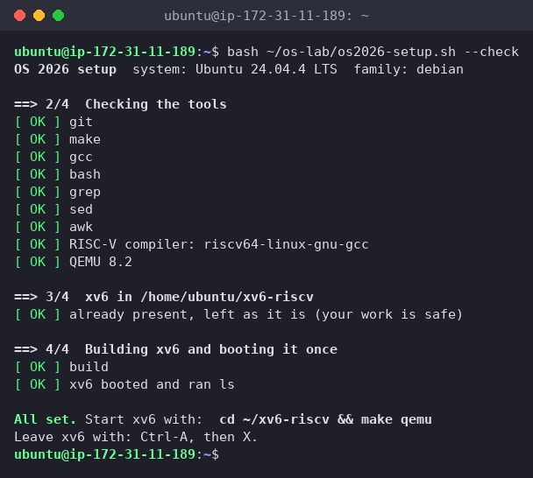
Figure 0.1 – The course setup check passes (tools, RISC-V compiler, QEMU 8.2, xv6 boots)
Then I generated the data set for Part 4 exactly as given in the lab:
mkdir -p ~/os-lab3 && cd ~/os-lab3
for i in $(seq 1 500); do
echo "2026-10-05 10:$(printf %02d $((i % 60))) user$((i % 7)) $([ $((i % 5)) -eq 0 ] && echo FAIL || echo OK) /page$((i % 4))"
done > access.log
head -3 access.log ; wc -l access.log
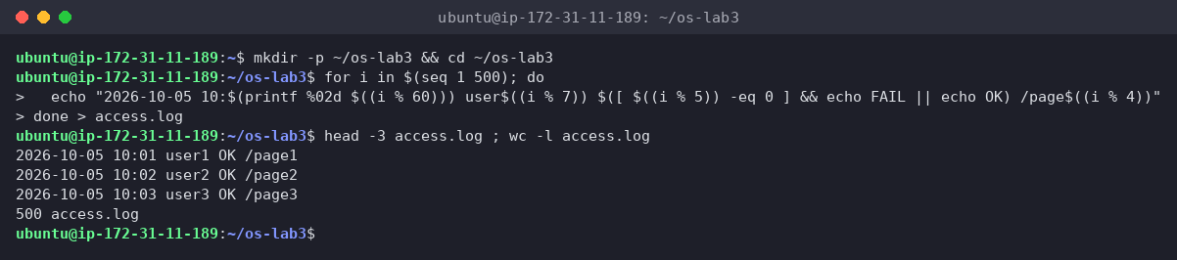
Figure 0.2 – Generating access.log; the check prints 500 access.log
The check passed: 500 access.log. Every line has the format date time user result page.

3 Part 1. Move fast, find help

3.1 Tab completion
I typed ls /usr/sh and pressed Tab, then cd /et and pressed Tab once.
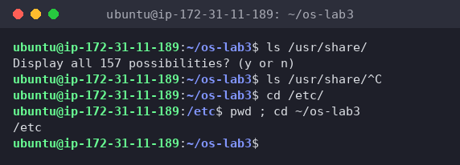
Figure 1.1 – Tab completion
- ls /usr/sh + Tab: only one entry in /usr starts with sh (share), so bash completed the whole name and added the slash: ls /usr/share/. The second Tab just rang the bell, because now the line ends in a directory with many possible entries. On a third Tab bash asked Display all 157 possibilities? (y or n) instead of flooding the screen. I answered n.
- cd /et + Tab (once): /etc is the only match, so one Tab was enough to get cd /etc/. After Enter, pwd confirmed /etc.
So one Tab completes when the match is unique, and a second Tab lists the choices when there are several.

3.2 Built-in or external, and where the shell looks
type cd ; type ls ; type echo ; which ls
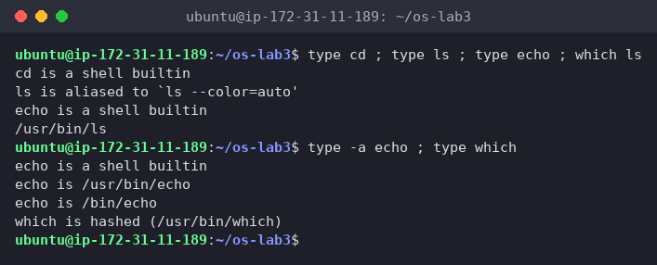
Figure 1.2 – Output of type and which
- cd is a shell builtin
- ls is aliased to 'ls --color=auto'. Ubuntu's .bashrc defines an alias, and behind it is the external program /usr/bin/ls (from which ls)
- echo is a shell builtin. With type -a echo I saw that there is also an external /usr/bin/echo, but bash finds its built-in first
echo $PATH
echo $PATH | tr ':' '\n' # one directory per line
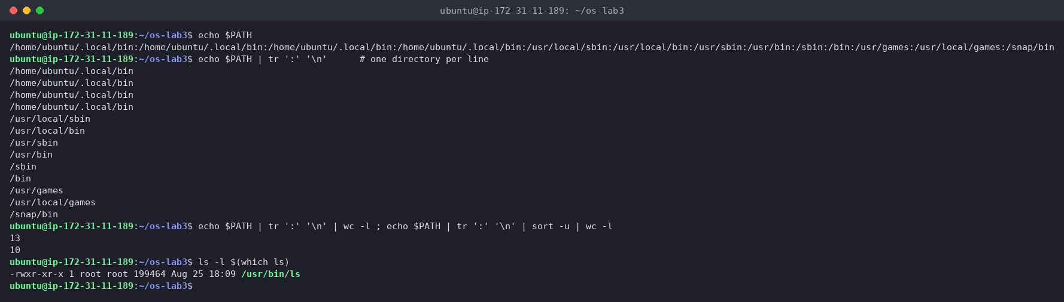
Figure 1.3 – The directories in PATH
tr ':' '\n' swaps every colon for a newline, so each directory gets its own line. wc -l counted 13 entries but only 10 unique ones: /home/ubuntu/.local/bin is there 4 times. Both my ~/.profile and ~/.bashrc prepend it, and each nested login shell (my SSH session → tmux → bash) adds it again. It does no harm, since the shell stops at the first match, but it's a good example of how PATH gets built by start-up files. ls lives in /usr/bin (/usr/bin/ls, 8th entry).
nosuchprog ; echo "exit code: $?"
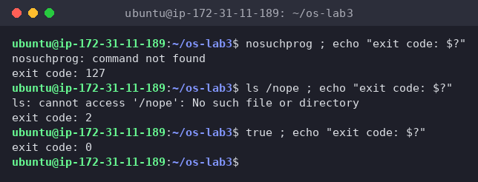
Figure 1.4 – Exit code of a missing command
nosuchprog: command not found, exit code: 127. For comparison, ls /nope (program found, but it failed) gives 2, and true gives 0.

3.3 History search with Ctrl+R
I ran three commands (date, hostname, uptime), then pressed Ctrl+R and typed dat:
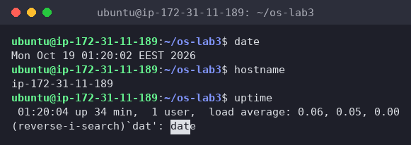
Figure 1.5 – Ctrl+R reverse search while typing dat
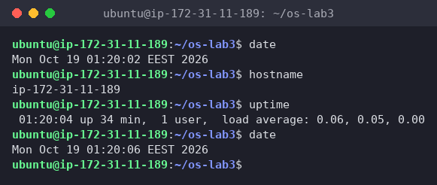
Figure 1.6 – After Enter, the found command date runs again
The prompt changed to (reverse-i-search)dat': date, and bash searched backwards through history as I typed, highlighting the match. Enter randateagain immediately (new time01:20:06`), without me typing it.

3.4 Help without a browser
I opened man ls, searched with /sort (n for the next hit), and then searched for the line that starts with -t:
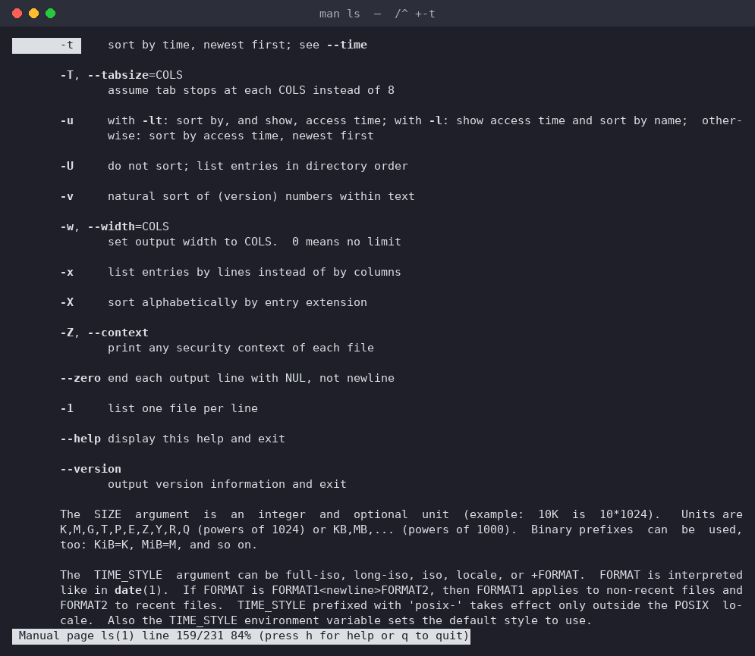
Figure 1.7 – man ls: the -t option
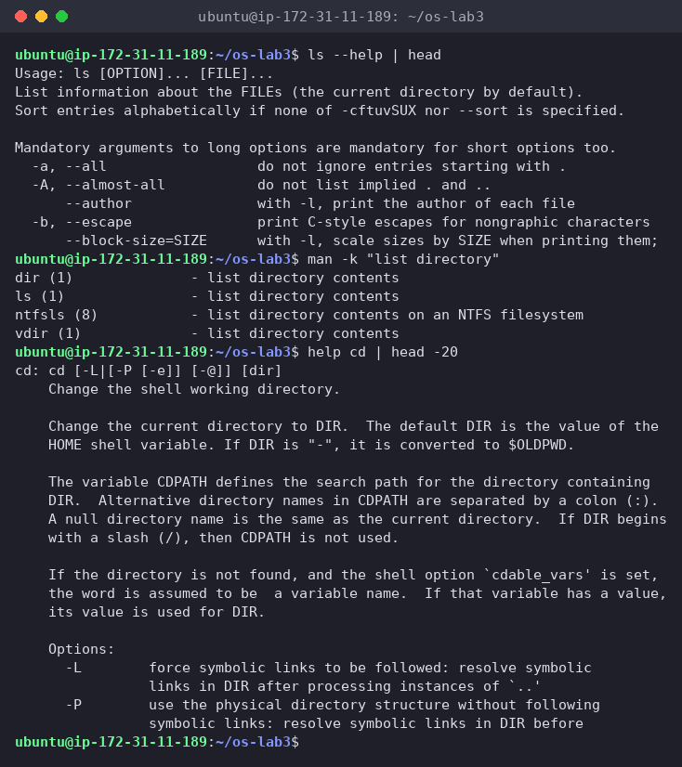
Figure 1.8 – ls --help, man -k "list directory" and help cd
- ls --help is a short summary built into the program itself
- man -k "list directory" searches man page descriptions and found dir, ls, ntfsls and vdir
- help cd works where man cd wouldn't, because cd is a bash built-in, so its documentation is inside bash
1. Which of cd, ls, echo are built-ins, and why MUST cd be one?
cd and echo are built-ins. ls is an external program (/usr/bin/ls, behind an alias). cd must be a built-in because the current directory is a property of each process. An external program runs in a new child process (fork + exec), so a /usr/bin/cd would change the child's directory and then exit, and my shell would stay where it was. Only the shell process itself can call chdir() on itself. (echo doesn't have to be a built-in, the external /usr/bin/echo exists too, it's just built in for speed.)
2. How many directories are in your PATH, and in which one is ls?
13 entries, 10 different directories (~/.local/bin is repeated 4 times). ls is in /usr/bin.
3. What exit code does a command that is not found return?
127. (126 would mean found but not executable, and a program that runs and fails returns its own code, like 2 for ls /nope.)
4. Which option of ls sorts by modification time?
-t: "sort by time, newest first" (Figure 1.7). Usually combined as ls -lt, or ls -ltr for oldest first.
Interesting output
The duplicated ~/.local/bin in PATH. I'd never have noticed it with the long echo $PATH line, but one entry per line with tr made it obvious. Also, type -a echo showing three echos (builtin, /usr/bin/echo, /bin/echo) shows that the order of lookup matters: aliases → built-ins → PATH from left to right. On Ubuntu /bin is a symlink to /usr/bin, which is why the same file appears twice.

4 Part 2. What the shell does to your line
mkdir -p ~/os-lab3/play && cd ~/os-lab3/play
touch a.c b.c file1.txt file2.txt notes.txt "alfa beta.txt"
ls
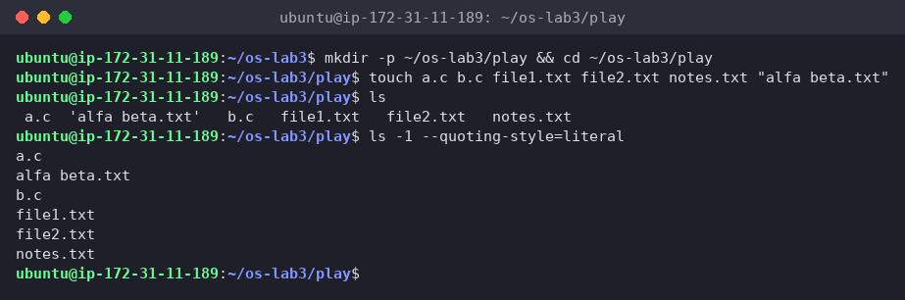
Figure 2.1 – Files created in the play directory
I wrote all my predictions down (in ~/os-lab3/predictions.md, at 01:21) before running anything, then ran each line:
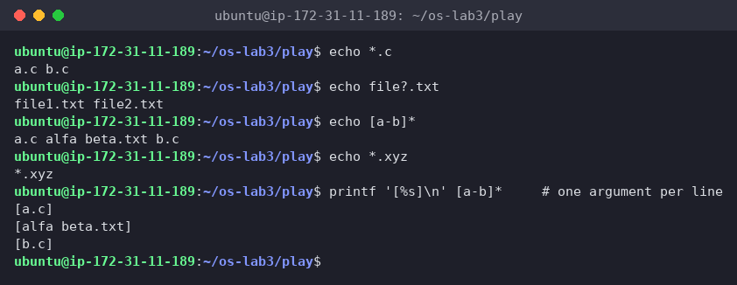
Figure 2.2 – Globbing results
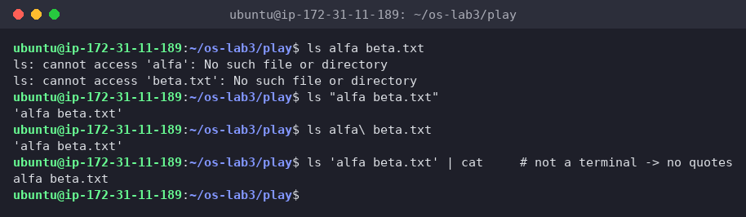
Figure 2.3 – The ls error on a name with a space, and the fix
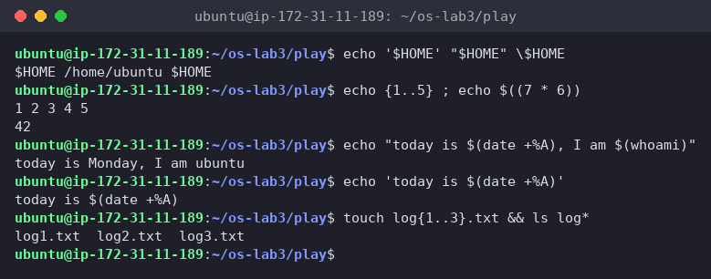
Figure 2.4 – Single quotes, double quotes and backslash (plus brace, arithmetic and command substitution)
Command | My prediction | Real output | Explanation (if different)
echo *.c | a.c b.c | a.c b.c | ✓
echo file?.txt | file1.txt file2.txt | file1.txt file2.txt | ✓ ? = exactly one character
echo [a-b]* | a.c alfa beta.txt b.c | a.c alfa beta.txt b.c | ✓ looks like 4 words, but it's 3 arguments (checked with printf '[%s]\n' [a-b]*)
echo *.xyz | *.xyz | *.xyz | ✓ no match, so bash leaves the pattern as it is
ls alfa beta.txt | 2 errors, for alfa and beta.txt | cannot access 'alfa' / cannot access 'beta.txt' | ✓
ls "alfa beta.txt" | alfa beta.txt | 'alfa beta.txt' | ✗ ls itself added the single quotes, see the note below
echo '$HOME' "$HOME" \$HOME | $HOME /home/ubuntu $HOME | $HOME /home/ubuntu $HOME | ✓
echo {1..5} ; echo $((7 * 6)) | 1 2 3 4 5 / 42 | 1 2 3 4 5 / 42 | ✓
echo "today is $(date +%A), I am $(whoami)" | today is Monday, I am ubuntu | today is Monday, I am ubuntu | ✓
touch log{1..3}.txt && ls log* | log1.txt log2.txt log3.txt | log1.txt log2.txt log3.txt | ✓
1. Prediction vs real output
See the table. The only mismatch was ls "alfa beta.txt", where I expected the bare name and got it in quotes.
2. echo knows nothing about files, yet echo *.c printed file names. Who produced them?
The shell. Before running echo, bash expands the glob *.c, reads the directory, finds a.c and b.c, and replaces the pattern with them. echo just receives the arguments a.c and b.c and prints them. That's also why echo *.xyz printed *.xyz: with no match, bash passes the pattern on unchanged.
3. Why did ls alfa beta.txt fail? Two ways to fix it.
The shell splits the line into words at spaces, so ls got two arguments, alfa and beta.txt, and neither file exists. The fix is to stop the split so the name arrives as one argument:
- quotes: ls "alfa beta.txt" (or 'alfa beta.txt')
- escape the space: ls alfa\ beta.txt
(A third option is Tab completion, which inserts the backslash for you.)
4. What is the difference between single and double quotes?
- Single quotes turn off everything: '$HOME' stays the literal text $HOME, and '$(date)' isn't run (Figure 2.4, line 4).
- Double quotes keep the text as one word (no splitting, no globbing) but still allow $VAR, $(command) and $((math)) expansions, so "$HOME" became /home/ubuntu and "today is $(date +%A)" ran date.
- Backslash protects just the next character: \$HOME → $HOME.
Note: why does ls show 'alfa beta.txt' in quotes?
Since coreutils 8.25, when the output goes to a terminal, ls quotes names that contain spaces or special characters (--quoting-style=shell-escape), so you can see where the name starts and ends and copy-paste it straight back into a command. The quotes are not part of the name. When the output goes into a pipe (ls 'alfa beta.txt' | cat) or with --quoting-style=literal, it prints the plain name alfa beta.txt (Figures 2.1 and 2.3).
Interesting output
echo [a-b]* looks like four words, but printf '[%s]\n' [a-b]* showed three arguments ([a.c], [alfa beta.txt], [b.c]). File names that come out of a glob are not split again at spaces, so globbing is safe with spaces while $var without quotes is not.

5 Part 3. Redirection, chaining and jobs
cd ~/os-lab3
ls /etc /nope > out.txt 2> err.txt
wc -l out.txt ; cat err.txt
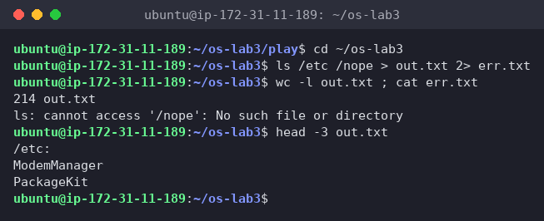
Figure 3.1 – stdout and stderr in separate files
Nothing appeared on the screen: the listing went into out.txt (214 lines, the /etc: header plus 213 names) and the error went into err.txt.
ls /etc /nope > all.txt 2>&1 ; tail -2 all.txt
ls /etc /nope 2>&1 > all.txt
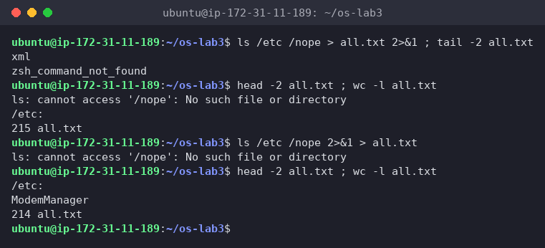
Figure 3.2 – Comparing the order of redirections
- > all.txt 2>&1: nothing on screen, and all.txt has 215 lines, the listing plus the error. tail -2 only shows xml and zsh_command_not_found, because the error is at the top of the file (head -2): stderr is not buffered, so ls writes the error immediately, while the listing on stdout is buffered and written at the end.
- 2>&1 > all.txt: the error appeared on the screen, and all.txt has only 214 lines, the listing alone.
echo first > notes.md ; echo second >> notes.md ; cat notes.md
wc -l < access.log
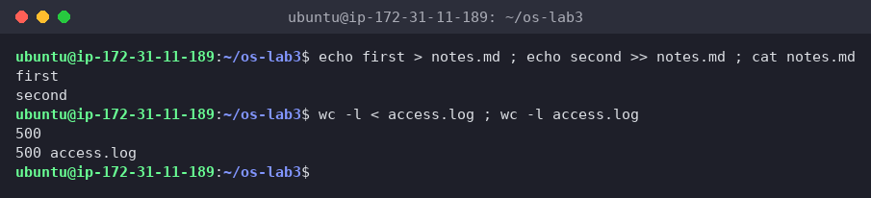
Figure 3.3 – Overwrite vs append, and stdin redirection
> created/truncated notes.md with first, then >> appended second, so both lines are there.
ls /nope 2> /dev/null || echo "failed with code $?"
mkdir -p tmp && cd tmp && echo "I am in $(pwd)" ; cd ~/os-lab3
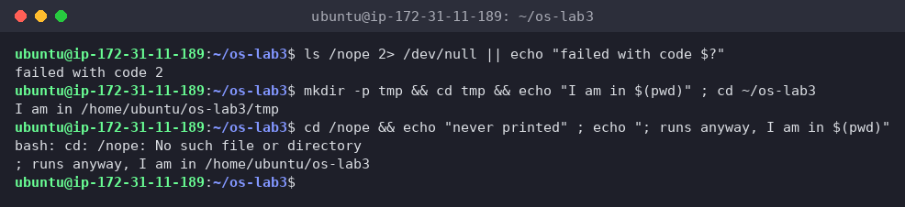
Figure 3.4 – The ; && || operators
- the error went to /dev/null (discarded), ls failed, so || ran the echo: failed with code 2
- mkdir succeeded → && → cd tmp succeeded → && → I am in /home/ubuntu/os-lab3/tmp, then ; ran cd ~/os-lab3 regardless
- I added one more line to show the difference: cd /nope && echo "never printed" ; echo .... cd failed, so && skipped the first echo, but ; still ran the second one
sleep 100 &
jobs ; kill %1 ; jobs
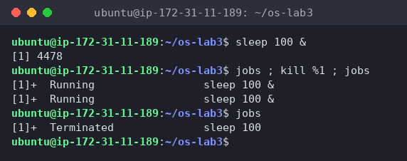
Figure 3.5 – Running a background job and stopping it
sleep 100 & printed [1] 4478 (job number and PID) and gave me the prompt back immediately. In the same line, both jobs printed Running, even the one after kill. kill only sends SIGTERM and returns at once, so the second jobs ran before the kernel had finished the process. A moment later, the next jobs showed [1]+ Terminated sleep 100.
1. Which file got the error message, and which got the listing?
err.txt got the error (ls: cannot access '/nope': No such file or directory) because 2> redirects file descriptor 2 (stderr). out.txt got the listing of /etc because > redirects file descriptor 1 (stdout).
2. Difference between > all.txt 2>&1 and 2>&1 > all.txt?
Redirections are processed left to right, and 2>&1 means "make fd 2 a copy of whatever fd 1 points to right now":
- > all.txt 2>&1: first fd 1 → all.txt, then fd 2 → copy of fd 1 = all.txt. Both go to the file.
- 2>&1 > all.txt: first fd 2 → copy of fd 1 = the terminal, then fd 1 → all.txt. fd 2 still points at the terminal, so the error shows on screen and only the listing goes into the file.
It's like copying a pointer: changing fd 1 afterwards doesn't change the earlier copy.
3. Why does wc -l < access.log print only a number, while wc -l access.log also prints the name?
With < access.log the shell opens the file and connects it to wc's stdin. wc gets no file name argument and just reads anonymous data from fd 0, so it has no name to print. With wc -l access.log, wc opens the file itself, knows the name and prints it next to the count (500 vs 500 access.log).
4. Each operator in one sentence
- ; runs the next command after the previous one finishes, whatever its result.
- && runs the next command only if the previous one succeeded (exit code 0).
- || runs the next command only if the previous one failed (exit code not 0).
Interesting output
Two timing effects I didn't expect: the error landing at the top of all.txt (unbuffered stderr vs buffered stdout), and jobs still saying Running right after kill. Both show that the shell and the processes run independently, and output order isn't always the order you typed things in.

6 Part 4. Answer questions with one-liners
Each line of access.log is date time user result page, so with cut -d' ' the fields are: -f2 time, -f3 user, -f4 OK/FAIL, -f5 page.
Q1. How many requests failed?
grep -c FAIL access.log
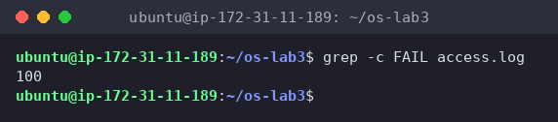
Figure 4.1 – Number of failed requests
100 requests failed. grep -c counts matching lines. (It makes sense: a line fails when i % 5 == 0, which is every 5th of 500.)
Q2. How many different pages were requested, and which?
cut -d' ' -f5 access.log | sort -u | nl
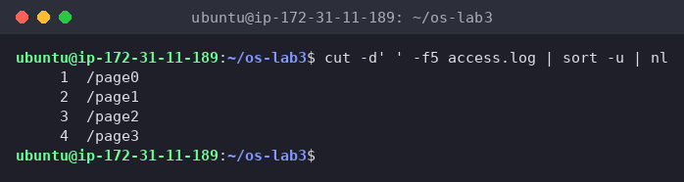
Figure 4.2 – The different pages requested
4 pages: /page0, /page1, /page2, /page3. sort -u keeps one copy of each, and nl numbers them, so the last number is the count.
Q3. How many requests did each page get?
cut -d' ' -f5 access.log | sort | uniq -c
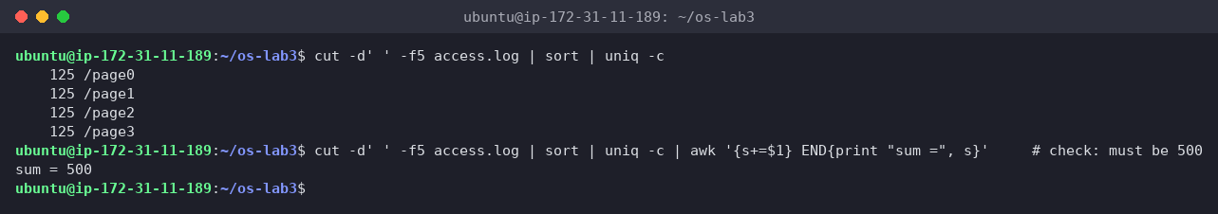
Figure 4.3 – Requests per page
Each page got 125 requests. The check 125 × 4 = 500 adds up to the log size (confirmed with a sum in the screenshot). uniq -c only merges adjacent equal lines, which is why sort must come first.
Q4. Which user or users have the most failed requests, and how many?
grep FAIL access.log | cut -d' ' -f3 | sort | uniq -c | sort -rn | awk 'NR==1{max=$1} $1==max'
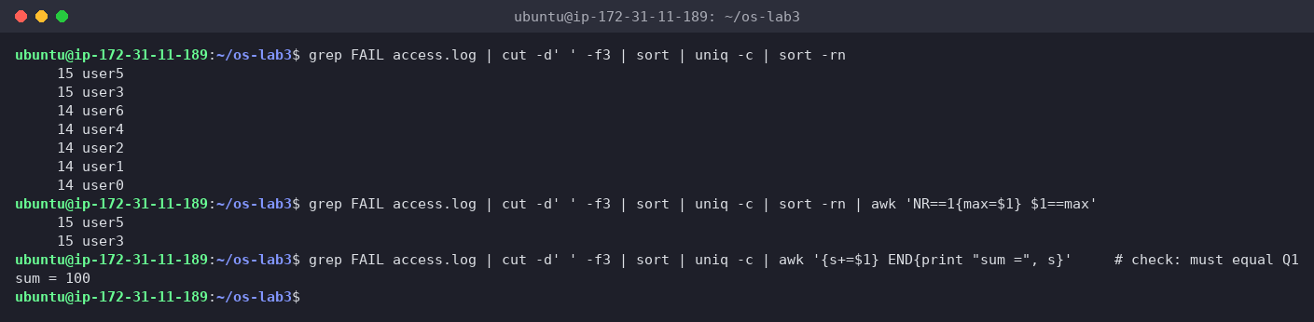
Figure 4.4 – Users with the most failed requests
user3 and user5, 15 failed requests each. It's a tie, so the usual sort -rn | head -1 would have shown only one of them and given a wrong answer. The last awk step remembers the count in the first (largest) line and prints every line with that same count. Check: the per-user failures (14+14+14+15+14+15+14) add up to 100, the same as Q1.
Q5. How many requests did user3 make, and how many of them failed?
echo "user3: $(grep -cw user3 access.log) requests, $(grep -w user3 access.log | grep -c FAIL) failed"
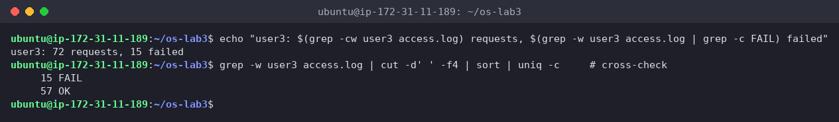
Figure 4.5 – user3: total and failed requests
72 requests, 15 failed (57 OK + 15 FAIL, cross-checked with uniq -c). -w matches whole words only, so a future user30 wouldn't be counted as user3.
Q6. Print the last 3 failed requests, showing only time and user.
grep FAIL access.log | tail -3 | cut -d' ' -f2,3
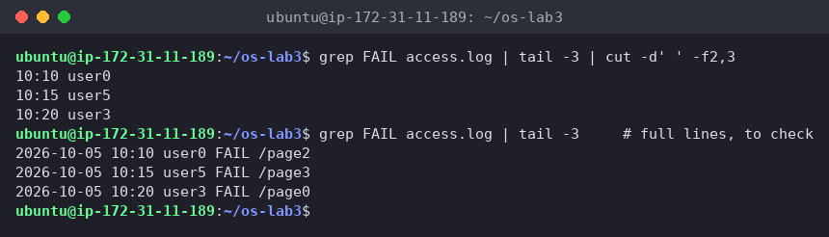
Figure 4.6 – The last 3 failed requests (time and user)
10:10 user0, 10:15 user5, 10:20 user3. The order of the filters matters: tail -3 has to come after grep FAIL, otherwise it would take the last 3 lines of the whole log.
Q7. Which login shells appear in /etc/passwd, and how many accounts use each?
cut -d: -f7 /etc/passwd | sort | uniq -c | sort -rn
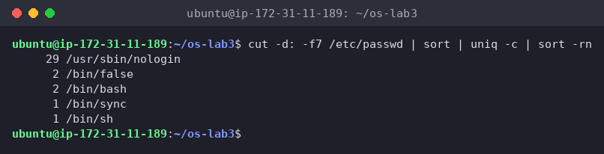
Figure 4.7 – Login shells in /etc/passwd
Accounts | Shell
29 | /usr/sbin/nologin
2 | /bin/false
2 | /bin/bash
1 | /bin/sync
1 | /bin/sh
Most accounts are system/service users (daemon, www-data …) with nologin or false, so nobody can log in as them. Only root and my ubuntu user have /bin/bash.
Q8. PREDICT, then explain: why do ls /etc | wc -l and ls -l /etc | wc -l differ by exactly one?
My prediction (written down first): ls -l prints an extra total <blocks> line at the top, so it has one more line.
ls /etc | wc -l
ls -l /etc | wc -l
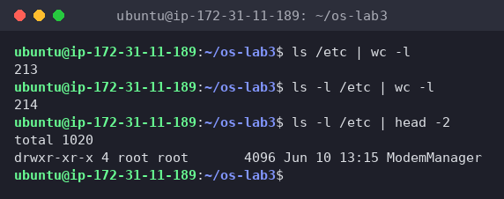
Figure 4.8 – ls vs ls -l line count
213 vs 214, and ls -l /etc | head -2 shows the first line is total 1020, so my prediction was right. Both print one line per entry (when ls writes into a pipe it switches to one name per line, not columns), but ls -l adds the total line: the disk space used by the listed files, in 1 KiB blocks.
Full run of oneliners.sh
The file has each question as a comment and one command line under it. I ran it with bash -v, which echoes every line of the script before running it, so the questions appear next to their answers:
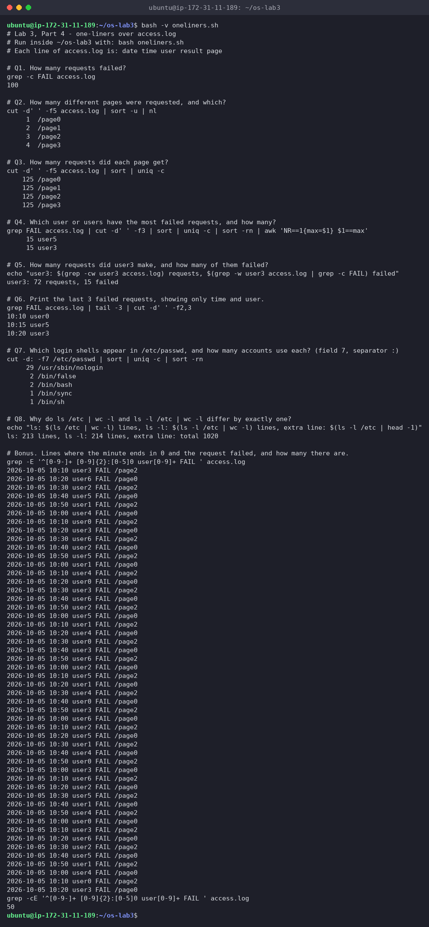
Figure 4.9 – Full run of oneliners.sh
Final oneliners.sh (also in this folder as oneliners.sh):
# Lab 3, Part 4 - one-liners over access.log
# Run inside ~/os-lab3 with: bash oneliners.sh
# Each line of access.log is: date time user result page
# Q1. How many requests failed?
grep -c FAIL access.log
# Q2. How many different pages were requested, and which?
cut -d' ' -f5 access.log | sort -u | nl
# Q3. How many requests did each page get?
cut -d' ' -f5 access.log | sort | uniq -c
# Q4. Which user or users have the most failed requests, and how many?
grep FAIL access.log | cut -d' ' -f3 | sort | uniq -c | sort -rn | awk 'NR==1{max=$1} $1==max'
# Q5. How many requests did user3 make, and how many of them failed?
echo "user3: $(grep -cw user3 access.log) requests, $(grep -w user3 access.log | grep -c FAIL) failed"
# Q6. Print the last 3 failed requests, showing only time and user.
grep FAIL access.log | tail -3 | cut -d' ' -f2,3
# Q7. Which login shells appear in /etc/passwd, and how many accounts use each? (field 7, separator :)
cut -d: -f7 /etc/passwd | sort | uniq -c | sort -rn
# Q8. Why do ls /etc | wc -l and ls -l /etc | wc -l differ by exactly one?
echo "ls: $(ls /etc | wc -l) lines, ls -l: $(ls -l /etc | wc -l) lines, extra line: $(ls -l /etc | head -1)"
# Bonus. Lines where the minute ends in 0 and the request failed, and how many there are.
grep -E '^[0-9-]+ [0-9]{2}:[0-5]0 user[0-9]+ FAIL ' access.log
grep -cE '^[0-9-]+ [0-9]{2}:[0-5]0 user[0-9]+ FAIL ' access.log
Bonus (+1): minute ends in 0 and the request failed
grep -E '^[0-9-]+ [0-9]{2}:[0-5]0 user[0-9]+ FAIL ' access.log
grep -cE '^[0-9-]+ [0-9]{2}:[0-5]0 user[0-9]+ FAIL ' access.log
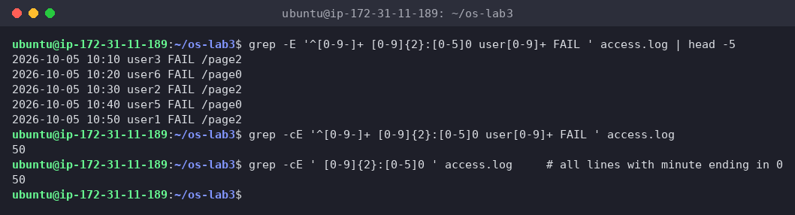
Figure 4.10 – Bonus: failed requests at minutes 10:00, 10:10, … (grep -E)
50 lines. The regex is anchored to the line's structure: date, then HH: followed by [0-5]0 (minutes 00, 10, …, 50), then a user, then FAIL. Interesting detail: counting all lines whose minute ends in 0 also gives 50. The minute is i % 60, and it ends in 0 only when i is a multiple of 10, which is also a multiple of 5, so every one of those requests is a FAIL.
Interesting output
The Q4 tie (user3 and user5 both have 15). The "count per user" pattern from the lab with head -1 would have silently given only one name. The checks the lab suggests (Q3 sums to 500, Q4 sums to Q1) passed, which confirms the pipelines filter the right thing.

7 Part 5. Your first script
I created report.sh from the template and completed the TODO with a loop over user0 … user6:
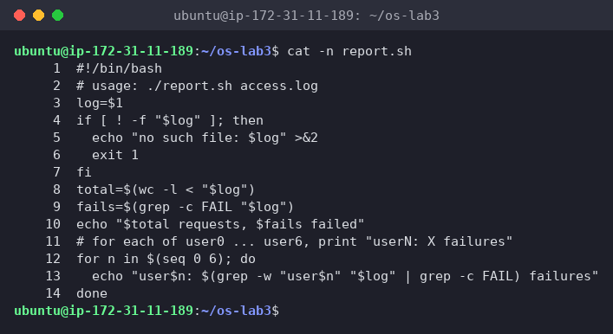
Figure 5.1 – Contents of report.sh
#!/bin/bash
# usage: ./report.sh access.log
log=$1
if [ ! -f "$log" ]; then
echo "no such file: $log" >&2
exit 1
fi
total=$(wc -l < "$log")
fails=$(grep -c FAIL "$log")
echo "$total requests, $fails failed"
# for each of user0 ... user6, print "userN: X failures"
for n in $(seq 0 6); do
echo "user$n: $(grep -w "user$n" "$log" | grep -c FAIL) failures"
done
Before chmod +x I deliberately tried to run it, then made it executable and ran it:
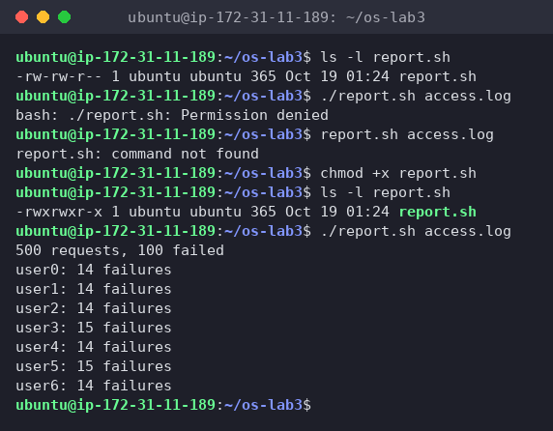
Figure 5.2 – Running the script on access.log (before and after chmod +x)
./report.sh nope.log ; echo "exit code: $?"
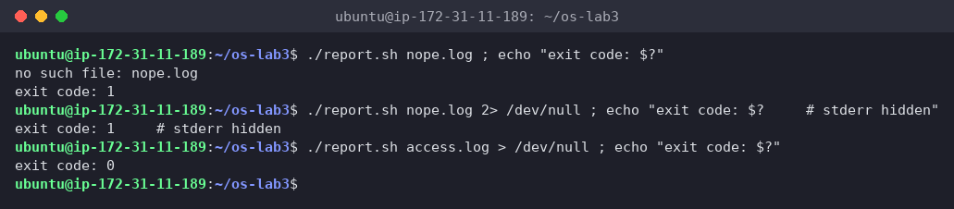
Figure 5.3 – Error handling for a missing file
The output matches the one-liners: 500 requests, 100 failed, user3 and user5 with 15, the rest with 14. With a missing file it prints no such file: nope.log and returns exit code: 1. With 2> /dev/null the message disappears but the exit code stays 1, and a successful run returns 0.
1. What does #!/bin/bash do, and what happens if you run ./report.sh before chmod +x?
#! ("shebang") on the first line tells the kernel, when it execs the file, which interpreter to start: it runs /bin/bash ./report.sh access.log, so the script works no matter which shell I'm using. Before chmod +x the file is -rw-rw-r-- (no x bit), so the kernel refuses to execute it: bash: ./report.sh: Permission denied (Figure 5.2). It could still be run as bash report.sh access.log, because then bash is the program being executed and the script is just a file it reads.
2. Why ./report.sh and not just report.sh?
A name without a / is looked up only in the PATH directories (Part 1), and ~/os-lab3 is not in PATH, so report.sh access.log gave report.sh: command not found. ./ is an explicit path ("in the current directory"), so no PATH search happens. The current directory is left out of PATH on purpose: otherwise a malicious file called ls in some folder would run instead of /usr/bin/ls.
3. Why does the script write the error with >&2 and end with exit 1?
- >&2 sends the message to stderr, not stdout. If someone runs ./report.sh x > result.txt or pipes it into another command, the error still shows on the screen and doesn't get mixed into the data.
- exit 1 returns a non-zero exit code, the standard way to say "failed". Callers can react to it with &&, ||, if, or cron/CI checks. Without it the script would return 0 and look successful.

7.1 Bonus (+1): run it with cron
I added one line to my crontab, keeping the line that was already there (my vault's auto-sync), with full paths and >> … 2>&1:
* * * * * /home/ubuntu/os-lab3/report.sh /home/ubuntu/os-lab3/access.log >> /home/ubuntu/os-lab3/report.log 2>&1
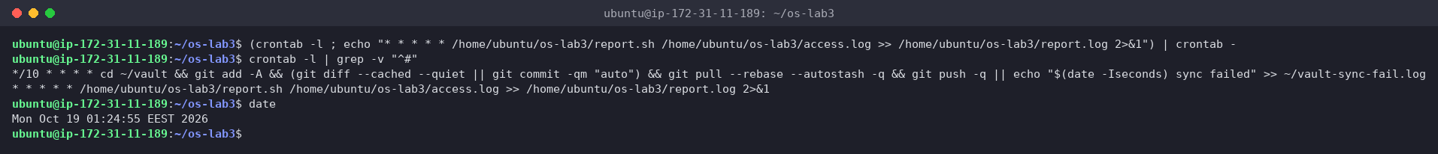
Figure 5.4 – The crontab line added (01:24:55)
After two minutes:
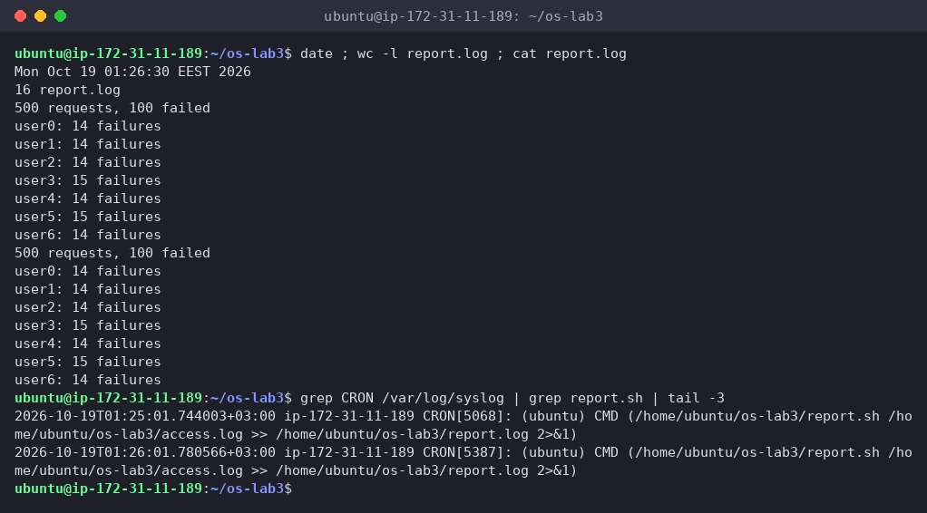
Figure 5.5 – report.log after two cron runs, and the CRON entries in syslog
report.log has 16 lines, two full reports, and /var/log/syslog shows CRON[...]: (ubuntu) CMD (...) at exactly 01:25:01 and 01:26:01. Then I removed only my line. I didn't use crontab -r, because that would also delete the sync job:
crontab -l | grep -v "os-lab3/report.sh" | crontab -
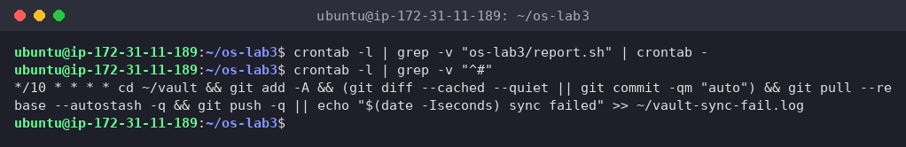
Figure 5.6 – Crontab after removing the line (only the original job is left)
Full paths are needed because cron runs jobs with a minimal environment (PATH=/usr/bin:/bin, home directory as the working directory, no terminal), so relative paths like access.log would point to the wrong place. 2>&1 makes sure any error also ends up in the log, since there's no screen to show it on.

8 Wrap-up
This lab showed me that the shell does much more than start programs: before anything runs, bash completes, expands globs, braces, variables and $(...), removes quotes and splits the line into words. The program then only gets the finished argument list. I saw this with echo *.c, the space in alfa beta.txt, and the difference between single and double quotes. Redirection and pipes are the shell connecting file descriptors 0, 1 and 2 to files or to other processes, and the order matters (> f 2>&1 vs 2>&1 > f). With grep, cut, sort, uniq, wc, head and tail joined by pipes I answered every question about the log in one line, and the sum checks caught the tie in Q4. Finally, exit codes and stderr turned those one-liners into a real script (report.sh) that other tools, like &&, || and cron, can rely on.

