MINISTRY OF EDUCATION, CULTURE AND RESEARCH
OF THE REPUBLIC OF MOLDOVA
Technical University of Moldova
Faculty of Computers, Informatics and Microelectronics
Department of Software Engineering and Automation

Report
on laboratory work no. 4
Operating Systems
Topic: The xv6 Shell from the Outside

Done by:
st. gr. FAF-242, Nichita Rusnac

Checked by:
Patricia Reitman, university assistant
DISA, FCIM, UTM

Chișinău – 2026

Table of Contents
1 Purpose of the work 3
2 Before you start 3
3 Part 1. Fix sleep for the current xv6 4
4 Part 2. bash versus the xv6 shell 6
5 Part 3. Who expands *? A program that prints its argv 12
6 Part 4. Read the shell 16
7 Wrap-up 20

All screenshots below come from my own session, in the order I ran the commands. Linux commands ran in bash on my Ubuntu 24.04 ARM machine on AWS. xv6 commands ran at the xv6 $ prompt inside QEMU (make qemu), on the revision the labs were tested on (06aad25). The files I handed in (sleep.c, args.c, args_linux.c, Makefile) are next to this note in the Lab4/ folder.

1 Purpose of the work
- make my sleep program from Lab 2 build and run on the current xv6, where sleep() was renamed to pause()
- use the xv6 shell (user/sh.c, ~500 lines) side by side with bash and find out by experiment what a shell must do and what bash adds on top
- write a program that prints its argv and use it to prove who expands * and removes quotes: the program, the kernel or the shell
- read the xv6 shell source to see how it parses and runs the five kinds of commands, and how it handles cd

2 Before you start
bash os2026-setup.sh --check
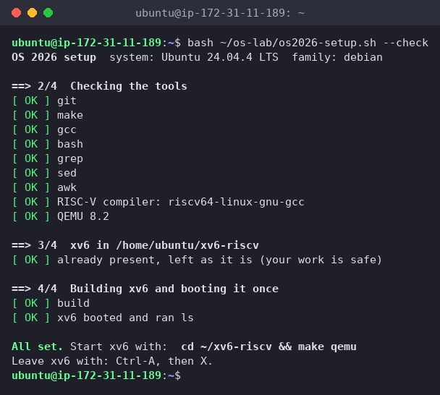
Figure 0.1 – The setup check: tools OK, QEMU 8.2, xv6 builds and boots
Everything passed, so I didn't need to run the full install.

3 Part 1. Fix sleep for the current xv6
cd ~/xv6-riscv
grep -n "pause\|sleep" user/user.h
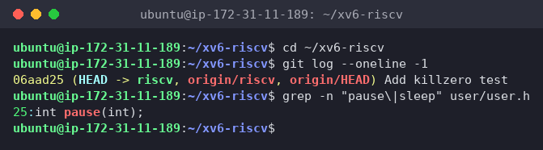
Figure 1.1 – The grep result in user.h
Only 25:int pause(int); matches. My tree has no sleep declaration at all, so it is the post-August-2025 xv6, and the system call is pause(). I'd already hit this in Lab 2 (implicit declaration of function 'sleep') and switched to pause(). For this lab I updated the comment to match the lab's version:
#include "kernel/types.h"
#include "user/user.h"
int
main(int argc, char *argv[])
{
if(argc != 2){
fprintf(2, "usage: sleep <ticks>\n");
exit(1);
}
pause(atoi(argv[1])); // was sleep() before Aug 2025
exit(0);
}
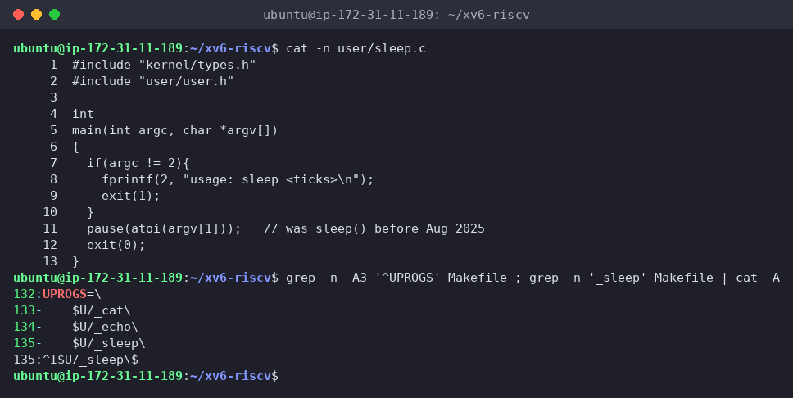
Figure 1.2 – The updated sleep.c and its UPROGS line
To check the Makefile I printed the UPROGS line with cat -A, which shows invisible characters: ^I$U/_sleep\$. ^I is the TAB at the start and $ (end of line) comes right after the backslash, so nothing follows it, exactly as the Makefile reminder requires.
make qemu
$ sleep 20
$ sleep
usage: sleep <ticks>
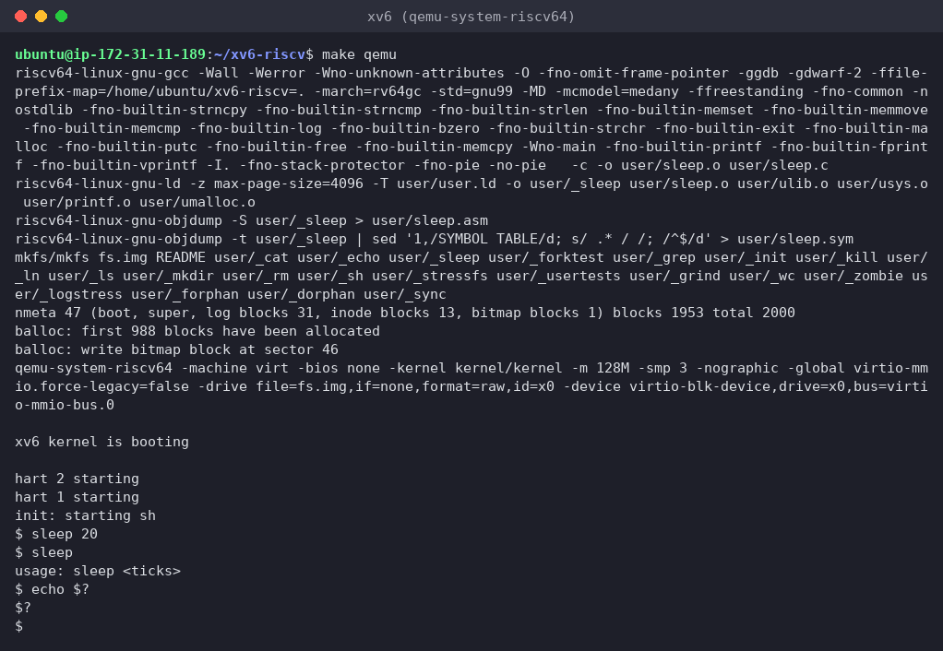
Figure 1.3 – sleep running in xv6, with and without an argument
make recompiled only user/sleep.c (the file I changed), relinked _sleep, and mkfs put it into fs.img. In xv6, sleep 20 paused and then gave the prompt back. I timed it from outside: about 2.0 s, so one xv6 tick is about 0.1 s (kernel/trap.c sets the next timer interrupt 1000000 time units ahead, with the comment "1000000 is about a tenth of a second"). Without an argument it printed usage: sleep <ticks>.
I also tried echo $? out of habit, and xv6 printed $? literally, a first hint for Part 2: the xv6 shell has no variables and doesn't keep exit codes.

4 Part 2. bash versus the xv6 shell
In bash I worked in a fresh test folder with a README (mkdir ~/shtest && cd ~/shtest && touch README). In xv6 I used the root directory, which already has README. To start from a clean xv6 disk I deleted fs.img before booting, so files from earlier runs were gone.
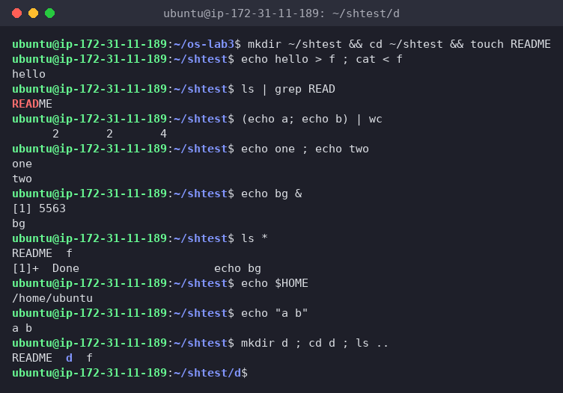
Figure 2.1 – The commands run in bash
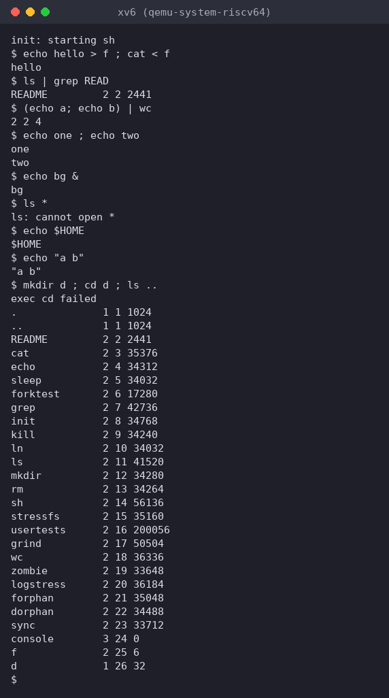
Figure 2.2 – The same commands run in xv6
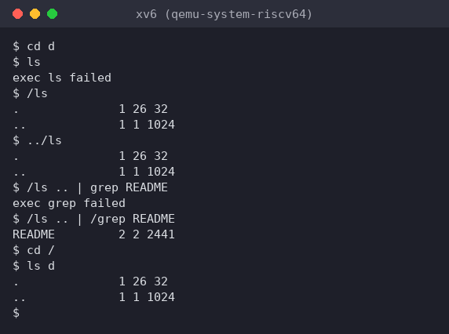
Figure 2.3 – ls failing after cd d, and the working alternative
For the last row I pressed Up, Tab and Ctrl+R in both shells:
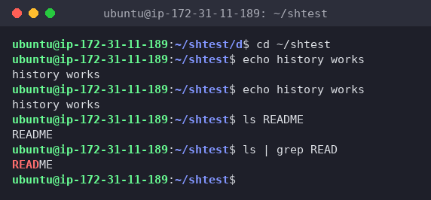
Figure 2.4 – bash: Up arrow re-runs the last command, Tab completes REA → README, Ctrl+R finds ls | grep READ
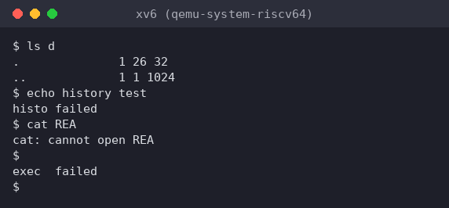
Figure 2.5 – xv6: the same keys send raw bytes to the shell
Command | Tests | bash | xv6
echo hello > f ; cat < f | redirection | hello | hello. Same: sh.c opens the file in place of fd 1 / fd 0
ls \| grep READ | pipe | README | README 2 2 2441. Pipe works, the line looks different only because xv6 ls prints type, inode, size
(echo a; echo b) \| wc | grouping, list | 2 2 4 | 2 2 4. Same, both support ( ) and ;
echo one ; echo two | sequence | one / two | one / two. Same
echo bg & | background | [1] 5563, bg, later [1]+ Done echo bg | bg. Runs in the background, but there's no job number, no jobs, no "Done" message
ls * | globbing | README f | ls: cannot open *. No globbing: ls gets a literal * and looks for a file with that name
echo $HOME | variables | /home/ubuntu | $HOME. No variables, $ is a normal character
echo "a b" | quotes | a b | "a b". Quotes are not special, they stay in the text
mkdir d ; cd d ; ls .. | PATH | README d f (now inside d) | exec cd failed, then ls .. lists / from the root. cd is only recognized at the start of a line (see Part 4). Typed alone, cd d works, but then ls → exec ls failed (Figure 2.3)
arrow up, Tab, Ctrl+R | history, completion | Up recalls the last command, Tab completes file names, Ctrl+R searches history | None. Up sends ESC [ A, which xv6 echoes (the terminal treats it as cursor-up, so the line gets garbled) and then tries to run: … failed. Tab is just whitespace (cat REA → cannot open REA). Ctrl+R becomes a ^R "command": exec ^R failed
1. Features both shells have, and the ones only bash has
- Both: running programs with arguments, I/O redirection < > >>, pipes |, sequences ;, grouping ( ), background &, and the built-in cd.
- Only bash: globbing (*, ?, [ ]), variables and $ expansions ($HOME, $?, $(...), $((...))), quoting ('…', "…", \), PATH search for programs, && / ||, job control (jobs, kill %1, fg, "Done" messages), line editing with history (Up, Ctrl+R) and Tab completion, cd anywhere in a line, scripts with if/for, aliases, helpful errors ("command not found" with suggestions instead of exec X failed).
2. In xv6, ls stops working after cd d. Why, and how to run ls from inside d anyway?
xv6 has no PATH. The shell passes the name I typed straight to exec("ls", argv), and the kernel resolves ls like any file name, relative to the current directory. All xv6 programs live in the root directory / (mkfs copies _ls, _cat, … there as ls, cat, …). At /, ls happens to be ./ls. Inside d there's no d/ls, so: exec ls failed.
Fix: give the path to the program myself:
- /ls (absolute path) or ../ls (relative path) work from inside d (Figure 2.3)
- the same goes for every program: /ls .. | grep README failed with exec grep failed, and /ls .. | /grep README worked
- or simply cd / and run ls d
3. Which missing feature would I miss most, and which would be easiest to add?
- Miss most: command history and line editing (Up arrow / Ctrl+R) together with Tab completion. In xv6, one typo means retyping the whole line, and I use these keys all the time in bash. Globbing would be a close second.
- Easiest to add: a PATH fallback. In runcmd (case EXEC), when exec(argv[0], …) fails and the name has no /, build "/" + argv[0] and call exec again. That's about 5 lines and fixes the ls after cd problem. Making cd work after ; is also easy: handle it inside runcmd as a special case. History is much harder, because the xv6 console works line by line (cooked mode) and would need a raw mode to see arrow keys.
Interesting output
The mkdir d ; cd d ; ls .. line behaved differently than the lab expected: instead of ls failing, xv6 printed exec cd failed and listed /. xv6 only checks whether the whole line starts with cd. Here the line starts with mkdir, so cd was treated as a normal program, and there is no /cd binary. And since cd never ran, ls .. ran from /, where .. is / itself. Typing cd d alone showed the real PATH problem.

5 Part 3. Who expands *? A program that prints its argv
user/args.c for xv6 and its UPROGS line ($U/_args\, with a TAB, right after _sleep):
#include "kernel/types.h"
#include "user/user.h"
int
main(int argc, char *argv[])
{
printf("argc = %d\n", argc);
for(int i = 0; i < argc; i++)
printf("argv[%d] = [%s]\n", i, argv[i]);
exit(0);
}
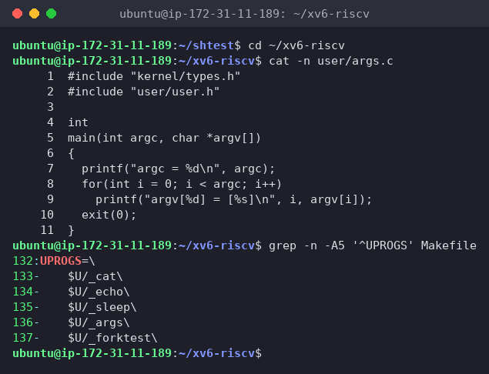
Figure 3.1 – args.c and the UPROGS line
args_linux.c is the same program with #include <stdio.h> and return 0:
#include <stdio.h>
int
main(int argc, char *argv[])
{
printf("argc = %d\n", argc);
for(int i = 0; i < argc; i++)
printf("argv[%d] = [%s]\n", i, argv[i]);
return 0;
}
In xv6 (after make qemu, which built _args and added it to fs.img):
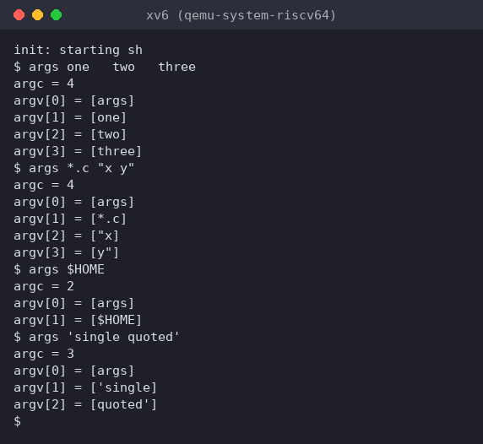
Figure 3.2 – args output in xv6
In bash, in ~/os-lab4, which contains args_linux.c, main.c and util.c, after gcc -o args args_linux.c:
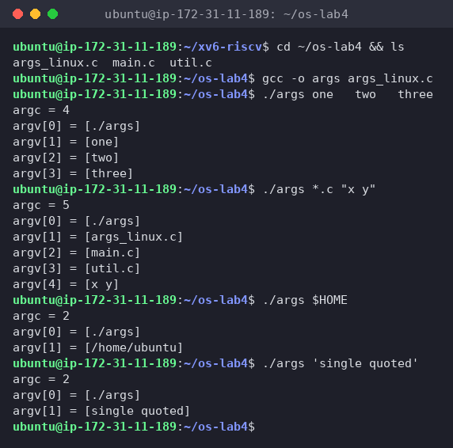
Figure 3.3 – args_linux output in bash
Line | xv6 argc / argv | bash argc / argv
args one two three | 4: [args] [one] [two] [three] | 4: [./args] [one] [two] [three]
args *.c "x y" | 4: [args] [*.c] ["x] [y"] | 5: [./args] [args_linux.c] [main.c] [util.c] [x y]
args $HOME | 2: [args] [$HOME] | 2: [./args] [/home/ubuntu]
args 'single quoted' | 3: [args] ['single] [quoted'] | 2: [./args] [single quoted]
1. Both outputs for args *.c "x y". How many arguments did each program receive?
xv6:
argc = 4
argv[0] = [args]
argv[1] = [*.c]
argv[2] = ["x]
argv[3] = [y"]
bash:
argc = 5
argv[0] = [./args]
argv[1] = [args_linux.c]
argv[2] = [main.c]
argv[3] = [util.c]
argv[4] = [x y]
Counting argv[0] (the program name), xv6's program received 4 and the Linux program 5. Not counting the name, that's 3 vs 4 real arguments. In xv6 *.c arrived unchanged, and "x y" was split at the space into two arguments that still carry the quote characters. In bash *.c became three file names and "x y" arrived as one argument, x y, without quotes.
2. Who turns *.c into file names and removes the quotes: the program, the kernel, or the shell?
The shell. It's the same C code and the same exec() system call on both systems, and the results differ only because the shells differ. The program just prints what it got, so it can't be the program. The kernel's exec copies the argv strings into the new process exactly as given, so it isn't the kernel either. bash expanded the glob and removed the quotes before calling exec. xv6's sh.c does neither, so the raw text reached the program.
3. What happened to the extra spaces in one two three?
They disappeared in both shells: each program got exactly one, two, three, with no spaces. Spaces are word separators, and the shell's tokenizer skips any run of whitespace between words (in sh.c, gettoken loops while (strchr(whitespace, *s)) s++). Spaces never reach the program unless they're protected, like "x y" in bash. xv6 can't protect them at all.
Interesting output
argv[0] differs as well: [args] in xv6 vs [./args] in bash. argv[0] is just whatever the shell passed as the first word, so it's the name I typed, not a fixed program name.

6 Part 4. Read the shell
wc -l user/sh.c
grep -n "#define" user/sh.c # the kinds of commands
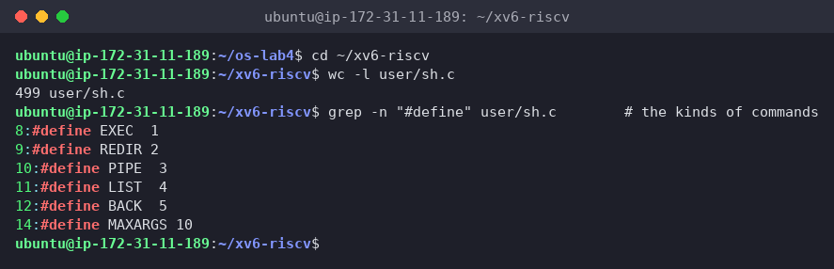
Figure 4.1 – The command kinds defined in sh.c
sh.c is 499 lines. It defines EXEC 1, REDIR 2, PIPE 3, LIST 4, BACK 5 (and MAXARGS 10, the most arguments one command can have).
grep -n "case " user/sh.c # where each kind is run
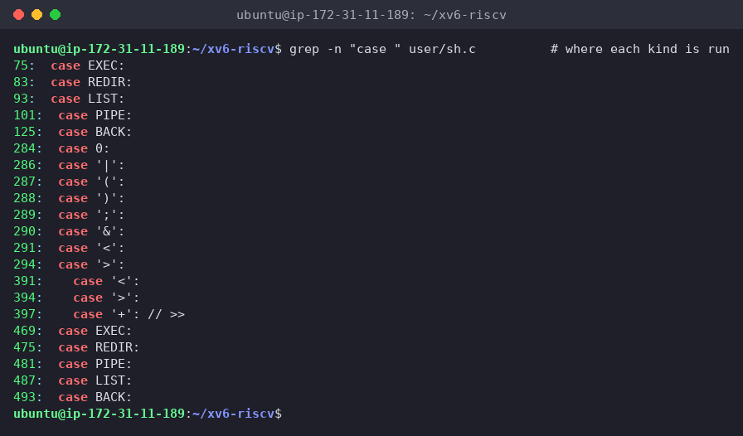
Figure 4.2 – Where each kind is run
Three groups of cases show the whole design:
- lines 75–125, runcmd(): executes each kind. EXEC calls exec(); REDIR does close(fd) and then open(file), so the new file gets the lowest free fd; LIST forks the left side, waits, then runs the right side; PIPE creates pipe(), forks two children and connects them with dup(); BACK forks and does not wait.
- lines 284–294, gettoken(): the tokenizer. The only special characters are | ( ) ; & < > (and >> as '+').
- lines 469–493, nulterminate(): walks the tree after parsing and puts \0 at the end of each word.
grep -n "cd" user/sh.c | head
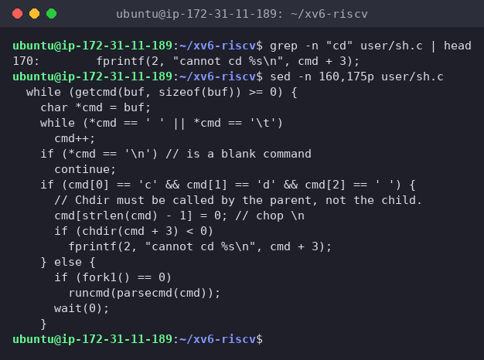
Figure 4.3 – The code that handles cd
grep "cd" finds only one line, the error message on line 170, because the check is written character by character. sed -n 160,175p shows the code in main():
if (cmd[0] == 'c' && cmd[1] == 'd' && cmd[2] == ' ') {
// Chdir must be called by the parent, not the child.
cmd[strlen(cmd) - 1] = 0; // chop \n
if (chdir(cmd + 3) < 0)
fprintf(2, "cannot cd %s\n", cmd + 3);
} else {
if (fork1() == 0)
runcmd(parsecmd(cmd));
wait(0);
}
Finally I searched for any code that handles *, $ or quotes:
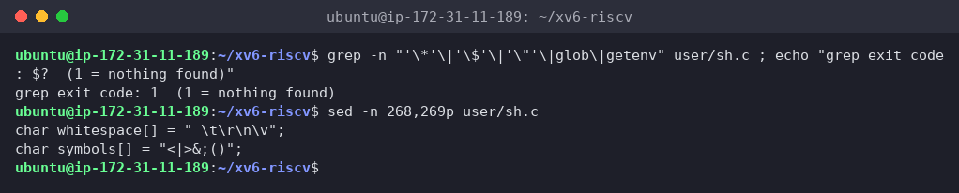
Figure 4.4 – No code for *, $ or quotes in sh.c; the only special characters
1. The five kinds of command and the character that produces each
Kind | Character | Example | What runcmd does
EXEC | none (plain words) | ls d | exec(argv[0], argv)
REDIR | <, >, >> | cat < f, echo hi > f | close fd 0/1, open the file in its place, run the inner command
PIPE | \| | ls \| grep READ | pipe(), fork two children, dup the ends onto fd 1 / fd 0
LIST | ; | echo one ; echo two | fork + run left, wait, then run right
BACK | & | echo bg & | fork, run the command, don't wait
Parentheses ( ) don't have their own kind. parseblock just parses what's inside them into a sub-tree, which is how (echo a; echo b) | wc became a PIPE whose left side is a LIST.
2. Where is cd handled, and why isn't it a separate program?
In main(), lines 166–170, before the shell forks. If the line starts with cd, the shell calls chdir() itself; every other line is forked and run by a child with runcmd. As the comment says: "Chdir must be called by the parent, not the child." The current directory belongs to each process. A child (or a /cd program) would change only its own directory and then exit, and the shell would stay where it was, the same reason cd is a built-in in bash (Lab 3). This also explains my Part 2 result: since the check only looks at the start of the line, mkdir d ; cd d sends cd to a child as a normal EXEC, giving exec cd failed.
3. Code that handles * or $? What does it explain about Part 2?
There's none. The grep for '*', '$', '"', glob and getenv found nothing (exit code 1), and the only special characters are whitespace[] = " \t\r\n\v" and symbols[] = "<|>&;()". Everything else is an ordinary word character. That explains all the "only bash" rows in Part 2:
- ls * → ls got a literal * → ls: cannot open *
- echo $HOME → printed $HOME, since there are no variables and no environment at all
- echo "a b" → printed "a b", and args "x y" gave ["x] [y"], since quotes are normal characters and the space still splits the words
- args *.c → [*.c], the program saw exactly what I typed
Interesting output
The >> case on line 397 opens the file with O_WRONLY | O_CREATE, without O_TRUNC and without any append flag (xv6's fcntl.h doesn't even have O_APPEND), so from reading the code, xv6's >> writes from the start of the file over the old contents instead of appending like bash does. And the BACK case explains why echo bg & has no "Done" message: the shell forks and simply never waits for that child or reports on it.

7 Wrap-up
Using the two shells side by side showed that a shell's essential job is small: read a line, split it into words, build a tree of EXEC/REDIR/PIPE/LIST/BACK commands, and run it with fork, exec, wait, pipe, dup, open and close, plus cd as a built-in because only the shell process can change its own directory. xv6 does all of that in 499 lines, and redirection, pipes, lists, grouping and background jobs worked the same in both shells. Everything else I'm used to is bash adding comfort on top: globbing, variables, quoting, PATH search, &&/||, job control, history and completion. The args program proved where that happens: the same C code and the same exec() received [*.c] ["x] [y"] from xv6 but three file names and [x y] from bash, so it's the shell, not the program or the kernel, that expands * and removes quotes. I also got sleep building on the current xv6 by calling pause(), and saw that 20 ticks ≈ 2 seconds.

