MINISTRY OF EDUCATION, CULTURE AND RESEARCH
OF THE REPUBLIC OF MOLDOVA
Technical University of Moldova
Faculty of Computers, Informatics and Microelectronics
Department of Software Engineering and Automation

Report
on laboratory work no. 5
Operating Systems
Topic: The File System with Your Own Hands (Linux)

Done by:
st. gr. FAF-242, Nichita Rusnac

Checked by:
Patricia Reitman, university assistant
DISA, FCIM, UTM

Chișinău – 2026

Table of Contents
1 Purpose of the work 3
2 Before you start 3
3 Part 1. The tree and the file types 3
4 Part 2. Inodes and links 5
4.1 An inode, and a name that is not part of it 5
4.2 Hard link, then remove the "original" 6
4.3 Symbolic link, then remove its target 6
4.4 Directories have links too 7
4.5 Size is not space 8
5 Part 3. Permissions 9
5.1 Files 9
5.2 Directories 10
5.3 Special bits and other people's files 11
6 Part 4. Disks and the kernel as files 12
7 Stretch (all four) 15
7.1 (a) Magic numbers 15
7.2 (b) Hunting for setuid programs 15
7.3 (c) Deleting a file that is still open 16
7.4 (d) A file system inside a file 17
8 Wrap-up 18

All screenshots below come from my own terminal session, in the order I ran the commands. I did the lab on my Ubuntu 24.04 ARM (aarch64) machine on AWS, connected over SSH, as my normal user ubuntu.

1 Purpose of the work
- see the Linux file tree and the different file types (regular file, directory, symlink, character and block devices)
- understand that a file is an inode and that names are only directory entries pointing to it, through hard and symbolic links
- learn how permissions work on files and on directories, what umask does, and what the special bits (setuid, sticky) are for
- look at the disks and partitions underneath, and at the kernel exposed as files in /proc

2 Before you start
whoami # must not print root
mkdir -p ~/os-lab5 && cd ~/os-lab5
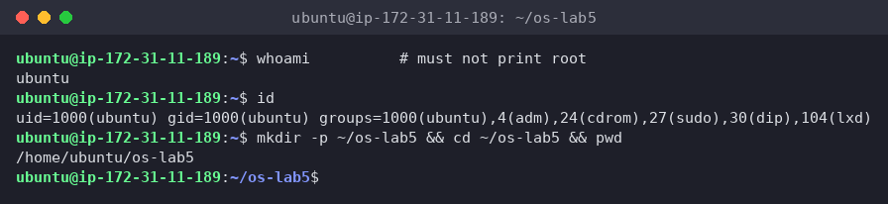
Figure 0.1 – Working as the normal user ubuntu (UID 1000), not root
whoami prints ubuntu (UID 1000). I'm in the sudo group, but I only used sudo where the lab asked for it (stretch d) and once to compare du results. Everything else ran without privileges, so the permission experiments are honest.

3 Part 1. The tree and the file types
ls /
ls -ld /etc /etc/passwd /bin /dev/null /tmp
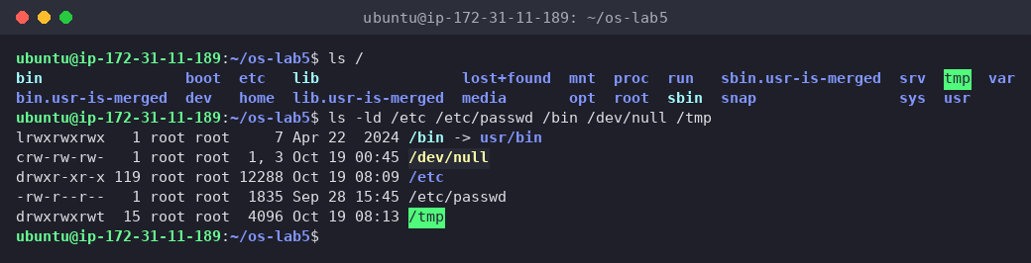
Figure 1.1 – The root of the tree and the types of five paths
ls -l /dev | head
ls -l /dev | grep '^b' # block devices (my addition)
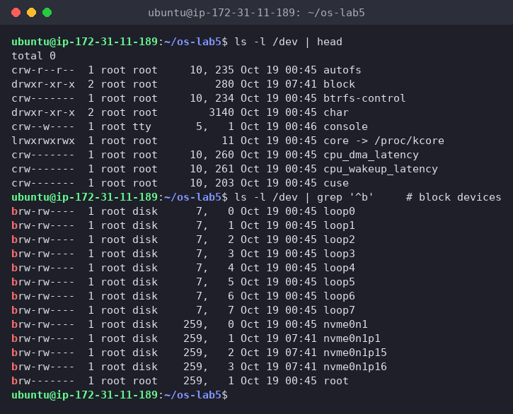
Figure 1.2 – Character and block devices in /dev
file /usr/bin/ls /etc/passwd /bin
du -sh /var/log 2>/dev/null ; du -sh /usr 2>/dev/null
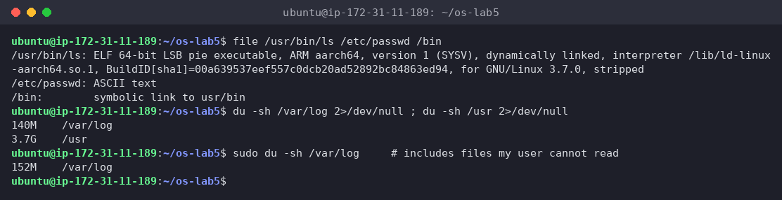
Figure 1.3 – file and du
(1) The type of each path, from the first letter of ls -l
Path | First letter | Type
/etc | d | directory
/etc/passwd | - | regular file (file says ASCII text)
/bin | l | symbolic link (/bin -> usr/bin)
/dev/null | c | character device (major 1, minor 3)
/tmp | d | directory, with the sticky bit: drwxrwxrwt (see Part 3)
(2) What is /bin on my system?
A symbolic link to usr/bin (relative target, so /usr/bin). ls -ld shows lrwxrwxrwx … /bin -> usr/bin and file /bin says symbolic link to usr/bin. Ubuntu uses the "merged /usr" layout: /bin, /sbin and /lib are all links into /usr. That's also why ls / shows the leftover marker entries bin.usr-is-merged, lib.usr-is-merged and sbin.usr-is-merged.
(3) One character device and one block device in /dev
- character device: /dev/console (crw--w---- root tty 5, 1) or /dev/null (c … 1, 3). They're read and written as a stream of bytes.
- block device: /dev/nvme0n1 (brw-rw---- root disk 259, 0), my whole NVMe disk, accessed in fixed-size blocks with random access. ls -l /dev | head showed no block devices, since only c, d and l appear among the first lines, so I filtered with grep '^b'.
(4) Which is bigger, /var/log or /usr, and by how much?
/usr is much bigger: 3.7 G vs 140 M for /var/log, about 25–27 times bigger. (sudo du counts 152 M for /var/log, because as ubuntu I can't enter some log directories and 2>/dev/null hid those errors.) It makes sense: /usr holds all installed programs and libraries, while /var/log only holds text logs, which are rotated and compressed.
Interesting output
file /usr/bin/ls says ELF 64-bit LSB pie executable, ARM aarch64. file doesn't look at the name at all, it reads the first bytes of the file (more on this in stretch a).

4 Part 2. Inodes and links

4.1 An inode, and a name that is not part of it
echo hello > notes.txt
stat notes.txt
ls -li notes.txt
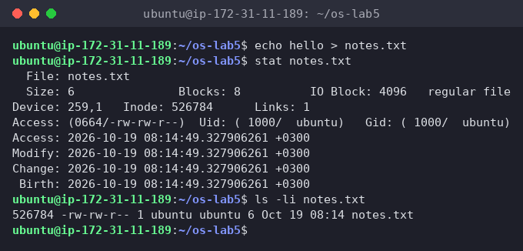
Figure 2.1 – stat and ls -li on notes.txt

4.2 Hard link, then remove the "original"
ln notes.txt hard.txt
ls -li notes.txt hard.txt
rm notes.txt
cat hard.txt ; ls -li hard.txt
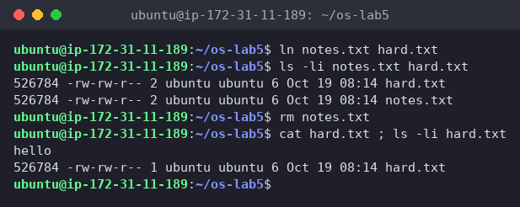
Figure 2.2 – A hard link survives rm of the original name
Both names show the same inode 526784 and the link count went from 1 to 2. After rm notes.txt, hard.txt still printed hello and the count went back to 1.

4.3 Symbolic link, then remove its target
ln -s hard.txt soft.txt
ls -li hard.txt soft.txt
cat soft.txt
rm hard.txt
cat soft.txt ; ls -l soft.txt
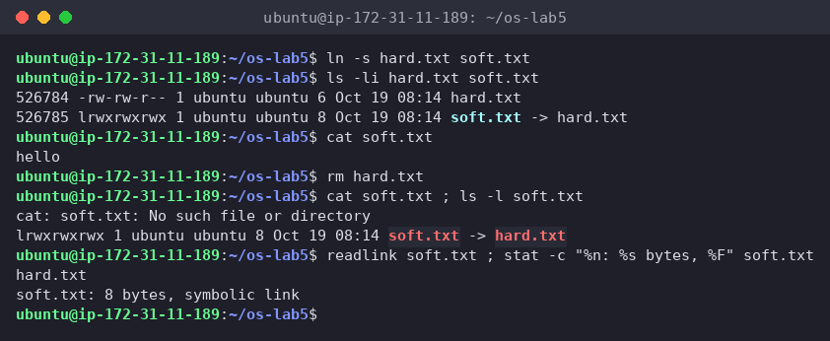
Figure 2.3 – A symbolic link breaks when its target is removed
soft.txt got its own inode 526785, type l, size 8. cat soft.txt worked while hard.txt existed, then failed with No such file or directory after rm hard.txt, even though ls -l soft.txt still shows soft.txt -> hard.txt.

4.4 Directories have links too
My prediction, written down before running: 2 for a new directory, 4 after two subdirectories.
mkdir d ; ls -ld d
mkdir d/x d/y ; ls -ld d
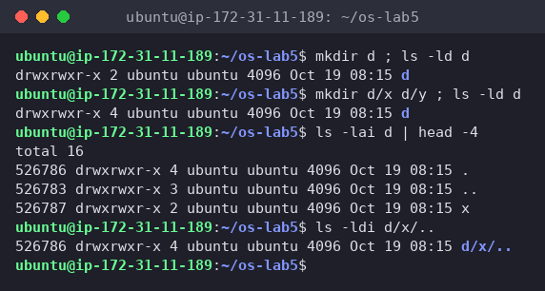
Figure 2.4 – Link count of a directory: 2, then 4
The prediction was correct: 2, then 4. I added ls -lai d and ls -ldi d/x/.. to show where the links are: d's own . and d/x/.. both have inode 526786, the same as d.

4.5 Size is not space
echo x > one.txt ; ls -l one.txt ; du -h one.txt
truncate -s 1G big.img ; ls -lh big.img ; du -h big.img
rm big.img
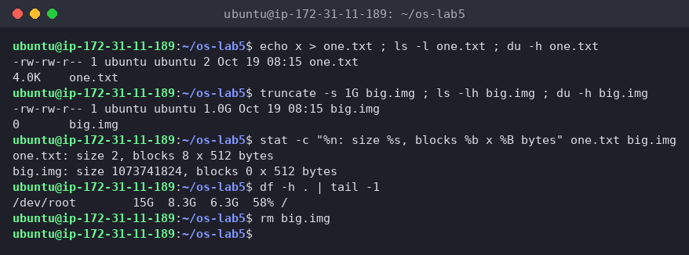
Figure 2.5 – Apparent size vs disk usage: 2 B → 4.0K, 1 G → 0
one.txt: size 2 bytes, but du says 4.0K (8 blocks × 512 B). big.img: size 1.0 G, but du says 0 (0 blocks), and the free space on / didn't change.
(1) Which number in stat is the inode, and which tells how many names the file has?
Inode: 526784 is the inode number. Links: 1 is the link count, the number of directory entries (names) that point to this inode. ls -li shows the same two numbers: the first column (inode) and the number after the permissions (links).
(2) After rm notes.txt, why could I still read hard.txt? What does rm really remove?
notes.txt and hard.txt were two names for one inode (same number 526784). Neither name is "the original", they're equal. rm calls unlink(), which removes only the name (the directory entry) and decrements the link count, here from 2 to 1. The inode and its data blocks are freed only when the link count reaches 0 and no process has the file open (stretch c shows the second condition). Since hard.txt still pointed at the inode, the data was untouched.
(3) Why did cat soft.txt fail at the end, although soft.txt still exists? How big is it, and why exactly that size?
A symbolic link doesn't point at an inode. It's a tiny separate file whose content is a path (hard.txt). When I open it, the kernel reads that path and looks it up again. After rm hard.txt there's no name hard.txt anymore, so the lookup fails with No such file or directory, a "dangling" link. The link itself (inode 526785) still exists. Its size is 8 bytes, exactly the length of the string hard.txt (8 characters, no terminating zero stored), as readlink confirms.
(4) A new directory has 2 links, and 4 after two subdirectories. Where does each link come from?
- link 1: the entry d in its parent ~/os-lab5
- link 2: the entry . inside d, which points to d itself
- links 3 and 4: the .. entries inside d/x and d/y, which point back to their parent d (confirmed: d/x/.. is inode 526786)
So for a directory, link count = 2 + number of subdirectories. (The parent os-lab5 also went up by one when I created d, which is why .. in Figure 2.4 shows 3 links.)
(5) Why does a 2-byte file use 4.0K, and a 1 GB file use 0?
- The file system hands out space in whole blocks of 4096 bytes (IO Block: 4096 in stat), so even 2 bytes (x plus a newline) take one full 4 KiB block. ls -l shows the logical size, and du shows the blocks actually allocated.
- truncate -s 1G only sets the size field in the inode and writes no data. That makes a sparse file: reading any part returns zeros, but no blocks are allocated until something is written, so it uses 0 bytes on disk. This is how VM disk images can be "1 GB" while using almost nothing.
Interesting output
stat also shows Birth:, the creation time. ext4 stores it, and newer stat versions can read it. For years Linux tools could only show access, modify and change times.

5 Part 3. Permissions

5.1 Files
echo secret > s.txt
chmod 600 s.txt ; ls -l s.txt
chmod 000 s.txt ; cat s.txt
chmod u+r s.txt ; cat s.txt
umask ; touch new.txt ; mkdir newdir ; ls -ld new.txt newdir
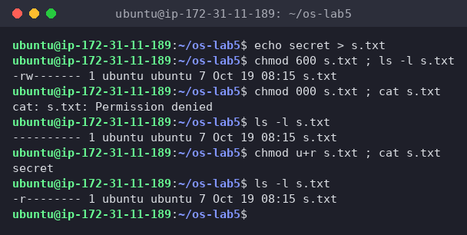
Figure 3.1 – chmod 600, 000 and u+r on my own file
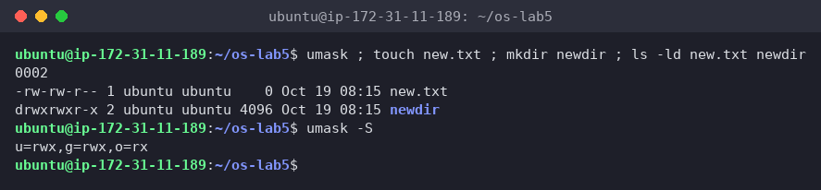
Figure 3.2 – umask and the permissions of a new file and directory
With 000 even I, the owner, got Permission denied. After chmod u+r (-r--------) I could read it again.

5.2 Directories
My predictions, written down before running (in ~/os-lab5/predictions.md):
- read only (u=r): ls box shows the name f, but with errors for the details, and cat box/f → Permission denied
- execute only (u=x): ls box → Permission denied, and cat box/f prints hi
mkdir box ; echo hi > box/f
chmod u=r,go= box ; ls box ; cat box/f # read only
chmod u=x,go= box ; ls box ; cat box/f # execute only
chmod 755 box
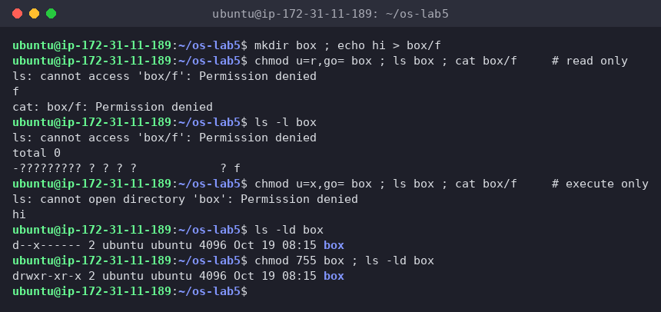
Figure 3.3 – The box experiment: r vs x on a directory
All predictions were correct:
- r only: ls box printed f, plus ls: cannot access 'box/f': Permission denied, because the --color=auto alias makes ls call stat on each name to choose a color. ls -l box shows -????????? ? ? ? ? ? f: the name is visible, everything in the inode is not. cat box/f → Permission denied.
- x only: ls box → cannot open directory 'box': Permission denied, but cat box/f printed hi.

5.3 Special bits and other people's files
ls -l /usr/bin/passwd ; ls -ld /tmp
cat /etc/shadow
ls -l /etc/shadow
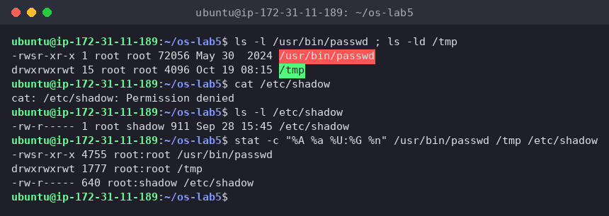
Figure 3.4 – setuid on passwd, sticky bit on /tmp, and /etc/shadow
(1) 600, 644, 755 and 700 as rwx strings, with one real use for each
Each digit is r=4 + w=2 + x=1, for owner / group / others:
Octal | rwx | Real use
600 | rw------- | private files only I may read or change: ~/.ssh/id_ed25519 (ssh refuses keys that others can read), ~/.bash_history
644 | rw-r--r-- | normal files everyone may read but only the owner edits: /etc/passwd, web pages, documents
755 | rwxr-xr-x | programs and public directories: /usr/bin/*, my report.sh from Lab 3, /etc
700 | rwx------ | private directories or scripts: ~/.ssh itself, my home directory on a shared server
(2) With chmod 000 I own the file but can't read it. Why doesn't ownership help?
The kernel checks permissions in a fixed order and stops at the first category that matches: if I'm the owner, only the owner bits are used, and the group and others bits are never looked at. With 000 the owner bits are ---, so read is refused even though I own the file. What ownership does give is the right to change the mode: only the owner (or root) can chmod, which is how chmod u+r gave me access back. (root would have read it anyway, since root skips these checks, which is why the lab says not to work as root.)
(3) My umask, and how it explains new.txt and newdir
umask is 0002 (u=rwx,g=rwx,o=rx). Programs create files asking for 666 (rw for everyone) and directories asking for 777, and the kernel clears the bits that are set in the umask:
- new.txt: 666 with the 002 bit cleared = 664 = -rw-rw-r--
- newdir: 777 with the 002 bit cleared = 775 = drwxrwxr-x
The umask removes only "write for others". Group write stays because Ubuntu gives every user a private group with the same name (ubuntu), so group write is safe.
(4) The box experiment: what does r allow on a directory, and what does x allow?
A directory is a table of (name → inode) entries:
- r = read the table, so you can list the names. Without x you can't go through the directory to the inodes, so you see f but not its size, owner or permissions, and you can't open it.
- x = "search/traverse": you can use a name you already know to reach the inode, so cat box/f works, cd box works, and so on. Without r you just can't list what's inside.
- (w would allow adding, removing and renaming entries, and it needs x too.)
So x without r works like a hidden directory: files can be reached only if you know the exact name.
(5) The s in /usr/bin/passwd, the t in /tmp, and why passwd needs the s
- s in the owner's execute position (-rwsr-xr-x, octal 4755) is the setuid bit: the program runs with the permissions of the file's owner (root), not of the user who started it.
- t in the others' execute position (drwxrwxrwt, octal 1777) is the sticky bit: everyone may create files in /tmp, but a file can only be deleted or renamed by its owner (or the directory's owner, or root). Without it, any user could delete other users' temp files, since w on a directory normally allows removing any entry.
- passwd has to write my new password hash into /etc/shadow, which is -rw-r----- root shadow. As ubuntu I can't even read it (cat /etc/shadow → Permission denied). With setuid root, passwd runs as root and can update the file, and the program itself makes sure I can only change my own password.
Interesting output
ls -l box printing a row of ? was the clearest way to see that the name and the inode are separate things: with r alone, the directory gives up the names but not a single field of the inodes.

6 Part 4. Disks and the kernel as files
lsblk
df -h
mount | grep " / "
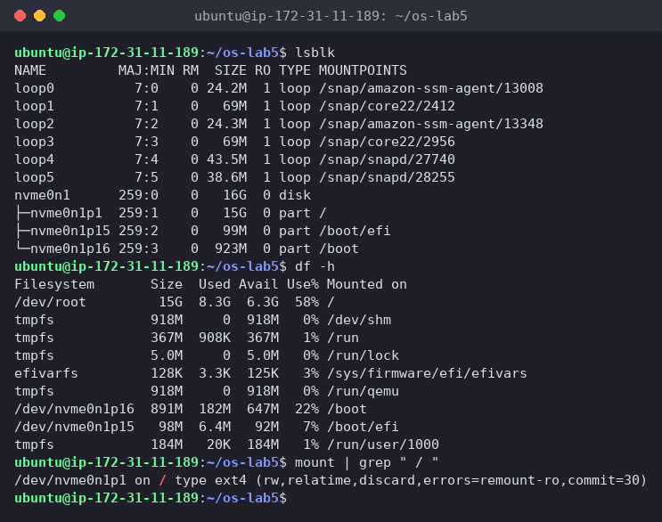
Figure 4.1 – lsblk, df -h and the root mount
grep -c processor /proc/cpuinfo
head -3 /proc/meminfo
head -5 /proc/self/status
ls -l /proc/self/fd
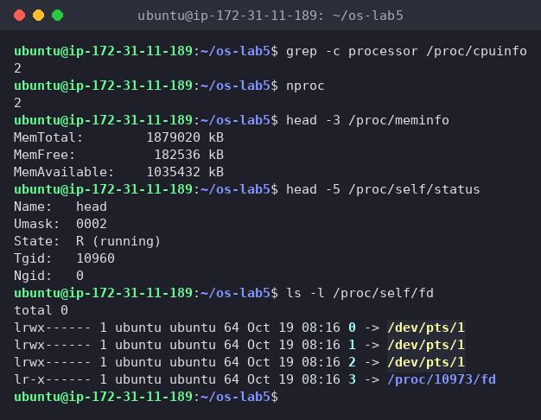
Figure 4.2 – CPU, memory and the process itself, read from /proc
(1) Drawing of my disk
nvme0n1 (NVMe SSD, 16 GiB, block device 259:0)
├── nvme0n1p1 15 GiB ext4 mounted on / ← root file system
├── nvme0n1p15 99 MiB vfat mounted on /boot/efi (EFI system partition)
└── nvme0n1p16 923 MiB ext4 mounted on /boot (kernels, initrd)
loop0 … loop5 24–69 MiB, read-only squashfs images mounted under /snap/…
mount | grep " / " confirms it: /dev/nvme0n1p1 on / type ext4 (rw,relatime,discard,errors=remount-ro,commit=30). The file system types of the other two partitions come from lsblk -f. df names the root device /dev/root, an alias for the same partition. The loop devices aren't real disks: each one is a snap package file mounted as if it were a small disk.
(2) How full is my root file system?
58%: 8.3 G used of 15 G, 6.3 G available (/dev/root 15G 8.3G 6.3G 58% /). The tmpfs lines (/run, /dev/shm, …) live in RAM, not on the disk.
(3) CPU cores and RAM according to /proc
- grep -c processor /proc/cpuinfo → 2 cores (nproc agrees)
- MemTotal: 1879020 kB ≈ 1.8 GiB RAM, of which about 1.0 GiB is available (MemAvailable: 1035432 kB)
(4) /proc/self/status showed the name of a program. Which one, and why?
Name: head. /proc/self is a magic link that always points to the /proc/<PID> directory of the process that is reading it. The process that opened /proc/self/status was head (PID 10960), not bash and not the shell before it, so it saw its own status: State: R (running), since it was running at that moment. In the same way, ls -l /proc/self/fd listed ls's own open files: 0, 1 and 2 on my terminal /dev/pts/1, and fd 3, the /proc/<pid>/fd directory ls itself had open to read it.
Interesting output
/proc takes no disk space at all (ls -l /dev showed total 0 too). The kernel creates these "files" when you read them, which is how one cat or grep works for both real files and live kernel data.

7 Stretch (all four)
The lab asks for any two. I did all four.

7.1 (a) Magic numbers
gzip -c /etc/passwd > notes.txt ; file notes.txt ; xxd notes.txt | head -1
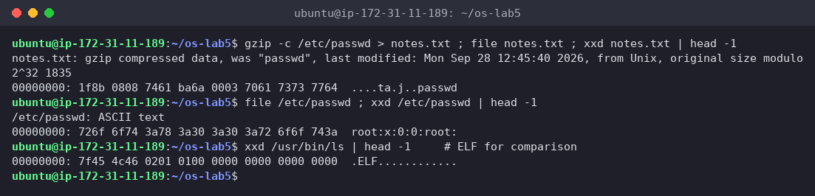
Figure 5.1 – file ignores the .txt name and reads the magic bytes
Even though it's called notes.txt, file says gzip compressed data, was "passwd". The first bytes are 1f 8b, the gzip magic number, followed by 08 (compression method = deflate). Then come flags, a timestamp, and even the original name passwd in plain text. For comparison, /etc/passwd starts with readable ASCII (root:x:0:0:), and an ELF program starts with 7f 45 4c 46 = \x7f E L F. On Linux the extension means nothing to the kernel, it's just part of the name.

7.2 (b) Hunting for setuid programs
find / -xdev -perm -4000 -type f 2>/dev/null
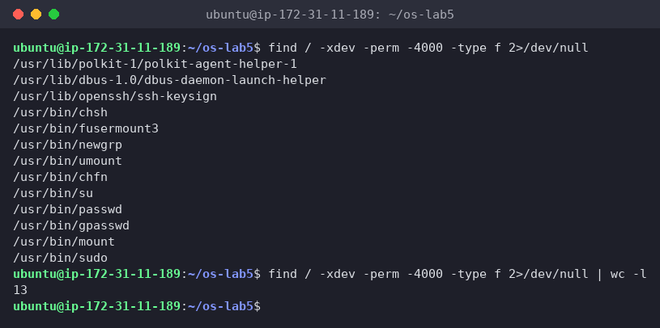
Figure 5.2 – All setuid programs on the root file system
13 setuid programs. The classic ones are passwd, su, sudo, mount, umount, chsh, chfn, newgrp and gpasswd. The less familiar ones on this server are:
- polkit-agent-helper-1: PolicyKit authentication helper
- dbus-daemon-launch-helper: starts system D-Bus services
- ssh-keysign: OpenSSH host-based authentication, needs to read the root-only host key
- fusermount3: lets normal users mount FUSE file systems
I compared against the classic tools, not the lecture slide itself. The point stands: every setuid-root binary has to be trusted, because a bug in it is a way to become root, which is why admins check this list.

7.3 (c) Deleting a file that is still open
exec 3< bigfile ; rm bigfile ; ls -l /proc/$$/fd
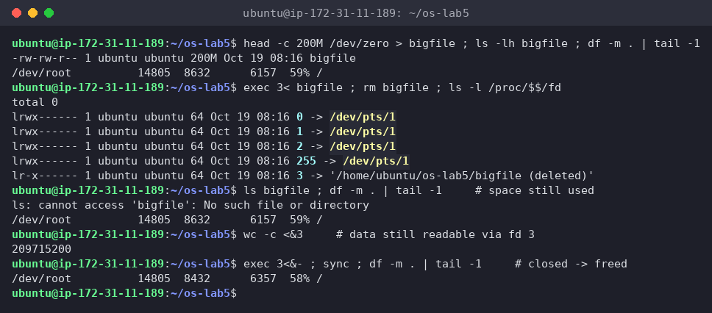
Figure 5.3 – A deleted but open file keeps its space until it is closed
I made a 200 MB bigfile first, so the effect is visible in df. After rm:
- ls bigfile → No such file or directory, the name is gone
- the link in /proc/$$/fd says 3 -> '/home/ubuntu/os-lab5/bigfile (deleted)'
- df still shows 8632 MB used, so the space was not freed, and wc -c <&3 could still read all 209715200 bytes through fd 3
- after exec 3<&- (closing fd 3): 8432 MB used, exactly 200 MB less
So the space is freed only when both the link count is 0 and the last open file descriptor is closed. This is the classic "disk full but du shows nothing" problem: a deleted log file still held open by a running service. The fix is to restart or signal the service, not to delete more files.

7.4 (d) A file system inside a file
truncate -s 64M disk.img ; mkfs.ext4 disk.img
sudo mount -o loop disk.img /mnt ; df -h /mnt ; df -i /mnt ; sudo umount /mnt
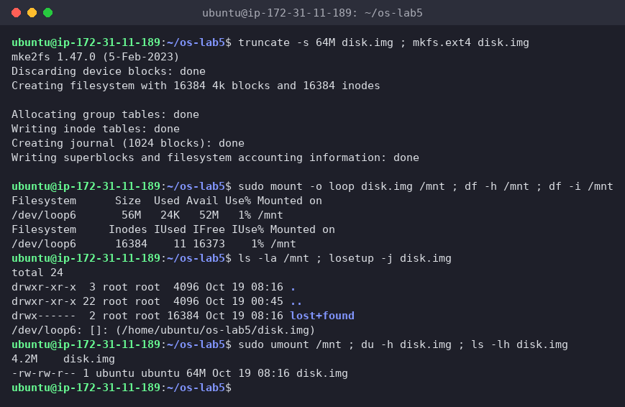
Figure 5.4 – mkfs.ext4 on a 64 MB file, mounted through a loop device
mkfs.ext4 said Creating filesystem with 16384 4k blocks and 16384 inodes, and df -i confirmed 16384 inodes, 11 already used (the root directory, lost+found and reserved inodes 1–10). One inode per 4 KiB block comes from /etc/mke2fs.conf: file systems under 512 MB get the "small" profile with inode_ratio = 4096. The number of inodes is fixed at mkfs time, so a disk can run out of inodes while it still has free space. df -h shows 56 M instead of 64 M because the journal (1024 blocks = 4 MiB), the inode tables and the reserved blocks take the rest. The kernel attached the file to /dev/loop6, so it looked like a real disk. Also, disk.img is 64M in ls -l but only 4.2M in du, another sparse file, since only the metadata was ever written.

8 Wrap-up
This lab made the lecture's model of the file system concrete. A file is an inode (type, permissions, owner, size, link count, block pointers), and names are just entries in directories that point to it. That explains everything I saw: a hard link is a second name for the same inode (same number, count 2), rm only removes a name, the data disappears when the last name and the last open descriptor are gone, and a symbolic link is a separate small file holding a path, which breaks when that path disappears. Directory link counts (2 + subdirectories) come from . and ... Logical size and disk usage differ because of whole blocks and sparse files. Permissions are checked against owner, then group, then others; on directories r lists names and x lets you use them; umask trims new files to 664 and directories to 775; and setuid and sticky solve two real problems (passwd writing /etc/shadow, a shared /tmp). Underneath it all is a 16 GB NVMe disk with an ext4 root partition, and /proc shows that the kernel itself can be read as files.

