MINISTRY OF EDUCATION, CULTURE AND RESEARCH
OF THE REPUBLIC OF MOLDOVA
Technical University of Moldova
Faculty of Computers, Informatics and Microelectronics
Department of Software Engineering and Automation

Report
on laboratory work no. 6
Operating Systems
Topic: Inside the xv6 File System

Done by:
st. gr. FAF-242, Nichita Rusnac

Checked by:
Patricia Reitman, university assistant
DISA, FCIM, UTM

Chișinău – 2026

Table of Contents
1 Purpose of the work 3
2 Before you start 3
3 Part 1. Read what xv6 shows you 4
4 Part 2. Write mystat 7
5 Part 3. Measure the limits 11
6 Part 4. Write find 15
6.1 Stretch: -n prints the inode number 19
7 Wrap-up 20

All screenshots below come from my own session, in the order I ran the commands. xv6 commands ran at the xv6 $ prompt inside QEMU (make qemu), and the rest ran in bash on my Ubuntu 24.04 ARM machine on AWS, in ~/xv6-riscv (revision 06aad25). The code I hand in (mystat.c, find.c, Makefile) is next to this note in the Lab6/ folder, together with dirdump.py, a small helper I wrote to look at directories inside fs.img.

1 Purpose of the work
- read what xv6's ls shows and decode it with kernel/stat.h and kernel/fs.h: types, inode numbers, directory entries
- write mystat, a program that calls stat(), and use it to watch hard links being created and removed
- find where the kernel decrements the link count and frees the blocks, and what an xv6 on-disk inode contains
- measure the limits written in kernel/fs.h (name length, largest file, disk layout)
- write find, which walks the directory tree recursively (the MIT 6.1810 util lab exercise)

2 Before you start
bash os2026-setup.sh --check
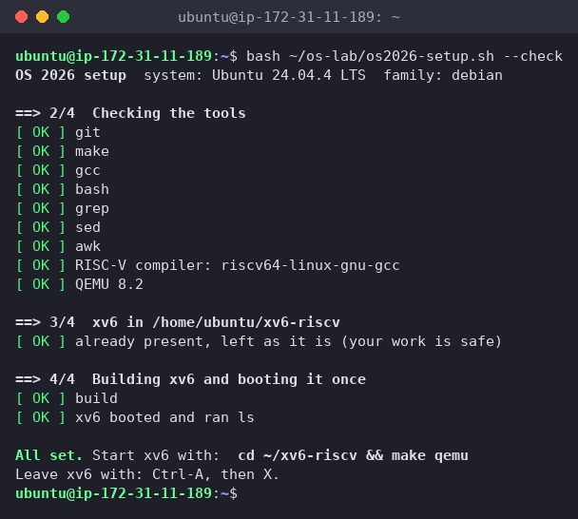
Figure 0.1 – The setup check passes
My tree already had sleep (Lab 2/4) and args (Lab 4) in UPROGS. For Part 1 I started from a clean disk with make clean ; make qemu.

3 Part 1. Read what xv6 shows you
$ ls
$ mkdir a
$ ls a
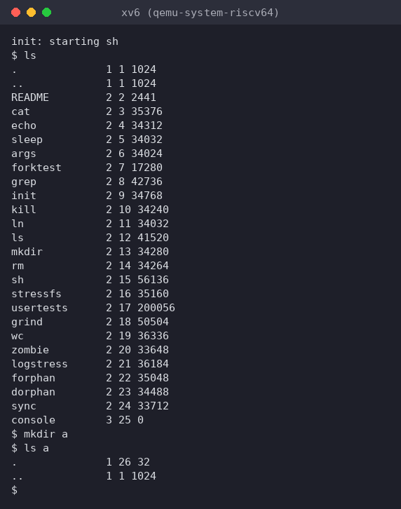
Figure 1.1 – ls on a fresh xv6 disk, then mkdir a and ls a
Each line is name, type, inode number, size. To decode the type I opened kernel/stat.h, and in kernel/fs.h I looked up the root inode and the directory entry:
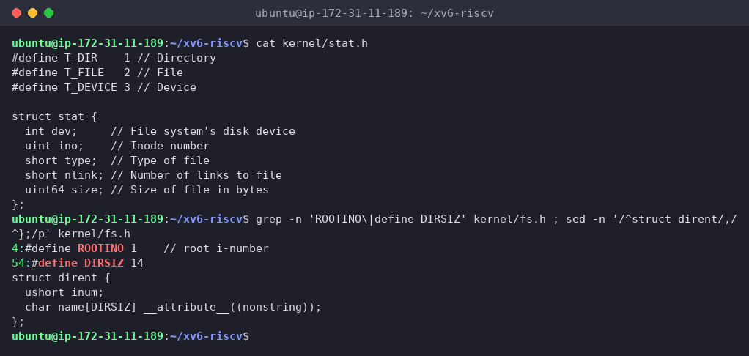
Figure 1.2 – kernel/stat.h, ROOTINO, DIRSIZ and struct dirent
To see a directory's bytes for myself, I wrote dirdump.py. It reads the superblock of fs.img, finds an inode, and prints each 16-byte entry of that directory (I ran it after a later session, when a was inode 28 and had a subdirectory b):
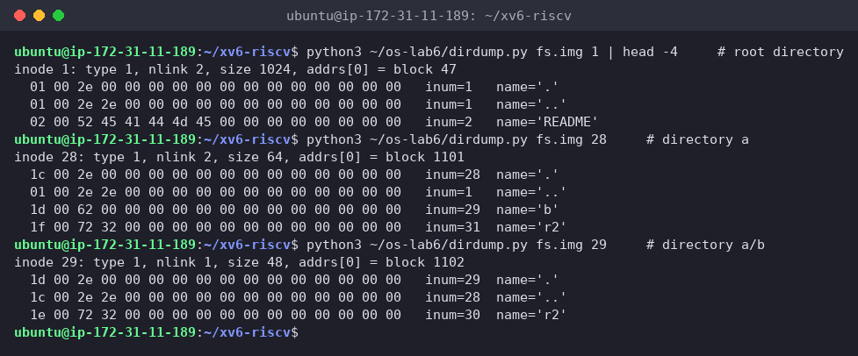
Figure 1.3 – Raw directory entries inside fs.img: root, a and a/b
(1) What do types 1, 2 and 3 mean?
From kernel/stat.h: T_DIR 1 = directory, T_FILE 2 = regular file, T_DEVICE 3 = device. So ./.. are directories, README, cat, … are files, and console 3 25 0 is the console device (size 0, since it has no data blocks, like /dev/console on Linux).
(2) Which inode number does the root directory have, and why are . and .. the same there?
Inode 1 (#define ROOTINO 1; inode 0 is never used, it marks a free directory slot). Both . and .. show 1 1 1024. . always points to the directory itself. The root has no parent, so when mkfs builds the disk it makes root's .. point to root itself, which is why cd .. at / stays at /. Figure 1.3 shows it in the raw bytes: both of root's first entries start with 01 00, inode 1.
(3) An empty directory has size 32. How big is one entry, and which two entries does a contain?
One entry is 16 bytes: struct dirent { ushort inum; char name[DIRSIZ]; } = 2 bytes for the inode number + 14 bytes (DIRSIZ) for the name. 32 / 16 = 2 entries:
- . → a itself (inode 26 in Figure 1.1)
- .. → the parent, root (inode 1)
In Figure 1.3, a with two more entries (b and r2) has size 64 = 4 × 16, so a directory really is just a file holding a table of these entries.
Interesting output
A directory's size grows 16 bytes at a time, and ls shows it in the size column (a 1 26 32), while on Linux directories show 4096. xv6 doesn't round up to a block in the size field.

4 Part 2. Write mystat
I completed user/mystat.c and added $U/_mystat\ to UPROGS:
#include "kernel/types.h"
#include "kernel/stat.h"
#include "user/user.h"
char *
typename(int t)
{
switch(t){
case T_DIR:
return "directory";
case T_FILE:
return "file";
case T_DEVICE:
return "device";
}
return "?";
}
int
main(int argc, char *argv[])
{
struct stat st;
for(int i = 1; i < argc; i++){
if(stat(argv[i], &st) < 0){
fprintf(2, "mystat: cannot stat %s\n", argv[i]);
continue;
}
printf("%s: %s, inode %d, links %d, size %d bytes\n",
argv[i], typename(st.type), st.ino, st.nlink, (int)st.size);
}
exit(0);
}
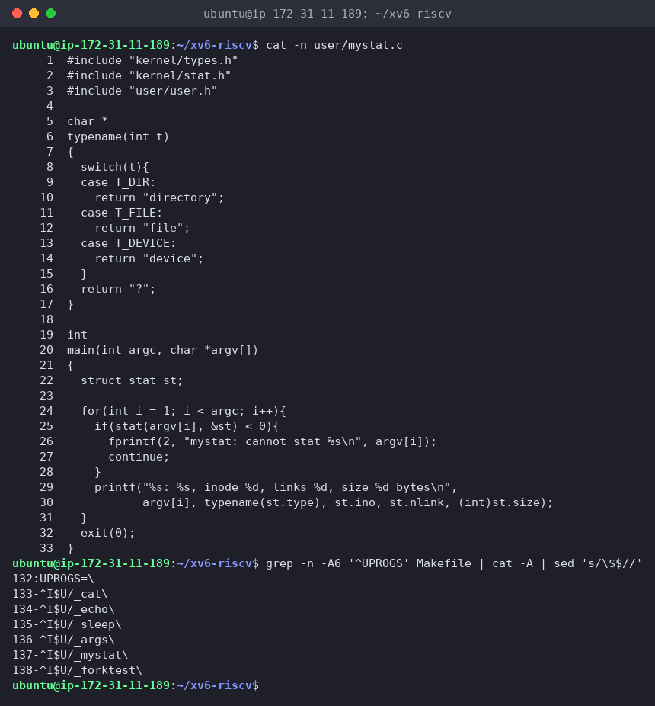
Figure 2.1 – mystat.c and the UPROGS lines (^I = TAB, nothing after the backslash)
stat() isn't a separate system call in xv6. It's a library function in user/ulib.c that does open + fstat + close. On an error my program prints to fd 2 and goes on with the next argument, as the TODO asks.
$ mystat README . console
$ ln README r2
$ mystat README r2
$ rm README
$ mystat r2
$ cat r2 | wc
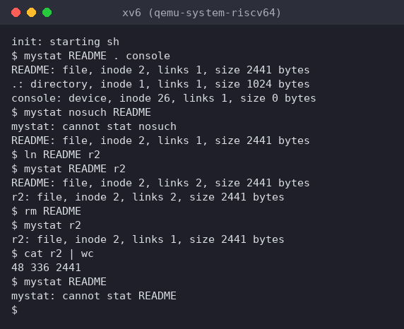
Figure 2.2 – mystat watching a hard link being created and the original name removed
The first line matches the lab's example, except console, which is inode 26 on my disk because of my two extra programs (sleep, args) and mystat. I also tested the error path: mystat nosuch README printed mystat: cannot stat nosuch and still handled README.
On the host I looked for the code that removes a link and frees the blocks, and at the on-disk inode:
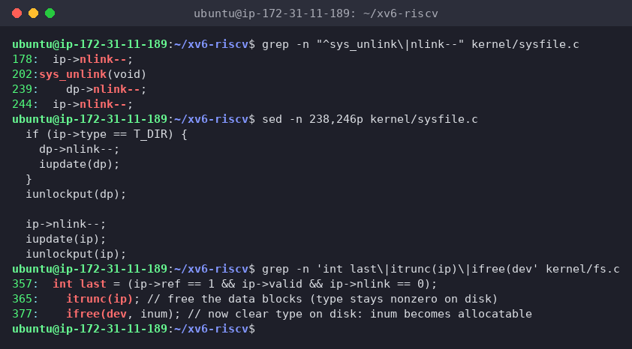
Figure 2.3 – nlink-- in sys_unlink, and where iput() frees the blocks
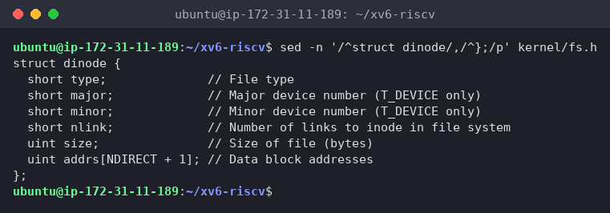
Figure 2.4 – struct dinode in kernel/fs.h
(1) Outputs after ln and after rm. What changed and what didn't?
After ln README r2:
README: file, inode 2, links 2, size 2441 bytes
r2: file, inode 2, links 2, size 2441 bytes
After rm README:
r2: file, inode 2, links 1, size 2441 bytes
$ cat r2 | wc
48 336 2441
- changed: only the link count, 1 → 2 after ln, back to 1 after rm. README no longer exists (mystat README → cannot stat README).
- didn't change: the inode number (2), the type, the size (2441) and the content. wc gives 48 336 2441, exactly what README gave in Lab 2. ln didn't copy anything, it added a second directory entry pointing to inode 2, and rm removed one entry.
(2) The line in sys_unlink that decrements the link count. When are the data blocks freed?
kernel/sysfile.c, line 244: ip->nlink--; followed by iupdate(ip), which writes the inode back to disk. (Line 239, dp->nlink--, is for removing a directory: the parent loses the link from the child's ... Line 178 is in sys_link's error path, which undoes a failed link.)
sys_unlink itself frees no blocks. That happens in iput() in kernel/fs.c (lines 357–377). When the last in-memory reference to an inode is dropped, it checks ip->ref == 1 && ip->valid && ip->nlink == 0. Only when that's true does it call itrunc(ip) (bfree on every direct block, every block listed in the indirect block, and the indirect block itself) and then ifree() to mark the inode free. So the blocks are freed when the link count is 0 and no process still uses the inode, for example has it open. That's the same rule as the Linux "deleted but open" file in Lab 5. Here, after rm README the count was still 1 (r2), so nothing was freed.
(3) Which fields does an xv6 inode have?
struct dinode (64 bytes on disk, 16 per 1024-byte block):
Field | Meaning
short type | 0 = free, T_DIR, T_FILE, T_DEVICE
short major, short minor | device numbers (only for T_DEVICE, like console)
short nlink | number of directory entries pointing to this inode
uint size | size in bytes
uint addrs[NDIRECT+1] | 12 direct block numbers + 1 indirect block number
There's no owner/UID/GID, no permission bits, no timestamps, and no symlink type, which is why xv6 has no chmod, no ls -l times, and no ln -s. A Linux ext4 inode has all of these, plus extents instead of a fixed block list.
Interesting output
mystat . on the fresh disk said links 1 for the root, and Figure 1.3 later showed root and a with nlink 2 and a/b with nlink 1. xv6 counts a directory's links differently from Linux: the name in the parent plus one for each child's .., but not its own .. sysfile.c says so: "No ip->nlink++ for ".": avoid cyclic ref count." On Linux, the empty directory d in Lab 5 had 2.

5 Part 3. Measure the limits
grep -n "define BSIZE\|define NDIRECT\|define NINDIRECT\|define DIRSIZ" kernel/fs.h
make clean ; make fs.img 2>&1 | grep nmeta
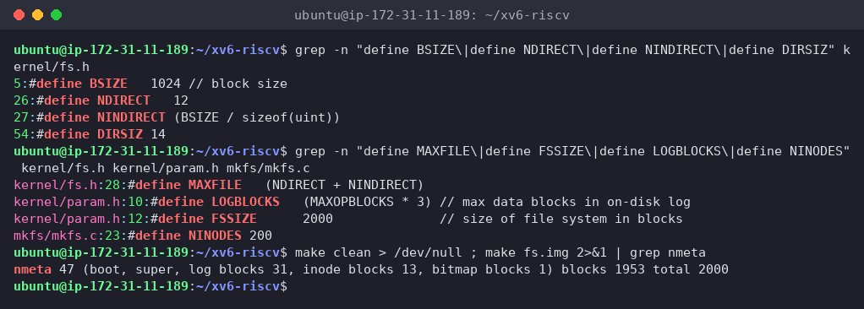
Figure 3.1 – The constants in fs.h and the disk layout printed by mkfs
$ mkdir averyveryverylongname
$ ls
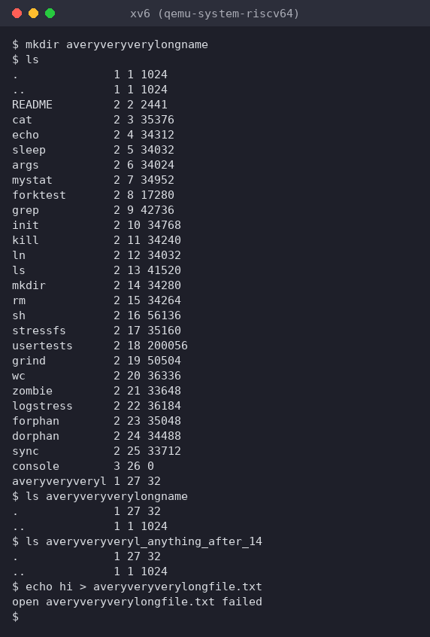
Figure 3.2 – A name longer than 14 characters is cut to DIRSIZ
(1) What does ls show for averyveryverylongname, and which constant explains it?
averyveryveryl 1 27 32: the name was cut to its first 14 characters, because of DIRSIZ 14, the size of name in struct dirent. The name is silently truncated, with no error. I tried two more things:
- ls averyveryveryl_anything_after_14 also listed the directory. When looking up a path, xv6 compares only the first 14 characters (namecmp uses strncmp(s, t, DIRSIZ)), so every name with the same first 14 characters means the same file.
- echo hi > averyveryverylongfile.txt failed: open averyveryverylongfile.txt failed. The new name also truncates to averyveryveryl, which is the existing directory, and a directory can't be opened for writing.
(2) The largest file xv6 can hold
- block size BSIZE = 1024 bytes
- direct blocks: NDIRECT = 12
- one indirect block full of 4-byte block numbers: NINDIRECT = BSIZE / sizeof(uint) = 1024 / 4 = 256 blocks
MAXFILE = NDIRECT + NINDIRECT = 12 + 256 = 268 blocks
max size = 268 × 1024 = 274 432 bytes = 268 KiB (≈ 0.26 MiB)
(kernel/fs.h has #define MAXFILE (NDIRECT + NINDIRECT).) The 12 direct blocks alone only cover 12 KiB, and the indirect block is what makes bigger files possible. The real 6.1810 "big files" lab adds a doubly-indirect block to go past this limit.
(3) The nmeta line: total blocks, and how many for the log, the inodes and the data
nmeta 47 (boot, super, log blocks 31, inode blocks 13, bitmap blocks 1) blocks 1953 total 2000
Region | Blocks | Why
boot | 1 | block 0, unused by xv6
superblock | 1 | sizes and start of each region (magic 0x10203040)
log | 31 | LOGBLOCKS = 30 data blocks + 1 header block, used for the journal
inodes | 13 | 200 inodes (NINODES) × 64 bytes = 12.5 blocks → 13 (16 inodes per block)
free bitmap | 1 | 1 bit per block, 8192 bits per block, enough for 2000
data | 1953 | everything else: file contents and directories
total | 2000 | FSSIZE 2000 in kernel/param.h = 2000 × 1 KiB ≈ 2 MB disk
1 + 1 + 31 + 13 + 1 = 47 metadata blocks, and 47 + 1953 = 2000.
Interesting output
In my first try of this part I ran cat averyveryverylo, a directory, so cat printed its raw 16-byte entries. The terminal then swallowed the next prompt and the first letter of my next command. I decoded the directory from fs.img to see why: the first entry starts with bytes 1b 00, the inode number 27 in little-endian, and 0x1b is the ASCII ESC character, so the terminal took the directory's contents as the start of an escape code. xv6 was fine (echo ok worked right after). Because of that I retook Figure 3.2 on a clean disk without the cat.

6 Part 4. Write find
user/find.c is based on user/ls.c: open the path, fstat it, and if it's a directory read struct dirents one by one, build path/name in a buffer, and recurse.
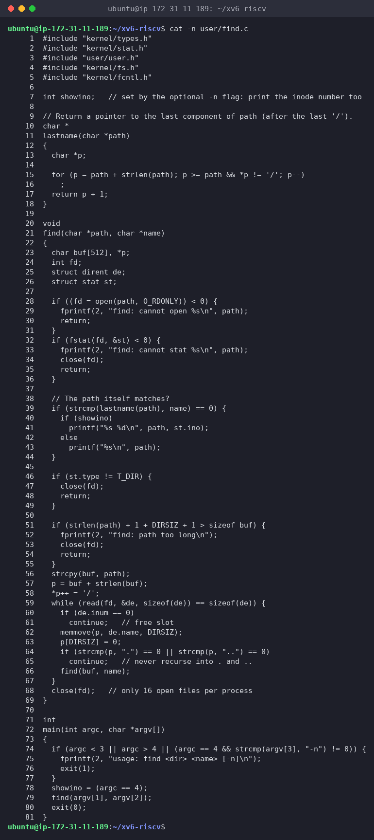
Figure 4.1 – find.c
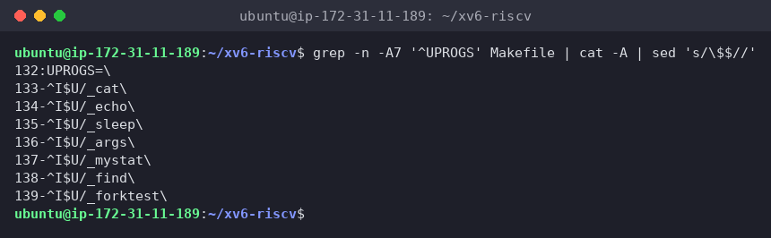
Figure 4.2 – UPROGS with mystat and find
#include "kernel/types.h"
#include "kernel/stat.h"
#include "user/user.h"
#include "kernel/fs.h"
#include "kernel/fcntl.h"
int showino; // set by the optional -n flag: print the inode number too
// Return a pointer to the last component of path (after the last '/').
char *
lastname(char *path)
{
char *p;
for (p = path + strlen(path); p >= path && *p != '/'; p--)
;
return p + 1;
}
void
find(char *path, char *name)
{
char buf[512], *p;
int fd;
struct dirent de;
struct stat st;
if ((fd = open(path, O_RDONLY)) < 0) {
fprintf(2, "find: cannot open %s\n", path);
return;
}
if (fstat(fd, &st) < 0) {
fprintf(2, "find: cannot stat %s\n", path);
close(fd);
return;
}
// The path itself matches?
if (strcmp(lastname(path), name) == 0) {
if (showino)
printf("%s %d\n", path, st.ino);
else
printf("%s\n", path);
}
if (st.type != T_DIR) {
close(fd);
return;
}
if (strlen(path) + 1 + DIRSIZ + 1 > sizeof buf) {
fprintf(2, "find: path too long\n");
close(fd);
return;
}
strcpy(buf, path);
p = buf + strlen(buf);
*p++ = '/';
while (read(fd, &de, sizeof(de)) == sizeof(de)) {
if (de.inum == 0)
continue; // free slot
memmove(p, de.name, DIRSIZ);
p[DIRSIZ] = 0;
if (strcmp(p, ".") == 0 || strcmp(p, "..") == 0)
continue; // never recurse into . and ..
find(buf, name);
}
close(fd); // only 16 open files per process
}
int
main(int argc, char *argv[])
{
if (argc < 3 || argc > 4 || (argc == 4 && strcmp(argv[3], "-n") != 0)) {
fprintf(2, "usage: find <dir> <name> [-n]\n");
exit(1);
}
showino = (argc == 4);
find(argv[1], argv[2]);
exit(0);
}
How it follows the lab's rules:
- match on the last component: lastname() returns what comes after the last /, compared with strcmp. A path is checked before deciding whether to descend, so find a b prints the directory a/b.
- free slots: entries with inum == 0 are skipped (that's what rm leaves behind in a directory).
- no infinite loop: . and .. are never recursed into. Without this, find . would follow . → . → … forever.
- file descriptors: every directory opened is closed before returning, including the error paths. Each recursion level holds one fd while its children run, so the depth is bounded by the 16-fd limit, and the full path by the 512-byte buffer. Each level also keeps a 512-byte buf on the stack, and the xv6 user stack is a single page (USERSTACK 1), so very deep trees would also hit the stack. For trees like the ones in this lab it's fine.
- memmove + p[DIRSIZ] = 0 because a 14-character name in a dirent has no terminating zero (__attribute__((nonstring))).
Test on a fresh disk (make clean ; make qemu):
$ mkdir a
$ mkdir a/b
$ echo x > a/b/r2
$ echo y > a/r2
$ ln cat r2
$ find . r2
$ find a b
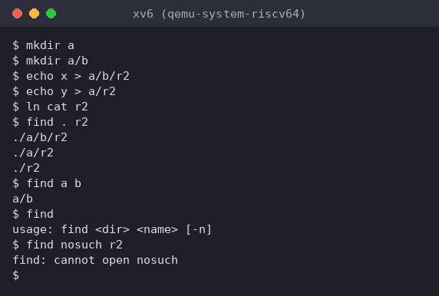
Figure 4.3 – find on the lab's test tree, plus usage and error cases
The output matches the lab exactly:
$ find . r2
./a/b/r2
./a/r2
./r2
$ find a b
a/b
I also checked the error handling: find with no arguments prints usage: find <dir> <name> [-n], and find nosuch r2 prints find: cannot open nosuch.

6.1 Stretch: -n prints the inode number
The optional third argument -n is already in the code above (showino):
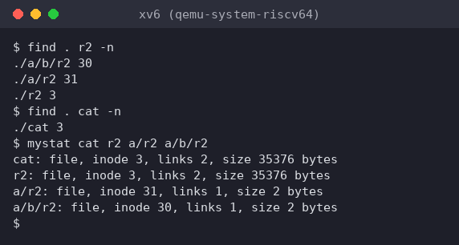
Figure 4.4 – find . r2 -n, and mystat on the four names
$ find . r2 -n
./a/b/r2 30
./a/r2 31
./r2 3
$ find . cat -n
./cat 3
Which of the three r2 files are the same file as cat? Only ./r2: it has inode 3, the same as ./cat, because ln cat r2 made it a second name for the cat program. mystat confirms it: cat and r2 both show inode 3, links 2, size 35376 bytes. ./a/r2 (inode 31) and ./a/b/r2 (inode 30) are separate 2-byte files created by echo, with only 1 link each. Same name, different files; different names, same file. Only the inode number tells which is which.

7 Wrap-up
xv6 shows the same file-system ideas as ext4 in a few hundred lines. A file is an on-disk inode (type, device numbers, link count, size, 12 direct + 1 indirect block addresses) and nothing more: no owner, permissions, times or symlinks. A directory is just a file of 16-byte entries (2-byte inode number + 14-byte name), which I could read byte by byte inside fs.img. That explains what I measured: names are cut at DIRSIZ = 14, a file can be at most (12 + 256) × 1 KiB = 268 KiB, and the 2000-block disk is 47 blocks of metadata (boot, superblock, 31-block log, 13 inode blocks, bitmap) plus 1953 blocks of data. With mystat I watched ln raise the link count of inode 2 to 2 and rm lower it back to 1 without touching the data. In the kernel, sys_unlink only does ip->nlink--, and the blocks are freed later in iput(), once the count is 0 and the inode is no longer in use. Writing find showed how a recursive tree walk is built from the same calls ls uses (open, fstat, read of dirents, close), and the -n stretch showed with inode numbers which r2 was really cat.

