March Madness 2018

Sila Solutions Group Code Challenge

By: Nicholas Eng

Round 1 Output

**SOUTH:**

Virginia vs. UMBC

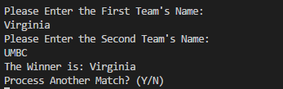

Creighton vs. Kansas St.

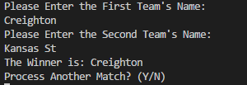

Kentucky vs. Davidson

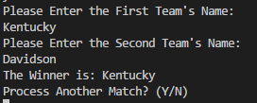

Arizona vs. Buffalo

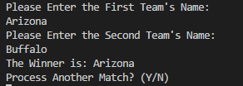

Miami (Fla.) vs. Loyola-Chi.

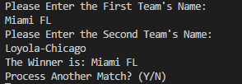

Tennessee vs. Wright St.

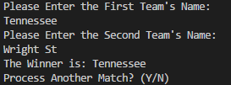

Nevada vs. Texas

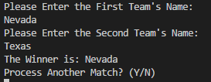

Cincinnati vs. Georgia St.

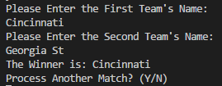

**WEST:**

Xavier vs. NC Central

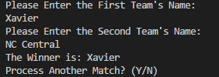

Missouri vs. Florida St.

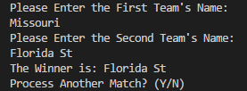

Ohio St. vs. S. Dak. St.

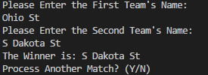

Gonzaga vs. UNC-Green.

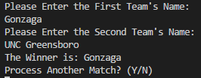

Houston vs. San Diego St

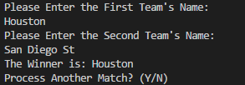

Michigan vs. Montana

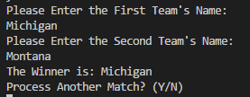

Texas A&M vs. Providence

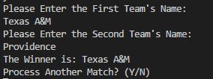

N. Carolina vs. Lipscomb

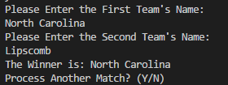

**EAST:**

Villanova vs. LIU – Brooklyn

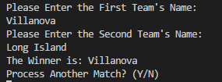

Va. Tech vs. Alabama

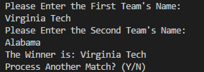

W. Virginia vs. Murray St.

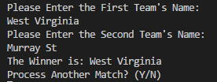

Wichita St. vs. Marshall

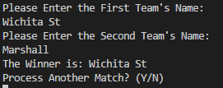

Florida vs. St. BONA.

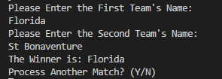

Texas Tech vs. SF Austin

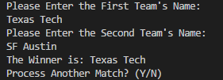

Arkansas vs. Butler

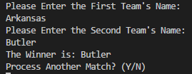

Purdue vs. CS Fullerton

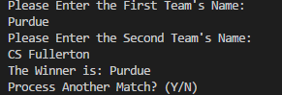

**MIDWEST:**

Kansas vs. Penn

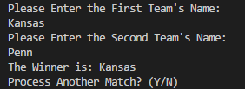

Seton Hall vs. NC State

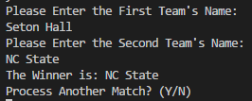

Clemson vs. New Mex. St.

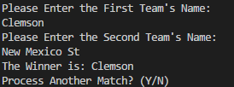

Auburn vs. Charleston

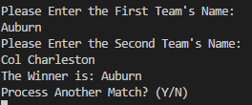

TCU vs. ASU

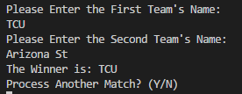

Michigan St. vs. Bucknell

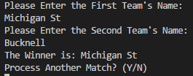

Rhode Island vs. Oklahoma

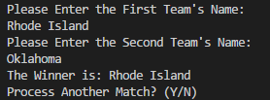

Duke vs. Iona

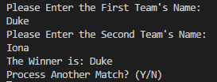

Round 2 Output

**SOUTH:**

Virginia vs. Creighton

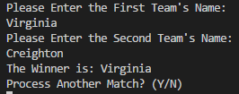

Kentucky vs. Arizona

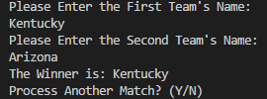

Miami (Fla.) vs. Tennessee

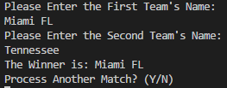

Nevada vs. Cincinnati

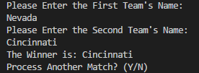

**WEST:**

Xavier vs. Florida St.

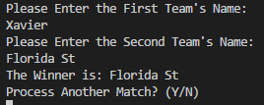

S. Dak. St. vs. Gonzaga

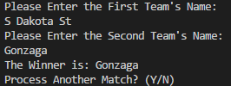

Houston vs. Michigan

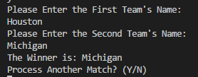

Texas A&M vs. N. Carolina

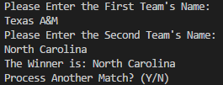

**EAST:**

Villanova vs. Va. Tech

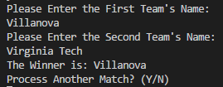

W. Virginia vs. Wichita St.

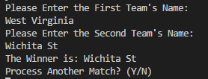

Florida vs. Texas Tech

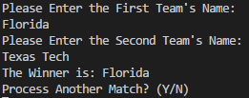

Butler vs. Purdue

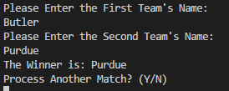

**MIDWEST:**

Kansas vs. NC State

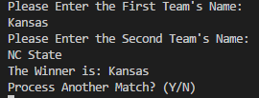

Clemson vs. Auburn

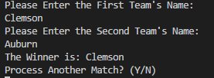

TCU vs. Michigan St.

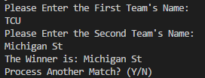

Rhode Island vs. Duke

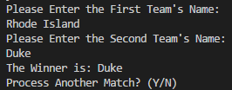

Sweet 16 Output

**SOUTH:**

Virginia vs. Kentucky

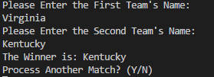

Miami (Fla.) vs. Cincinnati

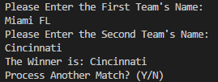

**WEST:**

Florida St. vs. Gonzaga

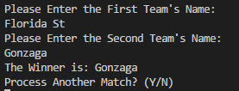

Michigan vs. N. Carolina

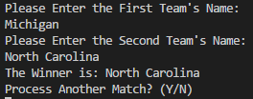

**EAST:**

Villanova vs. Wichita St.

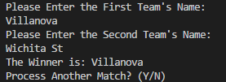

Florida vs. Purdue

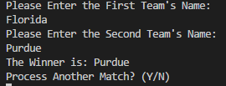

**MIDWEST:**

Kansas vs. Clemson

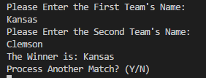

Michigan St. vs. Duke

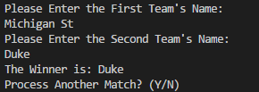

Elite Eight Output

**SOUTH:**

Kentucky vs. Cincinnati

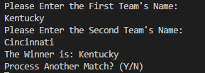

**WEST:**

Gonzaga vs. N. Carolina

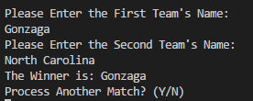

**EAST:**

Villanova vs. Purdue

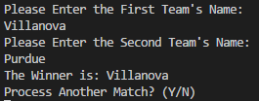

**MIDWEST:**

Kansas vs. Duke

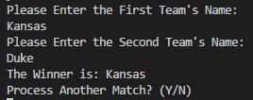

Final Four Output

Kentucky vs. Gonzaga

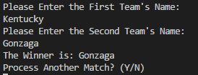

Villanova vs. Kansas

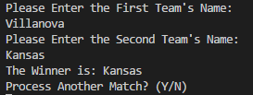

Final Output

Gonzaga vs. Kansas

