**Resources share in**

**https://drive.google.com/drive/folders/0B-4FbnaXy-85RW1wQUtKSXRUVVE**

**Steps for research**

**First Design**

1. Scan relevant data from raw data sets related to research

USA March 2015 nationwide movie ranking by BO

http://www.movieinsider.com/movies/march/2015

|  |  |  |
| --- | --- | --- |
| Movie | Release Date | Revenue USD (M) |
| Unfinished business | March 6 | 14.4 |
| Chappie | March 6 | 102.1 |
| Cinderella | March 13 | 542.7 |
| Insurgent | March 20 | 297.3 |
| The Gunman | March 20 | 15.9 |
| Home | March 27 | 386 |
| Get Hard | March 27 | 111.7 |

**First raw data sets scan: using date from 11 March 2015 - 17 March 2015**

**Second scan tweets with keyword:**

**1. Twitter account: @CinderellaMovie**

**2. Hash tag: #Cinderella**

**Need design an algorithm to: (Choose one method below)**

**1. Just simple count of these keywords**

**2. Calculate the degree of keyword HEAT**

**3. Calculate the sentiment of the keyword trend: negative, positive, or neutral**

**May combine movies released in the same date**

RGC stock March 2015 performance:

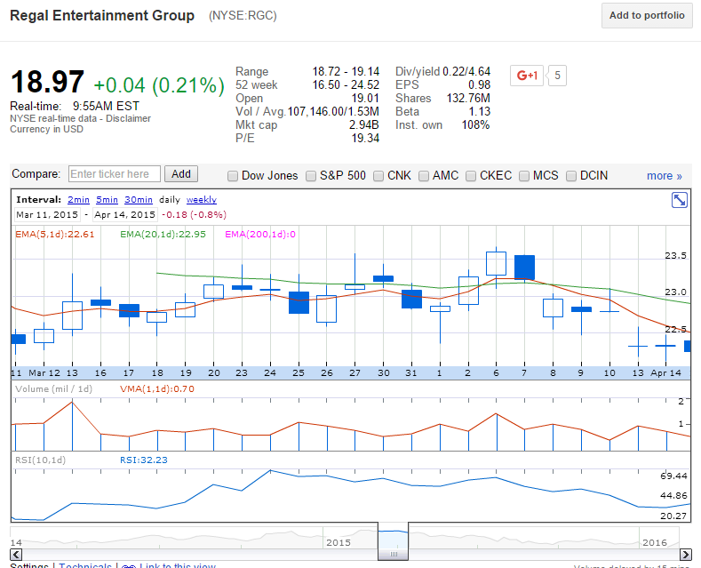

2. Calculate the holding period for this 7 days to profit most using the stock day-open and close price, i.e. not for intra-day trading

3. Analyze the keyword sentiment or Heat correlation with the stock price in the chosen 7 days

4. Stock price vs. the whole market trend

**April**

|  |  |  |
| --- | --- | --- |
| Movie | Release Date | Revenue USD (M) |
| Furious 7 | April 3 | 1.516B |
| The longest ride | April 10 | 62.94 |
| Cinderella | March 13 | 542.7 |
| Insurgent | March 20 | 297.3 |
| The Gunman | March 20 | 15.9 |
| Home | March 27 | 386 |
| Get Hard | March 27 | 111.7 |

**Scan data:**

1. Furious 7 and The longest Ride

April 1 to April 12 tweets

Process:

1. Get relevant tweets JSON file from each day:

Scan JSON files

Define Keywords:

Furious 7, Fast 7, Furious Seven, Fast Seven

#furious7, #fast7, #fastandfurious7

#paulwalker

#ff7

2.

2.

tweet JSON data structure:

{

  ...

  "text": "Four more years. http:\/\/t.co\/bAJE6Vom",

  "entities": {

    "hashtags": [],

    "symbols": [],

    "urls": [],

    "user_mentions": [],

    "media": [{}]

  }

}

Retweets JSON:

Relevant search fields:

text, hashtags