# Getting Started Guide

This guide will help you to be able to use our TPK simulation. We will begin with some explanation of the layout, then move on to how to use TPK, and finally how to get it set up to start working with customization.

# Layout

First off, from the home page you will be able to reach multiple different pages. The first one is the simulation page, which is where the TPK will actually be run. Next is the saved page, which holds all the info from previous TPKs.

Upon moving to the simulation page, you will be greeted with multiple different drop-down menus and customizations. First, you will be picking how many players you will be accounting for. Next, you will be choosing what classes and levels each player has. On the other side you will be picking the type and number of monsters for your players to fight. Lastly, you will be given some options regarding a map/terrain (WIP) for the encounter.

When reaching the saved page, you will see a history of previous runs and a history of saved characters that you have used. You can customize characters on this page if you want to reuse them with new information.

**1.0 Main Screen**

First off, from the home page you will be able to reach multiple different pages. At the top includes a navigation bar which can be used to traverse to the different sections of this web application, while below are four clickable icons.

1.1 Taskbar

The taskbar includes buttons to the following sections: Account, Character Creation, Encounter Creation, and simulation results. This will be ever present on all pages except account creation and serves as a good way to easily access each section. All you need to do to interact with these objects is to click on them.

1.2 Navigational Buttons

Each of these four navigational buttons serve as another way of traversing this web application. They include an icon indicator to their section, as well as a brief description of what each section contains. Clicking on one is equivalent to clicking on a taskbar navigational item.

**2.0 Account Login**

This section and its potential sub-pages are all dedicated to handling the user logging in, creating, or managing their account. All of the encounter and character information is tied to the account, so having one is paramount for use of this application.

2.1 Login

When first opening this application, or when not currently signed into an existing account, the far most navigational bar will show Account icon as well as the words [Login]. Once the user clicks on this button, the web application will navigate them to our login screen. Here the user will be prompted by entering their username and password. There are also three other buttons here below the text entry, them being respectively: Back, Create Account, and Login. Clicking the back button will bring the user back to the home page. Clicking the Create Account button will navigate them to the Account Creation subpage. Clicking on Login will compare the current input values for username and password against the database of current users. If they match, it will give a confirmation message before navigating to the Account Overview sub-page. If they don’t match, there will be a brief error message accompanied by a tooltip indicating what might have been improperly inputted.

2.2 Account Creation

After clicking the Create Account button in the login page, the user will be navigated here. This page will prompt the user to enter an associated valid email, username, and password which they must enter twice to ensure proper input. After filling out all the relevant information, the user can either hit the back button if they wish to cancel or click the create account button. Assuming that the username doesn’t already exist within the database, the user will be sent a confirmation email, and after confirming will be the proud owner of a new account and brought to the account details page.

2.3 Account Details

After logging in or the successful creation of a new account, the user will be brought to this page displaying their account overview. They will be able to view their current username and email, as well as having the option to edit or manage their account. Some of the options will be discussed in the remaining sections 2.4-2.7. Besides those though, the user will have a navbar icon again showing in the top that allows them to navigate to any of the other sections as normal.

2.4 Change Username or Password

Besides the username and password field will be edit icons for each. Clicking on either will bring the user to a brief popup, where it asks the user if they want to edit their account. If the user clicks yes, they will be prompted to enter in the old password or username, and then their new value twice in a row to ensure proper input. If they click confirm, it will update the changes on the website and in the database, and if they click discard, it will harmlessly stop the editing process.

2.5 Change linked email

Similar to the process in 2.4, the user will have the opportunity of changing the linked email. If they do, they will be prompted to put in the new email twice in a row to ensure validation. If the new email is valid, they will be sent a new confirmation email, and if affirmed, they will have their linked email updated both in the web application and database.

2.6 Sign-out

Near the bottom of the account details page will be a button titled [Sign Out]. If the user clicks this, they will be prompted for confirmation. If the user clicks [Decline], then this process stops. If they click [Confirm], then the user will be signed out and returned to the home screen.

2.7 Delete Account

Alongside a black background and red font, the button [Delete Account] will be present. If the user clicks on this, they will be prompted for confirmation. If they click [Confirm], they will be prompted one last time to input in their username and click [Confirm] one final time to validate changes. If so, the account will be deleted alongside an acknowledgement email and web page, before navigating the user back to the home screen.

**3.0 Character Creation**

This section and its corresponding sub-pages are all dedicated to the process of creating and editing various player characters and NPC character sheets. This involves the process of naming the character, filling in their numerical values, and then updating/adding behavioral rules. The end goal of creating characters in this section is for their use in encounter building which will be discussed later in this document.

3.1 Existing Character Vault

When first clicking into this section, the user will have two main sections, the left-hand character sheet which takes up about two thirds of the screen, and the list view on the right which includes all of the base and created character sheets linked to the user’s account. At the top of the list will always be a list entry with the text [Create New Character]. Clicking this will lead you to what’s detailed in 3.2. When clicking on any other entry in the list which is known as the Character Vault, the character sheet on the left will update with all of the information on that character. It’s split into three sections: Character Info, Base Attributes, and Behaviors. There will also be a pen icon and a trash bin icon that pops up on the right side of any list entry once hovered over. Clicking on the pen icon will bring you to the edit screen as discussed in 3.7. Clicking on the trash bin will have the user begin the process of archiving a character, as discussed in 3.8.

3.2 Creating a new character

When a user decides to create a new character, it will bring them to the new character page. This page has three sections, which all need to be filled out before the account can be created. These sections will be able to navigate from the three header tabs at the top with their respective section name displayed. A final tab called overview will also be visible, and is where the user will go to finish creating their character once finished with the first three

* Character Info: This section revolves around basic information about this character. What their name is, whether they’re a PC or NPC, and other indicators like ancestry or potentially class.
* Character Stats: This section involves putting in the stereotypical D&D character sheet info. This is your usual Ability Score Values, HP, Armor Class, etc.
* Character Rules: This is where the main engine of any character comes from in our application. There is the base default values for a monster or character, with some basic preset options such as “Melee Weapon Attack”, or “Magical Area of Effect attack”. However, in the advanced section, the user can finetune and adjust each of the individual production rules we have for each character to match their specific intention of playstyle. For instance, a cleric might have a predisposition to healing and buff spells over a very melee attack focused fighter.
* Overview: Once all of the previous values have been filled or selected, a final overview of the character sheet as a whole will be visible. The user can go back and edit if they realize they want to change something, otherwise, they can click submit and have their new character appear in the character vault.

3.3 Editing Existing character

Clicking on the pen icon on an existing character will bring back up the character sheet creation screen, except this time it will be pre-filled with all of the values that exist for the current iteration of that character. The user can then go through and edit whatever they need to, and can either click [Discard] to cancel their changes, or [Save] to apply their changes.

3.4 Archiving Existing character

In the case of a user wanting to hide away or archive a character they are no longer using as often; they can click the trash bin icon next to the character in the character vault. Doing so will prompt the user to confirm they want to do so, and if they click [Confirm], it will send them to the archive.

**4.0 Encounter Creation**

This section and its subpages are dedicated to the actual encounter building which this web application is created around. It allows the user to pull characters from their character vault onto a battle grid. They decide the dimensions of the grid and the program allows them to move and re-arrange the players and NPC’s. Once in their final position, the user can save or run their encounter.

4.1 Creating new Encounter

The Encounter creation page looks much similar to the character creation one such that the left-hand side shows a preview of the encounter map and corresponding characters on it, and the right-hand side of the screen shows a list with all of the existing encounters and their names. The top of the list holds a button that says [Create New Encounter]. Clicking this will prompt the user to enter a name for the encounter as well as setting the dimensions of the map, before bringing them to the encounter creation screen.

Here the user will be able to drag and drop their characters from the vault onto the map grid, re-arranging them as they seem fit. Once complete, they can either save the encounter as discussed in 4.3, or run the simulation as seen in 4.5

4.3 Saving Encounter

In the encounter creation screen will be two buttons, Discard and Save. Hitting the discard button will erase the encounter changes, while Save will have it be saved to the web application and database.

4.4 Editing Encounter

Hovering over an existing encounter in the encounter list on the right will have a pen icon show up. Clicking on this will put the user in the encounter creator page, but with the most recent presets of that encounter. Hitting the discard button here will just discard changes made since last submission, and Save will update rather than post to the database for that encounter.

4.5 Running Encounter

When hovering over a saved encounter, a video play button will show up. If the user clicks this, it will prompt them to run a simulation on that encounter. If the user clicks [Confirm], it will launch our simulation software on the encounter, and bring the user to the Simulation section automatically for that encounter as discussed in 5.2

**5.0 Simulation Results**

This section is where the user can go to look at the simulation results of an encounter for the current or previous encounters. Holds interesting statistics like chance of a TPK, chance for total victory, and everything in between.

5.1 Encounter History

This screen is dominated by one large central list, containing all of the encounter run history for the currently logged in account. It holds information such as time of run, encounter name, and other relevant information. Hovering over one of these encounter items will pop up an icon for [View Details]. If the user clicks this, it will bring them to the encounter details page for that run.

5.2 Encounter Details

This is where all of the data and results of our simulations will be displayed. It will show a list of statistics such as Percent Change TPK, Percent Chance Total Victory, Percent Chance 1 Player death, etc. It will also show some graph distributions for the outcomes of our monte carlo simulations. The user can click the [Back] button at any time to return to the Simulation Results section.

## Figure 1

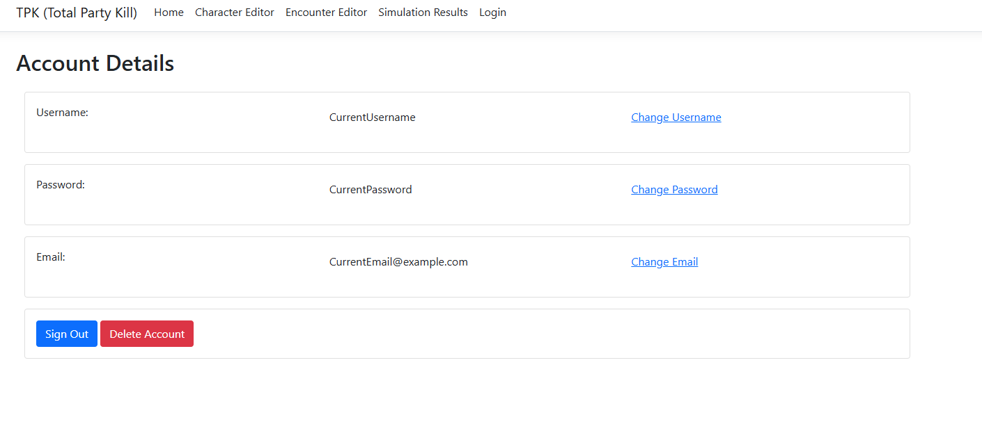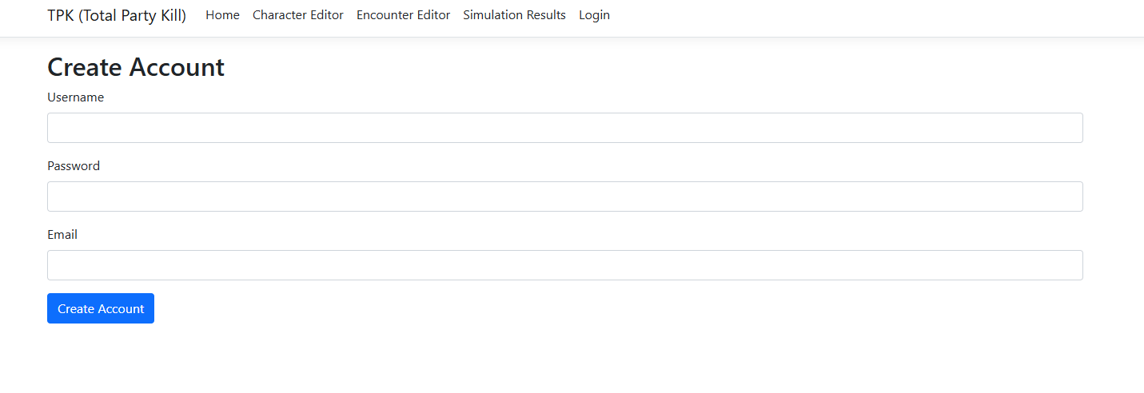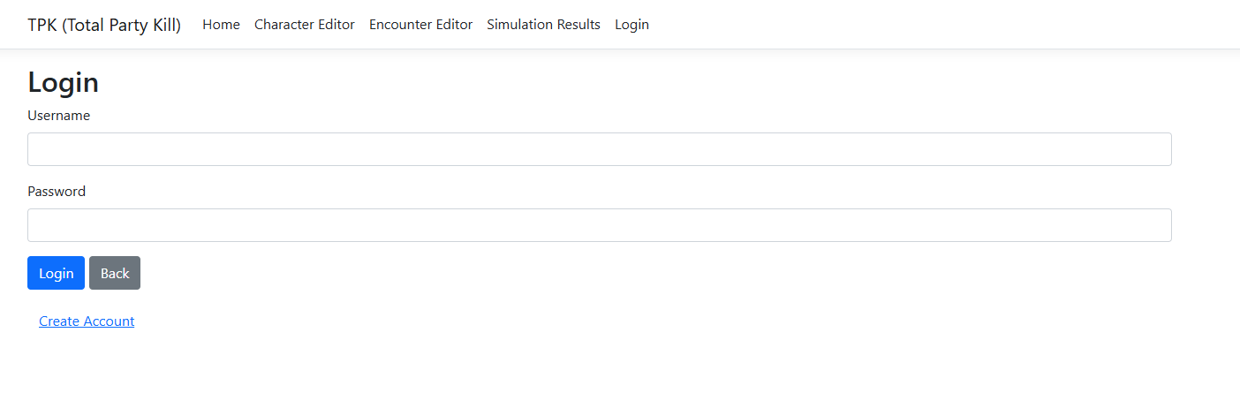

## Figure 2

# FAQ

* What is the TPK Simulation?
  + The TPK simulation is a tool designed by dungeon masters for dungeon masters! It’s used to simulate TTRPG combat encounters, enabling a DM to accurately predict outcomes based on player character behavior, monsters, and terrain.
* Do I need an account to use the TPK Simulation?
  + Yes, an account is required to save characters, encounters, and simulation results. You can create an account from the login page.
* Is the TPK Simulation free to use!
  + Yes it is!
* What browsers are supported for the TPK Simulation?
  + Our program is accessible on all modern browsers, including Google Chrome, Microsoft Edge, Firefox, and Safari.
* Can I use the TPK Simulation on mobile devices?
  + Unfortunately, no, at this time we don’t have any mobile support.
* What happens to all of my saved data when I delete my account?
  + All saved characters, encounters, and simulation results will be permanently deleted when you delete your account.
* Can I view past simulation results?
  + Yes, all past simulation results are stored in the “Encounter History” section under simulation results.
* The simulation isn’t running. What’s wrong?
  + Ensure all characters and monsters are properly placed on the map. If the issue persists, try refreshing the page or contact support.
* How do I contact support?
  + You can reach out to our support team at (513) 646-6615
* Can I customize the map/terrain for my encounters?
  + Map and terrain customization is currently a work in progress and will be available in future updates.