

Module Code | CT133-3-2-SRE
Intake Code | APD2F2509CS(CYB)
Submission Title | Switching and Routing Essentials Group and Individual Assignment
Lecturer Name | Noris Binti Ismail
Date Assigned | Monday, 8th September 2025
Date Completed | Sunday, 21st December 2025
Group No. | Group 01-08
Group Leader | Muhammad Faheem Khan bin Feroz Khan (TP076211)

No | Name | TP Number
1 | Muhammad Faheem Khan bin Feroz Khan | TP076211
2 | Nicholas Ong Kah Hao | TP074846
3 | Dean Armand bin Heron Khalid Goh | TP075877
4 | Mohamed Mabroor Saeed | TP084482
5 | Ziyad Alaa Mohamed Mahmoud | TP078283
6 | Muhammad Humaam Ajwad bin Maya Daleen | TP085314

Table of Contents
1. Introduction 4
2. Network Overview and Objectives 6
3. Entire Network Layout 7
4. IPv4 Addressing 8
5. LAN and WAN Configuration 10
5.1 VLAN Segmentation: 10
5.2 Trunk Ports: 11
5.3 Router on a stick: 11
5.4 DHCP server Configuration: 12
5.5 OSPF Neighbors: 12
5.6 OSPF learned Routes: 13
6. Proposed WLAN Architecture 15
6.1 WLC Management Interface 15
6.2 Lightweight Access Point: 16
6.3 WLAN Configuration and Security (WPA2-PSK): 17
6.4 Wireless Client Connectivity: 18
7. EtherChannel Implementation 20
7.1 EtherChannel Using LACP: 20
7.2 Port-Channel Interface Operation: 21
7.3 VLAN Traffic over EtherChannel: 21
8. HSRP Implementation 23
8.1 HSRP Status on Main active Router: 23
8.2 HSRP on Standby Router (Backup): 23
8.3 Client Using HSRP Virtual Gateway: 24
9. Server Farm Configuration 26
10. Inter-site Verification (Ping and Tracert) 30
11. Layer 2 Security Threats and Mitigation Deployment 32
12. Password Protecting Router 35
13. IoT Server 36
14. Recommendations For Security Enhancement 38
14.1 Honeypot Deployment 38
14.2 Bastion Host Implementation 38
14.3 Network Access Control (NAC) 38
15. Conclusion 40
16. References 41

Introduction
Alstom, a networking company, operates across four strategic locations: Kuala Lumpur (Headquarters), Australia, Singapore, and India (Remote Branch). The current network infrastructure requires comprehensive modernization to address evolving business needs, security concerns, and operational efficiency demands. Network administrators at Australia, Singapore, and India have planned to replace the current configuration with a new VLAN design to enhance network efficiency and security, with particular emphasis on the headquarters branch in Kuala Lumpur.

The Australia network administrator has planned to deploy WLC WLAN to ease the configuration of the wireless network and its access, while Singapore will implement a partial wired and partial wireless configuration. The KL headquarters and India branch will remain as wired networks. This project encompasses the complete redesign and implementation of Alstom's enterprise network infrastructure across all four locations, incorporating modern switching and routing technologies, wireless infrastructure deployment, and Layer 2 security best practices.

The network architecture adopts a hierarchical design approach ensuring scalability and manageability. Kuala Lumpur Headquarters houses Management, Human Resources, and Design departments. Australia Site accommodates Finance, R&D, and Delivery departments with WLC implementation. Singapore Site implements hybrid wired and wireless infrastructure. India Branch hosts Management and Development departments, along with the centralized Server Farm providing FTP, DNS, and Web services for the entire organization.

The implementation strategy employs Cisco Packet Tracer as the simulation platform. The technical approach incorporates VLSM for efficient IP address allocation, with public IP addressing for WAN connections and the Server Farm network, while private IP addressing is utilized for internal LAN segments. The scope includes deployment of DHCPv4 services across multiple LANs, implementation of WLC with WPA2 authentication for Australia and Singapore sites, configuration of OSPF and default static routes, and establishment of HSRP and EtherChannel for high availability.

Security mechanisms are implemented to mitigate Layer 2 attack vectors including DHCP spoofing, ARP spoofing, MAC flooding, and unauthorized access attempts, with particular emphasis on the KL headquarters. The successful implementation will position Alstom to leverage modern networking technologies while maintaining operational efficiency, security, and reliability across all geographical locations.

Network Overview and Objectives
The design satisfies business and technical requirements, by separating traffic into functional VLANs at each location, offering wireless service in Australia and Singapore with local Wireless LAN Controllers (WLCs) and hosting a public server farm in India with DNS, FTP and web services. Every site has its own DHCP service and all routers are part of OSPF so that routes can be distributed automatically. The KL central hub is linked by serial WAN to all the branches; this hub system is simpler to control route as well as construction of topology of laboratories.
The main design requirements were to reduce broadcast domains, enforce security and performance segmentation, provide redundancy of HQ gateway services through HSRP, aggregate high-capacity connections where it would benefit, and other common L2 design features including port security, DHCP snooping and Dynamic ARP Inspection.

Entire Network Layout
The rational topology is structured in a way that it has four locations KL (headquarters), Australia, Singapore and India. Each location is provided with a single distribution/access switch (or two access switches) which divides the clients into department VLANs. The use of WLC controlled wireless is in Australia and Singapore where lightweight APs are used to bridge client traffic into local VLANs. The server farm is located in India and is otherwise autonomously managed with its own publicly reachable network block in order to publish services. The KL site has also a core router which is connected to external services.
Physically Topology The topology of the lab utilizes one router per site, and the router is linked to local access switches. Each of the VLANs on the routers has router-on-a-stick subinterfaces that are configured as default gateway; this option makes it easier to configure the lab and fits the brief given in the project. The routers are serial linked with KL as the hub to AU, SG and IN towards OSPF domain.
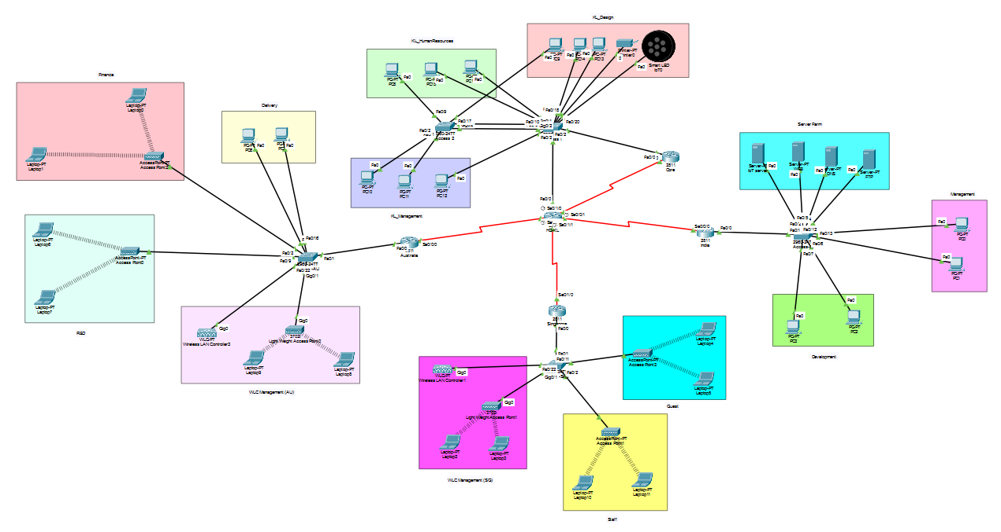

IPv4 Addressing
Address space in the addressing plan is used as in the following manner: the LAN subnets are assigned to the private address space and the documentation/public address space to the WAN point-to-point links and server farm as needed. The blocks of the private site addresses were selected as continuous within the 10.0.0.0/8 space to make route summarization easier. The size of subnets was determined based on a number of expected hosts in a VLAN; subnets of /24 give enough capacity to host and at the same time, addressing is simple and clear in a lab setting. To simulate the use of public IP addresses, the WAN links use addresses of documentation that are public.

Addressing table and IP scheme

Location | Network | Subnet | Mask | Gateway
KL | KL Management (VLAN10) | 10.10.10.0/24 | 255.255.255.0 | 10.10.10.254
KL | KL Human Resources (VLAN20) | 10.10.20.0/24 | 255.255.255.0 | 10.10.20.254
KL | KL Design (VLAN30) | 10.10.30.0/24 | 255.255.255.0 | 10.10.30.254
KL | KL Management VLAN (switch/WLC mgmt) | 10.10.99.0/24 | 255.255.255.0 | 10.10.99.254
AU | Finance (VLAN110) | 10.20.10.0/24 | 255.255.255.0 | 10.20.10.254
AU | R&D (VLAN120) | 10.20.20.0/24 | 255.255.255.0 | 10.20.20.254
AU | Delivery (VLAN130) | 10.20.30.0/24 | 255.255.255.0 | 10.20.30.254
AU | WLC Mgmt (AU) (VLAN150) | 10.20.150.0/24 | 255.255.255.0 | 10.20.150.10
AU | WLAN Clients (VLAN151) | 10.20.151.0/24 | 255.255.255.0 | 10.20.151.254
SG | Staff (VLAN210) | 10.30.10.0/24 | 255.255.255.0 | 10.30.10.254
SG | Guest (VLAN220) | 10.30.20.0/24 | 255.255.255.0 | 10.30.20.254
SG | WLAN Clients (VLAN230) | 10.30.30.0/24 | 255.255.255.0 | 10.30.30.254
SG | WLC Mgmt (SG)(VLAN299) | 10.30.99.0/24 | 255.255.255.0 | 10.30.99.10
IN | Management (VLAN310) | 10.40.10.0/24 | 255.255.255.0 | 10.40.10.254
IN | Development (VLAN320) | 10.40.20.0/24 | 255.255.255.0 | 10.40.20.254
IN | Server Farm (public) | 198.51.100.0/28 | 255.255.255.240 | 198.51.100.1

WAN / Public address scheme
The lab simulated public addressing of the WAN links by the use of documentation public block. The allocation of the 203.0.113.0/24 block of documentation in the following order was given sequentially:

Link | Network | Usable IPs | Assigned
KL – AU | 203.0.113.0/30 | .1 (KL), .2 (AU) | KL 203.0.113.1 / AU 203.0.113.2
KL – SG | 203.0.113.4/30 | .5 (KL), .6 (SG) | KL 203.0.113.5 / SG 203.0.113.6
KL – CORE | 203.0.113.8/30 | .9 (KL), .10 (CORE) | KL 203.0.113.9 / CORE 203.0.113.10
KL – IN | 203.0.113.12/30 | .13 (KL), .14 (IN) | KL 203.0.113.13 / IN 203.0.113.14

Rationale: the small /30s serial link is used to save address space by the publics but simulates routing by the publics. The server farm is using /28 that enables a number of public addresses to be used by web, FTP, DNS and possible demilitarised zone (DMZ) server.

LAN and WAN Configuration
The LAN set-up isolates the hosts into departments with 802.1Q VLAN tagging. Access ports are configured in each access switch to the corresponding VLAN, and trunk ports to deliver several VLANs to the upstream equipment. In the case of router-on-a-stick setup used in the laboratory, the router will be configured with subinterfaces which terminate VLAN tags and will also serve as a DHCP server to the local subnets. An example configuration of the KL router with VLAN 10 using sub interface will be: interface GigabitEthernet0/0.10 encapsulation dot1Q 10 ip address 10.10.10.1 255.255.255.0.
The serial links between routers offer WAN connectivity. OSPF is the dynamic routing protocol applied; every router should be set with an OSPF process which announces the local VLAN networks and serial link networks. The KL router acts as a hub; this offers a straightforward and easy to comprehend routing topology to the lab and at the same time displays route distribution, convergence, and reachability.
Where gateway redundancy was needed in the case of KL, HSRP was configured between KL and the CORE router such that the HSRP virtual IP (say 10.10.10.254 in the case of KL management VLAN) was the default gateway to its clients. The two KL access switches were configured to use EtherChannel to open throughput and offer link redundancy between access stacks.

5.1 VLAN Segmentation:
Location used: KL-ACC1
VLAN 10,20,30,99 were created and active, some for future input.

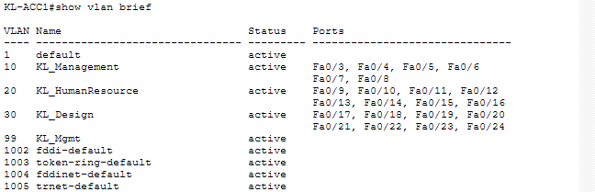

5.2 Trunk Ports:
Command used: sh int trunk or show interfaces trunk
Trunks are enabled and working and encapsulated in 802.1q and carrying the vlans stated below.

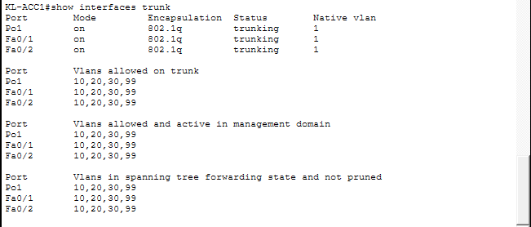

5.3 Router on a stick:
Command used: show running-config and scrolled down.
Location is KL-RTR which is the router for KL and also the main router.
Output shows the router-on-a-stick configuration using sub interfaces, meaning router provides intervlan routing for each department by ignoring the VLAN tags.

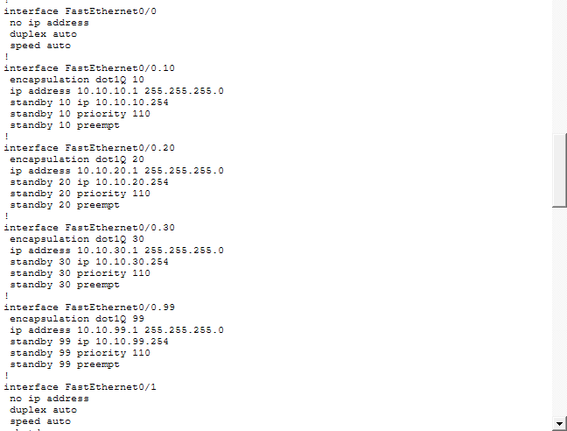

5.4 DHCP server Configuration:
Command used: show running-config and scrolled down
DHCP WORKS

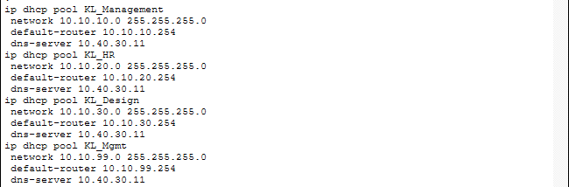

5.5 OSPF Neighbors:
Command used: show ip ospf neighbor
Image below its clear the router kl shows multiple neighbors in the state FULL, with unique Neighbor. This means that the Routers communicate with each other.
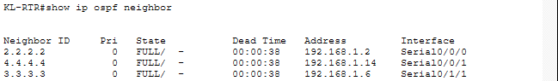

5.6 OSPF learned Routes:
Command used: show ip route ospf
In the table, O indicates that the routing was learned automatically with the help of OSPF. Meaning WAN works as intended.
Routing table:
Command used: show ip route
Extra to show KL is the main hub and is working as intended dynamically and manually.

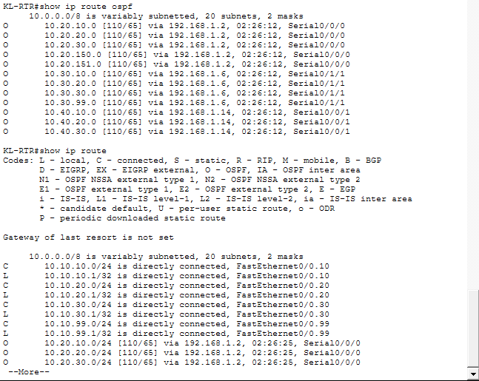

Proposed WLAN Architecture
The architecture of the WLAN deployed WLCs in Australia and Singapore to locally control APs, as well as to localize the wireless client traffic. Every WLC has a management interface on its management VLAN and dynamic interfaces which are mapped to WLAN client VLANs. In the laboratory, the WLC was set up to perform WPA2-PSK authentication, and both staff networks and visitor access were restricted to a smaller range of guests via the use of a secure pre-shared key.

The APs were set up as lightweight access points; they formed CAPWAP tunnels to the local WLCs towards which they could be controlled and managed. Local switching was switched on where the data of the clients could be bridged from the AP into the local VLAN at the access switch. The given option will decrease WAN usage on local traffic and simplify the DHCP management since the fully switched traffic of clients is in the same site as VLAN.

6.1 WLC Management Interface
Navigation used: WLC → Config → Management
Location chosen to demonstrate: Wireless LAN Controller, Hostname Wireless LAN Controller3
What this demonstrates:
The output shows the management interface of the Wireless LAN Controller, including its IP address, default gateway, and DNS server. This confirms that the WLC is correctly connected to the management VLAN and can be centrally managed within the network. 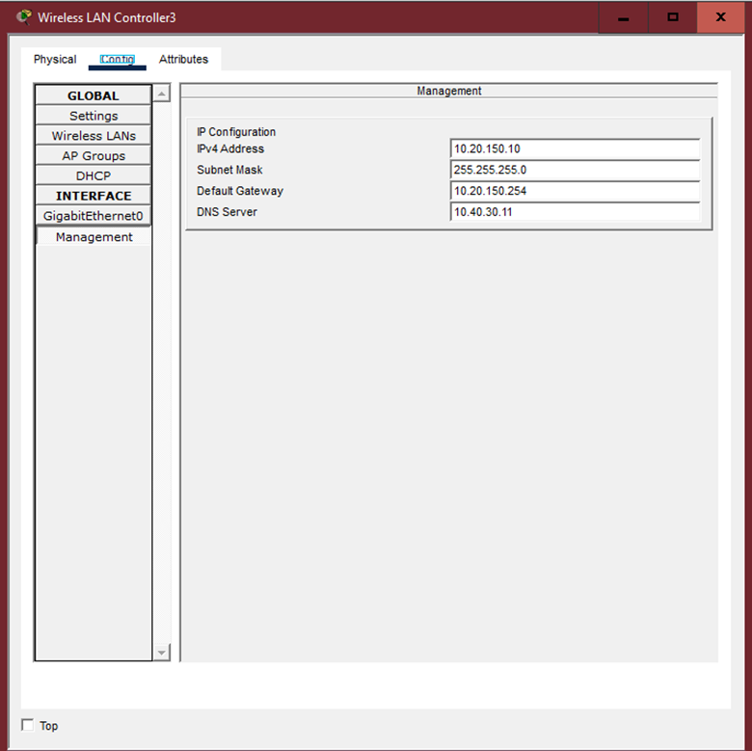

6.2 Lightweight Access Point:
Navigation used: Access Point → Config → Setting
Location chosen to demonstrate: Lightweight Access Point, Hostname Light Weight Access Point0
What this demonstrates:
The output means that the access point is operating in lightweight mode and has its IP configuration via DHCP. This means that the AP is controlled by the Wireless LAN Controller and communicates with it using CAPWAP for central management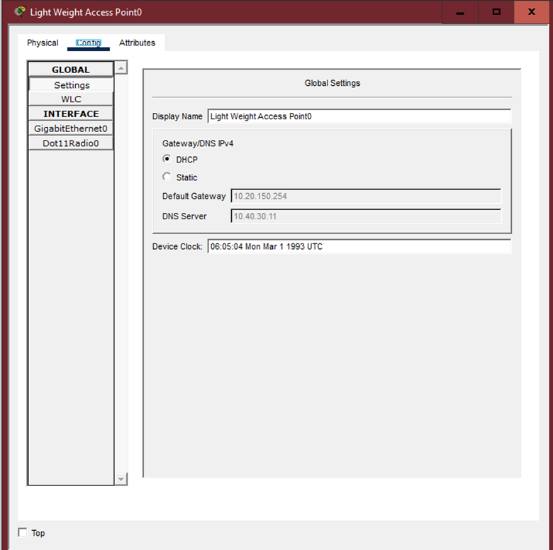

6.3 WLAN Configuration and Security (WPA2-PSK):
Navigation used:
WLC → Config → Wireless LANs
Location chosen to demonstrate:
Wireless LAN Controller, Hostname Wireless LAN Controller3
What this demonstrates:
This screen shows the WLAN configuration for the client wireless network. The WLAN is mapped to a specific VLAN and secured using WPA2-PSK with AES encryption. This confirms that wireless access is restricted to authorized users through the use of a secure pre-shared key.
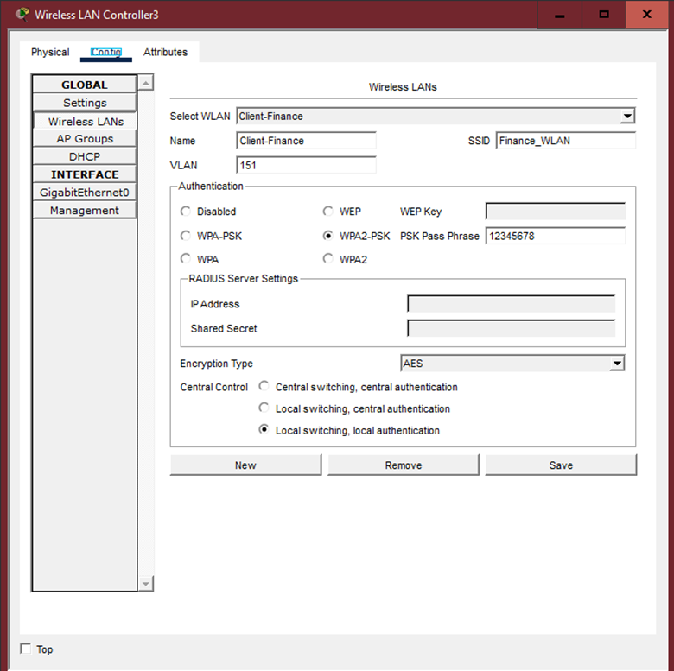

6.4 Wireless Client Connectivity:
Navigation used: Laptop → Desktop → PC Wireless
Location chosen to demonstrate: Wireless Client, Hostname Laptop9
What this demonstrates:
The output means that the wireless client has successfully connected to the access point in infrastructure mode. Signal strength and link quality is strong demonstrating that wireless authentication and client access are functioning correctly or that the device is very close
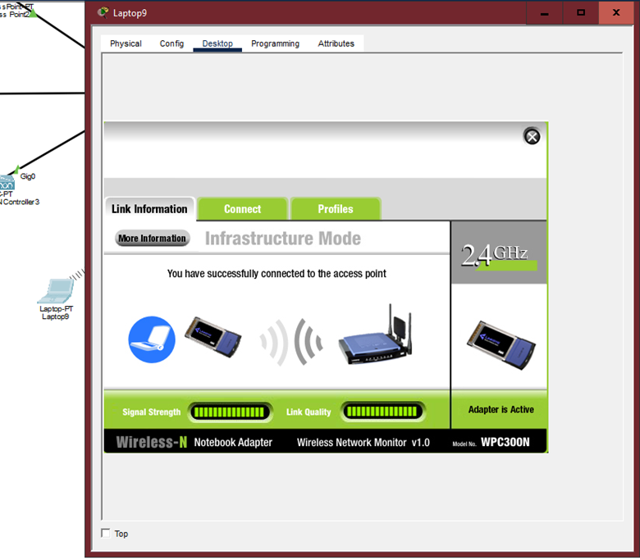

EtherChannel Implementation
The KL access switches were set to EtherChannel purposefully through LACP (mode active) due to the fact that it supports link aggregation with automatic negotiation and distributed traffic forwarding. The logical port-channel interface was introduced as a trunk which carried the site VLANs. The rationale of implementation is that it enhances throughput and adds link redundancy without necessitating Spanning Tree re-convergence with each individual physical link failure.
Verification commands were issued to check that member ports have been bundled and are in the right mode, show etherchannel summary and show interfaces port-channel. The snippet of the configuration on the access switches is done in the canonical form: interface range GigabitEthernet0/3 - 4; channel-group 1 mode active; and followed by interface Port-channel1 and trunking commands.

7.1 EtherChannel Using LACP:
Command used: show EtherChannel summary
Location chosen to demonstrate: Access Switch, Hostname KL-ACC1
What this demonstrates:
The output shows that EtherChannel has been successfully created on the access switch. The switch is using LACP, which is a protocol that allows both ends of the link to automatically agree to bundle multiple physical cables together.

The prompt shows that the GigabitEthernet0/1 and GigabitEthernet0/2 are both marked with a “P”, which means they are actively participating in the port-channel. This means that traffic is being shared across both links instead of relying on a single cable how it should be
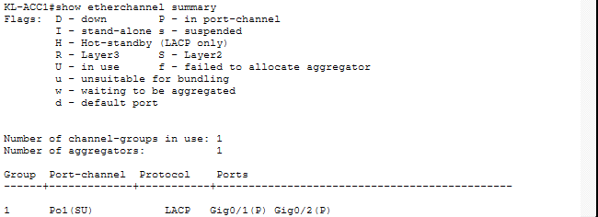

7.2 Port-Channel Interface Operation:
Command used: show interfaces port-channel 1
What this demonstrates:
This output shows that Port-channel1 is up and running as a single logical interface even though there are two physical cables connected, the switch treats them as one interface, which increases available bandwidth and provides redundancy.

If one physical link fails, traffic will continue to flow over the remaining link without causing a network outage or triggering a spanning-tree recalculation.
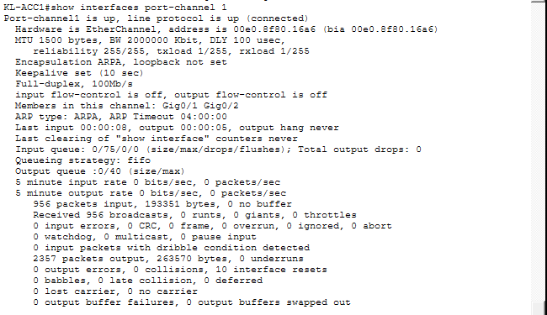

7.3 VLAN Traffic over EtherChannel:
Command used: show interfaces trunk
What this demonstrates:
The output means that the EtherChannel is configured as an 802.1Q trunk and is carrying VLANs 10, 20, 30, and 99. This means that all VLAN traffic is transported over the aggregated link rather than individual physical ports.

Because the trunk operates over the port-channel, the network benefits from both higher throughput, while still maintaining normal VLAN segmentation.
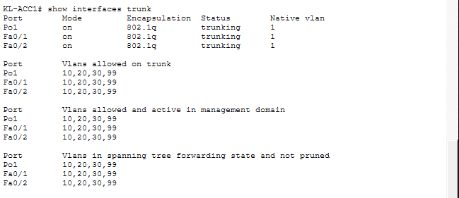

HSRP Implementation
HSRP groups were set to have the virtual IP as x.x.x.254 so as to offer redundancy to the KL default gateway to each KL VLAN. This was to be given priority whereby KL was to be the active router in normal circumstances and preemption was to permit an elevated router to be the active router after a recovery. The HSRP setup involves the standby commands on the respective sub interfaces and it was confirmed through the show standby of both routers. HSRP also provided that availability of client default gateway continued in the event of single router failure.

8.1 HSRP Status on Main active Router:
Command used: show standby brief
Location chosen to demonstrate: Router, Hostname KL-RTR
What this demonstrates:
The KL router (KL-RTR) is the active router for all configured HSRP groups. Every individual VLAN has a virtual IP ending in .254, which is the default gateway given to clients/end devices
The state being shown as Active means that KL-RTR (router) is currently handling gateway traffic under normal. The priority value of 110, along with preemption enabled, makes sure that KL-RTR will reclaim the active role after failing/failure and recovery fr.
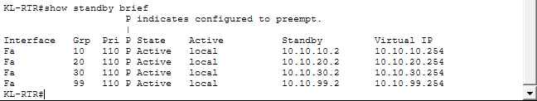

8.2 HSRP on Standby Router (Backup):
Command used: show standby brief
Location chosen to demonstrate: Router, Hostname CORE-RTR
What this demonstrates:
The Screenshot shows that the CORE router is in the state Standby for the same HSRP groups and virtual IP addresses. It is fully synchronized and ready to take over gateway if the active router (KL-RTR) fails.
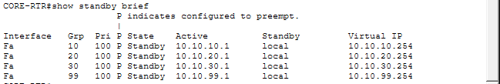

8.3 Client Using HSRP Virtual Gateway:
Command used: (GUI view – no CLI command)
Location chosen to demonstrate:
End host, PC12
What this demonstrates: This screenshot shows that the client’s default gateway is set to 10.10.10.254, which is the HSRP virtual IP rather than a physical router address.
This confirms that HSRP is transparent to end users. Clients do not need to know which router is active — they always use the same virtual gateway, ensuring uninterrupted connectivity even during router failures.
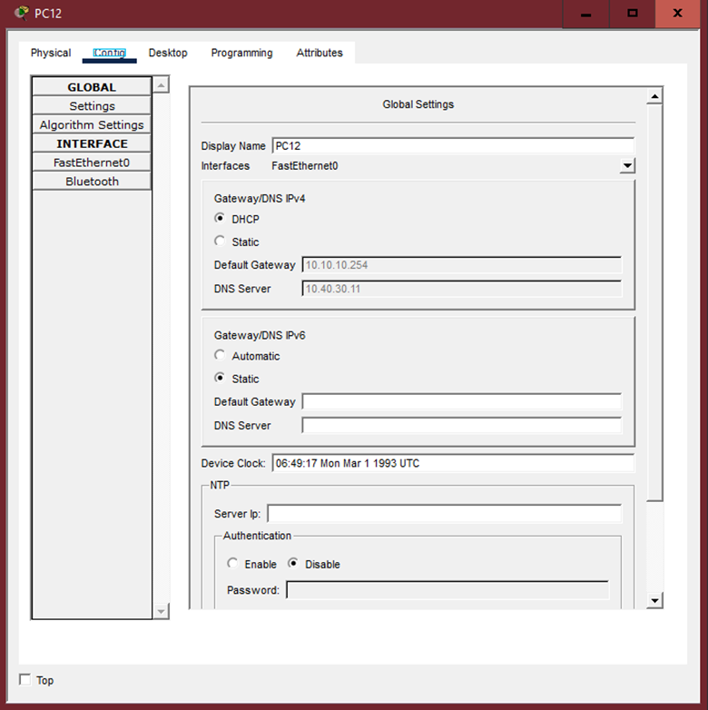

Server Farm Configuration
The DNS, FTP and web services are configured on separate IP addresses in the public network space where the India server farm can be placed to ensure that these services are addressed as externally routable and are open to firewall/NAT schemes. The DNS server also serves as authoritative A records of the www.alstom.local and ftp.alstom.local which get mapped to the public addresses of the web and FTP servers. The web server contains a barebone HTML welcome page, which confirms access, and the FTP server contains a test account to exchange files.
To test internal networks and check the name resolver server entries were also added to local DNS so that service-by-name resolution could be made in the intranet.
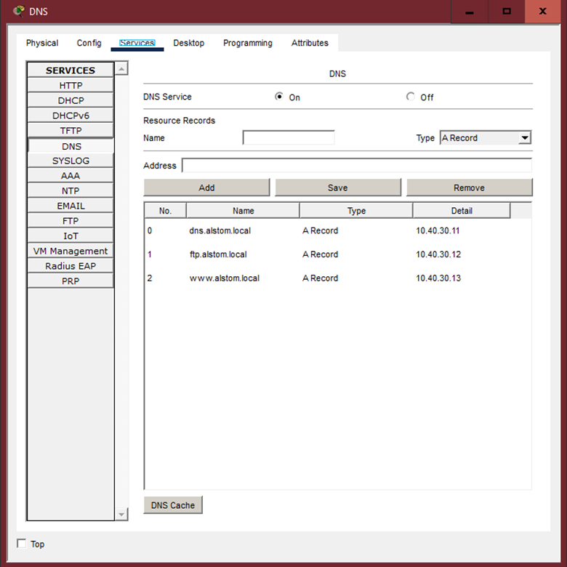
Above Image demonstrates that the configurations has been done for web, ftf and dns to work.
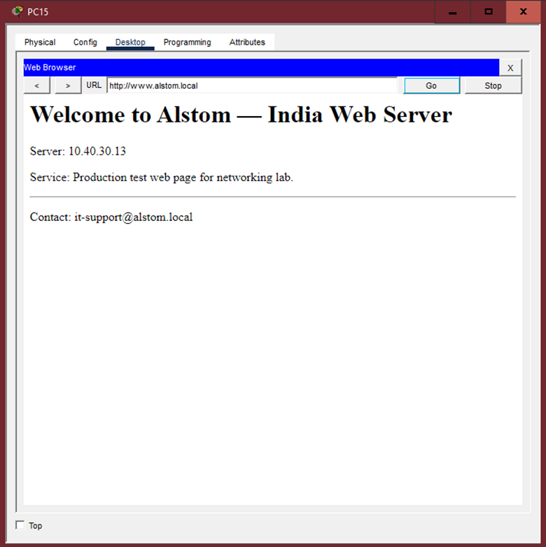
Above Image demonstrates that the web server is running and accessible via another end device in this case it is PC15 in KL.
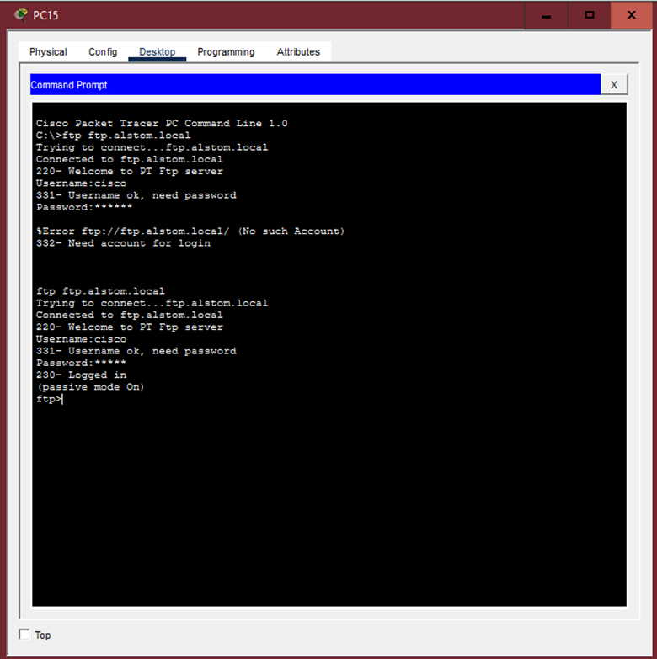
Image above demonstrates that the ftp servers are reachable and active. Also done via PC15 in KL.

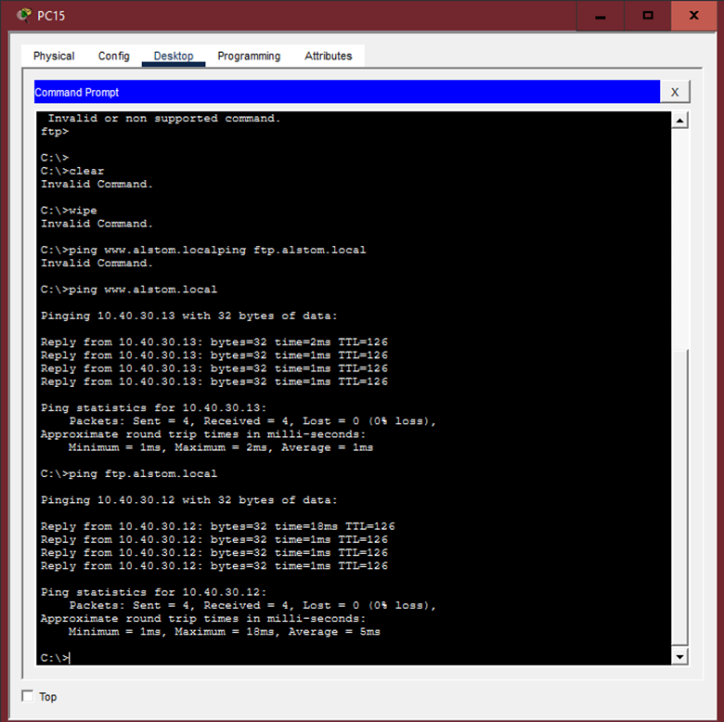
This shows that the ping works without any packet loss smoothly and correctly.

Inter-site Verification (Ping and Tracert)
The connectivity was checked by conducting ICMP echo tests and traceroute between representative hosts of each site. The tests also ensured the OSPF propagated the routes to all remote LANs and the inter-VLAN routing and NAT (when applied) were operating properly. Some of the example commands that were used during the verification process are ping 10.40.30.13, where an AU client is connected to the India webserver and tracing where the KL router is connected to a remote server
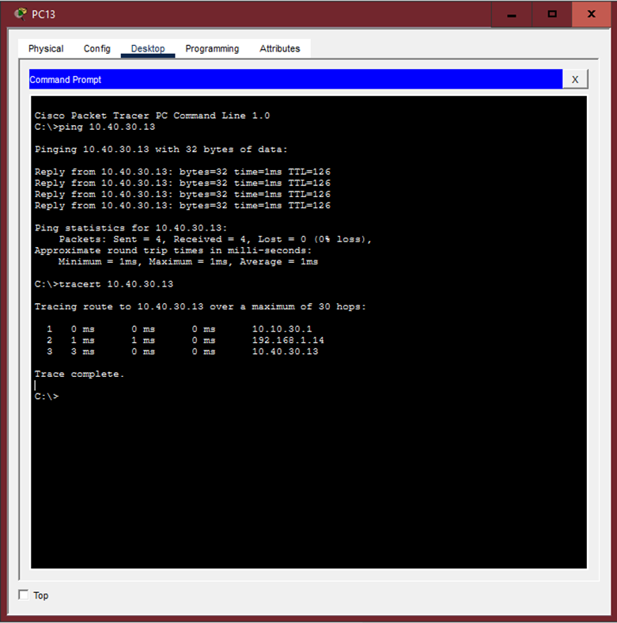
Command: Ping 10.40.30.13 (India’s Webserver)
No packet loss meaning ospf works, end to end reachability and intersite connectivity.
Command: tracert 10.40.30.13 (India’s Webserver)
Multiple hops with correct route path and traffic traversal and also no black holes or routing loops
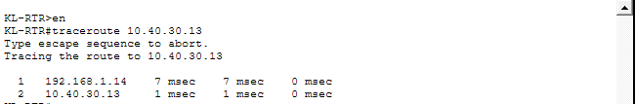
Command: Command: tracert 10.40.30.13 (India’s Webserver) Inside of KL Router (KL-RTR)
Router-level reachability and OSPF route propagation between sites

Layer 2 Security Threats and Mitigation Deployment
Four types of Layer-2 attacks are given a deliberate choice and the mitigation strategies applied in the design. The attacks under analysis are: (1) MAC flooding (CAM table overload), (2) ARP spoofing/poisoning, (3) rogue DHCP servers and (4) BPDU spoofing/bridge protocol compromise. Every attack is discussed in brief and the defensive measures that were used recorded.
The port security of MAC flooding was set to access ports using sticky MAC learning and restrictive violation action (restrict). This restricts the number of addresses learned over a port as well as uncontrolled expansion of CAM tables. In the ARP spoofing, DHCP snooping was enabled together with Dynamic ARP Inspection (DAI); DHCP snooping sets trusted bindings, which is used by DAI to check ARP traffic. DHCP snooping and use of uplink ports in known DHCP servers was used to mitigate rogue DHCP servers. The mitigation strategies of BPDU spoofing and unauthorized topology changes were to enable BPDU Guard on the access ports and Root Guard where topology needed to be controlled root bridge election.
These features are illustrated by a series of CLI excerpts in the Packet Tracer configuration reference and confirmed by the analysis of show ip dhcp snooping binding, show port-security, show ip arp inspection and similar.

Location chosen to demonstrate: Access-1, Hostname KL-ACC1
Note: Will work on other Access switches.
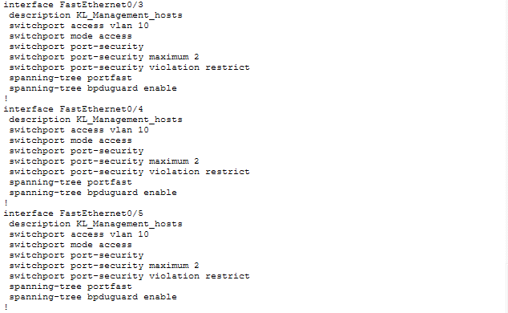
Command used: show running-config, and scroll down.
The output shows port security to mitigate MAC flooding attacks (CAM) and bdpuguard enabled to mitigate STP and dbpu spoofing poisoning
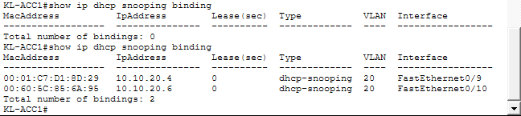
Command used: show ip dhcp snooping binding
DHCP snooping table and proof that it is functioning by turning dhcp off and on, on a end device, here it was 2 binding.
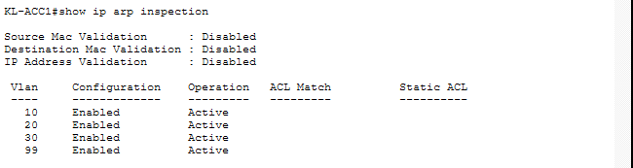
Command used: show ip arp inspection
On vlan 10,20,30,99 enabled and functioning as intended.

Password Protecting Router
Location chosen to demonstrate: Australia Router.
As you can see with the cli prompt AU-RTR#show startup-config: 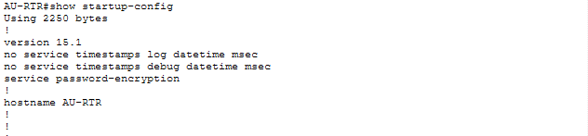

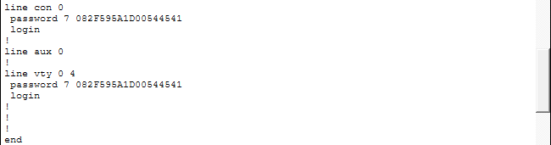

This indicates that the password is md5 hashed inside packet tracer and is up and running.
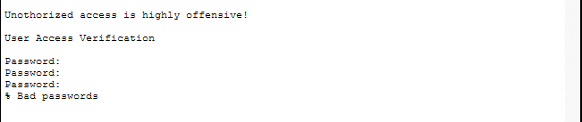
Custom banner to indicate the risks of accessing the router without authorization, and showcasing password protection working
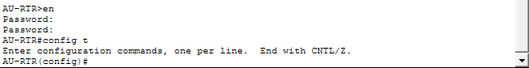
Accessible once password is input.

IoT Server
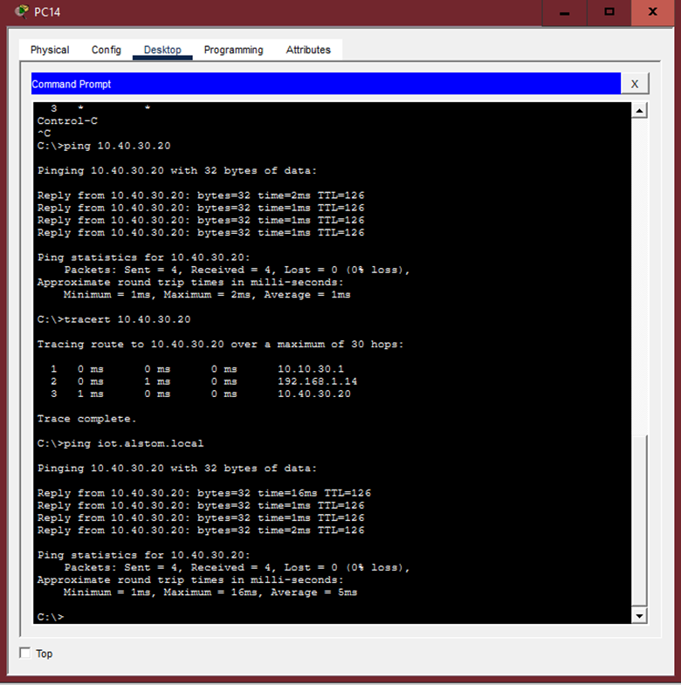
Above image demonstrates that the PC14 pings to our IoT server in India. This proves that IoT devices can be added.
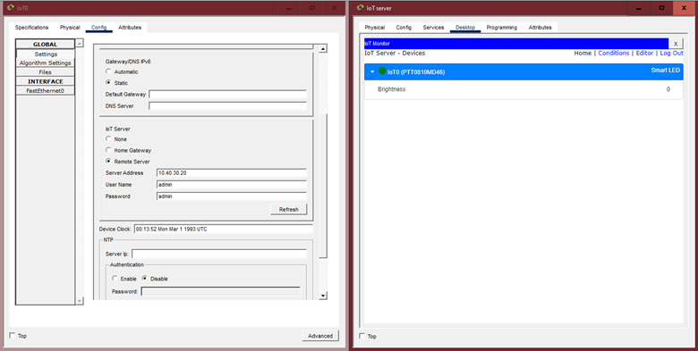
Since it is able to ping, assumptions can be made that the IoT server is on layer 2 and that the IoT monitor is just used as a cosmetic reference.

Recommendations For Security Enhancement
Apart from the Layer 2 security measures that have been implemented, three more recommendations are suggested to further improve Alstom's network security and help defend against advanced threats.

14.1 Honeypot Deployment
A honeypot system works by creating fake services or systems that look real to attackers. When someone tries to attack the honeypot, it gives network administrators useful information about what methods attackers are using, which tools they prefer, and what weaknesses they are looking for. This lets the security team fix problems in the real systems before any actual damage happens.
The honeypot needs to be kept separate from important systems but should look tempting enough for attackers to target it. Every interaction with the honeypot gets logged so it can be studied later. There are two main types that can be used - low-interaction honeypots that just pretend to be basic services and are simpler to set up, or high-interaction honeypots that act like complete systems and can catch more complex attack methods. Looking through the honeypot logs regularly helps spot new types of threats and understand what kind of attacks the organization might face.

14.2 Bastion Host Implementation
A bastion host acts as a secure entry point between the outside world and the internal network. It becomes the only way for administrators to remotely access the network from outside, which makes it much easier to control and watch who is connecting. Instead of having multiple entry points that all need monitoring, everything goes through this one hardened system.
The bastion host has to be set up very carefully with tight firewall rules, only a few ports open, multi-factor authentication for anyone trying to connect, and detailed logs of every connection attempt. It should only run the absolute minimum services needed to reduce the chances of something going wrong. Security checks should happen regularly, including scanning vulnerabilities and making sure the configuration is still correct. The best place for it is in a DMZ, which sits between the internet and the trusted internal network. When administrators need to manage routers, switches or servers from outside the office, they have to connect to the bastion host first. This gives one clear place where all access attempts are recorded and controlled.

14.3 Network Access Control (NAC)
NAC automatically checks whether devices meet security requirements before letting them onto the network. It looks at things like device identity, whether security software is installed and up to date, if patches have been applied, and if the device follows company policies. If a device does not meet the requirements, it gets put into a separate restricted VLAN where it cannot cause problems until the issues are fixed.
This matters more now because people bring their own phones and laptops to work, contractors connect their devices, and IoT gadgets are everywhere. Connecting NAC to existing systems like Active Directory makes login easier while keeping things secure. Different rules can be set for employees, visitors, and IoT devices so each type gets the right level of access. The system checks devices both when they first connect and continuously while they are connected, not just once at the start. For a company like Alstom with offices in different locations, having NAC managed from one place means the same security rules apply everywhere, but local IT staff can still make exceptions when needed for their specific site.

Conclusion
The project provides a secure and segmented and resilient multi-site network design that meets the stipulated goals. The configuration options are more conducive to visibility and simplicity within a learning enterprise and also implements realistic technologies like OSPF, HSRP, Etherchannel, WLC-controlled WLANS and frequently used L2 security mechanisms. The lab illustrates end-to-end routing and service availability and forms a basis on which it is hardened and operationalized to a production deployment.

The project provides a secure and segmented and resilient multi-site network design that meets the stipulated goals. The configuration options are more conducive to visibility and simplicity within a learning enterprise and also implements realistic technologies like OSPF, HSRP, Etherchannel, WLC-controlled WLANS and frequently used L2 security mechanisms. The lab illustrates end-to-end routing and service availability and forms a basis on which it is hardened and operationalized to a production deployment.

Workload Matrix
Area | Mohamed Mabroor Saeed  TP084482 | Nicholas Ong Kah Hao  TP074846 | Dean Armand bin Heron Khalid Goh  TP075877 | Ziyad Alaa Mohamed Mahmoud TP078283 | Muhammad Humaam Ajwad bin Maya Daleen TP085314 | Muhammad Faheem Khan bin Feroz Khan  TP076211
Project Planning | 16.7% | 15% | 16.7% | 16.7% | 16.7% | 16.7%
Network Analysis & Requirements | 16.7% | 16.7% | 16.7% | 16.7% | 16.7% | 16.7%
Network Design (Topology & IP) | 16.7% | 16.7% | 16.7% | 16.7% | 16.7% | 16.7%
Implementation & Configuration | 16.7% | 16.7% | 16.7% | 16.7% | 16.7% | 16.7%
Testing, Verification & Documentation | 16.7% | 16.7% | 16.7% | 16.7% | 16.7% | 16.7%
Overall Contribution % | 16.7% | 16.7% | 16.7% | 16.7% | 16.7% | 16.7%
Digital Signature

References
- Scarfone, K., & Mell, P. (2007, February 20). Guide to Intrusion Detection and Prevention Systems (IDPS). Csrc.nist.gov. https://csrc.nist.gov/pubs/sp/800/94/final
- ‌Lutkevich, B., Clark, C., & Cobb, M. (2021, February). What is a honeypot? How it protects against cyber attacks. SearchSecurity. https://www.techtarget.com/searchsecurity/definition/honey-pot
- ‌Cisco. (2025, March). ISE 3.0 Demo - Simplifying visibility and control in the zero-trust workplace. Cisco. https://www.cisco.com/site/us/en/learn/topics/security/what-is-network-access-control-nac.html
- ‌Kaspersky. (2020, April 16). What is a honeypot? Www.kaspersky.com. https://www.kaspersky.com/resource-center/threats/what-is-a-honeypot
- ‌What is a Bastion Host? (n.d.). Www.goodaccess.com. https://www.goodaccess.com/blog/what-is-a-bastion-host

