

Module 7

**Python Object-Oriented Programming**

Python Fundamentals, 1st Edition. © 2021 Cengage. All Rights Reserved. May not be scanned, copied or duplicated, or posted to a publicly accessible website, in whole or in part.

# Lesson 7.1: A First Look at OOP

* Object-oriented programming (OOP): Programming paradigm based on concept of objects.
  + Objects: Capsules of properties and procedures/methods.
* Allows us to abstract actual code and think more about attributes of data and operations around data.
* Advantages:
  + Code reusable.
  + Easier to design software as you can model it in terms of real-world objects.
  + Easier to test, debug, and maintain.
  + Data is secure due to abstraction and data hiding.

# Lesson 7.2: OOP in Python

* Classes are OOP building-blocks.
  + Blueprints for objects.
* Everything in Python is an object.
* Running type function on any object will reveal class.

# Lesson 7.2.1: Defining a Class in Python

* Syntax is minimal.
  + class ClassName
  + type function shows class type.
  + In Python, class and type are synonymous.
* Class: blueprint
* Attributes: noun, parts of the object
* Methods: action, things the object does
* Instantiation: copies of the class

## Declaring the Employee Class

* class Employee:

def _ _ init _ _(self):

## Developing the Attributes (nouns)

* Building the blueprint using the keyword class
* Employee is the class name
* def is used to create the function
* Init method is used to initialize the method
* When you create a method as a class, it receive the instance as the first argument automatically. By convention you may call the instance Self.

## Declaring the Employee Class

* class Employee:

def _ _ init _ _(self, fname, lname, age): self.fname = fname

self.lname = lname self.age = age

## Developing the Attributes (nouns)

* After “self” you may specify other arguments to accept
* Set instance variables
  + Could use self.first = fname
    - It’s best to keep things the same

## Declaring the Employee Class

* class Employee:

def _ _ init _ _(self, fname, lname, age): self.fname = fname

self.lname = lname self.age = age

emp_1 = Employee(‘Eric’, ‘Clayborn’, 23) emp_2 = Employee(‘Andrew’, ‘Churchill’, 25)

## Developing the Attributes (nouns)

* After “self” you may specify other arguments to accept
* Set instance variables
  + Could use self.first = fname
    - It’s best to keep things the same
* Pass in values

## Declaring the Employee Class

* class Employee:

def _ _ init _ _(self, fname, lname, age): self.fname = fname

self.lname = lname self.age = age

emp_1 = Employee(‘Eric’, ‘Clayborn’, 23) emp_2 = Employee(‘Andrew’, ‘Churchill’, 25)

## Developing the Attributes (nouns)

* After “self” you may specify other arguments to accept
* Set instance variables
  + Could use self.first = fname
    - It’s best to keep things the same
* Pass in values
* What happens:
  + emp_1 will be passed to self
  + Eric will be passed to fname
  + Clayborn will be passed to lname
  + 23 will be passed to age

## Declaring the Employee Class

* class Employee:

def _ _ init _ _(self, fname, lname, age): self.fname = fname

self.lname = lname self.age = age

emp_1 = Employee(‘Eric’, ‘Clayborn’, 23) emp_2 = Employee(‘Andrew’, ‘Churchill’, 25)

## Developing the Attributes (nouns)

* After “self” you may specify other arguments to accept
* Set instance variables
  + Could use self.first = fname
    - It’s best to keep things the same
* Pass in values
* What happens:
  + emp_2 will be passed to self
  + Andrew will be passed to fname
  + Churchill will be passed to lname
  + 25 will be passed to age

## Declaring the Employee Class

* class Employee:

def _ _ init _ _(self, fname, lname, age): self.fname = fname

self.lname = lname self.age = age

def fullname (self):

print(f”Hello {self.fname} {self.lname}, you are {self.age} years old.”)

emp_1 = Employee(‘Eric’, ‘Clayborn’, 23) emp_2 = Employee(‘Andrew’, ‘Churchill’, 25)

## Developing the Methods (actions)

* Each method within a class automatically takes the instance as the first argument.
  + Always call it “self”
* Create method containing self using a print statement to display full name and age

## Declaring the Employee Class

* class Employee:

def _ _ init _ _(self, fname, lname, age): self.fname = fname

self.lname = lname self.age = age

def fullname (self):

print(f”Hello {self.fname} {self.lname}, you are {self.age} years old.”)

emp_1 = Employee(‘Eric’, ‘Clayborn’, 23) emp_1.fullname()

emp_2 = Employee(‘Andrew’, ‘Churchill’, 25) emp_2.fullname()

## Developing the Methods (actions)

* Each method within a class automatically takes the instance as the first argument.
  + Always call it “self”
* Create method containing self using a print statement to display full name and age
* Call the methods in order to display the actions or results
* Notice the ( ) located at the end, because it is a method being called rather than an attribute being passed
  + This displays the return value of the method

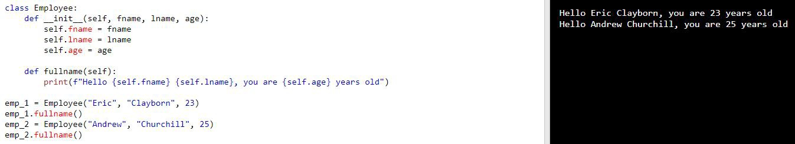

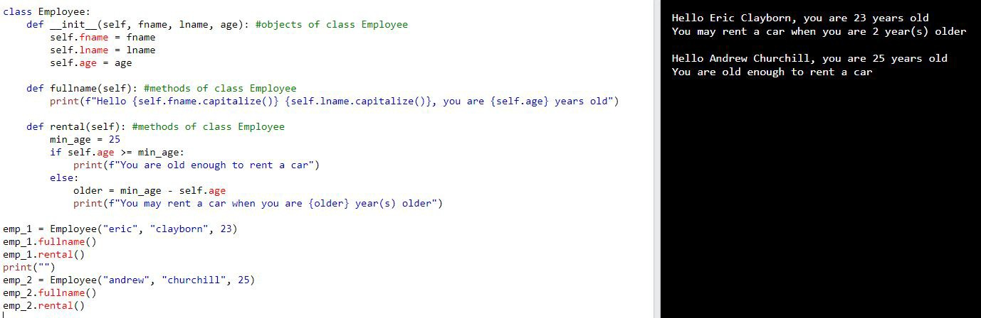

# Lesson 7.2.2: Instantiating an Object

* Example: jack = Person()
* Each new object instantiated points to different objects.
  + If we declare a second Person()such as, jill = Person()
    - jack is jill will be False

# Lesson 7.2.3: Adding Attributes to an Object

* Can add attributes dynamically.
  + Type name of object followed by dot (.) and then name of attribute.
  + Example: jack.name = "Jack Smith"
  + Try to avoid; this is bad practice.
* Every object has built-in attributes.
  + Such as dict
    - Dictionary that holds all attributes of object.

# Lesson 7.2.4: The

**init**

**Method** (1 of 2)

* Preferred way to add attributes is by defining them in object’s constructor method.

In Python constructor is init

* + class ClassName
* hasattr() function checks whether object has specific attribute or method.
  + In Python, class and type are synonymous.
* Define init just like function and specify attributes that need to be passed

when instantiated object.

* + Snippet 7.13 shows example.
  + Note: self refers to object we’re in process of creating.
  + If init defines parameters and you instantiate object without passing argument,

you get TypeError.

**Lesson 7.2.4: The**

**init**

**Method**

* The init () function is always executed when the class is being initialized.
  + Use this function to assign values to objects properties

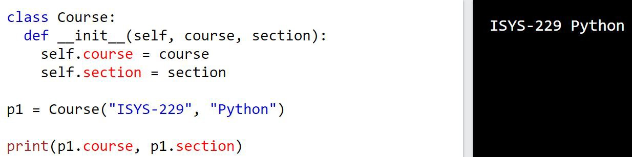

# Lesson 7.2.4: The

**init**

**Method** (2 of 2)

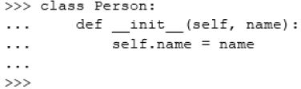

*Snippet 7.13*

* Define method in class just like you would init .
* Can access instance attributes within instance methods.
* Snippet 7.22 shows example of creating method, accessing instance attributes within method, and calling method.

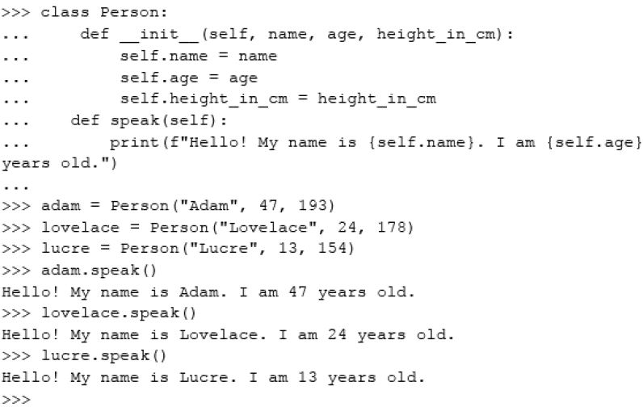

*Snippet 7.22*

# Lesson 7.3.2: Passing Arguments to Instance Methods

* Can pass arguments to instance methods, just like normal functions.
* Can add condition statements to instance methods.

# Lesson 7.3.3: Setting Instance Attributes within Instance Methods

* Can add instance attributes to instance methods.
  + Same process as adding attributes to init .

# Lesson 7.4: Class versus Instance Attributes

* Instance attributes are bound to specific instance of the class.
* Class attributes are bound the class and shared by all instances.
* Syntax is just like defining variable, only you do it in the class body.
  + Snippet 7.33 shows example.
* Access class attribute via class itself.
* Changing class attribute through class will reflect on all existing instances.
* Changing class attribute through instance will create instance attribute.
* Can access and change class attributes in instance methods.

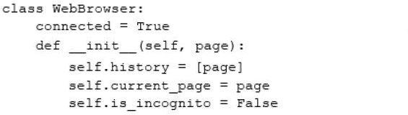

*Snippet 7.33*

# Lesson 7.5.1: Creating Instance Methods (1 of 2)

* Instance methods must receive self as first argument.
  + Don’t need to explicitly pass in value for self.
* Bound method: One that takes an instance (self) as first parameter.
  + Every instance of class has its own copy of method.
* Snippet 7.49 shows instance method examples.

# Lesson 7.5.1: Creating Instance Methods

* The Self parameter is a reference to the current instance of the class and is used to access variable that belongs to the class.

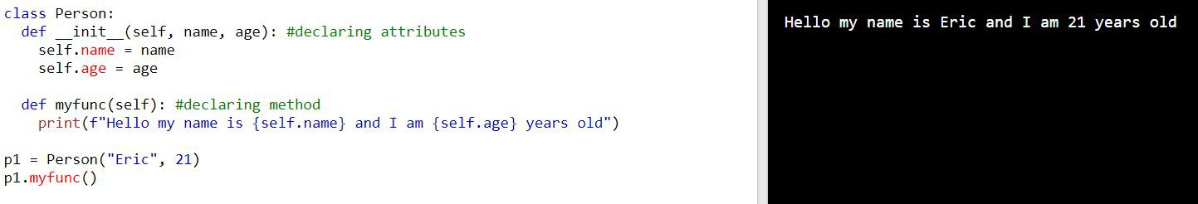

# Lesson 7.5.1: Creating Instance Methods (2 of 2)

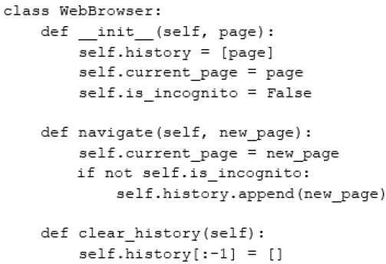

*Snippet 7.49*

* Class methods are bound to class itself and not instance.
* Do not have access to instance attributes.
* Called through class; don’t require creation on instance.
* First parameter is always class itself.
  + First argument is reserved.
  + Convention is to use name cls.
* Common use is for making factory methods.
  + Factory methods are ones that return objects.
  + Can be used to return objects of different types.
* See Snippet 7.52 for class method example.
  + Function definition starts with @classmethod.

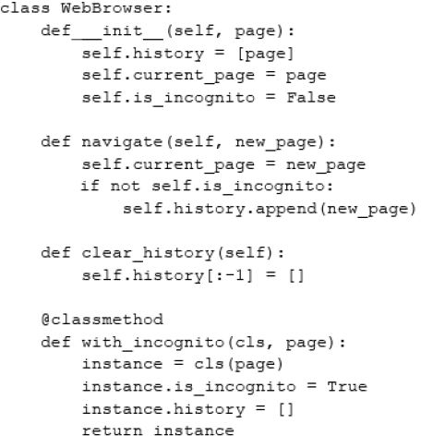

*Snippet 7.52*

# Lesson 7.5.3: Encapsulation and Information Hiding

* Encapsulation: Bundling of data with methods that operate on that data.
  + Used to hide internal state of object.
* Information hiding: Hiding of internal state of object.
  + Used to abstract away irrelevant details about class to prevent users from changing them.
  + In Python, accomplished by marking attributes private or protected.
    - private: only used inside class definition and not accessed externally.
      * Prefix attribute name with double underscore.
      * Attribute inaccessible outside of class.
    - protected: similar to private, but only used in very specific contexts.
      * Prefix attribute name with underscore.
      * Interpreter doesn’t enforce restrictions, this is just marker letting users know not to access outside of class.

# Lesson 7.6: Class Inheritance

* Inheritance: Allows for class’s implementation be derived from another class’s implementation.
  + Subclass/derived/child class inherits all attributes and methods of superclass/base/parent class.
* Benefits:
  + Makes code more reusable.
  + Makes it easier to extend functionality.
  + Adds flexibility.
* In Python define class as usual but pass the base class as parameter.
  + Syntax: class Subclass(Superclass):

# Lesson 7.6.1: Overriding init ()

* Overriding: Redefining the implementation of a method defined in superclass to add or change subclass’s functionality.
* Can override

init

to add attribute to subclass.

* + Use super method to access inherited methods from parent class that have been overwritten in child.

# Lesson 7.6.2: Commonly Overridden Methods

Dunder or magic methods: Special methods prefixed and suffixed with

double underscores.

* + Examples:
    - init
    - str
    - del
* Commonly overridden to customize class.

# Lesson 7.6.3: The

**str**

# () Method

* Every object has

str

method by default.

* Called every time print is called.
* Override to customize string containing readable representation of object.

# Lesson 7.6.4: The

**del**

# () Method

* del is destructor method.
* Called whenever object gets destroyed.
* Might want to override to print message to user.

# Lesson 7.7: Multiple Inheritance

* Allows you to inherit attributes and methods from more than one class.
* Commonly used for mixins.
  + Mixins: Classes that have methods/attributes that are meant to be used by other functions.
    - Example: Logger class has log method that writes to logfile, and when added to your class as mixin gives it that capability.,