

**ST0507 Application Development Studio**

**Continual Assessment 3**

**DIT/FT/2B/01**

**Group Members:**

Dereck Rupert Belda Zorca (1837689)

Nicholas Tay Kai Yuan (1936067)

Lem Hui Yan (1922772)

# Content Page

**Content Page** **2**

**Project Backlog** **3**

**Sprints** **4**

SCRUM Meeting #1 (11/01/2021): Week 13 5

SCRUM Meeting #2 (18/01/2021): Week 14 6

SCRUM Meeting #3 (25/01/2021): Week 15 7

SCRUM Meeting #4 (01/02/2021): Week 16 8

SCRUM Meeting #5 (08/02/2021): Week 17 9

**Test Cases** **10**

Website: Test Cases 10

Mobile Application: Test Cases 20

**Developer’s Setup Guide** **21**

Website: Developer’s Setup Guide 21

Mobile Application: Developer’s Setup Guide 21

# Project Backlog

|  |  |
| --- | --- |
| **Priority** | **Item** |
| **1** | **Website** |
| **2** | **Mobile Application** |
| **3** | **Test Cases and Developer’s Setup Guide** |

# Sprints

**Timeline**

|  |  |
| --- | --- |
| **Sprint Week** | **Task** |
| Sprint #1  (11/01 - 17/01) | * Website Development   + Adding/Removing Trackings |
| Sprint #2  (18/01 - 24/01) | * Website Development   + Configuring Individual Tracking   + Error Handling   + Website Test Cases |
| Sprint #3  (25/01 - 31/01) | * Mobile Development   + Happy Flow |
| Sprint #4  (01/02 - 07/02) | * Mobile Development   + Alternate Flow |
| Sprint #5  (08/02 - 15/02) | * Mobile Development   + Error Handling & Caching   + Mobile Application Test Cases |

**Definition of “Done”**

|  |
| --- |
| **Our Team’s Definition of Done**  *Product Backlog Items are done at the end of Sprint if:*   * Items have been reviewed thoroughly. * Items have been tested and meet the requirements. * Documentation Updated. |

## 

## SCRUM Meeting #1 (11/01/2021): Week 13

**Present:**

Dereck Zorca

Nicholas Tay

Lem Hui Yan

|  |
| --- |
| 1. **What have you done?** |
| **Dereck Zorca:** Created and formatted Google Docs for documentation |
| **Nicholas Tay:** Went through the project brief and recapped on html, css and react-native |
| **Lem Hui Yan:** Went through the project brief |
| 1. **What are you going to do next?** |
| **Dereck Zorca:** Setup GitHub and start on website |
| **Nicholas Tay:** Setup react-native and start on website |
| **Lem Hui Yan:** Start on website |
| 1. **What are the blocking issues?** |
| **Dereck Zorca:** No issues |
| **Nicholas Tay:** No issues |
| **Lem Hui Yan:** No issues |

## 

## SCRUM Meeting #2 (18/01/2021): Week 14

**Present:**

Dereck Zorca

Nicholas Tay

Lem Hui Yan

|  |
| --- |
| 1. **What have you done?** |
| **Dereck Zorca:** Adding/Removing Function for Tracking |
| **Nicholas Tay:** The pop up form for front end and started on connecting to backend. |
| **Lem Hui Yan:** The error page and styling for front end |
| 1. **What are you going to do next?** |
| **Dereck Zorca:** Touch up on tracking & start on graph |
| **Nicholas Tay:** Combine the codes to ensure the front end connects to the backend(for getting a queue). |
| **Lem Hui Yan:** Finish with the front end and starts connecting to backend |
| 1. **What are the blocking issues?** |
| **Dereck Zorca:** Remembering jquery |
| **Nicholas Tay:** Error connecting front end to backend. |
| **Lem Hui Yan:** Remembering CSS |

## 

## SCRUM Meeting #3 (25/01/2021): Week 15

**Present:**

Dereck Zorca

Nicholas Tay

Lem Hui Yan

|  |
| --- |
| 1. **What have you done?** |
| **Dereck Zorca:** Designing of webpage and graph |
| **Nicholas Tay:** Connecting frontend to backend and jQuery to add multiple forms. |
| **Lem Hui Yan:** Trying to do the dropdown for the queue id |
| 1. **What are you going to do next?** |
| **Dereck Zorca:** Finish designing website and graph |
| **Nicholas Tay:** Touch up on adding multiple forms. |
| **Lem Hui Yan:** Writing functions to connect the backend |
| 1. **What are the blocking issues?** |
| **Dereck Zorca:** Elements keep stacking horizontally |
| **Nicholas Tay:** Trying to find the right logic to ensure each id in form is unique. |
| **Lem Hui Yan:** Connecting to the backend |

## 

## SCRUM Meeting #4 (01/02/2021): Week 16

**Present:**

Dereck Zorca

Nicholas Tay

Lem Hui Yan

|  |
| --- |
| 1. **What have you done?** |
| **Dereck Zorca:** Finished entire website |
| **Nicholas Tay:** Started a bit on mobile part |
| **Lem Hui Yan:** Loading animation and starting on mobile part |
| 1. **What are you going to do next?** |
| **Dereck Zorca:** Minor error handling on website and mobile |
| **Nicholas Tay:** Finish up backend for mobile |
| **Lem Hui Yan:** Finish up frontend for mobile |
| 1. **What are the blocking issues?** |
| **Dereck Zorca:** No issues other than graph peaks |
| **Nicholas Tay:** Export default app error |
| **Lem Hui Yan:** No issues |

## 

## SCRUM Meeting #5 (08/02/2021): Week 17

**Present:**

Dereck Zorca

Nicholas Tay

Lem Hui Yan

|  |
| --- |
| 1. **What have you done?** |
| **Dereck Zorca:** Completed website with necessary requirements and finished test cases as well as developer's setup guide. |
| **Nicholas Tay:** Connected app to backend |
| **Lem Hui Yan:** Try to connect backend to frontend |
| 1. **What are you going to do next?** |
| **Dereck Zorca:** - |
| **Nicholas Tay:** - |
| **Lem Hui Yan:** - |
| 1. **What are the blocking issues?** |
| **Dereck Zorca:** - |
| **Nicholas Tay:** Errors with test data for backend |
| **Lem Hui Yan:** - |

## 

# Test Cases

## **Website: Test Cases**

|  |  |
| --- | --- |
| **#1: Existing & valid Company ID with “Hide Inactive” enabled** | |
| **Description** | When a valid and existing Company ID has been entered as well as “Hide Inactive” has been enabled, active queues under the Company ID will be displayed in the dropbox. |
| **Pre-Condition** | * CompanyID input is valid and exists. * “Hide Inactive” checkbox has been checked. |
| **Test Steps** | 1. Click on the Green Plus Sign button 2. Enter valid & existing Company ID (1000000001) 3. Enable “Hide Inactive” 4. Press Search |
| **Expected Results** | Active queues under Company ID 1000000001 will be displayed. |

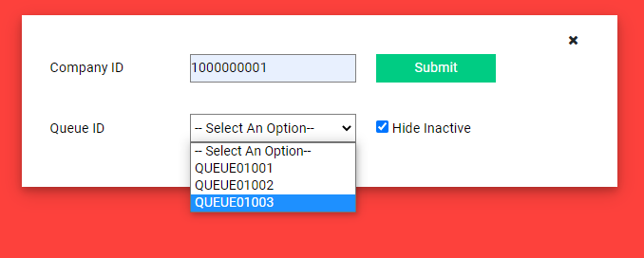

|  |  |
| --- | --- |
| **#2: Existing & valid Company ID with “Hide Inactive” disabled** | |
| **Description** | When a valid and existing Company ID has been entered but “Hide Inactive” has been disabled, active queues as well as inactive queues under the Company ID will be displayed in the dropbox. |
| **Pre-Condition** | * CompanyID input is valid and exists. * “Hide Inactive” checkbox is not checked. |
| **Test Steps** | 1. Click on the Green Plus Sign button 2. Enter valid & existing Company ID (1000000001) 3. Disable “Hide Inactive” 4. Press Search |
| **Expected Results** | All queues under Company ID 1000000001 will be displayed and inactive queues will be marked with [X]. |

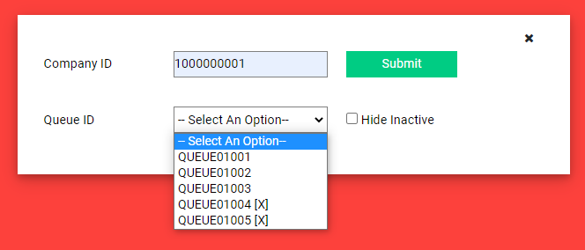

|  |  |
| --- | --- |
| **#3: Non-existing and/or invalid Company ID**  *(Input is not numeric with less/more than 10 digits and cannot be found in the database)* | |
| **Description** | When an invalid/non-existing Company ID has been entered, an error message will pop-up displaying that the CompanyID cannot be found. |
| **Pre-Condition** | * CompanyID input is invalid/non-existent. |
| **Test Steps** | 1. Click on the Green Plus Sign button 2. Enter invalid/non-existing Company ID (12345678) 3. Press Search |
| **Expected Results** | An error message will pop-up to inform the user that the CompanyID does not exist. |

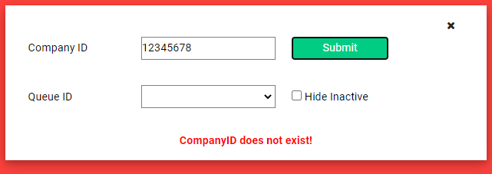

|  |  |
| --- | --- |
| **#4: Searching with empty Company ID field** | |
| **Description** | When an empty Company ID has been submitted, an error message will pop-up displaying that the CompanyID field is empty. |
| **Pre-Condition** | * CompanyID input field is empty. |
| **Test Steps** | 1. Click on the Green Plus Sign button 2. Leave Company ID field empty 3. Press Search |
| **Expected Results** | An error message will pop-up to inform the user to fill up the Company ID field. |

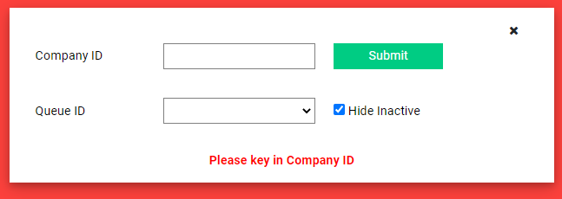

|  |  |
| --- | --- |
| **#5: Valid & existing Company ID with active queue** | |
| **Description** | When a valid and existing Company ID has been submitted and an active queue has been selected, a graph will be displayed. |
| **Pre-Condition** | * Valid and existing Company ID has been keyed in. * Active queue has been selected |
| **Test Steps** | 1. Click on the Green Plus Sign button 2. Valid and existing Company ID has been entered 3. Press Search 4. Dropdown box will display queues 5. Select active queue |
| **Expected Results** | A graph displaying the arrival rate of customers in that queue will be displayed. |

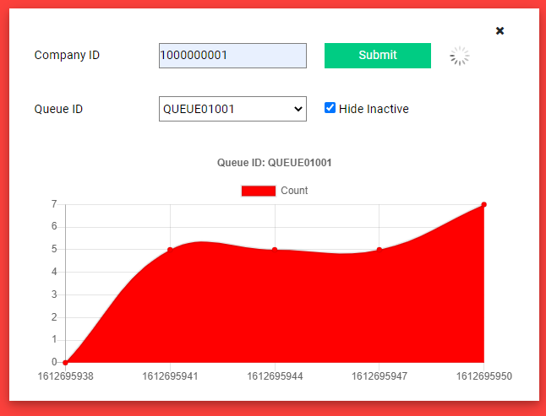

|  |  |
| --- | --- |
| **#6: Re-select another queue after previous selection of queue** | |
| **Description** | When re-selecting another queue after previous selection, the graph of the new queue should be displayed, while the previous graph as well as back-end fetching will be stopped and deleted. |
| **Pre-Condition** | * Valid and existing Company ID has been keyed in. * Active queue has been re-selected |
| **Test Steps** | 1. Click on the Green Plus Sign button 2. Valid and existing Company ID has been entered 3. Press Search 4. Dropdown box will display queues 5. Re-select active queue |
| **Expected Results** | A graph displaying the arrival rate of customers in the new queue will be displayed. |

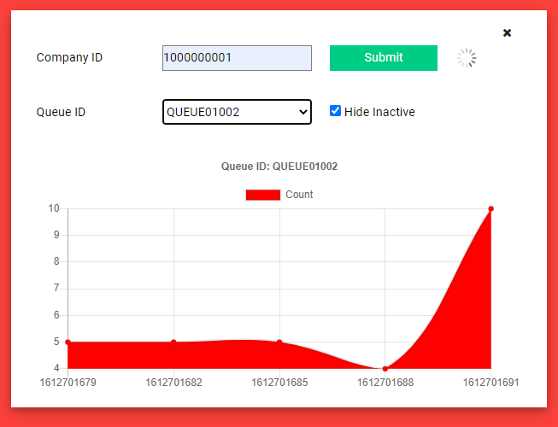

|  |  |
| --- | --- |
| **#7: Entering a valid & existing Company ID, but selecting an inactive queue** | |
| **Description** | When selecting an inactive queue, the graph of the inactive queue should not be displayed, but instead, an error message should pop-up informing the user that the queue is inactive. |
| **Pre-Condition** | * Valid and existing Company ID has been keyed in. * Inactive queue has been selected |
| **Test Steps** | 1. Click on the Green Plus Sign button 2. Valid and existing Company ID has been entered 3. Press Search 4. Dropdown box will display queues 5. Select inactive queue |
| **Expected Results** | Graph will not be displayed. Error message “Queue is inactive” will appear. |

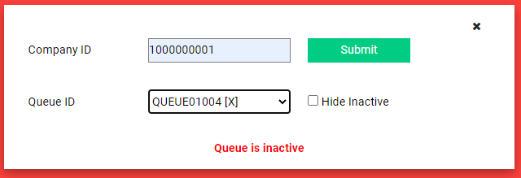

|  |  |
| --- | --- |
| **#8: Multiple Tracking with valid & existing Company ID** | |
| **Description** | Both tracking fields should simultaneously display active queues for their respective Company IDs. |
| **Pre-Condition** | * Valid and existing Company ID has been keyed in. * “Hide inactive” has been checked |
| **Test Steps** | 1. Click on the Green Plus Sign button twice 2. Valid and existing Company ID has been entered in both trackers 3. Press Search 4. Dropdown box will display queues |
| **Expected Results** | Queues in both trackers will be displayed based on their Company ID |

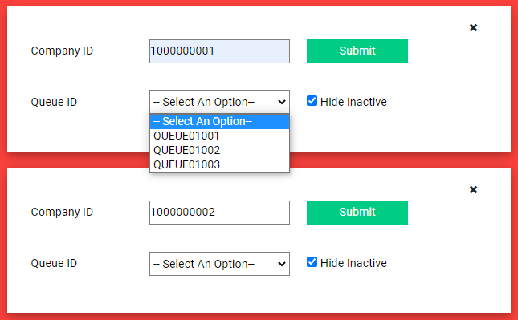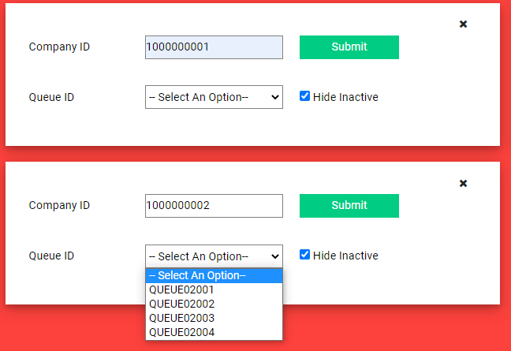

|  |  |
| --- | --- |
| **#9: Multiple Tracking with valid & existing Company ID with Graph** | |
| **Description** | Both tracking fields should simultaneously display graphs for their respective queues. |
| **Pre-Condition** | * Valid and existing Company ID has been keyed in. * “Hide inactive” has been checked * Active queue has been selected |
| **Test Steps** | 1. Click on the Green Plus Sign button twice 2. Valid and existing Company ID has been entered in both trackers 3. Press Search 4. Dropdown box will display queues 5. Select active queues |
| **Expected Results** | Graphs will be displayed based on their respective Queue IDs. |

## 

|  |  |
| --- | --- |
| **#10: Closing trackers** | |
| **Description** | Trackers that have been closed will automatically stop back-end fetches and will be deleted. |
| **Pre-Condition** | * Valid and existing Company ID has been keyed in. * “Hide inactive” has been checked * Active queue has been selected * Graph is displayed while fetching from back-end |
| **Test Steps** | 1. Click on the Green Plus Sign button twice 2. Valid and existing Company ID has been entered in both trackers 3. Press Search 4. Dropdown box will display queues 5. Select active queues 6. While the graph is running, close the tracker using the “X” icon at the top right. |
| **Expected Results** | Tracking container will be deleted and back-end fetching will be stopped. |

## 

## 

## **Mobile Application: Test Cases**

|  |  |
| --- | --- |
| **#1: Queue is inactive** | |
| **Description** | When an inactive queue (e.g QUEUE12341) is entered to check the queue, an error message will be displayed to show that the queue is inactive. |
| **Pre-Condition** | * Queue id exists * Queue is inactive |
| **Test Steps** | 1.Enter QUEUE12341 in Queue id input  2. Click the checkQueue button |
| **Expected Results** | Error message ‘Queue is inactive’ will be displayed. |

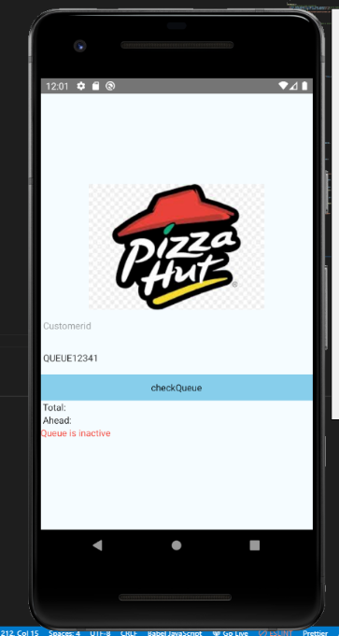

|  |  |
| --- | --- |
| **#2: Invalid Customer id or Invalid Queue id** | |
| **Description** | When invalid customer id or invalid queue id is entered to check the queue, an error message will be displayed to show that the queue id or customer id is invalid. |
| **Pre-Condition** | * Both queue id and customer id is entered * Entered inputs does not match the pattern |
| **Test Steps** | 1.Enter invalid customer id ‘ABCD’ and queue id ‘QUEUE’  2. Click the checkQueue button |
| **Expected Results** | Error message ‘Invalid Queueid or Customerid’ will be displayed. |

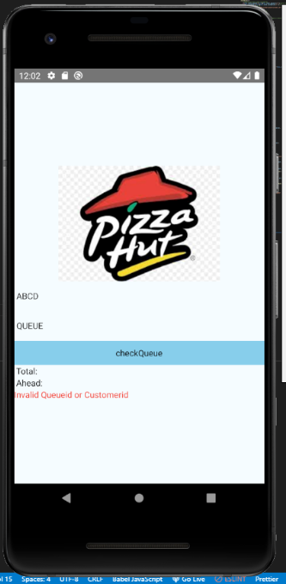

|  |  |
| --- | --- |
| **#3: Queue not found** | |
| **Description** | When a non-existing queue id is entered to check the queue, an error message will be displayed to show the queue is not found. |
| **Pre-Condition** | * The queue is non-existing |
| **Test Steps** | 1.Enter non-existing queue id ‘QUEUE11111’  2. Click the checkQueue button |
| **Expected Results** | Error message ‘Queue not found’ will be displayed. |

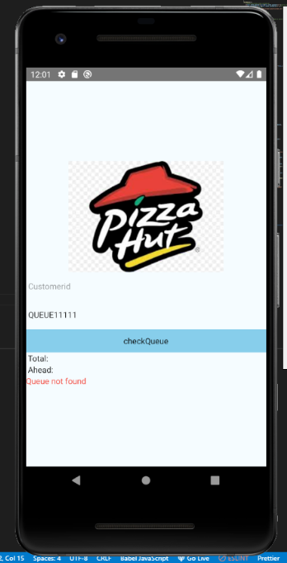

|  |  |
| --- | --- |
| **#4: Queue id not entered** | |
| **Description** | When nothing is entered in queue id input , an error message will be displayed to show the queue id is not entered. |
| **Pre-Condition** | * Nothing entered in queue id |
| **Test Steps** | 1.Enter nothing in queue id  2. Click the checkQueue button |
| **Expected Results** | Error message ‘Please enter queueid’ will be displayed. |

# 

|  |  |
| --- | --- |
| **#5: Check queue without customer id** | |
| **Description** | When a valid queue id is entered, data will be shown in total and the text ‘Have not joined queue’ will be shown in ahead |
| **Pre-Condition** | * Valid and existing queue id to be entered * Nothing entered in customer id |
| **Test Steps** | 1.Enter nothing in customer id  2. Enter ‘QUEUE12340’ in queue id  3. Click the checkQueue button |
| **Expected Results** | Total will show 10, Ahead will show ‘Have not joined queue’ |

# 

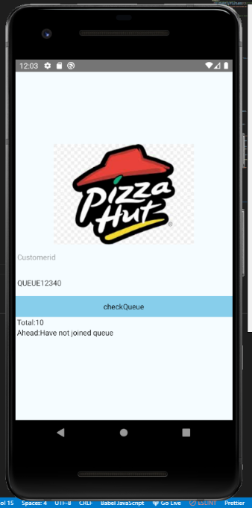

|  |  |
| --- | --- |
| **#6: Check queue with customer id that already joined queue** | |
| **Description** | When a customer that had joined queue clicked check queue  Button, the join Queue button will not show. But data for ahead and total will be shown. |
| **Pre-Condition** | * Valid and existing queue id to be entered * Customer had already joined the queue |
| **Test Steps** | 1.Enter ‘1234567899’ in customer id  2. Enter ‘QUEUE12340’ in queue id  3. Click the checkQueue button |
| **Expected Results** | Total will show 10, Ahead will show 0 |

# 

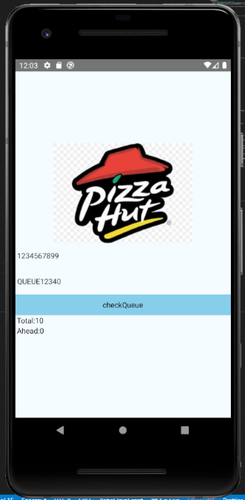

|  |  |
| --- | --- |
| **#7: Check queue with customer id that have not joined queue** | |
| **Description** | When a customer that has not joined the queue click check queue button, the join Queue button will show. But data will be shown in total and the text ‘Have not joined queue’ will be shown in ahead. |
| **Pre-Condition** | * Valid and existing queue id to be entered * Valid customer id to be entered |
| **Test Steps** | 1.Enter ‘1111111111’ in customer id  2. Enter ‘QUEUE12340’ in queue id  3. Click the checkQueue button |
| **Expected Results** | Total will show 10, Ahead will show ‘Have not joined queue’ |

# 

|  |  |
| --- | --- |
| **#8: Successful join queue** | |
| **Description** | When the customer clicks the join queue button, customer id and queue id will be posted on the backend. |
| **Pre-Condition** | * Valid and existing queue id to be entered * Valid customer id to be entered * Join queue button to be displayed |
| **Test Steps** | 1.Enter ‘1111111111’ in customer id  2.Enter ‘QUEUE12340’ in queue id  3.Click the checkQueue button  4.Click the joinQueue button |
| **Expected Results** | Customer id and Queue id will be posted to elephantSQL database. |

# 

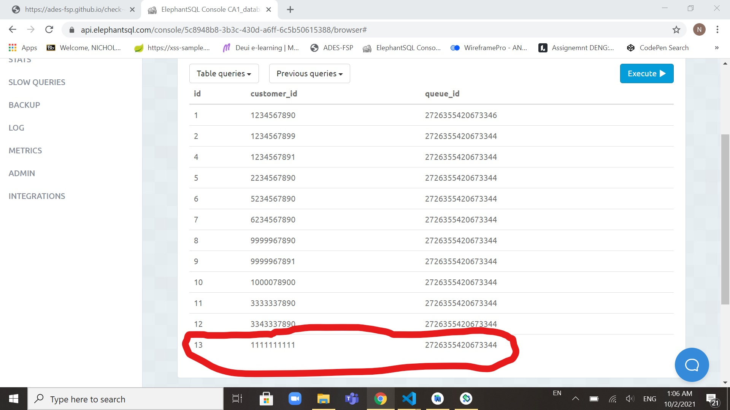

|  |  |
| --- | --- |
| **#9: Server Error** | |
| **Description** | When there is internal server error, an error message ‘Failed to fetch’ will be displayed |
| **Pre-Condition** | * Errors with the backend |
| **Test Steps** | 1.Enter ‘QUEUE12340’ in queue id  2.Click the checkQueue button |
| **Expected Results** | Error message ‘Failed to fetch’ will be displayed. |

# 

# 

# Developer’s Setup Guide

## **Website: Developer’s Setup Guide**

|  |
| --- |
| Go to: <https://github.com/ADES-FSP/virtual-queue-website-2b01-dnh-team> and click the Code button. Proceed to download the codes as a zip file. Extract the file onto your desktop. You should be able to see a folder called ***virtual-queue-website-2b01-dnh-team.*** Once done, open the folder and you will see 7 folders and 5 files.  After that, go to: <https://github.com/ADES-FSP/ades-2021s2-backend-tester>, click the Code button and download the zip file. Extract the file onto your desktop. You should be able to see a folder called ***ades-2021s2-backend-tester.*** Once done, open the folder and you will see 3 folders and 8 files.  Before running the project, go to ***ades-2021s2-backend-tester*** and set it up by adding your database connection string in the **.env** file.  Then go to [***virtual-queue-website-2b01-dnh-team***](https://github.com/ADES-FSP/virtual-queue-website-2b01-dnh-team) and open the file location in the terminal and run npm install to install all dependencies.  To start the back-end, use npm run start-<os>-customer and npm run start-<os>-company where <os> is either win, mac, or linux based on your current operating system.  Finally, launch indexv1.html to start using the website.  You have successfully set up the website. |

## 

## **Mobile Application: Developer’s Setup Guide**

|  |
| --- |
| Go to: <https://github.com/ADES-FSP/virtual-queue-mobile-2b01-dnh-team.git> and click the Code button. Proceed to download the codes as a zip file. Extract the file onto your desktop. You should be able to see a folder called ***virtual-queue-mobile-2b01-dnh-team.***  Go to ***ades-2021s2-backend-tester*** and run npm run start-customer  Try run npx react-native init Project name in an empty folder  Open the CA3 mobile folder inside ***virtual-queue-mobile-2b01-dnh-team*** using visual studio code  Open CA3 mobile folder with android studio  Run the emulator  Type react-native start in terminal and r to reload.  You have successfully set up the application. |