PART 1
Conways game of life
First iteration
8x8 with a simple glider took less than 0.001 seconds over 15 generations
1000x1000 with a simple glider took 1561.565 seconds/26 minutes over 15 generations

I decided to make a universe class that inits default information to itself. Next I created functions to import an input file and the ability to output a file when done. It was difficult to format and process the format to other variables. A bug I ran into was not converting strings to ints to the file. Next I created a show method that shows the grid and a showstats function to give me basic stats of that generation and to debug writing and reading from file. Next I made the startGenerations function. It loops through the generations and then loops through each tile of the universe. In a 100x100 universe then itll be a 10,000 tile universe. I then made a detect and rules function. The detect will return an integer of how many living cells are one tile away and the rules takes how many living cells are near and if the current cell is alive and returns whether the cell should die or live. Each generation goes through each tile and detects and then checks the rules and then updates that position in a new list. The new list is then set to the universe. I used python 3.13 for my programming language and used 2D lists to achieve the universe. The most significant issue I encountered was not reading the rules correctly and getting weird looking patterns from a default glider. I had to debug my detect and rules function and found out that dead cell and living cells were treated the same.

PART 2
Time complexity: O(n^2), A generation calculates each position in a 2D grid, First the loop goes through the x coordinate and finds out if there are any living cells around it and then seeing if it dies or lives on. Then it goes to the next and rinse and repeat until the last line on the X. Then it goes down a y and checks those x coordinates. It has a nested for loop to traverse the grid depending on size.

Space Complexity: O(n^2) The space that is required is a 2D array containing the current generation which is determined by the size of the grid and then another that contains the same sized grid that is updated from the rules of the game.

Empirical Benchmarking:
100x100: 10,000 | 200x200: 40,000 | 500x500: 250,000 | 1,000x1,000: 1,000,000 | 10,000x10,000: 100,000,000
17.165s  187,152 bytes | 65.723s – 1m 7s  667,024 bytes | 626.518s – 10m 27s  4,226,176 bytes | 2965.569s – 49m 26s  17,731,512 bytes | Was not able to complete: predicted below
0.086s per gen  Scale Multi  Linear  Exponential Predict  Linear Predict  Est. Finish Time | 0.329s per gen  x4  0.344s  .3974s  .4109s  79.48s – 1m 19s | 3.133s per gen  x25  2.15s  3.122s  3.538s  624.4s – 10m 24s | 14.828s per gen  x100  8.6s  14.828s  14.706s  2965s – 49m 25s | N/A  x10,000  860s  28,658s – 7h 58m  1488.9s – 24.8m  66d 8h 6m 40s  3d 10h 43m 0s
200 generations with glider

It seems that the time per generation grew exponentially with the size of the universe. The time seems to be tied to it resulting in the o(n^2) behavior shown in the table. It also seems the memory allocation has the same issue to where the memory required seem to grow exponentially too when I assumed it would only grow at o(n).

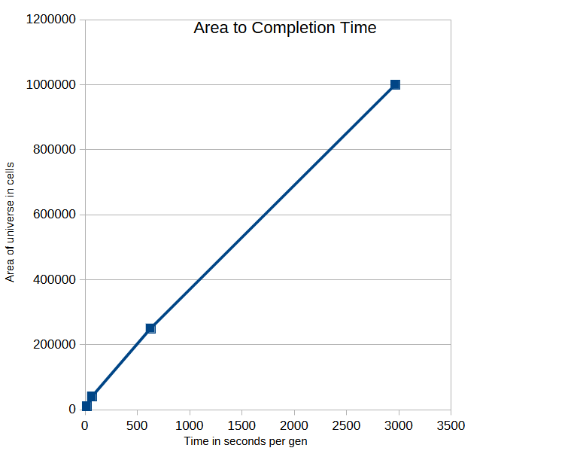Figure 1: Graph of Area to Time per second

Reflections:
Theory vs Reality:
The growth curve doesn’t perfectly match my prediction because there are so little data points and since the area of the universe is measured almost exponentially too. I feel the empirical data does help predict the data that was received and even gave me an estimation of the final 100,000,000 tile universe finish time.

Architectural Flaws:
The top flaw/bottleneck has to be the fact that every dead cell is accounted for and detected when they have no hope to live unless they are within 3 living cells or 1 tile away from living cells. I also think that if there are no longer any living cells then the simulation should end because nothing will change from there on.

PART 3:

Proposal for Alternative solution:
Make it so that the universe is not simulated but is just simulating the living things in and a 3x3 area with it in the center. Then those points are then updated each generation.

PART 4:

100x100: 10,000  Area | 200x200: 40,000 | 500x500: 250,000 | 1,000x1,000: 1,000,000 | 10,000x10,000: 100,000,000
0.184s  complete time  11,889 bytes  Peak MALLOC | 0.187s  11,889 bytes | 0.186s  11,889 bytes | 0.192s  11,889 bytes | 0.190s  11,889 bytes
200 generations with glider

Time Complexity:
The time complexity seems to be O(n) and the variable it is attached to is the living cells. I reached this conclusion through the implementation of how I calculate living cells. Each cell is gone through to find overlaps and those overlaps then get applied to the rules of conways game of life.

Space Complexity:
The space complexity should be O(n) again because instead of the entire universe taking up space, it is the living cells of the universe that is tracked.

Test Case A & Test Case B:

Case A: Dense Soup – 1,000 x 1,000 | Case B: Sparse Void – 10,000 x 10,000
 | 52.242 seconds – Peak Malloc: 1,065,699
200 generations at 50% infill 200 generations with ~100 gliders aka 495 living
aka 500,000 living cells cells

Conclusion:
Case A seemed to be longer than the original implementation. I predict that maybe how I detect overlap it what causes the slow down. Case B was faster though because the original equivalent would have taken over 3 days to complete.

Plot Twist:
I would say that my prediction did turn out to be wrong and its weird to see what I thought would be faster turn out to be slower in certain cases. I feel my empirical results match theoretical performance only a little bit. I feel more testing should be done with how living cells affect the system.

