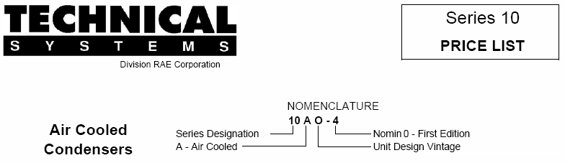

**Standard Features**

**CABINET**

The Cabinet is constructed entirely of mill galvanized sheet steel panels and formed structural members. All panels are removable for access and service.

**MOTORS**

Motors are industrial duty 1140 RPM, ball bearing, weather resistant, three phase with inherent electrical protection.

**FANS**

Fans are of heavy gauge steel with a corrosion resistant coating.

**CONDENSER**

Coils are of seamless copper tube with die stamped aluminum plate fins, galvanized steel frames and tube sheets.