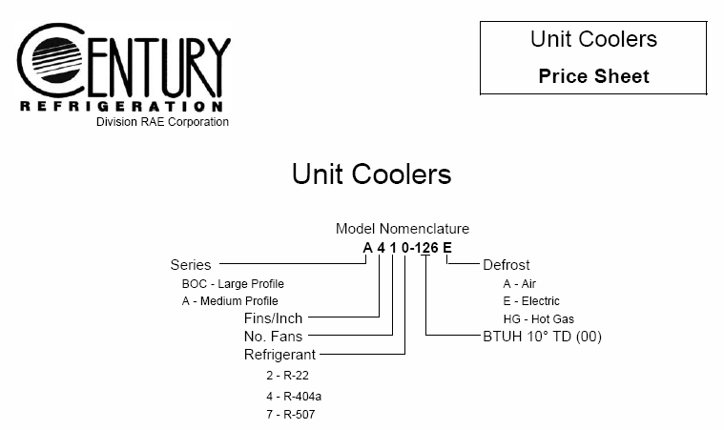

**Information Notes**

1. All unit coolers coils are factory pressure tested, using a two- stage test pressure. Coils are first pressured to 150 lbs. and submerged under water and increased to 400 lbs. for a visual test.The unit is then certified by quality control and shipped with a 5 lb. holding charge of dry nitrogen. Coils are tagged for shipment with warning label that coils are under pressure.

2. Coils are must be evacuated by the installing contractor, prior to charging the system.

3. All units are tested electrically, motors are run at the nameplate voltage, rotation and amps are recorded.

4. Just prior to crating or boxing for shipment, the unit nameplate is affixed to the unit, along with appropriate instructional and warning labels.

5. A & BOC series unit coolers are shipped upright on legs (legs are removable). The installer can lift unit in place with the shipping base for eace of installation.

6. Installation and maintenance manuals are included with each unit.

**TERMS OF SALE -** Net 30 days, FOB our plant

**FREIGHT TERMS -** All shipments are FOB our plant, with freight allowance to the

first destination within the continental United States, excluding Hawaii and Alaska

on shipments of 600 pounds or more.