Problem 2

A matrix A, of size n x n is nilpontent if A^k yields a matrix of all zeroes

For cyclic, directed matrix:

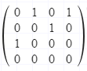

Squaring, cubing, and raising to power 4 do not yield a matrix of all zeroes

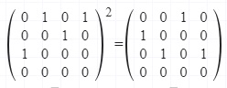

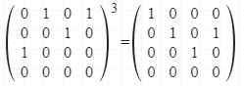

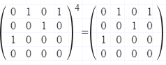

Cyclic graphs are never nilpotenet!

For an acyclic, directed matrix:

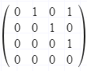

Raising to power 4 yields a matrix of all zeroes, therefore it is nilpotent.

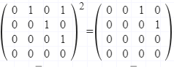

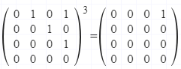

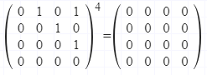

Acyclic graphs are nilpotent!

The eigenvalue for nilpotent graphs is always 0, therefore, the eigenvalue for acyclic graphs is always 0