**QuantLibXL Rate Curves Framework User Guide**

**Banca IMI – Quantitative Structuring**

**Giugno 2016**

**MISSING: a true introduction to the problem with a hint to yield curve topics, the need to interpolate values of instruments, relative pricing…..Explain typical curves (pillar date,pillar value), why it is called curve calibration, merge with Maddalena’s section 2 describing different pillar value curve types.**

**Most of the material which follows should be merged with Maddalena section 3 to become the practical guide.**

**- Framework Introductio**

~~The~~ ***~~Rate Curves Framework~~*** ~~provides an efficient way to execute multiple curve calibration for different currencies; so far, the framework includes 37 rate curves for 7 currencies summarized in the underlying table:~~

~~[this table is redundant with maddalena’s]~~

|  |  |  |  |  |  |  |
| --- | --- | --- | --- | --- | --- | --- |
| **~~Currency/Curve~~** | **~~STD~~** | **~~ON~~** | **~~1M~~** | **~~3M~~** | **~~6M~~** | **~~1Y~~** |
| **~~EUR~~** |  |  |  |  |  |  |
| **~~GBP~~** |  |  |  |  |  |  |
| **~~USD~~** |  |  |  |  |  |  |
| **~~HKD~~** |  |  |  |  |  |  |
| **~~JPY~~** |  |  |  |  |  |  |
| **~~AUD~~** |  |  |  |  |  |  |
| **~~SEK~~** |  |  |  |  |  |  |

~~Compute a curve calibration (or bootstrapping) means using a process to calculate discount factors (or zero rates) for different maturities tenors or currencies from a set of Interest Rate Derivatives whose quotes are available on market (or synthetically derivable from market’s information). This is possible by means of~~ *~~QuantLibXL~~* ~~Excel Add-in.~~

*PART 1: Yield curve, interpolation,relative pricing, calibration +sez.2 maddalena*

*PART 2: QuantlibXL RateCurveFramework*

*QuantLibXL* is a compiled Add-in (i.e. specific type of application used to add features to Excel) which provides an Excel User Interface for the use of *QuantLib* functionality. *QuantLib* is a C++ free/open-source library for quantitative finance based on object based programming . In order to export *QuantLib* object-oriented functionality to Microsoft Excel, *QuantLibXL* uses *ObjectHandler*, a C++ library that provides functionalities to create, access, query, update and destroy C++ classes. For more information please visit [quantlib.org](http://quantlib.org/).

In the following we will explain which tools are needed to configure a curve calibrator based on QuantLibXL and describe how these functionalities are used within the rate curve framework.

[Missing: paragraph] Calibrating Curves with QLXL

[Here a session is needed to describe how a curve is built: instruments, indexes, … It should be a short list of the QL objects needed]

[Missing Paragraph] Rate Curve Framework structure

Here we need to put a scheme of how the framework is built: how ,many workbooks, their content,…

**- Launching the Rate Curve Framework**

Rate Curve Framework workbooks are typically delivered….. Unzip the QuantLibXL-1.7.0.zip file: the unzipped folder looks like:

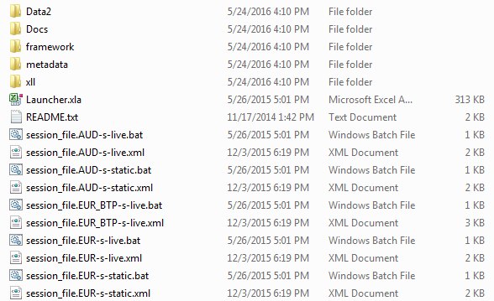

For each currency (CCY), you can find two batch (.bat) and their related (i.e. with the same name) xml files. The batch files are used to launch the Excel Rate Curve Framework session: **session_file.CCY-s-live.bat** is used for a live data feed session [footnote: This feature requires the availability of a data provider add-in like ***Thomson Reuters Eikon or Bloomberg]***, **session_file.CCY-s-static.bat** is used to load an historical data session.

The xml files contains a list of startup parameters and options needed by the Add-in (for example: currency, evaluation date, xll path ect...).

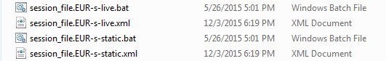

**[following period, as well as the graph, overlap with maddalena’s]**

Once the curves have been calibrated, a key point to understand is how to export the related information from Excel to the *Front Office Systems* (***Murex*** for example) which expects a set of market quotes as input. This passage is called ***contribution process*** in which all new quotes bootstrapped, for quoted and non-quoted maturities, are identified internally by a specific ***RIC*** (*Reuters Identification Code*) and finally sent to the front office systems.

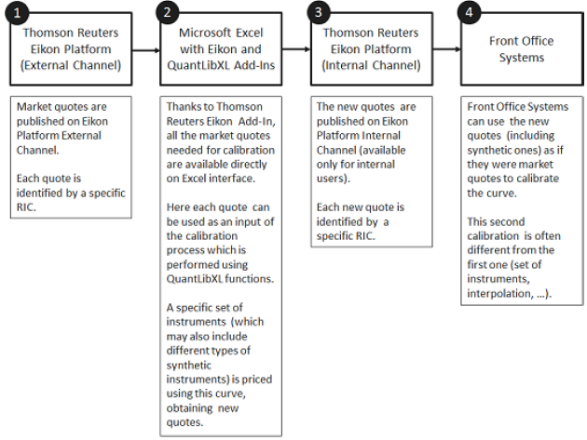

When a session as been launched you will see across the board the *MainChecks* workbook. As an example, we consider now the procedure for a live session for *EUR* currency (the procedure for another currency can be obtained simply substituting the currency name. As an example, we consider now the procedure for *EUR* (the procedure for another currency can be obtained simply substituting the currency name)

**- MainChecks**

The aim of this workbook is to provide an easy way to control the live data (in the following, we will for simplicity assume *Thomson Reuters Eikon is Used)* connection and to control if the framework has bootstrapped correctly.

1. **Launch Framework**: Double click on the corresponding *.bat* File (in our example: *EUR-s-live.bat*).

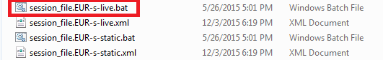

1. Wait until the Excel session is loaded (**this passage may require a few minutes**): you will see the ***EUR_MainChecks.xlsx*** workbook.

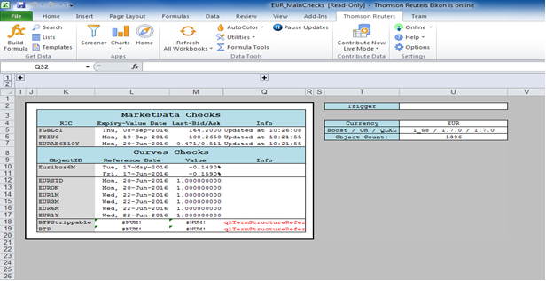

1. Check the loading: you must see the “Ready” message in the XL status bar (lower left corner)

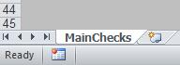

1. **Real Time Feed**: in cells **Q5**-**Q6**-**Q7** you must see the message “**Updated at [current time]”.**

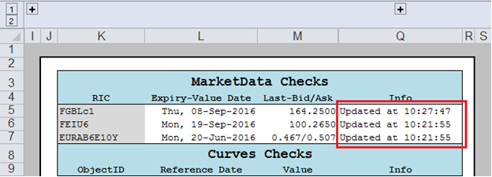

If you see a message like: “**Paused at …**” please **Resume Updates** using ***Thomson Reuters***

Tab and check another time cells **Q5**-**Q6**-**Q7**: you must see the message: “**Update at** **[current time]**”.

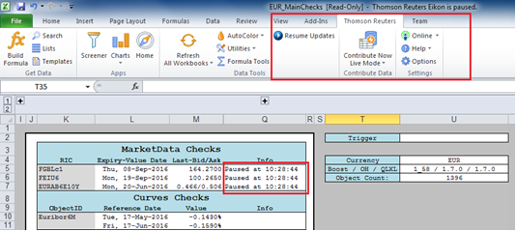

1. If you see a message like: “**Offline at …”** please go to ***Thomson Reuters*** Tab and check the Eikon LogIn: you must be **Online.** If you are **Offline** click the button to force the LogIn. Then check another time cells **Q5**-**Q6**-**Q7**: you must see the message: “**Updated at** **[current time]**”.

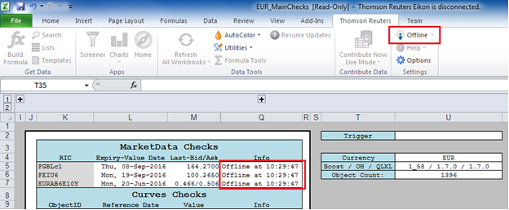

At the end, your must have:

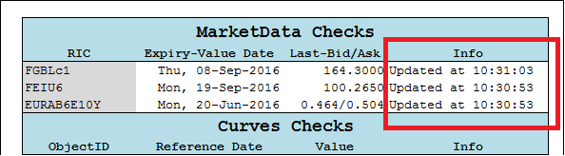

A final check can be made looking if the ***Thomson Reuters*** values in **Q** column (“*Last-Bid/Ask*”) for instruments in **K** column (“*RIC*”) are correct. In particular this Reuters RICs refers to the most liquid instruments quoted in the reference market. Logically, this are well known values for traders that can immediately check if Reuters is really downloading live quotes.

[Missing: another error message worth being added is the “Access denied”, which occurs when a page has become private and the data provider should be contacted for support]

1. **Check Curves Calibration:** Go to cell **U2** (“*Trigger*”)and delete the content. This passage is fundamental to eliminate false errors which may occur if the workbook isn’t triggered.

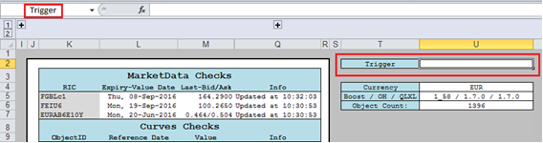

If everything works, you will see no error message in **Info** Column:

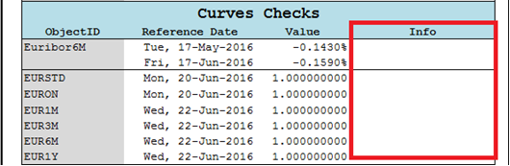

If you still have error messages in Info Column try to Refresh All Workbook (***Thomson Reuters*** Tab) and cancel again the Trigger.

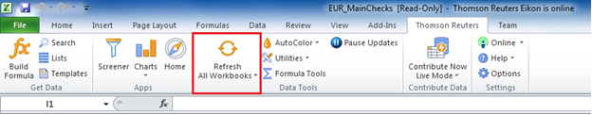

If, after all that, you still have error messages, please close the framework and launch it another time following the same steps.[????? looks like the ctrl-alt-canc Microsoft suggestion…]

1. Please check also that:
   1. For each curve, column **L** **(“***Reference Date***”)** is equal to [curve’s spot date] (for example, for HKD *spot date = today* for all curves) and column **M** (“*Value***”)** is equal to 1.000000000
   2. For Ibor Index (Euribor6M for EUR), **Index Reference Date** must be [yesterday] if you launch the framework before fixings publication, otherwise [today]; **Index Value** must be the last published index fixing.

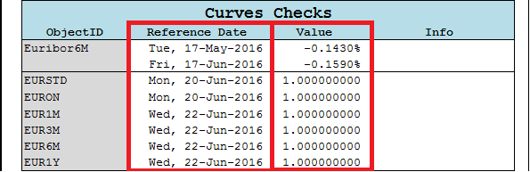

The workbooks primoworkbook.xlsm, secondoworkbook.xlsm,….described in sect[add reference to the section where the workbooks are described] are hidden, to unhide them go to “*View*”, on Excel ribbon, and then click “*Unhide*”.

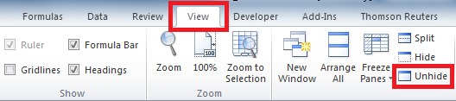

Once you did it, you will be ready to see the whole set of workbooks, namely:

1. Market;
2. JumpQuotesFeedON;
3. SynthQuotesFeed;
4. CurvesBoostrapping;
5. YCSTDBoostrapping;
6. MainChecks;

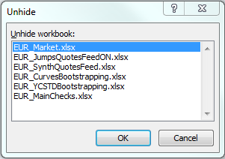

- **Market**

**1. GeneralSettings:** let’s start looking at the first sheet in which are summarized the

workbook’s main settings.

1. The first step to do is checking the ***Live Feed*** to understand if you are online with the

*Thomson Reuters* server and quotes are updating in real time.

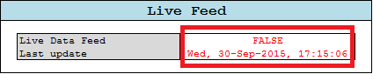

Therefore, in a live session it’s important to see: “TRUE” in *Live Data Feed* cell

and the [current-Date] ; [current-time] in the *Last Update* cell. If not, please check

your connection and refresh it if necessary. Instead, if you are in a static session,

you’ll find “*FALSE*” in Live Data Feed cell and the date from which the framework is

getting static historical data (this is the case of the imagine above).

1. Control the *Trigger Counter* cell; if all goes right, it must continue triggering during

the session meaning that the framework is updating market quotes from the data

provider. To check this, it is sufficient that trigger counter rises over time.

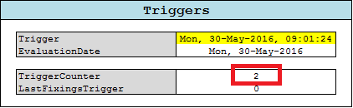

c. As usual, it is possible to change currency and general settings.



d. In the *Contributors* table it is possible to choose from which broker import market

quotes.

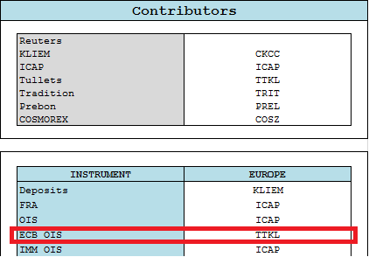

In this example we are taking FRA, OIS and IMM OIS from ICAP and ECB OIS from Tullets.

1. **Euribor**: this sheet has the task to create an object for each Euribor Index; When the framework completes each calibration, this objects will be indirectly linked to the curves bootstrapped using the *QuantLibXl* **Relinkable Handle**.

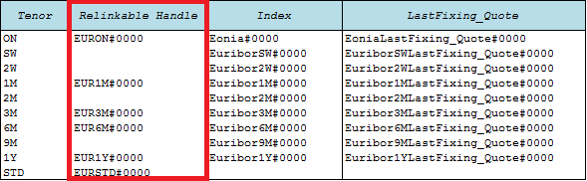

This process might appear useless but it’s a fundamental step especially for live sessions. In fact, doing this, index object won’t be re-created each time that curves changes due to the updating of market values. In fact, when a user want to create a model using *QuantLibXL*, must keep in mind that the best practice is to build each object **just one time** because, every time an object is created, Excel allocates memory and this can overload the entire framework.

1. **Other sheets**: all other sheets have the task to create an object for each market instruments and then associate to this object a market quote taken directly from *Thomson Reuters.* This process will be helpful in the *CurveBoostrapping* workbook in which you will be able to filter and select the best set of instruments that will be included in the bootstrap algorithm.

Each sheet is devoted to a particular market instruments and characterized by different columns with different values like the figure below:



In the **Mid** column you find the Live Thomson Reuters quotes and, in the **Static** column, the historical ones referred to the old date (see the general settings Last Update cell). If you have launched a live session, the **Effective** column takes **Mid** column data, otherwise it takes the **Static** column data.

Finally the **Change** column calculate the percentage change in market quotes (useful in Live sessions).

**- JumpQuotesFeedON**

Like the previous workbooks let’s begin from general settings.

1. **General settings:** the first jump analysis step is to bootstrap an overnight curve till 2Y in which jumps are not considered.
2. The characteristics of this curve can be changed as usual but the important thing actually is to check if the calibration is working simply looking to **D18**-**D19** cells

img10

If you see an error message there, please try to trigger or refresh the session. The error message can also be generated by the *Thomson Reuters* connection, so, to control it, please check **D23**-**D24** cells.



Remember that, in live sessions, *LiveDataFeed* must be: “TRUE” and *LastUpdate* must be [current-date] and [current-time].

1. In this sheet you also find the Final Curve settings that is this workbook’s outcome; in fact, cell **I14** represents the new “jump-corrected” overnight curve. To check that this passage works, please remember that cells **I18**-**I19** mustn’t contain an error message.

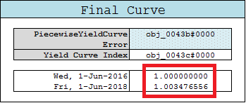

1. **RateHelpers:** here, you find the whole set of instruments used to bootstrap the overnight curve till 2Y. This passage will be discussed accurately in the *CurveBootstrapping* sheet.
2. **Calculation:** the aim of this sheet is to estimate where, in the overnight curve over the maturity window [today,today+2Y], jump occurs and to value its size.

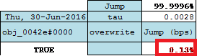

If the analysis finds a jump, you will see a value different from zero (which is the

jump size) in the red-written cells, otherwise you will find: “**0.00**%”

1. **Contribution:** in the last workbook’s sheet you will find jumps contribution in which jumps, pre-calculated, will be fixed in quotes. As you can see, in this example there are 3 jumps.[are jumps multiplicative?no “effective” is 100%-jump size]

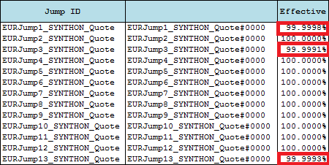

- **SynthQuotesFeed**

After opening this workbook you will see on the board the general settings. As usual it is important to make a brief check to the real time connection (if you are in a live session) and to the 1M Curve ???why 1M??? (if all goes right, you don’t have to see an error message in cells **D34**-**D35**).

Remember to trigger after changing any settings.

1. **1M,3M,6M,12MSynthDepo:** the aim of these sheets is to build synthetic deposits for 1M,3M,6M,12M curves respectively. The “**selected**” columns represent the interactive part of each sheet in which you can decide what Delta’s [what is a Delta????] must be included in the α,β,γ calibration.



You can select Deltas simply writing: “*TRUE*” in the corresponding cell. Remember that

The quadratic parametrization needs 3 Deltas to be calibrated so, if you flag just 2

Deltas it will be impossible to use that.

1. **1M,3M,6M,12M Delta:** Deltas, that has been used in the preceding sheets, are calculated here. Even in this case, you can decide which basis must be computed directly and which one must be interpolated (the best practice is to base the choice looking at the instrument’s liquidity) writing: “*TRUE/FALSE*” in the “**Selected**” columns.



1. **Contribution:** Finally the workbook define objects for all synthetic deposits and summarize them with the corresponding value in the *Contribution* sheet. As you can see, there is a different column for *Live*, *Static* and *Effective* values. In particular, values in the *Effective* column change in according to the fact that you are using or not a live session (as already explained before).[can static be edited to override or are read only if the static mode is on?]



For a final check remember to control **E** column (“*Error”)*; there must be no error messages.

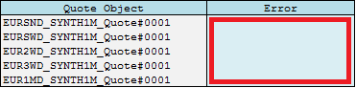

- **CurvesBootstrapping**

Let’s consider the case of EUR curve bootstrapping.

1. **GeneralSettings**: As you can see all curves bootstrapped are summarized here in the *PiecewiseYieldCurve* cells.

|  |  |
| --- | --- |
| **PiecewiseYieldCurve** | _EURON#0000 |

As usual, you can switch general settings (like currency, evaluation date or

pillar date) simply clicking on the right cell and selecting the parameter you need.



For example you can click on **D3** (“*EUR*”) (a drop down menu will appear) and choose another currency, or you can click on **I3** (“*Fri, 27-May-2016*”) and modify the evaluation date[footnote:which is the effect of modifying the val date? Do futures automatically roll?...spend a couple of lines on this topic]; **don’t forget to trigger after changing parameters!**

1. In the same way you can switch each Curve settings like:
2. **Settlement days** (“*NDays”*) - Usually it’s set to 0 or 2 and it fixes the day at which discount factor = 1;
3. **Curve parametrization** (“*TraitsID”*) - if is missing, default = Discount;
4. **Interpolation scheme** (“*InterpolatorID”*) - if is missing, default = LogLinear.



1. To check if the framework has bootstrapped all curves correctly, please control cells **D21**-**D22** (for Overnight Curve): the first rate (**D21**) is set on the reference date for the relative term structure and so must be 1.000000000; for the second rate (**D22**) it’s sufficient that you don’t see an error message. The same rules are applied for all other Curves.

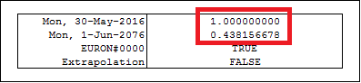

If you write: “*TRUE*” in **D24** cell (*Extrapolation*) the framework will be able to

provide rates also for dates after the last curve pillar using a flat extrapolator.

1. Part of the object description and construction should be moved into the section devoted to curve construction with ql (even non xl!).**EURON sheet**: Before going on with workbook’s analysis, we present a more accurate description of how the bootstrap is implemented in *QuantLibXL.* The calibration starting point are instruments market quotes selected for liquidity and tenor. For each of this instruments you need to create a *Quote Object* using the *QuantiLib* function “**qlSimpleQuote**”.

**Capture30**

After that, the next step is to associateto each object created a corresponding market

value using the QuantLib function “**qlSimpleQuoteSetValue**”.

Capture44

You are now ready to build *Rate Helpers*. The aim of *QuantLib Rate Helpers* is to link a market quote to a specific instrument with all the related conventions necessary to let the bootstrap algorithm know how it has to re-price that specific market value during the calibration.

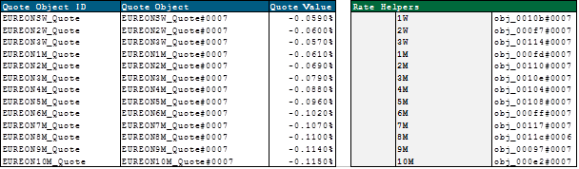

*QuantLib* uses directly these *Rate Helpers* to bootstrap any curve. Consequently, there are many types of *Rate Helpers*, one for each kind of market instruments (for example you’ll find a *Ois rate Helpers,* for overnight indexed swaps, or a *Fra Rate Helper,* for forward rate agreements and so on).

Capture33Capture34Capture35

Finally you can use QuantLib function “**qlPiecewiseYieldCurve**” to bootstrap the selected helpers. This function needs several input like:

1. Euribor Index pre-constructed with *QuantLib* “**qlEuribor**” function;
2. Rate Helpers;
3. Settlement Days;
4. Calendar;
5. Day Count Convention;

And also advanced settings like:

1. Interpolation scheme;
2. Parametrization;
3. Jump inclusion.

Choosing the right settings is crucial in order to obtain a state of art rate curve.

[what follows is meant to stay here]

After this short introduction we are now ready to analyze the *EURON* sheet. Before starting, it’s important to know that there are some hidden cells that you can find by clicking on the **plus** buttons visible over **I**, **T**, **V** columns. The hidden part shows the construction of *Rate Helpers*for the whole set of instruments indexed on overnight rate.

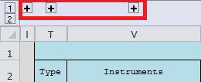

Bear in mind that the framework doesn’t build all rate helpers to avoid overloading but you can create them all doing copy/paste of rate helper’s formula.[what is this remark meant for?]

1. In particular cells in column **N** (“*Include Flag*”) , **O** (“*Priority*”), **P** (“*Min Dist*”) are very important because they define the inclusion and priority rules for all instruments.



You can force the framework to exclude a specific instruments simply writing: “**FALSE”**

in the relative cell of column **N** (“*include Flag*”).

img3

For example, you can chose whether or not to exclude *OIS60Y* writing: “*FALSE*” in the

right cell or change inclusion priority (for less priority digit a lower number).[how is this priority configured: only positive numbers? how can block priority be set? Using same number?...]

Another important setting is the “*Min Dist*” field,which represents the minimum distance (in days) that must separate a pillar from its successor/neighbourghs [am i right? Does it look forward or backward]

If two pillars are near each other in

less than the minimum distance, just one of them will be included in the

calibration (specifically the one with the higher priority).[what if they have same priority?]

1. In column **V** (“*Instruments*”) you find a summary of the set of instruments that **are included** in the bootstrap algorithm and will contribute to the curve calibration.
2. In cells **AH3**-**AH4**-**AH5**-**AH6** you can decide the futures and deposits selection criteria and in particular:



1. **Cell AH3 (“***nIMMFutures***”):** allows to force the maximum number of IMM Futures that

can be included in the calibration;

1. Cell AH4 (“*nSerialFutures*”): allows to force the maximum number of Serial Futures that can be included in the calibration;
2. Cell AH5 (“FrontFuturesRollingDays”): let you decide how many days before its expiry the Front Futures must be discarded (zero implies the use of the Front Futures during its expiry day);
3. Cell AH6 (“*DepoFuturesPriority*”): allows you to set up the deposits inclusion criterion (if missing, default = AllDepos).
4. Finally from column **AC** to column **AJ** you find the jumps summary table calculated in the *JumpQuotesFeedON* sheet. In particular, in column **AI** (“*overwrite*”), you can force the calibration to **NOT** consider a jump simply writing: “**0**” in the jump’s corresponding cell or set another jumps estimation simply writing the jump size.

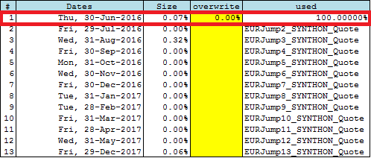

You can find a similar table also in *JumpQuotesFeedON* workbook.



However, the jump overwrite in the two tables is slightly different. In particular

overwriting in *JumpQuotesFeedON* sheet implies overwriting in the whole set of

curves while doing the same in *CurveBootsapping* workbook means change jumps size in

relation to a single curve.

1. **EUR1M/EUR3M/EUR6M/EUR1Y:** For the other curves spreadsheets you can apply the same methodology explained before concerning the overnight curve with no significant difference.

- **YCSTDBootstrapping**

In this workbook you find the old Standard Curve construction which was the old bootstrap methodology. The sheets structuring is the same as the previous adopted for multiple curve.

The differences are more theoretical than practical and are strictly connected to the instruments selection. The Standard Curve was meaningful only in a single curve approach in which it wasn’t necessary to separate instruments according to their underlying tenor but they were kept togheter, selecting only the most liquid ones.

For this reason, in this curve, you can find all deposits till the first IMM future, futures strips and finally swap with different underlying.

Another difference that is not relevant anymore is visible in *EURSTD* sheet in **AF** column “*Mx Convexity*” in which are reported futures convexity adjustment estimations. [i would avoid adding this information; otherwise it is important to explain why it is not relevant anymore]