QuantLibXL User Guide

Rate Curves Framework

Banca IMI – Quantitative Structuring

Giugno 2016

- Framework Introduction

The aim of the Rate Curves Framework is to provide an efficient way to execute multiple curve calibration for different currencies; so far, the framework includes 37 rate curves for 7 currencies summarized in the underlying table:

Currency/Curve | STD | ON | 1M | 3M | 6M | 1Y
EUR
GBP
USD
HKD
JPY
AUD
SEK

Compute a curve calibration (or bootstrapping) means using a process to calculate discount factors (or zero rates) for different maturities tenors or currencies from a set of Interest Rate Derivatives whose quotes are available on market (or synthetically derivable from market’s information). This is possible by means of QuantLibXL Excel Add-in.
QuantLibXL is a compiled Add-in (i.e. specific type of application used to add features to Excel) which provides an Excel User Interface for the use of QuantLib functionality. QuantLib is a C++ free/open-source library for quantitative finance based on an object model. In order to export QuantLib object-oriented functionality to Microsoft Excel, QuantLibXL uses ObjectHandler, a C++ library that implements a repository in which objects may be instantiated, queried, updated and destroyed . For more information please visit quantlib.org.

This document explains how to have access to the framework and how to use it.

- Access to Rate Curve Framework

Unzip the QuantLibXL-1.7.0.zip file: the unzipped folder looks like:

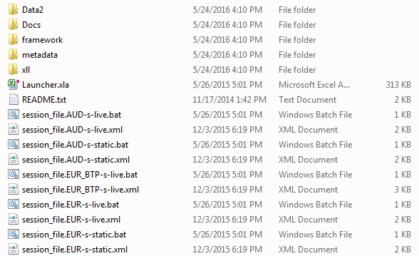
For each currency (CCY), you can find two batch (.bat) and their related (i.e. with the same name) xml files. The batch files are used to launch the Excel Rate Curve Framework session: session_file.CCY-s-live.bat is used for a live data feed session by means of Thomson Reuters Eikon, session_file.CCY-s-static.bat is used to load an historical data session.
The xml files contains a list of startup parameters and options needed by the Add-in (for example: currency, evaluation date, xll path, ect).

Once the curves have been calibrated, a key point to understand is how to export the related information from Excel to the Front Office Systems (Murex for example) which expect a set of market quotes as input. This passage is called contribution process in which all new quotes bootstrapped, for quoted and non-quoted maturities, are identified internally by a specific RIC (Reuters Identification Code) and finally sent to the front office systems.

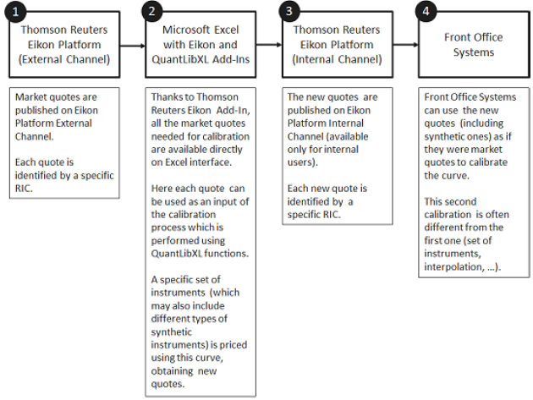

When a session has been launched you will see across the board the MainChecks workbook.
As an example, we consider now the procedure for a live session for EUR currency (the procedure for another currency can be obtained simply substituting the currency name).

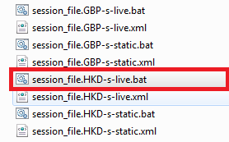

Wait until the Excel session is loaded (this passage may require a few minutes): at this point you will see the EUR_MainChecks.xlsx workbook.

- MainChecks

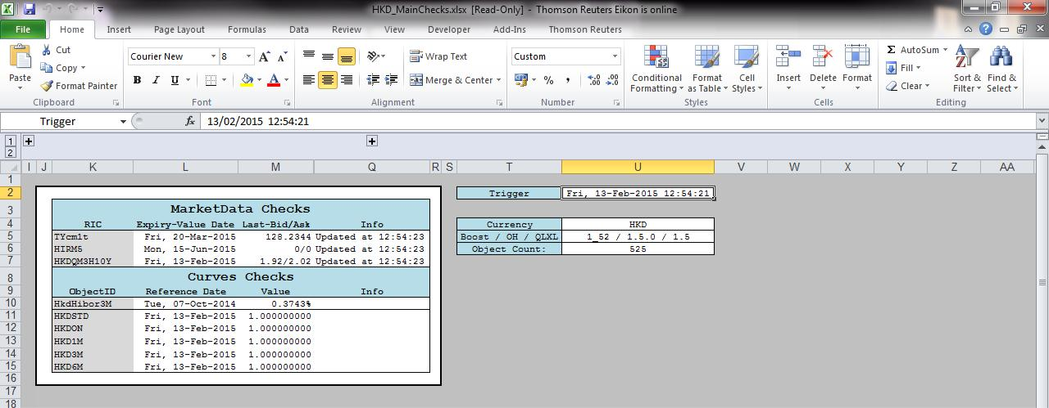

- Real Time Feed: in cells Q5-Q6-Q7 you must see the message “Updated at [current time]”.

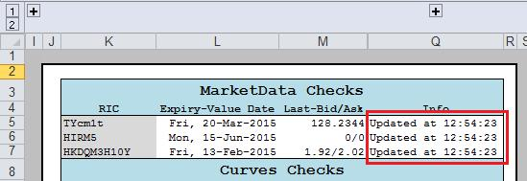

- If you see a message like: “Paused at …” please Resume Updates using Thomson Reuters

Tab and check another time cells Q5-Q6-Q7: you must see the message: “Updated at [current time]”.

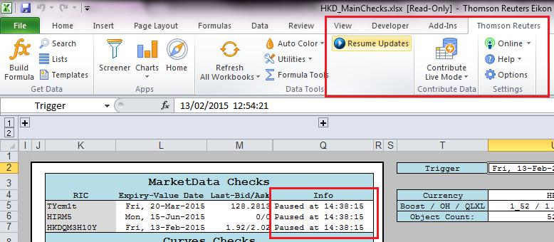

- If you see a message like: “Offline at …” please go to Thomson Reuters Tab and check the Eikon LogIn: you must be Online. If you are Offline click the button to force the LogIn. Then check another time cells Q5-Q6-Q7: you must see the message: “Updated at [current time]”.

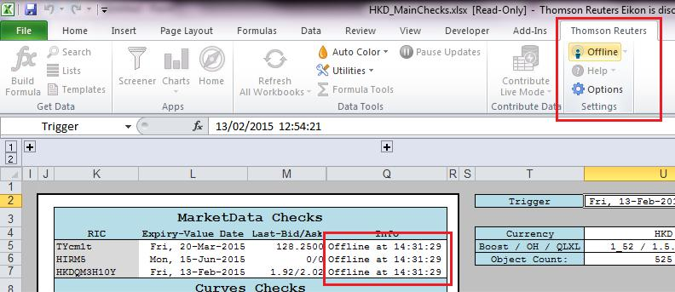
At the end, your must have

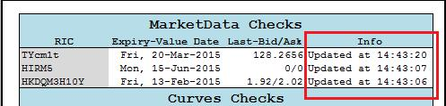

A final check can be made looking if the Thomson Reuters values in Q column (“Last-Bid/Ask”) for instruments in K column (“RIC”) are correct. In particular this Reuters RICs refers to the most liquid instruments quoted in the reference market. Logically, this are well known values for traders that can immediately check if Reuters is really downloading live quotes.

- Check Curves Calibration: Go to cell U2 (“Trigger”) and delete the content. This passage is fundamental to eliminate false errors which may occur if the workbook isn’t triggered.

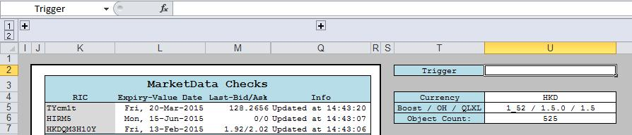

If everything works, you will see no error message in Info Column:

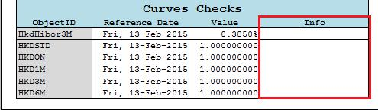

If you still have error messages in Info Column try to Refresh All Workbook (Thomson Reuters Tab) and cancel again the Trigger.

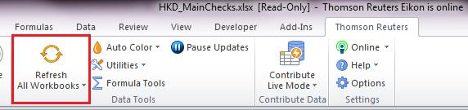

If, after all that, you still have error messages, please close the framework and launch it another time following the same steps.

- Please check also that:

  - For each curve, column L (“Reference Date”) is equal to [curve’s spot date] (for example, for HKD spot date = today for all curves) and column M (“Value”) is equal to 1.000000000

  - For Ibor Index (HkdHibor3M for HKD), Index Reference Date must be [yesterday] if you launch the framework before fixings publication, otherwise [today]; Index Value must be the last published index fixing.

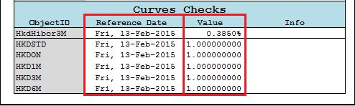

The other workbooks are hidden, to unhide them go to “View”, on Excel ribbon, and then click “Unhide”.

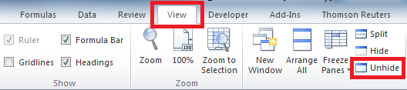

Once you did it, you will be ready to see the whole set of workbooks, namely:

- MainChecks;
- MarketQuotes;
- JumpQuotesFeedON;
- SynthQuotesFeed;
- CurvesBoostrapping;
- YCSTDBootstrapping.

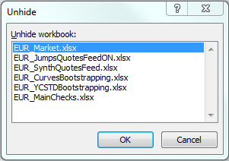

- Market

1. GeneralSettings: let’s start looking at the first sheet in which are summarized the
workbook’s main settings.

- The first step to do is checking the Live Feed to understand if you are online with the
Thomson Reuters server and quotes are updating in real time.

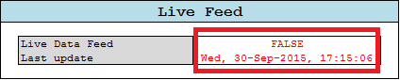

Therefore, in a live session it’s important to see: “TRUE” in Live Data Feed cell
and the [current-Date] and [current-time] in the Last Update cell. If not, please check
your connection and refresh it if necessary. Instead, if you are in a static session,
you’ll find “FALSE” in Live Data Feed cell and the date from which the framework is
getting static historical data (this is the case of the imagine above).

- Control the Trigger Counter cell; if all goes right, it must continue triggering during
the session meaning that the framework is updating market quotes from the data
provider. To check this, it is sufficient that trigger counter rises over time.

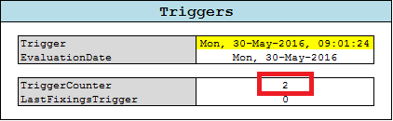

c. As usual, it is possible to change currency and general settings.

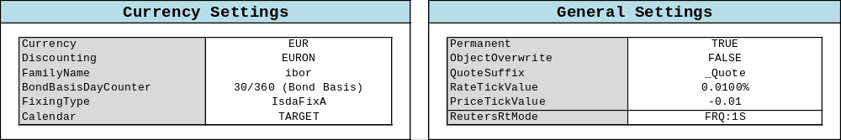

d. In the Contributors table it is possible to choose from which broker import market
quotes.

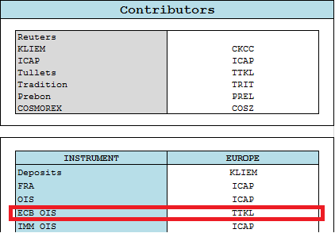

In this example we are taking FRA, OIS and IMM OIS from ICAP and ECB OIS from Tullets.

- Euribor: this sheet has the task to create an object for each Euribor Index; When the framework completes each calibration, this objects will be indirectly linked to the curves bootstrapped using the QuantLibXl Relinkable Handle.

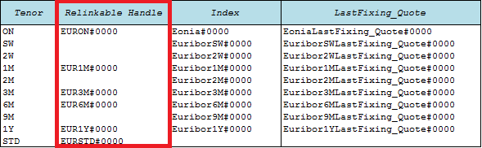

This process might appear useless but it’s fundamental step especially for live sessions. In fact, doing this, index object won’t be re-created each time that curves changes due to the updating of market values. In fact, when a user want to create a model using QuantLibXL, must keep in mind that the best practice is to build each object just one time because, every time an object is created, Excel allocates memory and this can overload the entire framework.

- Other sheets: all other sheets have the task to create an object for each market instruments and then associate to this object a market quote taken directly from Thomson Reuters. This process will be helpful in the CurveBoostrapping workbook in which you will be able to filter and select the best set of instruments that will be included in the bootstrap algorithm.
Each sheet is devoted to a particular market instruments and characterized by different columns with different values like the figure below:

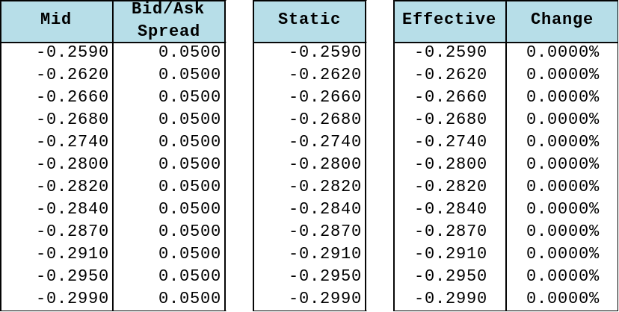

In the Mid column you find the Live Thomson Reuters quotes and, in the Static column, the historical ones referred to the old date (see the general settings Last Update cell). If you have launched a live session, the Effective column takes Mid column data, otherwise it takes the Static column data.
Finally the Change column calculate the percentage change in market quotes (useful in Live sessions).

- JumpQuotesFeedON

Like the previous workbooks let’s begin from general settings.

- General settings: the first jump analysis step is to bootstrap an overnight curve till 2Y in which jumps are not considered.

- The characteristics of this curve can be changed as usual but the important thing actually is to check if the calibration is working simply looking to D18-D19 cells

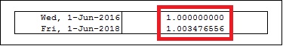

If you see an error message there, please try to trigger or refresh the session. The error message can also be generated by the Thomson Reuters connection, so, to control it, please check D23-D24 cells.

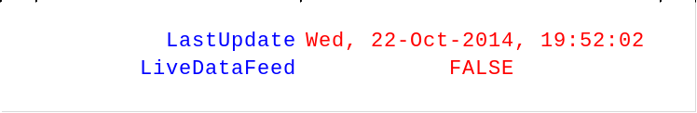

Remember that, in live sessions, LiveDataFeed must be: “TRUE” and LastUpdate must be [current-date] and [current-time].

- In this sheet you also find the Final Curve settings that is this workbook’s outcome; in fact, cell I14 represents the new “jump-corrected” overnight curve. To check that this passage works, please remember that cells I18-I19 mustn’t contain an error message.

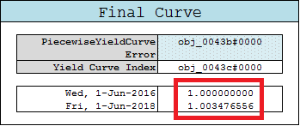

- RateHelpers: here, you find the whole set of instruments used to bootstrap the overnight curve till 2Y. This passage will be discussed accurately in the CurveBootstrapping sheet.

- Calculation: the aim of this sheet is to check where, in the overnight curve 2Y time frame, a jump can occur and calculate it.

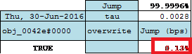

If the analysis find a jump, you will see a value different from zero (which is the
jump size) in the red-written cells, otherwise you will find: “0.00%”

- Contribution: in the last workbook’s sheet you’ll find jumps contribution in which jumps, pre-calculated, will be fixed in quotes. As you can see, in this example there are 3 jumps.

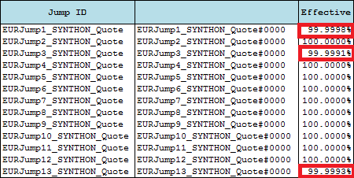

- SynthQuotesFeed

After opening this workbook you will see on the board the general settings. As usual it’s important to make a brief check to the real time connection (if you are in a live session) and to the 1M Curve (if all goes right, you don’t have to see an error message in cells D34-D35).
Remember to trigger after changing any settings.

- 1M,3M,6M,12MSynthDepo: the aim of this sheets is to build synthetic deposits for 1M,3M,6M,12M curves respectively. The “selected” columns represent the interactive part of each sheet in which you can decide what Delta’s must be included in the α,β,γ calibration.

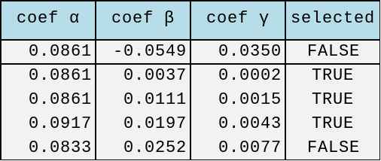

You can select Deltas simply writing: “TRUE” in the corresponding cell. Remember that
The quadratic parametrization needs 3 Deltas to be calibrated so, if you flag just 2
Deltas it will be impossible to use that.

- 1M,3M,6M,12M Delta: Deltas, that has been used in the preceding sheets, are calculated here. Even in this case, you can decide which basis must be computed directly and which one must be interpolated (the best practice is to base the choice looking at the instrument’s liquidity) writing: “TRUE/FALSE” in the “Selected” columns.

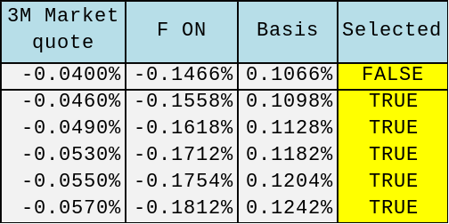

- Contribution: Finally the workbook define object for all synthetic deposits and summarize them all with the corresponding value in the Contribution sheet. As you can see, there is a different column for Live, Static and Effective values. In particular, values in the Effective column change in according to the fact that you are using or not a live session (as already explained before).

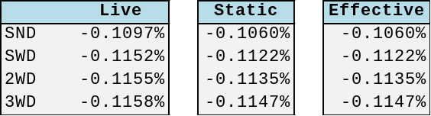

For a final check remember to control E column (“Error”); there must be no error messages.

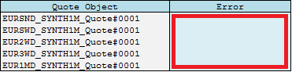

- CurvesBootstrapping

Let’s consider the case of EUR curve bootstrapping.

- GeneralSettings: As you can see all curves bootstrapped are summarized here in the PiecewiseYieldCurve cells.

PiecewiseYieldCurve | _EURON#0000

As usual, you can switch general settings (like currency, evaluation date or
pillar date) simply clicking on the right cell and selecting the parameter you need.

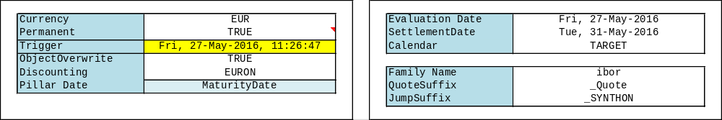

For example you can click on D3 (“EUR”) (a drop down menu will appear) and choose another currency, or you can click on I3 (“Fri, 27-May-2016”) and digit another evaluation date; don’t forget to trigger after changing parameters!

- In the same way you can switch each Curve settings like:

- Settlement days (“NDays”) - Usually it’s set to 0 or 2 and it fixes the day at which discount factor = 1;

- Curve parametrization (“TraitsID”) - if is missing, default = Discount;

- Interpolation scheme (“InterpolatorID”) - if is missing, default = LogLinear.

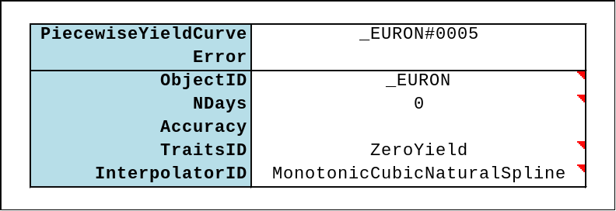

- To check if the framework has bootstrapped all curves correctly, please control cells D21-D22 (for Overnight Curve): the first rate (D21) is set on the reference date for the relative term structure and so must be 1.000000000; for the second rate (D22) it’s sufficient that you don’t see an error message. The same rules are applied for all other Curves.

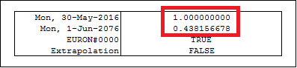

If you write: “TRUE” in D24 cell (Extrapolation) the framework will be able to
provide rates also for dates after the last curve pillar using a flat extrapolator.

- EURON sheet: Before going on with workbook’s analysis, we present a more accurate description of how the bootstrap is implemented in QuantLibXL. The calibration starting point are instruments market quotes selected for liquidity and tenor. For each of this instruments you need to create a Quote Object using the QuantiLib function “qlSimpleQuote”.

After that, the next step is to give at each object created the corresponding market
value using the QuantLib function “qlSimpleQuoteSetValue”.

You are now ready to build Rate Helpers. The aim of QuantLib Rate Helpers is to link a market quote to a specific instrument with all the related conventions necessary to let the bootstrap algorithm know how it has to re-price that specific market value during the calibration.

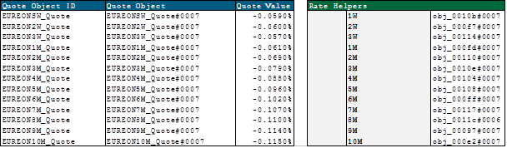

QuantLib uses directly this Rate Helpers to bootstrap any curve. Consequently, there are many types of Rate Helpers, one for each kind of market instruments (for example you’ll find a Ois rate Helpers, for overnight indexed swaps, or a Fra Rate Helper, for forward rate agreements and so on).

Finally you can use QuantLib function “qlPiecewiseYieldCurve” to bootstrap the selected helpers. This function needs several input like:

- Euribor Index pre-constructed with QuantLib “qlEuribor” function;
- Rate Helpers;
- Settlement Days;
- Calendar;
- Day Count Convention;

And also advanced settings like:

- Interpolation scheme;
- Parametrization;
- Jump inclusion.

Choosing the right settings it’s crucial in order to obtain a state of art rate curve.

After this short introduction we are now ready to analyze the EURON sheet. Before starting, it’s important to know that there are some hidden cells that you can find by clicking on the plus buttons visible over I, T, V columns. The hidden part shows the construction of Rate Helpers for the whole set of instruments indexed on overnight rate.

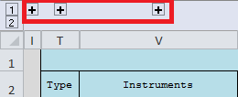

Bear in mind that the framework doesn’t build all rate helpers for not overload itself but you can create them all doing copy/parse of rate helper’s formula.

- In particular cells in column N (“Include Flag”) , O (“Priority”), P (“Min Dist”) are very important because defines the inclusion and priority rules for all instruments.

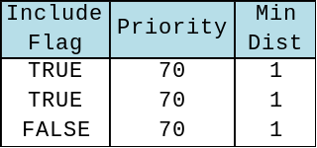

You can force the framework to exclude a specific instruments simply writing: “FALSE”
in the relative cell of column N (“include Flag”).

For example, you can chose whether or not to exclude OIS60Y writing: “FALSE” in the
right cell or change inclusion priority (for less priority digit a lower number).
In particular the “Min Dist” column represents the minimum distance (in days)
required by an instrument from another pillar. If two pillars are near each other in
less than the minimum distance, just one of them will be included in the
calibration (specifically the one with the higher priority).

- In column V (“Instruments”) you find a summary of the set of instruments that are included in the bootstrap algorithm and will contribute to the curve calibration.

- In cells AH3-AH4-AH5-AH6 you can decide the futures and deposits selection criteria and in particular:

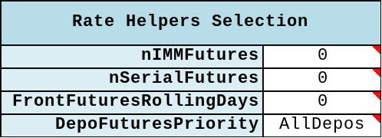

- Cell AH3 (“nIMMFutures”): allows to force the maximum number of IMM Futures that
can be included in the calibration;

- Cell AH4 (“nSerialFutures”): allows to force the maximum number of Serial Futures that can be included in the calibration;

- Cell AH5 (“FrontFuturesRollingDays”): let you decide how many days before its expiry the Front Futures must be discarded (zero implies the use of the Front Futures during its expiry day);

- Cell AH6 (“DepoFuturesPriority”): allows you to set up the deposits inclusion criterion (if missing, default = AllDepos).

- Finally from column AC to column AJ you find the jumps summary table calculated in the JumpQuotesFeedON sheet. In particular, in column AI (“overwrite”), you can force the calibration to NOT consider a jump simply writing: “0” in the jump’s corresponding cell or set another jumps estimation simply writing the jump size.

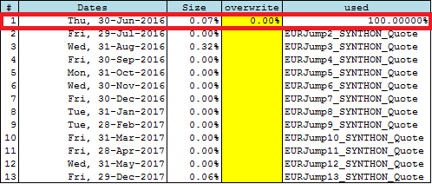

You can find a similar table also in JumpQuotesFeedON workbook.

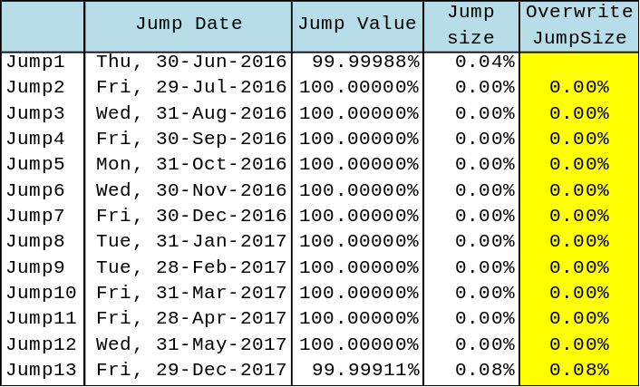

However, the jump overwrite in the two tables is slightly different. In particular
overwriting in JumpQuotesFeedON sheet implies overwriting in the whole set of
curves while doing the same in CurveBootsapping workbook means change jumps size in
relation to a single curve.

- EUR1M/EUR3M/EUR6M/EUR1Y: For the other curves spreadsheets you can apply the same methodology explained before concerning the overnight curve with no significant difference.

- YCSTDBootstrapping

In this workbook you find the old Standard Curve construction which was the old methodology. The sheets structuring is the same as the previous adopted for multiple curve.
The differences are more theoretical that practical and are strictly connected to the instruments selection. The Standard Curve is the single curve world approach in which wasn’t necessary to select instruments for underlying tenor but just for liquidity.
For this reason, in this curve, you can find all deposits till the first IMM future, futures strips and finally swap with different underlying.

Another difference that is no relevant anymore is visible in EURSTD sheet in AF column “Mx Convexity” in which are reported futures convexity adjustment estimations.

