Min distance overall '0.2' (Game scene)

Malta and Gozo texture based buildings

Time to render: 53 seconds

CPU Usage



GPU Usage



Rendering

Memory

Min distance overall '0.2' (Game scene)

Malta 1km area

Time to render: 29.30 seconds (2 minutes 40seconds 10milliseconds)



CPU Usage: 57.07ms



GPU Usage: 43.32ms



Rendering

Memory

Min distance overall '0.2' (Game scene)

Malta 2km area

Time to render: 29.70 seconds (2 minutes 41seconds 20milliseconds)



CPU Usage: 152.56ms



GPU Usage: 98.00ms



Rendering

Memory



Min distance overall '0.2' (Game scene)

Malta 3km area



Time to render: 30 seconds (2 minutes 42seconds 70milliseconds)

CPU Usage: 299.12ms



GPU Usage: 200.67ms



Rendering

Memory

Min distance overall '0.2' (Game scene)

Malta 4km area

Time to render: 29 seconds (2 minutes 46seconds 40milliseconds)



CPU Usage: 445.96ms



GPU Usage: 318.39ms



Rendering

Memory

Min distance overall '0.2' (Game scene)

Malta 5km area

Time to render: 30 seconds (2 minutes 48seconds 45milliseconds)



CPU Usage: 547.99ms

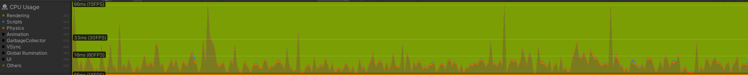

GPU Usage: 408.61ms



Rendering

Memory

Min distance overall '0.5' (Game scene) (Realistic models)

Malta and Gozo texture based buildings

Time to render: 20 seconds

CPU Usage



GPU Usage

Rendering

Memory

Min distance overall '0.2' (Game scene)

Malta 1km area

Time to render: 30 seconds (2 minutes 47seconds 50milliseconds)



CPU Usage: 586.90ms



GPU Usage: 314.43ms



Rendering

Memory

Min distance overall '0.2' (Game scene)

Malta 2km area

Time to render: 32 seconds ( 2minutes 50seconds 20milliseconds)



CPU Usage:1,621ms



GPU Usage:1,163ms



Rendering

Memory

Min distance overall '0.2' (Game scene)

Malta 3km area

Time to render: 34 seconds (2 minutes 55seconds)



CPU Usage: 11,792ms



GPU Usage: 9,180ms



Rendering

Memory

Min distance overall '0.2' (Game scene)

Malta 4km area

Time to render: 33 seconds (2 minutes 56seconds 50milliseconds)



CPU Usage: 37,652ms



GPU Usage: 34,514ms



Rendering

Memory

Min distance overall '0.21' (Game scene) This was set because it crashes on 0.2

Malta 5km area

Time to render: 35 seconds ('0.2') (2 minutes 44seconds) '0.21'

CPU Usage



GPU Usage



Rendering

Memory

200m

Time to render: 30s

600m

Time to render: 31s

1000m

Time to render: 32s

1400m

Time to render: 33s

Density point test:

1km (0.18): 3 minutes and 29s

1km (0.2): 2 minutes and 47s

1km (0.22): 2 minutes and 15s

1km (0.24): 1minutes and 50s

1km (0.26): 1minutes and 33s

1km (0.28): 1minutes and 19s

1km (0.3): 1minutes and 8s