# Lab 9 – Week 10 (DDL & DML)

This week reviews and extends the knowledge of Data Definitional Language (Create and Alter) and DML (Data Manipulation Language).

## Getting Started

***Your submission will be a single text-based SQL file with appropriate header and commenting.***

## Tasks

You will:

* create tables first,
* add / modify /remove some columns and finally
* add / modify / remove some constraints in this lab.

1. Create table L09SalesRep and load it with data from table EMPLOYEES table. Use only the equivalent columns from EMPLOYEE as shown below and only for people in department 80.

Column Type

RepId NUMBER (6)

FName VARCHAR2(20)

LName VARCHAR2(25)

Phone# VARCHAR2(20) ALL these columns’ data types match

Salary NUMBER(8,2) one’s in table EMPLOYEES

Commission NUMBER(2,2)

**You will have exactly 3 rows here**.

1. Create L09Cust table.

CREATE TABLE L09Cust (  
 CUST# NUMBER(6),  
 CUSTNAME VARCHAR2(30),  
 CITY VARCHAR2(20),  
 RATING CHAR(1),  
 COMMENTS VARCHAR2(200),  
 SALESREP# NUMBER(7) );

**NOTE**: Caution that copying from WORD will create errors if WORD is using quotes that look like ‘this’ - SQL needs straight quotes like 'this'

The constraints were left off in the above. The constraints shown below are what would normally be applied as shown. These were applied at the table level. Do not add these at this time, you will do so through the following questions.

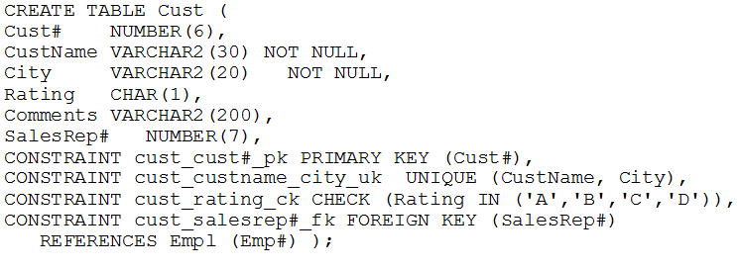

Load the table with these values in the chart.

|  |  |  |  |  |
| --- | --- | --- | --- | --- |
| **CUST#** | **CUSTNAME** | **CITY** | **RAT** | **SALESREP#** |
| **501** | ABC LTD. | Montreal | C | 201 |
| **502** | Black Giant | Ottawa | B | 202 |
| **503** | Mother Goose | London | B | 202 |
| **701** | BLUE SKY LTD | Vancouver | B | 102 |
| **702** | MIKE and SAM Inc. | Kingston | A | 107 |
| **703** | RED PLANET | Mississauga | C | 107 |
| **717** | BLUE SKY LTD | Regina | D | 102 |

1. Create table L09GoodCust by using following columns but only if their rating is A or B.

Column Type

CustId NUMBER (6)

Name VARCHAR2(30)

Location VARCHAR2(20) → ALL these columns’ data types match ones

RepId NUMBER(7) in table L09Cust

**→ You will have exactly 4 rows here.**

|  |  |  |  |
| --- | --- | --- | --- |
| **CUSTID** | **NAME** | **LOCATION** | **REPID** |
| 502 | Black Giant | Ottawa | 202 |
| 503 | Mother Goose | London | 202 |
| 504 | BLUE SKY LTD | Vancouver | 202 |
| 701 | MIKE and SAM inc. | Kingston | 10 |

1. Now add new column to table L09SalesRep called JobCode that will be of variable character type with max length of 12. Do a DESCRIBE L09SalesRep to ensure it executed

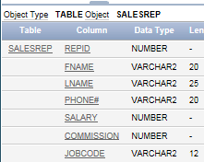

1. Declare column Salary in table L09SalesRep as mandatory one and Column Location in table L09GoodCust as optional one. You can see location is already optional.

L09GoodCust before looks like the following

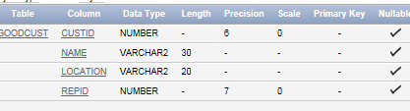

AFTER the change it would look as follows:

|  |  |  |  |  |  |  |  |  |  |  |  |  |  |  |  |
| --- | --- | --- | --- | --- | --- | --- | --- | --- | --- | --- | --- | --- | --- | --- | --- |
| **Table** | **Column** | **Data Type** | **Length** | | **Prec.** | | **Scale** | | **PK** | | **Nullable** | | **Default** | | **Comment** |
| [**SALESREP**](javascript:ret_Column('RON.SALESREP');) | [REPID](javascript:ret_Column('REPID');) | NUMBER | - | 6 | | 0 | | 1 | | - | | - | | - | |
|  | [FNAME](javascript:ret_Column('FNAME');) | VARCHAR2 | 37 | - | | - | | - | | nullable | | - | | - | |
|  | [LNAME](javascript:ret_Column('LNAME');) | VARCHAR2 | 25 | - | | - | | - | | - | | - | | - | |
|  | [PHONE#](javascript:ret_Column('PHONE" \l "');) | VARCHAR2 | 20 | - | | - | | - | | nullable | | - | | - | |
|  | [SALARY](javascript:ret_Column('SALARY');) | NUMBER | - | 8 | | 2 | | - | | - | | - | | - | |
|  | [COMMISSION](javascript:ret_Column('COMMISSION');) | NUMBER | - | 2 | | 2 | | - | | nullable | | - | | - | |
|  | [JOBCODE](javascript:ret_Column('JOBCODE');) | VARCHAR2 | 12 | - | | - | | - | | nullable | |  | |  | |

5. Lengthen FNAME in L09SalesRep to 37. The result of a DESCRIBE should show it happening

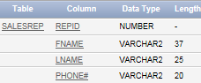

You can only decrease the size or length of Name in L09GoodCust to the maximum length of data already stored. Do it by using SQL and not by looking at each entry and counting the characters. May take two SQL statements

1. Now get rid of the column JobCode in table L09SalesRep in a way that will not affect daily performance.
2. Declare PK constraints in both new tables → RepId and CustId
3. Declare UK constraints in both new tables → Phone# and Name
4. Restrict amount of Salary column to be in the range [6000, 12000] and Commission to be not more than 50%.
5. Ensure that only valid RepId numbers from table L09SalesRep may be entered in the table L09GoodCust. Why this statement has failed?
6. Firstly write down the values for RepId column in table L09GoodCust and then make all these values blank. Now redo the question 10. Was it successful?
7. Disable this FK constraint now and enter old values for RepId in table L09GoodCust and save them. Then try to enable your FK constraint. What happened?
8. Get rid of this FK constraint. Then modify your CK constraint from question 9 to allow Salary amounts from 5000 to 15000.
9. Describe both new tables L09SalesRep and L09GoodCust and then show all constraints for these two tables by running the following query:

SELECT constraint_name, constraint_type,   
 search_condition, table_name  
 FROM user_constraints  
 WHERE lower(table_name) IN ('l09salesrep','l09goodcust')  
 ORDER BY table_name, constraint_type;