Assignment 2 and 3 - “Who wants to be a millionaire”

Name: Nicholas Defranco
Student id: 106732183
Professor: Kadeem Best
Due Date: March 6th 2018

Table of Contents

- Screenshots of working script
- code
- link to code
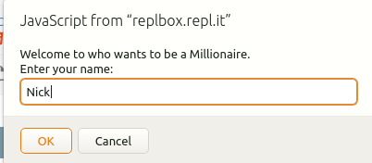

Beginning of script – prompts player for their name.
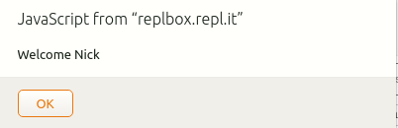

Greets user.
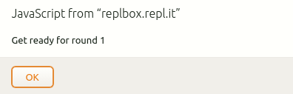

This is repeated at every start of every round.
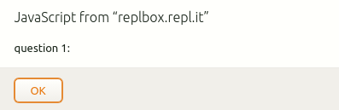

This is repeated before the player is given a question.
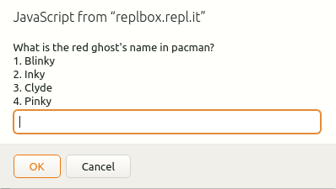

All questions follow this format.

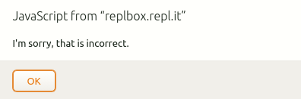

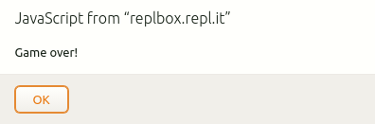

If the player answers incorrectly this will display.

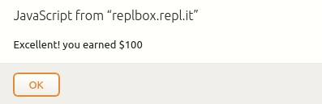

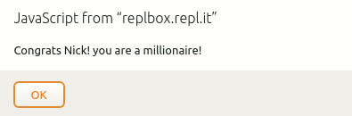
If the player correctly answers a question.

If the player has won.
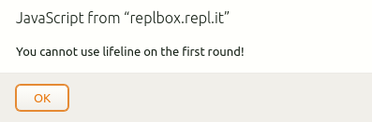

If player tries to use lifeline on the first round
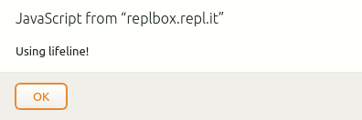

When player uses lifeline
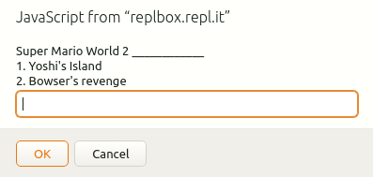

Result of using lifeline
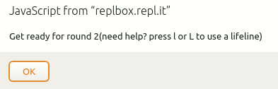

Before every round from the 2nd and onward, player will be notified that they can use a lifeline for assistance.

// Name: Nicholas Defranco
// Student #: 106732183
// Assignment - Who wants to be a millionaire!

// Question class

// first option is the correct answer (will be randomized
// afterward).
class Question {
constructor(str, a, b, c, d) {
this.question = str;
this.options = [a, b, c, d];
this.correct = a;
}
}

// constants
const MAX_ROUNDS = 3;
const QUESTIONS_PER_ROUND = 3;
const MAX_LIFELINES = 2;
const ROUND_EARN_END_OFFSET = 2;

// reward values in order
const rewards = [100.00, 500.00, 10000.00, 25000.00, 50000.00, 75000.00, 125000.00, 500000.00, 1000000.00];

//question array
const questions = [];

questions.push(new Question("Which of these games were released in 1996", "Super Mario 64", "Super Contra", "Super Mario World", "Donkey Kong"));

questions.push(new Question("Where is Nintendo World located", "New York City", "Toronto", "Buffalo", "LA"));

questions.push(new Question("The princess is in _____ _____", "Another castle", "Your house", "The wild", "The Kingdom"));

questions.push(new Question("Mario's last name is: ", "Mario", "Bro", "Luigi", "Man"));

questions.push(new Question("What does NES stand for?", "Nintendo Entertainment System", "Nintendo's Extra Stuff", "Nintendo's Encyption System", "Nintendo Education System"));

questions.push(new Question("When was Minecraft created?", "2009", "2010", "2008", "2011"));

questions.push(new Question("My body is ______", "Ready", "Not ready", "Here", "There"));

questions.push(new Question("What is the name of Megaman in japan?", "Rockman", "Metalman", "Cutman", "Still Megaman"));

questions.push(new Question("Who is the main character is the Legend of Zelda?", "Link", "Zelda", "Shiek", "Tetra"));

questions.push(new Question("Princess Zelda from The Legend of Zelda games by Nintendo has gone by a few names. Which of these names has she NOT been called in a video game?", "Malon", "Tetra", "Sheik", "She has only been called Zelda"));

questions.push(new Question("What was Mario originally refered to as?", "Jump man", "It was always Mario", "Red Luigi", "The Plummer Guy"));

questions.push(new Question("What video game console has the highest number of video game console sales of all time?", "Playstation 2", "Wii", "Xbox 360", "NES"));

questions.push(new Question("Who is the fastest of these video game characters?", "Sonic", "Mario", "Donkey Kong", "Little Mac"));

questions.push(new Question("What is the red ghost's name in pacman?", "Blinky", "Inky", "Clyde", "Pinky"));

questions.push(new Question("In Super Mario Bros, what colours was Mario's outfit?", "Red and Brown", "Red and blue", "Green and blue", "Orange and Brown"));

questions.push(new Question("Mario's first time saying 'It's-a me Mario!' in what game?", "Super Mario 64", "Super Mario World", "Super mario Sunshine", "Super Mario Galaxy"));

questions.push(new Question("What end of what year was the last Nintendo Power issue released?", "2012", "2010", "2008", "2014"));

questions.push(new Question("What year was the first Nintendo Power released", "1988", "1990", "1984", "1986"));

questions.push(new Question("Which of these games is considered a successor to Mario Paint", "Super Mario Maker", "Super Smash bros", "Mario Paint 2", "Hotel Mario"));

questions.push(new Question("How many Mario Kart games have been made? (excludes releases and must have been released on a nintendo console)", "8", "9", "6", "10"));

questions.push(new Question("Mike ______'s Punch-Out!!", "Tyson", "Huckabee", "Trout", "Sullivan"));

questions.push(new Question("When did Tetris come out?", "1984", "1980", "1986", "1989"));

questions.push(new Question("When did Super Mario World release in North America", "1991", "1988", "1992", "1995"));

questions.push(new Question("Super Mario World 2 ____________", "Yoshi's Island", "6 Golden Coins", "Bowser's revenge", "Wario World"));

questions.push(new Question("When did the virtual boy release in North America?", "1995", "1991", "1998", "2000"));

// helper functions

// sort randomizer
function ran(a, b) {
return 0.5 - Math.random();
}

// displays a question
function display(q) {
let str = q.question + '\n';
for(let i = 0; i < q.options.length; i++) {
str += `${i + 1}. `;
str += q.options[i];
str += '\n';
}

return prompt(str);

}
//////////////////////////

// performs all round logical operations.
// Accesses arrays globally.
// returns a bool determining if the player has to continue.
function round() {

// static variables keeping track of data
// required for future rounds
if( typeof round.counter == 'undefined' ) {
round.counter = 0;
round.lifeline = 0;
}

let msg = `Get ready for round ${round.counter + 1}`;

if(round.counter > 0) {
msg += " (need help? press l or L to use a lifeline)";
}

alert(msg)

let done = false;

// iterates for every question in a round
for(let i = 0; i < QUESTIONS_PER_ROUND && !done; i++) {

alert(`question ${i + (round.counter * QUESTIONS_PER_ROUND) + 1}: `);

// random question chosen
let rand = parseInt(Math.random() * questions.length);

// randomizing options array stored in question object
// so that the first option is not always the right
// answer.
questions[rand].options.sort(ran);

let used = false;
// will loop if lifeline is used
do {
choice = display(questions[rand]);

if(choice === 'l' || choice === 'L') {
if(round.counter < 1) {
alert(`You cannot use lifeline on the first round!`);
} else if(round.lifeline >= MAX_LIFELINES) {
alert(`Out of lifelines!`);
} else if(used) {
alert(`You already used lifeline on this round!`);
} else {
round.lifeline++;
alert(`Using lifeline!`);
let i = 0;
while(!used) {
if(questions[rand].options[i] !== questions[rand].correct) {
used = true;
questions[rand].options.splice(i, 1);
}
i++;
}
}
}
} while(choice === 'l' || choice === 'L');

// check if answer is correct
if(questions[rand].options[choice - 1] === questions[rand].correct) {
alert(`Excellent! you earned $${rewards[(round.counter * QUESTIONS_PER_ROUND) + i]}`);
// remove question from list to ensure it is
// not selected again.
questions.splice(rand, 1);

// logic if it is the last round.
if(round.counter + 1 === MAX_ROUNDS && rewards[(round.counter * QUESTIONS_PER_ROUND) + i] === 1000000.00) {
done = true;
} else {
done = false;
}
// if incorrect ...
} else {
alert(`I'm sorry, that is incorrect.`);

// logic if it is the last round.
if(round.counter + 1 === MAX_ROUNDS) {
done = false;
break;
} else {
done = true;
}
}

}

round.counter++;

return done;

}
////////////////////

// start of script
let name = "";
let done = false;

name = prompt("Welcome to who wants to be a Millionaire.\nEnter your name: ");

alert(`Welcome ${name}`);

// game loop
for(let i = 0; i < MAX_ROUNDS && !done; i++) {

done = round();

// if last round ...
if(i === MAX_ROUNDS - 1) {
// if won ...
if(done) {
alert(`Congrats ${name}! you are a millionaire!`);
// if lost ...
} else {
alert(`Game over!`);
done = true;
}
} else {
// if lost...
if(done) {
alert(`Game over!`);
// if won round ...
} else {
let ans = prompt(`Would you like to leave with the money(y or n)?`);
if(ans === 'Y' || ans === 'y') {
done = true;
alert(`Congrats ${name}! You won $${rewards[i * QUESTIONS_PER_ROUND + ROUND_EARN_END_OFFSET]}`);
}
}
}

}

Link to code

https://repl.it/@CodeRed231/Nicholas-Defranco-Assignment-2and3

