## GEOHackathon Field Development Plan Report

### **Thermalize**

### Recommendations

Outline development plan

The purpose of the project is to evaluate an asset calculating petrophysical properties, finding the best area (economically and technically) to produce geothermal fluids for direct use.

Our group considered 6 wells to analyse sonic data, and 4 wells to analyse well testing data. (Figure 1).

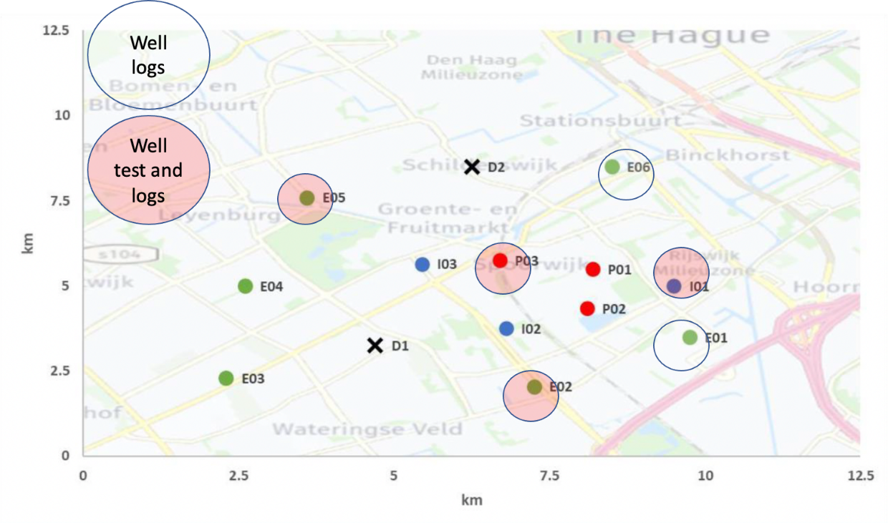

The evaluation of porosity was using the equation of porosity by sonic. Acoustic logging evaluates porosity because the compressional velocity of sound in the fluid is less than the velocity in rock. If there is pore space in the rock, and it is fluid-filled, the acoustic energy will take longer to get from the transmitter to the receiver. The recorded velocity or travel time represents the sum of the velocity of the solid part or framework of the rock (matrix), rock lining the pores, fluid filling the pore space. In turn, travel time in the rock matrix, Δtma , is influenced by variations in lithology, and confining pore pressure. Porosity are related through an empirical relationship known as the Wyllie time-average equation, when the velocity (transit time, Δt, or travel time, t) of the rock matrix and borehole fluids are known, porosity can be computed in the following ways.

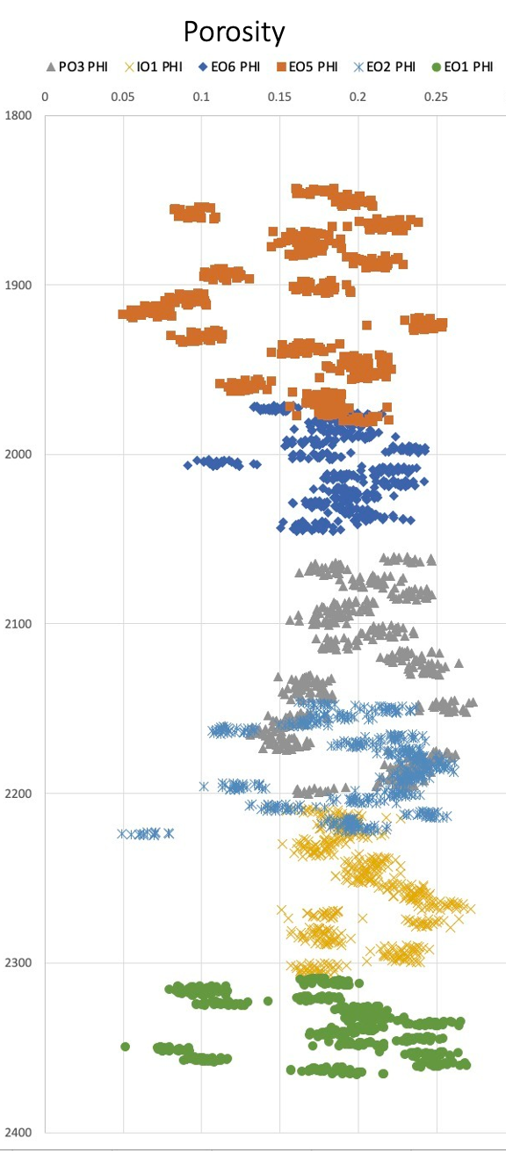

Well test analysis consists of defining the interpretation models that best describe the available pressure data, recorded during a given flow rate history. Permeability was evaluated from well test data. Doing some considerations, assuming a sandstone rock. For the 4 cases, it was evaluated the permeability from the build-up time.

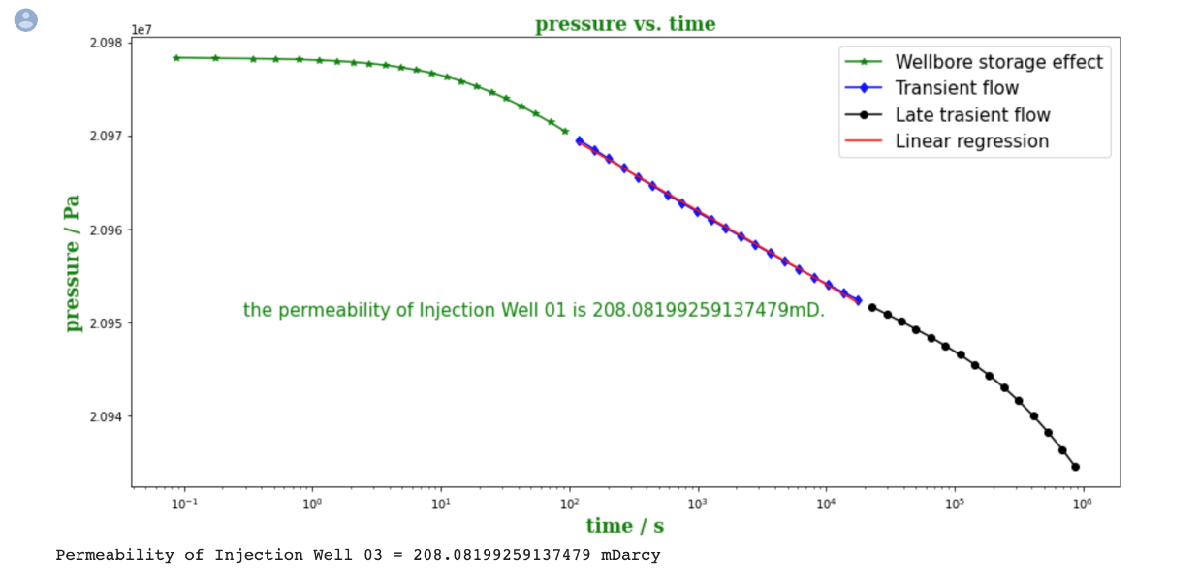

After evaluating ll logs and well testing files. Table 1 shows a summary of results. Then, it was generated 4 zones to evaluate a possible exploration well, in the function of the areas. A zone e to EO5 at 1900 meters, it was considered the best option due to it was good petrophysical properties (porosity, and permeability) and good thermal properties in comparison to other depths. The deviation in permeabilities is due to the assumptions on reservoir width at depth.

|  |  |  |  |  |  |
| --- | --- | --- | --- | --- | --- |
|  |  | EO5 | PO3 | IO1 | EO1 |
| wellbore radius | m | 0.15 | 0.15 | 0.15 | 0.15 |
| reservoir radius | m | 2000 | 2000 | 2000 | 2000 |
|  | ln(re/rw) | 9.498022 | 9.498022 | 9.498022 | 9.498022 |
| permeability | mD | 583 | 646 | 798 | 786 |
|  | m2 | 5.75376E-13 | 6.37552E-13 | 7.87565E-13 | 7.75722E-13 |
|  | ft | 455.9 | 459.2 | 324.7 | 187 |
| thickness | m | 138.9 | 140 | 99 | 57 |
| viscocity | CP | 1 | 1 | 1 | 1 |
| visc cinematica | Pa*s | 0.0038 | 0.0038 | 0.0038 | 0.0038 |
| Flowing Pressure | Pa | 20300000 | 20500000 | 20500000 | 20500000 |
| Reservoir Pressure | Pa | 21757600 | 21028900 | 20984600 | 20897100 |
|  | m3/s | 0.020 | 0.008 | 0.007 | 0.003 |
| Caudal volumetrico | l/s | 20 | 8 | 7 | 3 |

### Short background of the project

The project allows to the group learn about programming, taking some consideration how to use Python in the process to analyze well testing and evaluate the potential of heat extraction. The only place where a linear regression machine learning model was used can be found in the exploratory notebook, confirming that the area of well E05 had the greatest consistency in pumping energy across the formation given any injection separation.

Another important learning opportunity was about the workflow to evaluate assets for geothermal projects, considering some economy and technical factors.

### Information that was used

* Well logs of EO1, EO2, EO5, EO6, PO3, AND IO1 were considered to analyse the porosity. Also, well testing of EO5, PO3, IO1, and EO2 were considered to calculate the permeability and initial pressure.
* Those wells were chosen we tried to cover the whole area. First, it was chosen EO5 and EO1 to have a cross-section of the assets, and we figured out that we received different depth and zones.

### Methodology

We try to cover the whole area, asking for extreme wells to get more information about the asset. After calculating some parameters to evaluate which zone is more feasible to develop a geothermal project. It was evaluated the zone near E05 would provide the greatest opportunity to intersect a large pay zone near the northern demand point.

In DARTS we ran two iterations. The first iteration was run at a confirmed flow rate from the E05 well test of 1130m3/day maintaining an average separation of 400m across new drilling for 4 wells. After confirming a very low thermal drawdown over a 50-year period, we reconfigured the wells to 1000m separation and divided the flow rate by the 14MWth average output, multiply that value by the 80MW demand. By increasing the flow rate to 6400m3/day we thought it would be likely we could meet the 80MWth demand. To confirm, 5 flow rates – 5600, 6000, 6400, 6800, and 7200 m3/day – were run through DARTS.

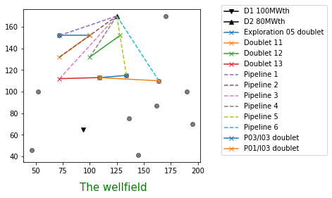

If you used machine learning, which techniques were most successful? And how did they contribute to your conclusions?

We only used linear regression on the well separation and pumping power around well E05, assuming separation differences of 400, 600, 800, and 1000m. Eventually, the linear regression simply confirmed our belief that E05 would likely be a good opportunity to deliver heat over the entire lifetime of the project, even at greater pumping rates.

### Results

According to the results, the area close to EO5 is the best, due to good petrophysical properties (porosity and permeability), and from the DARTS model. Our initial run was surrounding EO5 will a six-doublet configuration, taking advantage of E05 as a production well. The second iteration of DARTS indicates that we could likely get away with a flow rate below the 6400m3/day that was initially thought. From the five flow rates, 6000 m3/day provides adequate heat above 80MWth over a 40-year period. Though the LCOH continues to decrease with higher pumping rates, our target demand point was inadequate (80MWth) to payback the incurred pumping costs as quickly. Without the ability to sell every unit of heat, there is no point in producing it. We chose the 6000m3/day pumping rate across 6 doublets. This configuration has a LCOH of less than 0.005 € after only 15 years.

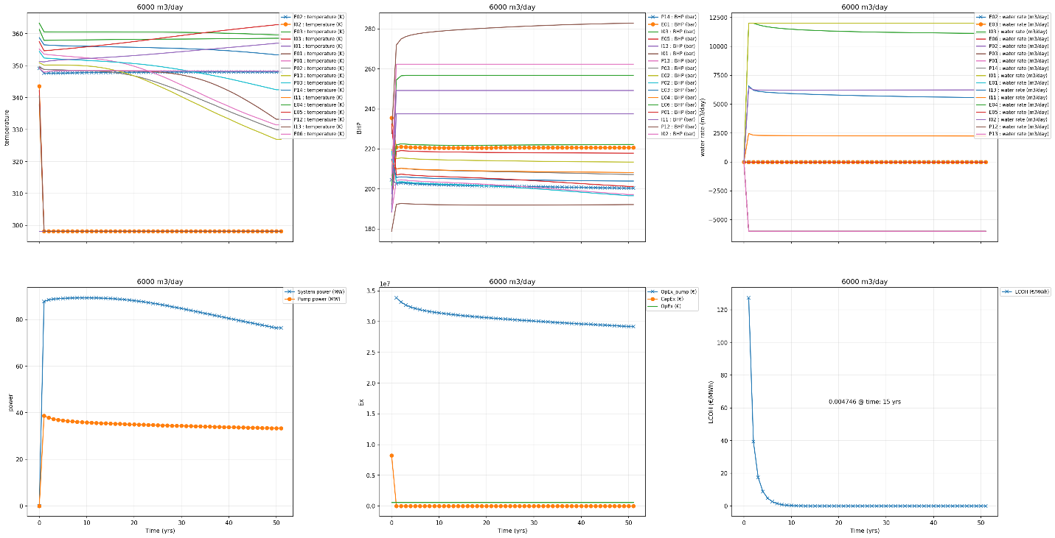

Discuss uncertainties and risks

One of the most important points going forward will be to develop a better conceptual model of the subsurface. Since we could not control the drilling depth inside of the subsurface we avoided having to consider preferential fluid flow pathways, or fractures, that may short circuit out doublet configurations, resulting in a rapid thermal drawdown. This is a project risk that all stakeholders, including municipalities must be aware of with geothermal projects.

Generally, geothermal has one of the lowest marginal heat generation costs in the world. In other words, the cost of producing one additional unit of heat is quite low by comparison to fossil and non-fossil methods. Regardless, this black box model might have been run incorrectly or it might be presenting an overly optimistic example. One thing is certain, the capital costs are high – initially €80.366.700 – which is highly characteristic of geothermal development projects. As with all geothermal models, this one has plenty of room for improvement before proceeding with the drilling targets.

### Conclusions

Our exploration method, thought to be for developing cross-sections across the same formations, did not work entirely like we expected. In all 4 zones were investigated. Fortunately, the data from that well data provided use with almost continuous sonic logs from about 1850-2350m. This gave us an unexpected advantage and our drilling targets near E05 worked quite well. Our 4 well test permeabilities gave us the confidence to go after the thicker formations at a shallower drilling depth around well E05. The LCOH could be lowered further by allowing us to control the drilling depth, but this was a good exercise in considering a more robust workflow for geothermal development projects.