**Final Report: PA1**

Nicholas Gingrich and Derek Roberts

**ER-Diagram:**

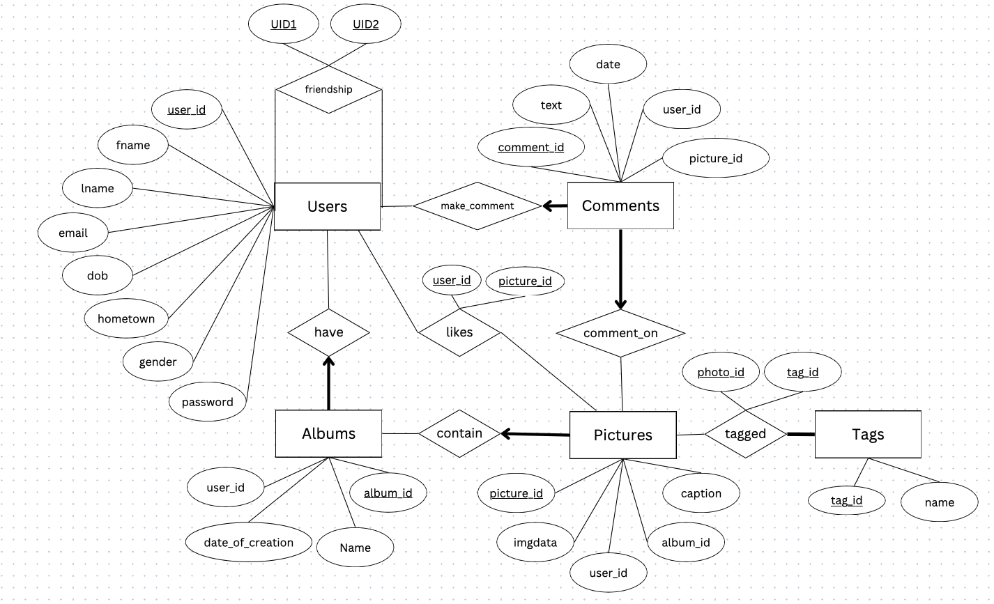

**Assumptions:**

* An album can exist with 0 photos inside
* We assume that photos in the same album can share tags
* Album names can’t contain spaces or special characters
* A user won’t click on “create a new album” after other fields in ‘upload’ are filled in
* Photos can appear as different sizes on the feed depending on the dimensions of the photo
* Once a user comments, the comment can’t be deleted unless the photo itself is deleted

**Functionality:**

* Implemented all required functionalities needed in the deliverable
* One limitation in our system is that if photos are deleted, all tags associated with that photo are also deleted, however if an album is deleted the tags associated with the photos inside are not.