Recursive Self-Improvement as a Fixed Point: A Test Paper
Ada Example (University of Testing), Grace Sample (Example Institute)

Abstract
We study when an agent that improves its own improvement procedure converges. Our main result gives a sufficient condition in terms of a contraction constant $λ<1$, and we show the bound is tight.

1. Introduction
Recursive self-improvement has been discussed since Good (1965). We make three contributions:
- A formal definition of an improvement operator.
- A convergence theorem (Theorem 1).
- Experiments, summarised in Table 1 and Figure 1.
Related ideas appear in several lines of work:
- Fixed-point theory
  - Banach's theorem
  - Kleene's recursion theorem
- Meta-learning
TODO: add a sentence on bounded rationality here.

2. Main Result
Definition 1. An improvement operator is a map $T:A→A$ on a complete metric space of agents.
Theorem 1. If $T$ is a contraction with constant $λ<1$, then the sequence $a_{n+1}=T(a_{n})$ converges to a unique fixed point.
Proof. This is the Banach fixed-point theorem applied to $T$. The error after $n$ steps is at most
$d(a_{n},a^{*})≤λ^{n}d(a_{0},a^{*})$
which goes to zero.

2.1 Implementation
The update loop is short:brief
for step in range(n):
agent = improve(agent)

3. Experiments
Table 1 reports convergence speed. We set $\epsilon = 10^{-3}$ throughout.
Method | Steps to converge | Final error
Baseline | 120 | 0.031
Ours | 45 | 0.004
Table 1: Convergence speed on the toy benchmark.
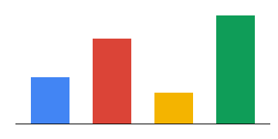
Figure 1: Steps to converge across four settings.
As Figure 1 shows, the contraction constant predicts speed well.

References
Good, I. J. (1965). Speculations concerning the first ultraintelligent machine. Advances in Computers, 6, 31–88.
Banach, S. (1922). Sur les opérations dans les ensembles abstraits. Fundamenta Mathematicae, 3, 133–181.

Good’s paper is often cited as the origin of the intelligence explosion argument.

