Problem I – Question 1: Attitude Determination

1. *Extracting Body Frame unit vectors*

The first step was to make sure that Matlab was properly able to open the .png file. The following image shows that Matlab succefully opens the image, as shown in Figure 1.

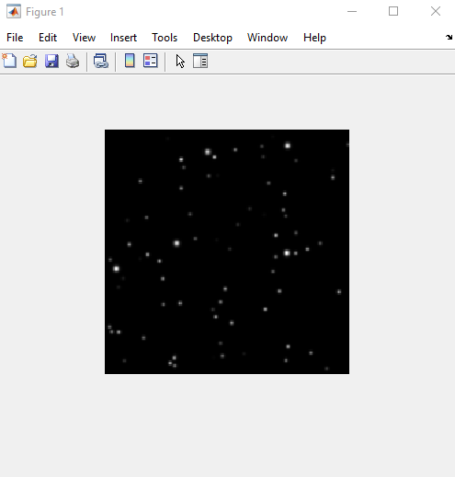

Figure 1. Raw image

The next step was to extract all the stars in the image, regardless of its brightness. The following image shows just that.

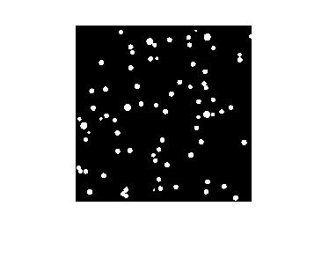

Figure 2. Identified stars

The next step is to find the centroid of each of these stars in the image. Specifically, the x & y pixel coordinates, whose origin is at the top left corner, were found. The following is that data:

However, we do not care about the coordinates of every star. We only want to analyze the ones labeled in this image:

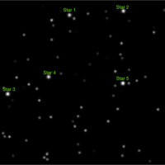

Figure 3. Image with the stars of interest labeled

Using Matlab’s built-in feature, the coordinates of these stars were approximately found and then manually compared to the centroid data to find the exact coordinate. The star coordinates are as follows:

Table 1. Coordinates of the stars of interest

|  |  |  |
| --- | --- | --- |
| Star # | x-coordinate | y-coordinate |
| 1 | 86.3143 | 19.8000 |
| 2 | 150.1887 | 13.5660 |
| 3 | 9.7843 | 114.3137 |
| 4 | 59.5000 | 93.5000 |
| 5 | 156.5000 | 101.5000 |